ENGLISH

Grade 8

Government of Nepal

Ministry of Education, Science and Technology

**Curriculum Development Centre**

Government of Nepal

**Publisher:**

Ministry of Education, Science and Technology

**Curriculum Development Centre**

Sanothimi, Bhaktapur

**© Curriculum Development Centre**

**All rights reserved, no part of this publication may be reproduced, transmitted in any other forms or by any means without the written permission of the publisher. However, this does not prohibit making photocopies of its pages for teacher training or other non-profit making purposes.**

**First Edition: 2023**

***The audio files for the listening tasks provided in this book are available on the website of the Curriculum Development Centre.***

Send your comments and suggestions to:

Curriculum Development Centre

Phone: 01-6630-588, Fax: 01-6630-797

Email: [info@moecdc.gov.np](mailto:info@moecdc.gov.np)

Website: moecdc.gov.np

**Preface**

The curriculum is the central guide that decides what is essential for teaching and learning. A textbook is one of the main tools to deliver the intent and the content of the curriculum. An amendment in the curriculum and textbook is a regular process to make them relevant, practical, and useful for the overall development of a learner. This textbook ‘English Grade 8’ has been developed to address the main aims of the Basic Level (Grade 6-8) English Curriculum: Exposing the students to the vast treasure of knowledge available in both written and spoken English and enabling them to communicate their ideas in English. It is aligned with the intent of the National Curriculum Framework for School Education, 2076. This textbook has been developed based on the new Basic Level (Grade 6-8) English Curriculum 2077.

This book was prepared by a team that includes Ms. Krishna Kumari Upadhayaya, Ms. Mallika Joshi Shrestha, Mr. Matrika Subedi, and Mr. Pushpa Raj Paudel. Several people notably; the Director General Mr. Baikuntha Prasad Aryal, Professor Dr. Bal Mukunda Bhandari, Dr. Bamdev Adhikari, Dr. Netra Prasad Sharma, Mr. Basanta Raj Dhakal, Mr. Nawaraj Sapkota, Mr. Tukaraj Adhikari, and Mr. Shankar Adhikari also contributed significantly on the development of this book. The content and language of this book were edited by Ms. Kunti Adhikari, Mr. Nabin Kumar Khadka, and Mr. Nim Prakash Singh Rathaur. The illustrations in the book were done by Mr. Kushal Karki. Art editing of this textbook in its four-colored version was done by Mr. Shreehari Shrestha. The Curriculum Development Centre extends sincere gratitude to all of them. With the view that the learning of English should be based on authentic materials, we have retrieved and adapted the texts and tasks including the audio from various authentic sources. Therefore, the Centre would like to extend its acknowledgment to all of them.

The contents in this book are arranged in such a way that the learners get an opportunity to practice listening, speaking, reading, and writing skills as well as grade-appropriate vocabulary, grammar, and language functions in each unit. Considerable effort has been made to make the book activity oriented and interesting to the learners. All the components of each lesson in this textbook are equally important. The teachers can adapt the contents and tasks to the need of their learners and classroom contexts. This textbook can be used as a major resource for classroom teaching but it is not all in all. The teachers are also en­couraged to explore other resources in addition to this book and use them to supplement the language learning of their learners.

The Curriculum Development Centre always welcomes constructive feedback for the betterment of its publications.

2022

Curriculum Development Centre  
Sanothimi, Bhaktapur

**Table of Contents**

|  |  |  |  |  |  |  |  |
| --- | --- | --- | --- | --- | --- | --- | --- |
| **Unit** | **Reading** | **Speaking** | **Listening** | **Grammar** | **Writing** | **Project work** | **Page** |
| 1 | A Tour to Central  Zoo: Timetable  A Request Letter | Pronunciation:  Word Stress  Asking for  Information and Repetition of Information | Conversation about Timetable | Modal verbs: can, could, would  Simple Present Tense | Interpreting  Timetable and Schedule  Filling in a Form | Designing a  Timetable | 1 |
| 2 | A Father's Letter to his Son  Poem: Changing  World | Pronunciation: /t/, /d/, /**i**d/  Asking for  Permission  Giving and Denying  Permission | Asking for and  Giving  Permission | Yes/No  Question | Completing a Skeleton Story  Writing an E-mail | Composing a poem | 13 |
| 3 | Public Announcements  How to Wash Clothes in a Washing Machine | Pronunciation: /r/  Requesting and Responding | Conversation about Going to the Cinema | Reported Speech:Yes/No Question | Writing an Announcement | Preparing a Set of  Instructions | 25 |
| 4 | A Memoir: A Visit to Mustang  A Diary Entry | Pronunciation: Diphthongs  Talking about Personal Experiences | Sharing Personal Experience | Present Perfect  Past Simple | Writing an  Account of a Memorable Event  Writing a Diary  Entry | Assessing Diary Entry | 37 |

|  |  |  |  |  |  |  |  |
| --- | --- | --- | --- | --- | --- | --- | --- |
| 5 | The Old Woman and the Lime Tree  Poem: Free Birds | Pronunciation: Syllable  Persuading | Planning a Tour | Reported Speech: Imperatives | Punctuation  Completing a Skeleton Story | Collecting the Expressions used for Persuading | 51 |
| 6 | Traditional Wedding Customs around the World  Life Saving Inventions | Pronunciation:  /s//z/, /**i**z/  Getting Things  Done | Conversation:  Getting Things  Done | Causative Verbs  Subject Verb Agreement | Describing a Ceremony  Paraphrasing | Making a Collage | 64 |
| 7 | Weather Forecast  Migration | Pronunciation: Words Used to  Forecast Weather  Making Prediction | Weather  Forecast | Simple Future Going to Future Future Perfect | Punctuation  Writing Paragraphs on Environment | Designing a  Picture | 79 |
| 8 | Having Fun  Historical Inventions | Pronunciation: /t/, /d/, /**i**d/  Talking about the  Past | Conversation about Activity Week | Past Simple,  Past Continuous,  Past Perfect  Used to | Completing a Skeleton Story  Writing a Narrative Essay | Making a Survey | 90 |
| 9 | The Leap between High School and College  Smartphones in our Life | Pronunciation: College Related Words  Making Comparison and Contrast | Making Comparison and Contrast | Comparative and Superlative | Writing a Paragraph Comparing the Places  Writing an Essay | Making a Survey | 105 |

|  |  |  |  |  |  |  |  |
| --- | --- | --- | --- | --- | --- | --- | --- |
| 10 | Vacancy  Announcement  Invitation | Pronunciation: -tion and -sion words  Making an Invitation and Responding | Making an  Invitation and Responding | Prepositions of  Place and Time  Question Tag | Writing a Vacancy Advertisement  Writing a Message of  Invitation | Designing an Invitation Card | 116 |
| 11 | Sir Isaac Newton  Khaptad National  Park | Pronunciation:  Tongue Twisters  Describing Places, People, and Objects | Description of a Place | Relative Clause  Article | Preparing a  Leaflet  Writing a Set of Rules | Collecting  Information about a Place | 128 |
| 12 | Nepal's Bird Man  Poem: My Teacher Ate my Homework | Pronunciation: Words with -ch  Expressing Likes, Dislikes, and Preferences | Expressing  Likes and Dislikes | Verb-ing/Infinit ive  Yes/No  Question  Wh Question | Writing an Essay on Hobbies and Interests | Collecting a Poem | 145 |
| 13 | Nepal is the First Country to Double its Tiger Population  Drama: A  Mousetrap | Pronunciation: Words Used to Interpret Charts and Graphs  Interpreting Charts, Graphs, and Table | Conversation: Expressing Quantity | Much/Many Some/Any | Interpreting Charts, Graphs and Tables | Presenting Data in a Form of a Graph | 157 |
| 14 | The Magic Mirror  Poem: If I was a Superhero | Pronunciation: British and American Pronunciation  Expressing Conditions | Describing a job | Type 1, Type 2, and Type 3 Conditional | Writing a News Story | Preparing a Draft of a Speech | 172 |

|  |  |  |  |  |  |  |  |
| --- | --- | --- | --- | --- | --- | --- | --- |
| 15 | Conservation of  Earth  An Official Notice | Pronunciation:  English Consonants  Giving Explanation | Giving opinion about Animals in Zoo | Connectives:  Reason, Purpose, Contrast | Writing an Argumentative Essay  Writing a Notice | Preparing a Bulletin Board | 189 |
| 16 | An Anecdote: Why I Became a Vegan  A History of Pens | Pronunciation:  Words with Silent Letters  Narrating a  Sequence of Events | Narrating an Event | Past simple,  Past Continuous  Past perfect | Writing a Story  Writing  Paragraphs about Historical Events | Describing Major  Events | 201 |
| 17 | Naresh and the Stranger  Poem: From a Railway Carriage | Pronunciation: Contractions  Making and Accepting Offers | Making and Accepting Offers | Voice | Writing an E-mail  Writing a Reply Letter to an  Invitation | Collecting the Expressions Used to Make Offers and Accept/Decline the Offers | 214 |
| 18 | Road Accidents in Nepal: Are Poor Roads Solely to Blame?  Poem: Long Life | Pronunciation:  Words Related with Road  Asking for and  Giving Opinion | Giving Opinion | Intensifiers: too, enough  Subject Verb  Agreement | Writing an Opinion Essay  Punctuation | Filling a Survey Form and Making Presentation | 226 |
| 19 | A Tale of Two Birds  News Report: Pokhara International Airport Inaugurated | Pronunciation: Consonant Cluster  Reporting | Reporting­  Replace | Reported  Speech | Writing a Story  Writing a News Report | Designing a Front Page of a  Newspaper | 238 |

**Getting started**

**The pictures below show Neetu's activities in a day. Ask questions and answer them.**

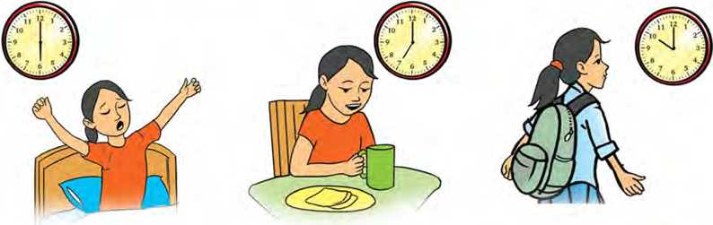

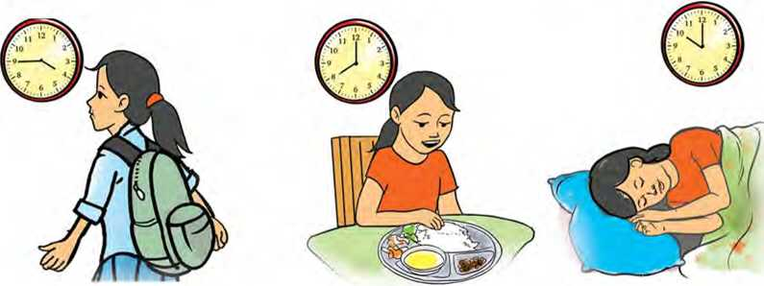

**Reading I**

**Answer these questions.**

1. Have you ever been to an educational tour?
2. Where and when did you go?
3. What did you do during the tour?

A Tour to Central Zoo

**Saraswati Niketan Secondary School  
Teku, Kathmandu**

Notice!

Date: 20th June The school is organizing an educational tour to the Central Zoo, Jawalakhel, Lalitpur on 24th June for the students of Grade Eight. The timetable of the tour activities is scheduled as follows:

|  |  |
| --- | --- |
| Arrive at school and arrange groups | 9:00 a.m. |
| Board the bus | 9:15 a.m. |
| Attendance | 9:20 a.m. |
| Reach Central Zoo | 9:45 a.m. |
| Form small animal groups (See animal groups below.) | 10:00 a.m. |
| Enter the zoo | 10:05 a.m. |
| Explore the animals in the zoo | 10:05 a.m. - 2:00 p.m. |
| Board the bus | 2:10 p.m. |
| Attendance | 2:15 p.m. |
| Arrive back at school | 2:40 p.m. |
| Return to classroom | 2:50 p.m. |
| Grand discussion | 2:50 p.m. -4:00 p.m. |

Animal groups:

1. Birds b. Reptiles
2. Mammals d. Amphibians

*Note: Mrs. Karki. the English teacher will lead the tour. Students are expected to follow the timetable and the guidelines given by the teacher.*

1. **Match the words in column A with their meanings in column B.**

**Column A Column B**

|  |  |  |  |
| --- | --- | --- | --- |
| a. | tour | i. | to travel to or around an area to learn about it |
| b. | board | ii. | any animal that can live both on land and in water |
| c. | explore | iii. | a visit to a place |
| d. | grand | iv. | to get on or into a vehicle |
| e. | amphibian | V. | large and important |

1. Answer these questions.
2. What time do the students need to arrive at school?
3. How long will it take them to reach the zoo from their school?
4. Why do you think the teacher will take the students' attendance twice?
5. Why do you think the students will explore the zoo in animal groups?
6. Who should the students contact if they have any problem during the tour?
7. **You might have been to an educational tour from your school. Share the most exciting activity you had during the tour.**

**Pronunciation**

Pronounce these words. Notice the stress mark.

attendance a'rrange 'mammal 'reptile a'rrival ex'plore a'rrive am'phibian return in'form

**Speaking**

1. **Act out the following dialogue in pairs. Notice the use of would and could.**

|  |  |
| --- | --- |
| Raima | : Namaste, sir! Are we going to the national museum this month? |
| Sanjeev | : Yes, we are. |
| Raima | : Could you tell me the day of the visit? |
| Sanjeev | : We're going there on Monday at 9:00 a.m. |
| Raima | : Sorry, would you tell the time again, please? I couldn’t quite get you. |
| Sanjeev | : Of course. It’s 9:00 a.m. |
| Raima | : Thank you, sir. |

1. **Work in pairs. Study the following situations. Now, ask and answer the questions. Begin the questions with could, would or can.**
2. You want to know your teacher’s mobile number.
3. You want to know how much a cup of coffee costs.
4. You want to know what time you can get an appointment to see the dentist.
5. You want to know whether your tea has sugar in it.
6. You want to know what time the next bus for Pokhara leaves.
7. You want to know how far the hospital is.
8. You want to know where Mina bought her new bag.

**Grammar I**

1. Change the following statements into yes/no questions.
2. They could rescue the victims.
3. Linda can win the match.
4. Your mother can drive a car.
5. You could help me.
6. He would suggest a solution to a problem.
7. They would do social work.
8. Your father would take us to the park.
9. You could come to meet me.
10. **Fill in the blanks using can, could and would. Use negation**

**if necessary.**

1. I go to the party last night because I was sick.
2. A: Ganesh cook Thakali food? B: Yes, he can.
3. My sister ride a bike last year, but now she
4. If I had a car, I drive it around the city.
5. Lots of dinosaurs walked on land, but some fly

or even swim.

1. I wish they take us to visit a new place.
2. I read without my reading glasses. Where are

they?

1. I rather go to the cinema today.

**Listening**

1. **Look at the picture and answer these questions.**
2. 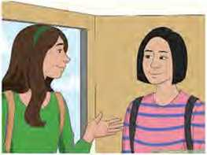Who do you think these girls are?
3. What do you think they are talking about?

**Listen to the audio and complete the table with missing information.**

**B.**

|  |  |
| --- | --- |
| Maths |  |
| Lunch | 12:00 noon |
| History | in the afternoon at |
| Science |  |
| class | Art |

C. What is the timetable of your daily activities? Ask and answer questions as in the audio.

**Reading II**

**Answer these questions.**

1. What is the type of the text given below?
2. What do you think it is about?

A Request Letter

Kushma - 9, Parbat

27 April 2023

The Headteacher

Adarsha Secondary School

Kushma, Parbat

**Subject: A Request to increase computer lab facilities**

Respected Sir,

We are very grateful that you have been successful in establishing a computer lab at our school. We are overjoyed seeing a computer lab at our school. The lab provides us with the most up-to-date learning devices. It helps us gain technological knowledge too.

This admirable effort, however, is not quite sufficient in accomplishing its goal. In fact, the lab is lacking some necessary equipment. To begin with, there are insufficient numbers of computers. Second, only a few computers have the required software installed. This limits our learning. Third, our lab does not have an internet connection. So, we cannot access the vast world of knowledge and information.

We would be thankful if you provided us with all the necessities for a modern computer lab at our school. We would welcome your reply to our request. Thank you.

Yours faithfully,

Students of Grade 8

1. **The meanings of some of the words from the above letter are given below. The words are scrambled. Unscramble and write them.**

|  |  |
| --- | --- |
| **Meanings** | **Scrambled words** |
| 1. having qualities that you admire and respect 2. not having enough of something 3. tools needed for a particular purpose 4. large in area, amount, etc. 5. the programmes used by a computer | amirdaleb  Ickaing euipqmnet vsta sotfwrae |

1. Answer these questions.
2. Who wrote the letter?
3. Who is the letter addressed to?
4. Why are the students of Grade 8 grateful to the headteacher?
5. Why are the students very happy about the computer lab?
6. List the three issues the students talk about.
7. **Mention a problem you are facing at your school. How is it affecting your study? Discuss with your friends.**

**Grammar II**

1. **These sentences are from the letter. Complete them with the missing words.**

a. Grade eight students grateful for the computer

lab.

1. The lab us with the most up-to-date learning

devices.

1. It us gain technological knowledge too.
2. Only a few computers the required software

installed.

1. This our learning.
2. **Rearrange the jumbled words to form correct sentences in simple present as shown in the example.**

*Example:*

*leave/the bus/ot 9:00 a.in./to Dharan.*

*The bus to Dharan leaves at 9:00 a.m.*

1. work/he/in a department store.
2. Suman/at the weekend/do his laundry.
3. my friends and I/once a month/go to the cinema.
4. give/nice gift/a/me/my neighbour/never.
5. playing/always/love/the guitar/Akash.
6. a doctor/mother/be/my.
7. drive/she/always/too fast/her scooter.
8. the day/a lot of/work/people/during.
9. where/your brother/work?
10. what time/your sister/every day/get up?
11. **Complete the following text using the present simple form of the verbs in the brackets.**

Peter Hanson (start) his day at 7:00. He

(have) his breakfast in the kitchen with all the family. He (like) orange juice, toast and milk. He always (have) an apple: his mother (believe)

“an apple a day (keep) the doctor away.” After

breakfast, Peter (make) his bed and

(tidy) up his bedroom. He (get) ready for lessons.

He mustn’t be late, his mother (be) very strict.

At 8:00, the other Hanson kids (start) their

lessons. At midday, they (have) their lunch.

Then, it’s sports time: they (love) playing

basketball, in-line skating and skateboarding. After a refreshing shower, the famous Hanson brothers

(rehearse) till dinner, because their fans (be)

very demanding: they (want) every detail to be

okay.

Peter and his brothers (not/have) dinner with

their parents as their father is always late. Their mother (not/like) it very much. So, at weekends they (be) always together.

**Writing**

1. **Study the sports timetable below and interpret it.  
   Janata Secondary School  
   Inter-house Football Tournament**

**B.**

|  |  |  |
| --- | --- | --- |
| **Date/Time** | **10.00-12.00 am** | **1.00 pm onwards** |
| May 3 | Opening, registration of teams and players | Sagarmatha House vs Manaslu House |
| May 4 | Cultural performance by Grade 8 students | Machhpuchhre House vs Annapurna House |
| May 5 | Final Match | Prize distribution and closing |

The form below is an application for hostel registration. Fill it in with your personal details.

**MERO JANMABHUMI HIGHER SECONDARY SCHOOL**

**GONGABU, GANESHTHAN**

Hostel Registration Form

DATE OF REGISTRATION

**PERSONAL INFORMATION**

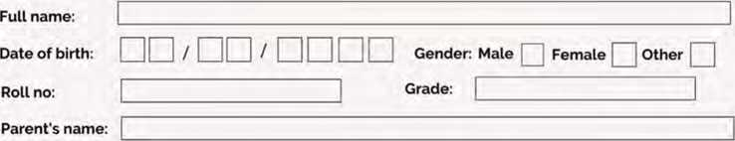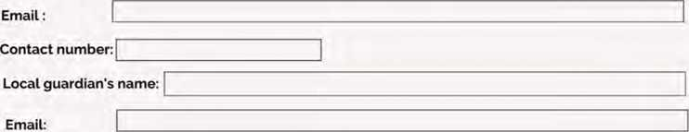

(Please write the names in BLOCK letters)

Contact number:

**ADDRESS**

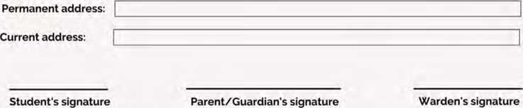

**SCHOOL ADDRESS:**

**Mero Janmabhumi Higher Secondary School Gongabu, Ganeshthan**

**THANK YOU FOR THE REGISTRATION!**

**Project work**

**Work in groups. Design an ideal timetable for your class for a week. Include the subjects of study, the time and the days you would like to study. Make your timetable attractive. Then, display it in your classroom.**

*bit*

Common abbreviations used in a dictionary

|  |  |  |  |
| --- | --- | --- | --- |
| **Abbreviations** | **Used for/words** | **Abbreviations** | **Used for/words** |
| adj. | adjective | pl- | plural |
| adv. | adverb | pp | past participle |
| art. | article | prep. | preposition |
| BrE | British English | pron. | pronoun |
| C | countable noun | Pt | past tense |
| cl | clause | Ref. | reference |
| conj. | conjunction | sb | somebody |
| det. | determiner | sth. | something |
| etc. | Et Cetera | symb. | symbol |
| I | intransitive verb | U | uncountable  noun |
| n. | noun | **V.** | verb |
| NAmE | North American English | Voc./Vocab. | vocabulary |
| phr. | phrase | Vol. | volume |

**Unit**

**Getting started**

**Look at the pictures and guess what permission these people**

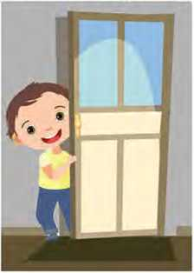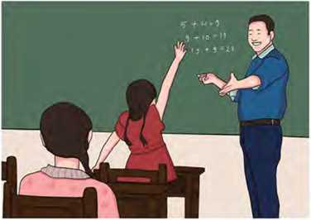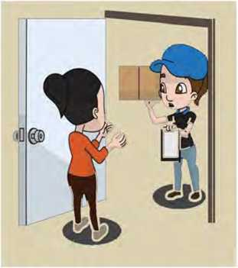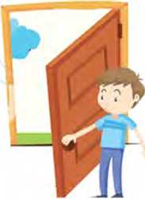

might be asking for.

Reading I

**Study the pictures below and answer these questions.**

1. Where do you think the boy in the first picture is?
2. What do you see in the second picture?

A Father's Letter to his Son

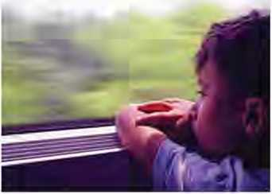In a city, a boy lived with his parents. His grandparents used to live far away in another city. The parents would take their son to his grandparents’ house during summer holidays every year. They would stay there for fifteen to twenty days and then return. The boy always loved visiting there. This continued every year.

With time, the boy grew up. One day, the young boy said to his parents, “Now, I am big, I can go to my grandparents’ house alone. Is it okay if I go on my own? Please let me go by myself.” His parents refused at first but when the boy insisted, finally they agreed. His parents were worried about his safety. So, they taught him everything he needed to know about travelling alone.

The boy wanted to enjoy his stay with his grandparents. He wanted to take some of his stuff. He asked his mother, “Mum, this is summer. I would like to take my swimming goggles and swimming suit. May I take them, please?” The mother said, “Okay but always go swimming with your grandparents.” He said, “Don’t worry, mum.” He loved his grandparents a lot. He wanted to take some gifts for them and said, “Would it be alright if I took sunglasses and mufflers for them?” She smiled and said that it was a good idea.

The day came when the boy was to leave for his grandparents’ house alone. His parents came with the boy to see him off. When the boy was comfortably settled in his berth in the train, hisparents left and waited for the train to depart. While waiting, the father went to the window and kept talking to his son. While talking, his father handed him an envelope through the window and said, “Son, if you feel afraid or scared on the way, open this and read it. It will help you to calm down.”

The boy kept that envelope safely in his pocket and said goodbye to his parents. A departure announcement was made. The boy smiled and told his father, “I remember everything. Don’t worry.” The train got a signal to depart.

At every station, where the train stopped, people kept coming and going. The boy was observing all this. He saw that everyone was with someone and soon started feeling lonely. At one station, a big man entered the compartment. The boy was scared of him. He tried to sleep but could not because he kept on thinking of the big man. He got even more scared. Then, he remembered his father’s letter. He put his hand into his pocket, opened the envelope, and read the letter.

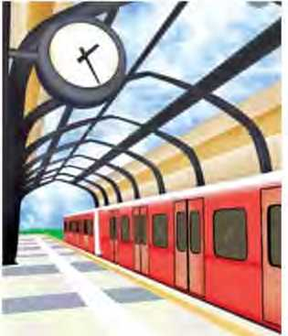His father had written - “Don’t be afraid. I am here with you on this train, in the adjacent compartment.” Just after reading that letter, the boy's face lit up and all the fear vanished.

A. Solve the crossword puzzle with the help of the given meanings.

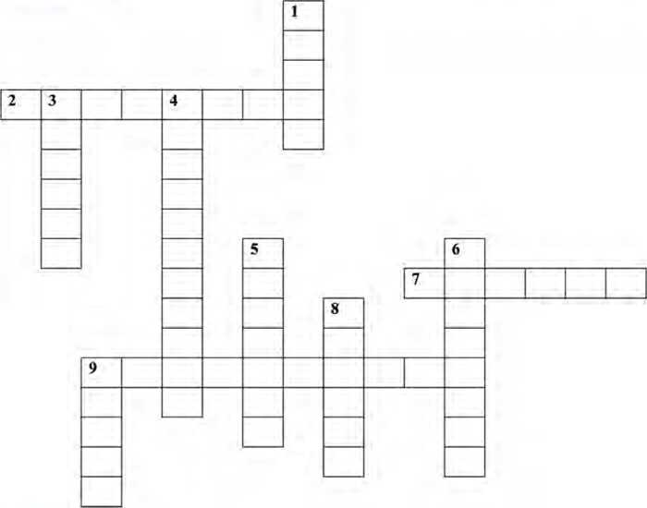

**ACROSS**

1. next to something: A
2. gave something to somebody: H

9. a pair of glasses to protect eyes from the Sun: S

**DOWN**

1. a place to sleep on a train or ship: B

1. to leave a place: D
2. a section on a train: C
3. a thick piece of cloth to keep your neck warm: M
4. disappeared suddenly: V
5. to demand something forcefully:
6. a group of objects: S

B. Write who made these remarks and for what purpose.

|  |  |  |
| --- | --- | --- |
| **Sentences** | **Speaker** | **Purpose** |
| a. Is it okay if I go on my own? |  |  |
| b. Please let me go by myself. |  |  |
| c. May I take them please? |  |  |
| d. Okay but always go swimming with your grandparents. |  |  |
| e. Would it be alright if I took sunglasses and mufflers for them? |  |  |

1. Answer the following questions.
2. Where did the boy want to visit?
3. How long would the boy live with his grandparents?
4. Why did the parents not want to let him go alone at first?
5. Do you think that the boy was loving and caring? Why?
6. What did the boy tell his father before the announcement?
7. Why do you think the boy felt relaxed at last?
8. **If you were the boy, what else would you ask your parents to take with you? Talk to your friends.**

**Pronunciation**

**Here is a list of words from the story. Pronounce the words and put them in the correct column based on the last sound. One example of each is given.**

asked loved insisted agreed lived worried

wanted said smiled handed stopped scared

|  |  |  |
| --- | --- | --- |
| /t/ | /d/ | /id/ |
| asked | loved | insisted |

**Speaking**

1. **Work in pairs. Match the questions in A with correct responses in B. Then, act them out with your partner.**

|  |  |
| --- | --- |
| **A** | **B** |
| a. Can I go out, please? | a. No problem. You can use it. |
| b. May I use your pen, please? | b. Not at all. I like loud reading. |
| c. Would you mind if I used your telephone? | c. Yes, you can. |
| d. Is it okay if I sit here? | d. Yes, it’s hot in here. |
| e. Do you mind if I read it loudly? | e. I’m sorry. I am doing my classwork. |
| f. Is it alright if I switch on the fan? | f. Yes. No one is sitting here. |

1. Work in pairs. Study the situations below. Take turns to ask for permission and respond to them.

*Example:*

*Kedar : May I use your compass?*

*Nima : I’m sorry. I’m using it.*

1. You want to use your friend’s computer.
2. You want someone to take your photo.
3. You want to have a glass of juice.
4. You want to take your friend’s notebook.
5. You want to drink water.
6. You want to take some rest.

Grammar I

1. Match the statements in column A with their correct questions in column B.

Column A Column B

1. I am late.
2. I can help you.
3. She is sleeping.
4. We have met before.
5. You work at home.
6. It costs Rs. 10.
7. She went home.
8. They left for the cinema.
9. Do you work at home?
10. Does it cost Rs. 10?
11. Did they leave for the cinema?
12. Am I late?
13. Is she sleeping?
14. Can I help you?
15. Have we met before?
16. Did she go home?
17. Change the following statements into yes/no questions.
18. He loves this town.
19. They always play football.
20. She can fly aeroplane.
21. There are some smart students in the school.
22. They went to the river yesterday.
23. She spends her money on books.
24. He decided to leave the town.
25. She goes to bed early.
26. They should rewrite their homework.
27. He was born in India.
28. Write honest answers to these questions.
29. Do you study in Grade VII?
30. Do you like watching television?
31. Have you ever been to a zoo?
32. Does your father cook food?
33. Did you go to a health post/hospital last month?
34. Can you draw a picture of a dragon?
35. Do you have classes on Saturdays?
36. Does your brother/sister like coffee?
37. Does your friend wear glasses?

**Writing I**

1. Develop a story based on the outlines given below. Write a suitable title too.

A poor shoemaker and his wife live in a small house

has tough days to earn his daily bread always dream of living happily runs out of money has a piece of

leather to sew shoes gets up in the morning and finds fine pairs of shoes gets surprised and sells them in market buys more leather cuts it out to make more

pairs and leaves on his work-table finds many pairs

there sells them and becomes rich continues for

some weeks buys a beautiful house comes to know

about the elves helping them leaves pairs of beautiful

shoes for them elves never come back again

1. **Write a story that ends in 'She finally realised her mistake'.**

**Reading II**

Study the picture below and answer these questions.

1. What do you see in the picture?
2. Why do you think the man is standing alone? Share your views.

Changing World

When I was a young man,

I wanted to change the world.

I found it was difficult to change the world,

So I tried to change my nation.

When I found that I couldn't change the nation.

I began to focus on my town.

I couldn't change the town

And as an older man, I tried to change my family.

Now, as an old man, I realized the only thing

I can change is myself.

And suddenly I realized, That if long ago I had changed myself.

I could have made an impact on my family.

My family and I could have made an impact on our town. Their impact could have changed the nation

And I could, indeed, have changed the world.

*- Edward de Bono*

**Learn these words from the poem and complete the sentences using them.**

**change suddenly realize I focus impacts indeed**

Great people always their mistake.

a.

b.

The meal was very delicious

Excessive use of electronic devices has negative

c.

on our mental health.

1. Thank you for your offer but I cannot my mind
2. Our exam is approaching but I cannot on my

studies.

1. **Answer these questions.**
2. Why do you think the poet wants to change himself?
3. Why does the poet feel sorry in the poem?
4. What does the poet realise when he grew old?
5. If the poet had changed himself, what could have happened?
6. Is changing the world easy or tough ? Give your opinions.
7. **How can we change ourselves and the society? Discuss.**

**Listening**

1. Look at the picture and answer these questions.

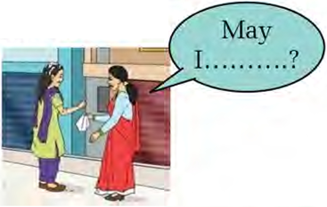Who do yoTi think the women in the picture are?

a.

b.

What do you think the woman in red saree is asking for?

1. Listen to the conversation and write True or False.
2. The two ladies are talking in the afternoon.
3. The girl is hungry.
4. The girl wants to use the washing machine to wash her clotlies.
5. She could use the washing machine the day after.
6. **Listen to the conversation again and answer these questions. Use one word only.**
7. What does the girl look for?
8. Which place is relatively hotter?
9. What clothes does the girl want?
10. Which drawer contains the clothes?
11. **Recall the questions you heard on the audio and find who can remember the most.**

**Writing II**

**Study the email given below.**

To karnatashmisarlaht(g>ginall com X

Cc Bee

Asking for permission to use the hall

Dear Madam,

It is an immense pleasure that our school is celebrating its Platinum Jubilee next month and organizing a short cultural programme on the occasion. I feel honoured to be selected as the coordinator of the programme. I, with my teachers and friends, have planned details for the programme. Indeed, participants have asked for permission to use our auditorium hall during lunch break to rehearse. Is it okay if they use the hall?

Would it be alright if they practised there for a couple of days? I look forward to your positive response. Thank you!

With warm regards,

*Kabir J ha*

**Sans Serif ’ TT ” B *JT* U A -** EE ~ ”

**A GO © A** B ft ***F : ■***

**Send**

1. **Imagine you are the headteacher. Write a reply email responding to the request made by Kabir Jha to use the hall.**

**Project work**

**Compose a poem on any one topic you like and share it in your class.**

Expressions used in asking, giving, and denying permission

|  |  |  |
| --- | --- | --- |
| **Asking for permission** | **Giving permission** | **Denying permission** |
| Can I leave at 4 o'clock?  Excuse me, do you think I could try this one?  Would it be possible to open the door?  Do you mind if I try these shoes on?  I was wondering if I could bring my pet here.  Any chance of borrowing your old camera for a few days?  May I have your permission to use your mobile phone once? | Yes, certainly. Of course.  By all means. Sure.  That's okay. Go ahead. Why not? That seems perfectly acceptable. | I'm afraid, you can't. I'm afraid not.  I'm sorry, that's not allowed.  I'm sorry.  You are not allowed to do that.  Sorry. No way. |

**Unit**

**Getting started**

**Study the pictures below and talk about them. What might they be requesting?**

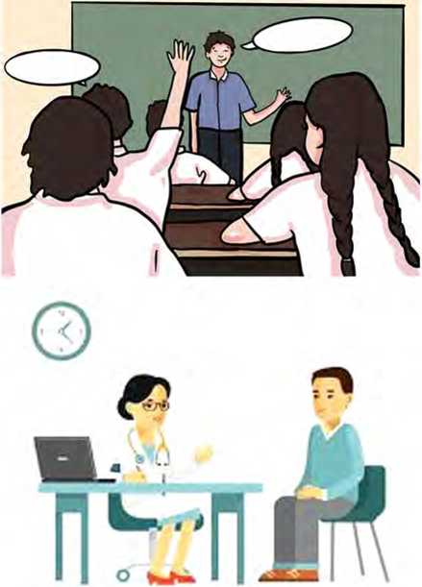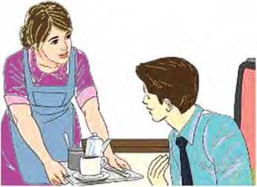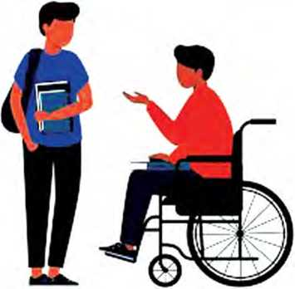

**Reading I**

**Answer these questions.**

1. Where do you think announcements are generally made?
2. Why do you think announcements are made?

Public Announcements

**Pre-flight Announcement**

Ladies and Gentlemen,

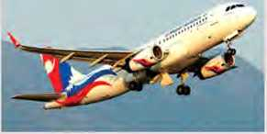Welcome to Flight RA-402 from Kathmandu to New Delhi. We're currently third in line for takeoff and are expected to be in the air in approximately five minutes. Please fasten your seatbelts and secure your baggage underneath your seat or in the overhead compartments. Make sure that you put your seat in the upright position for take-off. We also request you to turn off all personal gadgets, including laptops and mobile phones. Smoking is strictly prohibited during the flight. Thank you for choosing Nepal Airlines. Enjoy your flight.

**Nepal Airlines**

**Parents Day Announcement**

We are pleased to announce that our school is going to celebrate Parents Day on the 22nd of March on the auspicious occasion of its 42nd anniversary. The programme will be held in the Assembly Hall at 11:00 a.m. We feel privileged to announce that the Mayor of Bardaghat Municipality will grace the ceremony as the chief guest. We feel proud to announce that the mayor is an ex-student of this school. He will confer the prizes to the winning students in academic, extra-curricular and co-curricular activities. There is also a cultural performance by our talented students to entertain the audience. There will also be a short photo session with the chief guest at the end of the programme.

Thank you!

**Dibya Jyoti Secondary School**

sentences below.

**A. Find the correct words from the text to complete the**

1. We had to pay extra amount for our in

the aeroplane.

1. Would you switch off all your as the

plane is going to take off?

1. Tomorrow is my parents’ wedding
2. The Chief Guest will the prizes to the

winners.

1. Please keep your seat in the position. The

plane is going to land soon.

1. Our school will remain closed for 15 days on the occasion of Dashain.
2. **Write True or False for the following statements.**
3. Pre-flight announcement is about the landing of an aeroplane.
4. Baggage should be kept either under the seat or in the overhead compartments.
5. Parents Day is going to be celebrated on March 21st.
6. A dance will be performed by professional artists on the Parents Day.
7. The photo session is scheduled at the beginning of the programme.
8. **Answer these questions.**
9. What are the first and the second announcements about?
10. State the travel route of flight RA-402.
11. Why do you think the seats should be in the upright position during the takeoff?
12. Who is the Chief Guest on the Parents Day?
13. When and where is the Parents Day programme scheduled to be held?
14. **Why do you think it is important to celebrate Parents Day? Talk to your friends.**

Pronunciation

**Listen to your teacher pronounce these words. Notice how 'r' in them is pronounced and practise saying them.**

air underneath overhead compartment

turn off your anniversary minister

confer winner entertainment guardian

Writing

**Write a short announcement on behalf of class captain/monitor to celebrate any one event (e.g. Children’s Day) at your school. Include what, when, where, who and how the event is going to be celebrated. Also request people to attend the function.**

Speaking

1. **Study the following expressions used for making requests and responding to them.**

|  |  |
| --- | --- |
| **Expressions for making requests** | **Expressions for responding to requests** |
| Can I ask you to ? | Yes, what do you need? |
| I was wondering if you could | I'll see that I can do. |
| Do you think you could ? | Let me check and get back to you. |
| Could you please ? | Sure, no problem. |
| Would you mind if I ? | Of course not. Go ahead. |

B. Look at the pictures below. Imagine you are in the given situation. Work in pairs to make requests and respond them.

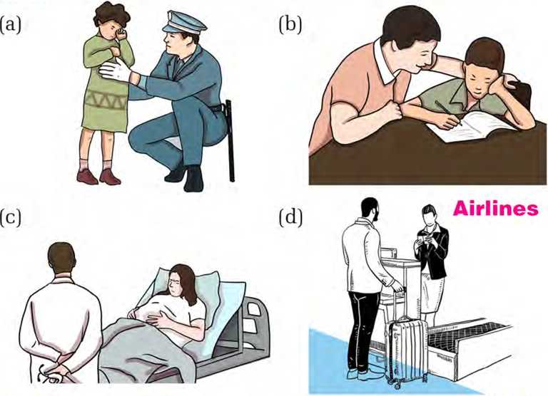

C. Work in pairs. Take turns to request and respond with the help of the clues. Use different expressions.

*Example: Help me with these bags.*

*A: Could you please help me to carry these bags?*

*B: Sure, no problem. Um sorry, I’ve injured my arm.*

1. help push my wheelchair across the road
2. give me your book
3. lend me your bicycle for a few days
4. drop me at the airport
5. read the newspaper for me
6. turn off the fan
7. speak slowly
8. be seated

Listening

Look at the picture and answer these questions.

1. 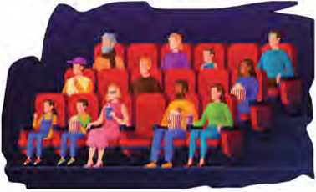Where do you think these people are?
2. What might these people be watching?
3. Listen to the audio and choose the correct options.
4. The young girl wants to go to
5. a park ii. a swimming pool iii. a movie
6. Who is going with the girl and her father?

i. the girl's older brother ii. the girl's best friend iii. the girl's mother

1. What time does the activity start?

i. 2:45 p.m. ii. 2:15 p.m. iii. 2:30 p.m.

1. What does the girl want to do later?
2. She wants to walk to the ice cream store.
3. She wants to swim.
4. She wants to go down to the beach.
5. What does the father want to do at the end of the day? i. play a board game ii. watch a firework display iii. go to a restaurant
6. **Share the story of a movie that you have watched to your class.**

Grammar I

**Match the questions on the left with their reported speech. Notice the changes.**

Column A

1. Can Sharmila read a book?
2. Was the waiter rude?
3. Is Punam his teacher?
4. Does she have a problem?
5. Does he love playing tennis?
6. Did the boss notice the mistake?
7. **Change the following questions into reported speech. The beginnings are given.**

**Column B**

1. She asked if he loved playing tennis.
2. Elis asked whether she had a problem.
3. The teacher asked if Sharmila could read a book.
4. She asked if the boss had noticed the mistake.
5. My aunt want to know whether the waiter had been rude.
6. They asked whether Punam was his teacher.

*Example: Does he like singing?*

*She asked if he liked singing.*

1. Does she spend her money on books?

My father asked

1. Did the farmer decide to sell her old oxen?

They asked

1. Can I borrow your pen?

She asked

1. Should the students concentrate on their studies?

Rajani asked

1. Will you come to my housewarming party tomorrow?

Milan asked

1. Was Srijana born in this hospital?

My friend wanted to know

1. Did he put the spoon on the table?

The waiter cpiestioned

1. Is his mother a professor of History?

My father asked

1. Has his sister gone to market?

Rachana inquired

1. Are you a foreigner?

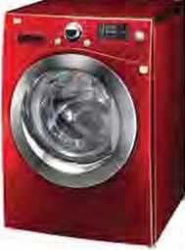She asked

Reading II

**Answer these questions.**

1. What do you see in the picture?
2. What is it used for? Discuss with your friends.

How to Wash Clothes in a Washing Machine

A washing machine is a home appliance used to do the laundry. It washes clothes automatically without having to supervise its operation. All one has to do is to put the clothes in the machine and select the wash mode. Here are a few steps to wash clothes.

**Step 1: Separate Your Laundry**

Sorting your laundry into different piles based on fabric type and colour is step number one. You should also check the care label of each garment for washing instructions so as to avoid damaging your fabrics. Make sure to pay extra attention to your more delicate items: you should wash them either by hand, or on the delicate cycle and in a mesh bag.

**Step 2: Load the Washing Machine**

This is the step where you dump your clothes into your washer. Make sure not to overload your clothes as it may result in the clothes not being washed as they should be.

**Step 3: Add Detergent and Fabric Softener**

Before adding your choice of detergent and fabric softener, make sure you read your washer’s manual to find out which goes where. The amount of detergent needed varies by load size and washing machine type, so check the back of the detergent box and look for any labels on your washing machine to find out how much you should use.

**Step 4: Turn on the Washer**

Just close the door and hit the start button. Some washing machines can indicate that the door is not closed properly, while some cannot.

**Step 5: Choose the Right Washing Cycle**

Wash cycle consists of two important speeds: a speed at which it agitates or tumbles your clothes with water, and a speed that spins the water out of your clothes. Once again, when picking the correct washing cycle, you should refer to the fabric care label. This way, you can maximize cleanliness while also protecting your clothes. Your options range from normal and permanent press to delicate and quick cycles.

**Step 6: Set the Water Temperature**

Using the correct water setting in your washer can make a difference in your laundry. Hot water, for instance, sanitizes and kills germs better. But in some cases, it can shrink your clothes, fade your fabrics, set certain stains, and requires a lot more energy. So, reserve hot water washes for bath and kitchen towels, bedding, sturdy fabrics and any extremely dirtied items. For moderately dirty loads, dark colours, and the permanent press cycle, use warm water. Cold water is the gentlest way of washing your garments, and it also requires less energy.

**Step 7: Clean Your Washing Machine**

Regular cleaning with a washing machine cleaner is an important part of knowing how to use washing machines. Leave your washing machine door open after use to allow it to air out and help prevent mold from growing.

|  |  |
| --- | --- |
| **A. Match the words in column B.**  **Column A** | **column A with their meanings in**  **Column B** |
| a. appliance | i. to make something move around by shaking |
| 1. agitate 2. shrink | 1. to squeeze 2. fungus |
| 1. detergent 2. dump | 1. to deposit in a careless way 2. a device designed to perform a specific task |
| f. mold | vi. a water-soluble cleansing substance |

1. Answer these questions.
2. What is a washing machine?
3. Why do you think it is necessary to separate the laundry?
4. How can the user maximize the cleanliness of clothes?
5. Mention the effects of overloading.
6. Why should we clean a washing machine regularly?
7. Do you think the text is useful for you? How?
8. **Make a list of the home appliances you have at your home. Write operation instructions for any one of them in brief.**

Grammar II

Change the following questions into reported speech.

1. "Are you going to the store?" said Pawan.
2. "Is your sister coming to the party?" says Pallawi.
3. Sophie said to me, "Do you like pizza?"
4. Siddhartha said, "Does your cat like to chase mice, Rani?"
5. The guest inquired, "Is it raining outside?"
6. "Did you finish your homework?" the teacher asked.
7. "Are you feeling well?" asked my mom.
8. My friend said, "Does your boss expect you to work overtime today?"
9. Smita wanted to know, "Is your favorite colour purple?"
10. The boss said, "Did you see the news this morning?"

Project work

**Work in groups. Research a food item of cultural significance in your community. Then, write a set of instructions to prepare it and share it in the class.**

&Xtra, bit

Use of commas, semicolons and colons

Comma (,)

1. Commas separate items in a series.

He bought bananas, apples, oranges, and cheese.

1. Commas are used after transitional phrases.

On the other hand, ceil phones have some disadvantages too.

1. Commas indicate direct quoted speech, tag question and yes/no.

He said to me, "I came from Butwal yesterday."

Yes, you should do homework in time.

Semicolon (;)

1. Semicolons connect two independent clauses that are closely related.

I am going to America this year; I will study MBBS there.

The movie is interesting; it is about a romantic love.

1. Semicolons separate three or more items in a series that already have commas in them.

I like branded, blue shirts; brown, flat-heeled shoes; and soft, red coats.

Colon (:)

1. Colons are used to introduce items or lists.

You know what to do: practice.

I need to buy: some milk, bread, biscuit, and vegetables.

1. Colons are used to qualify sentences by introducing meaning or an explanation.

She was feeling really down last week: she had failed her exam and lost her job.

Unit



Getting started

**Look at the pictures below. What exciting activities are the people doing? .**

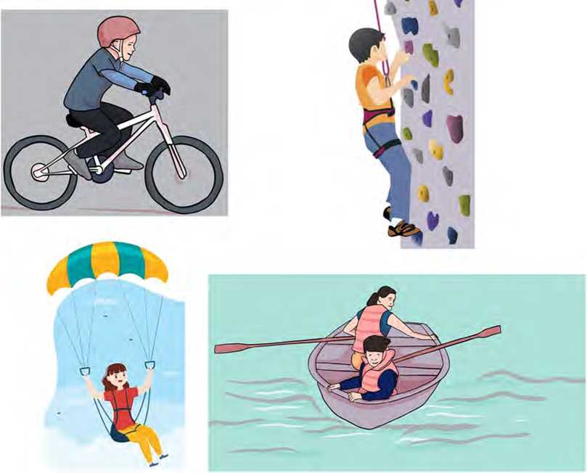

Reading I

**Look at the picture and answer these questions.**

1. What do you see in the picture?
2. Have you visited any new place recently? Share your experiences.

A Visit to Mustang

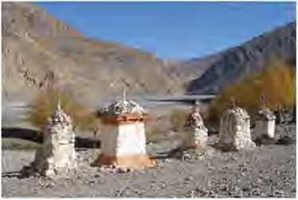I knew a little about Mustang, Nepal before I visited it in early 2020.1 was curious to see a place untouched by tourists, away from the busy life of Hong Kong. Mustang has only been open to tourists since 1992 and non- Nepali tourists need a special travel permit to enter Upper Mustang.

On the first night, I stayed in Pokhara to meet up with my tour group. Pokhara is the starting point for many treks that can be taken in the Himalayas. The staff of the hotel provided me with cushions and blankets to ensure I would not get cold during the night.

The next day, my tour guide Reena, picked me up early and we jumped in a jeep to start the journey. January in Nepal is usually somewhere between 00 to -150 C in the Himalayas. For that reason, the winter months draw few tourists to Nepal. Even though I was on my own, I was not lonely as we ended up picking up and dropping off several locals on the way.

After a full seven hours travel, we arrived at our first travel spot - Tatopani, meaning a hot spring. The spring itself was a small but charming natural pool. While relaxing in the warm water, my tour guide shared about her life growing up in Nepal. She told me about the rustic daily living conditions. The natural beauty of the place combined with its loving people was something that could not be replaced anywhere else in the world.

Next day, we continued our trip from Tatopani to Kagbeni along the Kali Gandaki River. We saw the Himalayan mountain range, cliffs, eroded lands, and canyons.

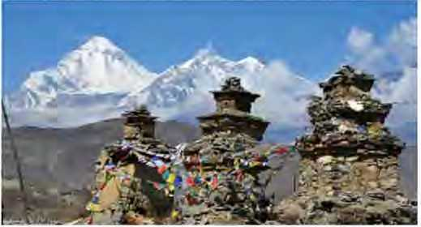After the unforgettable journey, we finally arrived at Muktinath Temple, a beautiful place located in about 3710 metres in the Annapurna range. Sacred for both the Hindus and Buddhists, the temple is also well known for attracting many pilgrims of different religions.

Decorated with colourful flags, the temple offers panoramic views of the Himalayas. Buddhists say this is the only place on earth to host five elements of life. They have been symbolised in the colours of flags. Blue symbolises sky, white symbolises air, red symbolises fire, green symbolises water, and yellow symbolises earth. Five colours altogether represent a balance.

After enduring a freezing night in a teahouse in Muktinath, we awoke to a beautiful sunrise over the mountains. After a quick bite to eat, we headed back into the jeep to visit the historical village of Marpha. Two hours later, the wheels of our van bumped into the heart of the village to have a look around.

The town is famous in the area for its apple trees and unique architecture. The houses are built close together with flat roofing, creating a network of narrow alleyways that snake endlessly. Given the proximity of all the houses, the locals seemed to mingle naturally and create a close-knit community. Awaking in Marpha on the last day of my journey, I felt refreshed and warm. The previous night, I was finally able to enjoy a hot shower, a luxury I had gone without for three days.

My time in Mustang was truly unforgettable!

*(Adapted from a memoir by Phoenix Yu)*

1. **Learn these words and complete the following sentences using them.**

**pilgrims architecture!charming alleyways panoramic**

1. She studied history of art and at the university.
2. All the of the city are resurfaced.
3. Many visit the Muktinath Temple every year.
4. I found Nepali people and helpful.
5. One can enjoy the view of the

Kathmandu Valley from the top of the Dharahara.

1. **Put these sentences from the text above in the correct order.**
2. It took seven hours for the writer to reach Tatopani.
3. The tourist guide shared experiences about her life with the writer.
4. The writer took a hot shower.
5. The writer appreciated the hotel staff in Pokhara.
6. The writer, together with other members, visited Marpha village.
7. The writer spent a night in Pokhara and met her tour group.
8. **Answer these questions.**
9. Is it easy for non-Nepalis to enter Upper Mustang? Why?
10. Why was the writer given cushions and blankets at the hotel in Pokhara?
11. Why do only a few tourists visit Nepal in January?
12. What was the Tatopani spring like?
13. Where does Kagbeni lie?
14. What, according to the Buddhists, are the five elements of life?
15. What is Marpha village known for?
16. Was the writer happy with her journey in the end? How do you know?

Pronunciation

Listen to your teacher and pronounce these words. Notice what sounds the red letters make.

behind island allowance tour night ensure, shower visual side manure financial

Grammar I

1. **Complete these sentences with missing words/phrases from the reading text. Discuss with your friends to identify the tenses.**
2. Mustang open to tourists since 1992.
3. On the first night, 1 in Pokhara to meet up with my

tour group.

1. Next day, we our trip from Tatopani to Kagbeni.
2. They in the colours of flags.
3. I refreshed and warm.
4. **Read the given paragraph carefully. Underline the verbs in the sentences and identify their tenses.**

Have you ever had a frightening experience? I have had one. Some years ago, I was heading to Biratnagar from Kathmandu by plane. It was alright at the beginning but suddenly a problem occurred. The captain of the plane said to us in a very calm voice, "Ladies and gentlemen, we're having a problem with one of the engines. There's no need to panic but keep your seatbelts fastened. We are heading back to Tribhuvan International Airport, Kathmandu." I felt a pain in my chest and people started to cry. After some time, we landed successfully back at the airport. I sighed with relief! Since then, I have decided not to travel in a plane.

1. **Fill in the blanks with one of the two alternatives given in the brackets.**
2. The sun (set/has set) at 6 p.m. yesterday.
3. Get up! The sun (rose/lias already risen).
4. Jackson (has eaten/ate) his lunch. The

plate is still on the table.

1. Jackson (ate/has eaten) his lunch at

11:00 yesterday.

1. Levi and Simon (were/have been)

friends for a long time.

f (Have you posted/Did you post) the

letter last Sunday?

1. The Smiths (spent/have spent) a week

in Paris recently.

1. Megha (ran/has run) two marathons

last year. He could not succeed with either.

1. I (have lost/lost) my keys yesterday.
2. Sumina (has lost/lost) her keys this

evening. She is at my home.

1. **Complete the given sentences with one of the suitable verb forms from the box.**

have forgotten have washed played have finished

planted bought called have not visited haven't eaten went

1. Richard football yesterday.
2. They their car again. It looks new.
3. Last year, some of my friends to Italy.
4. Juni and Bikram their homework. Now,

they can play.

1. I my parents two days ago.
2. We another country before.
3. The Smiths a new house in 2001.
4. I'm sorry, but I to do my homework.
5. The girls their lunch yet.
6. They some trees last week.

Listening

1. **Look at the picture and answer these questions.**
2. 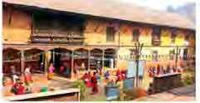What do you think the place is?
3. What do you think people do there?
4. Listen to the audio and complete the sentences. Use one word only.
5. The speaker remembers the events like holidays abroad

and parties.

1. Beautiful experiences are also gained through everyday
2. The speaker worked as a in an elderly home.
3. Her job was to read the newspapers and to

the elderly people.

1. The elderly people have told her their achievements

and stories.

1. The work at the elderly home was an interesting

to the writer.

1. The speaker gave them feelings of support and
2. **What do you think about the speaker’s work? Is it good to work as a volunteer? Talk to your friends.**

Writing I

**You must have had several memorable events in your life. Write two or three paragraphs about one of them. Include the answers to these questions in your paragraphs.**

1. What was the event about?
2. When did it happen?
3. What lesson did you learn from it?

Speaking

1. Study what these people are saying. What are they talking about?

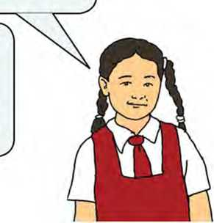Recently, I've waited for one of my friends for more than an hour. We had a plan to go to a movie. While I was waiting for him outside my school building, it started to rain. He arrived late but he didn't apologise. When we reached the entrance, the film had already begun. Since then, I've never asked him to go with me anywhere.

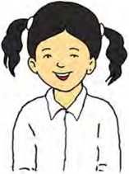I have recently visited the Central  
Zoo. At the entrance, we bought  
the tickets and entered. I saw many  
animals, reptiles, birds, etc. there. I  
really had fun!

1. Work in pairs. Take turns to ask these questions and to talk about your experiences.
2. Have you ever eaten a cake?
3. Have you read a story book recently?
4. Have you ever gone on a picnic?
5. Have you ever had a toothache?
6. Have you ever gifted anything to your friend?

Reading II

Look at the picture and answer these questions.

1. What do you see in the picture?
2. Why do you think people write a diary entry?

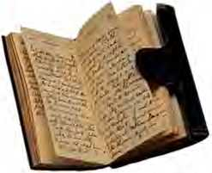A *Diary Entry*

Saturday, 5 March 2022

Time: 10:00 p.m.

Dear Diary,

Brought up in the Western world, I was unaware of Nepal before. But as soon as I heard about Nepal, I could not stop myself visiting here. Fortunately, the long-awaited day came in 2022.

Today, I went to a Nepali village located in Dhading district from Kathmandu. My day started very early in the morning. I was very excited. I travelled with my Nepali friend on an old bus at 7 a.m. in the morning. The bus was decorated with colourful images. It travelled along bumpy and windy roads and I nearly fell off my seat a few times. We stopped at a rest stop halfway for coffee. Later, two young boys jumped onto the bus with instruments and played Nepali songs. I gave them fifty rupees because they made me feel close to the Nepali community. I would have given them more money if I had any to spare.

*W!e* arrived in the main village near the river and walked up a steep hillside. Finally, we reached a smaller village. My friend’s large extended family lived there. They were very friendly. They served me a delicious lunch that included rice and curry in a traditional Nepali kitchen. I was so happy to see life in a rural village and meet lovely people. I was introduced to all the families of the village. I played football with the youngest child - he was good. I also had popcorn and Daal for a snack in the afternoon. I looked at the oxen, goats and stroked a baby goat (kid). I also enjoyed looking at the view from the top of the hill. The view from there was charming which I cannot describe in words. Though I liked to stay there longer, we had to return. We left the place at 3.00 p.m. bidding goodbye to all.

The journey back to Kathmandu was tiring. We walked down the hill from the village which was hard. There were very few public vehicles with lots of passengers inside. We caught a bus that arrived on the main road. Soon, I quickly found a vacant seat and sat. I closed my eyes as we travelled and fell asleep for ten minutes. A man got onto the bus and played a musical instrument, which was interesting. However, I could not understand the words! I got off the bus and went to the supermarket on my way home to buy some bread and eggs. If I did that again, I would buy a bar of chocolate to take home as a treat. I arrived home in the evening, ate an omelette with bread, and got into bed early. I was really tired and sleepy.

I write a diary every night so I can remember the amazing adventures I have had. I think I will start to write my diary during the day though, not just at night - I am always too tired to write.

I had a wonderfid day today. I will always remember the journey, the village, and meeting the family. In fact, the friendliness and support of Nepali people is really admirable.

*Neil*

1. **Match the words in column A with their meanings in column B.**

**Column A**

**Column B**

1. bumpy i. very pleasant or attractive
2. rural ii. (of a slope} rising or falling quickly
3. charming iii. (of a surface} uneven/not smooth
4. tiring iv. connected with or like the countryside
5. steep v. deserving respect, excellent
6. admirable vi. making you feel the need to sleep or rest
7. **Decide whether these statements are True or False. Write NG (not given) if the information is not given.**
8. This was Neil's first visit to Nepal.
9. He visited the village together with his friend from England.
10. Neil did not like the music and the song.
11. He admires the Nepali people.
12. Neil never closed his eyes throughout his journey so that he could enjoy the scenery.
13. Neil is going back to his homeland in the near future.
14. **Answer these questions.**
15. When did the writer visit a village in Dhading?
16. Why did the writer give some money to the boys on the bus?
17. Was the journey to the village comfortable for the writer? Why?
18. Why does the writer feel he needs to write diary during the day?
19. What did the writer like the most about Nepal?
20. **Surf the internet or search other sources and find an interesting diary entry. Share it with the class.**

**Grammar II**

1. **Complete these sentences with the correct forms of the verbs. Use simple past or present perfect tenses. Use negative forms where necessary.**
2. A: Did you watch the movie "The Queen"?

B: No, I haven't. Actually, I (never/watch)

English movies.

1. Sam (visit) Bali a year ago.
2. My best friend and I (know) each other for

fifteen years. We meet very often.

1. Sunita is a fantastic writer. She (already write)

ten books.

1. We (go) on a picnic yesterday but my

younger brother (do/not).

1. Ranjita: they (play) chess

yesterday?

Dawa: No, they didn't. I did though.

g you (brush) your teeth yet?

1. He (arrive) here yet. He must have got

stuck in the traffic.

1. 'What's wrong with you?' I (lose) my pen.
2. **Use present perfect or simple past forms of the verbs to make sentences from the given clues, as in the example.**

*Example: Udit/already sing/many songs*

*Udit has already sung many songs.*

a. We/know each other/since 2019.

1. Mohammad/buy a house/in July last year.
2. The Nepali Cricket Team/already win/several matches.
3. I/never visit/a museum.
4. People/grow/a lot of rice last year?
5. Phurba/sing a song/just now.
6. Diana/leave for England/last week?
7. My parents/live/in Stockholm/for several years.
8. It/rain/a lot last winter?

Writing II

**Write a short diary entry about one of your days this week. You can use Reading II as a model. Include the following.**

1. What activities you did
2. How you felt when you got involved in those activities
3. What you would have done differently

Project work

Work in groups. Read each other's diary entry and vote for the best one.

*&Xtra, bit*

**Compound words in English**

Compound words are two or more words combined to form a new single word or a phrase that acts like a single word. These words have their own distinct meanings that are different from the meanings of the words they are made of. There are three types of compound words in English.

1. Open compound words

These words have spaces in between them which can make them hard to identify. They are mostly nouns. When we make them plural, we only pluralise the final word in the group. For example: cell phone, dining room, heart attack, french fry, real estate, role model, post office, washing ma­chine, web page, etc.

1. Closed compound nouns

Unlike open compound words, these words do not have spaces in between them. So, they look like a single word. We can find words of such type in all parts of speech. For example: airport, babysit, barefoot, bedroom, outside, raincoat, nonetheless, mailbox, without, weekend, etc.

1. Hyphenated compound words

These words have hyphens in between them. For example: check-in, father-in-law, long-term, one-sided, runner-up, up-to-date, well-being, one-dimensional, mind-blowing, deep-fried, twenty-four, etc.

Getting started

**What are the people in the pictures doing? How would you convince them to do something you would like them to do?**

*Example: Bikash, stop watching TV. Help your parents in the kitchen.*

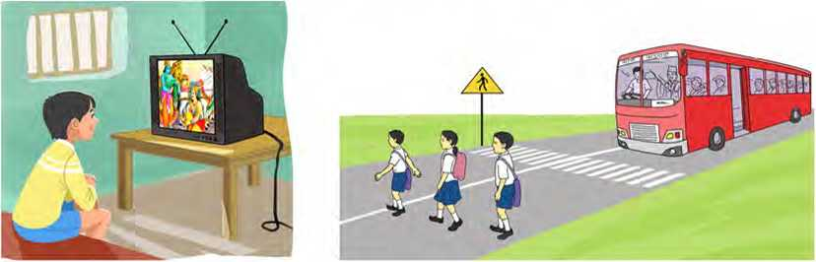

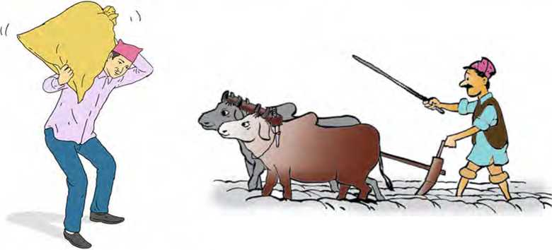

Reading I

**Answer these questions.**

1. Have you ever heard or read a fairy tale?
2. Do you think a tree can talk?

The Old Woman and the Lime Tree

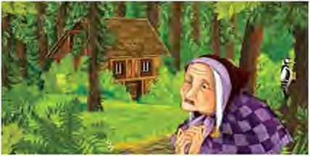Once upon a time, there lived an old couple who were very poor. One day the woman said to the man, “Why don’t you go to the forest and cut down a lime tree for us to use for firewood?” "Very well,” said the man. He

took an axe and went to the forest. He found a lime tree and was about to chop it down, but the lime tree said in a human voice, “Please, old man, don’t chop me down, and I’ll do you a good turn some day!”

The man was so frightened that he dropped his axe. He stood there and thought for a while, and then went home. He told his wife what had happened, and she said, “What a fool you are! Go back at once and tell the lime tree that you want a horse and a cart. Haven’t we had enough of walking!”

“Maybe so,” said the man. Putting on his hat, back he went to the forest. He came up to the lime tree and said, “Lime tree, my wife wants you to give us a horse and a cart.”

“Very well, you shall have them! Go home now,” said the lime tree. The man went home, and what should he see there standing beside his hut but a cart with a horse harnessed to it.

“See that, old man?” said the wife. “Now you and I are as good as anyone except for our hut. Our hut is so old that it might cave in any moment! Go and ask the lime tree to give us a new one.” Back went the man to the forest and he asked the lime tree to give them a new hut. “Very well, you shall have it!” said the lime tree. “Go home now.”

The man went home, and he could hardly believe his own eyes, for where once was their old hut stood a new one. The two oldpeople were as happy as children, but the wife said, “Now, why don’t you go to the lime tree and ask it for some livestock and fowls? Once we have that, we’ll need nothing else.”

The man went back to the forest and he asked the lime tree for some livestock and fowls. “Very well, you shall have them!” said the lime tree. “Go home now.”

The man went home, and there were livestock and fowls in plenty in the yard. He was overjoyed. “We don’t need anything now.” the old man said.

“That’s what you think!” said his wife. “Do go back again and ask the lime tree for some money.”

Back went the old man to the forest and asked the lime tree for some money.

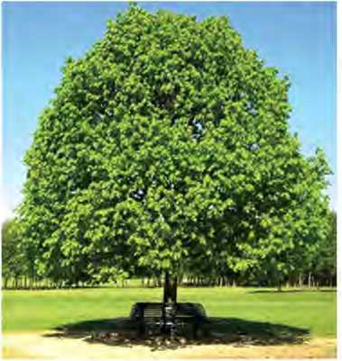“Very well, you shall have it!” said the lime tree “Go home now.” The man went home, and he found his wife at the table busy counting and stacking golden coins.

“We are rich now, old man!” the woman said. “But rich people must be feared. So, go and ask the lime tree to make everyone fear us.” Back went the man to the forest and begged the lime tree to do as the old woman had asked.

“Very well!” said the lime tree. “Go home now” The old man went home, and who should be there guarding the house but many policemen and soldiers!

But even this did not satisfy the old woman. “We have nothing to wish for now but for all the people in the village to work for us!” she said.

Back went the man to the forest, and he begged the lime tree to let the woman have her wish. The lime tree was silent for a while and then said, “Go home, old man, and I’ll do one last thing for yon!”

The old man went home, and there stood their old hut with his wife beside it. Their new house was gone and everything else with it.

*(Adapted from Ukranian folk tale]*

1. **Replace the words in red with their synonyms from the story.**
2. The old bridge was going to collapse which terrified the people.
3. The little girl pleaded with her parents to buy her a bicycle.
4. The players were delighted after scoring the winning goal.
5. When I lost my passport, I felt such an idiot.
6. The mountaineer was scared as he tried climb dangerous rock.
7. **Put the following events in the correct order.**
8. The old man asked for a new hut.
9. The old woman wanted to frighten everyone.
10. The old man went to the forest to cut down a lime tree.
11. There lived an old man and an old woman.
12. The two old people were as happy as children.
13. Everything was lost at the end.
14. The old woman sent her husband to ask for a horse and a cart.
15. **Answer these questions.**
16. Why did the old man go to the forest with an axe?
17. What did the lime tree tell the old man when he was abont to ent it down?
18. List the things that the old people received from the lime tree.
19. Do you like the old woman? Why?
20. What lesson did you learn from this story?
21. **What would you do if you were the old woman? Discuss.**

Pronunciation

Listen to your teacher pronouncing these woreds. Repeat after him/her and say the number of syllables in each word.

*Example: ex-cept (2 syllables)*

frightened harnessed except hardly policeman livestock soldier permission satisfy punishment

Grammar I

A. Study how the following sentences change into reported speech.

|  |  |
| --- | --- |
| a. Pragya said to him, “Put out the light.” | i. Pragya told him to put out the light. |
| b. My brother said to me, “Please, go to the market.” | ii. My bro ther requested me to go to the market. |
| c. She said to him, "Don't touch the hot water.” | iii. She warned himnottotouch the hot water. |
| d. Shreyasaidtome, “Get me a cup of tea.” | iv. Shreya told me to get her a cup of tea. |
| e. My father said to me, “Think before you act.” | v. My father advised me to think before I act. |

|  |  |
| --- | --- |
| f. Neha said to Dipa, “Don't touch my things.” | vi. Neha forbade Dipa to touch her things. |
| g. He said to me, “Give me a pen.” | vii. He asked me to give him a pen. |
| h. Teacher said to his students, “Don't waste your time.” | viii. Teacher advised his students not to waste their time. |

B. Choose the correct alternative.

1. Jiban said, "Clean the bedroom.”
2. Jiban told me to clean the bedroom.
3. Jiban said me clean the bedroom.
4. Jiban said clean the bedroom.
5. The teacher said to her, “Work with your classmates.”
6. The teacher told her to work with your classmates.
7. The teacher told her to work with her classmates.
8. The teacher told her to work with my classmates.
9. The doctor said to him, "Take your medicine regularly.”
10. The doctor advised him to take her medicine regularly.
11. The doctor advised to took his medicine regularly.
12. The doctor advised him to take his medicine regularly.
13. She told me, “Don’t do it.”
14. She told me to do it.
15. She told me to not do it.
16. She told me not to do it.
17. I said to him, “Please go to the market.”
18. I asked him to go to the market.
19. I told him go to the market.
20. I asked him not to go to the market.
21. He said to me, "Post this letter at once.”
22. He told me to post that letter at once.
23. He said to post this letter at once.
24. He told me to post this letter at once.
25. He said to me, “Wait here till I return.”
26. He asked me to wait there till he returns.
27. He asked me to wait there till he returned.
28. He asked me to waited here till he returned.
29. Sunita said to him, “Don't stay here anymore.”
30. Sunita ordered me not to stay here anymore.
31. Sunita ordered to stay there anymore.
32. Sunita ordered him not to stay there anymore.

Reading II

Look at the picture and answer these questions.

1. Where do you think the birds are flying to?
2. How do you think a student is like a bird?

***Free* Birds**

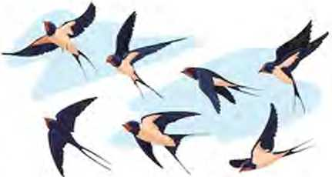Free birds you are students Flap your wings to fly, Do continue your expedition To touch the sky.

Come on dear students

You can reach the destination,

Hindrances may come on the way

Overcome them with determination.

Give a try to achieve your goal

Nothing is easy and nothing is impossible. Try to recognise the courage within You have the strength incredible.

Time and tide waits for none

Follow it with great care and caution, You can make your nation a piece of heaven Being a true patriot keep loving your nation.

1. **Find the words from the poem that match with the following meanings.**

a things that make it more difficult for

somebody to do something

b the ability to do something dangerous

c a person who loves and strongly

supports or fights for his or her country

d (of a bird) move (its wings) up and

down when flying or preparing to fly e an excursion or a journey made for

some specific purpose

f difficult to believe; extraordinary

1. **Answer these questions.**
2. What are students compared with in the poem?
3. How can students overcome the hindrances on their way?
4. How is it possible to achieve your goal?
5. Why is it necessary to value time?
6. How can we make our country a piece of heaven?
7. **What expression does the poet use to persuade you to do the things?**

**Grammar II**

Change the following sentences into reported speech as in the example.

*Example: Bring me a glass of cold water.*

*My mother told me to bring her a glass of cold water.*

1. Please open the window.

She asked me

1. Do not waste your time.

My teacher advised us

1. Speak the truth.

The old man suggested us

1. Avoid eating unhealthy food.

My grandmother told him

1. Please come to my birthday party.

Ranjana requested me

1. Clean the room.

My brother told me

1. Do everything in time.

My parents advised us

1. Give up bad habits.

The monk advised us



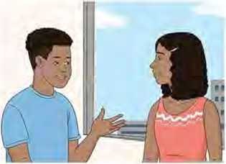

1. Answer these questions.
2. What do you often do in your free time?
3. What do you plan to do in your upcoming vacation?
4. **Listen to the audio and answer these questions.**
5. What does the man propose to do in their free time?
6. What does the man prefer?
7. How is the weather forecast?
8. Who will be the tour guide?
9. What can the woman do when they are on the tour?
10. Make a list of the activities you would do if you were going on a tour.

Speaking

1. Act out the given conversations in pairs.

Conversation I

Salman: Which shirt do you think I should buy?

Shruti: Well, buy the red one. It suits you.

Conversation II

Rajan : Puja, help your father in the kitchen. He will be happy.

Puja: Certainly, I will help him.

1. Here are some expressions that you can use to persuade others to do something. Learn them.
2. Try it. It suits you.
3. Give it a try. It’s really nice.
4. Come on! You can do this easily.
5. Watch the film. It’s interesting.
6. Go on, open your present.

g. You are good at singing.

1. You want to persuade someone to do something in the

following situations. What do you say? Take turns in pairs.

a. You want your friend to sing a song.

1. You want your sister to prepare an omelette.
2. Your friend is good at dancing but she does not want to take part in a dance competition.
3. Your friend does not want to go on a picnic.
4. You want your friend to take part in athletics.
5. Your friend hesitates to speak English in the class.

Writing

1. Rewrite the following paragraph with the correct punctuation marks.

david didnt really like school but he did enjoy practical subjects where he could use his hands to make things he also loved biology because he could draw lots of diagrams and do experiments In fact his mother once told him that he should become a surgeon

1. **Develop a story with the help of the clues given below. Give a suitable title to the story.**

A crow sticks some peacock feathers flies to

peacocks .... claim peacock as relatives they drive him

away .... fly to ducks ducks also drive him away ....

crow is left alone friendless

Project work

**Work in groups. Visit different shops nearby. Listen to the shopkeeper and customers talking. What do the shopkeepers say to the customers to persuade them to buy things from their shops? List the expressions. Translate them into English with the help of your teacher. Present it to the class.**

*bit*

**Prefixes and Suffixes**

|  |  |  |
| --- | --- | --- |
| **Prefixes** | **Meanings** | **Examples** |
| de- | opposite | decode, deform, defame, demoralise |
| dis- | not, opposite, reverse, away | disagree, disappear, dishonest, dis­  trust |
| mis- | bad, wrong | mislead, misplace, misunderstand |
| pre- | before | preboard, prehistorical, prepaid |
| re- | again, back | react, reappear, rethink, research |
| un- | again, not, opposite | undo, unequal, unusual, uncertain |

|  |  |  |
| --- | --- | --- |
| **Suffixes** | **Meanings** | **Examples** |
| -able | able to, having the quality of | comfortable, portable, sociable, readable |
| -er | comparative | bigger, stronger, faster, easier |
| -full | full of | beautiful, grateful, thoughtful, painful |
| -ly | forming an ad­verb | happily, lazily, easily, calmly |
| -ness | denoting a  state or condi­tion | kindness, wilderness, sharpness, brightness |
| -y | full of, denot­ing a condition | healthy, messy, dirty, filthy |

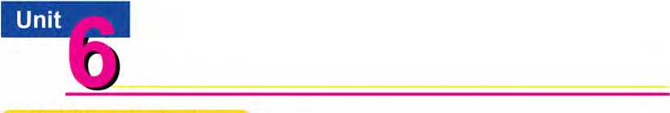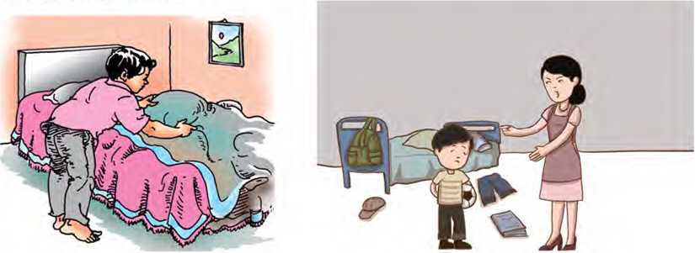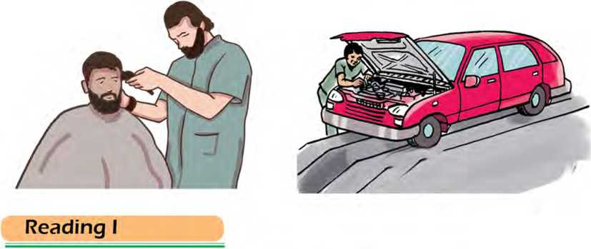

Getting started

Look at the pictures below and talk about what these people are getting done.

Look at the pictures and answer these questions.

1. What is happening in the following pictures?
2. When did you last attend a celebration? Share your experience.

Traditional Marriage Customs around the World

1. Marriage is a legally recognised relationship between two people. This union should also be recognised through social norms and rituals. The married partners are called spouses.

People around the world have been performing marriage ceremonies for a very long time. Each culture has something special and unique about marriage. Ancient societies started practising marriages because they needed to secure a safe environment in which they could have offspring and pass their property onto them. Marriage rituals are performed in different ways in different parts of the world.

Indian weddings last for days. They celebrate weddings with numerous rituals and ceremonies which depend on bride and groom’s likes and dislikes. The wedding starts with pre­wedding ceremonies, such as the engagement ceremony, where the bride and the groom exchange rings. Then, there is the Mehendi ceremony. The bride gets her palms, wrists and feet decorated. On the wedding day, the groom

2.

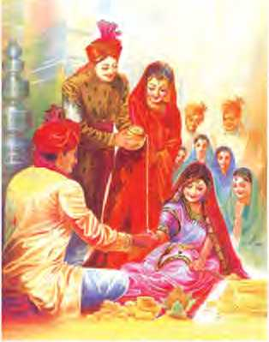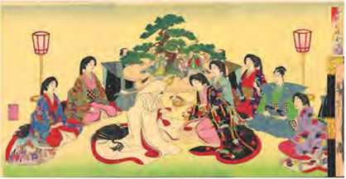In Japan, brides have their costumes changed several times throughout the celebration. As a symbol of the newly established union, the happy coupledrinks sake, a Japanese alcoholic drink made from rice. In this tradition, known as san-san-kudo, the bride and groom each take three sips from three different sake cups. Their parents do the same, which bonds their families together. Money is given as a wedding present. It should be wrapped in a special envelope. The wedding couple also gives small gifts to their guests. These can be sweets, candles, etc.

and bride put flower garlands around each other's necks. This symbolises the bride's acceptance of her husband.

In Jamaica, the entire community participates in nearly all stages of the wedding. Everyone in the village comes together to help plan the wedding. On the wedding day, everyone goes out in the street to see the bride and review how she looks.

4.

5.

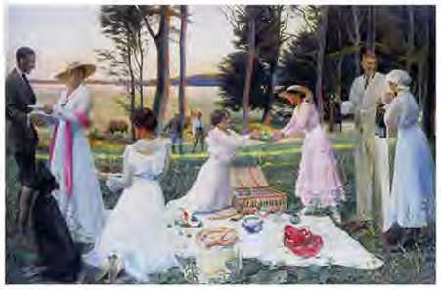She would then go home and improve her appearance. The wedding celebration also involves a lot of traditional dancing. Several cakes are brought, and the family has the bride serve them. The cake is the traditional black one, made from dark fruits and rum.

According to Welsh wedding tradition, a man should M carve a wooden spoon and give it to the bride. Another traditional wedding custom in Wales suggests that brides should get kidnapped by their families shortly 4 before the wedding day. It is the duty of the groom W and his family to find and get her rescued.

*(Adapted from Really Learn English)*

1. Find the words from the text which have the following meanings.

a a set of actions performed regularly

b a person's child or children

c something that stands for something else

e assess something to help improve it

f save someone from a dangerous situation

1. **Answer these questions.**
2. Why did ancient people start the marriage ritual?
3. What are the two pre-wedding ceremonies in India?
4. What is a sake?
5. Why is a community important during wedding ceremony in Jamaica?
6. Who reviews the bride's looks in Jamaica?
7. Why do you think Welsh wedding traditions seem strange?
8. **Match the paragraphs with their correct headings.**

Paragraph 1 Jamaican Wedding

Paragraph 2 Japanese Wedding

Paragraph 3 Indian Wedding

Paragraph *4* Welsh Wedding

Paragraph 5 Introduction to Marriage

1. **Which of the wedding cultures discussed in the text you liked the most? Give reasons.**

Pronunciation

Here is a list of words. Notice how the suffix ‘-s/es’ is pronounced in the words and put them in the correct column. One example of each is given.

|  |  |  |  |  |
| --- | --- | --- | --- | --- |
| spouses | establishes | rights | obligations | laws |
| suggests | societies | days | palms | sisters |
| parents | involves | brides | symbolizes | ceremonies |

|  |  |  |
| --- | --- | --- |
| **/iz/** | **/z/** | **/s/** |
| spouses | palms | suggests |

**Grammar I**

1. Read the following sentences. Place them in the correct column with similar structures.
2. It lets them live together.
3. The bride gets her palms, wrists, and feet decorated for the wedding.
4. The groom must bribe them in order to get his shoes returned.
5. Japanese brides have their costumes changed several times.
6. As a symbol of the union, the family gets them to drink sake.
7. Several cakes are brought, and the family has the bride serve them.

|  |  |  |
| --- | --- | --- |
| My teacher lets/has/ makes us correct our mistakes ourselves. | I got my friend to help me in my assignment. | We had/got our room swept. |
|  |  |  |

1. Complete the following sentences with the correct form of the verb in the brackets.
2. Ruksar is having the mechanic her scooter,

(service)

1. Teachers made us extra-classes in the evening, (take)
2. I let them their windows, (open)
3. Ahamad always gets his parents an expensive gift

on his birthday, (buy)

1. Samrat had his bedroom (clean)
2. How can we get people surroundings? (clean)
3. Shyanden got his hair yesterday, (cut)
4. Do your parents get you the household

chores? (do)

1. Our teachers let us football after 4:00. (play)
2. Did you get your shirt yesterday? (wash)
3. **Rewite the following sentences starting with the given words as subjects. Use the causative verbs in brackets.**

*Example: The doctor will check my throat next month.*

*I will have the doctor check my throat next month, (have)*

1. Indra ordered Kamini to book tickets.

Indra (make)

1. Somebody washed my clothes yesterday.

I (get)

1. Hamid used his mother’s mobile phone.

Hamid’s mother (let)

1. Did a painter paint your house?

Did ? (have)

1. Kripa goes to school on her mother’s scooter.

Kripa’s mother (let)

1. The boy types my documents.

I (get)

1. The police told the prisoners to raise their hands.

The police (make)

1. The lady hired a mechanic to mend her car.

The lady (have)

Writing I j

**How do people celebrate wedding ceremony in your culture? Write a short description.**

Listening

1. Study the picture and guess the answers to the following questions.

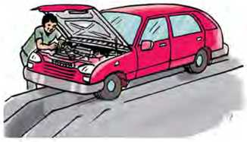Who do you think the man is?

a.

What is the man doing?

1. 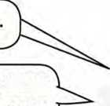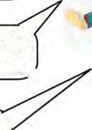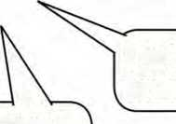Listen to the audio and answer these questions.
2. What does the customer want?
3. When is the first opening?
4. Why can't the customer take the first opening?
5. What is the next appointment time?
6. How much will the customer pay?
7. **Have you ever asked other people to do something for you? Talk to your friends.**

Speaking

1. **Study what Raghav is saying. Does he do everything by himself or get others to do something for him? Mark the sentences which mean he has others do something for him.**

I eat ice-cream

I get my clothes washed

My mother makes me brush my teeth after each meal.

TI have my trousers  
^ironed.

I listen to the news on  
dhe radio at 8 o'clock,

I have my hair cut at a barber’s.

I get my little sister to play with me.

I get my shoes brushed.

I get my teacher to check my work.

1. **Work in groups and discuss what someone lets/has/gets/ makes you to do/do in the following places. Say at least three sentences as in the example.**

*Example: library*

*The librarian doesn't let us read books aloud.*

*She gets us to return books on time.*

*She gets us to keep the table clean and tidy.*

*She doesn't let us eat food in the library.*

*She makes us keep quiet in the library.*

1. kitchen b. garden c. classroom
2. temple e. exam hall

Reading II

**Answer the question.**

How does technology make life easier? Discuss.

Life Saving Inventions

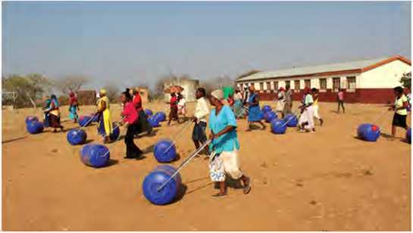Hippo-Rollers

Many women and children in Africa used to spend between three and nine hours a day carrying water to their homes. Life was tough withtraditional plastic buckets. They used 20-litre buckets, which they carried on their heads. The buckets were very heavy and often caused back and neck injuries. So, engineers Pettie Petzer and Johan Jonker designed a Tolling wheel’ called hippo-rollers which can carry ninety litres of water. They have been made and delivered to remote villages in Africa. This simple invention made women’s life easier. Women have more time to look after their families, the children have more time at school, and there are fewer injuries.

LifeStraw

There are 780 million people in the world who do not have clean and safe drinking water. This fact got the Swiss company Vestergaard to invent a special kind of straw that allows people to drink dirty water without \ | getting ill. LifeStraw is a long thin plastic tube that cleans the water as it passes through it into somebody’s mouth. This device is very light and can clean up to 1,000 litres of water before you need to replace it. It was used to help people after the Haiti earthquake, and floods in Pakistan and Thailand.

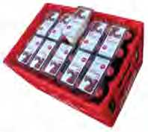AidPod

When Simon Berry, a British social entrepreneur, was travelling in Zambia, he noticed that he could buy Coca-Cola in the remotest villages. But in the same villages, the people had no medicines. Because of that, one in five children were dying before their fifth birthday. He had an idea. ‘Why don’t they bring medicines when they deliver Coca-Cola?’ So, he invented the AidPod, a triangular packet of medicines that fits between the bottles in a crate of Coca-

Cola. Berry has experimented with a number of designs for his AidPod and is testing his ideas in Zambia. If his plan works, he hopes to do the same thing in other African countries, and save thousands of lives. *I. \dapted from English 4realj*

1. Find the words/phrases from the text for the following meanings.

a change for a new one

b hand over goods to the proper recipients

c undertook a scientific procedure to make

a discovery

d a thing or an idea that has been created

e harms done to a person’s body

f goes through

1. **Write whether the following statements are True or False. If the information is not given, write NG.**
2. Women in Africa walked for a long time to fetch water for their homes.
3. With the hippo-roller, people can carry more water than with a normal bucket.
4. LifeStraw is made of paddy straw.
5. LifeStraw never stops working.
6. Japanese technology was used in those three inventions.
7. Coca-Cola company worked with Simon Berry to design AidPod.
8. AidPod has been used successfully in many different countries.
9. **Answer these questions.**
10. Why was life tough with traditional plastic buckets?
11. Who made the lives of African women easier?
12. How does LifeStraw work?
13. Where was LifeStraw used during disasters?
14. What made Simon Berry design the AidPod?
15. If his plan works well, what does Simon Berry hope to achieve?
16. **Which of the inventions mentioned above do you think is the most relevant in your locality? Talk to your friends. Give reasons.**

**Grammar II**

1. **Do the verbs in the following sentences match with the subjects? Tick (V) the correct sentences and cross (X) the incorrect ones.**
2. i. The students attend the language course.

ii. The students attends the language course.

1. i. Aayusha and her friend decorates her classroom.

ii. Aayusha and her friend decorate her classroom.

1. i. Either my brother or my father do not let us come

to the meeting.

ii. Either my brother or my father does not let us come the meeting

1. i. Has Utsav with his friends made preparation for

the programme?

ii. Have Utsav with his friends made preparation for the programme?

1. i. The story in a movie, including all the songs, attracts

audiences’ attention.

ii. The story in a movie, including all the songs, attract audiences’ attention.

1. i. They were made dance at the party.

ii. They were made to dance at the party.

1. **Choose the correct option from the brackets to complete the following sentences.**
2. Writing an email (needs/need) a lot of care.
3. Two plus three (make/makes) five.
4. Mr. Karki and Mr. Mandal (was/were) studying

mathematics together last evening.

1. Five years (pass/passes) too early.
2. Either the child or the parents (need/needs)

to come to receive the prize.

1. ................ (Was/Were) the scissors working properly?
2. The director and the actor never (go/goes) late

for the shooting.

1. A team of players (receive/receives) medals.
2. Both of them (has/have) returned home late.
3. Jina (do not like/does not like) tea.

Writing II

1. **Read the given paragraph and its paraphrased form carefully.**

**Original paragraph**

A cat sat on the mat and observed a mouse run across the floor. It was a warm summer day and the sun was shining brightly through the window, casting a beam of light on the cat's fur. The cat was feeling lazy and content, and it seemed as though nothing could bother its peaceful state of mind.

**Paraphrased paragraph**

A cat was sitting on a mat, watching a mouse running around the room. It was a nice, hot summer day and the rays of the sun were coming through the window making the cat's hair look bright. The cat was feeling relaxed and satisfied, as if nothing could disturb it.

1. **Read the given paragraph carefully and paraphrase it as in the example.**

A dog is a domestic animal often kept as a pet. It has a keen sense of smell and is used for a variety of tasks, such as hunting, search and rescue. Dogs come in a wide range of sizes and breeds, each with their unique characteristics and abilities. They are known for their loyalty and obedi­ence to their owners and are often considered to be mem­bers of the family. Training and proper care are essential for dogs to live happy and healthy life.

Project work

**Find information and pictures about any five useful inventions. Then, make a collage and display it in your classroom.**

*bt-t*

Learn these British and American words for the same meaning.

|  |  |  |  |
| --- | --- | --- | --- |
| **British** | **American** | **British** | **American** |
| aerial | antenna | autumn | fall |
| biscuit | cookie | chemist's | drug store |
| chips | french fries | crossroads | intersection |
| film | movie | rubbish | trash |
| garden | yard | ground floor | first floor |
| handbag | purse | holiday | vacation |
| lift | elevator | lorry | truck |
| paraffin | kerosene | pavement | sidewalk |
| petrol | gasoline | mailbox | postbox |
| queue | line | shop | store |
| sweet | candy | tap | faucet |
| trousers | pants | football | soccer |

Unit

Getting started

**Study the following pictures and predict the weather conditions for the following places.**

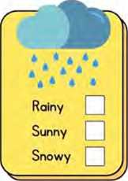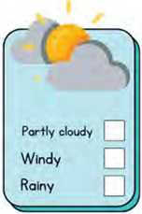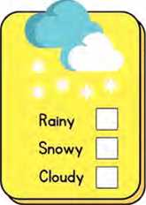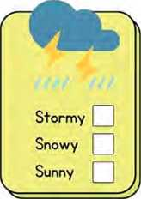

Dhankuta

Taplejung

Dhading

Ba j hang

Kaski

Rainy

Cloudy

Sunny

Dang

Reading I

**Answer these questions.**

1. Why do we need to know what the weather will be like in our location?
2. What information is shown in the boxes below?

Weather Forecast

Weather Condition

**Forecast**

Today

| Station | Maximum  Temp.* (°C) | Minimum Temp.  (°C) | 24 hrs. Rainfall (mm) |
| --- | --- | --- | --- |
| Dipayal | 28.0 | 20.4 | 6.7 |
| Nepalgunj | 36.6 | 26.2 | 0.0 |
| Ghorahi | 31.5 | 27.7 | 0.0 |
| Pokhara | 28.0 | 21.9 | 40.2 |
| Kathmandu | 27.3 | 20.4 | 23.8 |
| Janakpur | 32.0 | 27.8 | 0.0 |
| Biratnagar | 31.7 | 27 | 0.7 |
| *The maximum temperature as recorded yesterday afternoon. | | | |

It will be partly to mostly cloudy all over the country. Light to moderate rain with thunder and lightning will occur at many places in the hilly regions of the country and at a few places in the remaining parts of the country. There are chances of heavy rainfall at one or two places of Gandaki. Lumbini and Karnali Provinces.

*Tonight*

It will be generally to mostly cloudy throughout the country. Light to moderate rain with thunder and lightning will occur at many places of the hilly regions of the country and at a few places in the remaining parts of the country. There will be heavy rainfall at one or two places of Province 1, Gandaki and Lumbini Provinces.

1. Find the words from the texts to complete these sentences.
2. There was a violent storm with thunder and

yesterday.

1. Nepal measures an average annual of 10 cm.
2. The weather in Kathmandu is It is neither

too hot nor too cold.

1. When exactly did the incident ?
2. The weather says it will be sunny tomorrow.
3. Study the weather information in the texts and tick the correct answers.
4. Which place was the hottest yesterday according to the chart?

i. Kathmandu ii. Ghorahi iii. Nepalgunj

1. Which place was the coldest yesterday according to the chart?

i. Pokhara ii Kathmandu iii. Dipayal

1. Which places did not have rainfall yesterday according to the chart?

i. Janakpur ii. Biratnagar iiii. Nepalgunj

1. What will the weather be like today in the hilly regions?

i. windy ii. rainy iii. thunder and lightning

1. **Take turns in pairs and read the weather forecasts from the texts. Act like a newsreader.**

Pronunciation

**Learn to pronounce these phrases used in weather forecasts,** light rain moderate rain heavy rainfall

mainly fair mostly cloudy generally cloudy

windy partly cloudy

Grammar I

1. Study these sentences and notice the degree of certainty 'will' and 'be going to' express.
2. Look at those boys playing football! They’re going to break the window. (More certain)
3. The sky is getting darker and darker. It’s going to rain. (More certain)
4. I think he will win the next election. (Less certain)
5. It is monsoon. It will rain tomorrow. (Less certain)
6. Complete the sentences with will or be going to.
7. A: Did you buy some bread?

B: Oh, no! I forgot to buy it. I go back to buy

some.

1. A: Why have you put on these boots?

B: I walk on the snow.

1. If I meet him, I tell him the good news.
2. I’ve bought a new book. Tonight, I stay at

home and start reading it.

1. Look at those dark clouds! It rain soon.
2. I meet her next week. It’s been my plan

for a long time.

1. A: They say the weather will be awful tomorrow.

B: Really? In that case I cancel the trip.

C: I know. I heard the news. I spend the

whole day reading books.

Speaking

1. 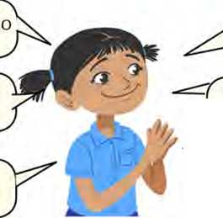**Imagine your friend, Sujana is moving to a new city. She asks her parents the following questions. Now, match her questions with the answers given below. Work in pairs and take turns to ask and answer them.**

Are we going to live in our own house?

Where will you work, father?

Will I have good friends?

Where will I go .study?

How long are we going to stay there?

Are we going to buy new clothes in the shopping ^nialls there? _

1. Yes, you will.
2. I will work in a hospital there.
3. You’ll go to a school in Butwal.
4. Yes, we are.
5. He will be very kind, respectful and he'll believe in equal rights.
6. Yes, we are going to live in our own house.
7. We are going to stay there forever.
8. **Work in pairs. Take turns to make predictions based on  
   the situations. Use ‘will’ or ‘going to’ in your answers.**

|  |  |  |  |  |
| --- | --- | --- | --- | --- |
| What will the weather be like tomorrow? | I know that I’ve lost my pen. | He knows that he has no money to buy a pencil. | What will happen next year? | **FINISH** |
| Are you going to write a story? |  | | | |
| What time will they reach Kathmandu? | Is it going to snow today? | What will your mother give you on your birthday? | Will you go abroad to work? | Where will you live in the future? |
|  | | | | He is cutting vegetables. |
| **START** | It's very cloudy today. | When will you go to college? | What will your father do tomorrow? | I have registered my name in a dance competition. |

Listening

1. 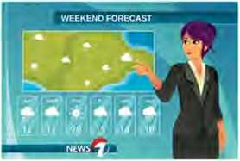**Look at the picture and answer the questions.**
2. What is the picture about?
3. Who do you think this girl is?
4. Listen to the audio and write True or False for the following statements.
5. The weather forecast is for tomorrow.
6. It will be mainly cloudy in Madhesh Province.
7. The weather will be partly cloudy to mainly fair in other parts of the country.
8. There will be heavy rain in Province 1.
9. Thunder and lightning will occur in all places of high hilly regions.
10. **What is the weather like in your locality today? Talk to your friends.**

Reading II

Look at the picture and guess the answers to these questions.

1. Where do you think these people are going?
2. Does this happen in your locality? Why?

Migration

People have moved from one place to another since the beginning of history. There are varieties of purposes for their movement. When they go to a new place for just a short visit, they are usually called tourists. If people move to another place with the intention of living there, it is called migration. People who move from one place to another in search of work or shelter are

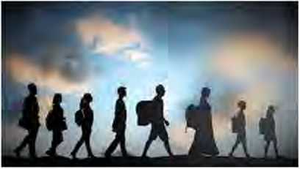called migrants. Many people plan to live in a new country for a long period of time. They want to become citizens of the new country. Since the trend of moving to a new country for better opportunities is

increasing, the number of migrants will surely rise in the years ahead.

There are two factors that cause migration. They are termed as push and pull factors. Pull factors attract migrants to the country of destination such as opportunities for better employment, higher wages, facilities, better working conditions, and others. Push factors drive people to leave their place and go to some other places or countries. Those factors consist of economic, social, or political problems or natural disasters.

The place of origin gets some benefits from migration. One of its benefits is the potential for economic opportunities. In many cases, people may find more job prospects or better paying jobs in their place of origin, particularly in rural areas where there may be a shortage of labor. Additionally, people may have access to land or other resources that they can use to start their own business or farm. Similarly, the country of destination can also have a lot of economic and cultural benefits from migration. For example, the country can fill labour shortages and start new businesses. This will also increase consumer expenditure. The new migrants can also bring new skills and knowledge that can help boost productivity and innovation in the country. Migrants can bring new skills, ideas, perspectives, and ways of life, which can enrich a country's cultural heritage and promote social cohesion.

Migration has some drawbacks. Many skilled people leave their country for better job opportunities which creates shortage of skilled human resources in the country of origin. Similarly, reaching a new land does not always bring good results for the migrants. Finding a job becomes challenging when a place is overrun by migrants. The presence of too many people leads to low pay. Population growth in a particular place or country has adverse effects on the environment. Migrants may also face cultural displacement and struggle to adapt to the culture and customs of the new country.

1. **The words for these meanings are hidden in the grid below. Find the words. The words are either vertical or horizontal.**
2. a place to which somebody is going
3. what you intend or plan to do; your aim
4. to fill or spread over an area quickly, especially in large numbers
5. disadvantages
6. an unexpected event, such as a very bad accident, a flood, etc.
7. chance
8. to force somebody to do something

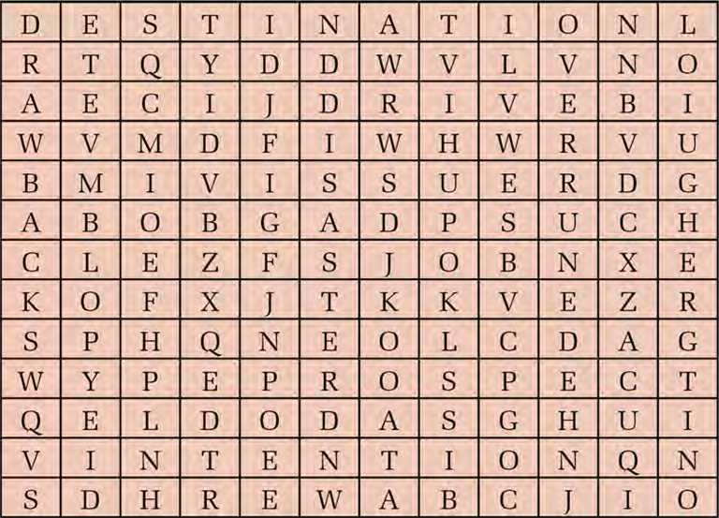

1. Answer these questions.
2. Who are called tourists?
3. Why do people move from one place to another?
4. List any two push factors for migration.
5. When does it become difficult for migrants to find a job?
6. List any two benefits of migration to the place of destination.
7. **Many Nepalis are migrating to other countries for different purposes. Discuss its positive and negative effects with your partner.**

Grammar II

A. Compare the following sentences. Do they mean the same thing or are they different? Discuss.

|  |  |
| --- | --- |
| He will leave home at 8 a.m. | He will have left home by 8 a.m. |
| She will pass the exam. | She will have passed the exam by next year. |
| I will eat hmch at 12 noon. | I will have eaten lunch by 12 noon. |
| Nita will finish her work tomorrow morning. | Nita will have finished her work by tomorrow morning. |
| Our team will do the project work next week. | Our team will have finished the project work by next week. |

B. Use the verbs in the brackets to write the sentences in future perfect.

1. I (not/finish) the game by 6 o’clock.
2. My mother (grow) 1000 tulips by the end of the month.
3. The mechanic (mend) my bicycle by tomorrow.
4. The shop (close) by 8 o’clock.
5. The programme (finish) by 4 p.m.
6. I (not/be) here by Friday.
7. My father (iron) the clothes by the evening.
8. Madhu (leave) before her parents reach home.
9. The painters (complete) their work by next week.

j. I (save) enough money to buy a bicycle by the

end of the year.

**C. Put the verbs in the brackets into future simple or future**

perfect.

1. Scientists (find) a cure for AIDS in twenty

years period.

1. Perhaps, she (come) for lunch tonight.
2. She is writing a book. She (finish) the book

by next month.

1. Wait a minute. I (drop) you at the station.
2. There’s no need to hurry now. The bus (leave)

by the time we get to the stop.

1. Someone is knocking at the door you

(open) the door, please?

g they (complete) the project in time?

h they (complete) the project by the deadline?

1. If they don’t work hard, they (not/pass) their exam.
2. They are decorating the room. In two hours’ time, they

(finish) doing it.

Writing

1. **Punctuate the following paragraph.**

nitin is one of the most laid-back students i know he is tall and slim with black hair and he always wears a shirt and black jeans his jeans have holes in them and his baseball boots are scruffy too he usually sits at the back of the class and he often seems to be asleep however when the exam results are given out he always gets an "A" i don't think hes as lazy as he appears to be

1. **Write a couple of paragraphs on Environment. Address the following questions.**
2. What is environment?
3. What is its importance?
4. What are the causes of environmental degradation?
5. How can we protect the environment?

Project work

**What things might change in your locality in the next ten years? Show it in the form of a picture and present it in the class.**

*bit*

Spelling Variation on Common British and American Vocabulary

|  |  |  |  |
| --- | --- | --- | --- |
| **British** | **American** | **British** | **American** |
| colour | color | flavour | flavor |
| humour | humor | labour | labor |
| neighbour | neighbor | programme | program |
| apologise | apologize | travelled | traveled |
| paediatric | pediatric | licence | license |
| defence | defense | honour | honor |
| cheque | check | centre | center |
| metre | meter | mould | mold |
| tyre | tire | theatre | theater |



Getting started

**Look at the pictures. How would you invite people in these situations?**



Reading I

**Answer these questions.**

1. What is the following text about?
2. Where do you find it?

Vacancy Announcement

United Nations Entity for Gender Equality and the Empowerment of Women

VACANCY ANNOUNCEMENT

UN Women, grounded in the vision of equality enshrined in the Charter of the United Nations, works for the elimination of discrimination against women and girls; the empowerment of women; and the achievement of equality between women and men as partners and beneficiaries of development, human rights, humanitarian action and peace and security.

*UN Women Nepal is seeking applications from qualified Nepalese citizens with commitment for women, high drive for results, integrity, demonstrable teamwork and other competencies as mentioned in the job descriptions.*

Job Title: ICT and Administrative Support Duty Station: Kathmandu, Nepal

Contract Type and Level: General Staff (SB-3) Duration: lyearwith possibility of extension

Vacancy closing date: 21 Nov. 2021 (mid night NY time)

Minimum Requirements: Completion of secondary education is required; Bachelor's degree in Computer Science is an asset; Cisco Certified Network Engineer (CCNE) and Microsoft Certified Systems Engineer (MSCE) or Microsoft Certified Professional (MCP) required; At least 5 years of progressively responsible experience in network administration and use of hardware/software, telecommunications facilities; Experience in the usage of computersand office software packages (MS Word, Excel, etc.); Experience in the use of ATLAS is an asset; Fluency in English and Nepali is required.

For detail job descriptions and for online application, please visit: [https://iobs.undp.org/ci view job.cfm?cur job id=103018](https://iobs.undp.org/ci_view_job.cfm?cur_job_id=103018)

Job Title: Driver Duty Station: Kathmandu, Nepal

Contract Type and Level: General Staff (SB-2) Duration: 1 year with possibility of extension Vacancy Closing Date: 21 Nov. 2021 (mid night NY time)

Minimum Requirements: Completion of SLC/SEE; Valid Driver's license is required; At least 3 years of work experience as a driver in an international organization, embassy or UN system with a safe driving record is an asset; Fluency in English will be an asset; Knowledge of the other UN working knowledge is an asset.

For detail job descriptions and for online application, please visit:

[https://iobs.undp.org/ci view job.cfm?cur job id=103019](https://iobs.undp.org/ci_view_job.cfm?cur_job_id=103019)

Application must be supported with UN Women Personal History Form-Pll which can be downloaded from UN Women website <http://www.unwomen.org/en/about-us/emploYment>.

All applications will be treated with the strictest confidence.

UN Women is committed to achieving workforce diversity in terms of gender, nationality and culture. Individual from minority groups, indigeneous groups, LGBTIQ and persons with disabilities are equally encouraged to apply.

1. Find correct words from the text for the following meanings.
2. a formal public statement about something
3. the process of becoming stronger and more confident,

especially in controlling one's life and claiming one's rights

1. able to be shown
2. an official permission to do something
3. a useful or valuable thing or person
4. **Complete the sentences with correct words from the text. Use one word only.**
5. UN Women works for between male and

female.

1. It is looking for from Nepalese citizens.
2. Both job titles require of secondary

education.

1. If someone wants to submit a/an

application, they should visit the given website.

1. An applicant for the post of a driver should be able to in English.
2. **Answer these questions.**
3. What do CCNE, MCSE, and MCP stand for?
4. Where is the work station for both the jobs?
5. Who is UN Women working for?
6. Why do you think the working duration is only for a year?
7. How is the job made inclusive?
8. **What other types of advertisements do you find published in different media?**

Pronunciation

**Pronounce the following words correctly and notice what sounds -tion and -sion make.**

mission occupation decision comprehension explosion infusion

action

collision

suspension revolution

Writing I

**Imagine your school is looking for an office assistant. Prepare a vacancy advertisement for the position.**

**Grammar I**

**The pictures below show apple(s) at different places. Study how the prepositions are used.**

**A.**

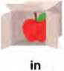

next to (beside)

in front of

**behind between**

**under through around**

**Complete the sentences with the correct prepositions from the box. You may use them more than once.**

**B.**

in at on under before over behind in front of

1. Call me the lunch break.
2. Your school starts at 10 a.m. You came sharp at 10 a.m. It means you came time.
3. Brush your teeth the evening you

sleep.

1. Our school starts Monday.
2. Alka will come back a week.
3. It’s cold in there. The baby is the blanket.
4. Your father is coming. Hide the curtain.
5. We exchange cards our birthdays.
6. Palak is busy ... the moment the phone.
7. Put the papers the dustbin.
8. Many children are good at using electronic

devices the 21st century.

1. Rehan parked his bicycle the house, not

behind the house.

Listening

1. **Study the picture and answer these questions.**
2. Who do you think the girls are?
3. What do you think they are talking about?
4. **Listen to the audio and fill in**

**the gaps with the correct words. Use one word only.**

1. Christina asks her friend if she has any plans this
2. Christina wants to invite her friend to her party.
3. The party is on the 15th
4. The friend will definitely to the party.
5. Christina lives at 104 Supaive
6. Christina wants her friend to bring snacks or
7. **If you were Christina, what gifts would you want from your friends? Note them down and discuss with your friends.**

Speaking

1. Read aloud the sentences used to make invitations.
2. Take your pen.
3. Would you like to come to dinner tomorrow?
4. Would you like some food?
5. Why don't you join us?
6. Inform me on time.
7. We would be pleased to have you for lunch.
8. Come and join us.
9. Come to the party, please.
10. You will have to go with us.
11. Fill in the form before you leave.
12. **Work in pairs. Take turns to make invitations in the following situations. Use the responses from the box.**
13. You want to have tea with your friend.
14. You want to have lunch with your sister.
15. You want to watch a horror movie with your brother.
16. You would like your friend to attend your party.
17. You want your friend to go shopping with you.
18. Sure, I'd love to.
19. Yes, that's a good idea.
20. Thank you so much for the invitation. I'll be there.
21. I'm afraid, I don't have time.
22. I'd love to, but I have an appointment.
23. That sounds great but I'm away tomorrow.
24. I wish I could, but I have other work.

Reading II

**Answer these questions.**

1. How do you invite people to different functions at your home?
2. Have you ever sent or received an invitation card?

Informal Invitation Email

To [pratik.acchami@gmad.eom](mailto:pratik.acchami@gmad.eom) X

**An invitation for attending an opening ceremony**

Hi Pratik,

How have you been? I hope you and your family are doing okay. I am doing great as we had a summer break here at school. I really enjoyed my holiday.

My father recently returned from abroad. He lived there for three tough years. He has decided to work in his own home country and start his own business. He is starting poultry and vegetable farming next week. My mother and grandparents are very happy with his decision. We have arranged an opening ceremony and I wonder if you are free on Saturday. Would you like to join us at our home for the ceremony?

We'd be delighted to have you there for the programme on 24th May, 2023. I look forward to your response. Thank you!

With lots of love,

Rahim

**/-a Sans Serif ~ fT ” B** *I* **U _A ” s: ” 5=**

**Send**

A ft 0 © A B /

Invitation Card

*Invitation*



***Mr. Bikas Prasad Joshi  
and  
Mrs. Honey Joshi  
cordially request your presence  
on the auspicious occasion of the  
BRATABANDHA CEREMONY  
of their grandson  
Mr. Sangam Joshi  
(Son of Manjit Joshi & Salina Joshi)  
Party Venue: Yak Palace  
Kali Marg, New Baneshwor  
Date: 14th February, 2023  
Time: 5 p.m. onwards  
R.S.V.P. : 9876543210  
With Kindest Regards  
All the Joshi Family***

1. Read the following definitions and choose the correct words from the texts.
2. a particular time when something happens
3. in a warm and friendly way
4. domestic birds such as chicken, ducks, etc
5. difficult
6. in or to a foreign country or countries
7. very happy
8. Read the texts again and choose the correct answers.
9. Manjit Joshi is the father of
10. Mr. Bikas Prasad Joshi
11. Mrs. Honey Joshi
12. Mr. Sangam Joshi
13. The Bratabandha party starts
14. late morning
15. early afternoon
16. early evening
17. Rahim's family is happy because
18. his father worked abroad for three years.
19. his father had tough three years in a foreign country.
20. his father has decided to start his own business in his homeland.
21. Rahim sent the email because
22. he wanted Pratik to know about his father’s progress.
23. Pratik was his friend.
24. he wanted to invite Pratik to join the event.
25. **Read the texts again and answer these questions.**
26. What is the first card for?
27. Where is the Bratabandha party taking place?
28. What does R.S.V.P. mean?
29. Who wrote the email to whom?
30. When is Rahim’s father starting his business?
31. Do you like Rahim's father’s decision? Why?
32. **Discuss with vour friends why and how Rahim invited Pratik.**

Grammar II

1. Study the following statements and their question tags.
2. IOM promotes humane and orderly migration, doesn't it?
3. They are supposed to work for one year, aren’t they?
4. The applicants should maintain diary of events, shouldn’t they?
5. They are appointed for the post in several branches, aren’t they?
6. Qualified candidates can write an email or send hand written application, can't they?
7. **Read the following sentences and correct the mistakes in question tags.**

*Example: Darpan invited his friends, doesn't he?*

*Darpan invited his friends, didn't he?*

1. Kunal has gone to market, haven’t he?
2. Ram and Laxman are twins, are not they?
3. Abdul will buy a new car, won’t Abdul?
4. Dolma has a car, hasn’t she?
5. Sanam had written a letter, didn’t they?
6. Someone is whispering, isn’t he?
7. I never go out in the evening, don't I?
8. Let's have a party, will you?
9. I am doing great at school, amn’t I?
10. Supply the correct question tags to the following statements.
11. Seema enjoyed the event a lot, ?
12. My father has recently returned home from abroad, ?
13. Rajkumar cannot write with his left hand, ?
14. Nabina has decided not to go to a university, ?
15. My mother believes in honesty, ?
16. My neighbour is starting his new business, ?
17. I am good at drawing, ?
18. My brother and sister are happy, ?
19. We have arranged a meeting at 6:00 p.m., ?
20. Nishu won't buy a new notebook, ?
21. Nobody has solved the puzzle, ?
22. They hardly attend social functions ?

Writing II

**Imagine your uncle has recently got a new job. Your family is organising a party to celebrate the achievement. Now, write a message of invitation to your friend to attend the party.**

Project work

**Design an invitation card for your birthday party. Make it as attractive as possible and share it with your friends.**

*bit*

**Expressions used for Inviting, Accepting, and Denying an Invitation**

|  |  |  |
| --- | --- | --- |
| **Inviting** | **Accepting** | **Denying** |
| Would you like to join me for a coffee? | Thank you. I'd love to. | Thank you very much, but I'm a bit busy at the moment. |
| Shall we meet for a coffee tonight? | That would be very nice. | Thank you very much for asking me, but I can't manage tune. |
| What about a dinner together? | It would be very nice to be there. | I'm very sorry, I don't think I can. |
| Come and have a tea with us. | That sounds great. | I wish I could, but I've an appointment with my doctor. |
| Why don't you come and stay with us for some days? | I'd like nothing better. | I'm afraid I have already promised to meet Nina today. |
| Like to have some fruits? | With pleasure. | I'm sorry. I can't attend the party. |
| We should be pleased if you could come and stay with us. | Great! | Thanks for the invitation. But, I can't attend it. |
| Would you care to attend the party? | I'm in. | It is a shame I can't be there. |
| Do you fancy coming along? | That's very kind of you. | Sony. We will be away on the vacation next week. |



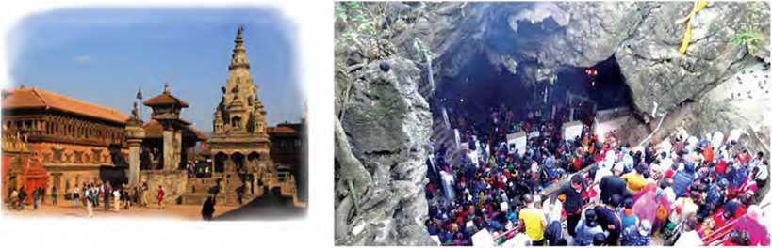

Getting started

Look at these pictures and talk about the places and the people.

at)

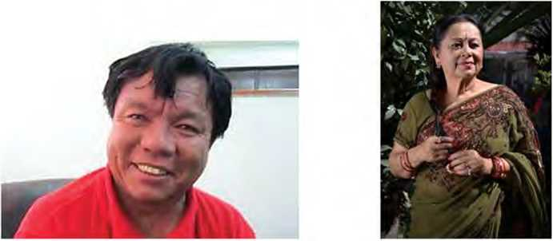

Reading I

**Answer these questions.**

1. Who is Sir Isaac Newton?
2. What is he famous for?

Sir Isaac Newton

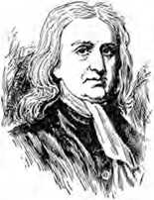Isaac Newton was born in 1643 in Woolsthorpe, England. He was the son of a peasant who died three months before Isaac was born. Newton spent most of his early years with his maternal grandmother after his mother remarried. His education was interrupted by a failed attempt to turn him into a farmer. In the beginning, he seemed to be a dull boy. He had little interest in his studies. However, he liked to use his hands. He used to make little machines, such as windmills. He would catch mice and make them drive some of his little machines.

At the age of nineteen, Newton went to Cambridge University where he studied mathematics and science. He started to make discoveries in mathematics when he was a college student. He continued to do so after he had achieved his degree. He was appointed Professor of mathematics when he was only 26 years old.

Newton did not limit his studies to mathematics. He became very interested in the behaviour of light. His interest in light led to the improvement of telescopes. The lenses used in telescopes in those days were not as good as modern- day lenses. Newton showed that curved mirrors could be used instead of lenses. These gave better results in some ways and such telescopes have been used ever since.

The story goes that one day Newton was sitting under an apple tree when an apple fell onto the ground. He began to wonder why it fell onto the ground, but why it did not go upwards in the sky. After a great deal of thought, he produced his theory of gravitation. He showed that each body attracts the other. The Sun and the Earth attract each other. The Moon and the Earth also attract each other, that is why the Moon remains near us and does not rush away.

Newton's head was usually so full of ideas and problems that he was often lost in thought. On such occasions, he forgot his meals and friends. There are many stories of his absent- mindedness. Once he was entertaining his guests at dinner, he went out of the room to fetch some more food items. For a long time, his friends waited for his return, but neither the host nor the food items appeared. At last, they went to look for him and found that he was busy with his studies. He had forgotten his friends and food.

On another occasion, Newton invited one of his friends for dinner at his home. His friend arrived on time, but Newton was not there. The guest sat down on a couch and waited for Newton to have dinner together. As he was feeling hungry, he often looked at the food items on the dinner table. The guest waited for a long time. He got tired of waiting, so he decided to have dinner alone. After having dinner, he waited for Newton again. After several hours, Newton arrived home. He was puzzled to see the guest at home. Soon, he realised that he had entirely forgotten about the invitation. After apologising, he turned to the dinner table and noticed that someone had already dined. “I’m sorry,” he said. “I see that I have already eaten my dinner. I should have waited for you.”

|  |  |
| --- | --- |
| **Match the words in** | **column A with their meanings in** |
| **column B.** |  |
| **Column A** | **Column B** |
| a. apology | i. forgetful |
| b. absent-minded | ii. unable to understand; confused |
| c. couch | iii. made something discontinue |
| d. curved | iv. a person who receives other people as guests |
| e. dull | v. the force of attraction |
| f. gravity | vi. a feeling of amazement and admiration |
| g. host | vii. lacking interest or excitement |
| h. interrupted | viii. a bent line; not a straight line |
| i. puzzled | ix. sofa |
| j. wonder | x. saying sorry |

Choose the correct words/phrases from the box to complete the following sentences.

absent-mindedness telescopes hosted

**B.**

gravitation

couch

dull

1. The construction work got .... heavy rain.

interrupted curved tired of

.. because of the

instead of

1. Newton used curved mirrors in lenses.
2. My grandmother keeps forgetting things. She is

suffering from

1. Anisha came into my room and sat on the
2. Please draw a line on the white board, not a

straight one.

1. Particles are attracted to each other by
2. Newton was a boy in his childhood.
3. My friend a birthday party yesterday.
4. I got working the whole day. I want to rest for

some time.

1. Read the text again and write whether the following statements are True or False.
2. Sir Isaac Newton's father was a lawyer.
3. Newton received his father’s affection during his childhood.
4. In the beginning, Newton was not good at his studies.
5. The fallen apple helped Newton develop the theory of gravitation.
6. Newton's mind always remained full of problems and thoughts.
7. He lived with his wife and children in his later years, application? Why?
8. **Answer these questions.**
9. How was Newton in his studies in the early life?
10. Which subjects did Newton study at Cambridge University?
11. What changes did Newton make to telescopes?
12. Why do you think Newton forgot his food and friends at times?
13. Find some other discoveries Newton has made.

Pronunciation

Practise these tongue twisters.

1. She sells seashells by the seashore.
2. Katie caught the kitten in the kitchen.
3. I scream, you scream, we all scream for ice cream.
4. Smelly shoes and socks shock Simon.
5. Fred fed Ted bread and Ted fed Fred bed.

Speaking

1. Read what the people in the pictures are saying and identify whether they are describing a person or a place or an object.

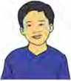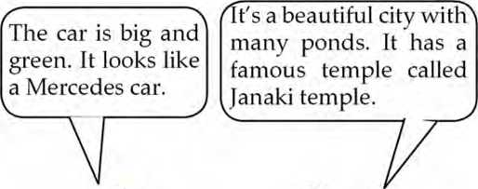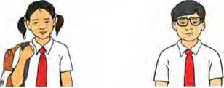

Ratna is a fifteen­year-old girl. She has an oval face. She has curly hair. She looks dike her mother.

B. Describe the following pictures.

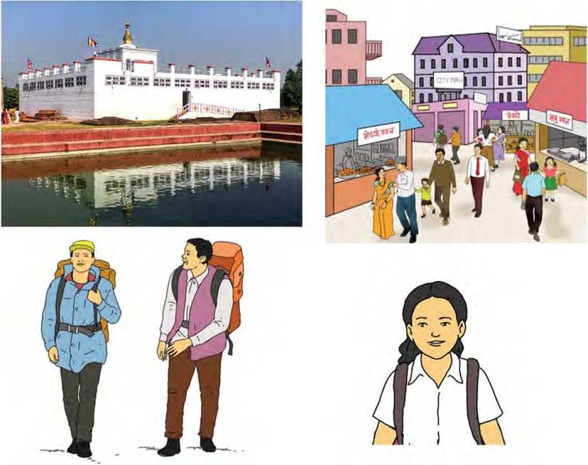

Grammar I

1. Read the following pairs of sentences and study how they are combined into a single sentence.
2. This is the room. I keep my computer there.

This is the room where I keep my computer.

1. I am looking for the person. He sent me this mail.

I am looking for the person who sent me this mail.

1. Eva doesn't like the presents. Owen has given them.

Eva doesn't like the presents which Owen has given.

1. **Complete the following sentences with the correct relative pronouns - who, where, whose, which, that, and when. You may use some of them more than once.**
2. The couple live next door has six grandchildren.
3. The house, is painted in red, is mine.
4. The woman .... house was broken into called the police.
5. The car my uncle bought is quite comfortable.
6. This is the school I study now.
7. This is the place I was born and brought up.
8. My uncle, is in the army, came to see us.
9. We have a friend plays the Madal well.
10. Is there anything I can do to help you?
11. She remembered the day she met her husband

for the first time.

1. **Join the following pairs of sentences using suitable relative pronouns.**
2. We know the woman. She donated this money.
3. We walked past my old school. It is celebrating its 50th anniversary this month.
4. I met the woman yesterday. I had helped her last month.
5. A new headteacher is going to be appointed next month.

It is good.

1. Bring me the file. The file is on the table.
2. This is the player. The committee appointed him the captain.
3. We met a girl. The girl has lost her way.
4. This is the house. Naresh built it.
5. Mandy is the girl. I am using her car today.

Writing I

**Study the information below about Pasang Lhamu Sherpa; the first Nepali woman to scale Mt. Everest. Write a short biography of her based on the given information.**

|  |  |
| --- | --- |
| Birth | Solukhumbu on 16 December, 1961 |
| Early age | grew up in mountaineering family, started to climb mountains in her teen age |
| At the age of 17 | went to Kathmandu with her love Lhakpa Sonam Sherpa and together with him owned a travel agency |
| 1989 | first climbed; Mount Pisang (6091m), climbed Mt. Blank(4848m) but failed to climb Mt. Everest reaching the height of 8000 m only |
| 1991 | made two attempts to climb Mt. Everest but could reach 8750m and 8500m respectively |
| April 22,1993 | reached the top of Mt. Everest |
| Death | April 22,1993; died due to bad weather while climbing down |
| Honours | National Hero, highways and mountains named after her |

Reading If

Answer these questions.

1. What is a national park?
2. Name some national parks of Nepal.

Khaptad National Park

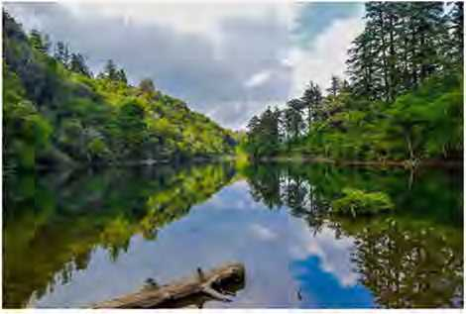Background

Khaptad National Park (KNP) was established in 1984. It is located in the mid mountains of Sudurpaschim Province of Nepal. It expands in an area of 225 square kilometre representing unique pastures mixed with coniferous forest. The park partially covers four

districts; Bajura, Bajhang, Achham and Doti. It lies at an average altitude of 3000 m above sea level.

**Features**

Khaptad National Park is one of the spectacular and pristine parks of Nepal with rich biodiversity. The park has 22 patches of grasslands on gentle hills which are locally called pa tans. In summer, they support local livelihood by offering ample grazing ground for cattle. Patans are decorated with flowers during June to August. A small lake named as Khaptad Daha is situated at the patan, which is the best place for aquatic and migratory birds.

The park with famous religious and cultural sites invites thousands of pilgrims each year. Among others, Khaptad Baba Ashram, Triveni and Sahashra Linga are the most popular places. Khaptad Baba Ashram is located close to the park headquarters which is named after the late Khaptad Swami, a renowned spiritual saint. On the way to the park headquarters, a Shiva temple is located at the confluence of three rivers, known as Triveni. The panorama of Triveni is amazing with other historical temples. Ganga Dashahara, a holy performance, is marked here during Janai Purnima. Many pilgrims make a holy visit to Triveni to worship the God Shiva on this occasion.

Another religious site is Sahashra Linga at 3,276 m above sea level which is the highest point in the park. Other religious areas include Ganesh temple, Nagdhunga, and Kedardhunga. As these areas are considered as places for meditation and tranquility, they should not be disturbed. Tobacco products, alcohol, and animal sacrifice are prohibited in these sites.

The national park is rich in flora and fauna. The main flora found in the park are sal, pine and alder species. The Khaptad plateau is dominated by sub-alpine vegetation. Fir, oak, birch, and rhododendron are the major species here. Similarly, the grassland flowers consist of primulas, buttercups, and wild berries. The park also harbours a wide variety of medicinal herbs.

The park is reported to have 266 bird species when migratory birds join the residential ones. Some of the common ones are

**Park Regulations to follow**

An entry fee of Rs. 1,500 (Foreigners), Rs. 500 (SAARC Nationals), and Rs. 100 (Nepali) should be paid.

Entering the park without a permit is illegal.

Get special permitfordocumentary/filmingfrom the Department of National Parks and Wildlife Conservation (DNPWC).

Documentary/filming fee of $ 1,500 (Foreigners), Rs. 50,000 (SAARC Nationals) and Rs. 10,000 (Nepali) should be paid at DNPWC. Additional 25% should be paid while using drones for documentary/filming.

Don't remove or damage plants and animals. All flora and fauna are fully protected and must not be disturbed.

Rubbish must be placed out, buried or disposed in designated areas.

Do respect the cultural and religious sites.

Camping inside the park should be made only at the designated areas.

Dhanphe, flycatcher, bulbul, cuckoo, and eagle. A wide variety of butterflies, moths, and insects are also the pride of the park. The park provides habitat for some 23 different species of mammals. The common ones include barking deer, wild boar, ghoral, black bear, yellow throated marten, rhesus, and langur monkey. Others include common leopard, wolf, wild dog, jackal and musk deer.

|  |  |
| --- | --- |
| **A. Match the words column B.**  **Column A** | **in column A with their meanings in**  **Column B** |
| a. pastures | i. the state of being quiet and peaceful |
| b. biodiversity | ii. a film or programme giving facts about something |
| c. aquatic | iii. the existence of a varieties of animals and plants |
| 1. confluence 2. tranquility | 1. land covered with grass 2. to contain something and allow it to develop |
| f. documentary | vi. growing or living in, on or near water |
| g. harbour | vii. the place where rivers meet and become one |

1. Fill in the gaps with correct information from the text.
2. Khaptad National Park comprises patches of

grassland.

1. The religious sites in the national park are visited by

thousands of every year.

1. A tourist from Pakistan should have to pay

as entry fee.

1. The highest point of the national park is

sitnated at the height of 3,276 meters.

1. Many pilgrims make a holy visit to Janai

Purnima.

1. **Answer these questions.**
2. What type of forest can be found in Khaptad National Park?
3. How have the patans supported local people around the national park?
4. Where is the Shiva temple?
5. After whose name is the national park named as Khaptad National Park?
6. If anyone is interested in shooting a film in the national park, how much money s/he has to pay?
7. Make a list of the flora and fauna found in the national park.
8. **If you visited Khaptad National Park, which thing would you enjoy the most? Why?**

Writing II

1. **You might have a religious/historical/natural place in your district or locality. Make an attractive leaflet about the place based on the guidelines given below.**

Introduction and location of the place

Major attractions

How to get there

Provisions and requirements

Suitable time to visit the place

1. Write a set of rules to be followed in the place you have selected in exercise A above using the following clues.

is/are strictly prohibited to   
allowed to/supposed to don't + infinitive

V-ing is not entertained

Grammar II

1. Put ‘a’ ‘an’ or ‘the’ to complete the sentences. Put a cross (X) if an article is not needed.
2. I'd like to ask you question now.
3. It is nice day today, isn't it?
4. Where is tallest statue of Lord Shiva located?
5. The boys are playing football in the backyard.
6. She is intelligent girl.
7. Do you want to go to restaurant where we first

met?

1. My father bought new TV set yesterday.
2. I live in old house house needs to be re paired.
3. Would you like to have piece of cake?
4. Sharmila can play guitar well.
5. We usually have lunch at 12:30.
6. **Put ‘a’, ‘an’ or ‘the’ to complete the paragraphs.**

a. You’ve probably learned rule that comes before

vowel, and that comes before consonant. While this is generally true, it is more accurate to say

that comes before vowel sound, and

conies before consonant sound. The can be used

with both singular and plural nouns, with nouns of any gender, and with nouns that start with any letter. The is most commonly used word in English

language.

b. Once upon time, there was old farmer. He

was honest and helpful. Once, the whole village was affected by famine. People remembered old

farmer. He helped villagers by providing food and

shelter. This news reached king. He invited

old farmer and gave him golden stick as gift for

his honesty and help to villagers during hard times.

Listening

1. 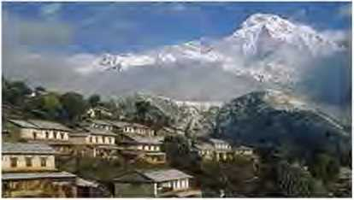Look at this picture and answer these questions.

What do you see in the picture?

a.

b.

What do you think the name of the place is?

1. Listen to the audio and fill in the blanks with missing words or numbers.
2. Sirubari village lies in the of Pokhara.
3. Sirubari introduced the concept of community-based in Nepal.
4. It takes about hours by bus to reach Sirubari

from Pokhara.

1. The Tourism Management Committee welcomes

tourists and manages sightseeing and for them.

1. Tourists are provided with food and lodging facilities at

the villagers’ own

1. **Listen to the audio again and choose the correct answers.**
2. When did Sirubari begin community-based tourism?
3. 1995 ii. 1996

iii. 1997 iv. 2001

1. How long does it take for the trekkers to reach Sirubari from Nagdanda?

i. two hours ii. a whole day

iii. a half day iv. one and a half days

1. Why do you think tourists visit Sirubari village homestay?
2. to enjoy the modern facilities available in the village
3. to enjoy unspoiled Gurung culture and heritage
4. to meet the local people
5. to enjoy a jungle safari
6. Why was Sirubari village tourism honoured with the

PAT A Gold Award?

1. for preserving local culture and heritage
2. for promoting modern development
3. for entertaining visitors
4. for preserving forests and mountains
5. **Share a real or an imaginary experience of visiting a homestay and spending time there with your friends.**

Project work

**Choose a famous place of your province. Collect information about the place. Then, write a short description of it. Use pictures/photos to make your description interesting and attractive.**

*bit*

Common Informal Expressions

|  |  |  |  |
| --- | --- | --- | --- |
| **Informal expressions** | **Standard expressions** | **Informal expressions** | **Standard expressions** |
| coz | because | lemme | let me |
| doc | doctor | lotta | a lot of |
| gimme | give me | outta | out of |
| gonna | going to | sorta | sort of |
| gotcha | got you | uni | university |
| gotta | got to | wanna | want to |
| hadda | had to | kinda | kind of |

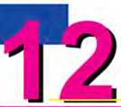Getting started

Unit

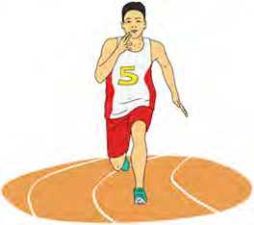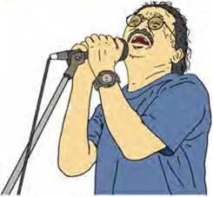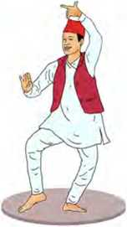**Look at the pictures. What do you think these people like, dislike or prefer? Talk to your friends.**

Reading I

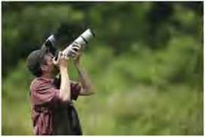

**Look at the picture and answer these questions.**

1. What do you think the man's hobby is?
2. Do you have a similar hobby? What is it?

Nepal's Bird Man

Hari Sharan Nepali's friends affectionately called him Kazi because of his smart dress and genteel manners. ‘Kazi Dai’ was a famous birder and ornithologist from Nepal. In fact, his keen interest in birdsmade him popular among Nepali and other birders.

Knowing Kazi was more than a coincidence for me: he was a friend of my father, Parasar Narayan Suwal. My father was a Ph.D. and Kazi Dai was a school dropout, but the two were bonded because of their shared love of the wilderness, often exploring the jungles of the Terai together.

In 1972, I joined my father and his students of Ananda Kuti Science College on a weeklong camping trip to Pokhara. Kazi Dai was invited as a visiting faculty to share his knowledge on bird ecology, field identification, and bird taxidermy technicpies.

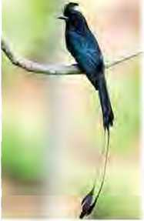In Pokhara, we trekked from Bagar to Hyangja, where we were hit by a heavy hailstorm. The next day when we reached Suinkhet, the river was filled with debris and boulders from overnight landslides and floods. There, Kazi Dai identified the Lesser Racquet-tailed Drongo, a Green Magpie and an Egyptian Vulture.

On our return journey to Kathmandu, Kazi Dai pointed out a showy Wall Creeper on a freshly dug mountain slope as it fluttered wings with maroon patches. His mentoring during this trip was a turning point for me to shape my interest in birds.

In the late 1970s, I eagerly took part in bird identification field trips with Kazi Dai and Kama Shakya, who was then with the IUCN (International Union for the Conversation of Nature) Commission on Education. Together they founded the Nepal Bird Watching Club, which was later named Bird Conservation Nepal (BCN).

Today, BCN is a well-established professional organisation nurturing a passion on hundreds of Nepali youth for bird documentation, photography, research, and conservation. Ornithological science has now gone on from just identifying and preserving birds to satellite tracking of their migration. Inaddition, it has also completed a digital recording of the more than 880 species of birds fonnd in Nepal.

Kazi Dai was very cooperative and always ready to share his wealth of knowledge, and mentor those birdwatchers and naturalists. Together, we documented his ornithological knowledge during the Biodiversity Profiles Project, under the Department of National Park and Wildlife Conservation in 1995. Both of us also served as members of the Environment Protection Council, chaired by the Prime Minister.

Birding with U.S.President Jimmy Carter was perhaps another highlight of my birding experiences with Kazi Dai. We also established the Lumbini Crane Sanctuary, and the enhanced wetland in Lumbini is now a preferred home for the nesting Saras cranes. It is supported by World Wildlife Fund (WWF) Nepal, in partnership with International Crane Foundation and Lumbini Development Trust.

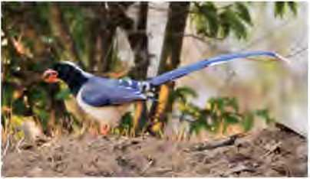Kazi Dai also personally led the Ornithological Survey of Nepal to study Nepal’s vast diversity of bird species. The Natural History Museum established by Tribhuvan University is an outcome of his passion. Kazi Dai identified thirteen new bird species in addition to the bird species described by Robert Fleming Sr, Robert Fleming Jr, and Lain Singh Bangdel in 1976.

Kazi Dai left us on 19 May 2021, but his passion for the study and preservation of Nepal’s birdlife lives on in the many young naturalists he mentored.

*(Adapted from an article by Rajendra N. Suwal published in Nepali Times)*

1. Learn these words and complete the sentences with them.

mentoring ) diversity | nurturing enhanced genteel

1. Nepal is known for her of people, still

there is harmony in them.

1. Despite being successful, Krishna is an example of lifestyle.
2. The food was tasty! They the flavour of

food items by adding natural herbs.

1. She encouraged women to start formal

programmes in their companies.

1. All the family members helped her in

her newborn baby.

1. **Choose the correct alternatives to fill in the gaps.**
2. Kazi Dai was a famous
3. teacher ii. birder iii. photographer

b has earned his Ph.D.

1. The writer ii. Hari Sharan Nepali

iii. Parasar N. Suwal

1. The writer became interested in becoming a birder
2. zafter returning to Kathmandu from Pokhara.
3. while returning to Kathmandu from Pokhara.
4. while they were on the trip to Pokhara.
5. Which of the following is a false statement?
6. Ornithological science in Nepal uses modern technologies for study.
7. The writer nevergotthe opportunity to work together with foreigners.
8. Kazi Dai worked with both the writer and his father.
9. Which of the following organizations did Kazi Dai not work for?
10. IUCN ii. BCN

hi. WWF

**Answer these questions.**

1. What made Kazi Dai a friend of Parasar Narayan Shrestha?
2. Was the journey to Pokhara a memorable one for the writer? How can you say so?
3. Name the personality with whom the writer worked except Kazi Dai.

Mention the areas BCN is working in at present. Who is the donor of the Lumbini Crane Sanctuary? Do you like Kazi Dai? Why?

d.

e.

1. **Can birdwatching be a good hobby for a Nepali student like you? Discuss with your friends.**

Pronunciation

Pronounce these words. Notice how ‘ch’ is pronounced in each word.

chaired

charade

chemist

chiffon

chair

chalk

choir

chore

child

Speaking

1. **Read the expressions given below. Do they express likes or dislikes? Write ‘Like’ or ‘Dislike’ at the end and practise saying them.**
2. She loves playing football.
3. I don't like rain.
4. I'm crazy about cricket.
5. She doesn't like going out at night.
6. My brother hates eating chocolates.
7. My father is keen on gardening.
8. 1 love reading books very much.
9. **Work in pairs. Complete the dialogue with the suitable form of the verbs given in the brackets and act it out.** Pasang: Hi, you two! What are you doing?

John: We’re playing basketball. Do you want to play? Pasang: No, thanks. I (not like/play) basketball.

Sara: Wow! I (love/play) basketball. It’s great!

John: What you (like) to do, Pasang?

Pasang: Well, I (ride) bicycle.

Sara: Yeah! That’s really fun.

Pasang: And, I (like) to dance.

John: Dancing! I can't stand dancing.

Sara: But, I prefer (sing) to dancing.

1. **Work in pairs. Ask and answer the questions about each other’s likes and dislikes. Use the given clues.**
2. listening to music b. drawing c. watching television
3. working in the kitchen e. doing mathematics

Grammar I

1. **Study the following sentences with special attention to the words in red. .**
2. I hate arguing about politics.
3. I hate to argue with you.
4. They like skiing.
5. They like to ski.
6. Children love playing with their friends.
7. Children love to play.
8. I will wait to hear from you.
9. She wants to tell you something.
10. **Choose and copy the correct answers.**
11. I don't like (going/go) out at night.
12. She learned (to tell/telling) stories.
13. I would like (coming/to come) to the party.
14. My grandfather enjoys people (asking/ask)

what he wants.

1. She kept on talking/to talk) during the film.
2. I am learning (speakingdo speak) English

nowadays.

1. Do you mind (givingdo give) me a hand?
2. Munal helped me (carry/carrying) this load.
3. I dislike (waiting/to wait) for people.
4. They've finished (preparing/toprepare)food-come

and eat!

1. **Fill in the gaps with the correct forms of the verbs given in the brackets.**
2. Joan loves (listen) to music.
3. Tina usually goes (fish) at the weekends.
4. We usually go (swim) on Saturdays.
5. He hates (write) emails.
6. Would you like (talk) to the manager?
7. Excuse me, I'd like (pay) the bill.
8. I like (call) her in the evening.
9. She avoided (talk) to her neighbour.
10. Mr. Thakuri agreed (pay) the debt on time.
11. He admitted of (steal) the money.

Writing

**Write an essay on My Hobbies and Interests. Include the answers to these questions.**

1. What are your hobbies and interests?
2. Why have you chosen them?
3. How are you going to achieve them?
4. What support do you need to persue them? (Are there any barriers stopping you?)
5. What changes might they bring to your life?

Listening

1. **Look at the picture and answer these questions.**
2. What do you think the lady is doing?
3. What do you think she is *M1K7*4

talking about? *

1. Listen to the audio and tick the correct answers.
2. What type of exercise does the speaker like?
3. jumping rope ii. mountain biking

iii. swimming

1. What does the speaker say she will do in her new house?
2. avoid letting strangers come in
3. have many animals iii. keep it clean
4. Why does she like dancing to American music?
5. because she is good at it.
6. because it is a Latin type.
7. because she is a dancer.
8. Which of the following does the speaker dislike?

i. rude people ii. American music

1. walk in the forest
2. Why does the speaker dislike waiting?
3. because she dislikes traffic.
4. because she is impatient.
5. because she gets travel sick.
6. What is the talk about?

i. personal preferences ii. hobbies iii. exercises

1. **What are your preferences? Make a list or a mind map and talk to your friends about why you like them.**

Reading Ii

1. **Look at the picture and guess the answers to these questions.**
2. Who do you think these people are?
3. What are they doing?
4. Do you like cooking classes? Why?

My Teacher Ate my Homework

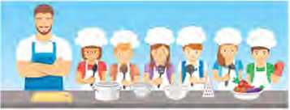My teacher ate my homework, which I thought was rather odd.

He sniffed at it and smiled

with an approving sort of nod.

He took a little nibble -

it’s unusual, but true - then had a somewhat larger bite and gave a thoughtfid chew.

I think he must have liked it, for he really went to town.

He gobbled it with gusto

and he wolfed the whole thing down.

He licked off all his fingers, gave a burp and said, “You pass.” I guess that’s how they grade you when you’re in a cooking class.

*- Kenn Nesbitt*

1. **Write the rhyming words for these words from the poem. Add one of your own words to each of them.**

odd:

true:

town:

pass:

1. **Here are the words from the poem related to eating. Find their meanings and use them in your own sentences.**

nibble bite chew gobble wolfed lick

1. **Complete the following text with the suitable words/ phrases given below.**

his fingers cooking class approved tasted strange The speaker found it when he saw his teacher

eating the homework. First, he sniffed and then smiled to

show the of what the speaker had done. Then,

he the homework bit by bit. The speaker guessed

that the teacher had liked his task. The teacher even licked

and finally said that the speaker had passed. This made the speaker gness the way the teachers grade the

1. **Write a short poem about your favourite subject and recite it in the class.**

**Grammar II**

A. Match the statements with their questions.

|  |  |
| --- | --- |
| **Statements** | **Questions** |
| a. My father is washing the car. | i. Do they have a hotel in India? |
| b. Ali doesn't want to help you- | ii. Did you have your com­puter repaired? |
| c. Yes. she sings English songs. | iii. When will Madan buy a computer? |
| d. Yes, they have a hotel in India. | iv. What is your father doing? |
| e. Madan will buy a computer next year. | v. Who doesn't want to help you? |
| f. We can go to the cinema tomorrow. | vi. Does she sing English songs? |
| g. Yes, I had my computer repaired. | vii. When can we go to the cinema? |

B. Change the given statements into questions. Use the words in brackets to start the questions.

1. Pravu is in class eight. (Who)
2. The dog is chasing a cat. (What)
3. They were practising English yesterday. (Were)
4. He went to the market to buy some vegetables. (Why)
5. I came to see you yesterday. (When)
6. Anuska bought a new computer. (Did)
7. William saw a snake under the tree. (Where)
8. They will have to do the work. (Will)
9. We paid in cash. (How)
10. She has a beautiful painting. (Does)

Project work

Find a poem/song about hobbies and interests and present it to the class.

*g-Xtta- bit*

What are the sciences that study different genres called? Study these genres with '-ology'.

|  |  |
| --- | --- |
| ornithology: | the study of birds |
| anthropology: | the study of humans |
| biology: | the study of life |
| dendrology: | the study of trees |
| felinology: | the study of cats |
| hematology: | the study of blood |
| oology: | the study of birds' eggs |
| pomology: | the study of fruits |
| sitiology: | the study of food, diet and nutrition |
| virology: | the study of viruses and diseases they cause |
| seismology: | the study of earthcpiakes |
| pathology: | the study of illness |
| hippology: | the study of horses |



Getting started

**What do the following charts/graphs represent? Discuss.**

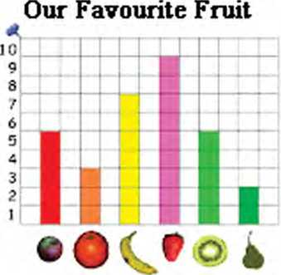

|  |  |
| --- | --- |
| **Students’ Favourite Fruits** | |
| **fruit** | **vote\*** |
|  | **©©©©©©©©©©** |
| ***t*** | **©©©©©©©** |
| *&* | **©©** |
| **•** | **©©©©©©** |
| **1 vote =** | |

Reading I

Study the chart below and answer these questions.

1. What is the name of the given charts?
2. Is it good to increase the number of tigers? Why?

Nepal is the first country to double its tiger population

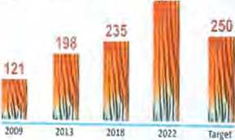Nepal started its fourth tiger and ' status of tigers in nepal 2022 prey survey from December of last year under the lead of the Department of National Parks and Wildlife Conservation (DNPWC) and the Department of Forests and Soil Conservation (DoFSC) of the Ministry of Forests and Environment. Periodic assessments of tigers are being conducted at intervals of four years since 2009. The first, second and third nationwide assessments carried out in 2009, 2013, 2018 estimated 121, 198, and 235 tigers respectively.

NEPAL ' 355

"The latest tiger population in Nepal is nearly three times compared to figures we had in 2009-2010, which is nothing short of historical," remarks Dr. Chiranjibi P. Pokharel, the National Trust for Nature Conversation's tiger expert. "Tigers are apex predators right at the top of the food chain, and their populations are intricately linked to the health of ecosystems and forests, so this is undoubtedly big news for wildlife conservation as a whole."

Only a century ago, some 100,000 tigers were estimated to roam the wide landscapes of Asia. But by 2010, their population in the wild had drastically dropped by 97%, to about 3200, mostly due to severe habitat loss

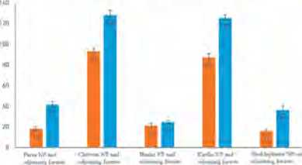and poaching. As a response, the world's 13 tiger-range countries, including Nepal had pledged to double their tiger population by 2022 (TX2) through endorsing the 2010 St. Petersburg declaration in Russia. Since then all tiger range countries, including Nepal, have taken important steps to achieve TX2.

IMW nyw in N'cptfw -Mdnustf r«i< »ix< »’pwnuijr imrv bwh «W.r

Since the 2010 declaration to save tigers from the threat of extinction, there have been important initiatives made in Nepal at all levels. During this period, additional habitats for tigers and prey species have been secured, namely with the establishment of Banke National Park and the extension of Parsa National Park.

Special institutions for the conservation of tigers have been formed right from the top political level to the community grassroots. Today, the Prime Minister of Nepal chairs the National Tiger Conservation Committee, whereas dedicated Wildlife Crime Control Bureau (WCCB} units have been set up from the central to district level to ensure that effective wildlife enforcement measures are in place. At the community level, over 450 community-based anti-poaching units have been formed.

The role of local to national to global partnerships is vital for this success story, with increased investment and support coming from both domestic and international stakeholders.

Poaching, illegal wildlife trade, and the impacts of climate change will continue to threaten the survival of tigers. Moving into the future, sustainably managing the increasing tiger population of Nepal will require additional measures over what is already working well. Habitat management efforts supporting large tiger prey species like gaur, swamp deer, sambar, nilgai and wild buffalo will need to be prioritized. Managing human­tiger conflicts and engaging communities meaningfully to create conditions for coexistence with tigers will be increasingly important.

Nepal's tiger conservation success will have to be backed by good science that is able to drive policy and action. The planning, construction, and development works need to be wildlife-friendly. Effectively managing corridors in a way that connect tiger habitats at the landscape level will continue to have a major role in the safe dispersal of tigers.

***(Adapted from a report published on ivww.nbic.org.np published on July 29. 2022.)***

1. **Match the words in column A with their meanings given in column B.**

|  |  |
| --- | --- |
| **Column A** | **Column B** |
| a. nationwide | i. the act of making people obey a particular law or rule |
| b. intricately | ii. hunting birds and animals illegally |
| c. poaching | iii. the state of being together in the same place at the same time |
| d. enforcement | iv. existing in all parts of a particular country |
| e. coexistence | v. the process of spreading something over a wide area |
| f. dispersal | vi. with a lot of different parts that fit together |

1. Fill in the blanks with correct information from the text.
2. The third tiger and prey survey found a total of tigers in Nepal.
3. Tigers are at the top of the chain.
4. The national commission related to tiger conservation

in Nepal is headed by

1. National and international have supported

the tiger conservation programme.

1. Development works and construction should be

conducted in a way.

1. **Answer these questions.**
2. How many tiger surveys have already been conducted?
3. What was the per cent of tigers in 2010 in Asia?
4. When was the St. Petersburg declaration made?
5. Mention any one initiative that Nepal has adopted for tiger conservation.
6. What are the threats to tiger conservation?
7. **In Nepal, some development and construction activities have been conducted without considering the nature and its ecosystem. What might be its effects? Discuss.**

Pronunciation

Here is a list of words used to interpret charts and graphs. Learn to pronounce them.

|  |  |  |  |  |
| --- | --- | --- | --- | --- |
| constant | rising | trend | ascend | descend |
| decrease | decline | steadilv  t | rapidly | proportion |

Writing I

**The chart below shows the number of men and women studying engineering in a university. Write an interpretation of the chart.**

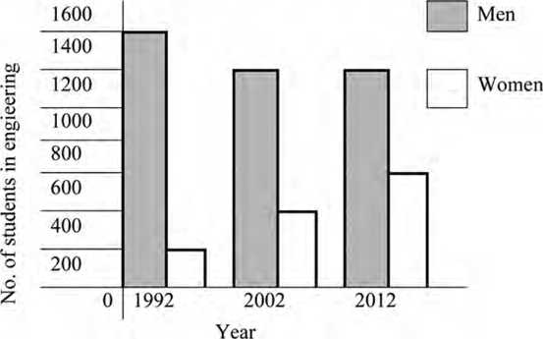

Listening

1. 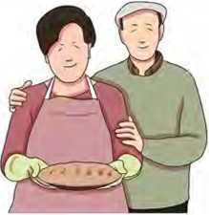Look at the picture and answer the questions.
2. Where do you think these people are?
3. What do you think they are doing there?
4. Listen to the the audio and complete the sentences with the missing information.
5. Mike wants to make
6. They have apples.
7. They have to use only apples.
8. They need 200 grams of
9. They don’t have any
10. They need grams of butter.
11. All the remaining ingredients will be bought from
12. **Note down as many ingredients as you can remember from the audio to make an apple pie.**

**Grammar I**

1. Study these sentences and discuss how the quantifiers in red have been used.
2. Most children start school at the age of five.
3. We ate some bread.
4. We saw lots of birds.
5. We have lots of time.
6. Did you see any friends?
7. Would you like any food?

The table below shows the quantifiers which are used with dferent types of nouns.

|  |  |  |
| --- | --- | --- |
| Quantifiers with countable nouns | Quantifiers with uncountable nouns | Quantifiers with both countable and uncountable nouns |
| many, each, either, (a) few, several, both, neither, fewer | much, a bit of, a little | all. some, more, a lot of, enough, no, any, most, lots of, less |

B. Choose the correct quantifier to complete the sentences.

1. I'm sorry, but there's (anv/no) milk. Is black

tea OK?

1. If you want to lose weight, you should eat

(less/more) chocolate.

1. If you want to help me make breakfast, you can peel

(any/some) potatoes.

1. We don't have (all/enough) tomatoes. Can

you bring another five or six, please?

1. When I was a child, I used to drink (a lot of/most)

milk.

1. I don't generally like fruits but I eat (no/a lot of)

mangoes.

1. I'm not sure if we can make a cake. Do we have

(some/much) eggs?

1. Sorry, I can't go with you. I've got (any/some)

work to do.

Reading II

Answer these questions.

1. What is the object shown in the  
   picture? What is it used for?
2. How do you react when someone asks you for your help?

A Mousetrap

*Characters*

MAN

WOMAN

DOCTOR

MOUSE

CHICKEN

LAMB

BUFFALO

*(A mouse is looking through the wall. A man and a woman are opening a package.)*

MOUSE: Hiimm, it looks good.

What kind of food is there

inside the package?

*(The mouse was horrified when he saw that it was a mousetrap. He went outside to tell others about the mousetrap.)*

MOUSE: There’s a mousetrap in the house. A mousetrap!

*(The chicken was looking for worms in the ground.)* CHICKEN: Excuse me, Mr. Mouse! I understand that it is a big problem for you, but I don’t care. That doesn’t bother me.

*(The mouse left worried. He went to inform the lamb.)*

|  |  |
| --- | --- |
| MOUSE: | Mr. Lamb, there’s a mousetrap in the house! |
| LAMB: | I think the mousetrap is not for me. Mr. Mouse! There’s nothing I can do. I can only pray. Stay calm, you are in my prayers!  *(Then the mouse went to inform the buffalo.)* |
| MOUSE: | There’s a mousetrap in the house, Mrs. Buffalo! |
| BUFFALO:  so. | That won’t hurt me. Am I in danger? I don’t think  *(Then the mouse went back looking sad and worried. That same night when everything was quiet, a loud noise was heard in the house. The woman ran to see the mousetrap. It was so dark. She did not see that the mousetrap got the tail of a deadly snake. Then the snake bit the woman.)* |
| WOMAN: | Help me! I got bit by a snake!  *(The woman fainted. The man called the doctor. The doctor came and took her temperature.)* |
| Doctor: | Chicken soup is good for people with a fever. *(The man went out to look for the main ingredient: the chicken.)* |
| MAN: | Come here, little chicken! I am going to make |
| soup.  CHICKEN: | Oh, no! My days are over. I will be the soup!  *(The man showed up with a chicken soup. Since the woman was still sick, her friends and neighbors came to see her. To feed them all, the man decided to cook the lamb.)* |
| MAN: | Come here, little lamb! I am going to cook a delicious dish. |
| LAMB: | Oh, no! I’m the next. |

*[The man cooked the lamb. The woman got bettei' after a few days. The couple wanted to celebrate by giving a big party to their well-wishers. They decided to cook the buffalo to feed their friends and neighbours.)*

MAN: Come here, buffalo!

BUFFALO: Who, me? No, I wasn’t invited to the party.

MAN: Yes, you were! You are the main dish.

*(Did you see who got saved? Next time, when you hear someone asking for help, remember that we need to help others in need. We never know when we will be in the same situation.)*

1. Look at the dictionary and find the meaning of the following words.
2. package b. worried c. ingredient

d. delicious e. celebrate

1. **Put the following events of the drama in the correct order.**
2. The mouse asked for help with other animals.
3. None of the animals were ready to help the mouse.
4. A man and woman brought a mousetrap.
5. All the animals except the mouse were killed one after another by the man.
6. A snake bit the woman.
7. The doctor recommended chicken soup to the woman.
8. The mouse was afraid that he would get trapped.
9. Read the drama again and answer these questions.
10. Why was the mouse shocked when he saw a mousetrap?
11. Who did the mouse complain with about the mousetrap in the house?
12. What did the lamb reply when the mouse asked for help?
13. What happened to the woman when she went to see the mousetrap in the dark?
14. Why did the couple decide to kill the buffalo?
15. **“We need to help someone if they ask us for our help because we never know when we will be in the same situation.” Do you agree with the statement? Give reasons.**

Grammar II

1. Study the following sentences. Underline the verb forms and identify their tenses. One example has been given.

*Example: I need a new pencil, (present simple)*

1. The diagram is a bar graph.
2. The bar graph shows the population growth in Nepal over the 20 years.
3. Look! The dog is running.
4. I've found this pen on the floor.
5. I'd been studying at this school when you were born.
6. Choose the correct options to complete the sentences.
7. Some teachers always us a lot of homework.

i. give ii. are giving

iii. have given iv. have been giving

1. Tim and Dolma good friends. They always

walk together.

i. are ii. are becoming

iii. has become iv. has been becoming

1. Every morning, I at seven o'clock.

i. get up ii. getting up

iii. have got up iv. have been getting up

1. It heavily at the moment.

i. rains ii. is raining

iii. has rained iv. has been raining

1. Fred his room. It looks neat now.

i. cleans ii. is cleaning

iii. has cleaned iv. has been cleaning

1. Listen! My sister the Madal.

i. plays ii. is playing

iii. has played iv. has been playing

1. We here for 13 years. I think we'll live here

for three more years.

i. live ii. are living

iii. have lived iv. have been living

1. Every day after breakfast, she the newspaper,
2. reads ii. is reading

iii. has read iv. has been reading.

1. We him very well.

i. know ii. are knowing

iii. have known iv. have been knowing

1. I wonder if he my name.

i. remembers ii. is remembering

iii. have remembered iv. have been remembering

1. **Use the correct forms of the verbs given in brackets to**

**complete the sentences.**

1. Give me that book. It (belong) to me.
2. Listen! The head teacher (call) Rama.
3. They (play) football every Saturday.
4. She (take) a shower now.
5. Look! Nima (carry) two bags.
6. I (lose) my key. Can you help me to look for it?
7. She (dance) for three hours. She will

continue dancing for the next hour.

h you (hear) the news? The school

will be closed tomorrow.

1. I usually live in Dhading but now I (live) in

Kathmandu.

1. He (teach) here for the last ten years. I think

he'll retire from this school.

Writing II

**The following flowchart shows the process of making orange juice. Study the chart and write a short description of it.**

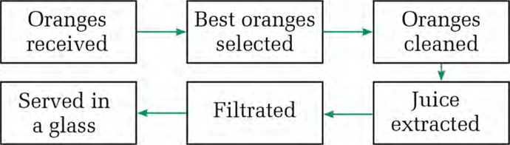

Speaking

A. Look at the table below. It gives information about different states of the USA. Take turns to ask and answer the questions using the given information.

|  |  |  |  |
| --- | --- | --- | --- |
| **State** | **Year it became a state** | **Area (Sq km)** | **Population (in million)** |
| California | 1850 | 423,970 | 34 |
| Florida | 1845 | 170,304 | 16 |
| Michigan | 1837 | 96,810 | 10 |
| New York | 1788 | 141,299 | 19 |
| Texas | 1845 | 695,621 | 21 |

*Source:* now. *en ch an tedlearning. com*

1. **Study the graphic organizer below showing the process of manufacturing tea. Take turns to ask and answer the questions about the process.**

|  |  |  |  |  |  |
| --- | --- | --- | --- | --- | --- |
| **Picking** | **Withering** | **Fermenting** | **Drying** | **Sorting** | **Storage and packaging** |

Project work

**Visit the classes from 6 to 8 in your school. Find the num­ber of boys and girls in each class. Present the data in a bar graph and share it to the class.**

*bit*

Vocabularies to use while describing the charts and diagrams

|  |  |
| --- | --- |
| Upward trend | increase, rise, rocket, climb, lift, grow, go up, jump, surge, shoot up, soar, arise, an increase, growth, an upward/rising/increasing trend, an improvement, a jump, a surge, extend, expand, step up, progression |
| Downward trend | decrease, drop, decline, fall, go down, slump, plummet, a fall, a decrease, a decline, a downward/falling/decreasing trend, a slump |
| Constant trend | Remain stable/constant/steady at, stay at the same level, stabilize, keep stable, hold constant |
| Degree of change | dramatic(ally), vast(ly), huge(ly), alot, significantly], considerable/ly, moderate(ly), slight(ly), substantial(ly), a little |
| Speed of change | rapid(ly), quick(ly), swift(ly), gradual(ly), gentle/ly, little by little, slow(ly), quiet(ly) |

Unit

Getting started

A. Look at the pictures and say what you would do in the given situations.

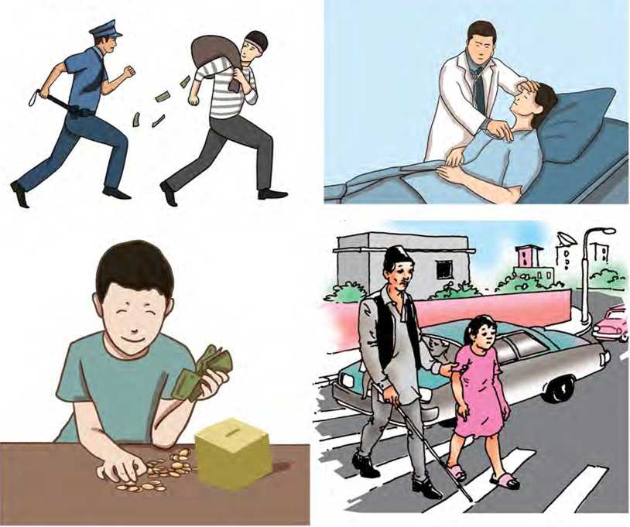

Reading I

**Look at the picture and guess answer to the given questions.**

1. What is the girl in the picture doing?
2. Where do you think she is?

The Magic Mirror

It was told throughout the kingdom of Granada that the king was ready to marry. He would marry the most worthy girl of the land. First, the news was told to the court barber, then to the night watchmen, and then to all the old women who sold fruits and cloths at the market. The king also announced that he would give a good sum of money to anyone who found a suitable bride for him.

The night watchmen shouted the news in such a loud voice, that all the young ladies were woken up, hearing the exciting news. The old women constantly reminded the young ladies that the king had decided to marry.

Everyone asked, "How will the king choose a wife?" The barber replied, "I am afraid I will have great trouble finding a worthy lady for the king."

"What, you?" they questioned. "What have you got to do with helping the king find a wife?" "I am the only man closest to the king,” said the barber. "And, I have a magic mirror. If any dishonest girl looks in my mirror, spots of her dishonesty will appear in her reflection."

"Is looking in your mirror one of the conditions to marry the king?" asked all. "That is the only condition," replied the cunning barber. "And ... what about the age?” They asked.

"Any lady above 20 years is eligible," said the barber. But each girl will have to gaze at the mirror with me by her side," he said. Although several ladies wanted to become the queen, they never dared to gaze at the mirror.

Days and weeks went by. The king was no closer to getting a wife. Some ladies would try to convince their friends to go before the mirror, but none were brave enough to try.

Every morning the king would ask the barber if any young lady had come forward to look into the mirror, but the answer wasalways the same - No! Many watched the barbershop to see if others went inside, but none had been brave enough to test their fate.

"Ah, is there no maiden in this land who wants to be my bride? In other lands, kings have no trouble finding a worthy young woman to marry. Why is this happening to me?" The king asked the barber.

"Your Majesty," replied the barber, "There is one chance. There is a lonely shepherd girl who lives by herself far away on the mountainside. She may be brave enough to look in the magic mirror, but would you marry a girl of such low birth?"

"Call her," answered the king. "Let the shepherd girl look into the mirror after you have told her what may happen if she dares to look."

Soon after, the barber brought the young woman to the court.

The whole kingdom filled the royal hall to see the girl.

When the girl entered the hall, she felt very shy. The king was very pleased with her appearance and received her kindly. He reminded her that if she wanted to be his wife, she would have to gaze at the magic mirror. He said, "If you have done something wrong in your life, there will be dark spots on its surface.

"Sir," replied the young lady, "everyone makes mistakes, and I am not an exception. With all due respect. Sir, I have no great desire to become the queen. But I am not afraid to look into that magic mirror."

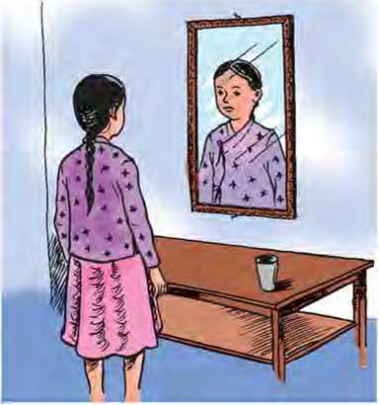Saying this, she walked up to the mirror and gazed at it. Soon after, all the women who were present, surrounded her. When they saw that the magic mirror showed no stains on its surface, they snatched it from her, passing the mirror back and forth from one lady to another. They shouted, "Look! There is no magic in this mirror - a trick has been played on us!"

But the king said, "No ladies, you have only yourselves to thank. If you had been as confident in yourselves as this young lady, you might have been the queen."

1. Match the given words with their meanings.

|  |  |  |
| --- | --- | --- |
| a. | kingdom | i. happy or satisfied |
| b. | merchant | ii. to cause someone to believe something or to do something |
| c. | surround | iii. to be everywhere around something |
| d. | convince | iv. a person whose job is to buy and sell products |
| e. | pleased | v. a country ruled by a king or |

queen

1. **Put these sentences in the order they appear in the story.**
2. The barber would have to tackle a lot of problems finding a bride for the king.
3. Many girls wanted to be the queen, but none dared to look into the mirror.
4. The king promised to give a good amount of money to those who would find him a bride.
5. The barber suggested a shepherd girl to the king.
6. The women present in the court knew that they were cheated.
7. Every day, the king asked about the progress.
8. The shepherd girl was present in the hall.
9. **Read paragraphs 1-10. Write whether these sentences are True or False. If the information is not given in the text, write NG.**
10. A watchman conveyed the message of the king early in the evening.
11. The woman's dishonest character would be reflected in the mirror.
12. The girl interested to marry the king must be in her twenties.
13. Many wanted to be queen but none wanted to look into the mirror.
14. The king found the suitable candidate at once.
15. Kings in other states were also facing the same problem as that of the king of Granada.
16. **Read paragraphs (11 -16) and answer these questions.**
17. What happened as soon as the shepherd girl was brought into the palace?
18. How do you know the king was happy at the first sight of the girl?
19. Was the shepherd girl really shy? How can you say so?
20. What was the secret about the mirror?
21. What did the other ladies realise at the end?
22. **Read these lines from the story and answer the questions.**
23. "I am afraid I will have great trouble finding a worthy lady for the king. "
24. Who is the speaker?
25. Who is he or she speaking to?
26. "What have you got to do with helping the king find a wife?"
27. Who is the speaker here?
28. Whom does 'you' refer to?
29. "No ladies, you have only yourselves to thank."
30. Who said this?
31. Whom did s/he say so?
32. **Recall a magic story you have read or heard. Tell it to your friends.**

Pronunciation

**These words are pronounced differently in British and American English. Learn them with the help of your teacher.**

|  |  |
| --- | --- |
| either schedule | leisure mobile |
| neither vitamin | multi dynasty |
| evolution advertisement | missile privacy |

Grammar I

A. Match the sentence halves to make sensible sentences.

|  |  |
| --- | --- |
| 1. If Anjali won the lottery, 2. What would you do 3. I will buy you some chocolates 4. If they had won the race, 5. If they don’t stop making noise, 6. If you drop an egg, | 1. we would have been very happy. 2. it breaks. 3. I will call the police. 4. if you were in my place? 5. if I find a grocery shop. 6. she would go for a long trip. |

1. Make sensible sentences using the words given.

*Example: wet/we/will get/if/rains/it.*

*If it rains, we will get wet.*

1. study hard/will pass/you/the exam/if you.
2. ice/if/melts/you/it/heat.
3. succeed/you/will/if/work hard/you.
4. she/would help/her/if/asked/me/I.
5. they/if/had invited/you/would have come/them.
6. doesn't know/if/the answer/she/will be unhappy/the teacher.
7. if/hadn't studied hard/she/her exams/could have failed/she.
8. would/me/if/I/help/asked/you?

Speaking

1. **Study what the people in the pictures are saying. Explain what those sentences mean.**

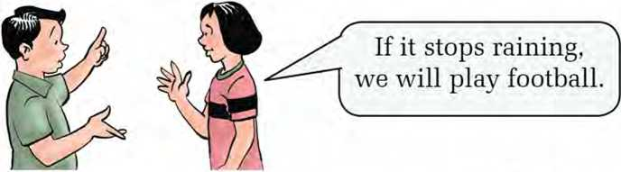

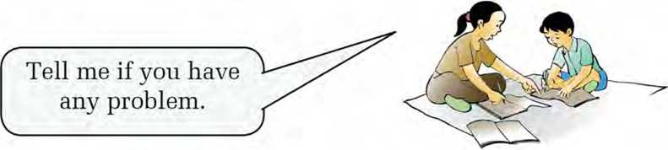

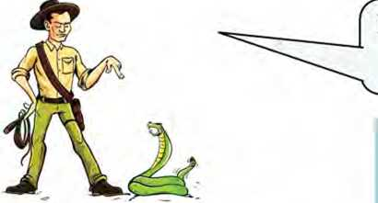^Daughter, if you don't" go out, I will bring you I some chocolates. _

If you tease a snake, it will bite you.

1. 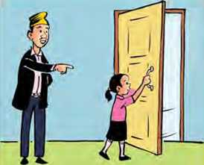Work in groups and take turns to make a chain of events as in the example. Use the given clues.

*Example: drink coffee/stay awake tonight/feel*

*sleepy in class tomorrow*

*Sanam: If I drink coffee*

*Anita: I will stay awake tonight.*

*Chandra: If I stay awake tonight,*

*Deepak: I will feel sleepy in the class tomorrow.*

1. rain heavily/stay inside/mother happy/provide delicious food
2. touch snow/get frostbitten/go to the doctor/need to spend money
3. join language class/improve English/get good grades/ parents happy
4. eat chocolates too much/teeth decay/see a doctor/take the teeth out
5. don't study hard/fail the exam/can’t go to a college/can’t get better job
6. Ask and answer the questions on the given situations as in the example.

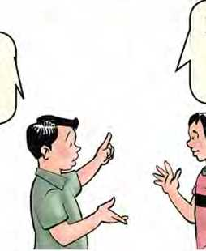*Example: what/if tomorrow were a holiday/go swimming*

What would you do if tomorrow

kwere a holiday?

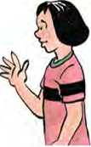If tomorrow were a holi-  
day, I'd go swimming  
with my friends.

1. what/if you found a purse/submit it to a police station
2. what/if weather is not good/won't go out
3. what/if I touch a live wire/get electric shock
4. what/if one exercises regularly/become healthy
5. what/if everyone is sincere/the world would be a better place

Writing I

Complete the story with the suitable forms of the verbs given in the brackets.

One day, a lamb (eat) sweet grass away from her flock

of sheep. She (not notice) a wolf walking nearer to her.

When she (see) the wolf, she (start) pleading,

"Please, don't eat me. My stomach (be) full of grass.

You can wait a while to make my meat taste much better. The grass in my stomach will be digested quickly if you let me dance." The wolf (agree).

While the lamb (dance), she (have) a new idea.

She said, "I can dance faster if you (take) my bell and

ring it so hard." The wolf (take) the bell and

(start) to ring it so hard. The shepherd (hear) the sound,

ran quickly to see what had (happen). And the lamb

was saved.

Listening

1. Look at the picture and answer these questions.
2. 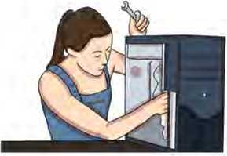Who do you think the woman is?
3. What does a technician do?
4. Listen to the audio and choose the correct answers.
5. The speaker works as
6. a doctor ii. a technician iii. a nurse
7. The first thing she does when she arrives at office is to
8. find if there are any problems.
9. greet everyone.
10. check her emails.
11. Every day, the speaker reaches her office on tune because
12. her manager is strict.
13. she is punctual.
14. she must talk to the other workers.

cl. People cycle to work because

1. it's good for their health.
2. parking is expensive.
3. public vehicles are not available.

e. Altogether people share the same cabin.

i. three ii. four iii. five

1. **Listen to the audio again and answer these questions.**
2. What time does the speaker reach the office?
3. What time do the workers go home?
4. What time does she leave her office?
5. How does she get back to home?
6. How much is the pay?
7. **If you were the speaker, would you continue that job? Why? Talk to your friends.**

Reading II

A. Look at the picture and answer these questions.

1. Who is the person in the picture?
2. How is the person different from common people? Discuss.

If I was a Superhero

If I was a superhero,

I'd definitely fly.

Arms outstretched, Racing birds in the sky.

If I was a superhero,

I'd have special powers Like extra strong legs For jumping over towers.

If I was a superhero

I'd save all the oceans,

With my secret and magical Cleaning up potions.

If I was a superhero

I'd save all the trees

And the mountains and rivers, The birds and the bees.

If I was a superhero,

I'd help all the poor,

Give them food,

And make them hungry no more.

If I was a superhero,

I'm sure you'll agree,

The world would be better,

Because of me!

*- Sally Gray*

**A. Solve the crossword puzzle.**

ACROSS

1. a special character with superhuman powers
2. a tall and narrow structure
3. insects that produce honey
4. having special power to make things happen

DOWN

1. reaching out as far as possible
2. certainty, without any doubt
3. a kind of liquid that is said to cure illness

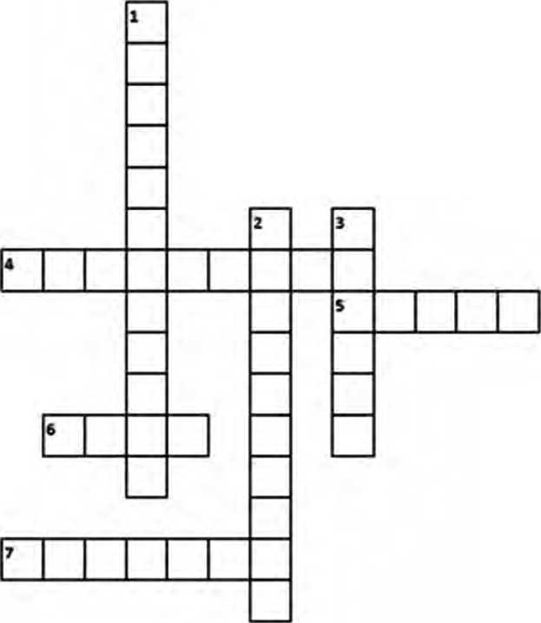

1. Fill in the blanks. Use information from the poem.
2. The speaker wants to fly stretching the
3. The strong legs would be used to over the

towers.

1. The oceans would be saved with
2. The speakers would save all the trees, and rivers.
3. The poor would be helped with
4. The would be a better place because of

the speaker.

1. **If you were a superhero, what would you do? List down at least five things you want to do.**

Writing II

**A. Read the given news story carefully and discuss these questions.**

Nepal begins exporting cement to India

By Satish Mishra

Kathmandu, 10th July 2021

Nepal has begun exporting cement to India. Palpa Cement, based in Sunawal-7 of Nawalparasi district, says it has begun exporting cement to India, for the first time in the country.

During a function on Friday, the company announced the beginning of the export of its Tansen brand.

On the first day. three trucks of cement have been export­ed. The company produces 3,000 metric tonnes of cement every day, according to the company's Public Relations Manager, Jeevan Niraula.

For the current fiscal year, the government has also decid­ed to provide some grant support to the cement companies involved in the export.

It has already been a few years since the country has been self-reliant in cement production. However, the export of cement had not begun.

*(Source: English. onlinekliabcir.com)*

Questions:

1. *What is the headline of the news story?*
2. *What is the by-line of the news story?*
3. *When is it written?*
4. *Identify the lead paragraph.*

**B. Write a news story with the help of the guidelines below.**

**Nepali youth awarded in Delhi**

* Mohammad Irfan from Banke
* National Youth Icon Award 2022
* a ceremony held in Delhi
* awarded by Chief Minister of Delhi
* for his excellent contribution to the field of development
* started career with USAID in Jumla
* is a very active social and political activist for disability awareness

Grammar II

A. Complete the sentences by choosing the correct options.

1. If you hungry, I will give you something to

eat. (was/were/are)

1. What if you were alone at your home? (you

do/will you do/would you do)

1. If they had gone to bed early, they been late

for the bus. (wouldn't have/will have/would have)

1. A snake you if you touch it. (bites/may bite/

would bite)

1. If it rains this evening, I at home, (would stay/

would have stayed/will stay)

1. Would you walk more if you a pair of shoes?

(have/had/had had)

1. Maria would have bought a watch if she enough

money, (had had/have had/will have)

1. If I hadn't climbed up the tree, I (would have

fallen/will fall/wouldn't have fallen)

i. What if the doors are closed? (happens/would

happen/will happen)

**B. Complete the given sentence in any way you like.**

1. If I were you
2. If you call him
3. I would have called your mother
4. If you don't brush your teeth regularly,
5. If they didn't hurry,

f we will play golf.

1. I can help you

Project work

**You are taking part in a speech competition. Prepare a draft of speech that starts with, 'If I were the Prime Minister of our country, I would first Share it to the class.**

*&Xtra. bit*

Learn the parts of a news story.

1. **Headline:** This refers to a short phrase at the top of a news story. It summarises the story and encourages people to read the news. People often read the news headlines to get a quick sense of what is going on in the world even when they are busy.
2. **Byline and dateline:** Byline is the name of the reporter/ writer of the story whereas dateline is the date when a piece of news is written.
3. **Lead:** It is the first paragraph of a news story. Generally, we answer 5WH1 (what, when, why, where, who, how). The most important information is mentioned in the lead.
4. **Body paragraph(s):** Here, a writer elaborates the lead by giving examples, presenting data, quotations, etc. and gradually leads to the conclusion.

Getting started

**Look at the pictures and discuss why the object/animal/place is important.**

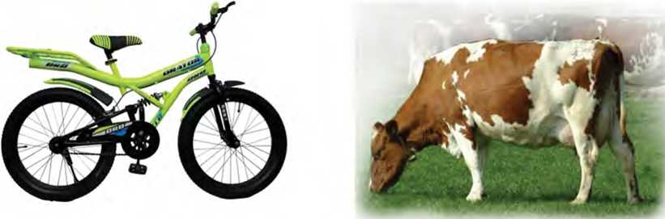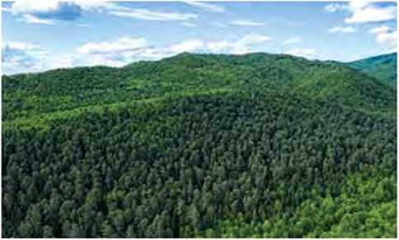

Reading I

**Look at the picture and answer these questions.**

1. What plants and animals can you see in the picture?
2. Do you think they are necessary for our lives? Why?

Conservation of Earth

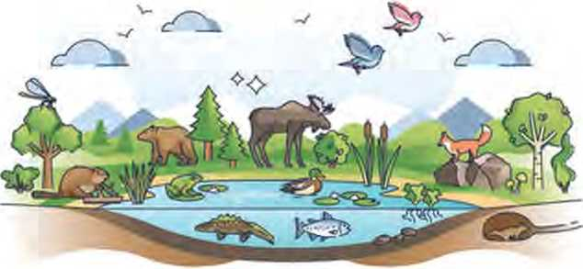

Every living creature has a place where it feels at home. Let us think about the differences between some of them. Polar bears are at home in the Arctic. They can protect themselves from freezing temperatures because they have thick layers of fat. Lions have their thinner coats and are at home in the African grasslands where temperatures can be scorching hot. The place where a creature feels at home is called its natural habitat. It feels comfortable and quite safe there. Why might this be? You tend to feel at home and usually safe in your own house surrounded by your own family and friends. You have nice food to eat. Although you may not be friends with all of your neighbours, you may know them. It is the same for all other creatures. Their natural habitat is a place where they and their ancestors have lived for perhaps millions of years along with their immediate families. The habitats vary greatly; usually identified by different surroundings including temperatures and vegetation. They are used to their individual climate and the other species in the same habitat. Wild creatures can only live in one sort of habitat and would never survive for long in a different one.

Conservationists realised these issues several decades ago and began by saving specific species which were in danger. They did this by banning some hunting, poaching, and overfishing. This was a great start, but people realised that saving a single species was not enough. The creature’s home and environment had to be saved as well. Natural habitats are increasingly in danger everywhere. People cut down forests for firewood and timber and the creatures living there may have nowhere else to go. Survival of some species has become difficult because global warming is causing ice caps to melt.

We have to make an important decision to protect different species from becoming extinct. We know that thousands of different species are in danger of becoming extinct. Once they are gone, they will never come back. There are probably thousands more species in existence that we do not know about because we have not discovered them yet. The ones undiscovered are usually located in areas and habitats that are currently difficult to reach. Examples of such areas include isolated rainforests, deep oceans, the Arctic and the Antarctic.

We need the other creatures in the biosphere because they provide us with food, building materials, fuel, and medicine. Although we get these things from the biosphere, we must use them carefully. If we destroy the biosphere because we are greedy or just silly, then we will die out ourselves. This raises another interesting question, are humans more important than animals? We need to look after our biosphere to survive. Conserving the biosphere means looking after ourselves to ensure the survival of all living creatures on our precious planet. What if we cannot achieve this?

Some scientists are planning well ahead. In the future, the Earth might not be able to support all the creatures living on it. They are searching for other planets in our solar system so that the human species and other creatures can move there to live. How might this be possible? The James Webb Space Telescope is looking for other planets that might be habitable. The telescope is looking for signs of oxygen and water vapour. The process will take many hundreds of years to work, therefore it is extremely important that we look after the Earth that we live on today.

1. **The meanings of some of the words from the text are given below. Find the words and write them down next to their meanings.**
2. no longer in existence
3. to hunt birds or animals illegally
4. a period of ten years
5. people in your family who lived a long time ago
6. kind or type
7. people who take an active part in the protection of the environment
8. the atmosphere in which plants and animals can live
9. suitable to live in
10. **Read the text again and write True or False for these statements.**
11. You feel at home when you live in your usual place.
12. Conservationists started to work saving animals only recently.
13. There are thousands of undiscovered species on the Earth.
14. Humans will also die out if they go on destroying the biosphere.
15. Scientists have already found another habitable planet.
16. **Read the text again and answer these questions.**
17. How is it possible for polar bears to live in the Arctic?
18. Why can't wild creatures survive for long in a different habitat?
19. What have the conservationists done to save some specific species?
20. What is the impact of cutting down trees?
21. Where are many of the new species of creatures found?
22. What is the contribution of other creatures to humans?
23. Why do you think scientists are looking for oxygen and water vapour on other planets?
24. **If you got the chance to go to another planet to live, what five things would you take with you? Make a list and talk to your friends. Give reasons why you would want to take those particular items with you.**

Pronunciation

Learn to pronounce the words. The letters in red represent the consonant sounds of English.

|  |  |  |  |
| --- | --- | --- | --- |
| creature | temperature | layer | habitat |
| ancestors | warming | freezing | bush |
| treasure | danger | living | great |
| thousands | another | you | decision |

Speaking

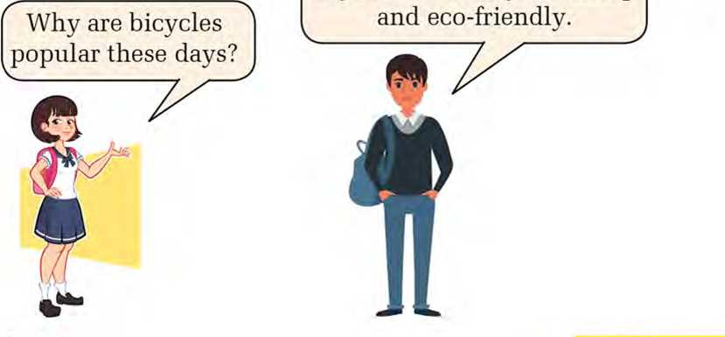**A. Read the dialogues between the people in the pictures. One is asking a question and the other is giving an explanation.** Bicycles are popular these

days because they are cheap

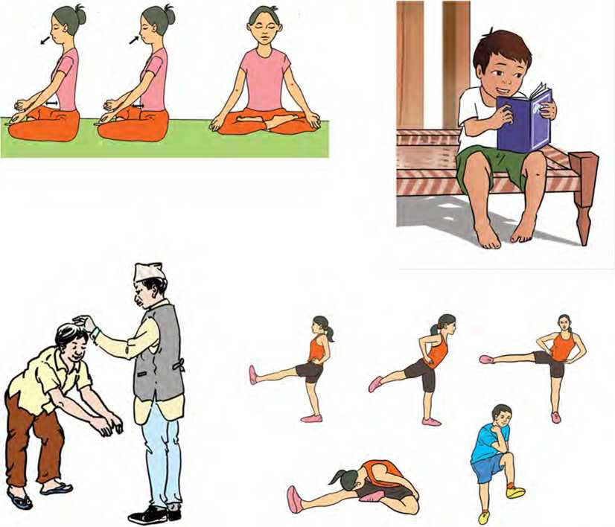Why did you go to the

Now, take turns in pairs to ask questions and provide

explanations based on the pictures below.

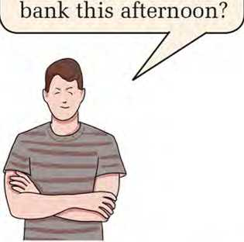

I went to the bank this afternoon in order to withdraw some money.



Grammar I

1. These sentences are from Reading I. Complete them with the missing words.
2. They can protect themselves from freezing temperatures they have thick layers of fat.

b you may not be friends with all of your

neighbours, you may know them.

1. Survival of some species has become difficult

global warming is causing ice caps to melt.

1. This was a great start, , people realised that saving

a single species was not enough.

1. We have to make an important decision protect

different species from becoming extinct.

1. They are searching for other planets in our solar system the human species and other creatures can move there to live.
2. **Complete these sentences with but/because/because of/so that/in order to/therefore/although.**
3. I can't walk any more I've been walking all day.
4. He could not join the army the visual impairment.
5. I like dogs a lot they are usually friendly.

d our class teacher was sick, she s till came to school,

1. I went to the bank I could withdraw some money,

f the heavy traffic, we could not reach the cinema in time.

g Sima was tired, she did her homework before

she went to bed.

1. She is talking clearly impress the headteacher.
2. I work a lot I do not get good grades.

Writing I

**Some people think that listening to radio and watching television is important for students, while others believe that it impacts them negatively. Write an essay expressing your opinion about it.**

Reading II

Look at the picture and answer these questions.

1. 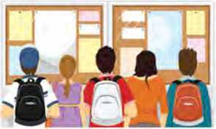Who do you think the students are doing?
2. How often do you visit the noticeboards at your school?

Government of Nepal

MINISTRY OF EDUCATION, SCIENCE AND TECHNOLOGY

Singhadurbar, Kathmandu, Nepal  
26th Poush 2078

Notice about School Closure

This is to notify all the concerned everyone that the Ministry of Education, Science and Technology has decided to close all schools because of the rapid spread of COVID-19 infection in recent days. All schools across the country will be closed from 27th Poush to 15th Magh.

The government has decided to vaccinate all children between 12 and 17 years at health posts at local levels during the vacation. All parents are requested to contact schools and take their children for vaccination on the specified dates.

Since schools will remain closed for about three weeks, schools should make necessary arrangements for the learning of their students to continue through alternative methods. The universities can conduct pre-scheduled examinations following the public health and safety standards.

in column A with their meanings in

**A.**

**Match the words column B.**

**Column A**

a. rapid

**Column B**

1. a plan made to do something
2. infection ii. a thing that can be chosen out of two or more possibilities
3. vaccination iii. happening quickly or in a short period of time
4. arrangement iv. the act of giving a person a vaccine
5. alternative v. the act or process of causing or getting a disease

**B. Answer these questions.**

1. What is the notice about?
2. Why did the government decide to close all the schools?
3. How long will the schools remain closed?
4. What are the parents asked to do?
5. What are universities suggested about the examinations?
6. **Imagine that a friend of yours was absent from the class on the particular day. Now, draft a message in your own words to communicate the notice to him or her.**

Writing II

**Write a short notice on behalf of your school about a one-day closure of the school. Give a reason in the notice as to why the school will remain closed.**

Grammar II

Combine the following pairs of sentences using the connectives given in the brackets.

1. She is very rich. She lives a simple life, (although)
2. He is ill. He wants to meet me. (in spite of)
3. She works carefully. She makes many mistakes, (although)
4. I went to the grocery. I could buy some rice, (so that)
5. She has got good grades. She has not passed the entrance test, (however)
6. He ran away. He was afraid, (because)
7. We did not go out. It was raining heavily, (because of)
8. It was hot. We went to play football, (although)
9. She bought a book. She bought a pencil, (and)
10. He likes dancing. He doesn't like singing, (but)

Listening

**A. Look at the picture and answer the following questions.**

1. 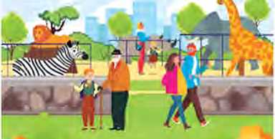What do you see in the picture?
2. Do you like to visit the zoo? Why?

B. Listen to the audio and complete these sentences. Use one word only.

1. The speaker feels for the animals kept in zoos.
2. According to him. the zoo animals usually look
3. Zoo bosses argue that zoos are an way of

educating children.

1. Children can learn about animals with the help of

television and

1. Most of the animals in zoos are not in danger of
2. **Listen to the audio again and write True or False.**
3. The speaker says the animals are happy in zoos.
4. The speaker is in favour of the freedom of zoo animals.
5. Most of the animals in zoos are endangered animals.
6. The speaker says only endangered animals should be kept in zoos.
7. **What do you think about keeping animals in zoos? Discuss.**

Project work

**Work in groups. Prepare a bulletin board using the locally available materials. Use the board to paste important notices of your class.**

*B/tra. bit*

Some Connectives and Transition Words

|  |  |
| --- | --- |
| **Function** | **Example** |
| Reason | because, because of, so that, in order to, to, as, thus, therefore |
| Adding | and, also, as well as, moreover, further­more, besides, in addition |
| Cause and Effect | because, so, therefore, thus, consequently, as a result of |
| Comparing | equally, in the same way, like, similarly, likewise, as with, as compared with |

|  |  |
| --- | --- |
| Contrasting | however, although, even though, whereas, instead of, alternatively, otherwise, unlike, on the other hand, in contrast |
| Emphasizing | above all, in particular, especially, signifi­cantly, indeed, notably, most of all |
| Illustrating | for example, such as, for instance, as re­vealed by, in the case of, as shown by |
| Qualifying | however, although, unless, except, if, as long as, apart from, yet, despite |
| Sequencing | next, then, first, second, finally, mean­while, after |



Getting started

**Study the pictures. Take turns to tell the story to each other.**

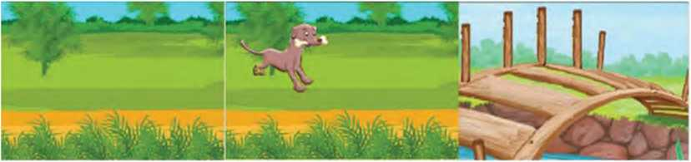

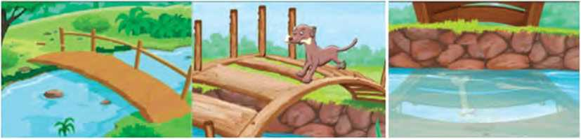

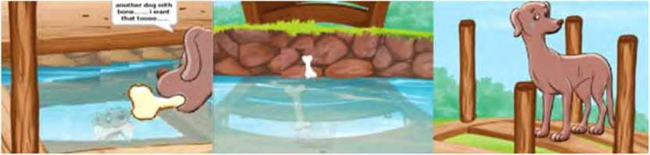

Reading I

**Answer these questions.**

1. What food do you like the most?
2. Do you prefer veg or non-veg food items? Why?

Why I Became a Vegan

Growing up, I did not really think about my weight. I cheered in middle and high school and just did not think too much about it in college. Post-college, though, I started gaining weight. I ate out more, was stressed more consistently with work, and looked up one day and was not happy about my weight.

Even more, I have become more in tune with my body and how I feel. This really started when I did the Whole30. Following those 30 days, I could really tell when my body did not feel good, and I was not thrilled about how much I did not feel great.

During this same time, I have started listening to the Almost 30 Podcast which has made me think tree is becoming a vegan. My aunt and uncle started the trend of becoming a vegan in our family, my dad was next, and then me.

about living a holistic lifestyle. I have already written about my  
transition to natural deodorant. The last branch of that holistic

People become vegan for lots of reasons. But for me, it was about eliminating foods out of my diet that my body does not like. It was about putting things into my body that would make me feel good and help me to live my best life.

Vegans do not eat products that have come from an animal. For me, that means I do not eat dairy and animal-based protein like eggs and meat. I will eat regular butter if I am at a restaurant and I do eat honey. Also, I point out those last two things to say all vegans do not have to be ‘strict’. I believe like any other lifestyle change, this is about what works best for the individual and about living your best life.

People often ask me if this has been hard. Has it been difficult to cut those things out of my diet? I thought it would be, but I have been surprised at how easy it has been for me.

When I did Whole30,1 learned that my body does not love dairy. Before those 30 days, I often went to bed with a stomach ache and really thought it was normal. Well, it was not. I rarely have a stomach ache now, rarely have a headache, have more energy and do not have acid reflux as much. It is kind of crazy!

There are ways to get protein outside of animals: I eat a lot of beans and chickpeas. And, there are an abundance of vegetables that I can incorporate into my diet. There are many options for your favorite non-vegan foods. You don’t have to give up your favorite foods to be vegan.

*(Adapted from an article by Jessica Sharp published on gentwenty, com)*

A. Meanings of some of the words are given below. Decide which one among them is the contextual one.

|  |  |
| --- | --- |
| a. cheered | 1. to encourage somebody or to give them hope or comfort 2. to shout loudly to show support or praise for somebody |
| b. consistently | 1. in a way that has different parts that all agree with each other 2. always the same |
| c. eliminating | 1. stopping to consider that somebody might be responsible for something 2. removing or getting rid of something |
| d. dairy | 1. milk, cheese and other milk products 2. a place on a farm where milk is kept and where butter and cheese are made |
| e. incorporate | 1. to create a legally recognized company 2. to include something so that it forms a part of something |

1. Use the above words to fill in the gaps below.
2. Despite our requests, the manager denied

the changes we wanted to bring.

1. The plan for the risk of nuclear weapons is

still lingering.

1. The audience clapped and when she stood

up to speak.

1. These designs the best features of

our earlier models.

1. Many people find it difficult to digest milk, and get a

stomachache if they eat products.

1. **Decide whether the given sentences are True or False.**
2. The writer started gaining weight when she was at college.
3. She listened to only 30 podcasts that guided her to live a holistic life.
4. She became vegan because she did not like non-veg food.
5. Cutting off her diet was an easy task for the writer.
6. According to the writer, there is food outside of animals from which she can get proteins.
7. **Answer these questions.**
8. Who are vegans?
9. When did the writer start gaining the weight?
10. Who first started to become vegan in the writer's family?
11. Mention the reason for which the writer became a vegan.
12. What was the impact of Whole30 on the writer?
13. Do you think all the nutrients needed for our body can be achieved from non-veg food? How?
14. **Has any incident caused you to adopt or avoid eating a particular food item? Discuss.**

Pronunciation

**Listen to your teacher. Pronounce the words and notice the letters that remain silent.**

debt muscle ledger comb design psychology knee heir calf autumn scene foreign

Speaking

Study the pictures below. Tell the story in groups.

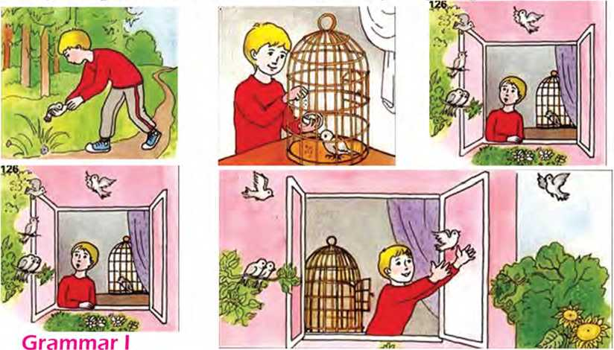

**A. Underline the verbs in the following sentences and identify their tenses. One example has been given.**

*Example: The incident changed my life completely, (simple past)*

1. We had a cow at our home.
2. I felt as if I was taking away somebody else’s right.
3. By the time my mother came to me, I had already drank all

the milk.

1. My mother was serving food for my father when he started talking with me.
2. Perhaps, I was not prepared to share the real reason.
3. **Answer these questions in complete sentences.**
4. What did yon eat yesterday evening?
5. What were you doing when the teacher came into the classroom this morning?
6. What had your mother cooked when you reached home yesterday?
7. What did you see as soon as you opened the door this morning?
8. Had the class already started when you reached school yesterday?
9. **Complete the sentences with the correct form of the verbs given in the brackets.**
10. The car (hit) the tree while the driver was

talking on the phone.

1. The bus (leave) the stop before I reached

there.

1. A boy (dig) the field when his father saw

him.

1. When I woke up, the birds (chirp).
2. I (not/do) anything wrong, but my friend still

shouted at me.

1. My father (order) the food before I reached home,
2. The girl (speak) quite fast. So, we didn't

understand her.

1. The customers (order) the foo d at the counter before the waiter came to their table.
2. What (you/do) when I called you yesterday

evening?

Listening

1. **Look at the picture and answer these questions.**
2. 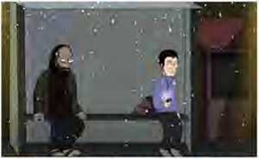Who do you think these people are?
3. Where are they?
4. Listen to the audio and complete the sentences. Use one word only.
5. The incident happened when the speaker was going to
6. He did not call his because they were out for the

evening.

1. Instead of calling his parents or a taxi, he decided to

for a bus in the bus shelter.

1. He got his phone out and listened to some
2. He saw a guy dressed in thick layers of clothing,

walking slowly towards him.

1. **Listen to the audio again and write whether these statements are True or False.**
2. The man seemed average and smart.
3. The bus arrived on its scheduled time.
4. The man grabbed the speaker's bag.
5. The speaker ran away to another bus stop.
6. The man followed the speaker to another bus stop too.
7. **What would you do if you were in the speaker's situation? Tell your friends.**

Writing I

**Arrange the sentences in order to make a story.**

**A.**

1. Now he said, ‘Bad habits are like them. It is easy to pull them out when they are young but it is impossible to uproot them later’.
2. Once upon a time, a rich businessman asked a wise man to wean his son away from his bad habits.
3. And he had to struggle for it.
4. The man took his son to a garden and asked him to pull out a tiny plant.
5. This session changed the son’s life completely.
6. He grasped the trunk but it was impossible for him.
7. Later he asked him to uproot a slightly bigger plant.
8. Finally he asked him to uproot a guava tree.
9. The boy held the plant between his thumb and forefinger and pulled it out easily.

**Study the following pictures and write a story based on them. You can start in the following way.**

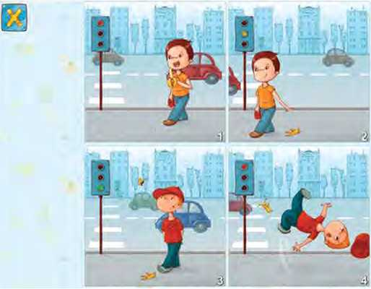

Once upon a time, there was a little boy named Sanam in a city

Reading II

Answer these questions.

1. What are the different types of pens you know?
2. What type of pen do you use for your everyday writing?

The History of Pens

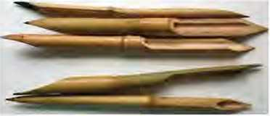The need for a pen developed as humans discovered papyrus. To write on papyrus, the Egyptians created the reed pen. They used hollow tubular marsh grass, espe­cially bamboo as the body of the pen. One end of the tube was sharpened into the shape of a pen’s nib and the tube was filled with writing fluid. The pen would be squeezed to allow the ink to flow out.

After centuries of using the reed pen, the quill pen was cre­ated in Seville, Spain. The quill pens were made from bird feathers like swans, turkeys, and geese. The feathers were dried to discard any oils present in them that would interact with the ink. The end of the feather was cut with a knife to sharpen it, making the tip of the pen. The quill could be used by dipping the feather in ink, which would fill up in the shaft as a reservoir. These pens were durable

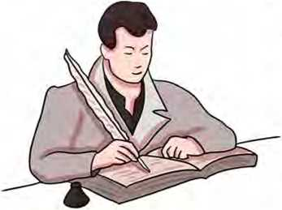but they had to be sharpened with a knife frequently.

Before the quill, writing used to be in capital letters. But as the quill improved the smoothness and writing speed, more decorative and faster means of writing, includinglowercase letters were developed. The quill pen would go on to be used for nearly twelve centuries.

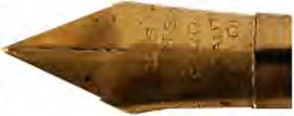The quills were replaced when John Mitchell from Birming­ham, England started develop­ing machine-made steel-point pens or dip pens on a mass scale. These pens functioned the same way as quills but were much cheaper and sturdier.As writing became smoother and faster, constantly dipping the pens in ink got more and more frustrating. This led to the invention of the fountain pen.

The fountain pen was patented by Petrache Poenaru, a Roman inventor in 1827. This pen had an ink barrel and did not need to be dipped in ink regularly. In 1884, American inventor Lewis Edson Waterman designed and patented the three-channel ink feed fountain pen. It ensured a smooth flow of ink and made pen into a truly transportable tool. The fountain pen underwent many inventions throughout the 20th century, like the use of replaceable and refillable ink cartridges, and the use of plastic, metal, and wood.

Although American inventor John J. Loud patented the earliest design for a ballpoint pen in 1888, he could never perfect the flow of ink for the writer. Decades later, Hungarian journalist LaszloBiro, living in Argentina started working on new designs for the ballpoint pen.

LaszloBiro, the inventor of the first commercial ballpoint pen was a journalist. He was too familiar with the annoyance of ink smudging on paper. He decided to use the quick­dry in and introduced a small metal ball that rotated at the tip of the pen. This managed to keep the ink fromdryingandalsodistributingitsmoothly.Inl943,Laszldandhis brother Gyorgy, a chemist, patented this new design. These pens, known as biromes were a huge commercial success. The patent for this design was then bought by Marcel Bich in 1945, whose company sold over 100 billion ballpoint pens worldwide. Biro pens or biromes were the first commercially successful ballpoint pens.The ballpoint pen was a turning point in the evolution of pens. It was highly durable, more convenient, could write on multiple surfaces such as cardboard and wood, and even underwater and at high altitudes.

Today, with the advent of technology, pens are being replaced by smartphones, tablets, and laptops, and the use of pens is steadily declining. However, pens will go down as one of the most important inventions in the history of mankind.

*(An article adopted from historyojyesterday.com)*

A. Find the different types of pens mentioned in the text and write their details as mentioned in the example below.

|  |  |  |  |
| --- | --- | --- | --- |
| **S.N.** | **Type of Pen** | **Time/Year** | **Inventor** |
| Example | Reed Pen | When humans developed papyrus | Egyptians |
|  |  |  |  |
|  |  |  |  |

B. Match the following words with their correct meanings.

|  |  |  |
| --- | --- | --- |
| a. | hollow | i. strong and not easily damaged |
| b. | discard | ii. to obtain a right for an invention or a process |
| c. | shaft | iii. having a hole or empty space inside |
| d. | sturdy | iv. slow steady development of something |
| e. | patent | v. the long narrow part of an arrow, hammer, etc. |
| f. | smudge | vi. the coming of an important event, person, invention, etc. |
| §• | evolution | vii. to get rid of something that you no longer want or need |
| h. | advent | viii. to make a dirty mark on a surface |

1. Answer these questions.
2. How were the reed pens made?
3. What were the quill pens made of?
4. Mention the changes brought by quill pens in writing.
5. How were steel-point pens different from quill pens?
6. What were the variations of the fountain pen?
7. Who designed the ball pens for the first time?
8. Describe the features of biromes.
9. Do you think the use of pens will decline in the days to come? Why?
10. **Prepare a timeline illustrating the historical development of pens.**

Writing II t.

**Write a couple of paragraphs about one of the historical events you know.**

Project work

Work in groups. List the major events that happened last month in your school. Write a short paragraph using the list.

*bit*

Blending: A Word Formation Process

Blending is a word-formation process in which parts of two or more words combine to create a new word. Such words have some of the properties of both of the words combined.

|  |  |  |
| --- | --- | --- |
| **Word** | **Word** | **New word/Blend** |
| breakfast | lunch | brunch |
| motor | hotels | motels |
| information | entertainment | infotainment |
| biography | picture | biopic |
| romantic | comedy | romcom |
| documentary | drama | docudrama |
| emotion | icon | emoticon |
| friend | enemy | frenemy |
| motor | pedal | moped |
| sports | broadcast | sportcast |
| stay | vacation | staycation |
| work | alcoholic | workaholic |
| camera | recorder | camcorder |
| video | blog | vlog |
| hungry | angry | hangry |
| web | seminar | webinar |

Unit

17

Getting started

**Study the pictures below. What are the people offering? Discuss.**

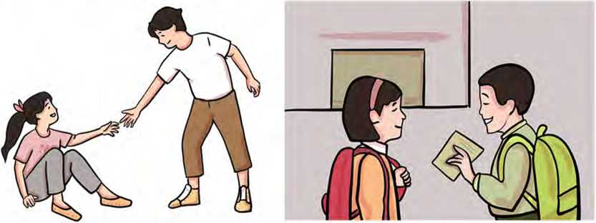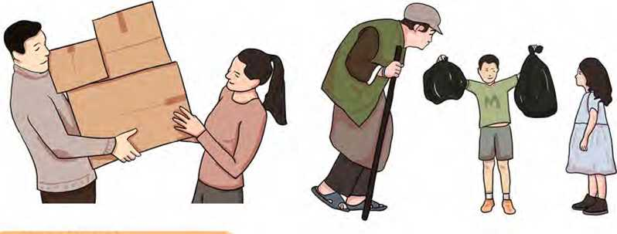

Reading I

**Study the picture and answer these questions.**

1. Who do you think the man in the picture is?
2. Does he look poor or rich? Why do you think so?

Naresh and the Stranger

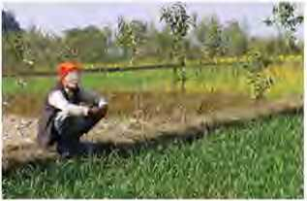Naresh was a simple, honest man. He lived in a little village with his family. He had a wife, three children, and his father and mother. He needed to work very hard to provide food for them. His wife had to look after the family. Therefore, she could not go out for work. The only income from Naresh was insufficient for the family. Sometimes, he would ask himself, "When will you be able to earn enough money to buy food? How will the children grow strong if they do not have nutritious food to eat?”

Poor Naresh went into his field and worked from morning till night every day. His only friend were his oxen, so he used to talk to them. “My friends,” he would say, “When would I earn enough money to provide nutritious food for my kids?”

Sometimes even the neighbours heard him talking to his oxen. They laughed at him, but they were sorry about his condition too.

One day, Naresh went to a river to fetch some water. He had just finished filling his pot when he saw a stranger walking towards him. The man looked tired and ill. Naresh was a kind man, so he went up to the man and said, “Do you need some help? You look tired and ill.”

The stranger replied, “Will you give me a drink and show me a place to rest?” Naresh gave him some water to drink. Then he said, “Will you come home with me? You can take a rest in my house and leave when you feel better.”

The stranger thanked him and walked slowly by his side. When they reached the house, Naresh's wife asked. “Who is this man? Has he come to stay here?”

Naresh took his wife to a corner and said, “This poor man looked ill, and he asked me if I would give him some water and show him a place to rest. When I saw that he was alone, I asked him if he would come with me. He has come, so I want yon to look after him.”

When she heard this, the wife started crying. She said that they did not have enough food for themselves.

"God will help ns if we help others,” said Naresh. “Give the guest some food.” The stranger stayed for three days. On the third day, he felt better, so he said to Naresh, “I am leaving now, but before I go, would you like to come with me to the river?”

Naresh told his wife that the stranger wanted him to go to the river with him. and left. He said that he would soon return to his work and went to the river with the stranger. The stranger took him to the river bank. There, he pointed at a big stone and said. “Lift the stone and dig the ground beneath it.”

Naresh did as the stranger had told and found a big pot. He lifted it up and passed it to the stranger. The stranger opened the pot and pulled out a bag. It was full of money.

"You are a good man,” he said, “And, I want to help you. You were kind to me when I was ill and alone. The money is for you and your family. Take it."

Naresh was very surprised. He said, “God is great and helps us all. I did not help you for money. You are very kind, but I cannot take this money.”

The stranger replied, “I shall be very happy if you take it. You have been a good friend and I want you to have it.”

Naresh took the money and thanked the stranger. “Where are you going? What will you take with you?” He further said, "Let me give you some food to eat."

The stranger smiled and thanked Naresh. “When God gives me friends like you, I need nothing. I shall reach home safely,” he said. Then he said goodbye to Naresh and left.

1. Find the words from the text and complete the following sentences.
2. Nilima found her lost purse a pile of leaves,

b means 'the quality of being kind'.

1. She is a/an and hard-working girl. She tries

to stand on her own.

1. There is a complete sitting at my desk. I have

never seen or met him before.

1. We need to eat food to help our body to

grow.

1. **These sentences are from the story above. Who said them to whom?**
2. Do you need some help?
3. Will you come home with me?
4. Would you like to come with me to the river?
5. The money is for you and your family. Take it.
6. I shall be very happy if you take it.
7. Let me give you some food to eat.
8. **Answer these questions.**
9. Why could Naresh's wife not earn any money?
10. What was Naresh worried about when he talked to his oxen?
11. Why did Naresh's wife cry when she knew the stranger would stay in their home?
12. Why do you think the stranger wanted to give money to Naresh?
13. Did the stranger take anything from Naresh when he left? Why?
14. What lesson did you learn from the story?
15. **Imagine you are Naresh. Tell the story to your friends in your own words.**

Pronunciation

Listen to your teacher and practise how these contractions are pronounced.

stranger's Naresh's I'm they'd she'll can't she's they've Neil's couldn't aren't mustn't

Speaking

**A. Match the offers in the left column to the appropriate responses in the right column. Practise saying them in pairs.**

|  |  |
| --- | --- |
| **Offers** | **Responses** |
| a. Can I help you? | i. Yes, please. I’m dying of coffee. |
| b. Shall I get you something to drink? | ii. No, thanks. I'll wash them myself. |
| c. Would you like some coffee? | iii. Yes. Can I have orange juice, please? |
| d. Would you like me to wash your clothes? | iv. Yes, please. There's no one to help me with them. |
| e. How about some juice? | v. No, nothing. Thank you. |
| f. Shall I help you with the chores? | vi. Yes, I hope so. I can't lift the luggage. |
| g. Is there anything else tha t you'd like me to do? | vii. Yes. That would be nice. I'm very thirsty. |

**B. Work in pairs. Make offers in the following situations and respond to them.**

1. Your friend is at your home. You want to give him a cup of tea.
2. It is raining outside. You want to offer your neighbour your umbrella.
3. Your friend is sweating. You want to open the window of the classroom.
4. Your father is carrying two heavy bags. You want to help with one bag.
5. You want to donate some money to an orphanage.

Grammar I

A. Match the active sentences counterparts in column B. Column A

1. Naresh gave him some water to drink.
2. The stranger thanked him.
3. The stranger took him to the river bank.
4. The stranger opened the pot.
5. Naresh took the money.
6. The neighbours heard him talking to his oxen.

**in column A with their passive**

**Column B**

1. He was taken to the riverbank by the stranger.
2. The money was taken by Naresh.
3. He was given some water to drink by Naresh.
4. He was heard talking to lais oxen by the neighbours.
5. The pot was opened by the stranger.
6. He was thanked by the stranger.
7. Study the following pairs of sentences with passive form of the verbs.
8. She plays the piano. The piano is played by her.
9. The radio is being repaired by my father. My father is repairing the radio.
10. My pen has been stolen. Someone has stolen my pen.
11. She made that table. That table was made by her.
12. Nitesh was painting the wall. The wall was being painted by Nitesh.
13. The oranges had been picked up for them. Somebody had picked up the oranges for them.
14. He will buy the guitar. The guitar will be bought by him.
15. John will have finished the project work. The project work will have been finished by John.
16. This task must be completed on time. He must complete this task on time.
17. **Change the following sentences into passive.**
18. The dentist pulled out my tooth.
19. The pohce are questioning him.
20. The waitress serves breakfast at 7 o'clock.
21. Students from our class collected the rubbish.
22. You should take these tablets before meals.
23. The teacher has sent him out of the classroom.
24. You must wash coloured clothes separately.
25. The mayor will inaugurate the new sports centre next month.
26. Somebody has stolen Nabina's bicycle recently.
27. People grow apples in Dolpa.

Writing I

**Here is an email written by an online marketing company to a regular customer. Read it carefully and write a reply to it. You can accept or deny the offer.**

To: [sameerdangol@gmail.com](mailto:sameerdangol@gmail.com)

Subject: About the New Offer

Dear Mr. Dangol,

Nepal Sunglass House has an important announcement that you get two pairs of sunglasses for the price of one. This is a seasonal offer for this week, only one for this summer. Place your order as soon as possible.

For more details, visit our website: [www.nplsunglasses.com](http://www.nplsunglasses.com)

With best regards,

Sukla Devkota

Managing Director

Nepal Sunglasses House

Tinkune, Kathmandu

Email: [nepal_sunglasseshouse@gmail.com](mailto:nepal_sunglasseshouse@gmail.com)

Listening

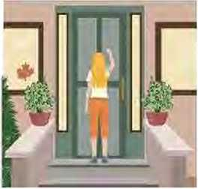**A. Look at the following picture and answer these questions.**

a. What is the girl doing?

1. Have you ever visited your friend’s house? Why?
2. 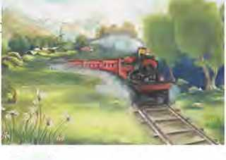Listen to the audio and answer these questions.
3. Who is the visitor?
4. How is her dress?
5. Why does Lora like to keep the bag with her?
6. Where does Lora sit?
7. Why does she not eat cake?
8. What are they planning to do?
9. **Recall an event you spent time with your best friend and write what you did together.**

Reading II

Answer these questions.

1. What is your favourite means of travelling? Why?
2. How do you try to make your journey more interesting?

From a Railway Carriage

Faster than fairies, faster than witches,

Bridges and houses, hedges and ditches;

And charging along like troops in a battle

All through the meadows the horses ar

All of the sights of the hill and the plai Fly as thick as driving rain;

And ever again, in the wink of an eye, Painted stations whistle by.

Here is a child who clambers and scrambles,

All by himself and gathering brambles;

Here is a tramp who stands and gazes; And here is the green for stringing the daisies!

Here is a cart runaway in the road Lumping along with man and load;

And here is a mill, and there is a river:

Each a glimpse and gone forever!

*- Robert Louis Stevenson*

1. **Consult a dictionary and find the meanings of the following words.**

a. hedge b. ditch c. troop d. wink

e. glimpse f. tramp g. lump h. bramble

1. **Complete the summary of the poem with the correct words/ phrases from the box.**

so quickly describes experiences a child faster crosses amazement speedy daisy flowers

glimpse battlefield

The poet presents his of travelling in a train. He

the sights that he notices while travelling in the train. The train moves than fairies and witches. It

runs like soldiers in the The train leaves

behind bridges, houses, fences, and the green fields.

The poet mentions that the train all the scenes as

quick as the drop of rain. In one scene the train passes rail­way stations that looks like a painted picture. The poet also

sees climbing a steep ground and collecting ber­

ries. Further, he sees a homeless person who looks at the  
train with As the train moves forward, he sees

some ladies in a village making garlands with

The poet then sees a cart moving slowly in the highway. It is full of load and the cart driver is sitting on the top of the load. He also gets a of a mill and a river by its side.

All these objects appear and disappear

1. Answer these questions.
2. What is the movement of the train compared with?
3. What does the speaker see in the meadows?
4. What is the child trying to do while climbing the hill?
5. Why do you think the poor man looks at the train with amazement?
6. What is the theme of the poem?
7. **Recite the poem in a group.**

Writing II

**Imagine one of your friends has invited you to attend his/her success party. Write a reply letter to him or her.**

Project work

**Observe people speaking in different situations. How do they make offers and accept/decline them? Collect as many expres­sions as you can and present them in the class.**

*bit*

Passive voice chart

|  |  |  |
| --- | --- | --- |
| **Tense** | **Examples** | **Structure** |
| Present simple | Bread is made from flour. | am/is/are + past participle |
| Present continuous | The road is being built. | is/am/are being + past participle |
| Present perfect | Apples have been grown in Mustang for a long time. | has/have been + past participle |
| Past simple | The goat was killed in an accident. | was/were + past participle |

|  |  |  |
| --- | --- | --- |
| Past continuous | The house was being painted. | was/were being + past participle |
| Past perfect | His house had been burnt down. | had been + past participle |
| Future simple | The work will be finished next month. | will/shall be + past participle |
| Future perfect | They will have been sent to the city. | will/shall have been + past participle |
| Modal verbs | The ceiling can be touched. | modal verbs + be + past participle |

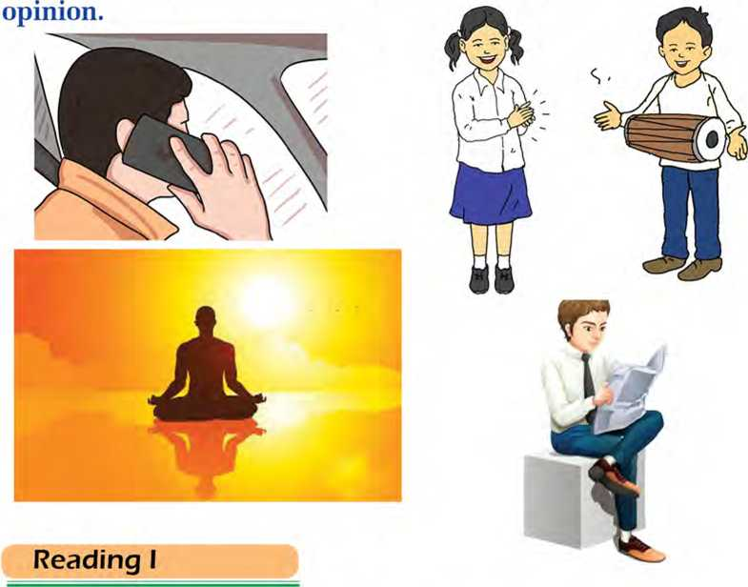What do you think is going to happen?

Getting started

Look at the pictures carefully and talk about them with your

**Look at the picture and answer these questions.**

a.

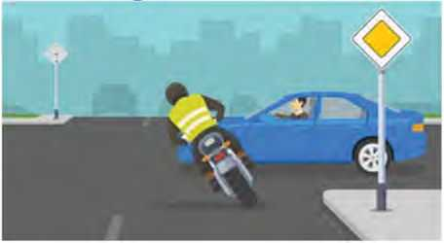What precautions should be taken on the road while driving? Share your opinions.

b.

Road accidents in Nepal:  
Are poor roads solely to blame?

Every day, as we scroll through the news feed or flip through the pages of a newspaper, we witness news of a road accident. After that, we curse a lot of people - those in power and those responsible for the poor construction of the road. But if we delve into the causes of road accidents, we will find it is not just the government or the department associated with road infrastructure.

Driver's negligence is a key factor contributing to the high number of deaths in road accidents. Driving is a personal thing, and the responsibility for maintaining safety is more on the drivers.

Safe *driving is a mixture of discipline. experience and maturity - traits young people lack. If the minimum age to acquire a driving license is extended from 16 to 20, it might help reduce the road* Occidents.

Motorbikes, among others, are the most popular form of vehicle in Nepal. In developing countries like Nepal, motorbikes outnumber cars. Among other reasons, what makes two- wheelers so popular is the cost. What is more, motorbikes can manoeuvre themselves through traffic congestion, which is another problem on Nepali roads. Mostly they are between the age of 18 and 40, and it is the age where one does not have much control over emotions and desires. Youths in Nepal are seen riding motorbikes at a very high speed.

Safe driving is a mixture of discipline, experience, and maturity - traits young people lack. If the minimum age to acquire a driving license is extended from 16 to 20 or even more, it might help to decrease the number of road accidents. The parents at home and the educational institutions should also play their roles by monitoring the youngsters. Schools and colleges can restrict students from riding until they turn 20. And parents should not be in a hurry to buy their kids a motorbike or any other vehicle. The youths should be given access to vehicles only after they attain a sense of maturity.

At night, we often come across drivers who drink and drive. Since driving requires great concentration, a slight mistake can cause severe injury or even death. The drivers themselves must be conscious of their drinking habits. They should not drink before driving. That is something a responsible driver can do.

And from the perspective of the law, a person who drinks and drives must be punished and made aware so that s/he does not repeat it. Strict checking should be held at the checkpoints in the city areas, and enough traffic officers should be deployed to get hold of the culprits.

Poor road infrastructure is something that should not be overlooked while discussing the deaths caused byroad accidents. The narrow lanes with countless potholes are responsible for the increasing number of road accidents. There are roads where two vehicles cannot even pass through. During the monsoon, especially in hilly areas, roads are blocked for days due to landslides. The passengers face such ordeal that they opt to stay home than travel. Such is the condition of road infrastructure in Nepal.

Poor road conditions result in a number of accidents. To develop better road infrastructure, the different government agencies; Department of Roads and Department of Transport Management should coordinate between themselves. That way, we will witness less number of road accidents.

*(Adapted from an article by Sugam Gautam published in The Himalayan Times)*

1. Complete the sentences with the correct words given below.

perspective witnessed congestion infrastructure ordeal coordination

1. A car hit a boy. People the accident.
2. The earthquake destroyed the of the building.
3. Excessive number of motorbikes and violation of

traffic rules cause traffic

1. As we judge others from our , we fail to understand

their problems.

1. Good among the staff flourishes a healthy

relationship.

1. Anusha looks sad as she faced a/an
2. **Answer these questions.**
3. According to the writer, who do we curse for road accidents?
4. Why are motorbikes popular in Nepal?
5. Why should parents and educational institutions monitor the youngsters?
6. What measures should be taken to stop drink-driving?
7. What is the main cause of road accidents in your opinion?
8. **What measures can be taken to maximise the road safety in Nepal? Discuss.**

Pronunciation

Listen to your teacher. Practise pronouncing these words.

congestion infrastructure witness pedestrian

manoeuvre jaywalking mishap motorways

transport safeguarding

Speaking

1. **Act out the following conversation in pairs.**

**Conversation I**

Manoj: What do you think about working until midnight?

Sundar: In my opinion, working until midnight is very bad for health.

Manjila: I think working until midnight helps one meet deadlines.

Pratik: I don't think so. Some people are unlikely to utilise their time properly.

**Conversation II**

Seema: Don't you think social media is making us less social?

Anil: That's a good point. People hardly talk to each

other face to face because of the social media.

Anita: I agree with you to some extent. But, it helps us get updated.

Vim: I don't quite agree with you. Without social media,

we'd have been unable to keep in touch with people.

1. **How do you feel about the following statements? Give your opinion.**
2. Celebrities earn too much money.
3. All children should be able to access school.
4. We should not eat too much fast food.
5. Watching television is necessary for schoolchildren.
6. The internet is a good source of learning.

Grammar I

1. Study the following sentences. Notice how subject and verb agree with each other.
2. Games and sports are part and parcel of our regular life.
3. There is lots of research.
4. Participating in sports reduces our stress and makes our mood better.
5. Some of our food habits are also risking our lives.
6. Choose the correct words from the brackets to complete the sentences.
7. My uncle and aunt to my house every Friday,

(come/comes)

1. There time to watch the movie, (is/are)
2. My friends who are in the band me to play a

musical instrument, (wants/want)

1. Everyone time to relax, (needs/need)
2. Your trousers new. (looks/look)
3. Some of the books on the shelf missing, (is/are)
4. One of my friends living in that house, (was/were)
5. One hundred rupees not enough for me. (is/are)
6. Five kilometres a long distance to travel, (is/are)
7. You or he responsible for that job. (is/are)
8. Linguistics her favourite subject, (is/are)

Writing I

Do you think extracurricular activities are important for students? Write an essay giving your opinions. Divide the essay into the following parts.

1. **Introduction:** definition and examples of extracurricular activities
2. **Body:** importance and challenges of extracurricular activities
3. **Conclusion:** summing up ideas

Listening

A. Look the picture and answer these questions.

1. What countries do these flags belong to?
2. What are these countries famous for?

B. Listen to the audio and fill in the gaps with correct words. Use one word only.

1. Sweden was voted the best place in the world for being safe and
2. Canada is also considered the best place to live because

it has got lots of and nature.

1. It is okay to live in Canada but it is really there.
2. The time is the perfect time to live in Canada.
3. Hotels and restaurants in Canada were not very
4. Canadians are really and outgoing as well.
5. One of the speakers wants to to Canada.
6. **If you were asked to choose between Sweden and Canada, which country would you choose to visit? Why? Talk to your friends.**

Reading II

Look at the picture and answer these questions.

1. How would you feel if you were there in the picture?
2. What do you think; life is short or long?

Long Life

Life is too short to be spent

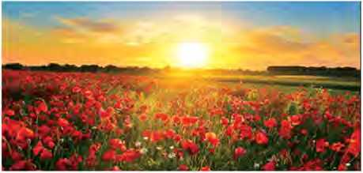griping about the past, things you don't have, places you haven't seen, things you haven't done.

Life is too short to be spent holding grievances against another, finding fault in your brother, counting the wrongs done on you.

Life is just long enough to enjoy the beauty of a sunrise, the smell of wet earth, and the sound of laughter, after a long day's work.

Life is just long enough to practice compassion and generosity, to comfort the grieving, to lend strength to the fainthearted, and direction to the lost.

*- Tricia Mae Chua*

**A. Match the words in column A with their meanings in column B.**

|  |  |
| --- | --- |
| **Column A** | **Column B** |
| a. griping | i. sympathy and concern for others' feelings |
| b. grievances | ii. feel intense sorrow |
| c. fault | iii. complaints |
| d. compassion | iv. kindness with giving time, help, money, etc. |
| e. generosity | v. lacking courage |
| f. fainthearted | 1. moaning about something 2. error, defect, flaw |

1. Complete the summary of the poem with the suitable words given below.

past compassion faults waste beauty enjoy

Life could be both short and long depending on how you perceive it. It is too short to our time in taking

worries about the finding others’ and

wrong doings. But it is long enough to nature-

made and have and kindness to the

needy.

1. **Answer these questions.**
2. How do people make their lives short?
3. What can we do with our life if it is long enough?
4. Who does the word ‘you’ refer to?
5. How would you like to live your life?
6. **Do you agree with the poet's views about life? Give your opinion.**

Grammar II

1. **Study the following pairs of sentences. Do they have similar or different meanings?**
2. i. Life is too short to spend on luxuries.

ii. Life is not long enough to spend on luxuries.

1. i. Kanchan’s sister is too young to get married.

ii. Kanchan’s sister is not old enough to get married.

1. i. It’s not late enough to go to school.

ii. It's too early to go to school.

1. i. The box is heavy enough for them to lift.

ii. The box is too light for them to lift.

1. i. The dress is loose enough to wear.

ii. The dress is not too tight to wear.

1. Choose the correct words from the brackets to complete

|  |  |  |
| --- | --- | --- |
| **these sentences.** | | |
| a. | Akash was  strength) | enough to lift the suitcase, (strong/ |
| b. | They aren’t too | to deal with, (sociable/sociably) |
| c. | My friend is | ... enough to help me with maths. |
|  | (intelligent/intelligence) | |
| d. | Seema is  (smartness/smart) | enough to solve the problems. |
| e. | The baby is too | to sit.(weakness/weak) |
| f. | I'm worried. It’s too | to buy. (expensive/expense) |

C. Rewrite the following sentences so that they have similar meanings. Use the words given in the brackets. One example is given.

*Example: The tea is too hot to drink, (cold enough)*

*The tea is not cold enough to drink.*

1. I can’t reach there on time. It's too far. (near enough)
2. Samata can't wear a saree. She is too yonng to wear it.

(old enough)

1. My bag is light enough to carry, (too heavy)
2. Sangam is too young to drive a motorbike, (old enough)
3. Priya isn't tall enough to reach the ceiling, (too short)

Writing II

1. **Punctuate the following paragraph correctly.**

How do you spend your holiday I usually do a lot of activi­ties clean rooms do shopping visit new places watch mov­ies etc Yesterday I cleaned my room My best friend’s par­ents like the quality of my cleaning Last year they visited our house and saw my cleaning He said Wow I love the way you decorate your room While I was cleaning I dropped an ink bottle It broke into pieces It was really tough to clean the floor as the floor turned red because of the smashed bottle I wiped a painting which was gifted to me by my uncle on my birthday We celebrated it on January 22 2023 the day was a memorable one

1. **Some people prefer to have food from restaurants while others prefer homemade food. What is your preference? Write an essay giving your opinion.**

Project work

**Work in groups. Make a survey of the opinion of your friends on the following topics. Then, present it to the class.**

Survey form

|  |  |  |  |  |  |
| --- | --- | --- | --- | --- | --- |
| **Topics** | **Friend**  **1** | **Friend**  **2** | **Friend**  **3** | **Friend**  **4** | **Friend**  **5** |
| a. What is the best way to learn English? |  |  |  |  |  |
| b. What is your favourite subject? |  |  |  |  |  |
| c. What clothes do you like the best? |  |  |  |  |  |
| d. What is the easiest way to make friends? |  |  |  |  |  |

*bit*

Pronouns in English

|  |  |  |  |  |  |
| --- | --- | --- | --- | --- | --- |
|  | **Subject** | **Object** | **Possessive pronouns** | **Possessive determiners** | **Reflexives** |
| 1st person | I/we | me/us | mine/ours | my/our | myself/ ourselves |
| 2nd person | you | us | yours | your | yourself/ yourselves |
| 3rd person | he/she/ it/they | him/ her/ it/ them | his/hers/ its/their | his/her/ its/ theirs | himself/her- self/ itself/ themselves |



Getting started

Look at the pictures and report what these people are saying.

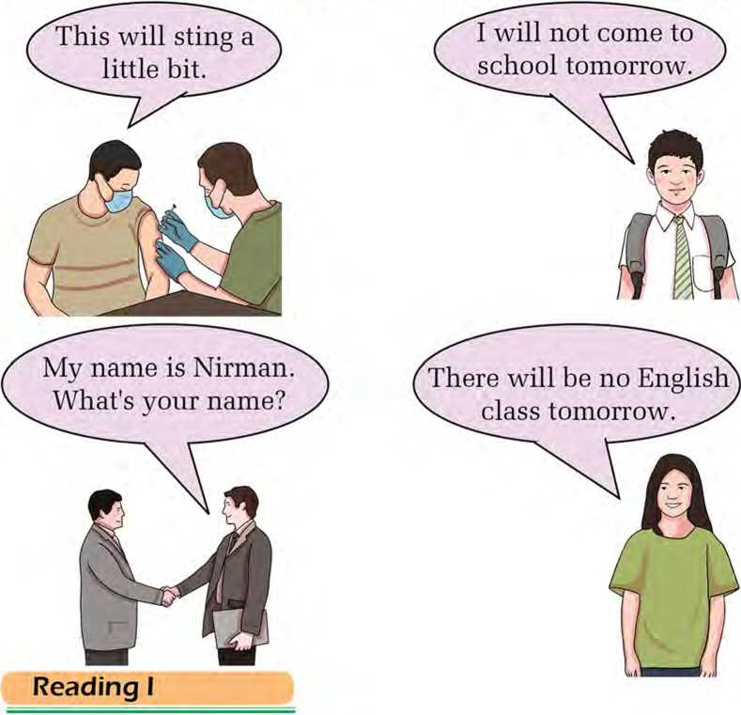

Answer these questions.

1. Where do birds make their nests?
2. Do you think our surroundings play a role in shaping who we are?

A Tale of Two Birds

Once upon a time, there lived a bird and her two newly hatched nestlings in a forest. They had a nest in a tall, shady tree where the mother bird took care of her little ones day and night.

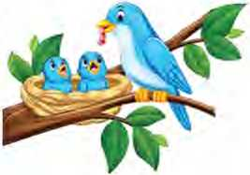One day, there was a big storm. There was thunder, lightning, and rain. The wind blew down many trees. The tall tree in which the birds lived also fell down. A big heavy branch hit the nest and killed the mother bird. Fortunately, the nestlings were not killed but the strong wind blew them away to the other side of the forest. One of them came down near a cave where a gang of robbers lived. The other landed outside a hermitage where an old cultured hermit resided. Both places were close to each other.

Days passed and the nestlings became big birds. One day, the king of the country came to the forest for hunting. He saw a deer and rode after it. It ran deep into the forest followed by the king. Soon, the king lost his way. He could not come out of the forest because he did not know where he was.

He rode on for a long time till he came to the other side of the forest. Very tired, he got off his horse and sat down under a tree that stood near a cave. Suddenly, he heard a voice cry out, "Quick! Hurry up! There’s someone under the tree. Come and take his jewels and his horse. Hurry up or else he'll slip away." The king was amazed. He looked up and saw a big, brown bird on the tree under which he was sitting. The wicked bird said to the king, "Where are you going?" He also heard faint noises issuing from the cave. He quickly got onto his horse and rode away as fast as he could. One of the robbers saw the king and said, “Stop where you are or I will kill you with my sword”. The king was brave. He stopped and picked up his bow, took an arrow, and targeted the robber. The king said, “Come and

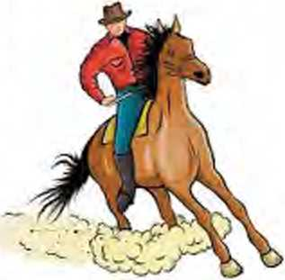fight with me.” Then the robber went into the forest to call his gang. Since the robbers were more in number, the king decided not to mess with them. He rode swiftly away.

Soon, the king reached a safe place. It was a tranquil place. The surroundings were beautiful. There was a hermitage. The king tied his horse to a tree and sat down in its shade. Suddenly, he cave,” he said to himself aloud.

heard a gentle voice announce, “Welcome to the hermitage, Sir. Please go inside and rest. The hermit will be back soon. There’s some cold water in the pot. Please make yourself comfortable." The king looked up and saw a big, brown bird in the tree. He

was amazed. “This one looks like the other bird outside the

"You are right, Sir", said the kind bird. “He is my brother but he has made friends with robbers. He now talks as they do. He doesn’t talk to me anymore." Just then the hermit entered the hermitage.

"Welcome, Sir", the hermit said to the king. "Please come inside and make yourself comfortable. You look tired. Rest for a while. Then you can share my food."

The king told the hermit the story of the two birds and how each had behaved differently though they looked so alike. “The forest is full of surprises," he said.

The holy man smiled and said to the king, “After all, one is known by the company one keeps. That bird has always heard the talk of robbers. He imitates them and talks about robbing people. This one has repeated what he has always heard. He welcomes people to the hermitage. Now, come inside and rest. I will tell you more about this place and these birds."

A. Find the words from the text that have the following

|  |  |  |
| --- | --- | --- |
| **meanings.** | | |
| a | i. | young birds that have not yet learned to fly |
| b | ii. | evil or morally wrong |
| c | iii. | peaceful |
| d | iv. | the dwelling of a hermit |
| e | V. | a person living in solitude as a religious disciple |
| f | vi. | someone who steals money or property |
| t> | vii. | copy the way a person speaks or behaves |

1. Put the following events of the story in the correct order.
2. The tall tree in which the birds had their nest fell down.
3. The mother bird was killed; however, the nestlings survived.
4. A bird and its two nestlings lived in a forest.
5. The other nestling lived near a hermitage.
6. The bird welcomed the king and requested him to be comfortable at the hermitage.
7. The hermit told the king that one was known by the company one kept.
8. The robbers were informed by a brown bird about the arrival of the king.
9. **Read the story again and answer the following questions.**
10. What caused the tall tree to fall down?
11. Where were the nestlings blown to?
12. 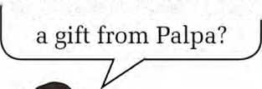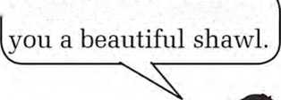Was the king able to catch the deer? How do you know?
13. Why do you think the brown bird informed the robbers about the arrival of the king?
14. Why did the king not fight with the robber's gang?
15. **One is known by the company one keeps. Do you agree with the statement? Discuss.**

Pronunciation

**Pronounce the following words with help of a dictionary,** storm splash nestling hermit cruel

trustworthy surrounding struggle treasure crayons

Speaking

**A. Read what the people in the pictures are saying. Act out in a group of three.**

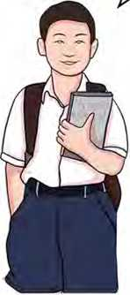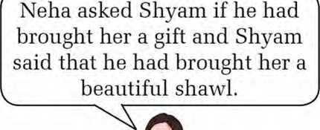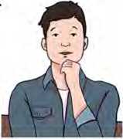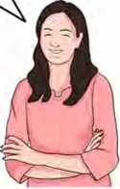'Have you brought me> < Yes, I have brought

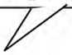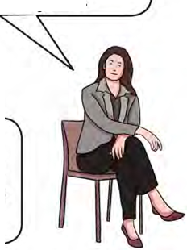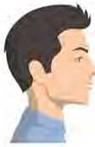Dan asked Sarah when she  
would go to Nepal and Sarah  
told him that she wonld go to  
Nepal the following year.

When will yon go to  
Nepal?

I will go to Nepal next year.

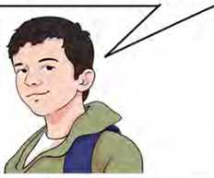**B. Work in a group of three. Act out the following conversa tions like you did in task A above. Student C will report what students A and B said earlier. Then, switch your role, so everyone does the role of 'C'.**

1. A: Why did you come here?

B: I came here to meet my relatives.

C:

1. A: Do you like ice-cream?

B: Yes, I am fond of ice-cream.

C:

1. A: Can you give me your pen for a while?

B: It’s okay. You can take it.

C:

1. A: Why are you sad today?

B: My brother is sick.

C:

1. A: We have planned a picnic next week.

B: I will join.

C:

**Grammar I**

**A. Match the sentences in the left column with their indirect**

**speech in the right column.**

|  |  |
| --- | --- |
| **Direct speech** | **Indirect speech** |
| a. The teacher said to the boys, "Have you done your homework?" | i. My mother told me to go and change my dress. |
| b. The little girl said to the man, "Will you help me?" | ii. Rita said that she had read that book before she had given it to me. |
| c. Ridish said, "I have been reading this book." | iii. Alish said that he would bring his guitar. |
| d. My mother said to me, "Go and change your dress." | iv. The teacher asked the boys if they had done their homework. |
| e. Rita said, "I had read this book before I gave it to you." | v. Rabina asked Shambhu where his watch was. |
| f. Alish said, "I will bring my guitar." | vi. Ridish said that he had been reading that book. |
| g. The boss told the clerk, "Bring me that file." | vii. Sophia inquired me what I wanted. |

|  |  |
| --- | --- |
| **Direct speech** | **Indirect speech** |
| h. Prima asked, "Have you read that book?" | viii. The little girl asked the man to help her. |
| i. Rabina said to Shambhu, "Where is your watch?" | ix. Prima asked if I had read that book. |
| j. Sophia said, "What do you want?" | x. The boss ordered the clerk to bring her that file. |

B. Change the following sentences into indirect speech. Use the reporting clauses given.

1. I'm coming now.

She told me

1. Please, help me get to the hospital.

He requested

1. Can you give me your phone number?

She asked me

1. Reshma does not work.

He said

1. Where is he?

She asked me

1. Come here at once.

She commanded me

1. What are you doing?

She asked me

1. Do you work in a factory?

She asked him

1. Why did you go out last night?

She asked me

1. Water boils at 100 degree Celsius.

She told me

Writing I

**Write a story beginning with 'Two friends were walking along**

**the forest '**

Reading II

Look at the picture and the title of the news report and answer these questions.

a. What do you think the place is?

b. Have you ever visited any airport?

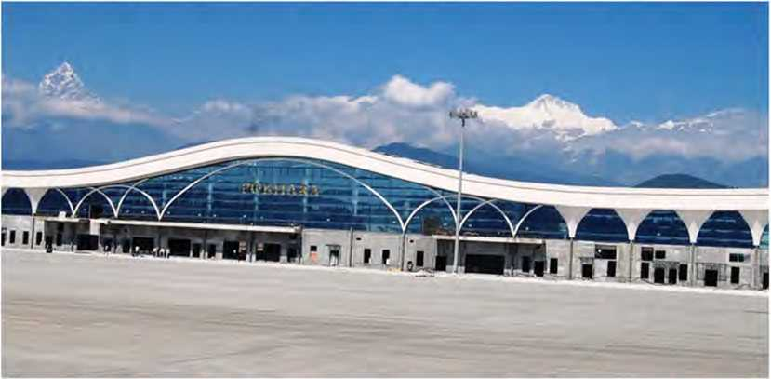

Pokhara international airport inaugurated

*By Himalayan News Service*

*Published: 08:00 am Jan 02, 2023*

POKHARA, JANUARY 1

Newly-built Pokhara Regional International Airport - the third international airport in the country - was inaugurated by Prime Minister Pushpa Kamal Dahal at a special ceremony held here today.

On the occasion, Dahal unveiled a plaque marking the official inauguration of the airport after arriving in Pokhara along with Deputy Prime Minister and Minister for Finance, Bishnu Paudel. Extending his gratitude to everyone who played a role in conceptualising and completing the project, Dahal said the long-awaited moment by the people of Pokhara had finally come. Stating that connectivity is an integral part of bringing positive development in the region, he said, "The newly-built airport will contribute to the economic development of not just Pokhara, but the whole country as well."

Paudel also commended locals of Pokhara for their sacrifices and patience for the completion of the project.

"With the completion of a new international airport in the region, the question remains on how we can make the most effective use of the airport. I urge the authorities to complete all the necessary processes responsibly to conduct international travel from the airport. There is also a need to link Pokhara with other areas of the country to increase tourism activities within the country and we are working towards proper upgradation and maintenance of roadways to ease connectivity among them. The government will focus on developing necessary physical infrastructure across the country to reach the targeted milestones in other sectors as well," he said. Regional Director of the Asia and Pacific Office of the International Civil Aviation Organisation Tao Ma expressed his gratitude and appreciation to the government of Nepal for inviting him to the inauguration ceremony of PRIA.

Stating that the development of airport infrastructure and air services are vital for ensuring connectivity, socio-economic development, and disaster relief efforts in landlocked countries, he congratulated the Government of Nepal on the completion of the national pride project.

"We are glad that CAAN has certified PRIA in line with ICAO standardsandguidance.AswetransitionawayfromtheCOVID-19 pandemic of 2020, the opening of PRIA, together with the Gautam Buddha International Airport, will assist in harnessing the expected increase in air traffic and ease congestion both in air space and on the ground across the country's major airports. ICAO is grateful to the Nepali government and CAAN for their long-standing commitment, consistency, and comprehensive support to the organisation's works," he said.

Buddha Air, Shree Airlines, Yeti Airlines, and Guna Air have started conducting daily flights to and from the newly-built international airport.

Meanwhile, Himalaya Airlines performed a successful demonstration flight at PRIA today, becoming the first airline to land Airbus A320-214 in Pokhara.

*(Source: thehimalayantimes.com)*

1. The meanings of some of the highlighted words are given below. Find the words and write them down.
2. praised formally or officially
3. extremely crowded and blocked with traffic or people
4. made a formal beginning of; initiated
5. the process or a period of changing from one state or condition to another
6. a formal religious or public occasion
7. the act of keeping something in good condition
8. **Answer these questions.**
9. Who inaugurated the newly built Pokhara Regional International Airport and when?
10. How is the airport useful according to the Prime Minister?
11. What was the first airline to land on the newly built airport?
12. Why were the locals commended by the Deputy Prime Minister?
13. Why is ICAO grateful to the Government of Nepal and CAAN?
14. How are airport infrastructure and air services vital according to Mr. Tao Ma?
15. **Why do you think the operation of an international airport is helpful in the economic development of a country? Discuss.**

Writing II

**Write a news report using the following clues.**

**Hospital inaugurated in Doti**

A hospital inaugurated among a big mass by Minister

of Health built from the financial support of the

Government of Nepal work started in 2019

ended in 2021 has the capacity of 60 beds

people look happy and hopeful about the future

Grammar II

A. Choose the correct alternative for each of the following sentences.

1. The teacher said to us, “What do you want?”
2. The teacher asked us what we want.
3. The teacher asked us what we wanted.
4. The teacher asked us what did we want.
5. She said to me, “Will you please help me?”
6. She asked me please help her.
7. She asked me to help me.
8. She asked me to help her.
9. He said to me, “Don't sit on my bed.”
10. He told me to sit on his bed.
11. He told me not to sit on my bed.
12. He told me not to sit on his bed.
13. My sister said to him. “The Earth moves round the Sun.”
14. My sister told him that the Earth moved round the Sim.
15. My sister told him that the Earth is moving round the Sun.
16. My sister told him that the Earth moves round the Sim.
17. She said to me, “I don't believe you.”
18. She told me that she didn't believe me.
19. She told me that she doesn’t believe me.
20. She told me that she don’t believe her.
21. She said, "Can you run?”
22. She asked if I can run.
23. She asked that if I could run.
24. She asked if I could run.
25. They said, “They have seen a lion.”
26. They said that they had seen a lion.
27. They said that they have seen a lion.
28. They said that they saw a lion.
29. She said, “I am waiting for Sarita.”
30. She said that she is waiting for Sarita.
31. She said that she has been waiting for Sarita.
32. She said that she was waiting for Sarita.
33. Nancy said, "I may leave tomorrow.”
34. Nancy said that she might leave the next day.
35. Nancy said that she might leave tomorrow.
36. Nancy asked if she shonld leave the next day.
37. Manisha said to me, “When did yon come to Nepal?”
38. Manisha questioned me when did yon come to Nepal.
39. Manisha questioned me when I came to Nepal.
40. Manisha questioned me when I had come to Nepal.

**B. Change the following sentences into indirect speech.**

1. He said, "I'll send a post card."
2. "We’ve bought a new car," they said to me.
3. Aruna said, "I don’t speak German."
4. Hem says, "Don't play on the grass, boys."
5. My mum said, "Are you feeling well?"
6. Nishan said, "Where did you meet him last week?"
7. Doctor said to my father, "You must stay in bed."
8. The boy said, "Let me go."
9. Arpan said, "How often do you play cricket?"

Listening

**A. Look at the picture and answer these questions.**

1. 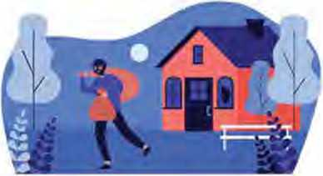Who do you think the man is?
2. Do you think that the man is doing bad?
3. Listen to the audio and fill in the blanks.
4. The two stopped very different crimes.
5. The first story took place in
6. Ralph Black was years old.
7. He found a in the living room.
8. Listen to the audio again and answer these questions.
9. Was Ralph scared when he saw the robber?
10. Where was the robber standing?
11. How did Ralph help arrest the robber?
12. Did the family get their property back?
13. What did the robber receive?
14. Do you think that robbery is a bad deed? Discuss with your friends.

Project work

Work in groups. Design the front page of a newspaper. For this, you can take help from your teacher, or visit a library, or surf the internet.

Adverbs or adverbial phrases denoting ‘near’ in direct speech turn into those denoting ‘distant’ in indirect speech as follows.

|  |  |
| --- | --- |
| **Direct speech** | **Indirect speech** |
| today | that day |
| yesterday | the day before/the previous day |
| the day before yesterday | two days before |
| tomorrow | the next day/the following day |
| the day after tomorrow | in two days’ time |
| next week/next month | the following week/month |
| last week/month | the previous week/month |
| a year ago | a year before/the previous year |
| now | then |
| here | there |
| this | that |
| these | those |