ENGLISH

Grade 7
Government of Nepal
Ministry of Education, Science and Technology
Curriculum Development Centre

Publisher: Government of Nepal
Ministry of Education, Science and Technology
Curriculum Development Centre

Sanothimi, Bhaktapur

© Curriculum Development Centre
All rights reserved, no part of this publication may be reproduced, transmitted in any other form or by any means without the written permission of the publisher. However, this does not prohibit making photocopies of its pages for teacher training or other non-profit making purposes.
First Edition: 2022

Printed at: Janak Education Materials Centre Ltd.
Sanothimi h , Bhaktapur

Price Rs:

Send your comments and suggestions to:
Curriculum Development Centre
Phone: 01-6630-588, Fax: 01-6630-797
Email: info@moecdc.gov.np
Website: moecdc.gov.np

Preface
The curriculum is the central guide of education and details what is essential for teaching and learning. A textbook is a main tool to deliver the curriculum. The revision of the curriculum and textbook is a regular process so as to make it relevant, practical, qualitative and useful for the overall development of an individual. This 'English Grade 7' textbook is developed to address the main aims of Basic Education; developing the fundamental skills of basic literacy and life skills in addition to arousing interest in arts and aesthetic values. It aligns with the intent pursued by the National Curriculum Framework for School Education, 2076 and is developed fully in accordance with the new Basic Level English Curriculum, 2077. All components of each lesson in the textbook are equally important and they have the specific aim of presentation so as to fulfill the learning outcomes stated in the curriculum.

This textbook, initially prepared by a team that includes Mr. Shankar Adhikari, Mr. Matrika Subedi, Ms. Shikha Gurung and Mr. Narad Rijal, has been revised by a team comprising of Ms. Ramita Prajapati, Mr. Devraj Karki, Dr. Neil David Rose, Mr. Nim Prakash Singh Rather and Mr. Nabin Khadka. Several people notably; the Director General, Mr. Ana Prasad Neupane, the subject committee chairperson, Prof. Dr. Jib Lal Sapkota and the subject committee members; Prof. Dr. Rishi Ram Rijal, Dr. Gopal Prasad Pandey, Mr. Madhav Prasad Ghimire, Ms. Maiya Niraula Pokharel and Mr. Tuka Raj Adhikari have contributed significantly on the development of this book. The contribution made by other experts and the school teachers; Dr. Tika Ram Bhatta, Ms. Mallika Joshi, Ms. Anita Paudel, Ms. Sumita Lama, Ms. Yashoda Khadka, Ms. Bhawana Limbu, Mr. Parshu Ram Tiwari, Ms. Chandramaya Adhikari and Mr. Birat Chaulagain is also appreciated. The illustrations in the book are designed by Ms. Shaili Malla and Kushal Adhikari; and the layout by Mr. Shreehari Shrestha and Mr. Khados Sunuwar. The Curriculum Development Centre extends sincere gratitude to all of them. With the view that the learning of English should be based on authentic materials, we have retrieved and adapted the texts and tasks including the audios from various authentic sources. Therefore, the Centre would like to extend its acknowledgements to all of them.
This textbook may be used to deliver the foundation for the content of the curriculum, the balance of skills to be taught and the types of language practice the students are to take part in. However, teachers can adapt the contents and tasks as per the need and context of their individual students. This textbook can be used as the primary resource for classroom teaching but teachers are encouraged to make use of their own resources to supplement the language learning of their students.
The Curriculum Development Centre always welcomes constructive feedback for the betterment of its publications.
2022

Curriculum Development Centre
Sanothimi , Bhaktapur

Table of Contents
Unit | Reading | Speaking | Listening | Grammar | Writing | Project work | Extra bit | Page
1 | Job interview  Announcement | Introducing others | Conversation | a/an/the  'Be' verb | A dialogue Check in form | Preparing notice | Dictionary entry | 1
2 | Story  Poem | Permission | Conversation | Countable/ uncountable a/an/some | E-mail  Personal letter | Request letter | Homophones | 10
3 | Story  Letter to the  Editor | Requests | Pieces of conversation | Will, would, can, could | Letter to the  editor | A list of requests | Reading a dialogue | 22
4 | Festivals of  Nepal  Email | Wishes | Description | I wish ..  Simple past | Description of a festival Paragraph | Greeting cards | Reading a story | 35
5 | Story  Food Habits | Suggestions | Pieces of conversation | Should  II conditional | Message  Paragraph | A list of suggestions | Reading a  poem | 46
6 | Holiday plan  Poem | Wants and needs | Explanation | Present simple  I conditional | Essay  Story | Needs and  wants | Reading a story | 56
7 | News article  Speech | Opinions and feelings | Explanation | To infinitive  Present continuous | Punctuation  Paragraph | Speech competition | Punctuation marks | 66
8 | Story  Autobiography | Past | Conversation | Connectives  Used to | Paragraph  Skeleton story | Past habit | Skeleton story | 77

9 | Charts  Poem | Comparison and contrast | Opinion | Comparative and superlative | Interpreting chart Comparative paragraph | Bar chart | Writing comparative sentences | 88
10 | Leaflet  Rules and regulations | Obligations and prohibitions | Explanation | Can, could, be allowed to, must, have to | Leaflet  School rules | Rules and regulations | Reading a story | 97
11 | Biography Description of a place | Describing | Description | Relative clause  Wh questions | Biography Description of a place | Poster about a famous person | Adjectives and adverbs | 107
12 | Description  Poem | Appearances | Conversation | Look/look like Present simple | Paragraph | Pictures | Reading a story | 118
13 | Story  Poem | Ability and  reasons | Conversation | Because, because of | Story  Reordering Paragraph | Chart | Reading a sports news | 128
14 | Description of  Mt. K2  Prospectus | Quantity | Description | Concord  Wh questions | Description Prospectus | Collecting prospectuses | Some, any, many, several, (a) few, a little, much, a bit of | 142

15 | Climate change Poem | Probability | Weather report | Simple future  Future perfect  May, might, must | Paragraph | A list of causes of change | May, might, could, will, should, must, can, can't | 154
16 | Story  Narration of a  party | Narrating past events | Narration | Past simple  Past continuous  Past perfect | Story  Narration | Picture story | Reordering pictures | 166
17 | Story  Conversation | Surprise and dismay | Narration | Past simple  Past continuous  Past perfect | Punctuation  Dialogue | Watching a movie | Expressions for surprise | 179
18 | Menu  Market place | Confirmation | Conversation | Question tag | Menu  E-mail | Collection of  menus | Question tags | 189
19 | Description of elephants Operating instructions | Facts and truths | Monologue | Reporting statements Zero conditional | Short  messages  Instructions | Pictures | Facts about human body | 199
Glossary |  |  |  |  |  |  |  | 212

Unit 1

Getting started

Look at the pictures below and talk about them.
- Are they Nepali?
- Which communities do you think they belong to?
- What are they doing?
- How do the people of your community greet each other?

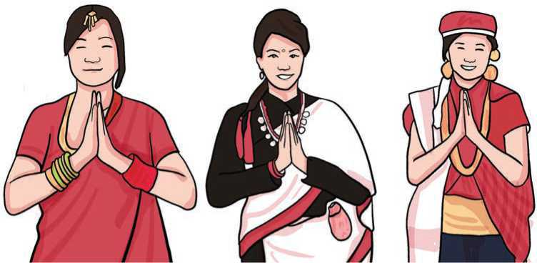

Figure 1 nepali cultural dresses

B.Listen and sing.
I've got a friend whose name is Sam.
He goes with me wherever I am.
If you need fast, Sam can fly a plane.
If you need water, Sam can make it rain.
If you need some sugar, Sam gets sugarcane.
Everybody knows Sam's name.
Introduce Sam to your friends.

Reading I
Look at the picture below and answer the questions.
- Who do you think these people are?
- What do you think they are doing?
- Who do you think the interviewee is? Why?

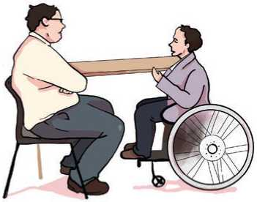
A Job Interview
Mike : Good morning, John. I am Mike.
John : Good morning.
Mike : How are you doing?
John : I am doing fine. Thank you.
Mike : How was the traffic coming over
here?
John : I am so glad that the traffic was
light this morning. No traffic jam and no accidents.
Mike : That is good. John, let’s start the interview. Are you ready?
Figure 2 interview
John : Yes, I am.
Mik First of all, let me introduce myself. I am the Finance Department Manager. As you know, there is an open position in my department, and I need to fill it as soon as possible.
John : What kind of experience are you looking for?
Mike : Doing office work is good.
John : That is great!
Mike : John, tell me a little bit about yourself.
Joh I am studying at a college. I have been working part-time as a clerk for the last two years.
Mike : Good! I think, you'll work well here.
John : I will try my best sir.
Mike : John, nice meeting you. Thank you for coming.
John : Nice meeting you too. Thank you for seeing me.
(Adapted from: Conversations for all occasions)
- Match the words in column 'A' with their meanings in column 'B'.
Column A | Column B
a. traffic | i. post
b. interview | ii. a section of a large organisation
c. position | iii. a formal meeting in which somebody is asked questions
d. department | iv. for part of the day or week
e. part-time | v. the vehicles that are on a road

- Write True or False for the following statements.
- John and Mike are talking in the afternoon.
- The traffic was lighter in the morning.
- Mike works as the manager.
- John is still studying at a college.
- John is doing a part-time job.

Pronunciation
What sounds do these words start with? Put them in the correct column.
than, thank, first, phone, closely, payroll, theory, check, ply, chat, there, quick.
/p/ | /f/ | /θ/ | /ð/ | /k/ | /tʃ/

Speaking
- Act out the conversation in which Jim is introducing Carol to Peter.
Jim : Carol, let me introduce you to Peter Brien.
Peter, this is Ms. Carol Smith.
She is from Argentina.
Carol : Pleasure to meet you.
Peter : Good to meet you too.
Jim : Peter works for our New York branch.
Has Carol met Peter before? How do you know? Talk to each other in pairs.
- Now practise this dialogue using the prompts below in groups of three. Use your real names.
A: Good afternoon!
B: Good afternoon! My name is
A: Hello! My name is
B: Have we met before?
A: No, we haven’t. Pleased to meet you!
B: Pleased to meet you too. Have you met ?
A: I’m not sure.
C: Yes, we have met before. Good to see you again!
A: Oh yes, I remember now. Good to see you again too!
- Learn these expressions below showing how to introduce others.
Hello! Meet my friend Reena.
She is from Kathmandu.
Reena, This is Nitesh Karki.
She is an English teacher. She is good at teaching pronunciation.

Grammar
- The sentences below are from the Reading. I Read the text again and complete the sentences with missing words.
- I am Finance Department Manager.
- There is open position in my department.
- Please, tell me little bit about the position.
- I am studying at college.
- I've been working part-time as clerk for last
two years.
- Complete the conversation below with ‘a/an or the.’
Nancy : Thank you for calling the Sports Center. May I help you?
Lisa : I bought exercise bike from your store last year,
and I am having problems with it. I need to have it repaired.

Nancy : Let me connect you to service department. One
moment please.
Karen : Service department, this is Karen. How can I help you?
Lisa : I bought exercise bike from the Sports Center last
year and it needs to be repaired.
Karen : What seems to be problem?
Lisa : I am not very sure, but I think there is problem with
the bike’s computer console because the LCD screen dose not . . display……….. Different features.
Karen : Nothing was on when you pushed start button?
Lisa : No, nothing.
Karen : Someone will come to take look at your bike.

Listening
- Look at the picture and answer these questions.
- Do you think the two men know each other?
- What do you think they are doing?
- What is the woman doing?
- Listen to the audio and complete the sentences with the given words/phrases below.
Figure 3 Employers
boss, new staff, Mr. Peterson
- Mr. Thomas is a
- The lady introduces Thomas to
- Mr. Peterson seems to be the
- Make a group of three. Role play as different people in different situations to introduce one another.

Reading II
Look at the text in the box and answer the questions.
- What kind of text is it?
- What is it about?
- Who has issued this notice?
Jyoti Girls Hostel
Interview for Accommodation
Interviews for Girls Hostel applicants have been scheduled as below.
March 5th to March 7th 2021
Interview time of individual candidates will be on a first come first served
basis between 10:30 am to 5:00 pm. Please bring the following original
documents at the time of interview:
- Birth registration certificate.
- Mark sheets and certificates of the previous class.
- Proof of admission at Jyoti Secondary School.
If you need any further help, please contact the school administration team.
Warden

- Use these words to complete the following sentences.
accommodation, applicants, original, registration, proof, further
- The room still has many of its features.
- Can you give me any information?
- Hotel is included in the price of your holiday package.
- The police suspected him of dealing drugs, but they didn't have any
- There were over 500 for the job.
- What is your school number? Mine is 453125.
- Answer the following questions.
- What is the name of the hostel?
- Will there be interviews on more than one day?
- What time are the interviews?
- Who will attend the interview first?
- What documents should the students bring to the interview?
- If they want to know more about the interview, who should they contact?

^Grammar II
- Study the following sentences and notice the use of ‘am, is, and are’.
- Everybody is equal. Is everybody equal?
- I am a strong girl. I am not weak.
- You are a hard working student. You are not/aren't lazy.
- He is an honest guy. He is not/isn't a cheat.
- Nature is beautiful. Is nature beautiful?
- Trees are important for us. Are trees useful for us?
- Social workers are the real heroes.

- Complete the following sentences with am, is or are. Use negative forms where necessary.
- A: Have you two met each other?
B: No, we haven't.
A: Ben, this Carol. Carol this Ben.
B: Nice to meet you Carol.
C: Nice to meet you too, Ben.
- A: Where you from, Nitesh?
B: I from Bara. How about you, Ranjita?
A: Kailali.
B: How do you know Pemba?
A: He my friend from college.
- A: Brad Pitt French?
B. No, he He American.
A: What about Angelina Joli? she American, too?
B: Yes, she
A: Brad Pitt and Angelina Joli French?
B: No, they They both American.
- A: you a new student?
B: Yes, I
- My sister and I students.
- The Dharahara in Kathmandu.
- A: Mt. Everest in Bhojpur?
B: No, it It' in Solukhumbu?

Writing
- Suppose you are introducing two of your friends to each other. Compose a dialogue that takes place during the introduction.
- Below is a hotel check-in form. Complete the form with your own personal information.

ABC Hotel

Sundhara, Kathmandu

Guest Registration Card

Family Name/Surname: ………….

Given Name: Address: …………..

Mobile number: ………………

Date of birth: …………………. Travelling to: ………..

Arrived from: ………………….. Time : …………….

Arrival date: ………………. Time: ……………

Departure date: ……………..

Purpose of visit: Tourist/Holiday Conference

Business Personal work

Mode of payment: Cash Credit card

……………….

Guest's signature

Project work
Get into groups of four. Choose either: an eco club, a dance club, a social club or a sports club. Work together to prepare a short notice for the club.

Extra bit
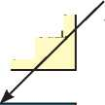
Study the following dictionary entry.
The definition
This tells you the meaning of the head word.
Head Word.
This is the word you searched for.
Independent
Part of Speech.
This shows you what type of word this is e.g. Noun verb, adjective etc.
ADJECTIVE
'• Pronunciation
/indi'pendant/
1 not governed or ruled by another country
The country recently became independent independent from: Croatia became independent from Yugoslavia in 1991.
Pronunciation Audio.
When you click this, you can hear an example of how the word is pronounced.
Phonemic Transcript.
This shows you how the word is said and helps you understand every sound in the word.
The Definition.

Unit 2

Getting started
- Act out the dialogue.
No, dear. You can't. It's time to go to bed.
Sure! But try to go to sleep early.
Please mum, can I use the mobile phone?
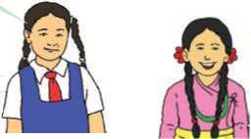
May I read a story before I sleep?
Figure 4 conversation between two peoples
Thank you, mummy.

- Listen and sing.
I can’t count food
But I can count fish
I can’t count water
But I can count glasses
I can’t count bread
But I can count slices
I can’t count knowledge
But I can count subjects
How many fingers am I holding up?
How much money do you have?
How many people make you laugh?
- Philip Evan Cowlishaw

Answer these questions.
- What things in the song can you count?
- What things in the song can't you count?

Reading
Look at the picture below and answer the questions.
- What do you think the man is doing in the picture?
- Do you think the bird wants to be free? Why?

The Small Bird's Wisdom
A rich man was walking through his springtime garden and, there, he found a small bird caught in a net. He took it in his hand and, to his surprise, the small bird spoke. ‘Set me free. There is nothing I love more than my freedom.’ ‘Why should I set you free?’ asked the rich man.
‘I am too small to eat. My feathers are grey. I am not pretty. I do not sing. Please set me free.’ ‘What will you give me in return for your freedom?’ ‘I will give you three pieces of advice.’
‘I will listen to your advice. Then I will decide whether to give you your freedom.’ ‘First, do not wish for what you cannot have.
Second, do not try to change what has already happened.
Third, do not believe in what is impossible.’
‘Wise words indeed!’ said the rich man.
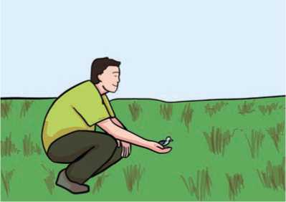
He opened his hand, and the small bird flew up to the branch of a tree overhead.
The rich man heard the small bird laughing.
‘Small bird, why do you laugh? Are you laughing at me?’
‘Yes. What you do not know is that, inside me, I have a diamond the size of a chicken’s egg.’

For a moment, the rich man could not speak. His eyes grew dark. His heart stopped beating. He could hardly catch his breath.
Figure 5 Rich man catching a bird

Finally, he said: ‘Small bird, come back to me. Now it is springtime and all is well, soon summer will come and go, but then winter will come and it will be

cold. You will be hungry. The snow will be deep, and you will have nothing to eat. You will starve to death in the cold. Come back to me and I will look after you. I will keep you warm and feed you through the long winter.’
The rich man held out his open hand to the bird, but the bird just laughed.
‘Are you still laughing at me?’
‘Yes. You are like all men. So soon you have forgotten my advice:
Do not wish for what you cannot have - you cannot have me, for there is nothing I love more than my freedom. Do not try to change what has already happened - you have already set me free, and you cannot change this. Do not believe in what is impossible - how would it be possible for a small bird like me to have a diamond the size of a chicken’s egg inside?’ And, laughing, the small bird flew away.
(Source: Storytelling with our students)
- Write the words from the text which have the following meaning. The first letter of each word has been given.
- That cannot be done. I
- Above your head; in the sky. O
- The power or right to do something. F
- A series of regular hits of something, such as your heart. B
- To suffer or die because you do not have enough to eat. S
- A clear precious stone, the hardest substance. D
- Complete the following sentences with the words from the previous task.
- She is ing herself to try to lose weight.
- I find it to lie to her.
- Planes flew constantly.
- Gold is less expensive than
- I have been running for one hour. My heart is faster.
- Everyone has the right to of education.

- Read the story again and write True or False for the following statements.
- The man held the bird in his hand.
- The bird said that it enjoyed being caught in the net.
- The bird's suggestions were wise.
- The bird really had a diamond inside it.
- The man believed that the bird had a diamond.
- The bird was happy to be free.
- Read the story again and put the following sentences in the correct order.
- The man requested the bird to come back to him.
- A man saw a bird caught in a net.
- The small bird gave him three suggestions.
- The man set the bird free.
- The bird laughed for the third time and flew away.
- The small bird talked to the man.
- Retell the story (in your own words) to your friends and teacher in class. You can tell the story either as the man or the bird. You can start your story for example:
As the man: I am a rich man. Once I was walking through my richly- scented springtime garden and I found a small bird caught in a net....
As the bird: One unfortunate day, a rich man found me caught in a net in his garden ..

Pronunciation
Listen to your teacher and pronounce these words. What difference do you find?

Grammar

sing | you | starve | just | breath | laugh
reach | soon | warm | first | cream | haunt
- Read the story, ‘A Small Bird’s Wisdom’ again and write down all the nouns in the correct columns below.
Things that you can count | Things that you cannot count

- Countable or Uncountable? Look at the sentences below. Are the nouns highlighted in the following sentences countable or uncountable?
- I made a cake this morning.
- She has bought a box of chocolates.
- I love coffee with hot milk.
- Can you get some coffee please?
- I'll have a coffee, please.
- I've got some garlic and some butter.
- I haven't got enough paper.
- I'm frightened of dogs.
- Strawberries have a lot of vitamin C.
- Some students have run away after seeing the headteacher.
- Complete the sentences with a, an or some.
- He'll need umbrella if he goes out.
- Daisy needs new phone.
- How about cup of tea please?
- I've got idea!
- Could you get me more tea please?
- I've got lemon, an apple and chicken.
- I'd like blue pen.
- There are books on the table.
- Would you like apple?
- Here's lemon from our garden.

Listening

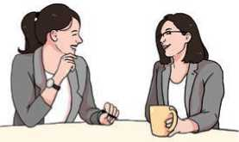
- Look at the picture and guess the answers to these questions.
- Where do you think the women are?
- Where do you think they work?
- What do you think they are talking about?
Figure 6 official talk
- Listen to the audio and complete the sentences with ONLY ONE word.
- The lunch break lasts for …………….. minutes.
- The woman can't leave for lunch 30 minutes …………… .
- Everyone has to work from ……… a.m. to 4 p.m.
- There is no flexy …...............….. at the company
- The company has a ………. code too.They are not allowed to wear casual clothes.
- The workers can take all their vacation days at once with one month prior …..............……. .

- Write as many questions as you remember from the audio.

Speaking
- What might you say in the following situations? Choose one expression from the box.
- You are feeling hot.
- Your mobile phone isn't working.
- You are looking for a chair to sit on.
- You want to type something on the computer.
- It's raining outside but you need to go out.
- You are going to a party but you don't have any appropriate clothes.
- You've lost your pen and you want to write something.
- Can I use your pen, please?
- Do you mind if I take your umbrella please?
- Is it okay if I sit here please?
- Can I wear your suit tonight please?
- May I use your computer please?
- Do you mind if I use your phone please?
- May I open the window please?
- The following expressions are used for responding to someone asking for permission. Put them in the correct box.
No, no I don’t mind. I'm afraid you can't. Yes, you can. Sure. I'm sorry. Sure, go ahead. No problem. Yes, you may. Yes, certainly.
Giving permission | Refusing permission

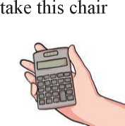
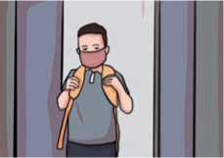
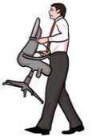
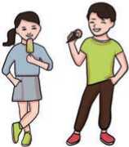
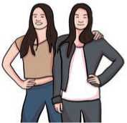
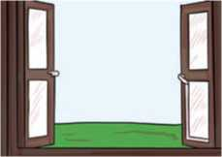
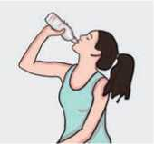
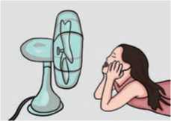
Figure 7 take this chair
Figure 8 Leave class early
Figure 9 vTake this Chair
Figure 10 Have Some ice cream
Figure 11 Bring My Friend to the Party
Figure 12 Drink Water
Figure 13 Turn on the Fan
Figure 14 Open the Window
C.
Work in pairs. Take turns to talk to each other in the following
situations. Give or refuse permission.

Reding

Answer the following questions.
a. How do you feel if you are tired of something?
b. How does a very old man/woman feel in the last stages of his/her life?

May I go now?
Do you think the time is right?
May I say goodbye to pain filled days
And endless lonely nights?

I've lived my life and done my best,
an example tried to be.
So can I take that step beyond
and set my spirit free?

I didn't want to go at first,
I fought with all my might.
But something seems to draw me now
to a warm and living light.

I want to go I really do.
It's difficult to stay.
But I will try as best I can
To live just one more day.

To give you time to care for me
and share your love and fears.
I know you're sad and afraid,
Because I see your tears.

I'll not be far, I promise that,
and hope you'll always know
that my spirit will be close to you
wherever you may go.

Thank you for loving me.
You know I love you too,
that's why it's hard to say goodbye
and end this life with you.
So hold me now just one more time
And let me hear you say,
because you care so much for me,
You'll let me go today.
-Susan A. Jackson
- Find words from the poem that rhyme with these words.
a.be b.might c.stay d.know e.say
- Find the words from the above poem and match to the meanings below.
- a situation when you have no one to talk to
- strength
- the part of a person that includes their mind, feelings and character
- pull
- to have something/somebody in your hand, arms, etc.
- Read the poem again and write True or False for the following statements.
- The speaker wants to escape the lonely nights.
- The speaker isn't satisfied with his past life.
- The speaker wants to live his best forever.
- The speaker has tears in his eyes.
- The speaker thinks that it's easy to go.

^Grammar II

A. Study the following sentences.
a. I don't have a dog.
b. There are some pens.
c. Would you like to have some more tea?
d. There's some milk in the fridge.
e. I don't have any pens.
f. There isn't any salt.
g. How many chairs do we need?
h. How much milk have we got?
B. Complete the sentences with a/an, some or any.
a. | It is dog.
b. | Have you got | friends?
c. | I bought | milk.
d. | Linda does not have . | pets.
e. | There is | orange on the table
f. | Tim eats | cheese every day.
g. | We don't have | bread.

Writing
- Below is the format of an email. Fill up the blanks with the phrases from the box below to complete the email.
Sanskriti, good health, 15th, 21st April, 2021, your positive reply, attend my sister’s wedding in my village, seven days’ leave, your permission, cover all my missed lessons, Sanskriti Rai
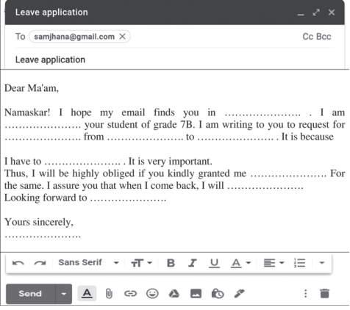
Figure 15 Sample Of Leave Application
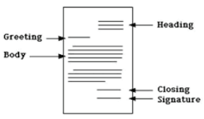
- A friendly, personal or an informal letter is written to our friends, family or relatives. Try singing the friendly/personal letter song together in your class.
Figure 16 Parts of Letter
I choose a closing like “Your Friend” or “Love” forever more.
I end it with a comma (,) of That I'm very sure.
I sign my first & last name
And now I'm at the end.
And my perfect friendly letter, I'm ready now to send!
-Lindsey Shepley
C.Your school is going to organise an educational tour to Lumbini. You also want to go with your school friends. Write a letter asking your sister, who lives away from home, for permission to go on the trip.
Friendly Letter Song
I am a friendly letter.
My heading's at the top.
Slide over to the right to
Write the date & then I stop.
And then I put “Dear
Someone” a comma (,) at the end. Next I go write the body,
My message to my friend.
Greeting
Body

Project work
You and your friends are organising a science exhibition in your school. You would like to use the football ground for that exhibition. Work in groups of four and write a request letter to the headteacher about asking their permission to host the event.

Extra bit
air - heir | eye – I | be - bee | buy - by | cell - sell
cent - scent | dear – deer | die - dye | fair - fare | flour - flower
hair - hare | heal – heel | hole - whole | hour - our | night - knight
know - no | mail – male | principal - principle | right - write | sight - site
Read the following pairs of words. They have the same pronunciation. Do they mean the same or different? Use a dictionary to learn their meanings.

Unit 3

Getting started

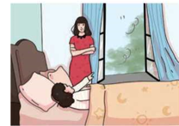
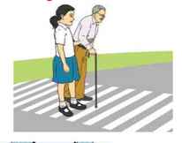
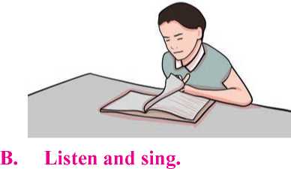
- Look at the pictures. Guess what the people in the pictures are
Figure 17 small girl help to cross the road
Figure 18Readind a book
Figure 19 old man try to lift load
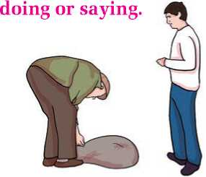
- Listen and sing
Please
Figure 20 mother convice her daughter for sleep
Don’t close your heart
It is so big inside
Search for treasure
Kindness is hidden
under the veins
inside the cage
Don’t close your eyes
Look
deep in the ocean
up in the sky
right and left
(Source: I Love Poems)
and let them rest
What does the poem tell you not to do? Talk to each other in pairs.

Reading

Answer the following questions.
- How do people feel when their relatives pass away?
- Is death sure to happen?

Kisa Gotami and the Mustard Seed
There lived a woman called Kisa Gotami in one of the villages of Nepal. She got married, gave birth and lived with her only son as her husband died very recently. She loved her son very much. She worked and lived only for him. The days were passing by happily.
One unfortunate day, the son fell sick and died. Kisa could not believe what had happened. She refused to accept that her dear son had left her forever. She cried and cried and was in total grief. The villagers came and consoled her. They advised her that she should prepare for his funeral. But she refused to do so. Instead, she carried her son’s dead body in her arms and went around the village from door to door. She begged people to help her bring her son back to life. But the villagers saw that the son was already dead and nothing could be done. She believed that her son would come back and thus spent some days with her dead son. She neither let anybody touch her son’s dead body nor would take him to the graveyard.
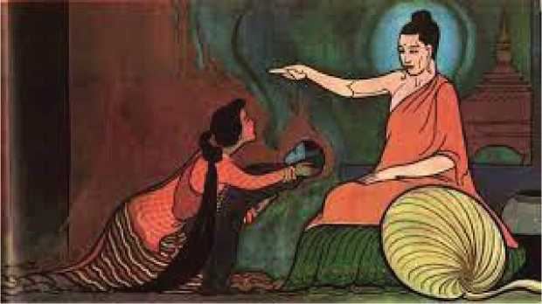
On seeing this, one of the old men of the village came and advised her, ‘Kisa, I see that you are in great pain. Why don’t you go to Gautam Buddha? He has the remedy for all the pains and sufferings in our lives. He will definitely help you.’ Kisa was very happy to hear that. She
Figure 21 Buddha telling the remedy of pain

said, ‘Really? Could Gautam Buddha do that?’ When the old man confirmed the possibility, she immediately took her son in her arms and ran towards Gautam Buddha, who was meditating under a Peepal Tree.
On reaching there, she cried, ‘Gautam Buddha, my lord, will you please help me? I have heard that you have magic and power. So, would you please use them to restore my son back to life? Please, I request you and I beg you.’ Gautam Buddha thought for a while and said, ‘Well! Kisa, I think I can help you. But you must do as I say.’ Kisa’s face brightened and she said, ‘I am ready to do everything, Buddha. Please tell me, what should I do to see my son live again?’

Gautam Buddha replied, ‘Okay then. I need a handful of mustard seeds from a house where no family member has died ever.’ Kisa got hopeful and excited. In no time, she ran towards the first door and knocked. ‘Excuse me neighbour, could you please lend me a handful of mustard seeds to bring my son back to life?’ The neighbour happily said, ‘Yes, I can surely do that. If my help can make that possible, why wouldn’t I? Wait for a moment and I will be back.’ As the neighbour turned around to get the seeds, Kisa remembered Budha’s condition and asked, ‘Has anyone died in your house?’ ‘Oh! Well, it was only a year ago that I lost my father’, replied the neighbour.

Kisa said, ‘I am so sorry to hear that, but I cannot take the seeds from you.’ Then, she went to the next door. She repeated her request, ‘Could you please give me a handful of mustard seed? But no one should have died in your house.’ But the next neighbour told her that her grandmother had passed away a few weeks ago.

Kisa got extremely sad. She went from one door to other doors. But she got similar replies everywhere; some said a few years while others said some days back; some said they had lost their daughter while others said their mother.

Kisa realised an important thing. She understood what Buddha was trying to teach her: death takes away everybody one day; it is inevitable. It was not that only she had lost her dear one; but it was in everybody’s house where people die. When you are born, you are destined to die one day.’
(Adapted from www.buddhiststories.wordpress.com)
- Find the words from the text above and match to the meanings below.
- gave sympathy to somebody
- a ceremony for burying/burning a dead person
- an area of land where dead people are buried
- a way of improving a difficult situation
- sitting in silence in order to make the mind calm
- sure/certain to happen
- Answer the following questions.
- Did Kisa love her son? How do you know?
- What did she not accept?
- What help did she first ask for from the neighbours?
- Why did she not prepare for her son's funeral?
- What did the old man advise Kisa to do?
- What was Gautam Buddha doing when Kisa saw him?
- What request did she make with Gautam Buddha?
- What did Gautam Buddha tell Kisa to do?
- Did Kisa find a house where no one has ever died?
- What did Kisa finally learn?
- What did you learn from the story linked to current events? Talk to your friends.

Pronunciation
Practise saying the following.
- Peter Piper picked a peck of pickled peppers.
A peck of pickled peppers Peter Piper picked.
If Peter Piper picked a peck of pickled peppers,
Where’s a peck of pickled peppers Peter Piper picked?

- Betty Botter bought some butter.
But she said the butter’s bitter.
If I put it in my batter, it will make my batter bitter.
But a bit of better butter will make my batter better.
So it was better Betty Botter bought a bit of better butter.
- How much wood would a woodchuck chuck if a woodchuck could chuck wood?

Listening
- Answer these questions.
- What do you do if you want someone to do something for you?
- If someone asks you to help him/her lift a load, how do you respond politely?
- How do you politely reject if someone asks you to lend him/her your pencil?
- Listen to the audio and complete the following dialogues with the missing words/ phrases/ sentences.
- A: Hey Lisa, I'm going to the new art gallery at the weekend.
to come with me?
B: I have to study for exams at the weekend.
- A: Some of my friends and I are going to sing karaoke tonight.
to join us?
B: , I'd love to. It sounds like fun.
- A: There's a technology show at the International Convention Centre.
?
B: Yes, Will they have smartphones? I need a new one.
- A: Hey Jim, we're going to see a concert tonight at the stadium. I was
wondering if ?

B: But I have to work tonight.
- A: Tony, there's a big sale at Central ?
We could get some cheap brand name clothes.
B: I love buying brand name clothes.
- A: Hey BJ, there's a new horror movie playing tonight. I'm going
with some friends
B: I love horror movies. What time are you going to meet?
- Work in pairs to act out the above dialogues. Learn the correct pronunciation of the expressions with your teacher.

Speaking
- Read the following sentences from the story (Reading I) and say who said them to whom.
- Will you please help me?
- Would you please use them to restore my son back to life?
- Well! Kisa. I think I can help you.
- Could you please lend me a handful of mustard seeds to bring my son back to life?
- Yes, I can surely do that.
- Here are some other expressions for making requests and responding. Put them in the correct column in the table below.
- Can you show me your photo album please?
- No, I'm sorry I need it.
- Will you lend me your book please?
- Sure, here you are.
- Could you show me the way to the post office please?
- I'm afraid I can't.
- Would you help me with this exercise please?
- I'd love to but I'm busy today.
- Of course.
Requests | Responses

- Work in pairs. Roll a dice and where you land, try and make the request in the given situations. The clues are given.
Finish | It's really hot here.  (open the window) | I'm starving. (give me some bread) | I'm really thirsty. (make lemonade) | I'm going to sleep. (wake me up at 6)
The luggage is heavy.
(carry it)
I'm organising a party.  (come) | The cat must be very hungry.  (feed it) | The bag is very heavy.  (hold this for me for a second) | It's freezing out there.  (close the window) | I don't understand my homework. (help me with it)
The matches are on the table. (light the fire)
My bag is in my room.  (bring it to me) | I don't understand the instructions. (translate them) | I've got a terrible headache. (leave me alone) | I'm reading a book.  (be quiet) | The music is terrible and too loud.  (turn it off)
I have to clean the house before my parents come home.
(help me)
Start | I've never been to the city.  (be my guide) | I'm talking to you.  (listen to me) | Dad came in and left the door open (close the door) | I'm leaving for 2 days.  (look after my cow)

- Work in pairs. Take turns to make requests and respond in the following situations.
- You want to find out where the nearest bus stop is.
- You want to fill a water bottle at a coffee shop.
- You want to write something but you have lost your pencil.
- You want your friend to go to the cinema tomorrow.
- It's raining outside. You want to borrow your friend's umbrella.
- You want to know the time but you don't have a watch.

Grammar

- Study the following sentences. When do you use them?
- Will you help me please?
- I would like a drink please?
- Would you mind turning off the music please?
- Could you pass the juice please?
- Can you pass the salt please?
- Which is correct? Tick the correct one in each pair.
- Could you please send me the money?
Could you please to send me the money?
- Could you to help me please?
Could you help me please?
- I would liking a drink.
I would like a drink.
- She would likes a coffee.
She would like a coffee.
- Could you please bring my keys?
Could please you bring my keys?
- Can I have another drink please?
Can I have to another drink please?
- Complete the sentences with will, would, can or could.
- He ran as fast as he
- She swim when she was just five.
- Raju speak six languages.
- I don't think I pass the test.
- He failed the test because he answer only two questions.
- He said that he help but he didn't.
- You borrow my car if you want.
- Who cook dinner today?
i you like to dance with me?

Reading

Answer the following questions.
- Have you ever written a letter to an editor of a magazine or newspaper?
- Why would you write to an editor?

Kathmandu
19th Sep, 2021
The Editor
The Rising Nepal
Kathmandu, Nepal

Subject: Air pollution – a concern.
Dear Sir/Madam

Through your esteemed daily newspaper, I’d like to highlight the problem
of air pollution in our city.

Among other environmental problems, we have a problem with air pollution which is on the rise. Factories are the major source of air and water pollution. Air pollution leads to suffocation, breathing problems and lung diseases when our lungs are choked with polluted air. Factory owners should be aware of this. They should take responsibility for the environment around them. The thick smoke emitted by the factory chimneys is full of poisonous gases. This mixes with pure air and causes pollution. There should be a strict law to punish the owners of such factories if they do not take the moral responsibility to keep the air clean.
Yours faithfully,
Nitin Rai

A. Complete the table below with the information from the letter above.
Sender's address
Receiver
Name of the newspaper
Subject of the letter
Sender's name
- Answer the following questions.
- What type of problem is air pollution?
- What are the major sources of air pollution?
- What health problems are caused by air pollution?
- What does the smoke from chimneys contain?
- How does the smoke from factories pollute the pure air?
- What according to Nitin is necessary to stop air pollution?
- Who according to Nitin should take responsibility for air pollution?

Writing
Is there any public problem (e.g. noise, traffic, drainage) in your locality? Write a letter either to the editor of a local newspaper or to the ward chairperson about the problem. Use the letter above as a guide.

Grammar
- Study the following sentences.
- Could you please do me a favour?
- I've finished my work. Can I go now?
- Would you like some help?
- Can I help you?
- Will you stop talking like that please?
- Would you like some cake?
- Would you mind closing the window please?
- Will you give me a hand please?
- Complete these sentences with can, could, will or would. Use negative forms where necessary.
- My grandmother is eighty-five, but she still read and write
without glasses.

b I come with you?
c you help me with the housework please?
- There was a time when I stay up very late.
- You lose any more weight because you eat a lot.
- I get you a shawl from Kashmir.
g you take care of my cow for a day?
h you swim when you were 10 years old?
- He's amazing, he speak five languages.
- She's seven but she read yet.

Project work
Work in groups of five. Go around different sections of your school: library, staff room, headteacher's room, canteen, etc. Find the requests in one of the notices in those areas. If they are in Nepali, translate them into English. Write all the requests on chart paper. Which of them are applicable to your class? Write them on another piece of chart paper and stick it on your classroom wall.

Extra bit
Work in pairs to act out the dialogue and answer the questions.
Tailor : What can I do for you sir?
Customer : I want a woollen suit to be made.
Tailor : Would you like to buy the cloth from us, sir?
Customer : No. I've brought the suit-length with me. Here it is.
Tailor : All right. May I take your measurements, sir?
Customer : Yes. I'd like a tight-fitting suit.
Tailor : Right, sir.
Customer | : Now, how long will it take you to get the suit ready?
Tailor | : About three weeks, I think. It takes longer at this time of the year because of the holiday rush, you know.
Customer | : That'll be all right. But I'd like to have it before the end of the month.
Tailor | : All right, sir. Would you prefer one inside pocket in the jacket, or two?
Customer | : I want three. Two on the left and one on the right.
Tailor | : And would you also like a hip-pocket in your trousers, sir?
Customer | : No, not really. But I prefer a ticket pocket.
Tailor | : Very well, sir. Will you call in for a fitting next Tuesday?
Customer | : I'd rather come on Wednesday. Oh dear! I haven't asked you about your charges at all.
Tailor | : Don't worry, sir. Our prices are competitive, and here's the price list, sir.
Customer | : Seven hundred and seventy-seven rupees for making a suit! I think I'll go elsewhere.
Tailor | : I recommend FITWELL across the street, sir. Goodbye, sir!  (Source: Spoken English)

Questions for discussion.
- Where is the dialogue taking place?
- Who is taking part in the dialogue?
- Is the customer a man or a woman? How do you know?
- When will the suit be ready?
- At the end of the dialogue, what does the customer decide to do? Why?

Unit 4

Getting started
- Look at these pictures. What do you think people do during their festivals? Talk to your friends.
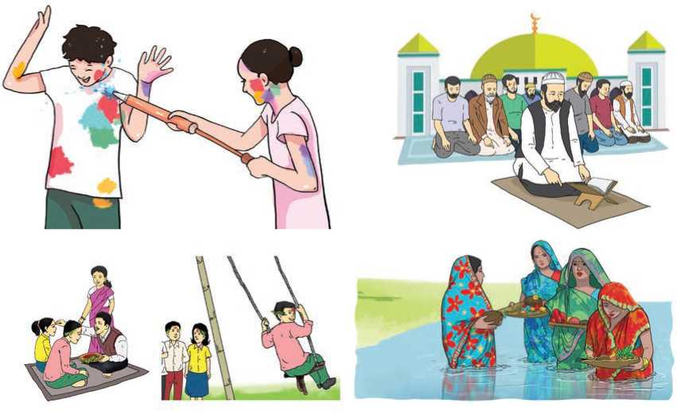
Figure 22 Festivals of different religions

- Listen and sing.
I wish you good friends that always treat you fair.
Wanna wish you ribbons to tie around your hair.
I wish you truckloads of cheers and many happy years.
Wanna wish you freedom to do the things you love.
Wanna wish you blessings and kindness from above.
Wanna wish you sunlight through the clouds.
And I hope you laugh out loud.

Why do people make wishes? Talk in pairs.

Reading
Answer the following questions.
- What festivals are celebrated in your community?
- What do people do at the festivals you have identified?
- Which festival do you like most? Why?

Some Festivals of Nepal
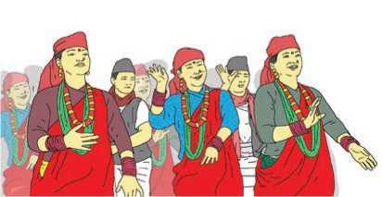
Lhosar is the combination of two words, Lho means year and sar means new. Lhosar is one of the most popular festivals of Nepal, celebrated by different communities on different days. Tamu Lhosar is celebrated amongst the Gurung community, whereas Sonam Lhosar is celebrated by the Tamang and Yolmo communities. Likewise, Gyalbo Lhosar, is observed by the Tibetan and Sherpa communities. The beginning of new year is celebrated by dancing, singing and family meet-ups exchanging greetings and gifts. Families pray together during this festival and enjoy special foods.
Figure 23 Gyalbo Loshar
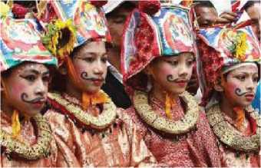
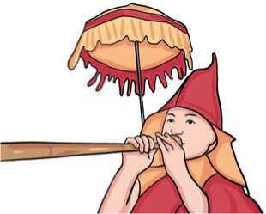
Among the widely celebrated festivals of Nepal, Gai Jatra (festival of cows) is celebrated to commemorate the death of people during the year. Local people believe that cows can help the deceased to reach Yama, the God of death. This is one of the most unique festivals of Nepal, where cows are decorated and led through the streets and lanes. Families of the deceased join the procession and distribute food packets and fruits to others. To lower the sorrow and grief of the departed souls, local people join in rallies, menfolk wear women's dresses and enjoy songs. Lakhe dance is also seen during Gai Jatra.
Figure 24 Gai jatra
Buddha Jayanti is a national festival of Nepal. Lord Buddha was born in Lumbini on this day.
Figure 25 Buddha jayanti
Hence, Buddhists from all over the world visit Nepal during this ceremony. Places like Boudhanath, Swayambhunath and Lumbini are decorated with prayer flags. Monks gather to offer prayers and chant Buddhist mantras. People visit Stupas and observe the day. Kheer (sweet porridge) in cooked in every household during Buddha Jayanti.
- Match the meanings with their corresponding words.
- two or more things joined together i. monk
- celebrated festival or birthdays, etc. ii. decorated
- give and receive something iii. commemorate
- recall and show respect for someone iv. deceased
or something
v. procession
- made something look more attractive by putting things on it
f.
dead
vi. exchange
- a line of people that move along vii. observed
slowly
- a member of a religious group of viii. combination
men who live apart in a monastery
and who do not marry
- Complete the following sentences with the correct forms of the words in A above.
- Look! They are Buddhist
- The made its way down the hill.
- I buy you lunch and you fix my computer. Is that a fair ?
- His treatment was a of surgery, radiation and drugs.
- Do they Dashain?
- The family of the are crying.
- He is the car with flowers.
- Answer the following questions.
- Who celebrates Sonam Lhosar?
- Why is Gai Jatra celebrated?
- Who is Yama?
- What is done with cows at Gai Jatra?
- What do monks do at Buddha Jayanti?
- What festivals are celebrated in your country? Which of them do you like most? Why?

Pronunciation
Practise the following expressions with the help of your teacher.
a. Happy Eid/Dashain/Lhosar! | b. | Happy birthday to you ! you!
c. Good luck! | d. | Have a nice journey!
e. Have a wonderful holiday! | f. | Enjoy the meal!??

Writing
Which festival have you celebrated recently? Write a short description of it. Describe what people do at the festival.

Grammar
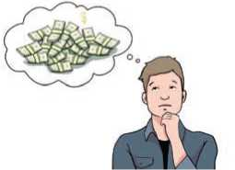
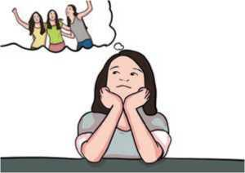
A.
Study the following pictures and read the sentences. What do
they mean?
I wish I had more money.
I wish I had more friends.
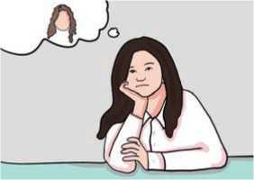
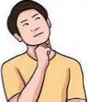

. I wish I had a smartphone.

B. Complete the following sentences with the given beginnings as given in the example.
. I wish I had curly hair.
Example: I don't have a car
I wish I had a car.
- I can't play the piano.
I wish
- I'm at work.
I wish
- It's winter.
I wish
- I'm ill.
I wish
- I don't have new shoes.
I wish
- I can't afford to go on a holiday.
I wish………..
- Complete the sentences using the correct forms of the verbs in the brackets.
- I wish we (not have) a test today.
- I wish these exercises (not be) so difficult.
- I wish we (live) near the beach.
- Do you ever wish you (can travel) more?
- I wish I ……………. (be) better at maths.
f. | I wish we | . (not have to) wear a school uniform
g. | Sometimes, I wish I . | (can fly).
h. | I wish we | . (can go) to Disney World.

Listening
      - Answer the following questions.
- When is your birthday?
- How do you celebrate your birthday?
- What do people give you on your birthday?
- Listen to the audio and complete the table with the information you heard. Use no more than two words.
Name | Martha
She's from
What does she do?
Who does she usually celebrate her birthday with?
Who gives her money? | Her parents and
Name | Kenji
He lives in
When is his birthday?
Where does he go for a picnic?
What does his family buy for him?
What are his parents giving him this year?
Name | Sun-Hyi
She's from | Busan,
When is her birthday?
Very special age in her country
Who cooks a special meal?

- What do the people speaking in the audio do on their birthdays? Do you do the same? If not, how would you like to celebrate? Talk to your friends.

Reading
Answer the following questions.
- Do you write emails/letters to your friends?
- What do you write in your email/letter?
Hi Sangita,
Just a quick email to say how I celebrated my birthday. My last birthday was the most memorable birthday to date. It was 15th Jeth 2078, when I turned 12 years old. That was a very special day for me. I woke up early at 6:30 a.m. because my family sang a special song for me & they gave me some gifts.
My cousins Sunita and Arun arrived to surprise me. Their presence made my day even more special. They gifted me a big box full of chocolates and a CD of my favourite singer.
All of us had breakfast together. Mum made breakfast. Dad bought a big cake for me which I cut. Then I started receiving calls from relatives and friends.
At 6 p.m., I was out with my family to celebrate the occasion. I received a message on my mobile phone from Heena. She said that she knew it was my birthday but she was busy planning the surprise. Heena wanted me to go to her house. She told me that she was going to pick me up at 7:30 p.m. I asked my parents. They said, "ok".
Heena came after one and a half hours to pick me up in a beautiful car. When I reached her house, she opened the door. As soon as we entered, we saw that all my friends were inside with many balloons and flowers.
They all shouted loud in chorus- “Happy Birthday, Niru!”. Everyone hugged me one by one and gave me gifts and roses. Then, they all sang my favourite song. I cut the cake again. We had a delicious meal, danced and enjoyed ourselves. It was a memorable event for me. I missed you a lot. Please make time to come to my home soon.
See you soon!
Niru

- Complete the following sentences with the words from the box.
memorable, presence, occasions, surprise, chorus, hugged
- I know him well. I've met him on several
- All are attending the meeting. Your is also expected.
- I can't forget my last birthday. It was a truly
event for me.
- My father bought me a mobile phone on my birthday. It was a big for me.
- They put their arms around each other and
- Nitu started the song and everyone joined in the
B Answer the following questions.
- To whom was this email written?
- When was Niru's birthday?
- What woke Niru up on her birthday?
- What gift did Niru get from her cousins?
- Who did she get the message from?
- Why did Heena message Niru to go to her house?
- What was the surprise for Niru at Heena's house?
- What did they do at Heena's house to celebrate the occasion?
- Suppose you are Sangita. How will you respond to Niru? Write a reply email to her.

Grammar
- The past forms of the following verbs are given in the email above. Find and write them.
celebrate | gift | want | shout
is | have | tell | hug

reach | buy | ask | give
wake up | cut | come | dance
sing | start | open | receive
enter | enjoy | arrive | say
see | miss | make | know
are

- Study the following sentences.
- I met him in 2015 AD.
- We went to Pokhara for our last holiday.
- They got home very late last night.
- We swam a lot while we were on holiday.
- I saw him last one month ago.
- Did you meet my father?
- Where did you go yesterday?
- They didn't go to Pokhara last year.
- Complete the sentences with the past simple forms of the verbs in the brackets. Use negative forms where needed.
a. | The old man (take) out his purse and |  | ... (pay) the bill.
b. | The nurse | (put) the little boy on the bed and
 | (speak) to him softly.
c. | They …... | ..(hear) the fire alarm and…… (run) out of the building.
d. |  | (do) you remember to buy the salt?
e. |  | (do) I say anything wrong?
f. | I | .. (call) the waiter but she | (hear) me.

g. I ............. (see) Sani in the supermarket but we ............. (talk).
h. She ............. (spend) all the morning in the bookshop, but in the
end she ............. (buy) anything.
- They (cut) off our telephone because we (pay) the bill.
- It was very hot, so I (take) a bath two times yesterday.

Speaking
- How do you give your best wishes in the following situations? Make a wish for each.
- Your friend's birthday is today.
- Your friend is going to have a week's holiday.
- Your brother is attending the exam today.
- Your friend is celebrating Lhosar tomorrow.
- What wish do you make in the following situations? Tell your friends.
- You are short and you want to be taller.
- You want to be rich.
- You want to have a big house.
- You want your neighbours to be nice.
- You want to have a different English teacher.
- You want to live for 100 years.
- You want to have a younger brother.
- You want to pass the exam.

Writing
Which events do you celebrate at your school: Children's Day, Democracy Day, School Day, etc? Choose one and recall how it was celebrated last year. Write a paragraph about it. Use past tense.

Project work
Work in small groups (maximum five). Make colourful greeting cards to express wishes to your friends and relatives on any of the occasions your group chooses.

Extra bit
Read the story and find the answers to these questions.
- What three wishes did the man and his wife make?
- Were they wise or foolish? How?
A man and his wife were sitting in a small room and were lamenting that they were poor. "Oh," said the man, "if there were only some good fairies who would say to one, ‘What do you wish for? I will grant it.' Then, I would wish for something that would make me happy, all my life."
The man had hardly ceased speaking when the door opened and a beautiful fairy walked in. "I heard the words you spoke, and I will not only grant you one wish, but three, so wish for something good." And the fairy disappeared. They were very happy and bethought themselves of something to wish for. The man said, "Let us eat our meal first and meanwhile we will think of something to wish for."
These people were so poor they had only potatoes for their meal, and as they were very hungry the woman said, "Oh, if I only had a banana!" A banana came flying into her room and lay on her plate; a voice said, "One wish is now fulfilled."
Her husband became very angry and called out, "I only wish the banana was hanging to your nose!" The banana hopped from the plate and hung on to his wife's nose, and so the second wish was granted.
The poor woman looked very funny with a banana on her nose; she lamented and wept and tried every way to take it off, but it hung so tight that the only thing for her to do was to make another wish and wished that it was off. Both the man and his wife exclaimed, "If banana was only a thousand miles away!" The banana immediately flew out of the window and they were happy. They made no more wishes and were satisfied the rest of their lives.

Unit 5

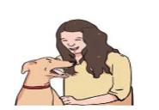
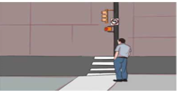
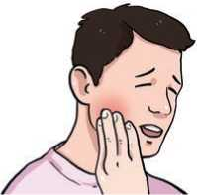
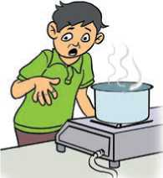
Getting Started A.What do you think these people should or shouldn't do?Talk to your friend.
Figure 26 looking traffic lights before crossing road
Figure 27playing with pets
Figure 28 rubbing his chick
Figure 29 Playing with gas stove
B.Listen and Sing.
If I were a bird,
I would fly high and high.
If I were a bird,
I would cross the limits of the sky.
If I were a bird,
I would fly from tree to tree.
In search of someone free.
To play with me and to talk to me.
If were a bird,
I would learn all the good things.
Answer these questions.
- Where would the bird fly to search for someone?
- What would the bird do with the person?
Reading
Look at the picture and answer the following questions.
- Who do you think they are?
- What do you think they want to be?

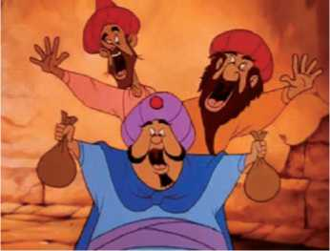
The Three Merchants
There were once three merchants who lived in the same town. They were friends. One day, they agreed among themselves to work together and share their profits. They decided to leave their home town and go to work in a distant land. They travelled a long way and at last they arrived at a town where they began to sell their goods. Trade was very good and they soon made a lot of money. As there were no banks in those days, they agreed to leave their money with an old man whom they could trust. This old man was in charge of a bathhouse.
Figure 30 Three merchants
The three friends handed over the bag of money to the old man. One of them said to him, "Please keep this money until we ask for it. It belongs equally to all three of us. So, you must give it back to us only when we are all present." The old man agreed to do this.
One of the three friends was a dishonest man. One day, when they were passing the bathhouse, he said to the other two that he was going to buy a ticket for a bath. He left them and went up to a little window where the old man was sitting. He did not ask him for a ticket, but for the bag of money.
The man refused to give it to him. "You know what you and your friends told me to do," he said. "I shall give the money back only when you are all present." "You are quite right," the man replied. "Look out of the window and you will see that the others are with me."
The old man did so and was satisfied. He handed the money over to the man.

The dishonest man put the bag of money into his pocket and went back to his friends. He told them that he had received news that his grandfather was ill, and so he would have to leave them for some time. The other two men agreed and he went off.
The two friends did not think that anything was wrong until several days had passed. One day, they went to the old man and asked him to return the money to them. He said that he had already given it to their friend when they were with him. They remembered the place where they had last seen their friend, and the time when they had last seen him speaking to the old man, but they did not believe that he had given the money to their friend. The two men, therefore, went to the judge, who ordered the old man to pay back the money the next day. The poor man did not know what to do. He went to the village where his friends lived. One of his friends gave him some good advice. The next day, when the two men appeared before the judge, he said, "I am ready to pay back the money when the three men come to me together and ask me for it. Until they appear together, I shall keep the money."
The judge said "You are quite right. That is what you promised to do, and the law cannot make you break your promise."
- Complete the sentences with the words/phrases from the box.
dishonest, merchants, bathhouse, appeared, distant, promised, handed over
- People who buy and sell goods in large quantities are
- It is 450 km to the city. It's in a location.
- A public building in which there are baths, steam rooms, etc. is called
a
- I requested the money from him. He a cheque for Rs. 5000.
- He always cheats people. He is a person.
- While we were dancing, my father ………...around the corner of
the house.
- They arrived at 7:30 a.m. as they had
- Write True or False for the following statements.
- The three merchants used to live in three different towns.
- They earned a good amount of money.

- The old man was their banker.
- The old man refused to give the money back to one merchant at first.
- The dishonest merchant's grandfather was really ill.
- The old man gave back the money to the two merchants too.
- Answer the following questions.
- What agreement did the merchants make with each other?
- What did they start to do in the town?
- How did they earn a good amount of money?
- Why did they give the bag of money to the old man?
- Did the first merchant really want to buy a bath ticket? Why?
- Why did the old man give the money to the first merchant?
- What would you suggest to the old man and the two merchants?

Pronunciation
Pronounce the following words with the help of your teacher.
'merchant | dis'honest | a'ppear | 'distant | 'promise
hand 'over | 'bathhouse | a'greement | a'mount | judge

Writing
- One of the old man's friends in the village gave him advice in the story. His advice was this: Since you have agreed to give their money back when they are all present, you should tell them that you will pay back their money only when all three come together. Did this advice work? How? Discuss.
- Imagine that you are the old man. Write a message thanking your friend for the advice.

Grammar
- Read the list of suggestions given to someone who has a toothache.
- You should go to a dentist.
- You shouldn't have a cold drink.
- How about taking a painkiller?
- If I were you, I would go to a dentist.
- Why don't you go to a dentist?
- Complete the sentences with the correct phrases used in A above.
- You study hard if you want to improve your
English.
- You quit the job. You will be short of money.
- You get your mum a mobile phone for her birthday.
- You watch that movie. It is really good.
- Why don't you a new pencil?
- How about a new book? This is already torn.
- How about to the new restaurant? It's just opened.
- If I were you, I help her. She really needed help.

Speaking
- Act out the following dialogue in pairs.
Alina: Rabina, why don't we go to the cinema to watch The Jungle
Book?
Rabina: No, let's not. We've seen the film many times before. What about going to the library? We have to finish our project work.
Alina: That sounds like a good idea. But when we finish, let's go to the
cafe.
Rabina: Yes, I'd love to.
- What do you suggest in the situations a to g? Use the following structures to help you.
You should
How about ?
Why don't you ?
How about ?
If I were you,
- It's a lovely Saturday afternoon. Your brother is bored at home.
- Your mother goes outside and it starts raining. She comes back.
- It has stopped raining outside.
- Your sister has been playing for a while. Now, she is hungry.
- Your friend has a headache.
- Your friend has lost some money in the class.
- Your friend has forgotten to bring his pen.

- Nabina and Nita are discussing birthday presents for their dad. Complete the dialogue with the words from the box and act out the dialogue.
Let's How about What about sounds good don't think so
Why don't I don't think Shall we perfect

Nabina : It's Dad's birthday on Friday. …………. buy him some socks?
Nita : ………………. that's a good idea. Socks are such a boring
present to give someone.
Nabina : ………………. taking him to a football match then?
Nita : Hmm. I ………………. . The tickets would be quite expensive.
………………. we make a birthday cake for him?
Nabina : We are both terrible at cooking. …………. buying him a watch?
Nita : Yes, that ……………. . He doesn't have a watch. ……………….
go to the shopping mall this afternoon and buy one.
Nabina : That's ………………

Listening
- How do you make suggestions to people? What are the structures you used for making suggestions to people?
- Listen to the recording and fill in the blanks.
- A: I'm …………………
B: Why don't you ………………… a book?
A: Nah, I don't ………………… like reading
- A: I’m ………………… . Let’s get something to eat
B: Why don’t we………………… pizza?
A: That’s a good …………………!
3. A: ………………… do something tonight.

B: How about seeing a ?
A: What movie do you want to see?
4: A: I’ve got a
B: Why don’t you an aspirin and rest?
A: Thanks. I
- A: Where we meet?
B: How the coffee shop door?
A: It’s too Let’s go some place quiet.
- A: I need some
B: How about going for a with me?
A: Sure. I’ll get my
- A: That was a day. I’m exhausted.
B: Why you get to bed ?
A: I can’t. I have work to do.
- A: I’m
B: Why don’t you borrow some ………. from your brother?
A: I can’t. He’s broke
- Underline all the suggestions in the above task and practise saying them.

Reading
Answer these questions.
- What types of food do you usually eat?
- Are they healthy?
- What are healthy foods?

Food Habits
Your body is a complicated piece of machinery. Many of the organs in the human body work together to take energy from food to keep you going all day. In some ways, this is just like putting fuel in a car. However, if you did put the

wrong fuel in a car, the engine would soon start to splutter and things would go wrong. Your body is just like this - it needs the right fuel. Because of this, you need to think carefully about what you eat.
No one is saying that you cannot have treats like sweets and crisps. Your diet (which is a way of saying everything you eat) needs to be varied, interesting and enjoyable. Many people plan their meals so that they include a variety of vegetables, protein, fruits and grains. Some people must be extra careful about what they eat. A vegetarian (someone who chooses not to eat meat) may have to find ways to replace meat with another source of protein. All of us need a balanced diet to keep us healthy. We need the right fuel to keep us going throughout the day, just like a car.
All living things eat and all living things excrete. You only get one body, so it is important to take some control over what happens to it; fuel it up properly, exercise it, and try to lead a balanced and healthy life.
- Match the words for the meanings a-e from the above text. The first letter has been given.
- not easy to understand, analyse. C
- to make a soft spitting noise. S
- very surprising. A
- someone who does not eat meat. V
- discharge as waste. E
- Answer the following questions.
- What is our body compared with in the text?
- What kinds of food should we eat?
- Describe one way in which vegetarians have to plan what they eat.
- Why do we need a balanced diet?
- Why is it important to take control of our body?
- Give suggestions to your friends about eating a balanced diet. Use the structures you learnt earlier.

Grammar
- Study the following sentences with their meanings.
- If I won the lottery, I would buy a big house. (I probably won't win the lottery)

- She would pass the exam if she ever studied. (She never studies, so this won't happen)
- If I had his number, I would call him. (I don't have his number now, so it's impossible for me to call him).
- If we had a garden, we could have a gardener. (We don't have a garden.)
- Choose the correct option to complete the sentences.
- What would you do differently if you to do this again?
- had ii. have iii. would have
- If I a bike, I would go to Mustang.
i. buy ii. bought iii. will buy
- If I you, I'd go to the doctor's.
i. am ii. were iii. will be
- If I a car, I would learn to drive.
i. had ii. will have iii. would have
- Use the correct forms of verbs from the brackets to complete the sentences.
- If I (be) you, I would get a new job.
- She would travel a lot, if she (have) a car.
- If we (not/be) friends, I would be angry with you.
- If I had enough money, I (buy) a big house.
- If she had some money, she (buy) some chocolates for us.
- If we won the lottery, we (travel) the world.

Writing
- What types of food do you eat? Are they healthy? Do they make a balanced diet? Do you have any plans to change your food habits? Write a paragraph about your eating habits.
- Why should we eat a balanced diet? Prepare a short message in the form of a poster.

Project work
Give suggestions to your friends at school regarding their food habits. Work in groups of five. Prepare a list of suggestions. Write on chart paper with beautiful handwriting and stick the charts in different places at your school. Look at each other's poster, vote and decide the best one. Give reasons.

Extra bit
Read the poem and find out what the speaker would do if he/she were a bird.

I will Soar
If I were - a birdie,
I'd head up to the sky.
I'd spread my wings like sunshine.
I know I could fly mighty high!
If I were a birdie,
I'd sing a lovely song.
Everyone would stop and listen;
They would begin to sing along.
If I were a birdie,
I'd flit about from tree to tree
With many different flocks of birdies.
We would be free to be free.
If I were a birdie,
I'd head up to the sky.
I'd spread my wings like sunshine.
I know I could fly mighty high!
- Annette R. Hershey

Unit 6

Getting started
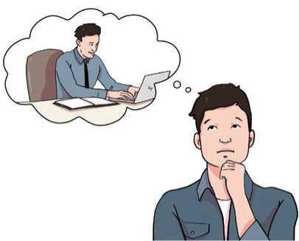
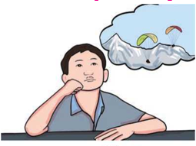
- Look at the pictures and guess what these people might want.
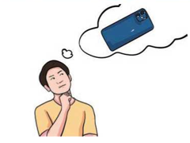
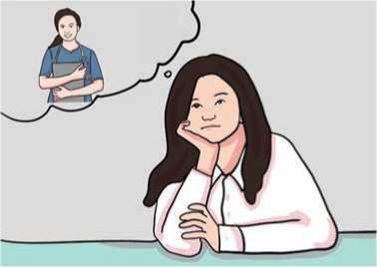
Figure 31 Imagination of fancy mobile
Figure 32 Imagination of officer
Figure 33 Imagination of doctors
Figure 34 Imaginations of paraglider
B. Listen and sing.
Oh, needs and wants,
Oh, needs and wants,
We can’t have all the things we want.
We really want
A lot of stuff,

But sometimes there’s just not enough.
Oh, needs and wants,
Oh, needs and wants,
We can’t have all the things we want.
Answer these questions.
- Can we get all the things we want? Why?
- What's the difference between needs and wants?
Reading
Look at the pictures and answer the questions.
- What are the girls doing in the pictures?
- Do you do these types of things?
- What are the benefits of doing these things?

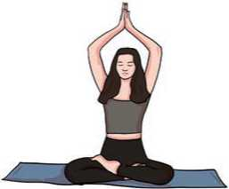
My Holiday Plan
All these years, I have spent my summer holidays going out on trips. This year I have planned to make it a productive holiday time.
I am going to focus on two things during my summer holidays this year. One is yoga and another is my favourite hobby, gardening. My father always tells me that yoga is a great art; one who practises yoga will be able to increase his/her concentration power. In order to improve my focus on studies, I have decided to go to yoga classes this year during the holidays. The local “Yoga for Youth” organisation conducts free sessions for school students every year, especially during summer holidays. I have enrolled my name for this programme and two of my friends are joining me for the same.
Figure 35 Yoga
The next thing I am planning to do is gardening. Gardening has been an interest
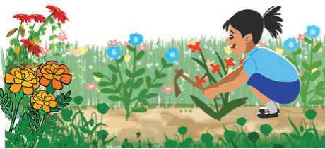
for me; but since I have dance classes every evening after school, I couldn’t do any gardening. So, I have planned to design a garden myself and give all my time during the summer holidays. Within a month or two, I am sure that the garden will be ready so that I can
Figure 36 Gardening
spend a little time to preserve all plants and trees once the school reopens. I am looking for rare plants that are good for the environment. Once my garden work is done, I am planning to build a fence around it.
Both these tasks have been my plans ever since the last summer holidays. I didn't manage to complete either of the tasks so, I am not happy with my achievements. So no matter what, I have planned to prioritise these two things and be a better person when I move to the next class.

- Choose the correct words from the box to complete the sentences.
preserve, productive, concentration, enroll, gardening, fence,
achievements, rare
- Both of their children got good grades in their examinations. They
were proud of their children's
- We must our natural resources.
- It was a meeting. I learnt a lot from it.
- Do you want to learn how to dance? If yes, …………on the course
before 25th July.
- The school has a bamboo………….You must use the front gate to enter
- A panda is a…………..animal……….. It's only found in some places.
- The ability to direct all your efforts and attention to one thing means………….
- My father is very interested in………. We have a beautiful garden.
- Read the text and write True or False for these statements.
- The writer of 'My Holiday Plan' is going out on a trip during her summer holiday.
- 'Yoga for Youth' is going to charge school students.
- She is going to get help from her father in the garden.
- She achieved a lot from her last summer holiday.
- Answer the following questions.
- What two things is the writer going to do during her holiday?
- What is the advantage of doing yoga?
- Is the writer going to yoga classes alone?
- Why couldn't she do gardening in the past?
- What type of plants is she going to grow in the garden?
- What does she plan to do when she goes to the next grade?
- What are the two most interesting things you really want to do in your coming holiday? Talk to your friends.

Pronunciation
Listen to your teacher pronouncing the word rare. Does he/she pronounce it as a single unit or more than one unit?
How many syllables do these words have? Listen to your teacher and say the number of syllables.
Example: pro-duc-tive three syllables
productive | summer | preserve | concentration | plant
herbal | fence | achievement | holiday | gardening

Grammar I
- These sentences are from the above text (My Holiday Plan). Complete them with the correct words from the text.
One yoga and another is gardening.
a.
b.
c.
My father always me that yoga is a great art.
One who yoga will be able to increase his/her
concentration power.
d.
done, I am planning to build a fence
Once my garden work …………...
around it.
to the next class.
e. I want to be a better person …………………..
Now, talk to your friends.
a. What words did you write for the blanks?
b. What class of words do they belong to?
c. What tense are the verbs in?.

B. Study the following table.

They work hard. | Do they work hard? | They do not/don't work hard.
She makes her bed. | Does she make her bed? | She does not/doesn't make her bed.
She wants to be a doctor. | Does she want to be a doctor? | She does not/doesn't want to be a doctor.
They need some water. | Do they need any water? | They do not/don't need any water.
- Complete these sentences about yourself with correct verb forms.
- My friend also in grade 7. We both in grade 7
- My father in an office and my mother
in a bank.
- Our school not very big. It only has 10 rooms.
- She likes tea but I coffee.
- We are regular students. We don't classes.
- Do you your homework every day?
- Does she ?We need a dancer for tomorrow's programme
- My mother earns a lot of money but I

Writing
You have summer/winter holidays every year. How do you spend your holidays? Write a short essay in approximately 100 words. Use the following questions as clues.
- When does your school close for the holidays?
- How long is the next holiday?
- What things do you usually do during the holidays?
- What's your plan for the coming holiday?

Listening

- Look at the pictures and answer the question.
- Can we live without these things? Why or why not?
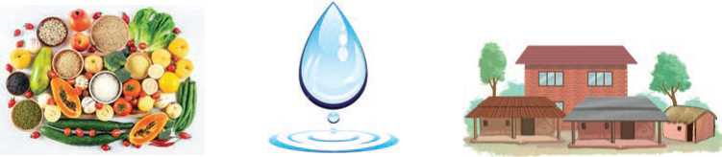
Figure 37 Foods, water and shelter
B. Listen to the audio and write True or False.
- We must have food to live.
- Shelter keeps us safe.
- People have the same needs to stay safe and healthy.
- Games and computers are necessary for us to live.
- We don't need any of the things if we want to survive.
- Listen to the audio again and complete the sentences. Use ONLY ONE word.
- We need food to
- It's to decide if something is a need or a want.
- A hamburger is a type of
- Trees and create other things we need and want.
- Look at the list of things. Discuss and categorise them into NEEDS and WANTS.
Food, computer, water, cold drinks, air, mobile phones, shelter

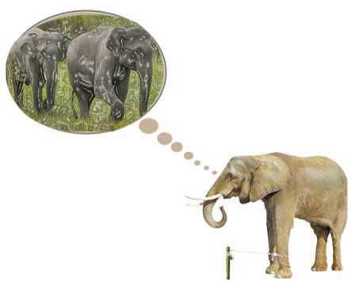

Reading
Answer these questions.
- Does the elephant in the picture look happy or sad? Why?
- Where do you think he wants to go?

The Circus Elephant
What are they thinking?
The circus elephants,
As they tramp round the ring each night?
Do they wish that they
Were far away
In the forest's leafy light? Where they'd roam at will
And could eat their fill
Far from human sight
As the gentle giants
Perform their tricks
The children stare with delight But is it fair?
Figure 38 Elephants
Should they be there
Is keeping them captive right?
- John Forster
- Find the rhyming words for these from the poem.
a. fight b. pill c. play

- Are the following statements true or false? Write True or False.
- The circus elephant walks round the ring each night.
- They want to stay in the forest.
- They are free at the circus.
- The children are happy to see the elephant's tricks.
- The circus elephant should be set free.
- Have you ever been to a circus? If yes, what types of things did you see there? If no, what types of things do you think you will find at the circus? Talk to your friends.

Grammar
- Study the following sentences.
- If the circus elephant is freed, it will walk to the jungle.
- If the elephant walks to the jungle, it will find its friends.
- If the elephant finds its friends, it will become happy.
- If the elephant becomes happy, I will be happy too.
- Choose the correct response for each of the sentences.
a. | If you  i. eat | . greasy food, you will become large. ii. will eat
b. | If your sister goes to Paris, she a good time.
 | i. has | ii. will have
c. | If he | that, he will be sorry.
 | i. will do | ii. does
d. | If I leave now, I | in Kathmandu by 8:00 p.m.
 | i. will arrive | ii. arrive
e. | You | on your test if you don't study.
 | i. won't do well | ii. don't do well
f. | They won't know the truth if you them.
 | i. won't tell | ii. don't tell
g. | If I bake a cake, | have some?
 | i. will you | ii. do you
h. | If he | you, will you answer the phone?
 | i. will call | ii. calls

Speaking
- Look at the pictures and say what they want to be.
Figure 39Jay
Figure 40 Himesh is running
Figure 41 Dinesh Doctor
Figure 42 Nitu Teacher
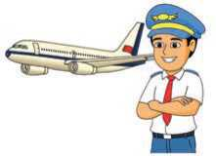
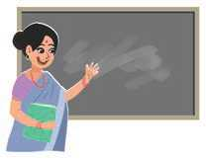
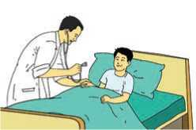
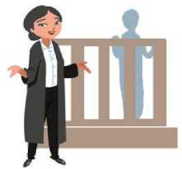
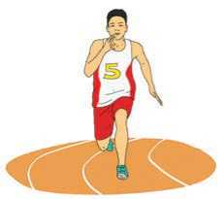
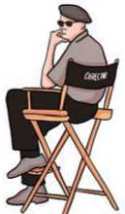
Figure 43 Pemba
Figure 44 Nabina
- Work in pairs. Take turns to complete the sentences.

Example:
A: If you want to be a doctor,
B: You need to study hard.
- If you want to be an engineer,
- If you want to be a pilot,
- If you want to be a driver,
- If you want to be a teacher,
- If you work hard,
- If you don't sleep well,

Writing
A farmer wanted his sons to be hard working. Read how he made his lazy sons hard working. Put the verbs from the brackets in the past forms to complete the story.
Once there (live) a farmer in a village. He (be) very hardworking. He (have) three sons. They (be) very lazy. This worried the farmer. He (want) his sons to take care of his fields as he (do). So, one day, he (call) his sons to his side and (say), “Dear sons, there is a great treasure hidden in one of my fields to make sure that you three never go hungry”. After a few days, the farmer (die). After that, the sons (decide) to search for the treasure their father (be) talking about. They (take) the farmer’s spades and mattocks and (dig) every portion of their field hunting the treasure. But they (find) nothing.
A friend of their father (see) this and (suggest) that they should sow some seeds. They (accept) the suggestion and (do) the same. It (rain) well that season. Days (pass). The fields (reward) their labour with good crops that season. The sons (realise) what their father's hidden treasure (be). From that day on, the sons (start) working hard.

Project work
Talk to five different people from your locality. Ask them what five things they would like to have. Create a table and write 'need' or 'want' next to each thing. Also give reasons why you think so. Share it with your friends.
S.N. | Name | Things they would like to have | Need or Want? | Why?

Extra bit
Read the story below to find the answers to these questions.
- What was the problem with the boy?
- What did his father give him?
- What do the holes in the wall mean in the boy's life?

Controlling Anger
Once, there was a young boy. This boy had problems controlling his anger. When he got angry, he would say the first thing that came to mind, even if it affected people.
One day, his father gifted him a hammer and a bundle of nails, then said, “Whenever you get mad, hammer a nail into the backyard fence.”
In the first days, the boy used up half of the nails. Over the next weeks, he used up fewer nails, until his temper was under control. Then, his father asked the young boy to remove a nail for each day he didn’t lose his temper.
On the day when the boy removed his last nail, his father told him, “You have done good, boy. But, can you see the holes in the wall? The fence is never going to be the same. Likewise, when you say mean things in anger, you’ll leave a scar.”

Unit 7

Getting started
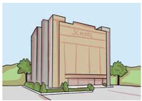
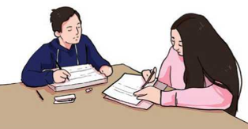
- What is your opinion about the pictures below? Why do you have those opinions? Talk to your friends.
Figure 45 Combine study

Figure 46 School in peaceful environment

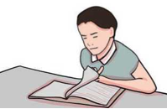
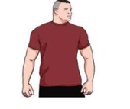

Figure 47 Reading a book
Figure 48 Healthy person

- Listen and sing.
He tells her that the earth is flat -
He knows the facts, and that is that.
In altercations fierce and long
She tries her best to prove him wrong.
But he has learned to argue well.
He calls her arguments unsound
And often asks her not to yell.
She cannot win, he stands his ground.
The planet goes on being round.
- Wendy Cope

Now, answer these questions.
- Is the earth flat or round? What does the boy say?
- Does the girl believe that the earth is flat? How do you know?
- Who do you think is right? Why?

Reading
Answer the questions below.
- Name all the food items in the picture.
- What type of food are they?
- What are the disadvantages of eating such food?

Fast Food
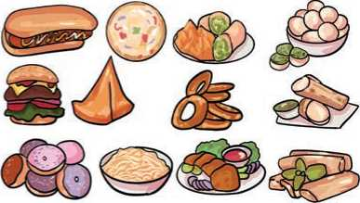
A lot of people around the world are getting fat because they eat too much junk food. Junk food is food that has a lot of calories, but not many nutrients. Nutrients are things that your body needs, such as vitamins, minerals and fibre.
Most "fast food", such as stuff sold in
Figure 49 Junk food
packages, is junk food. It comes from factories, where scientists add refined sugar, salt and vegetable oil to make it taste good. They do this because they want to make money. They do not care about your health: that is your job.
Junk food does taste good, though. That's why people drink huge bags of "iced tea" and coke, and eat a big bag of potato chips, and still feel hungry. Their brains keep telling them to eat because it knows the body does not have all the nutrients it needs.
Humans evolved eating three main kinds of food: meat, vegetables and fruits. These are "real foods". Things like refined sugar, flour and vegetable oil are not part of a human's natural diet.
In America, which has the most obese number of people, it is hard for poor people to find 'real food'. Fresh vegetables and meat are usually sold in supermarkets, and they are more expensive than junk foods. In America, more poor people are obese than rich people. Even people in prisons are obese.
Here, we are lucky. Real food is still available but so is junk food. Your body is the most valuable thing you will ever have in your life, so you should treat your body like a temple - not a garbage bin. I think, you shouldn't eat junk food.

A. Match the words in column A with their meanings in column B.
Column A | Column B
a. nutrients | i. made pure by having other substances taken out
b. refined | ii. very useful or important
c. obese | iii. substances needed to keep a living thing alive and grow
d. valuable | iv. waste food, paper, etc. that you throw away
e. garbage | v. very fat, in a way that is not healthy

- Answer the following questions.
- Why are people in the world getting fat?
- Give some examples of nutrients.
- Why do you think refined sugar is added into fast food?
- Which is not a real food? Why?
i. Apple ii. Bean iii. chicken wing iv. potato chips
- Which country has the most fat people?
- How should we treat our body? Why?
- What is the writer's opinion about junk food?
- Do your parents encourage you to eat real food or junk food? Talk to your friends.

Pronunciation
/'nju:triant/ /ri'faind/ /ao'bi:s/ /'vsljuabl/ /'gcvbidy/

Grammar
- Read the above text again and underline all the verb forms with 'to +verb'.
Example: 'to make'
- Study the following sentences.
- She studies hard to get better grades.
- He goes to the gym to be healthy.
- I went to the cinema to see the new film.
- I play computer games to have fun.
- She went to the park to play with her friends.
- Put the words/phrases into the correct groups.
to travel to speak to other people to keep fit
to be healthy to run faster to play with other friends
to get a good job to understand films and music to get good grades
We learn English | We do exercise
D. Match the two halves of the sentences to make them meaningful.

a. He is going to the shop i. to see the Dharahara.
b. He's making a card ii. to ask for help with his homework
c. He went to Kathmandu iii. to give it to his mother
d. They were at the cinema iv. to buy a new computer game.
e. He called his friend v. to get extra pocket money.
f. He washes the car every Sunday vi. to watch a film .

Listening

- Answer these questions.
- A habit is a routine behaviour. What are your habits? Make a list of any five habits.
- Are they good habits or bad habits? Ask your friends.
- Listen to the audio and write True or False for these statements.
- Not all people have bad habits.
- All smokers think that smoking is a bad habit.
- Making a noise while eating in England is a bad habit.
- The speaker wants other people to stop their bad habits.
- He doesn't like it when people arrive late for meetings.
- The speaker wants motorists to improve their driving habits.
- What habits was the speaker talking about in the audio? Make a list of those habits. Do you have any of those habits? Share them with your friends.

Writing
- Tick the correct sentence from each group below.
a. | I know, what you want.
 | I know what you want.
 | I know what you want?
 | I know What you want.
b | You don't know me well do you?
 | You don't know me well, do you
 | You don't know me well do you?
 | You don't know me well, do you?

c | He said, I am a student.
 | He said I am a student.
 | He said "I am a student."
 | He said, "I am a student."
d | Ugh! Why are you yelling at me?
 | Ugh, why are you yelling at me.
 | Ugh, Why are you yelling at me?
 | Ugh! Why are you yelling at me!

- The following text has several punctuation errors. Rewrite the text correcting the errors.
winston is one of the most laid-back people i know he is tall and slim with black hair and he always wears a t-shirt and black jeans his jeans have holes in them and his baseball boots are scruffy too he usually sits at the back of the class and he often seems to be asleep however when the exam results are given out he always gets an "A" i don't think hes as lazy as he appears to be.

Reading

Answer these questions.
- What two things are shown in the picture?
- What does the picture imply?
- Do you think that a pen is more useful than a sword? Why?

The Pen is Mightier than the Sword
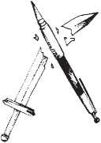
I would like to thank you all for giving me the opportunity to stand in front of you and deliver a speech today. The topic of my speech is The Pen is Mightier than the Sword. It’s a very popular proverb. We all know that a sword is a very powerful weapon
Figure 50 The Pen is Mightier than the Sword

and can give enormous power to the person holding it. It is so powerful that with this you can even make people bow down to you and establish your supremacy. However, you can enslave a person physically, but cannot enslave his mind and heart. This power lies with the pen. Pen, even though small in size, is known to be more powerful than the sword.

History gives us enough proofs to realise that military power does not last for a long time. Alexander the Great, Napoleon Bonaparte and Hitler are some examples. On the contrary, the teachings and sayings of the great writers are remembered by the people forever. It doesn’t die down and has a lasting impact. In fact, writers, poets and scientists never die, but live in our hearts forever through their exemplary works.
The ability of a human is to put their thoughts on a piece of paper. What makes human beings superior to animals? It is not their physical strength, but their mental faculty and the way they think differently. Therefore, it’s not the sword, but the pen, from which powerful thoughts flow down that make humans superior to other animals on this earth.
Thus, I would want to say that violence never ever helps. So, the pen is indeed mightier than the sword because what can be achieved through language and thoughts cannot be achieved through violence and power.
So, adopt the path of non-violence and influence the world with your pen. Thank You!
- Match the words in column A with their meanings in column B.
Column A | Column B
a. enormous | i. providing a good example for people to copy
b. supremacy | ii. to accept something
c. enslave | iii. extremely large
d. exemplary | iv. a position in which you have more power or status
e. violence | v. to make somebody a slave
f. adopt | vi. physical force so as to damage
- Complete the sentences with the words from column A above.
- Is there too much on TV?
- The company has established total over its rivals.
- The boy has a/an record. Follow him.
- The turnip is It weighs 1 kg.
- Read the text again and write True or False for the following statements.
- The speaker is thankful to all the audience.
- One can enslave another's heart and mind too.
- Writers are always remembered by people.
- The mental ability of human beings makes them superior to other animals.
- The speaker says that violence never helps.
- The writer believes that the pen is mightier than the sword.
- What arguments does the speaker make to support her statement 'The pen is mightier than the sword'? List the main points.

Speaking
- In the reading text above, the speaker says that the pen is mightier than the sword. Do you agree with the speaker? Talk to your partner. Use the following expressions.
- I think
- I believe
- In my opinion,
- I strongly believe that
- I'm sure that
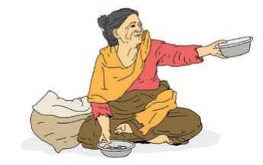
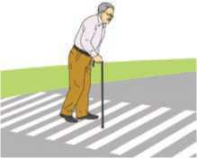
- Look at the pictures. What is happening in each of them? Is it right or wrong? Give your opinions. Think broadly. Use the expressions from A above to start your statements.
Figure 51 sanitation by students
Figure 52 Adult begger
Figure 53 Fedding a goat
Figure 54 Zebra crossing
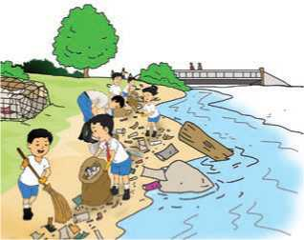
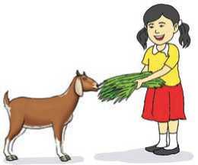
- Some people say life is much easier in the city than in the village. Do you agree or disagree? Give your opinion.

Grammar
- Study the following sentences.
- I'm just leaving my office. I'll be home in an hour.
- Please be quiet. The children are sleeping.
- Mina is going to a new school next month.
- What are you doing next week?
- Are you listening to me?
- Are they coming to the party?
- I'm tired. I'm not doing that.
- She isn't going home until Tuesday.
- In your opinion, what is happening in the picture below? Write as many sentences as you can.
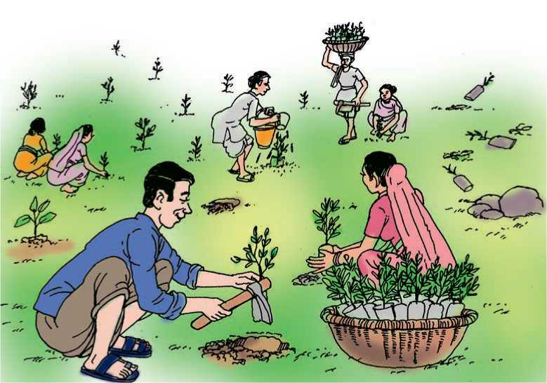
Figure 55 Plantation
- Use present simple or present continuous form of the verbs to complete the sentences. It could be affirmative, negative or a question.
Example : (you come) tonight?
Are you coming tonight?
A (he/eat) rice every day?
- I (work) at the moment.
C (he/go) to Kathmandu often?
- They (not/come) to the party tomorrow.
- They (go) to a restaurant every Saturday.
- She (not/go) to the cinema very often.
- I (not/drink) coffee very often.
- Keep quiet! Julie (sleep) now.
- I am (read) a story these days.

Writing
Some students think that having a lot of homework is good, while others don't like doing homework at all. What do you think? Write a short paragraph expressing your opinion.

Project work
Consult with your English teacher. Set a topic for a speech competition and organise the event in your class.

Extra bit
Study the use of different punctuation marks.
Full stop (.) | Jane and Jack went to the market.
Question mark (?) | When did he leave for the market?
Exclamation mark (!) | What a beautiful flower!
Comma (,) | Thanks for all your help, Nita.
Semicolon (;) | He was hurt; he knew she only said it to upset him.
Colon (:) | She bought four things: a shirt, a pair of shoes, a scarf and a story book.
Hyphen (-) | I have a part-time job.
Apostrophe (') | He's done the work on time.
Quotation marks (" ") | "Don't go outside," she said.

Unit 8

Getting started
- Look at the pictures. Take turns to ask and answer questions as in the example.
Example:
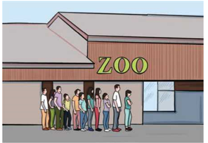
What did you do yesterday? I went hiking.
Figure 56 Zoo
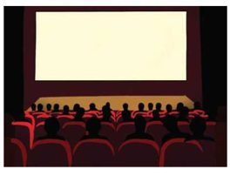
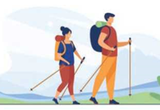
Figure 57 Nepali Thali set
Figure 58 cinema hall
Figure 59 Trekkers

B. Listen and sing.

I gave a letter to the postman,
I gave a letter to the postman,
he put it in his sack.
But in early next morning,
he brought my letter back.

She wrote upon it:
Return to sender, address unknown.
No such number, no such zone.
Write the past forms of all the verbs used in the above song.

Reading
Answer the questions.
- Describe the road in the picture below.
- Have you ever travelled along a similar road? How did you feel?

A Trip to a Village
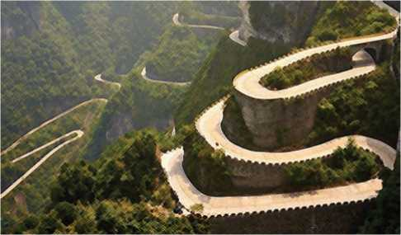
Last year, three friends of mine decided to spend a holiday in the mountains. They set off by car early in the morning. By the late afternoon they had almost reached the village where they were going to stay. They had a quick cup of tea at a wayside cafe. They set off again along the winding road that led to the mountains. They had a map with them. According to the map, the village they were going to stay in was only about fifteen miles away.
Figure 60 Hill side road
It got dark and it began to rain too. This made it more difficult to see the road clearly. After they had driven for about fifteen miles, there was still no sign of the village. Obviously, the map they had was not a very good one.
They went on for another five miles and then the car suddenly stopped. At first, my friend thought that they had run out of petrol but, on examination, they found that this was not the problem. Something else was wrong with the car. Since they could not start it again, they decided to spend the night in the car. They had very little food with them and there was not much room for three people.
Early in the morning, a car came along the road. They stopped the driver and asked him where the village was. He told them that it was just on the other side of the hill. They tied their car to his car and he pulled them to the top of the hill. After that their car ran all the way downhill to the village. They found a hotel and had a good breakfast. Of course, if they had walked up the hill the night before, they would not have had to spend an uncomfortable night in the car.
(Source: Basic Comprehension Passages, Longman)
- What are the words/phrases for these meanings below? Find them from the text above and write them down.
- to use up or finish a supply of something
- not feeling physically relaxed
- clearly
- having many bends
- started/began a journey
- the act of looking at something very carefully
- space
- Now, complete these sentences with the words you found above.
a. | I couldn't sleep because the bed was so
b. | They for Kathmandu just after 10 a.m.
c. | The walk follows a ... | path through the forest.
d. | Diet and exercise are . | important for our health.
e. | They had | . of time for the trapped miners.
f. | After a thorough  device was harmless. | , they announced that the suspicious
g. | Is there enough ... | for all of us to sleep?

- Are these statements true or false? Write True or False.
- They drove all day without stopping until the car broke down.
- They forgot to take a map with them.
- Their car stopped because they had run out of petrol.
- They spent a comfortable night in the car.
- They had to push their car to the top of the hill.
- Answer the following questions.
- Where were the three friends going to spend their holiday?
- Why was it difficult to see the road?
- How long did they drive until the car stopped after tea?
- What did they ask the driver of the passing car?
- What did the driver tell them?
- What was the first thing they did when they reached the village?
- Write all the past forms of verbs from the above story 'The First day of Holiday'. Choose at least five of them to talk about yourself.

Pronunciation
Listen to your teacher. Notice what sounds the '-ed' in the words make and put them in the correct column.
decided, reached, stopped, asked, pulled, walked, pumped, cheered, wanted, practised, jumped, finished, enjoyed, demanded, played, nodded, planted, hatched, briefed, turned
/t/ | /d/ | /Id/

Grammar
- Study these sentences.
- They went on for another five miles and then the car suddenly stopped.
- They thought that they had run out of petrol but they found that this was not the problem.
- Although they had very little food with them, they decided to spend the night there.
- They had very little food with them, however, they decided to spend the night there.
- There was not much room for three people, however, they managed to sleep there.
B. | Match the two halves to make meaningful sentences.
a. | We wanted to go to the show | i. | however, I went to bed late last night.
b. | Shall we go to the cinema | ii. | but there weren’t any seats left.
c. | Although burgers are very tasty, | iii. | and watch the film you were talking about?
d. | My neighbours are friendly | iv. | they are not very healthy.
e. | I feel extremely tired, | v. | but they’re noisy.

- Complete these sentences with and, but, although or however.
- I passed the exam, , I didn't get a better score.
b it was raining, we still went to the park.
- She worked hard made a lot of money.
- I like her , I don't like her friend.
- He was late was allowed to get in.
- She is rich helpful.
- I finished the homework, it wasn't easy.
h we had an umbrella, we got extremely wet.
- She didn't want him to see her hid behind a plant.
- I don't like running, I like swimming.
- She was feeling cold, , she went for a long walk.

Listening
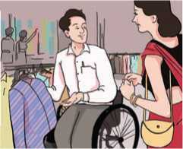
- Look at the picture and answer the questions.
Figure 61 Buyer and seller bargening
a. What do you think is happening in the picture?
b. Have you ever been shopping? What did you buy?
B.

Listen to the audio and answer the following

questions.
- What did Mary do at the weekend?
- Who accompanied Mary to the restaurant?
- Why didn’t Peter go out at the weekend?
- Who are the people talking?
- Listen to the audio again and complete these sentences.
- Mary a new dress from the shopping store.
- She went home and a shower.
- Tom and Mary at the Green Stake.
- They the dinner very much.
- Peter a cough and fever.

Writing
A. Ask these questions to your friends. Write down their answers in complete sentences.
Questions | Friend 1 | Friend 2 | Friend 3 | Friend 4
When was your last vacation/trip?
Where did you go?
How did you get there?
Who did you go with?
What did you do?

- Where did you go on your last vacation? Write a short paragraph about it. Try answering the above questions in your paragraph.

Reading
Look at the picture and answer the questions.
- Who do you think the woman is?
- Have you heard anything about her? State what you know.

Anuradha Koirala
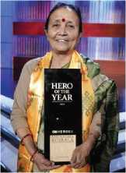
I was born on 14th April, 1949 to Colonel Pratap Singh Gurung and Laxmi Gurung. I studied at St. Joseph Convent School in Kalimpong, India. It was from the school where I started my devotion towards social work.
Mother Teresa has always been my largest source of inspiration. I spent more than 20 years teaching children at various schools around Kathmandu. Although this brought me great satisfaction, I realised that I had a bigger personal calling to fulfill. Children, girls and women were being trafficked within and from Nepal for sexual exploitation. Therefore, in 1993, I founded Maiti Nepal with the aim of providing services for both children and
Figure 62 anuradha Koirala

women who have endured untold pain and suffering, often in silence.
After establishing Maiti Nepal, I got involved in the service of humanity. My first work was setting up of a home. Now, Maiti Nepal has three prevention homes, eleven transit homes, two hospices and a formal school. More than 1000 children are receiving direct services from Maiti Nepal every day. It was all made possible with my determination and leadership.
Maiti Nepal today conducts a wide range of activities. They are: organising awareness campaigns, community sensitisation programs, rescue operations, apprehending traffickers, providing legal support, women empowerment programmes etc.
So far, I have been awarded 38 national and international awards for my courageous acts and achievements. Some of the national and international awards include; Prabal Gorkha Dakshin Bahu Medal- Nepal 1999, Trishaktipatta Award 2002, Best Social Worker of the Year Award - Nepal 1998, German UNIFEM Prize 2007, Queen Sofia Silver Medal Award 2007, The Peace Abbey, and Courage of Conscience 2006. Due to my continuous struggle, Government of Nepal now recognises 5th September as an anti-trafficking day. In 2010, I was declared as CNN Hero. It was the result of my struggle to fight the social evil of human trafficking. My victory as CNN hero is a pride and honour to the nation itself. (Retrieved and adapted from www.maitinepal.org)
- What do these numbers, date and years refer to? Read and write.
Example:1949: Anuradha Koirala was born.
a. | 20
b. | 1993
c. | 1000
d. | 38
e. | 1999
f. | 2006
g. | 2010
h. | 5 th Sep.

B. Match the words on the left with their meanings on the right.
a. | devotion | i _{t} | something that makes you continue do something
b. | inspiration | ii. | hospitals
c. | endure | iii. | morally bad and cruel
d. | hospices | iv. | great care and support to somebody/ something
e. | determination | v. | to deal with something that is painful
f. | apprehending | vi. | the act of giving somebody more power
g. | empowerment | vii. | given the awards
h. | awarded | viii. the source of desire to do something
i | evil | ix. | catching somebody and arresting them

- Answer the following questions.
- Where did Anuradha Koirala receive her school education?
- Was she fully satisfied with her teaching job? How do you know?
- Why did she establish Maiti Nepal?
- Why was she awarded with different prizes?
- Why do you think she was declared a CNN hero?
- Is her victory as CNN hero just a proud moment for her? Why?

Grammar
- Study the following sentences.
- Anuradha Koirala used to teach school children, but now she doesn't.
- She established Maiti Nepal in 1993.
- I used to play marbles when I was a child, but now I don't.
- I played football yesterday.
- People used to travel on foot 300 years ago, but now they can travel by bus.
- People did not use to work in factories 500 years ago.
- Rewrite these sentences using used to as in the example. Use negatives too.
Example: My family/go to Pokhara for the weekend.
My family used to go to Pokhara for the weekend.
- Dinesh/not like watching sport.
- My sister/have short hair.
- Nitu/not wear jeans .
- We/go to visit our relatives on New Year's Day.
- I/go to bed early.
- My grandfather/drink a cup of coffee after dinner.
- He/walk along the beach every evening.
- She/love playing badminton.
- I/have long hair.
- Complete the story. Use past simple forms of the verbs from the brackets.
One autumn evening, Charles and Beth (go) to the theatre. They
(attend) a play. The play (start) at 7:00 p.m. Charles and Beth (enjoy) the play. After the play, they (walk)
together in the park. They (walk) beside the lake. The moon
(be) bright. They (talk) about their future. When Charles and Beth (go) home, their children (not be) asleep. They
(wait) for Charles and Beth to return. They (be) excited to hear about the play. Charles (tell) the children about the play.
Then, Beth (put) the children to bed. Charles and Beth
(be) very tired. It (be) a good night!

Speaking
- Work in pairs. Take turns to talk about your past habits. Talk about at least five things you used to/didn't use to do.
- What did you do last week? Complete the table below. Work in pairs and take turns to ask and answer as in the example. Use the past tense.
Day | What did you do?
Sunday | went to the market and bought some books.

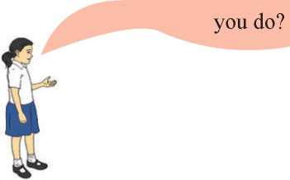
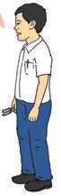
Example:
Last Sunday, I went to the market and bought some books. What did
I went to the
field with my
father.
- Look at the pictures below. They make a story. Discuss with your friends. Try telling the story. 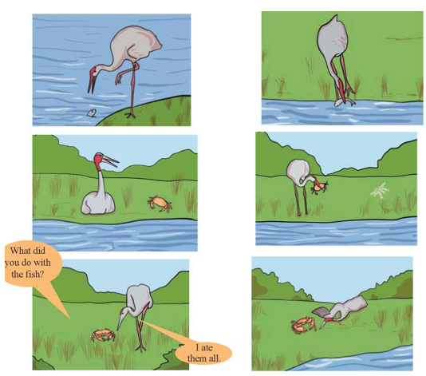 Figure 63crane try to catch fish, crane catch fish, after while it saw crab, it catch crab, conversation with crab and finally crab teach lesson to crane.

Writing

Write the story from C above. Use these points to help you. Use past tense.
Old crane can no longer catch fish starving finds an idea tells
fish that the fisherman would come and catch them fish asks crane to
help them takes them to another pond eat them one day
crab asks the crane to take him to the other pond crane agrees along
the way crab notices fish bones ... asks the crane about the fish crane said
that he ate them all crab kills the crane with his pincers.

Project work
Visit an elderly person in your neighborhood. Ask him/her what they used to or did not use to do. Make a list and share with your friends.

Extra bit
Use the correct forms of verbs from the brackets to complete the story. Suggest a title for the story and retell it to your friends. You can draw a suitable picture for the story.
There (be) a dog that was very hungry. He (search) for food everywhere and at last he (find) a bone. He (pick up) the bone with his mouth and (start) going back to his home. There (be) a bridge on the way to his home. When he (start) crossing it he (see) his reflection in the water. The dog (think) that there (be) another dog with a bone in the water. He (want) to get the other bone too. So, he (start) barking at his own reflection. His bone (fall) in to the water as soon as he (open) his mouth. The greedy dog (lose) his bone.

Unit 9

Getting started
- Look at the pictures. Take turns to ask and answer questions as in the example.
Example:
Which is higher: Mt. Makalu or Mt. Dhaulagiri?
Mt. Makalu is higher than Mt. Dhaulagiri./Mt. Dhaulagiri is shorter than Mt. Makalu.
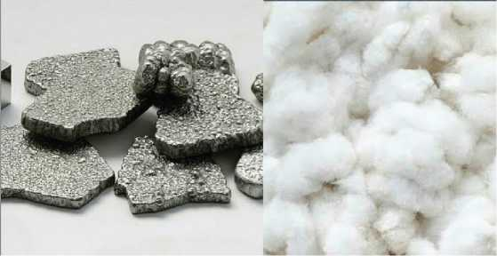
Mt. Makalu
8463 m
Mt. Dhaulagiri
8167 m
Figure 64 Pencil
Figure 65 pebbles and snow
- Listen and sing.
What doesn't kill you makes you stronger
Stand a little taller
Doesn't mean I'm lonely when I'm alone
What doesn't kill you makes a fighter
Footsteps even lighter
Doesn't mean I'm over 'cause you're gone
What doesn't kill you makes you stronger, stronger
Just me, myself and I
What doesn't kill you makes you stronger
Stand a little taller
Doesn't mean I'm lonely when I'm alone.
What are the '...er' words of these words?
strong tall light

Reading
Answer the questions.
Figure 66 Chart II
Figure 67 Chart I
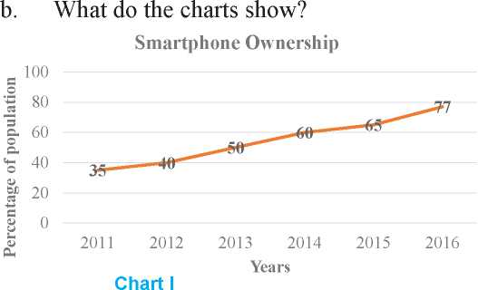
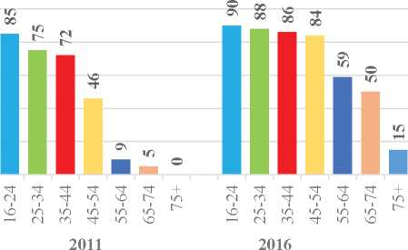
a. Why do you think the charts are different?
100
80
Chart II
Smartphone ownership by age group: 2011 and 2016
The first chart illustrates the percentage of the population who owned a smartphone from 2011 to 2016. The second breaks the percentages down by age for 2011 and 2016.
Overall, smartphone ownership increased during the six-year period. In general, the younger people were, the more likely they were to own a smartphone. However, the most significant increases in smartphone ownership between 2011 and 2016 came from people aged 45 to 54, from 46% to 84%.
The percentage ofpeople who owned a smartphone rose steadily, starting at around 35% in 2011 and reaching about 77% by 2016. People aged 16 to 24 represented the greatest percentage of smartphone ownership in both 2011 and 2016.
Although almost nobody in the 75+ age category owned a smartphone in 2011,
15% of this group owned smartphones in 2016. It seems they have developed more interest in modern technology.
- Match the words with their meanings.
a. | illustrates | i. | important
b. | ownership | ii. | be a symbol of something
c. | significant | iii. | the fact of owning something
d. | steadily | iv. | shows
e. | represent | v. | gradually and in an even and regular way

- Answer the following questions.
- What does the second chart show?
- By what percentage have the smartphone owners increased in the period between 2011 and 2016?
- In which age group are smartphones the most popular in 2016?
- What is interesting about the 75+ age group?
- Look at the charts and the descriptions again and ask and answer comparative questions in pairs.

Pronunciation
Learn the pronunciation of '...er' words.
higher | younger | heavier | bigger
wiser | taller | smarter | clearer

Grammar
- Study the following sentences.
- My sister thinks she's more intelligent than me, but I don't agree.
- Avatar is probably the worst film I've ever seen.
- What is the wettest month of the year in Nepal?
- Do you think films are better than books?
- Who is the most powerful person in your village?
- I think Ritesh is funnier than Nitesh.
- Is Nitu older than Nima?
- John is the nicest person that I know.
B. Fill in the missing forms of the given adjectives.
Positive | Comparative | Superlative
intelligent | more intelligent | most intelligent
 |  | worst
 |  | wettest
 | better
 |  | most powerful
 | funnier
 | older
 |  | nicest

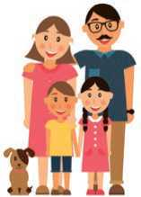
- Complete the following sentences to make comparison with correct forms of the adjectives from the brackets.
a. | The clothes here are | (good) than the ones in my town.
b. | It’s (far) than I thought - I think we’re lost.
c. | That’s the | .. (disgusting) meal I’ve ever had!
d. | I hope your team’s | (lucky) today than last week.
e. | They’re  old one. | (happy) in their new school than in their
f. | Your tomato sauce is | (tasty) than my mum’s.
g. | Is this flower | (beautiful) than that one?
h. | This is the | .. (interesting) book I have ever read.
i. | Non-smokers usually live | (long) than smokers.
j. | What is the | ... (dangerous) animal in the world?

Listening
- Look at the picture and answer the questions.
- Who do you think they are?
- Who is taller: the man or the woman?
Figure 68 Nuclear Family
- Listen to the first part of the audio and complete the table. Place a tick in the correct box.
Descriptions | Mother | Father
older
more active
more talkative
taller
- Listen to the second part of the audio and complete the sentences with not more than two words.
- Los Angeles and San Francisco are in California.
- San Francisco is than Los Angeles.
- Los Angeles is than San Francisco.
- San Francisco is than Los Angeles.
- The speaker says San Francisco is a place to live.
- Work in small groups (maximum five). In two minutes, write as many adjectives as you can from the audio.

Speaking
- Observe the pictures. Use the adjectives to make comparisons.
tall intelligent heavy fast strong dangerous slow
Example: A lion is more dangerous than a snail.
An elephant is the largest animal.
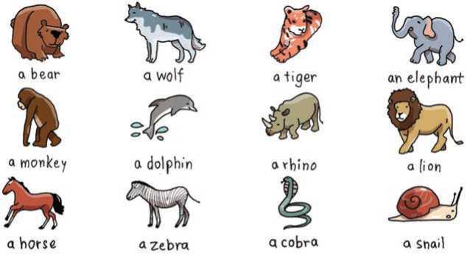
Figure 69Picture Name;A bear, A Wolf, A Tiger, An Elrphant, A Monkey, aDolphin, A Rhino, A Lion, A Horse, A Zebra, A Cobra, ASnail

- Look at the following clues (a-f) and make a comparison as in the example.
Example: | English/interesting/Nepali.
 | English is as interesting as Nepali.
a. | apple/sweet/orange
b. | bullet train/fast/airplane
c. | algebra/difficult/geometry
d. | grammar/easy/spelling
e. | apple/sweet/orange
f. | morning/warm/afternoon

Writing

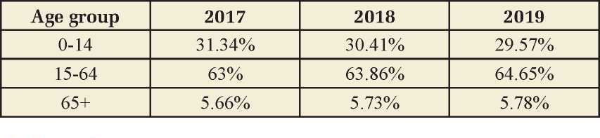
The table below shows the age-wise population percentage of Nepal over three years. Interpret the table in your own words.

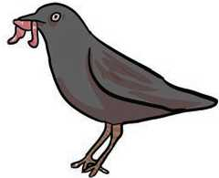
Figure 70 Bird with worm

Reading
Guess the answer to these question.
a.Name the bird in the picture.
b.Which is stronger: a crow or a worm? Why?
A Bird, came down the Walk
A Bird, came down the Walk
He did not know I saw
He bit an Angle Worm in halves
And ate the fellow, raw.

And then, he drank a Dew
From a convenient Grass
And then hopped sidewise to the Wall
To let a Beetle pass.
He glanced with rapid eyes,
That hurried all abroad
They looked like frightened Beads, I thought,
He stirred his Velvet Head.
- Emily Dickinson
- Write the words that rhyme with these words.
saw grass abroad
- Answer the following questions.
- What did the bird bite?
- Where did the bird drink water from?
- What was his head made of?

Grammar
- Complete the following sentences with the correct superlative forms of the adjectives below. Please read carefully before answering.
high delicious smart cold boring
lucky valuable long funny
Example: He bought the most valuable jewellery for his mother.
- Yesterday was the day of the year. I almost
froze to death walking home from school!
- Please give me your recipe. That is the cake I’ve ever eaten.
- Aaradhya is the student in our class. She gets the top grades
in every course.

d. | Samjhana told the | .... story last night. I couldn’t stop laughing.
e. | The Nile is the | river in the world.
f. | Ramila is the  lottery four times! | person I know. She has won the
g. | He is the | speaker I have ever heard. Half the
 | audience fell asleep during his speech.
h. | Mount Everest is the .... | mountain in the world.

- Complete the following sentences with the correct form (comparative or superlative) of the adverb provided.
- I drive (carefully) than my husband.
- Anu works (hard) than I do, but our secretary works
(hard) of us all.
- Anita sings (beautifully) of all the people in the choir.
- Our teacher explains the lessons (clearly)than yours.
- Pema arrived at the meeting (early) than Barun did.
- Kamal arrived (early) of them all.
- Make comparisons of the following. Use your own ideas.
Example: papaya/orange/watermelon
A papaya is bigger than an orange. A papaya isn't as big as a watermelon.
A watermelon is the biggest fruit of the three.
- turtle/rabbit/fox
- feather/book/television
- running shoes/bedroom slippers/high heeled shoes
- bicycle/motorcycle/car
- teacher/doctor/lawyer

Writing
Write your answers to the questions below. Ask one of your friends the same questions and make notes. Then, write a paragraph about the similarities and differences that you and your friend have.
Question | Me | My friend
How old are you?
Are you shy?
Do you like to watch television?
Do you like pets?
Do you like mobile phones?
Do you like to tell stories or jokes?
Do you love to exercise?

Project work
Collect the number of students in different grades of your school. In a group of five, make a bar chart on chart paper. Try to make it as attractive as possible and stick on the classroom wall.

Extra bit
Look at the two pictures. Write any five sentences to make comparisons between them.
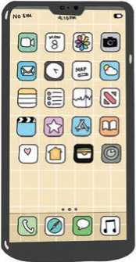
Figure 71 Telephone
Figure 72 Mobile

Unit 10

Getting started
- Look at the signs below. What do you think they mean? Talk to your friends.
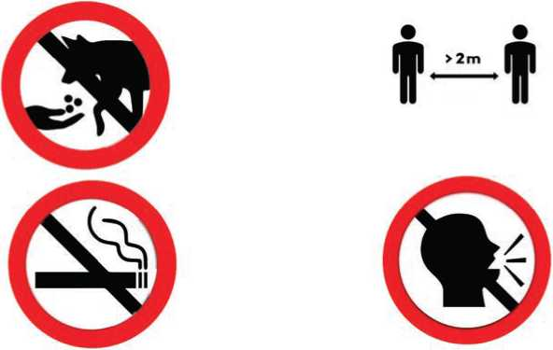
Figure 73 donot feed coyote, Keep the 2 meter distance, no smoking and keep silence

- Listen and sing.
I couldn't see, now I can.
I wouldn't listen, now I will.
He may seem happy, but he might be sad
You ought to be kind, you should do your best
can and could
will and would
may and might
ought to and should
You don't have to walk, no you needn't
'cause I'm able to drive, yes I can
We have to,
We must obey the traffic lights
We can go on green but we mustn't on red.
Don't have to and needn't
able to and can
have to and must, mustn't and can't.
Underline all the auxiliary verbs (e. g. could) in the above song.

Reading
Answer the following questions.
- What is the text below about?
- Have you heard of Covid-19? What have you heard?
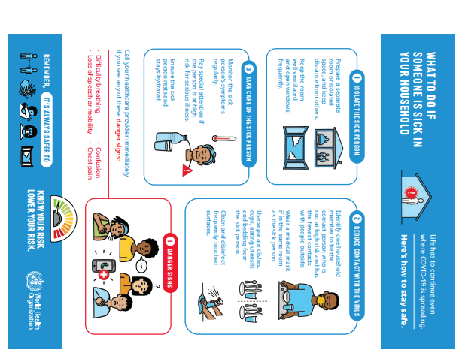
Figure 74 Preventive Measures of Covid-19
R RISK.
A.
a. | isolated | i. | to clean something using a substance that kills bacteria
b. | ventilated | ii. | changes in your body or mind that show that you are not healthy
c. | disinfect | iii. | made something/somebody take in and hold water
d. | symptoms | iv. | away from others
e. | hydrated | v. | devices or tools used in kitchens
f. | utensils | vi. | allowed fresh air to enter and move around a room
Match the words with their corresponding meanings.

- Answer the following questions.
- How should a sick person be isolated?
- What should the isolation room be like?
- How can you protect yourself if you and the sick person are in the same room?
- When should the surfaces be cleaned?
- What are the serious symptoms of Covid -19?
- What three things should be done if somebody is sick in your household?
- Who has prepared the brochure?
- Communicate the five safety measures of Covid-19 to your friend.
Example: Keep a distance.

Pronunciation
Learn the meanings of the following words from your teacher or from a dictionary. Also, learn their pronunciation.
antibody | contact | trace | isolate | coronavirus
epidemic | pandemic | immunity | hygiene | sanitiser

Writing
Prepare a one-page leaflet similar to the above poster on ‘How to stay safe from Covid-19?' for the juniors.

English Grade 7 99

Listening
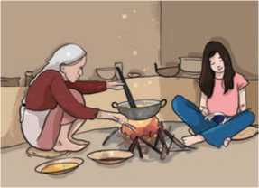
- Look at the picture and answer the questions.
Figure 75 Grand mother with grand daughter
- Who do you think the people are in the picture?
- Where do you think they are?
- What do you think the grandmother is doing?
B. Listen to the audio and complete the table below.
The grandmother is going to cook
The girl must wear an
They must mix everything to get the
The dough must be rolled with a
The grandmother is not going to let the girl slice the
The girl can cut the
The girl must be careful with the
They shouldn't bake the pizza for more than
They are going to the park to have some
They are taking their roller skates and

- Listen to the audio again and write down two-word verbs like ‘should wear’.

Reading
Answer the following questions.
Have you ever visited or heard of zoo?
a.
b.
c.
d.
What do you find in a zoo?
What are the dangers in a zoo?
Do you think there are rules for visitors in a zoo?

Central Zoo
Jawalakhel, Lalitpur
Rules
Respect the Animals
Please treat the Zoo animals with the respect they deserve. Do not yell at or taunt the animals, do not bang on their enclosures and do not throw objects into their habitats.
Respect your Boundaries
Never cross any fence or barrier in the Zoo. Do not try to touch the animals— if an animal has teeth, it can bite; if an animal has claws, it can scratch. This is for the safety of both our visitors and our animals.
Do Not Feed the Animals
The animals at Central Zoo have veterinarian approved and formulated diets to ensure their health and wellbeing. Human food may make them sick.
Note: You may feed the animals that participate in the “Feed Your Friends” programme with approved food purchased from the gift shop.
No Smoking
To decrease fire hazards and ensure the safety and health of the animals, guests and staff, smoking is not permitted inside the Zoo. This includes the parking lot too.
No Pets
All pets are prohibited in the Zoo to protect both the zoo animals and your animals.
Children Must be Supervised at All Times
We get it— kids are adventurous and like to wander! However, we want your kids to stay safe. Keep an eye on them and make sure they are supervised at all times. Any individual under the age of 16 must be accompanied by an adult when visiting the Zoo.
- Identify from the text above, the single word that means the following.
- to utter a loud cry, scream, or shout
- a remark made in order to anger, wound, or provoke someone
- dangers or risks
- being forbidden
- Complete the sentences below with the words from the box.
yell veterinarian prohibited accompanied
- You shouldn’t smoke here. Smoking is in this building.
- Do not leave your dog alone. It should be by the
owner at all times.
- My sister is a She treats animals.
- Do not at the baby. She is crying.
- Are these statements true or false? Write True or False.
- Visitors shouldn’t tease the Zoo animals.
- Visitors can give food to the Zoo animals.
- Smoking is allowed at the parking lot.
- Visitors can take their pets to the Zoo.
- Children aged 15 can go to the Zoo on their own.
- Answer the following questions.
- Why aren’t visitors allowed to go close to and touch the animals?
- When can you feed the Zoo animals?
- Why should the children be supervised at all times?
- Which rule do you like or dislike the most? Why?
- Some people tend to violate the rules. What do you think of their behaviour? How might you improve people's behaviour? Talk to your friends.

Grammar
- Study the following sentences.
- You can put your shoes there.
- You are allowed to put your shoes there.
- You can’t leave your car there. It’s a no parking zone.
- I must call an electrician to get the light fixed.
- You mustn’t worry about me. I’ll be fine.
- You have to have a driving license to drive a tractor.
- You are not allowed to drive a tractor without a driving licence.
- You don’t have to have a licence to ride a bicycle.
- Complete the sentences with the correct word/phrases. You can use the words more than once.
can can't must mustn't have to don't have to
- The sign says we park the bicycle here.
- The chemist sell medicines without prescriptions.
- Visitors park their cars in the staff car park.
- Baggage be attended every time.
- You be late to class.
- I call my sister. It’s her birthday today.
- You go to the bank. You can pay online.
- You hit your friend again! Do you understand?
- You remember everything. Just try to remember these
points.
- The hotel is vegetarian. You find a meat item there.
- You park your bike here for a maximum of 25 minutes.
- Complete the B sentences using can/could/might/must + given verbs from the brackets as given in the example. In some sentences, you need to use the negative too.
Example
A : I’m hungry.
B : But you’ve just had lunch. You can’t be hungry already. (be)
- A : I haven’t seen our neighbours for ages.
B : No. They in their house. I saw them in the morning. (be)
- A : What’s the weather like? Is it raining?
B : Not at the moment but it later. (rain)
- A : Where has Manshu gone?
B : I’m not sure. She have gone to the bank. (go)
- A : I didn’t see you at John’s party last week.
B : No, I had to work that evening, so I (go)

Speaking
- Look at the signs below. Tell your friends what they mean. Use must or mustn’t.
ff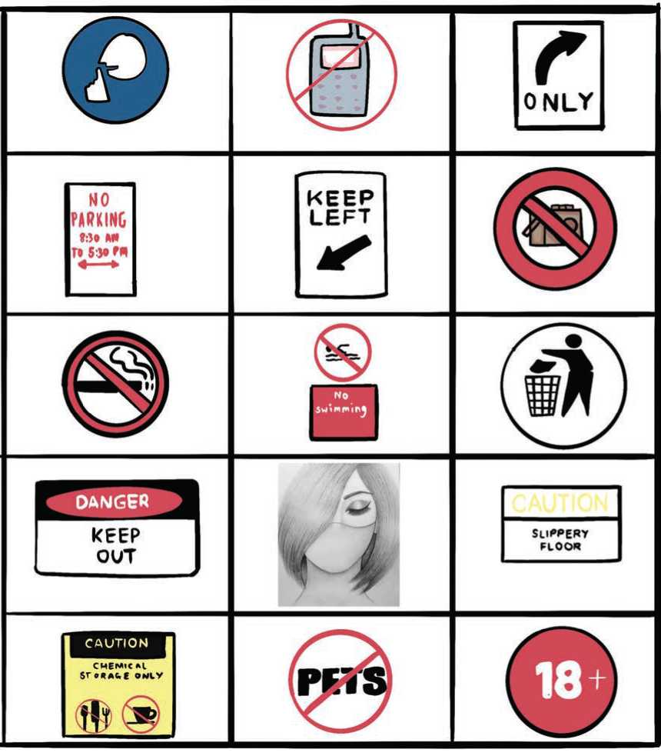

- Dinesh has to do many things today. Look at the 'To-Do-List' and say what he has to do today.
- pay the electricity bill
- buy a pair of sandals
- buy a kilo of sugar
- wash clothes and brush shoes
- cook food in the evening
- Choose one topic from the following ‘How to list. Work in pairs and take turns to talk about the topic. Use the structures in the box below as a prompt.
- How to pass an exam?
- How to earn money?
- How to persuade others?
- How to win the football match?
- How to be a good student?
You have to
You must
You should
You don't have to
You mustn't
You shouldn't

Writing
- Here are some rules for school students. Complete the sentences with appropriate words. You may need to use negative forms as well.
You attend every lesson.
You be even one minute late.
You do all your homework.
You look at your watch to check the time.
You come early and do your homework before the class.
You bring all your textbooks.
You worry about making mistakes when you are speaking.

- You might have a library or a computer lab at your school. Prepare a set of rules (at least six) to be followed by students when they visit that area.

Project work
Work in groups of four or five. Gather information about Covid-19 from different sources. Make a set of rules and regulations to follow for protecting yourself from the disease. Display them at different locations around of your school.

Extra bit
Read the story below and discuss the answers to these questions.
- Why did the Dean give the second question?
- What would be the answer to the second question?
- Were the students lying to the Dean?

The Four Smart Students
One night, four college students were out partying late and didn’t study for the test which was scheduled for the next day. In the morning, they thought of a plan. They made themselves look dirty with grease and dirt. Then, they went to the Dean and said they had gone out to a wedding last night and on their way back, the tyre of their car burst and they had to push the car all the way. So, they were in no condition to take the test.
The Dean thought for a minute and said they can have the re-test after 3 days. They thanked him and said they will be ready by that time.
On the third day, they appeared before the Dean. The Dean said that as this was a Special Condition Test, all four were required to sit in separate classrooms for the test. They all agreed as they had prepared well in the last 3 days.
The test consisted of only 2 questions with the total of 100 points.
- Your Name (1 point)
- Which tyre burst? (99 points)
Options - (a) front left (b) front right (c) back left (d) back right

Unit 11

Getting started
- What do you think you see in the pictures? Describe them to your friends. Say five things for each picture.
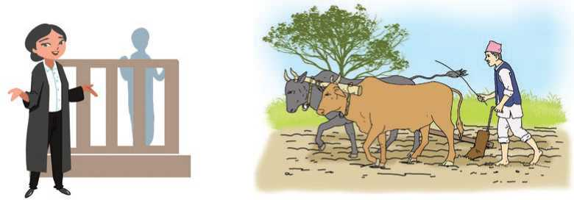
Figure 76 picture A. judge picture B. Farmer

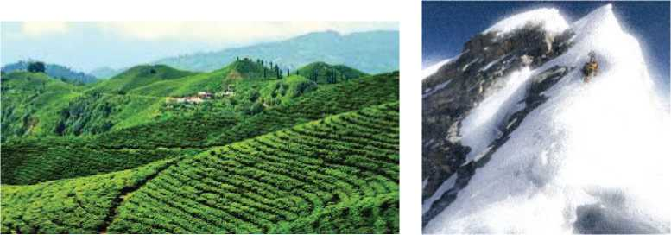
Figure 77 picture A. hilly region B. mountain region

- Listen and sing.
It might seem crazy what I'm about to say.
I'm a hot air balloon that could go to space.
Clap along if you know what happiness is to you.
Clap along if you feel like that's what you wanna do.
Look for five other words that rhyme with space and you.

Reading
Answer the questions.
- Who do you think the person in the picture is?
- What do you think his profession is?

Dr. Sanduk Ruit
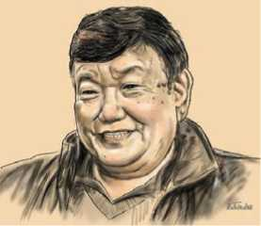
Dr. Sanduk Ruit who is an ophthalmologist was born on September 4, 1954 in the remote mountainous village Olangchunggola, Taplejung, Nepal. It was one of the most remote locations of Nepal with no electricity, no school and no health facility. Ruit was the second of his parents’ four children.
The nearest school from his village was eleven days' walk away in Darjeeling. His father, a small-time businessman, placed a priority on providing education to his children, and sent Ruit to St. Robert's School in Darjeeling. In 1969, Ruit did his SLC at Siddhartha Vanasthali School in Kathmandu, Nepal. He was further educated in India. He studied MBBS from King George's Medical College, Lucknow from 1972 to 1976. He further studied at All India Institute of Medical Sciences, Delhi. He also studied in the Netherlands, Australia, and the United States.
Figure 78 Dr. Sanduk Ruit
In 1980, while working on a Nepal Blindness Survey, Ruit met Fred Hollows, an Australian eye surgeon who soon became his mentor. Hollows helped Ruit choose his life’s path: to restore eyesight to people who are unnecessarily blind. Ruit went on to study with Hollows at Sydney’s Prince of Wales Hospital in Australia. Hollows and Ruit held the idea that all people with treatable blindness have the right to restored eyesight. In 1995, Ruit developed a new lens that could be produced far more cheaply and is used in over 60 countries. Ruit's method is now taught in U.S. medical schools. Despite being far cheaper, Ruit's method has the same success rate as western techniques.
In 1994, Ruit and The Fred Hollows Foundation founded the Tilganga Eye Centre. The Centre is now called the Tilganga Institute of Ophthalmology.

Tilganga has performed over 90,000 operations and trained over 500 medical personnel from around the world.
As a tribute to his remarkable achievements, Dr. Ruit has received a number of prestigious awards. In June 2006, he was awarded the Ramon Magsaysay Award. In 2018, the Government of India honoured him with the Padma Shri, India's fourth-highest civilian honour. And, in 2021, Government of Nepal awarded Dr Sanduk Ruit with Suprasiddha Prabal Janasewashree (First).
Now, Dr. Sanduk Ruit is the co-founder of the Himalayan Cataract Project. Its mission is to bring eyesight back to anyone who needs it, regardless of his or her ability to pay.
- Which words in the text have the following meanings? Write the words from the text. The first letter has been given.
- something that you think is more important than other things: P....
- to bring back a situation that existed before: R....
- unusual way that causes people to take notice: R....
- that can be treated/cured: T....
- an act to show respect: T....
- a doctor who treats eye diseases: O....
- having a lot of prestige: P....
- aim: M....
- a doctor who performs operations: S....
- Complete the table with the information from the text above.
Year | Event
1954 | Born
1972-1976
1980
1995
2006
2018
2021

- Write True or False for the following statements.
- Dr. Ruit was born in the early 50's.
- He is the eldest child of his parents.
- His father gave importance to his childrens' education.
- He did his SLC in India.
- He studied MBBS in Nepal.
- Ruit developed cheaper eye lenses.
- Tilganga Eye Centre is now known as Tilganga Institute of Ophthalmology.
- Answer the following questions.
- Where was Dr. Ruit born?
- What was his father's occupation?
- How far was the nearest school from his home?
- Name the countries where he studied.
- What is special about Dr. Ruit's new eye lenses?
- When was Tilganga Eye Centre established?
- What type of awards has Dr. Ruit got?
- Work in pairs. Take turns to talk about Dr. Sanduk Ruit in your own words.

Pronunciation
Learn these words with the help of your teacher.
ophthalmologist | radiologist | biotechnologist | zoologist
psychologist | dermatologist | ornithologist | criminologist

Writing
Write a short biography of a person you like most. Use the following clues to help you.
- Full name, date of birth, place of birth
- Early life
- Educational details highlighting any major achievements
- His/her contribution to the society
- Why he/she is famous
- Awards and achievements

Grammar
- Study the following sentences.
- Dr. Sanduk Ruit is an ophthalmologist. He cures people's eyes.
Dr. Sanduk Ruit is an ophthalmologist who cures people's eyes.
- Olangchunggola is a remote place. It lies in Taplejung. Olangchunggola is a remote place which lies in Taplejung.
- They are the boys. They were dancing at the party yesterday.
They are the boys who were dancing at the party yesterday.
- This is the house. I was born here.
This is the house where I was born.
- She is the girl. She cuts my hair.
She is the girl who cuts my hair.
- Complete the sentences with who, where or which.
- I have a friend speaks four languages.
- We should only buy products can be recycled.
- I can't find the pen I borrowed from you.
- Do you remember the park we met?
- At the party, there were three people knew me.
- I want to see the film everybody's talking about.
- What's the name of the man lives next door?
- This is the computer I bought from my friend.
- Look at the man is dancing with your sister.
- That's the house I lived as a child.
- Combine the sentences using who, which or where. The beginning of each sentence is given.
- These are the friends. I met them in Kathmandu.
These are the friends
- That's the neighbour. He helped us.
That's the neighbour
- What's the name of the film? You watched the film yesterday.
What's the name of the film ?

- He drives a car. The car is very expensive.
He drives a car
- The octopus is the only animal. It has three hearts.
The octopus is the only animal
- That's the shop. I bought my TV from that shop.
That's the shop
- This is the school. I studied in this school.
This is the school
- That's the bus. It was broken down yesterday.
That's the bus

Listening
- Answer the following questions.
- Name the following things.
- What are they used for?
- Complete the sentences with the words from the audio. USE ONLY ONE WORD.
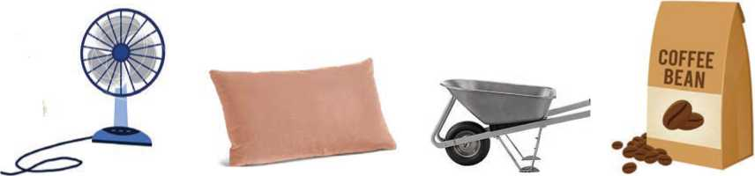
Figure 79 First picture is Table Fan, Second Picture is Cushions, covers, Third picture is Groundwork Steel. Fourth picture is Coffee Bag

Fan | It's made of and metal.  It is used for keeping the room
Pillow | It is in shape.  It is used for
Wheelbarrow | It is used for moving things around in the  It has one wheel and two
Coffee | It is in colour.  It gives us

- Talk to your friends about the objects above. Say: what they are, what they are made of and what they are used for.

Speaking
- Look at the pictures. Work in pairs and take turns to describe and identify each person.
Example: A: Who is the woman wearing a white coat?
B: The woman who is wearing a white coat is a doctor.
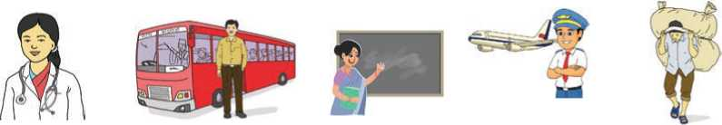
Figure 80 Nurse, Bus Station, Teacher, Airline Pilot, Asian Farmer,

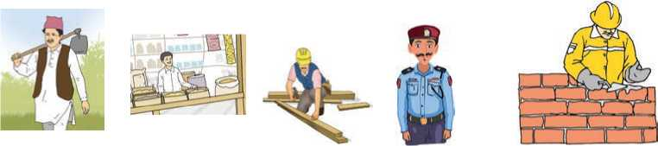
Figure 81 Farmer, Shop Keeper,Carpenters, Police, Building a Solid

Look at the images again. Do you think there are any problems with them? Talk to your friends.
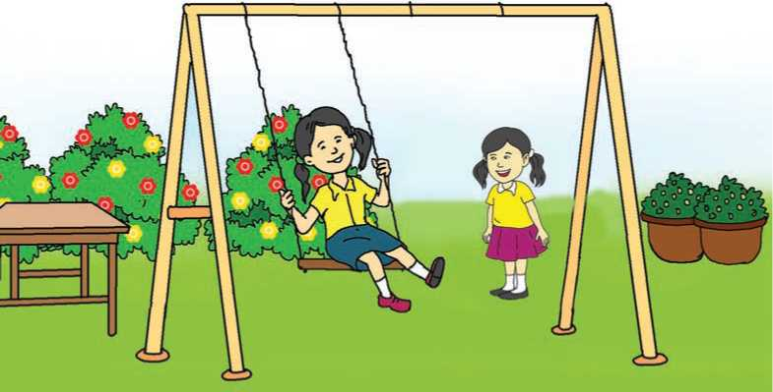
- Look at the picture. Describe the scene in five sentences.

Figure 82 Children Play Swing in the park

- Look at the objects. Describe them. Talk about: what they are made of, what they look like and what they are used for.
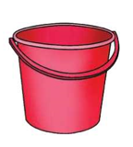
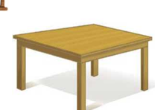
Example: The pencil is made of wood. It is long. It is used for drawing.
Figure 83 Bucket
Figure 84 Table
Figure 85 White Board and pencil
Figure 86 Book
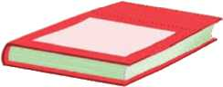
Figure 87 Ball

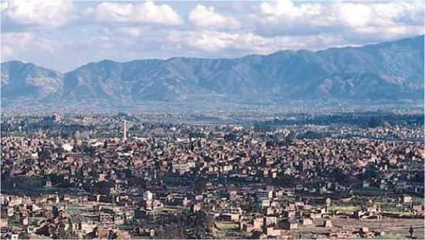

Reading

Answer the questions.
- Which city is shown in the pictures?
- What things is it famous for?

Kathmandu
Kathmandu is the capital of Nepal. It lies in a hilly region at 4,344 feet (1,324 metres) above sea level. It was founded in 723 by Raja Gunakamadeva.

The present name comes from Kasthamandap which refers to a wooden temple said to have been built from the wood of a single tree in 1596.
In the 1970s, the construction of new roads and the expansion
of air travel were centred upon Kathmandu, making it the hub of the national transportation system.
Figure 88 Kathmandu City
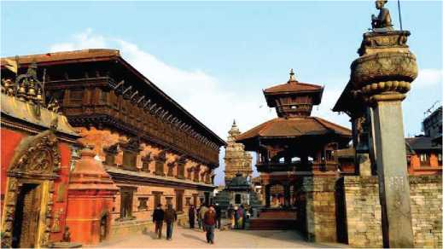
Kathmandu’s present day streets contrast strongly to the older sectors of narrow streets and brick houses with carved doors and windows. Destruction caused by an earthquake in 1934 CE (Common Era) resulted in the construction of many modern-style buildings. The city’s most notable building is the old palace of the Malla Kings, which includes Taleju temple (1549), built by Raja Mahindra Malla. The palace’s main gate is guarded by a figure of the God Hanuman; in a small, adjoining square.
To the east is Tundikhel, the parade ground, from which important government pronouncements were formerly made first to the army. There is a tall tower built by Bhimsen Thapa, a former prime minister. On the outskirts of Kathmandu, there are many palaces built by the Rana family. Singha Durbar which was once the official residence of the Rana prime ministers and is now housing the government secretariat. About 3 miles northeast is the great white dome of Boudhanath, a Buddhist shrine revered by Tibetan Buddhists. The surrounding Kathmandu Valley, noted for its vast historic and cultural importance, was designated a UNESCO World Heritage site in 1979 CE. Vulnerable to urban sprawl, it was placed on the List of World Heritage in Danger in 2003 CE but was removed from the list in 2007 CE after conservation efforts from the government.
Figure 89 Windows Place
On April 25, 2015, an earthquake with a magnitude 7.8 earthquake struck central Nepal with its epicentre about 50 miles northwest of Kathmandu. Some 9,000 people were killed and about 16,800 were injured throughout Nepal by the main quake and numerous aftershocks. Kathmandu was also severely damaged, especially the buildings in its historic centre, and tens of thousands were made homeless.

A. Match the words with their meanings.
a. | hub | i. | next to or joined to something
b. | carved | ii. | the parts of a city that are furthest from the centre
c. | adjoining | iii. | a spherical roof with a circular base
d. | pronouncements | iv. | weak or easily hurt
e. | outskirts | v. | construction spreading in an ugly way
f. | dome | vi. | a central point
g. | vulnerable | vii. | formal public statements
h. | sprawl | viii. | having the patterns on something made by cutting

- Complete the sentences with the words from above.
- The government made some…….. on changes in its policy.
- They live on the of Kathmandu.
- The roof of the stadium looks like a
- Old people are highly to the flu.
- The airport has become an international
- The door of the temple looks nice.
- They live in rooms.
- Answer the following questions.
- What does Kasthamandap mean?
- What prompted the construction of modern style buildings in Kathmandu?
- Who built Taleju temple?
- What is meant by Tundikhel?
- Where is Boudhanath located?
- Why did UNESCO list various sites of Kathmandu in the World Heritage List?
- What was the impact of 2015 earthquake on Kathmandu?
- Suppose you are talking to a foreigner who doesn't know anything about the place where you live. Describe it to him/her.

Grammar
- Study the following sentences.
- My name is Ram Karki. What is your name?
- I'm from Dhading. Where are you from?
- She is sad because she's lost the match. Why is she sad?
- She is my sister. Who's she?
- Banks open at 10 o'clock. When do banks open?
- Make questions for these statements so that the answers will be the words in bold.
a. | They went to Spain. | b. | He writes novels.
c. | The girls watched a movie. | d. | He discovered the truth.
e. | I am leaving at 7:00 a.m. | f. | This is my book.
g. | He runs fast. | h. | I like pop music.
i. | There are twenty students. | j. | The film was interesting.

Writing II
Write a short paragraph describing your village/town. Use the given clues.
Name-location-area covered-where does the name come from? - special features- your likes and dislikes about your town/village.

Project work
Go to the library and look for information about a famous person from Nepal or abroad. Prepare a poster/mind map. Include the information such as; name, date of birth, place of birth, major contributions, name of the awards he/she has received.
Extra bit
Choose the correct words from the brackets to complete the sentences.
a. Mary pronounces every word ...................... . (clear/clearly)
b. We like to go sailing in ...................... weather. (clear/clearly)
c. The teacher asked us an ...................... question. (easy/easily)
d. I answered the teacher's question ...................... . (easy/easily)
e. You speak English very ...................... (good/well)
f. Your English is very ...................... (good/well)

Unit 12

Getting started
- What do the people in the picture look like? Describe each

person.
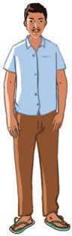
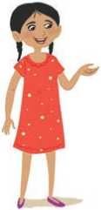
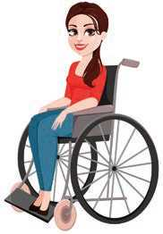
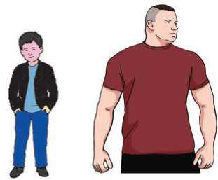
Figure 90 Tall man
Figure 91 small girl
Figure 92 PHYSICALLY DISABLE WOMAN
Figure 93 sMALL BOY WITH PHYSICALLY FIT MAN
- Listen and sing.
What does he look like?
Is he short or tall?
What colour are his eyes?
He has short black hair and brown eyes.
What does she look like?
Does she have long hair?
Are her ears small or big?
Does she wear glasses?
She is short and has a small nose.

Answer these questions.
- What is the boy like in the song?
- What is the girl like in the song?

Reading
Answer the questions.
- Who do you think the person in the picture is?
- Describe what he looks like.

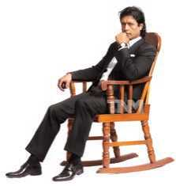
Height : in centimetres - 188 cm
: in metres - 1.88 m
: in feet - 6'2"
Weight : in kilograms - 78 kg
Eyes : brown
Hair : black
Face : oval
Figure 94 Rajesh Hamal

Differences between People
People differ physically from the moment of conception, but it is only after birth that the difference can be observed. Eye colour, skin colour and the texture of our hair are all different and depend on our inherited genes. A baby born with ginger hair may in a few months’ time have fair hair as the birth hair falls out. Hair can be fine, thick, straight or curly, and as we grow older it gets thinner. Some people experience hair loss at quite an early age whilst others have a full head of hair throughout their lives. People with dark hair may find that it turns to grey or white even before they reach their 40's.
European people, in general, have paler skin if their ancestors come from Africa or Asia. Skin can change colour if exposed to sunlight.
The rate at which we develop and grow differs. Boys and girls of the same age show big differences in growth especially when they reach puberty. At the age of 12, girls are much taller than boys of the same age, but at 16 years of age, boys shoot up and usually overtake the girls in height and body strength.
The way the body develops is not just a result of physical changes, as our mental processes have a large part to play in what we want to achieve. A desire to become a skillful footballer, a long distance runner or a strong swimmer requires

stamina and years of practice to try and attain the top level.
The food we eat will, to a certain extent, determine how we grow and gives us strong bones. A lack of activity and eating too much sugary food can result in people gaining excessive amounts of weight. It seems unfair that one person can eat all sorts of fattening food and not put on weight whilst others just 'looking at a cream cake' can put on pounds or kilos.
- Find the words from the text above which mean the following.
- having qualities similar to those of your parents, grandparents, etc.
- the process of an egg being fertilized inside a woman's body
- the way something feels
- grow taller rapidly
- physical or mental strength that enables you to do something difficult.
- Choose the correct answer.
- What changes take place in a baby a few months after birth?
- The noise they make
- Their skin colour
- Their hair
- What causes pale skin to become brown?
- Exposure to the sun
- Staying indoors
- Covering the body with sun cream lotion
- Roughly, at what stage in their development do girls start to grow in height?
- When they start learning to swim
- When they eat raw vegetables
- When they reach puberty at the age of 12 or 13
- What happens to our bodies if we eat too much and do not do enough exercise?
- We feel happy.
- We get fat and overweight.
- Our muscles become weak.

- What words are used to describe eyes, skin and hair in the text above? Talk to your friends.

Pronunciation
Listen to your teacher saying these words and put them in the correct box.

Falls, others, turns, differences, girls, results, amounts, bones, changes, boys, girls, processes.

/s/ | /z/ | /iz/

Grammar
- Study the following sentences. Notice the use of look and look like. Also notice what words are used after them.
- Rajesh Hamal looks tall.
- He looks handsome.
- A child looks beautiful.
- It looks like it's going to rain.
- He looks like his father.
- She looks beautiful.
- Complete the following sentences with look(s) or look(s) like.
- My little sister always says she a princess.
- Ann her mother.
- You stressed. What's the matter?
- Your trousers are very fashionable. You smart.
- She's older but she healthy.
- That house a palace!
- You don't cheerful. Are you okay?

C. | Match the questions with the possible answers. Sometimes, answers can repeat or more than one answer can be correct.
a. | What's Naresh like? | i. | She's very pretty and tall.
b. | How are you? | ii. | She's very shy.
c. | Who do you look like? | iii. | He's tall and blue eyed.
d. | What do you like? | iv. | Like her mother, very talkative.
e. | What does he look like? | v. | She's better, she left hospital yesterday.
f. | What's she like? | vi. | My mother.
g. | What does Mike look like? | vii. | Sports cars and science fiction.
h. | Who does Mike look like? | viii. | Not bad, thanks!
i. | How's your mother? | ix. | He looks like his father.
^{j}. | Who's Ann like? | x. | He's very talkative.

D. Choose and write the correct verb: look(s), be like, look(s) like or like.
- Peter worried. Is he ok?
- What She ? - She's tall, pretty and very friendly.
- You an actress in this dress!
- Who she ? Like her father, very determined.
- She (not) very happy today.
- They dancing but they don't like singing.
- What does your brother ? - He's tall with blue eyes.
- What they ? - They're very friendly.
- They angry. What's the matter?

Listening
- Study the following sentences and learn the meanings of the bold words.
- My brother and I both play sports. He's like me.
- A: What does Sam look like? B: He's tall and wears glasses.
- Listen to the audio in which Tom and his father are talking about Tom's friends. Answer the questions below.
a. | Patrick has short, brown, straight hair.  i. TRUE ii. FALSE
b. | Who is a talkative person?
 | i. Tom's teacher ii. Patrick | iii. Marcel
c. | Tom says Marcel . . . .
 | i. is short ii. likes him | iii. is tall
d. | Who looks like Harry Potter?
 | i. Marcel ii. Tom | iii. Patrick
e. | Tom and . . . like to talk about video | games at lunch.
 | i. Dad ii. Patrick | iii. Marcel
f. | What are Tom and Dad going to do?
 | i. play a game ii. go shopping | iii. go out

- What words did Tom use to describe his friends? Write as many words as you can remember.

Speaking
A. Look at the words to describe people's appearances. Discuss what they mean.
General appearance | beautiful, pretty, funny, cute, handsome, attractive
Age | young, middle-aged, old
Build | thin, slim
Height | short, medium-height, tall
Eyes | blue, brown, small
Face | round, oval, square
Nose | straight, hooked, long, small
Mouth | large, small
Ears | large, small

B. Look at the pictures. Talk about their general appearance, age, build,
height, eyes, face, nose, mouth or ears. Use the words from
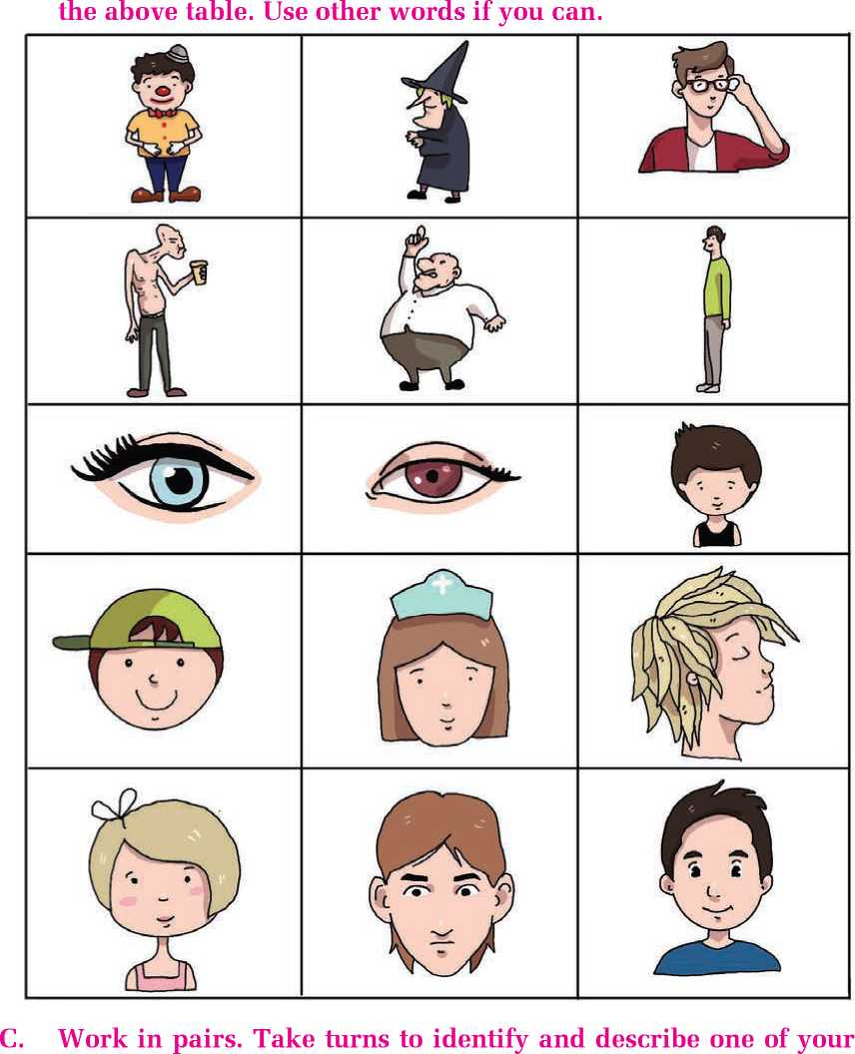
friends in your class. Talk about his/her height, ears, nose, eyes, face, build, etc.

Writing
Write a paragraph about a friend. Describe that person. Remember to include information such as height, hair (colour; long or short; straight, curly or wavy), age, and facial characteristics. Also describe that person's personality and why you like him or her.

Reading

Answer the questions.
- What do you see in the picture?
- Why do you think the grass is moving?
- Have you ever been into a playground when there is wind? How do you feel?

Wonderful World
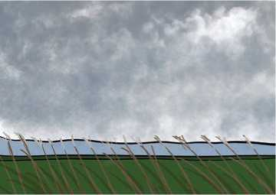
Great, wide, beautiful, wonderful World, With the wonderful water round you curled, And the wonderful grass upon your breast— World, you are beautifully dressed.
Figure 95 natural scenario
The wonderful air is over me,
And the wonderful wind is shaking the tree, It walks on the water, and whirls the mills,
And talks to itself on the tops of the hills.
You friendly Earth, how far do you go,
With the wheat-fields that nod and the rivers that flow,
With cities and gardens, and cliffs, and isles,
And people upon you for thousands of miles?

Ah! you are so great, and I am so small,
I tremble to think of you, World, at all;
And yet, when I said my prayers today,
A whisper inside me seemed to say,

"You are more than the Earth, though you are such a dot:
You can love and think, and the Earth cannot!"
- W.B. Rands
- Find the rhyming words for these words from the poem.
a. breast | b. me | c. mills | d. go
e. isles | f. small | g. today

- Answer the following questions.
- What does the wind do to the tree?
- Who does the wind talk to?
- Why is the wind so great?
- What does the whisper say?

Grammar II
- What does the wind do in the poem? Study these sentences.
It walks on the water.
It whirls the mills.
It talks to itself.

Now, look at these sentences.
- I work at a bank.
- She lives with her parents.
- Cows feed on grass.
- She earns a handsome salary every month.
- Momila wants to be a singer.
- Complete the sentences with correct forms of verbs from the brackets.
- The plane at 6.30 p.m. every day. (arrive)
- I will phone you when he back. (come)
- Unless we now, we can’t be there on time. (start)

 | d. The sun | .... in the east. (rise)
 | e. The next term | this Monday. (begin)
C. | Turn a-g into questions as in the example.
 | Example: Where/you/live? | Where do you live?
a. | How many children / you / have? | b. How often / you / study English?
c. | What time / the film / start? | d. Where / you / play volleyball?
e. | When / you / drink tea? | f. Why / he / play football?

Writing
How do you spend a typical day? Write a paragraph describing what you do from the morning to the evening. Use present simple tense.
Project work
Work in groups of five. Look for other/more words to describe the physical appearances of people. Draw pictures to illustrate the appearances and stick them on the wall.

Extra bit
Read the story below and find the answers to these questions.
- What was the stag very proud about?
- What was he unhappy about?
- What lesson do you learn from the story?

The Stag and its Reflection
Once upon a time, there lived a stag in a dense forest. It looked beautiful because of his horns. Once, it was thirsty. He went to a pool to quench his thirst. The water was so clear that the stag could see his reflection quite clearly.
On seeing his antler’s image in the water, the stag felt very proud of its beauty. But suddenly on seeing his fore legs being very slender, the stag felt very sad without thinking that they gave him his high speed. After quenching his thirst, the stag raised his head and was shocked to see a lion nearing him. So, he took to his heels and the lion was left far behind.
But unluckily, the stag’s antlers were caught in a thick bush. He tried his best to relieve it but he could not. The stag now realised his mistake of praising his horns and condemning his legs. But it was too late. The lion came there, caught him and tore him into pieces.

Unit 13

Getting started
A. Look at the pictures. What do you think they can/can't do and
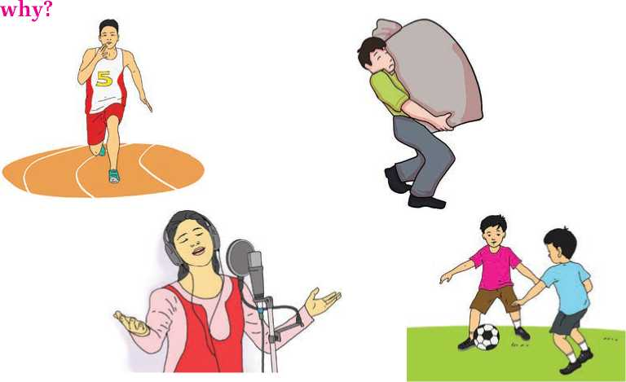
Figure 96 picture A. running, picture B. lifting load, picture c. singing and picture D. playing Football
- Listen and sing.
Any man can claim, few can find.
Any girl can blink, few can lie.
Anyone can promise, few can raise.
Anyone can try, but a few can stay.

Any brain can hide, few can stand.
Any kid can fly, few can land.
Any gang can scatter, few can form.
Any kid can chatter, few can inform.
Any soul can sleep, few can die.
Any dog can weep, few can cry.
Everyone complains, few can state.
Anyone can stop, few can wait.
What can any woman/man/girl/brain/kid/gang/soul/dog do? Talk to your friends.

Reading
Answer these questions.
- What do you think the people are doing in the picture?
- Who do you think they are?

A Terrifying Night
Shortly after the war, my brother and I were invited to spend a few days' holiday with an uncle. He had just returned from abroad. He had rented a cottage in the country, although he rarely spent much time there. We understood the reason for this after our arrival: the cottage had no comfortable furniture in it, many of the windows were broken and the roof leaked, making the whole house damp.
On our first evening, we sat around the fire after supper listening to the stories which our uncle had to tell of his many adventures in distant countries. I was so tired after the long train journey that I would have preferred to go to bed; but I could not bear to miss any of my uncle's exciting tales.
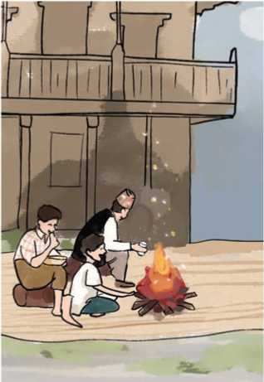
He was just in the middle of describing a rather terrifying experience when there was a loud crash from the bedroom above, the one where my brother and I were going to sleep.
Figure 97 Cottage
"It sounds as if the roof has fallen in!" exclaimed my uncle, with a loud laugh. When we got to the top of the stairs and opened the bedroom door, we could see nothing at first because of the thick clouds of dust which filled the room. When the dust began to clear, a strange sight met our eyes. A large part of the ceiling had collapsed, falling right on to the pillow of my bed. I was glad that I had stayed up late to listen to my uncle's stories, otherwise I should certainly have been seriously injured, perhaps killed.

That night we all slept on the floor of the sitting-room downstairs, not wishing to risk our lives by sleeping under a roof which might at any moment collapse on our heads. We left for London the very next morning and my uncle gave up his cottage in the country. This was not the kind of adventure we cared for.
- Learn these words and use them in the sentences below.
Abroad, damp, adventure, terrifying, collapsed
- The road to Karnali is dangerous, however, it's an to
travel along the road.
- Look! The building has Let's not go nearer.
- My sister studies She is in Australia.
- Our grandfather tells us stories about witches.
- The roof of the cottage leaks. It makes the cottage
throughout the rainy season.
- Choose the correct answer.
- The writer did not go to bed immediately after supper because
- it was pleasant sitting round the fire.
- his uncle terrified him with his stories.
- he wanted to hear all his uncle's exciting stories.
- his uncle made him listen to his stories.
- It was quite clear that the ceiling had fallen in
- when they opened the bedroom door.
- after the dust had begun to clear.
- as soon as they heard the crash.
- when they reached the top of the stairs.
- The word 'leaked' in the passage means
- was beginning to fall down.
- let the rain in.
- needed to be repaired.
- was in bad condition.
- The word 'injured' means
- killed.
- not hurt.
- wounded.
- trapped.
- Answer the following questions.
- Had the writer's uncle bought or rented the cottage?
- Why didn't the writer's uncle spend much time in his cottage?
- Why did the writer not go to sleep?
- Was the writer's uncle amused when he heard the loud noise?
- What could have happened to the writer if he had gone to sleep earlier?
- Why were they afraid to sleep upstairs that night?
- Did the writer's uncle continue living in his cottage?
- Imagine that you were the writer's uncle. Tell your friends about the incident.

Writing
Have either you, your family members or friends ever experienced a similar incident to the one in the story? What happened? Write a paragraph.

Pronunciation
Listen to your teacher and learn how to pronounce these words. Notice the letter 'r'.
war | brother | for | our | were | other
train | story | roof | otherwise | very | wear

Grammar

A. Study the following sentences. They are based on the previous story.
- The writer couldn't bear to miss any of his uncle's exciting stories.
- The writer could see nothing because of the thick cloud of dust.
- They couldn't sleep upstairs because the roof might fall in at any time.
- The writer couldn't stay there the next day because of his fear.
- Study these sentences too.
- I can touch the ceiling because I'm tall.
- I could run fast when I was a child.
- I couldn't speak English when I was in grade one.
- I can't run because I have a problem with my leg.
- He can't come to school because of his illness.
- Choose the correct answer.
a drive a car?
i. He can ii. Can he ii. Can he to
- Can the children read yet? Yes,
i. they read. ii. you can. iii. they can.
- He when he was a child.
i. couldn't swim ii. couldn't to swim iii. can swim
d draw well when you were a child?
i. You could ii. Could you to iii. Could you
- She two kilometres.
i. can to swim ii. can swim iii. can swims
- Complete these sentences with the words from the brackets.
a. | We stayed inside | . the storm. (because/because of)
b. | I wanted to stay longer  (since/because of) | ... I was really enjoying the party.
c. | she hated cats, she bought three. (As/Because of) | wasn't happy when her husband
d. | John didn't go to work…………. | . his illness. (because of/as)
- I didn't want to leave I was having a great time.
(because of/as)
f. Luca bought the shoes they were perfect. (because of/since)
g. . it was really cold, I put on my gloves and my hat. (As/
Because of)
- We stopped playing tennis the rain. (because of/because)
- It was all her that we got into trouble. (because/because of)
- We had to hurry indoors it was raining. (because of/because)
- I am late the traffic. (because/because of)
- We didn’t arrive until seven o’clock the traffic was terrible.
(because/because of)

Listening
- Make a list of things that you can and can’t do. Share it with your friends.
- Listen to the audio. Tick (^) the things the girl and the boy can do and cross (X) the things they can’t do.
Girl | play basketball
 | play baseball
 | run pretty fast
 | jump high
 | play soccer
 | sing
 | play an instrument
Boy | play an instrument
 | cook very well
 | cook basic things
 | cook an omelette
 | bake cookies

- Can you recall the names of any sports and any food from the audio?
Make a list and say who in your class can play/cook those things.

Speaking
- Study the following sentences.
- A: Can you lift this table? B: Yes , I can.
- A: Can you speak English? B: No, I can’t.
- A: Can you help me? B: Yes, I can.
- A: Can you play the piano? B: No, I can’t.
- I can speak three languages.
- He can swim two kilometres because he has racticed a lot.
- I could play football very well when I was a child.
- I cannot play tennis because I have never played it.
- I cannot touch the ceiling because I’m too short.
- Move around the class. Talk to your friends and find at least one person who can do these things below. (Ask them to show you too) When you finish, report back to your class.
Use the question: Can you ?
Report like: can name ten colours.
Activities | Name
name ten colours
raise one eyebrow
name three countries in Africa
draw an elephant
make a paper bird
sing a song
bark like a dog
dance
say the English alphabet backwards
hold their breath for ten seconds

C.What do the people on the left typically do? Match the descriptions and tell your partner.
Example: A farmer can grow vegetables and fruits on his/her farm.
a. | Farmer | i. | I can cook you nice dishes in a restaurant.
b. | Painter | ii. | I can play the drums in a band.
c. | Cook | iii. | I can serve your food in a restaurant.
d. | Musician | iv. | I can grow vegetables and fruits on my farm.
e. | Carpenter | v. | I can treat you when you have a toothache.
f. | Teacher | vi. | I can catch thieves and robbers.
g. | Magician | vii. | I can paint houses and buildings.
h. | Dentist | viii. | I can teach kids new things at school.
i. | Waiter | ix. | I can do experiments in my laboratory.
j. | Scientist | x. | I can do tricks to make you surprised.
k. | Police officer | xi. | I can make furniture from wood.

- Give any reason why the people in the next sentences can/could or can’t/couldn’t do the task.
Example: She couldn’t come to school yesterday.
She couldn’t come to school yesterday because she was ill.
a. | He can’t jump high.
b. | Naren can’t help you.
c. | Shital can help you with your homework
d. | Namita couldn’t call you yesterday.
e. | They couldn’t attend the prayer meeting.
f. | The teacher can help you with this task.
g. | She can give you the book.
h. | Birendra can attend the show.

Writing
- Have you heard the story ‘The Hare and the Tortoise’? Put these sentences in order to make the story.
- But the hare slept on very peacefully; and when at last he did wake up, the tortoise was near the goal.
- The hare was soon far out of sight.
- The tortoise, meanwhile, kept going slowly but steadily, and, after a time, passed the place where the hare was sleeping.
- The hare now ran his swiftest, but he could not overtake the tortoise in time.
- A hare was making fun of the tortoise one day for being so slow.
- The fox, who had consented to act as judge, marked the distance and started the runners off.
- The hare was much amused at the idea of running a race with the tortoise, but for the fun of the thing he agreed.
- “Yes,” replied the tortoise, “and I get there sooner than you think. I’ll run you a race and prove it.”
- He lay down beside the course to take a nap until the tortoise could catch up.
- “Do you ever get anywhere?” he asked with a mocking laugh.
- Have you heard the story of a thirsty crow? Read the hints below and write the story. Use the past tense.
A thirsty crow searches water finds a pitcher
can’t drink the water is low has an idea picks up pebbles in its beak drops them into the pitcher water level rises can drink.

Reading
Answer the questions.
- Do you think the scene in the picture is beautiful? Why?
- Do you like greenery? Why?

The Echoing Green
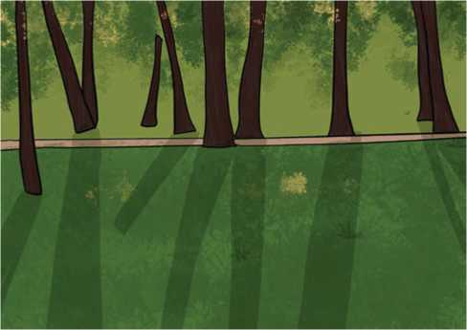
The sun does arise,
Figure 98 Greenery
And make happy the skies.
The merry bells ring
To welcome the Spring.
The sky-lark and thrush,
The birds of the bush,
Sing louder around,
To the bells’ cheerful sound.
While our sports shall be seen
On the Echoing Green.

Old John, with white hair Does laugh away care, Sitting under the oak, Among the old folk,
They laugh at our play,
And soon they all say. ‘Such, such were the joys. When we all girls and boys,
In our youth-time were seen,
On the Echoing Green.’
Till the little ones weary
No more can be merry
The sun does descend,
And our sports have an end:
Round the laps of their mothers,
Many sisters and brothers,
Like birds in their nest,
Are ready for rest;
And sport no more seen,
On the darkening Green.
- William Blake
A. Match the words in column A with their meanings from column B.
Column A | Column B
a. oak | i. happy
b. merry | ii. to rise
c. folk | iv. a kind of tree
d. arise | v. to go down
e. descend | vi. very tired
f. weary | vii. people in general

- Choose the correct answer.
- The sun makes the sky
- happy.
- sad.
- excited.
- The merry bells welcome the
- autumn.
- spring.
- winter.
- Old John has
- brown hair.
- black hair.
- white hair.

- The old men are sitting under
- a tree.
- a canopy.
- an umbrella.
- In the evening, the children come to the laps of the
- aunt.
- mother.
- father.

Writing

This is a description of the above poem. Use present simple forms of verbs from the brackets to rewrite the passage.
The poem (describe) the joy and happiness after the arrival of the spring. The sun (shine) brightly. The sky (look) beautiful. The sound of bells coming from nearby (be) very pleasant. Birds (sing) cheerfully. The sounds of bells and the songs of the birds (mix) into a beautiful melody worthy of the season of spring. The old people of the village (sit) under the trees on the green and young innocent children (play) their favourite games there.
During the day the green grass (be) filled with the noises of the children playing different games. The children (be) happy and excited. The old people (watch) their children play happily on the green and (think) of the happy days of their childhood. They, too, had played on the same green. They even had the same excitement and joy which only young children can experience. When the sun sets, it (become) dark and lonely. Then, the evening (come). Children (grow) tired. They (return) home to rest in the laps of their sisters and mothers.

Grammar

Complete the sentences with because or because of.
a. | We cancelled the trip | the rain.
b. | He sat down | he was feeling dizzy.
c. | It is | your mother that we got into this mess
- We hurried indoors it was raining.
- I was late the traffic.
- We could not arrive on time the traffic was terrible.
- The exam was easy he knew all the answers.
- He can't walk his illness.
- He lost his job the strike.
j the language problem, I couldn't win the argument.

Project work
Meet at least five people from your village/town with different professions. Ask what they can and can't do. Write in the table below as in the example. When you all finish, compare each other's work.
Name | Profession | Can do | Can't do
Nitesh | driver | drive a bus | fly an aeroplane

Extra bit

Read the following news story and find the answers to these questions.
- What is the headline?
- When was the news written?
- Which nation won the match?
- How many goals did Nepal score?
- Who scored the goal for Bangladesh? At what time?
- How much was the prize for the winner?
- Was it the first time Nepal and Bangladesh played football together?
- Who organised the game?

Nepal Wins Three Nations Football Tournament
KATHMANDU, Nepal, March 29 (Xinhua) -- Nepal claimed the Three Nations Football Cup, defeating Bangladesh 2-1 at Dasharath Stadium in Kathmandu on Monday, with Kyrgyzstan finishing third.
Sanjog Rai scored the first goal for Nepal in the 18th minute, his first-ever international goal, after making his debut against Bangladesh last Saturday.
Nepal doubled its lead in the 41st minute thanks to a goal by Vishal Rai. Bangladesh pulled a goal back in the second half after Mahbubur Rahman scored in the 83rd minute.
Champion Nepal received prize money of 5,000 U.S. dollars, while runnersup Bangladesh pocketed 3,000 U.S. dollars.
This is the third time that Nepal and Bangladesh have met in a final. The two teams previously played in the final at the first South Asian Games (SAG) in 1994 and the eighth SAG in 1999.
Nepal won the first match and in 1999, Bangladesh defeated Nepal at Dasharath Stadium. 21 years later Nepal defeated Bangladesh at the same stadium.
In the group stage of the Three Nations Cup, Nepal drew 0-0 with both teams, securing a place in the final. Bangladesh defeated Kyrgyzstan 1-0 to reach the final.
Organised by the All Nepal Football Association (ANFA), the Three Nations Football Cup is not recognized by football's world governing body FIFA.

Unit 14

Geeting Started
A.Look at the pictures. Ask and answer the questions in pairs. Use the given clues.

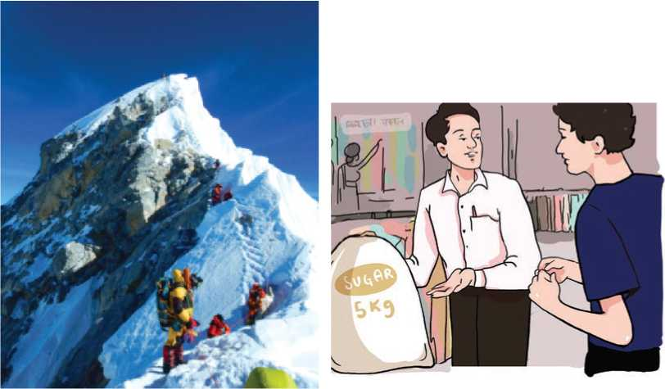
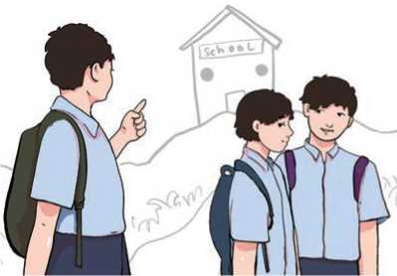
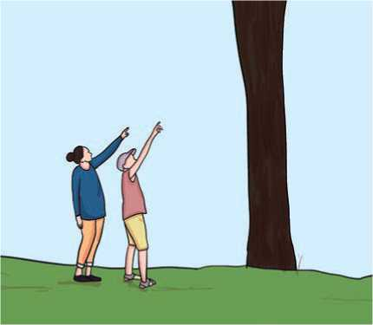
How tall?/8848.86 metres How much?/5 kg
How tall?/about 20 metres
How far?/five kilometres
- Listen and sing.

Tall Trees
With their feet in the earth
And their heads in the sky
The tall trees watch
The clouds go by.
When the dusk sends quickly
The birds to rest
The tall trees shelter them Safe in a nest.
And then in the night
With all the trees peeping,
The moon shines down On a world that's sleeping.

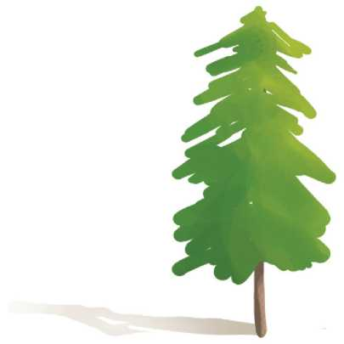
Do you agree with the following statements? Write 'Yes' if you agree and 'No' if you don't.
Figure 99 Tall Tree
- Eillen Mathias
- The trees watch the clouds go above them.
- The birds return to the shelter at midday.
- The birds have made their nests on the rocks.

Reading I
Look at the pictures below and answer the following questions.
- Have you ever seen a snow-covered mountain from another country?
- Do you know the name of any three mountains? If yes, tell your friends about them.

Mt. K2
K2, also called Mount Godwin Austen, called locally Dapsang or Chogori is the world's second highest peak. It is 8,611 metres. It is the second highest mountain in the world after Mt. Everest (8848.86 metres). K2 is located in the Karakoram Range and lies in the Gilgit-Balistan portion of Kashmir under the rule of Pakistan.
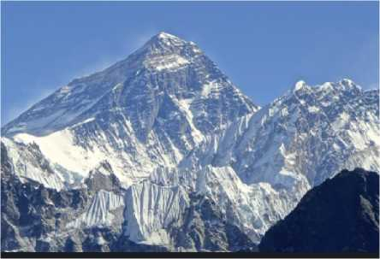
The glacier and snow-covered mountain rises from the base at about 4,570 meters on the Godwin Austen Glacier. The mountain was discovered in 1856 by Colonel T. G. Montgomerie of the Survey of India, and it was named K2 because it was the second peak measured in the Karakoram Range. The name Mount
Figure 100 Mountain
Godwin Austen is for the peak's first surveyor, Colonel H. H. Godwin Austen, a 19th century English geographer.
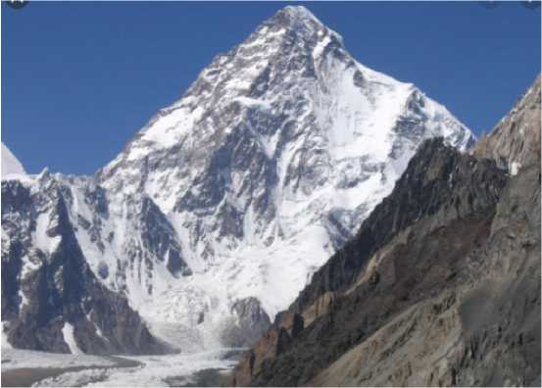
The first attempt to reach the summit was made by an Anglo-Swiss expedition in 1902 that ascended to 5,670 metres on the peak's northeastern crest. Other unsuccessful attempts include an Italian expedition in 1909 via the southeastern ridge that reached approximately 6,100 metres. In 1938, an American expedition led by Charles Houston via the Abruzzi Ridge reached about 7,925 metres. In 1939, another American-led expedition following the same route reached about 8,380 metres; and in 1953, another expedition led by Houston reached 7,900 metres on the Abruzzi Ridge. Finally, in 1954, an Italian expedition consisting of five scientists, a doctor, a photographer and 12 others, including a Pakistani managed to conquer the Abruzzi Ridge despite the severe weather conditions. They reached the summit at 6 p.m. on July 31. In the course of ascent, Mario Puchoz, one of the guides, died of pneumonia.
Figure 101 Everest
Because K2 is prone to frequent and severe storms that make the already dangerous climbing conditions on its slopes even more challenging - and humans find functioning at such high elevations difficult - it is
one of the world's most difficult mountains to climb. The number of people to have reached the top constitutes only a small fraction compared with the number of people who have successfully climbed Mt. Everest. In addition, although there have been fewer deaths on K2 compared with those on Mt. Everest, the proportion of those killed to the number of people who have attempted climbing K2 is significantly higher.
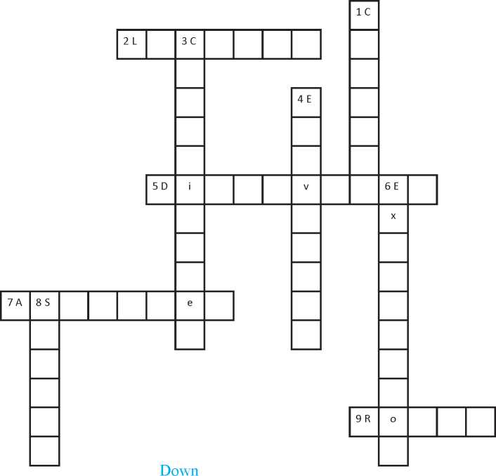
A.
Solve the crossword puzzle. Use the clues below.
B.
Across | 1. | to defeat
2. situated | 3. | forms or makes
5. found out | 4. | height of a place from sea level
7. climbed/went up | 6. | an organised journey for a particular purpose
9. way | 8. | the highest point of a mountain
Answer these question

a. What is the local name of K2?
b. When was the mountain discovered?
c. Who is H. H. Godwin Austen?

d. When did people start to climb K2?
e. When did people successfully reach the top of K2?
f. What makes the climbing of K2 more difficult?
- Write True or False for the following statements.
- K2 is the highest mountain in the world.
- The mountain was unknown until the 1900s.
- A team of Americans first attempted to climb K2.
- The first successful expedition was a complete success without any death.
- Mt. Everest is easier to climb than K2.
- There are many mountains in the northern part of Nepal. Make a list of the mountains and find out their heights and compare them.

Pronunciation
Listen to your teacher and repeat after him/her. Notice the mark ' ' '.
'portion | 'glacier | 'summit | expe'dition | a'pproximately
'conquer | ele'vation | 'fraction | pro'portion | suc'cessfully

Writing I
A. Review the idea map carefully.
location : Mugu Distrtict
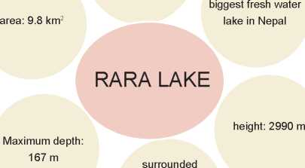
by the smallest national park, Rara National Park

- Using the idea map, write a short description of Rara Lake.

Grammar
- Study the sentences. Notice the subjects and the verb forms.
- One of my friends is very rich. He offers us parties on special days.
- My friends are busy doing their class work.
- Twenty dollars is not a small amount.
- Someone bangs on the door every night.
- Either you or Hari is top of the class.
- Look! The goats are grazing there.
- This furniture costs a lot these days.
- Choose a verb from the brackets to complete the sentences.
- Every generation its own characteristics. (has/have)
- A generation gap of differences in different
aspects. (consists/consist)
- A lot of changes occurred in the village since I left it. (have/has)
- The beautiful scenery of the place more tourists. (attract/attracts)
- Ten kilos of sugar sufficient for us now. (are/is)
- Police investigating the case carefully. (were/was)
- One of the students been selected for the school award. (has/have)
- The man with roses in his hands …………like your brother. (look/looks)

Listening
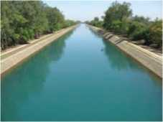
- Look at the picture and answer the questions.
Figure 102 Canal
- What do you see in the picture?
- Have you seen this in your locality? Where?
- What is it used for?
- Now, listen to the audio and complete the sentences. Use one word only.
- The Panama Canal connects the pacific and the ocean.
- The began to construct the canal in 1881.
- Almost people died while building the canal.
- The USA handed the canal to Panama in
- Every year, almost 40,000 come through the canal.
- Surf the Internet or visit the library and find out more statistics
about the Panama Canal and share them with your friends.

Reading

Look at the text below and answer these questions.
- Have you ever seen this type of document? Where?
- What is it called?
- Does your school have one?

Saraswati Secondary School

Ilam

Prospectus

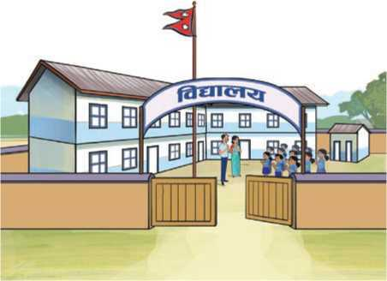

Vision
Our motto is to develop our academic institution as a
centre for academic excellence.

Introduction
Saraswati Secondary
School was established
in 2018 BS. It has been
running classes for grade
1 to 12 since 2070 BS.
The school is completely devoted to maintaining quality education and
aims to produce highly skilled human resources, academically excellent,
Salient Features
Highly qualified and trained teachers.
Salient Features
Highly qualified and trained teachers.
Regular meetings with students and guardians.
Weekly tests and support classes for those needing a little extra help.
Practical classes.
Well-equipped computer
lab, library and science lab.
Free WiFi.
Additional classes, if
required.
Audio-visual classes.
Well-managed cafeteria.
Scholarships
The school offers various
types of scholarships to
the deserving students
and the students from
underprivileged and
marginalised groups.
Mission
To provide an
opportunity of
quality education
for the students of
underprivileged
and marginalised
communities.
To create an
excellent academic
environment.
To create an inclusive
environment
for all students and
staff.
well-motivated and
creative individuals in
the national and global
context. The school has
a very dynamic team
consisting of highly
acclaimed staff from
various sectors to ensure
the proper functioning of
academic activities in the
school.
Programmes
Montessori based pre-
primary classes
Basic level classes (1-8)
Secondary level classes
(9-12)
.

Fee Structure (for grade 11 & 12)
We charge nominal fees for bus fare.
We are committed to provide quality
education to all so that they can get an opportunity for higher education. We believe that no one should be deprived of education.
Admission Process
Any student fulfilling the basic criteria
set by the school can apply for the
entrance test to grade 6, 9 and 11.
Uniform
Students have to wear uniform as
specified by the school administration.

Saraswati Secondary School
Ilam Municipality -9, Ilam
Email: ssschool2018@gmail.com

Uniform
A. Choose the words from the box to complete the sentences.
nominal | underprivileged | devoted | human resources
support | cafeteria | ensure | deprived of
- The baby is still not well. He was oxygen during
birth.
- She takes a bath regularly. She wants to personal hygiene.
- These children are from an community. We've
provided them with necessary things at school.
- Thirty percent of the students need classes in
Mathematics.
- Nepal needs skilled………to utilize the available natural
resources.
- Our school canteen is cheap. It provides its services at
prices.
- No one brings homemade food. Everyone eats at the
- After finishing her higher education, Ms. Tharu
herself to social work.
- Write True or False for the following statements.
- The school was established more than 50 years ago.
- The school is located in a remote village.
- Students and guardians get a chance to interact with the school family.
- The students can eat at the school cafeteria.
- The school is one of the most expensive schools in Nepal.
- Answer the questions.
- When was the school established?
- Make a list of the programmes offered by the school.
- Is the school suitable for underprivileged students? How do you know?
- Has the school got computers? How do you know?
- What is the email address of the school?
- Visit different sections of your school and list the facilities available there.

Speaking
- Act out the following conversations.

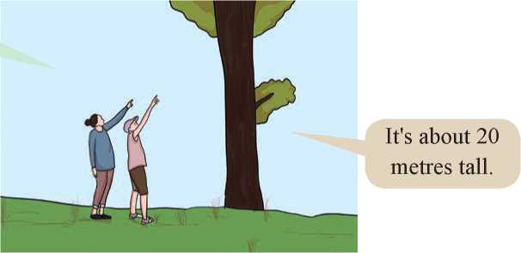
How tall is this tree?

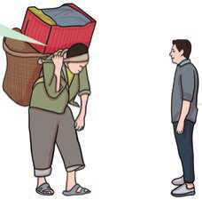

How much does it weigh?
It’s twenty
kilos.

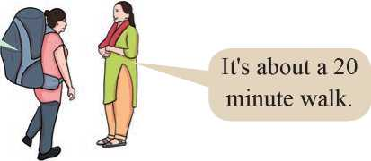

How far is the
nearest museum
from here?

- Work in pairs. Take turns to ask and answer questions based on

these clues.
a. time to get to your school/20 minutes
b. kerosene you need/5 litres
c. your school from the bus park/3 km
d. your father/5 feet
e. your weight/35 kg
f. your classroom window/3 fee
g.how long/Koshi River/720 km

C. Work in groups. Take turns to ask and answer questions. Think about different questions you could ask about height, weight and distance. Be honest with your answers.

Writing
Read the Reading II once again. And, design a similar prospectus for your school with the help of the given outline. Get help from your teacher. Use a photo if possible.
Introduction: the name, when it was established
Vision: to develop school as a centre of excellence
Mission: to provide quality education to all (inclusive school)
Major programmes
Main features (science lab/library/canteen/classroom equipment, etc.) Admission process
Fee structure
Scholarships

Grammar
A. Match the questions in column A with their possible answers in Column

Column A
Column B
a. | How tall is your house? | i. | It's about 2.5 kilograms.
b. | How long is the East West highway? \ | ii. | He's 3'5".
c. | How much water do you drink a day? | iii. | It's 1027.67 kilometres.
d. | How far is Kathmandu from Pokhara? | iv. | It's about 20 feet.
e. | How tall is your younger brother? | v. | It's about 200 kilometres.
f. | How much does your bag weigh? | vi. | I drink 2 litres of water every day.
B. Rearrange the words to make sensible questions.
Example:
How much can Shiva carry?
- has/How far/reached/the pilot?
- the Karnali Bridge/long/is/How?
- tall/a giraffe/is/How?
- How/can/high/you/reach?
- long/is/your ruler/ How?

Project work
Visit two or three schools, colleges or other institutions in your locality and collect as many prospectuses as you can. Present them to your class and talk briefly about them in short.

Extra bit
Study the use of 'some' and 'any'.
a. | Do you have any children?
b. | Did you see any children?
c. | I didn't see any children.
d. | We saw some tigers at the zoo, but we didn't see any elephants.
e. | I haven't got any money.
f. | He's very hungry. Give him some food.
g. | Would you like to have some tea?
Study the use of many, several, (a) few, a little, much and a bit of.
a. | I have many friends.
b. | She has several books.
c. | I have a few pages left to read.
d. | Few people came to the meeting.
e. | Would you like a little water?
f. | I don't have much money.

Unit 15

Getting Started
A. Look at the pictures. Give examples of may/might or must.
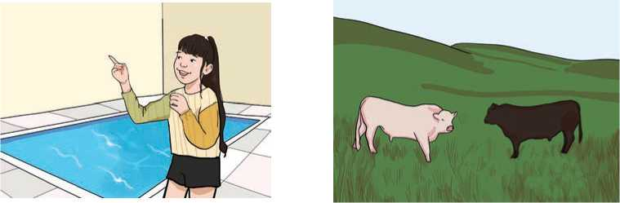
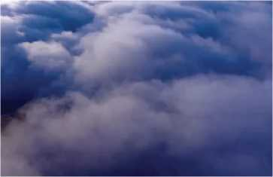
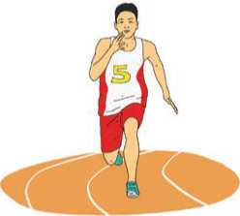
Example: The bulls may/might/must fight.
swim fight
rain
win the race
B. Listen and sing.
Of all the children in my school,
I may not be the tallest.
Of all the voices in the world,
Mine may be the smallest.
But I can almost touch the stars,
If I stand on my toes.
And soon my words might change the world,
So, you'd better listen close.
Answer these questions.
- Is the speaker a student?
- When can the speaker touch the stars?
- What can change the world?

Reading
Look at the picture below and answer these questions.
- What do you think is happening in the picture?
- Do you think it is good or bad for the environment? Why?

Climate Change
Climate change refers to the change in the average conditions - such as temperature and rainfall - in a region over a long period of time. For example, there were a lot of glaciers in the past in the Himalayan ranges of Nepal. But today, we have a warmer climate and fewer glaciers; the remaining ones are seriously challenged.
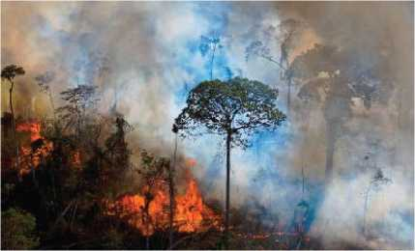
Global climate change refers to the average long-term changes throughout the earth. These include warming temperatures and changes in rainfall, rising sea levels, decreasing mountain glaciers, ice melting at a faster rate than usual in Himalayan regions, and changes in flower and plant blooming
Figure 103 forest fire
times, etc.
The earth's climate has been changing continuously - even long before humans came into the picture. However, scientists have observed unusual changes recently. For example, the earth's temperature has been increasing much more quickly than they would expect over the past 150 years.
Some parts of the earth are warming faster than others. But on average, global air temperatures near the earth's surface have gone up about 2 degrees Fahrenheit in the past 100 years. In fact, the past five years have been the warmest five years in centuries.
Many people, including scientists, are concerned about this warming. As the earth's climate continues to warm, the intensity and amount of rainfall during storms such as hurricanes are expected to increase. Shortage of water for a long

period of time and heat waves are also expected to become more intense as the climate warms.
When the earth's temperature changes by one or two degrees, the change can have a big impact on the health of the earth's plants and animals.
There are lots of factors that contribute to the earth's climate. However, scientists agree that the earth has been getting warmer over the past 50-100 years because of human activities.
Certain gases in the earth's atmosphere block heat from going out. This is called the greenhouse effect. These gases keep the earth warm like the glass in a greenhouse keeps plants warm.
Human activities - such as burning fuel in factories, cars and buses - are changing the natural greenhouse. These changes cause the atmosphere to trap more heat than it used to, leading to a warmer earth.
When human activities create greenhouse gases, the earth warms. This matters because oceans, land, air, plants, animals and energy from the sun all have an effect on one another. The combined effects of all these things give us our global climate. In other words, the earth's climate functions like one big, connected system.
Thinking about things as systems means looking for how every part relates to others. NASA's earth observing satellites collect information about how our planet's atmosphere, water and land are changing.
By looking at this information, scientists can observe how the earth's system works together. This will help us understand how small changes in one place can contribute to bigger changes in the earth's global climate.

A. Find the words in the text above that give the answers to a to i. The first letter has been given.
- a slow-moving mass or river of ice, formed from G
snow on mountains
- all the time; repeatedly C
- a scale of measuring temperature F

d. | a period of hundred years | C
e. | the quality of being great; very strong | I
f. | a violent storm with very strong winds | H…………………
g. | the mixture of gases that surrounds the earth | A…………………
h. | a structure made of glass which is used to grow plants | G………………….
i. | an electronic device sent into space to gather information | S
B. | Decide whether the following statements are True or False.

- Glaciers are found high in the Himalayas.
- Climate change is a global issue.
- The effect of climate change is not seen in the seas.
- Climate change affects human beings.
- Human activities are likely to increase changes in the climate.
- Production of carbon dioxide in the USA may cause the melting of snow in our Himalayas.
- Answer these questions.
- What is global climate change?
- List the negative effects of global climate change.
- When did climate change start?
- What human activities are affecting Earth's natural green house?
- What are the components of the global climate?
- Which organisation is conducting the research about climate change and its effects?
- Has Nepal been affected by the global climate change? How? Discuss in groups and draw a few pictures to demonstrate your points.

Pronunciation
Match the words with their pronunciation. Practise saying them with the help of your teacher.
intensity global glacier temperature atmosphere hurricane
/ˈtemprətʃə(r)/
/ˈætməsfɪə(r)/
/'hAriksn/
/in'tenssti/
/'glaubl/
/'gl^sia(r)/

Grammar I

A. Look at the following set of sentences.
Prerana will come here tomorrow. | Prerana will have come here by 4 p.m. tomorrow.
We shall buy a house next year. | By next year, we will have moved to our new house.
Jonathan will complete his studies in 2025. | Jonathan will have got a job by 2026.
Fukipa will climb Mt. Everest next week. | By the end of next week, Fukipa will have climbed Mt. Everest.

B. Choose the correct alternatives from the brackets to complete the sentences.
- I think our team the match this year. (will win/will have won)
- By 11 p.m. tonight, she writing the report. (will have
finished/will finish)
- If I finish this task early, I TV. (will have watched/will watch)
- They say it heavily tomorrow. (will rain/will have rained)
e fine tomorrow? (Will the weather have been/Will the
weather be)
- They here by 10 a.m. tomorrow. (will arrive/will have arrived)
- I Paris by the end of July next year. (will have visited/will
visit)
- I'm sorry. I you this time. I'm busy. (will not have helped
won't help)
- Make two sentences using the clues given below.
Example: complete home work
I will complete my homework soon.
I will have completed my homework by 8p.m.
a. | take bath | b. | watch TV
c. | go shopping | d. | call my parents
e. | wash clothes | f. | prepare food
g. | feed animals | h. | take final exams
- Imagine your life 20 years from now. Write some sentences about what changes you will have experienced by then. You can talk about your studies, visits, jobs, etc.

Writing
Look at the pictures below. What are the people doing? What may happen in the future there? What might be the results? Make notes and write a paragraph for each.
Figure 104 picture A. Noise pollution, picture B. water pollution, Picture C. air pollution and picture D. deforestation
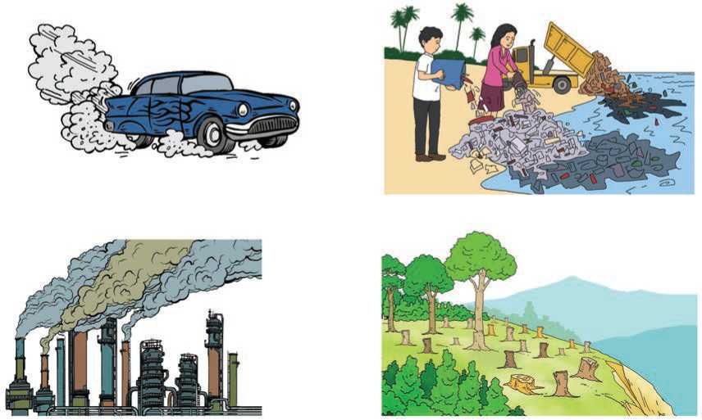

Listening
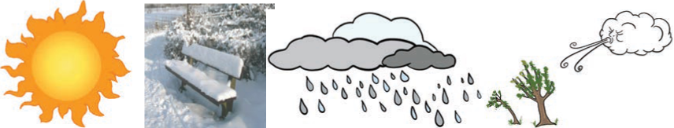
A. Say the weather words that represent the weather pictures below.
Figure 105 sunny, winter, rain and wind
B.
Direction | Temperatures
North
 | around 130
West
 | 150
Listen to the audio and complete the table below.

- Listen to the audio again and write True or False.
- It will rain for the whole day in the north.
- There may be thunderstorms in the east.
- The west will have quite windy weather.
- The best weather will be found in the south.
- What is the weather like in your locality now? Talk to your partner about it.

Reading
Look at the picture and talk to your friends about the answers to these questions.
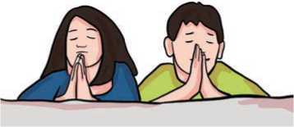
What do you think these people are doing?
a.
b.
c.
Figure 106 Praying
Are they happy?
Do you feel grateful because you are one of the best creations on the earth? Why?

Gratefulness
I am grateful for the eyes that I can see
the activities that can be done by me.
I am grateful for the ears that I may hear
the sobbing of those who need me near.
I am grateful for the lips that I might speak
words of comfort and peace to all who seek.
I am grateful for a mind that I might know
how to aid those who need me so.
I am grateful for the hands that I might do
some arduous or simple tasks for you.
I am grateful for the ability to always pray
to give me strength and guidance every day.
I am grateful for one thing, all else above
that I was given a heart, that I may love.
- Joseph T. Renaldi

A. Match the parts of the body with their functions as given in the poem.
a. | mind | i. | do difficult and easy tasks
b. | eyes | ii. | help the needy ones
c. | ears | iii. | perceive the activities done by the speaker
d. | hands | iv. | help people establish peace/comfort
e. | lips | v. | pay attention to the sorrows of the near
and dear ones

B. State whether the statements are True or False.
- The speaker finds herself grateful.
- She only performs difficult tasks.
- The ability to pray rarely gives her strength and guidance.
- Having a heart is the most important thing for the speaker.

Speaking
A. Act out the following pieces of conversation.
I will call you tonight
and inform you

I don’t have any.
Maybe I will go to
Mamaghar for some
time.
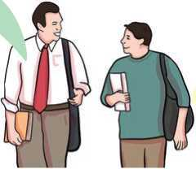
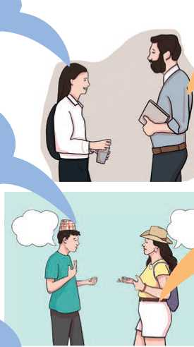
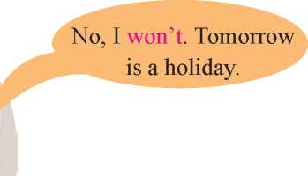
about the results.
Will you come to
school tomorrow?
Okay. I’ll wait
for your call.
Will the bus have
arrived here by 5 p.m.
We will have completed our exam by next month. What’s your plan after that?
Of course. It will come here about half past four.

B. Work in pairs. Take turns to ask and answer the questions as

given in the example.
For example: tomorrow morning

A: What will you do tomorrow morning?
B: I will cook food.
A: Will you have prepared food by 9 a.m.?
B: Yes.
- tonight
- on Saturday
- after your exams are over
- after your school today
- during your winter vacation
- during the Dashain vacation
- next week
- Go round the class. Ask your friends to say at least two things about their future plans. Complete the given table.
Name of your friend | What they will do in future | What they will have done by a certain time in future
1. Lakpa Tamang | ride a horse/tomorrow | learn Nepali by typing on computer by next month
2.
3.

Now, write about your friends as given in the example below.
My friend Lakpa Tamang will ride a horse tomorrow. He will have learnt Nepali by typing on a computer by next month

Writing
Work in pairs and discuss. What will the earth be like in 20 years time? Focus your attention to the issues below:
rapid population growth
cutting down of trees/deforestation
increased pollution
reduction of fuel production
Now, based on the ideas you have collected, write a paragraph on 'The Future of the Earth'.

Grammar
A. Review the pictures and read what each of these people are saying.
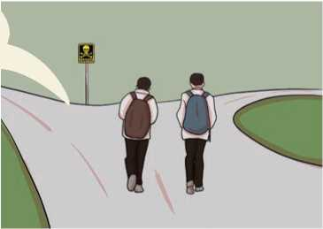
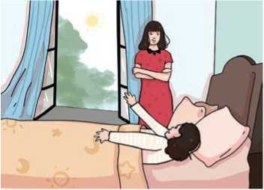
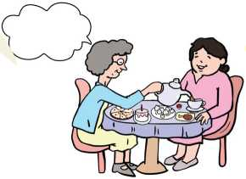
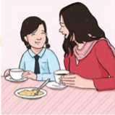
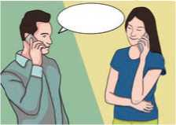
Get up darling!
You may be late
for school.
Don’t go there.
There must be danger.
Look! I’ve
prepared many
things.
You haven’t eaten
all day. You must
be hungry.
You must have
worked a lot.
We might meet
one day.

B. Make at least two sentences in the given situations. Use may/ might or must.
For example: Romeo is at the riverside.
He must be going to swim.
He might catch some fish.
a.
b.
c.
d.
e.
f.
She speaks Japanese.
They have books in their hands.
She bought a new car.
It's raining.
He works in a bank.
Bhagawati studies very hard.

Project work
Visit different places in your village/town and meet different elderly people. Ask them about the changes they have seen in their life and the negative or positive results of those changes. Draw a table like this and include your results.
Changes | Positive results | Negative results

Extra bit

Learn how may, might, could, will, should, must and can't are used in the following sentences.
- She might come soon.
- She could be lost.
- She may be in the wrong room.
- She'll be at work now.
- They should be there by now.
- It shouldn't take long to drive here.
- Prices can be high in Kathmandu.
- She must be in the office. It's already 10 a.m. and she usually goes to the office at 9 a.m.
- He can't be in the park. He doesn't go to the park at this time.

Unit 16

Getting started
A.The following pictures suggest a story. Put them in order and narrate the story.
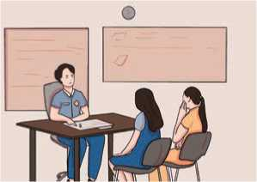
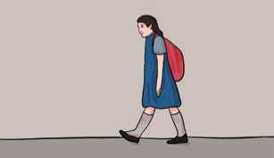
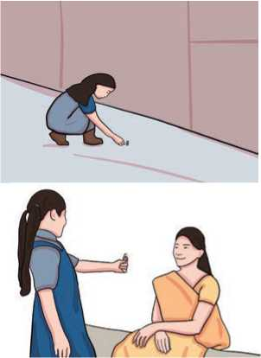
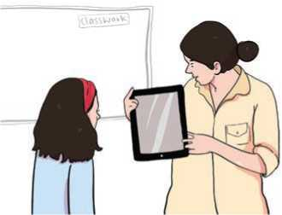

B.

Listen and sing.
My teacher took my iPod, She said they had a rule,
I couldn't bring it into class, or even to the school.
She said she would return it;
I'd have it back that day.
But then she tried my headphones and gave a click on Play.
on
My teacher said she changed her mind.
She thinks it's now okay
to bring my iPod into class.
She takes it every day.
What happened in the song? Discuss in pairs and put the following sentences in the correct order.
- The teacher allowed the student to bring her iPod to the class.
- She started using the iPod every day.
- The teacher took the iPod.
- She played her music.

Reading
Look at the picture and answer these questions.
- Where do you think these people are?
- What is the boy with long hair doing?

A Lesson from a Son
Velan was a carpenter who lived in a village. His mother had died a long time ago. His aged father, Kuppan, lived with him. Kuppan was very weak. He was so weak because neither Velan gave him enough food nor was the food nutritious. Thus, he had no energy, even to walk.
Velan had given his father a small earthen plate. Even a small quantity of rice on the plate appeared to be too much. He did not have a good social reputation. He was a drunkard, too. After being drunk, he always treated his father badly.
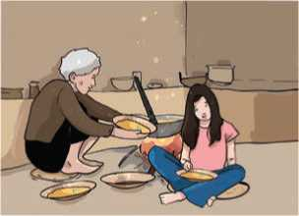
Velan had a son named Mithu who was just ten years old. He was a very good boy. He was very intelligent and had great respect for his grandfather. He did not like his father’s attitude and character because his father was not treating his grandfather well.
Figure 107 Velan and his father
One day, Kuppan was eating his food of the earthen plate that his son had given to him. It fell down and broke into pieces. The food also fell on the floor.
Velan was working at the other end of the room. He saw the broken plate. He was very angry with his father and used very harsh words to abuse him. The old man felt bad about what happened. He was sorry for his mistake. However, Velan’s words wounded him very deeply.
Mithu saw this. He did not like his father. His father was ill-treating his grandfather. Although he had pity about his grandfather, he was afraid to speak against his father. Thus, he could do nothing in support of his grandfather.

The next day, Mithu took some of his father’s carpentry tools and a piece of wood. He worked with the tools to make a wooden plate. His father saw him working.
“What are you making, Mithu?" he asked.
“I am making a wooden plate!" replied Mithu.
“A wooden plate? What for?" asked his father.
“I am making it for you, father. When you grow old, like my grandfather, you will need a plate for food. A plate made from earth may break very easily. Then I may scold you severely. So, I want to give you a wooden plate. It may not break so easily.
The carpenter was shocked to hear this. Only then, he realised his mistake. When Velan was a small kid, Kuppan had reared him with much care and attention. With time, he grew old. Velan remembered his joyous past and was now very sad about his own behaviour. He, then became a different person.
From that day, Velan treated his father with great respect. He gave up drinking too. Velan learnt a lesson from his own son.
- Find the words in the story above that have the following meanings.
- a person who makes and repairs wooden objects: C
- social recognition by other people: R
- clever, bright, brilliant: I
- strictly, harshly: S
- bring up and care for a child: R
- full of happiness and joy: J
- Put the given sentences from the story in the correct order.
- Velan did not have good relationships with other people because he was a drunkard.
- There lived a carpenter with his old father and a son.

- Velan realised his mistake and treated his father well.
- Velan gave a broken plate to his father.
- While eating, Kuppan dropped his plate and his son scolded him badly.
- The boy made a wooden plate for his father.
- Answer these questions.
- How many members were there in Velan's family?
- Why was the grandfather so weak?
- Describe Mithu's character.
- Why was Mithu making a wooden plate?
- What were Velan's childhood days like?
- Did Velan correct his wrong doing in the end? How do you know?
- Do you have a grandfather or a grandmother at home? How does your family treat him/her? Make a list. Using the list as a prompt, write a very short paragraph about how you should treat elderly people in the family.

Pronunciation
The pronunciation of some of the words from the story is given below. Listen to your teacher and write the words in the blank spaces.
- /'vilidj/ : village
- /'ena(r)d3i/ :
- /tri:tid/ :
- /'braokan/ :
- /'wodn/ :
- /ri'spekt/ :

Writing
- We use past forms of verbs when we tell a story. Write all the past forms of the verbs from the story.
- Put these new sentences in the correct order to make a new story.
- Both of them sped off into the jungle.
- Though the lion laughed at the mouse's confidence, he let the mouse go.
- “I promise you; I will be of great help to you someday if you save me.”
- This disturbed the lion’s sleep, and he woke up quite angry.
- A lion was once sleeping in the jungle when a mouse started running up and down his body just for fun.
- The lion was struggling to get out and started to whimper.
- They tied him up against a tree.
- The lion was about to eat the mouse when the mouse desperately requested the lion to set him free.
- Soon the mouse walked past and noticed the lion in trouble.
- The mouse quickly ran to set the lion free.
- One day, a few hunters came to the forest and took the lion with them.
- Now, develop a story with the help of the clues given in the correct order below. Give a suitable title too.
A farmer with several sons sons always quarrel the farmer sad
falls ill and is taken to hospital dying calls all his sons gives a bundle of sticks to break all try one by one cannot break the father gives the sticks separately they break the sticks easily moral

Grammar
A. Study the following sentences.
- My friends were cooking food last night.
- Indu was reading a novel when Joan came.
- Were the children laughing?
- They were drawing pictures some time ago.
- It was raining yesterday evening.
B. Make at least 10 sentences from the given table.
They |  | drinking tea when I arrived.
Pasang |  | watching TV at night.
Yamuna | was | having lunch when the teacher turned up.
The students |  | going to the cinema at this time yesterday.
A cat | were | studying algebra the whole day yesterday.
Smith |  | chasing a mouse yesterday.

- Put the verbs in the bracket in their correct forms. Use either was or were and present participle forms of verbs.
Example: A picture (hang) on the wall.
A picture was hanging on the wall.
- John (not play) cricket with his children. He was
writing a poem.
- When I entered the room, my parents (paint) the
wall.
- Kites (not fly) in the sky a few minutes ago.
- The leader (giving) a speech at this time yesterday.
- My mother (cook) food in the morning but I was dancing.
- Children (not do) their homework. They were watching
a movie.
- She (swim) in the pool when I saw her.
- Write at least 10 sentences about what was going on when you arrived at your school this morning.

Listening

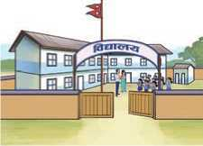
A. Look at the picture and guess the answers to these questions.
Figure 108 School
- Where are these people?
- What are they doing?
- What games do you play at school?

B. Listen to the audio and tick the right answers.
- Besides paper books, the little girl also made at school.
i. a person ii. a building iii. an animal
- The girl used crayons, paper and
i. a pencil. ii. glue. iii. a tape.
- In addition to playing games, she
i. watched television. ii. rode her bicycle. iii. went to the store.
- The girl played with her at the school.
i. teacher ii. father iii. cousin
- The conversation most probably took place at
i. a house. ii. a school. iii. a park.
- Make a list of the activities that you did at school and after school
yesterday.
At school | After school

Reading
Answer the questions.
- Do you or anyone you know celebrate birthdays?
- What do they do on their birthdays?

A Party in a Restaurant
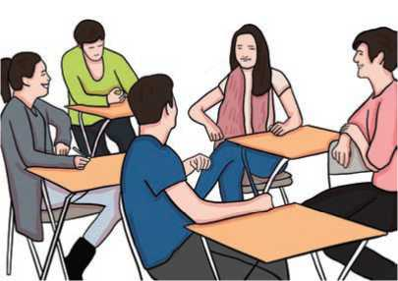
It was my birthday last Thursday and I decided to celebrate it by inviting a few friends out to supper. I chose a restaurant in a quiet part of town. It is one of my favourite restaurants because the food is good and the waiters are friendly. It is hardly ever crowded because few people know about it. So, it is not usually necessary to book a table. In any case,
Figure 109 Birthday Celebration
Thursday is not a busy evening as a rule.
When we entered the restaurant, I was surprised to find it completely full. I looked around - but not a single table was free. One of the waiters recognised me. He came across and explained the situation. "A party of tourists came in about half an hour ago," he said. "It was like an invasion! Suddenly the place was full! We can hardly manage!"
The waiter then pointed to a table in the corner. "The people there are just about to leave," he said. "Just hold on and you'll find a place there." He was right. Fifteen minutes later, the people at the corner table paid their bill, got up and left. I led my friends across and we all sat down.
Unfortunately, our table was almost out of sight. We tried to attract the attention of the waiter who sent us there but he, like all the other waiters, was busy with the party of tourists. They ordered enormous quantities of food. But at last, nearly an hour later, the tourists were finishing their meal and looking very pleased with life. The waiter, now very tired, appeared at our table. I advised my friends about the best dishes and finally the waiter went off with our order. A few moments later, he came back to our table. We could understand from his face that he had bad news for us. Full of apologies, he informed us that there was no meat or fish left. "All we can offer you," he said, "is an omelette!"
- Find and write the words from the text which mean the following.
- make it a happy occasion
- knew
- wait
- going to
- amounts
- Answer the following questions.
- Where was the restaurant?
- Why did the writer like the restaurant?
- Why did he not book a table before they ordered?
- Were the tourists already in the restaurant when they arrived?
- What food did they order? Did they get the food they ordered?
- Did the speaker and his friends want to eat an omelette? What do you think? Why?
- Say why:
- The writer invited some friends out to supper.
- He chose that restaurant.
- The restaurant was full that evening.
- The writer and his friends were able to get a table after fifteen minutes.
- The waiter didn't come to their table for nearly an hour.
- The writer was able to advise his friends about the food.
- The waiter who took their order came back and apologised.

Speaking
A. Act out the following conversations with your friends.
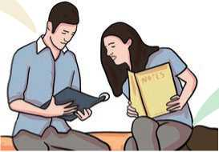
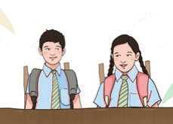
What were you
doing at this time
yesterday?
I was painting a
beautiful picture a
few minutes ago.
I was typing
a letter.
When I took this
Oh really? I was
also doing the
same.
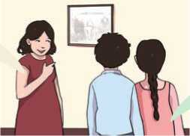
photograph, my father was
ploughing the field.
It rained heavily while we
were playing football.
We were also not at home.
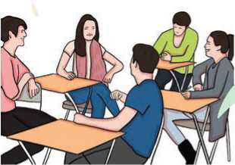
It also rained when we were playing cricket.

Look at the clues below. Say what they were doing at the given times.
B.
- Rupal/play chess/last night.
- Bunu/cut grass/an hour ago.
- Sukrit/ride a bicycle/when I see him.
- Mingma/wash dishes/at nine in the morning.
- Funurbu and his friend/talk on the phone/Saturday evening.
- They/paint the wall/yesterday.
- Last month/Paru/visit different places.
- Gunjana and her family/watch TV/in the evening.

Writing
A. Arrange the sentences to make a story.
- He said that they were brown but they were actually black.
- Ram told Anu to return the donkey to him.
- Anu was caught and Ram got his donkey back.
- Anu insisted that the donkey belonged to him.
- One day Ram saw Anu riding on his lost donkey.
- Ram covered the donkey's eyes and asked Anu the colour of its eyes.
B.
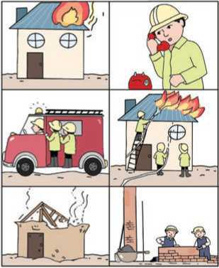
Your friend Anjali was going to school yesterday. On the way, she saw an incident. The following pictures show the sequence
Figure 110 fire in house, someone call fire extinguisher, control fire and reconstruction of house
of events.

Now, write a story based on the pictures above. Use past tense. You may start like this:
Yesterday, my friend Anjali was going to school. On the way she saw

Grammar
- Read the following passage carefully. Notice the highlighted words.
Last weekend, Madhavi and her friends went to a newly opened mall. They had never been to this mall before. Each time they had planned to visit it, some other work came up. They had to cancel their plans. They had never imagined that a get-together and outing of this kind would be so much fun. Madhavi and Rupali had already selected a beautiful dress to buy. Amit and Binit had agreed to buy Momos for all of them. By the time they left the mall, they had seen amazing displays in each of the shops. They were exhausted as they walked to almost every shop. They felt lucky that nobody they were with had been there before!
- Fill in the blanks with the suitable forms of the verbs given in the brackets. Use simple past or past perfect tenses.
- Fred (spend) his holiday in Italy, he wanted to learn
Italian.
- Jill had phoned her dad before she (leave) her office.
- When she (arrive), the match had already started.
- Before she (sing) the song, she had played the guitar.
- They (watch) a video after all the children had gone to
bed.
- After Eric had prepared the delicious meal, he (call) his
friends.
- I (be) very tired as I had studied too much.
- They had painted their house before they (move) in.
- After the man had come home, he (feed) the cat.

Project work
Work in groups of four. Find or create a short story with the help of your teacher. Draw a storyboard that tells the story. Vote which group has the best story.

Extra bit
Put the pictures in order and tell the sequence of events to your friends. Use past tense. When you are listening to the story, assess whether your friend is using the past tense.
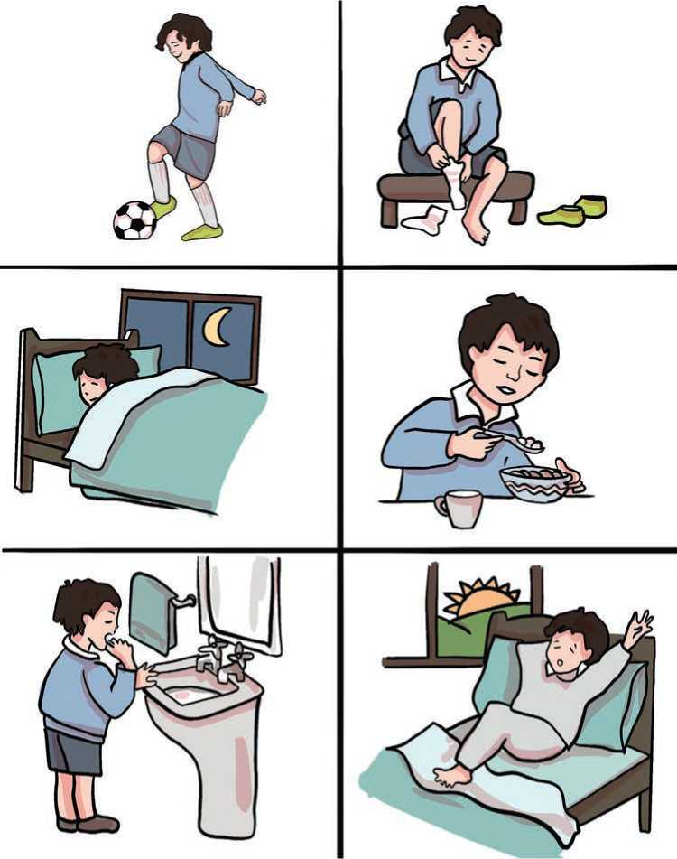
Figure 111 playing ball, wearing shoes, sleeping, eating breakfast, brushing teeth and get up
Unit 17
Getting started
- Look at the girl's expressions. Practise saying them.

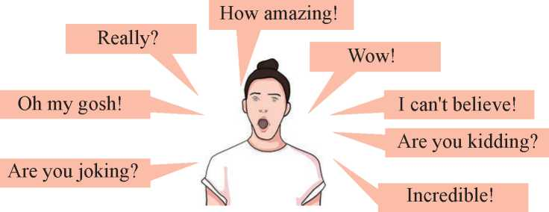

B. Listen and sing.
In England once there lived a big,
And wonderfully clever pig.
To everybody it was plain
That Piggy had a massive brain.
He worked out sums inside his head.
There was no book he hadn't read.
He knew what made an airplane fly,
He knew how engines worked and why.
He knew all this, but in the end,
One question drove him round the bend:
He simply couldn't puzzle out
What LIFE was really all about.
What was the reason for his birth?
Why was he placed upon this earth?
His giant brain went round and round.
Alas, no answer could be found.
- Rolad Dahl
Answer these questions.
- Where did the clever pig live?
- Could the pig in the song read? How do you know?
- What puzzled the pig?
Reading
Look at the picture below and answer these questions.
- What do you think the men are doing in the picture?
- Is the cow happy? Why?

Fair Shares
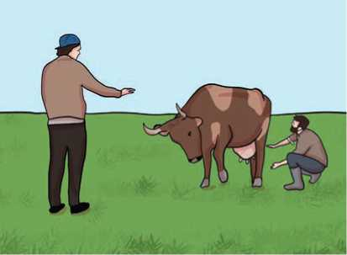
Ali and Abraham were brothers. Their mother died when they were very young. Soon after, their father also died. He left for his sons a cow and a date-tree.
Ali was cunning and greedy too. But Abraham was kind and honest. He trusted his elder brother. They wanted to divide their father’s property. Ali said, “I will be very fair with you, Abraham. You take the front portion of the cow as your share. I will take the hind of the cow.
Figure 112 Ali and abraham with their cow
Each one gets his profit only from his share." "It's a wonderful idea," Abraham thought and agreed with his brother.
The tree was also divided. The upper part of the tree went to Ali and the lower part went to Abraham.
Abraham fed the cow very well. As a result, the cow became healthy. It gave a lot of milk. Ali got the milk. He sold the milk and got a lot of money. But he did not share the money with Abraham. Abraham asked his brother about his share of money. Ali replied, “I got the milk from my portion of our cow. Hind part is mine as per the agreement. Each of us gets the benefits only from his part." "Oh, no! I've never expected to see this", Abraham said to himself. But he said nothing to his brother.
One of the villagers had given an idea for Abraham. The next day, while Ali was milking the cow, Abraham beat the cow. The cow started kicking. Ali shouted at Abraham. “You fool! Why do you beat the cow? Don't you see me milking the cow?"
“The front portion of the cow is mine. I can do anything. That is our agreement," replied the younger brother.
Ali could hardly utter a single word and instantly agreed to share the money. Abraham said, “Not just money. You must also share the work of feeding and taking care of the cow too." Ali agreed.
The case of the cow was resolved. But the issue of the tree was intact. Ali made holes on the upper part of the tree. A kind of sweet-smelling juice came out of those holes. Small pots were attached to the holes where the juice could seep. Ali sold the juice and earned a huge sum of money. "How cunning I am! I can still earn so much money though I have to share the cow", he was pleased with his cleverness.
One of his friends advised Abraham. The next day, Ali was on the top of the tree trying to fix the pots near the holes. At that time Abraham started chopping the tree. Ali shouted at Abraham but Abraham reminded Ali about the agreement. He said, “I can do anything with my part; you cannot interfere."
Ali now realised his mistakes. “How foolish I have been!" he said, "Abraham, I have been a bad brother to you. I feel ashamed of my selfishness. Please pardon me. I promise not to hurt you hereafter."
And, so he didnot. Both the brothers shared the profit and lived happily.
- Find the words from the story above which have these meanings.
- crafty
- a part of a whole
- great, massive
- cutting
- hinder, obstruct
- yelled, screamed
- Write True or False for the following statements.
- Nothing was left for the brothers when their parents had died.
- The elder brother was not as clever as the younger one.
- Ali milked the cow, sold it and earned a lot of money.
- Abraham never beat the loving cow.
- The tree was given to the younger brother.
- When Ali was up in the tree, his brother started cutting it.
- Finally, both brothers lived happily.
- Answer these questions.
- Which part of the cow was given to the younger brother?
- How many things did the brother divide between them?
- When did Ali agree to share the money they would earn from the cow?
- Why were small holes made in the tree?
- What did the villager suggest to Abraham?
- How did Ali react when his brother started cutting the tree while he was fixing the pots?
- Did Ali realise his mistake? How?
- What did you find surprising in the story? Share it with your friends.

Pronunciation
Learn the pronunciation of the phrases with the help of your teacher.
Oh, really? Are you serious? No way!
What a nice song you wrote! How amazing you are! My goodness!
Oh, my gosh! That's amazing!

Grammar
- Write all the past forms of verbs from the story above. Make sentences of your own.
Example: left -1 left home early this morning.
- Study the following diagrams. Describe them.
When I saw him, he was dancing.
|He was dancing. | I , saw him. |

Now
Past future
He had slept before I reached home.

I reached home.
He had slept.

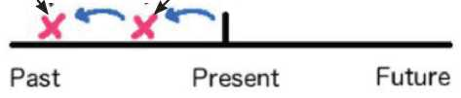

- Choose the correct answer
- He was hit by a car when he……………. to school.
i. cycled ii. was cycling
- The plane…………. off at 10 pm. It was right on time!
i. was taking ii. took
- Yesterday, she …………..to the post office.
  - i. went ii. was going
- He………..the party because he………... a good time
i. was leaving/didn't have ii. left/wasn't having
- France ..……. the football World Cup in 2012.
i. won ii. had won

D.Complete the sentences with the correct forms of verbs in brackets
Example: He (dance) when I saw him.
He was dancing when I saw him
- Peter was Sally's best friend. She (know) him all her life.
- We were very hungry because we (not/eat) anything.
- I was delighted when I found my keys. I (lose) them for
two days.
- She was exhausted because she (work) hard.
- Everything was white because it (snow).
- The passengers were angry because the airline (lose)
everyone's bags.
- I…… (not/see) Jacob for several years, but I recognised
him immediately.
- When I saw her, she (sing).
- The phone rang while I (wash) dishes.

Listening
A. Answer these questions.
- Have you or your friends ever won a prize? When?
- How do people feel when they win a prize?
B. Listen to the recording and complete the table.
Prize won
Prize includes
Prize has to be used by | , 20th
They have to go to | John and Charlotte's
They don't know who could use the
C. If you were the winner of the prize above, what would you do during the weekend? Talk to your friends.

Reading
Answer these questions.
- Have you ever spent a night away from home?
- Who did you go with?
- Where did you stay?

At the Hotel
Guest : Good morning. Do you have any rooms vacant?
Receptionist : Yes, sir. Double or single?
Guest : I would like a double please.
Receptionist : I have a double room on the second floor.
Guest : That's great! But I'd like to have one on the ground floor, or the first floor.
Receptionist : Let me see if I can.... I'm sorry. There's no double room vacant
at the moment, either on the ground or on the first floor.But

I wonder if you could wait till the check-out time. I'll have
two vacancies then. Could I book one of the rooms for you in
advance, sir?
Guest : Oh, no! I don't mind waiting for an hour or so. What's your
check-out time?
Receptionist : It's 12 noon, and it's already a quarter past eleven. So, you will
have to wait for less than an hour, sir.
Guest : How come? My watch shows ten minutes to eleven! That means
there's more than an hour to go. I'm not going to wait .....
Receptionist : I'm afraid your watch is a little slow, sir. My watch makes 11:20
now. I set the time only a few minutes before you came.
Guest : Oh, dear! There's something wrong with my watch. You're
right. I'll wait.
Receptionist : Thank you, sir. Would you take a seat, on the sofa over there?
Guest : Oh, but I don't know anything about the facilities you provide here.
Receptionist : Don't worry about that, sir. Here's a brochure giving all the
information about the hotel. On page ten, you'll find information
about the rooms and the facilities.
Guest : (After some time) Oh, no! The rooms are really expensive.
Receptionist : Our hotel is not expensive in comparison to other hotels around
here. And, what's more, we provide the best quality services.
You will be really satisfied with our services.
Guest : Umm... Thank you, young lady.
.
A. Fill in the blanks with appropriate information from the conversation above.
- The tourist needs room.
- The tourist wants to have a room on the
- The check-out time is
- According to the receptionist, the time was exactly
when they were talking.
- The information about the hotel can be found in the

- Answer these questions.
- Where has the conversation taken place?
- According to the receptionist, how many vacancies might be there that day?
- What has happened with the tourist's watch?
- Where does the receptionist want the tourist to wait?
- How did the tourist feel about the price of the hotel rooms?
- Underline the phrases/sentences in the 'At the Hotel' conversation above that show surprise or dismay.

Speaking
- Act out the following conversation with a partner. Notice and underline expressions of surprise or dismay.
A: Jina's got a new room partner.
B: A new room partner? Good for her!
A: Apparently, she is from Solukhumbu.
B: Is she? How amazing!
A: Yes. She met her in the market while shopping.
B: In the market? That's interesting!
A: Unfortunately, she can't speak much Nepali.
B: Can't she? She will learn soon.
- In what situtations might you say the following expressions of surprise or dismay? Act those out with a partner.
- Really?
- That’s very surprising!
- Wow!
- Oh no!
- What a surprise!
- Oh my goodness!
- I find that very surprising.
- You must be kidding.

- Look at the situations below. Work in pairs and take turns to talk as in the example. Use any appropriate expressions of surprise or dismay. Use different expressions for each situtation.
Example: A: I've seen that movie five times already.
B: Really?
- You don't understand the assignment.
- Your friend Janak is sick and has been hospitalised.
- You had an accident when you rode a bicycle yesterday.
- Gita had a nice vacation.
- The party was terrible.

Grammar
Rewrite the story given below. Use past simple or past continuous tense.
One afternoon, a big wolf (wait) in a dark forest for a little girl to
come along carrying a basket of food to her grandmother. Finally, a little girl did come along and she (carry) a basket of food. 'Are you carrying
that basket to your grandmother's?' asked the wolf. The little girl said that she (be). So, the wolf (ask) her where her grandmother lived and the little girl (tell) him and he (disappear) into the wood.
When the little girl (open) the door of her grandmother's house, she
(see) that there was somebody in bed with a nightcap and a nightgown
on. She (approach) no nearer than twenty-five feet from the bed when
she (see) that it was not her grandmother. So, the little girl (run) away.

Writing
A. The following extract from the earlier story contains some mistakes. Rewrite the text correcting the mistakes.
the case of the cow was resolved but the issue of the tree was intact Ali made holes in the upper part of the tree and a kind of sweet-smelling juice came out of those holes small pots were attached to the holes where the juice could seep Ali sold the juice and earned a huge sum of money
- Read and complete the following conversation using any correct expressions of your own.
Joe : What did you do yesterday?
May : Not much, I read a book ?
Joe : I watched TV for a couple of hours and went to bed early. I’ve been really tired lately.
May : ……………..what from ?
Joe : Nothing in particular, I think I’m just bored.
- You and your friend are planning for a picnic next week. Compose a dialogue that takes place between you and your friend. Include examples of surprise and dismay.

Project work
Watch a suitable movie of your choice. Listen how the characters express surprise or dismay. Write as many expressions of surprise or dismay that you hear and present them to the class.

Extra bit
Study the expressions of surprise.
Really? | We use 'really' as a short response to show interest or surprise. I don't like chocolate. - Really?
Are you for real? | We use it to express surprise and disbelief in English. I got an A+ on my Maths exam! - Dude, are you for real?
No way! | We use it to refuse to believe what we hear because it's so incredible.  Can I borrow your car? - No way!
What a ! | What a wonderful day!
How ! | How amazing you are!
Wow! | We use it when the surprise seems unreal. Wow! You are great.

Unit 18

Getting started
A. Work with your partner. Take turns to ask and answer different
questions.
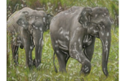 | 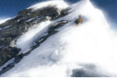
Elephants are not the tallest animals, are they? | The mountain is tall, isn't it?
They are nurses, aren't they? | This is not a helicopter, is it?

B. Listen and sing.
When dawn comes to promise a new day,
When the darkest of shadows are swept away,
Will you watch over me until I wake?
Will you hold me close if I break?
Will you be there to catch my fall?
Will you be next to me, standing tall?
Will you be there to soothe my pain?
And tell me it's okay when there is only rain.
When darkness comes back to creep,
Will you be there to guard my sleep?
Will you love me whole and true?
And keep me going when I'm blue?
Answer the following questions.
What comes to promise a new day?
Reading
Answer the questions.
- Have you or someone you know ever been to a restaurant/teashop?
- Have you seen the following type of text? What is it called? Where would you find it?

A Hotel Menu

THE BOAT RESTAURANT
London, England
Ph. - 044-2345678
It's the place where people want to come time and again.
Tomato Soup | £2.00
French Onion Soup | £2.50
Tomato Salad | £2.90
Chicken Salad | £3.30
All starters are served with bread and butter.

SNACKS
Lunchtime only
Cheese Burger
£3.20
Vegetable omelette
£3.25
Cheese & tomato
sandwich
£3.25
Chocolate cake
£2.25
Burger
£2.90
MAIN COURSES
German sausage and chips £6.50
Grilled fish and potatoes £6.25
Italian cheese & tomato pizza £4.85
Thai chicken and rice £5.95
Vegetable pasta £4.85
Roast chicken and potatoes £5.95
Chicken sandwich Cheese omelette
£3.50 £3.50
snacks are served wil
^{k} Special discount on Saturdays
 | Mineral water | £1.00
DRINKS | Fresh orange juice | £1.25
 | Soft drinks | £1.30
 | English tea | £0.90
 | Irish cream coffee | £0.90

Lunch served 12:30 - 2:30 pm/ Dinner
DESSERTS
Fruit salad and cream £2.25
Ice-cream £2.00
(choose from chocolate, coffee or lemon)
Lemon cake £2.25
Chocolate cake £2.25
Cheese and biscuits £2.50
6:00 - 9:00 pm
- Write whether these statements are True or False.
- The Boat restaurant serves five major categories of food.
- Chocolate cake is the cheapest dessert.
- If you order tomato soup, you will get bread and butter too.
- Ice cream is available in only one flavour.
- The restaurant remains open for dinner from 6 to 9 p.m. in the evening.
- Answer these questions.
- Where is the restaurant located?
- Which is the most expensive item?
- What is the cheapest item available?
- Why can't you enjoy a cheese burger anytime you like?
- If you want to have vegetable pasta, how much would you pay?
- What are the snacks served with?
- Have you or any of your friends ever seen a hotel/restaurant menu? Was that similar to or different from this? Share your experiences.

Writing
Suppose your family is going to start a new tea shop/restaurant. Prepare a menu similar to the example above for your restaurant. Use the clues in the box.
Name location contact details hot drinks
cold drinks main courses snacks desserts
special thing opening and closing time etc.

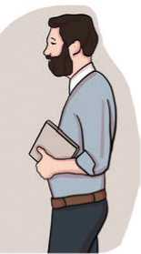
Grammar I
A. Study what the teacher says to his students.
- We are going to learn English now, aren’t we?
- We will finish everything in time, won’t we?
- You don’t have any problems, do you?
- You can’t make noise in the class, can you?
- At this time yesterday, we were writing a story, weren’t we?
Figure 113 Teacher
Match the sentences in column A with their question tags from column B.
B.
a. | Monika is drawing pictures, | i. | shouldn't we?
b. | I have a computer, | ii. | do they?
c. | She isn't my good friend, | iii. | don't I?
d. | We should work hard, | iv. | is she?
e. | We must go now, | v. | aren't they?
f. | We have never seen a tiger, | vi. | isn't she?
g. | They don't like coffee, | vii. | mustn't we?
h. | Pujan and Sabu are singing, | viii. | have we?
Complete these statements with the correct question tags.
a. | I don't need to finish this today, | ?
b. | James is working on that, ?
c. | Your parents have retired, ?
d. | The phone didn't ring, ?
e. | It was raining heavily, ?
f. | Your mum hadn't met him before, ... | ?
g. | The bus stop is near here, ?
h. | Hamid will dance in the cultural programme, ... |  | ?
i. | He doesn't understand Urdu, | ?
j. | She is living in a hamlet now, | ?
C.
Column A
Column B

Listening
- Look at the picture and answer these questions.
- Who do you think these people are?
- Where do you think they are?
- What might they be talking about?
- Listen to the audio and tick the correct answer.
Figure 114 Husband and wife in kitchen
- Who does Hana cook with?
- her roommate ii. her mother iii. her sister
- How does Daniel get food during the week?
- He cooks himself.
- He buys it from the shop.
- His mother provides for him.
- How often does Daniel eat out?
i. sometimes ii. never iii. occasionally
- How often does Hana normally eat out?
i. never ii. sometimes iii. during the weekend
- Who seems to be busier?
i. Hana ii. Daniel iii. both of them
- How often do you cook at your home? What would you like to cook more? What you would cook? Talk to your friends.

Reading

Look at the pictures and answer these questions.
- What place do you think it is?
- What do you think these people are doing?
- Have you ever been to a market? Who do you go with?

A Visit to a Market
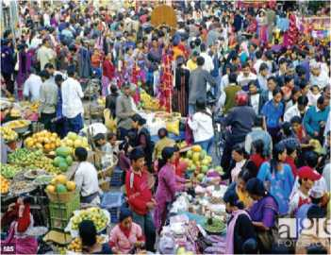
Hi, everyone! Today I'd like to share my experiences of visiting a market place.
Last Saturday, my mother and I went to the central market to buy some groceries which we needed for the New Year.
When we reached the market, we could not find a place to park the car. So, we requested our driver to find a suitable space for the car.
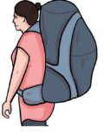
Going to the market just before a festive season was not a pleasant experience. The whole town seemed to be there. Everyone had things to buy. So, the prices of things shot up. Worst of all, we had to struggle to get the things we needed. So, we made our way carefully through the various sections buying vegetables, meat, fish, other food stuff and spices. We had wanted to buy some prawns but they
Figure 115 Market
were all sold out, despite their high prices.

The shopping bags got heavier and heavier. The
crowd got thicker and thicker. The noise and the
heat were almost unbearable. As we had nearly
done all the shopping, I told my mother that I
would wait for her in the car. I could not stand 'being among the hundreds and thousands of people roaming here and there. I carried the bag wearily to the car where our driver was waiting. I breathed a sigh of relief and sat in the car listening to beautiful songs being played. The air smelled sweet and fresh; and I was glad to be outside.
Almost half an hour later, my mother emerged in front of the car. She looked exhausted. We put the groceries in the boot and returned home. That day, I decided I would never go to the market during festive seasons.
- Rewrite the given sentences below replacing the underlined words with one of the words or the expressions given in the box.
breathed a sigh of relief emerged stuff unbearable pleasant
- We spent our holiday in a nice resort.
- Could you move all this shopping from the table?
- The atmosphere at work at present is unpleasant for us to experience.
- I felt very exhausted throughout the day. I felt relieved as soon as I reached home.
- New business techniques appeared with the developments in science and technology.
- Answer these questions.
- When did the speaker go to the market?
- Why was going to the market during a festive season not pleasant for the speaker?
- Why did the speaker return back to the car before his mother?
- What made the speaker feel relieved as soon as he got back to the car?
- How did the mother look when she appeared in front of the car?
- Have you ever been to a market during a festival season? How did you feel when you were there? Share your experiences with your friends.

Speaking

Study these short dialogues carefully. Then, act them out with
A.
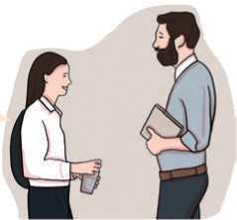
your peers.
You are a seventh grader, aren’t you?
Yes, I am.
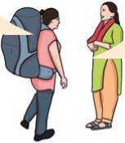
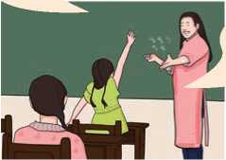
This place is quite far from
here, isn’t it?
No, it’s not. Actually, it’s
only a kilometre away.
Sandhya, you can speak
Japanese, can’t you?
There are five birds on
the board, aren’t there?
No, I can’t. But I can
speak Chinese.
Yes, miss.

B. Work in pairs. Take turns to ask and answer the questions. Use the clues.
Example: my books/no/Rajani's A: These are my books, aren't they? B: No, they aren't. They are Rajani's
- father/doctor/no/engineer
- speak Canadian/no/Korean
- type Nepali/yes/faster than English
- your computer/no/my brother's
- go swimming yesterday/yes/with my little brother
- called your parents/no/call now
- obey rules in school/yes/you must
- must do exercises/yes/to be healthy

- Work in pairs. Take turns to say any statement and supply the correct question tag.

Writing
Suppose you went to your nearest market last week. Write an email/a letter to your friend describing your experiences. Use the guidelines given.
who you went with describe the market place
things you saw and the things you liked things you bought
your feeling about the market

Grammar
- Read the following sentences and underline the question tags.
- He is not your uncle, is he?
- Rajaram works at an office, doesn't he?
- One should obey the rules, shouldn't one?
- Umar, type all these letters, will you?
- They have a beautiful house in London, don't they?
- She never works hard, does she?
- You should obey your teachers, shouldn't you?
- Let me see it, will you?
- Complete the following dialogue with appropriate question tags. Then, act it out with your friend.
Nira : Hello, you are new to this school ?
Niraj : Yes, I am.
Nira : You've just moved here from Kavre, ?
Niraj : That's right. It's nice here, ?
Nira : Yes, it's great. Have you got any brothers or sisters?
Niraj : No I haven't. But, you've a sister, ?
Nira : Yes, I have. How do you know that?
Niraj : She's in my class. She is Laura, ?
Nira : Yes, that's right.
Niraj : She has the same eyes and blonde hair like you, ?
Nira : Yes, we both look like our mum.

Project work
Work in groups. Visit two nearby restaurants or hotels or tea shops and make a note of their items and prices. Talk about them with your partner. Use question tags for confirmation.

Extra bit
Write the names of classmates in each sentence that you think best matches the statements.
a spends a lot of money on clothes.
b isn't afraid of spiders.
c went to bed late last night.
d had a haircut recently.
e studies English every day.
- doesn’t have a pet.
g doesn't like cats.
h has been to the cinema this week.
Ask the above statements with question tags to the classmates to see if your statements are right or wrong. Award yourself one point for each correct answer.

Unit 19

Getting started
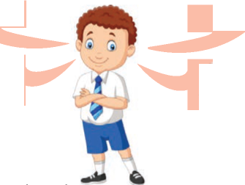
A. Read what Raju is saying. Tell your friends what he is saying.
There countless stars in the sky.

The Earth moves round the Sun.
The Sun is a star.
Two plus two is four.

Begin for example like: Raju said that……………
B.Listen and sing.

What is it,
It has a hard shell,
It doesn't have legs,
It eats plant and leaves,
and it lays tiny eggs.

It is big and brown,
It eats deer for lunch,
It has teeth and claws,
And it runs and hunts.

It is long and grey,
It doesn't have wings.
It eats small fish, And it has strong fins.
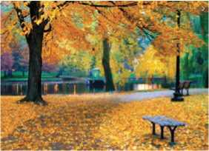
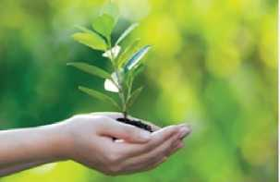
What three animals are described in the song
Reading
Guess the answers to these questions.
- What are the largest animals on Earth? Make a list of five animals.
- What animal do you think is the largest of them all?

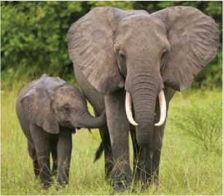
Elephants
Elephants are the largest land mammals on Earth, and they are one of the most unique-looking animals too. They have long noses, or trunks; large floppy ears; and wide, thick legs. There is no other animal with a similar physical structure. There are two species of elephants: the Asian elephants and the African ones. They live on separate continents and have many unique features too.
Figure 116 Elephants
African elephants live in Sub-Saharan Africa and the rainforest of Central and West Africa. Asian elephants live in Nepal, India and Southeast Asia in scrub forest and rainforests.
Among these two, African elephants are larger and grow taller to about 13 feet and weigh about 6,350 kilograms. Asian elephants are just a little smaller and grow up to 8.9 feet tall and weigh about 4,990 kilograms. The African elephants live up to 70 years while Asian ones live up to 60 years.
Both African male and female elephants have large tusks and two fingers on the end of their trunks to help them pick up items. Asian elephants have a single finger on the end of their trunks. Typically, only male Asian elephants will grow large tusks. The female and few males have much smaller tusks called tushes that do not always grow outside the mouth.
Tusks are large, deeply rooted teeth that evolved to assist the elephant in digging, lifting, gathering food and defense while also protecting their trunks. In the same way that human beings are left and right-handed, elephants are also either right-tusked or left-tusked. Their dominant tusk is easy to identify because it will be more worn down than the less dominant one.
Both the species eat all types of vegetation, including a variety of grasses, fruits, leaves, bark and roots. They spend around 18 hours consuming about 75 to 150 kilograms per day.
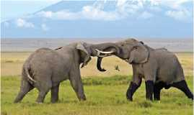
Groups of elephants follow a matriarchal structure with the eldest female in-charge. The matriarch also teaches young members how to socialise with other elephants. They pay close attention to the well-being of all the members of their herd and will take care of the weak and injured ones. Herds of elephants are composed primarily of female family members and young calves. When the family gets too large, herds often split into smaller groups.
Usually a single calf is born following a 22 month pregnancy. Male and female elephants become sexually mature by 8 to 13 years of age. At this age, the males quit their herd and live by themselves; or they make small bachelor herds.
A. Solve the crossword puzzle.
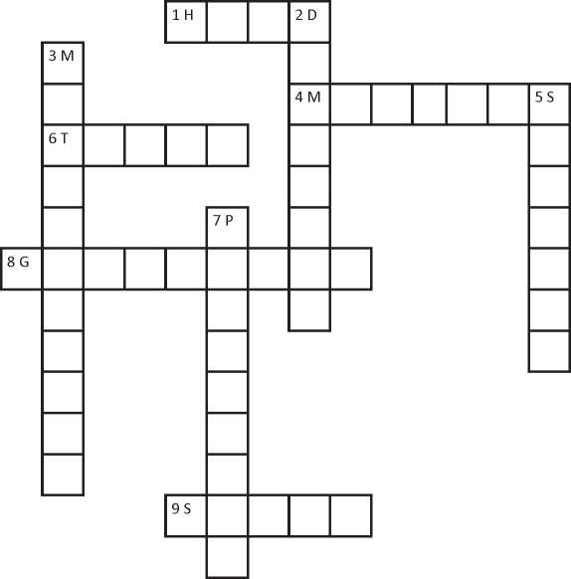
Across
- a large group of animals that lives and feeds together
- the animals that give birth to a baby and feed them with their milk
- long pointed teeth of an elephant
- collecting
- areas with short trees
Down
- more important
- ruled or controlled by females
- types, sorts of an animal or bird
- a period when a baby grows in the womb
- Write whether the following statements are True or False.
- There are other land animals larger than elephants.
- The Asian and the African are the two major species of elephants found in the world.
- African elephants weigh more than Asian ones.
- Tusks are of no use for elephants.
- Elephants spend two thirds of their time eating.
- The herd of the elephants is ruled by a male.
- Answer these questions.
- Why do elephants look unique?
- Where do African elephants live?
- What is the average age of Asian elephants?
- What unique things do elephants and human beings share?
- How do elephants care for weak and injured members?
- When do the male elephants quit their herd?
- Have you or any of your friends ever seen an elephant? Where did you or they see it? Describe the features of an elephant to your friends.

Pronunciation
Use an English dictionary and find the pronunciation for the following words.
mammals scrub tusks  species matriarchal herd | gathering dominant  pregnancy

Speaking
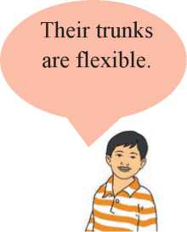
You can identify the
two species apart by
their ears.
A. Read what people are saying about elephants.
Elephants are the
world's largest land
animals.

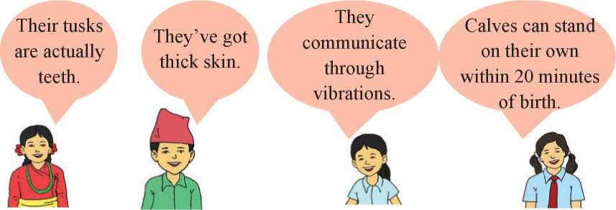

B. Work in pairs. Tell your partner what was said about elephants, as in the example.
Example: The teacher said that elephants are the world's largest land animals.

Grammar I
A. What is the boy in the picture saying? Tell your friends what the boy is saying.
China has the largest population in the world.
Rainbows have seven different colours.
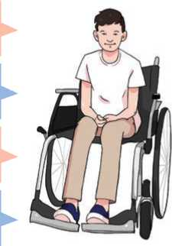
English is an international
language.
Nepal lies between India and China.
There are twelve months in a year.
Water boils at 100º centigrade.
Snow is white.
The Earth moves round the Sun.

B. Match the statements in column A with their reported speech in column B.
a.
Knowledge is power.
i. Mr. Sen said that truth always wins.
b.
The Sun sets in the west.
ii. Chitra said that man is mortal.
c.
The Earth is round.
iii. She said that honesty is the best policy.
All humans are born equal. iv. He said that knowledge is power.
d.
- Man is mortal. v. The teacher told us that the Sun sets in the west.
- Honesty is the best policy. vi. My father said that the Earth is round.
- Truth always wins. vii. She said that all humans are born equal.
- Now, report the following statements as in the example below.

The beginning of each sentence has been given.
Example: Human blood is red.
Mr Sen said that human blood is red.
a.
The sky is blue.
Nita said that
The Earth rotates on its axis.
Sabin told me that
There are seven days in a week.
Nabina said that
Diamond is the hardest element.
The science teacher said that
Sentences in English are separated by a full stop.
Our English teacher said that
Dark clouds are the signs of rain.
My mother said that
It’s very cold at the North and South Poles.
Our geography teacher told us that

b.
c.
d.
e.
f.
g.

Listening

A. Answer these questions.
- What is a voice message?
- When do you leave a voice message?

B. Listen to the audio and answer using no more than two words.
Example: Who is the speaker?
Ellen
- When are they moving into the new house?
- What function are they going to have when they celebrate?
- What day is the party?
- What time is the party?
- What is the name of the house?
- What does the speaker want Nadia to bring?
- Listen to the recording and write everything you hear. Your teacher will pause the audio for you to write.

Writing
- Look at the text you wrote in 'C' above in the listening section. Read it and answer these questions.
- What is the text?
- Who has left it?
- What is it about?

- Now, look at other similar messages.
Dear Urgen,
Many many happy returns of the day. Happy birthday.
Kanchan
Dear Manoj,
May the New Year bring you peace, progress and prosperity.
Pooja
Dear Karina,
I am pleased to hear that you passed grade 7 with good grades. Please accept my heartiest congratulations.
Mona
Hi! Nitu,
I think I left my coat in your house after the party. Have you seen it? Please let me know. Otherwise, I'll have to buy a new one.
Sara
Nimesh,
I said that the football practice will be on Monday. Well, it isn't - it's on Friday. Sorry! See you there.
Manoj
- Now, write similar messages to your friend in the following situations.
- Giving best wishes to a friend on a special occassion such as Dashain /Eid/Christmas.
- Your school starts at 9:00 a.m. tomorrow.
- The cricket match for tomorrow has been postponed for the day after tomorrow.

Reading

Look at the picture and answer these questions.
What do you see in the picture?
a.
b.
c.
Can you name any of the items?
Do you have any of these device? If yes, what do you use it/them for?

Use of a Personal Computer
Hi, I'm Isabella. Today I'm going to talk about how to use a personal computer.
Computers are one of the most used electronic devices in this era. Here is the general process of how you can use your computer.
Press the POWER button to turn on the computer. The power button may be in different places on different models of computer. It usually has a circle with a red arrow down the middle.
Figure 117 Computer
When you turn on the computer, the computer screen lights up. The computer screen is like a television screen. The screen of a computer is also known as monitor or display.
Another important part of a computer is the keyboard. There are different keys with special functions. There are functional keys on the top row, and can be numerical keys on the right-hand side. The function keys are numbered as F1 to F12 with specific tasks. Usually, the F1 key will help you to open the help screen.
There are also some other keys you have to learn. When you are typing a document, you can press the 'Home' button to go to the beginning of the document. Similarly, the 'End' button leads to the end of the document. The 'Delete' button is used to delete the documents or the text on the document while the 'Backspace' can erase the word to the left. Moreover, you can use different letters with the 'Ctrl' button for the smooth function for WORD and other programmes; for example, Ctrl + V helps you to paste something you've copied.

You can also use a mouse. It is a hand-held device which helps to move the cursor on the screen. The cursor is the arrow that shows where you are. The mouse has two different clicking options: right and left where you can click based on your purpose.
If you are using a laptop or a notebook computer, there is usually a mouse pad instead of a mouse. But the mouse and the keyboard can be used externally too.

When you have finished using a computer, you should turn it off properly. Here's how you can turn your computer off.
Move the mouse to the START button. It may vary based on the programme you are using. Click on the START button and click on the SHUT DOWN button. Remove the power cables; if there are any.
A. What do the words/phrases on the left refer to? Match.
a. | Power button | i. | leads to the beginning of the document.
b. | Monitor | ii. | helps to switch on the computer.
c. | Keyboard | iii. | erases text on a document.
d. | Home button | iv. | is available on a laptop computer.
e. | Backspace | v. | helps us type documents.
f. | Mouse pad | vi. | is the computer screen.

- Write True or False for the following statements.
- The 'Power' button varies based on the type of computer.
- A keyboard is not an input device.
- The F1 key helps to shut down the computer.
- The 'Delete' button erases text on a document.
- A mouse has more than two clicking points.
- One should remove the electric cables after shutting down the computer.
- Answer these questions.
- What type of device is a computer?
- What should a user do first to start a computer?
- What is the computer screen similar to?
- How many function keys are there on a keyboard?
- Write any one feature of the mouse.
- What should a user do after s/he uses a computer?

- Do you, your family or your friends have a computer at school or at home? What do you or they use it for? Discuss its advantages in student life.

Grammar
- Study the following sentences.
- If you heat water, it changes into vapour.
- If people eat too much, they put on weight.
- You get burned if you touch a fire.
- You get water if you mix hydrogen and oxygen.
- If you heat ice, it melts.
- If you want to pass the exam, study hard.
- Rearrange the given words to make meaningful sentences.
Example a baby/if/pull their ear/cries/you.
A baby cries if you pull their ear.
- don't waste/you want to be/your time/successful/if.
- everywhere/pollution increases/if/throw wastes/people.
- do regular exercises/our muscles/if/become strong/we.
- if/balanced diet/we don't eat/become weak/we.
- we plant trees/give off/they/if/oxygen.
- Use the correct forms of verbs from the brackets to complete the sentences.
- If you freeze water, it (become) solid.
- If you (mix) red and blue, you get purple.
- Does ice melt if you (heat) it?
- The metal (expand) if you heat it.
- Go to bed early if you (be) tired.
- If you press this button, the TV (switch) on.
- If they work too much, they (get) tired.
- The baby (wake up) if you make too much noise.
- Does oil float if you (pour) it into water?

Writing
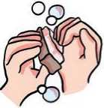
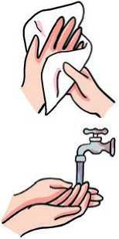
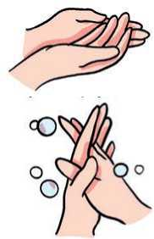
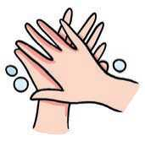

A.
Read the instructions for washing hands properly. Match the
1.

instructions with the correct pictures.
Wet the hands with warm or cold running water.
2.
Lather with soap between the palms, rubbing them together.
3. Lather and rub the back of the hands.
4. Rub between the fingers.
- Clean under the nails, ideally using a nail brush.
- Rinse the hands under running water.
7. Dry thoroughly with a clean towel.

B. Write a set of instructions for brushing your teeth. Use the given clues.
soak the brush put toothpaste brush teeth gently
spit the paste rinse mouth with water

Project work
Find an operation manual of an electronic gadget. Draw pictures to show the instructions. Present it to your class and display it on the classroom wall. Vote to decide the best one.

Extra bit
Read some interesting facts about our bodies. Choose your favourite five facts and put them in order of your priority.
- Your mouth produces about one litre of saliva each day.
- Your brain is sometimes more active when you're asleep than you're awake.
- Bodies give off a tiny amount of light that's too weak for the eye to see.
- The average person has 67 different species of bacteria in their belly button.
- Babies don't shed tears until they're at least one month old.
- The human heart beats more than three billion times in an average lifespan.
- Your left lung is about 10 percent smaller than your right.
- Human teeth are just as strong as shark teeth.
- Scientists estimate that the nose can recognise a trillion different scents!
- Humans are the only species known to blush.
- Your blood makes up about eight percent of your body weight.
(Source: www.natgeokids.com)

GLOSSARY
Abode /a'baud/ (n.): the place where somebody lives.
Abroad /a'broid/ (n.): in or to a foreign country.
Absorb /ab'zoib/ (v.): to take in a liquid, gas or other substance.
Accessible /ak'sesabl/ (adj.): that can be reached/available.
Acclaimed /a'kleimd/ (adj.): publicly praised/ celebrated.
Accommodation /a.koma'deifn/ (n.): a place to live, work or stay in.
Accompany /a'kAmpani/ (v.): to travel or go somewhere with somebody/something.
Achievement /a'tjiivmant/ (n.): a thing that somebody has done successfully, especially using their own effort and skill.
Adjoining /a'djDinin/ (adj.): next to or joined to something.
Adopt /a'dopt/ (v.): to start to use.
Adventures /ad'ventja(r)/ (n.): an unusual, exciting or dangerous experience, journey or series of events.
Affordable /a'foidabl/ (adj.): cheap enough that people can afford to pay it or buy it.
Aid /eid/ (n.): help needed to do something.
Amazing /a'meizig/ (adj.): very surprising, especially in a way that you like.
Appear /s'pis(r)/ (v.): to start to be seen.
Applicant /'^plilont/ (n.): a person who makes a formal request for something.
Apprehend /,^pri'hend/ (v.): (of the police) to catch somebody and arrest them. Approximately /a'proksimatli/ (adv.): about, roughly, more or less.
Arduous /'aidjuas/ (adj.): needing a lot of effort and energy.
Arise /a'raiz/ (v.): to start to exist.
Ashamed of /a'jeimd av/ (v.): to feel upset.
Atmosphere /'^tmasfia(r)/ (n.): the mixture of gases that surrounds the earth.
Attitude /'^titjuid/ (n.): way of thinking or feeling something.
Bachelor /'b^tjala(r)/ (n.): unmarried.
Bathhouse /'baiQhaus/ (n.): a public building in which there are baths, steam rooms, etc.
Beating /'biitig/ (n.): a series of regular hits to something such as your heart.
Blooming /'bluimig/ (adj.): flowering.
Bush /buj/ (n.): a plant that grows thickly with several hard stems coming up from the root. Cafeteria /k^fa'tiaria/ (n.): a place where you collect and pay or your food before you eat. Captive /'k^ptiv/ (adj.): kept as a prisoner or in a space that you cannot get out of. Carpenter /'kaipanta(r)/ (n.): a person who prepares objects of wood.
Carve /kaiv/ (v.): to make objects, patterns, etc. by cutting away material from a piece of wood or stone, or another hard material.
Celebrate /'selibreit/ (v.): to observe a day/event.
Check-out /tjekaut/ (v.): to pay bill and leave a hotel.
Cheerful /'tjisfl/ (adj.): happy, and showing it by the way that you behave.
Chopping /'tfopin/ (v.): cutting.
Chorus /'korras/ (n.): a group of people who sing and dance in a musical show.
Cliff /klif/ (n.): a high area of rock with a very steep side, often at the edge of the sea or ocean Combination /.kumbi'neijn/ (n.): two or more things joined or mixed together to form a single unit.
Commemorate /ka'memareit/ (v.): to remind people of an important event or person from the past.
Commercial /ka'm3:_jl/ (adj.): connected with the buying and selling of goods and services.
Compassion /kam'p^jn/ (n.): a strong feeling of sympathy for people or animals who are suffering and a desire to help them.
Concentration /.kunsn'treijn/ (n.): the ability to direct all your effort and attention on one thing.
Conception /kan'sepjn/ (n.): the process of an egg being fertilized inside a woman's body so that she becomes pregnant.
Conquer /'kugka(r)/ (v.): to climb (a mountain) successfully.
Console /kan'saul/ (v.): to give comfort to somebody who is unhappy.
Consuming /kan'sjurmig/ (v.): eating or drinking a lot of things.
Continent /'kuntinant/ (n.): one of the seven large land mass on the earth such as Asia. Contract /'kuntr^kt/ (v.): to become less or smaller.
Contrast /'kuntrarst/ (n.): a difference between two or more people or things that you can see clearly when they are compared or put close together.
Convenient /kan'virniant/ (adj.): useful, easy or quick to do; not causing problems.
Corrupt /ka'rApt/ (adj.): willing to use their power to be dishonest or illegal things in return for money.
Crest /krest/ (n.): the top part of a hill / mountain.
Crumb /krAm/ (n.): a very small piece of food, especially of bread or cake, that has fallen off a larger piece.
Cunning /'kAnig/ (adj.): clever and skillful.
Curl /k3:l/ (v.): to form or make something form into a curved shape.
Cursor /'k.3rsa(r)/ (n.): a line on a computer screen that moves to show where work is being done.
Damp /d^mp/ (adj.): slightly wet, often in a way that is unpleasant.

Darken /'da:kan/ (v.): to become dark.
Deceased /di'si:st/ (adj.): dead.
Decorate /'dekareit/ (v.): to make something look more attractive by putting things on it.
Degree /di'gri:/ (n.): the qualification obtained by students who successfully complete a university or college course.
Delight /di'lait/ (n.): a feeling of great pleasure.
Deprive /di'praiv/ (v.): to prevent someone from something necessary.
Descend /di'send/ (v.): to come or go down from a higher to a lower level.
Deserving /di'z3:vig/ (adj.): something that is qualified of reward or praise.
Dessert /di'z3:t/ (n.): sweet food eaten at the end of a meal.
Determination /di,t3imi'neifn/ (n.): the quality that makes you continue trying to do something even when this is difficult.
Devices /di'vaisiz/ (n.): an object / machine that has some purpose.
Devoted /di'vautid/ (adj.): loyal or faithful to something.
Diabetes /,daia'bi:ti:z/ (n.): a medical condition in which the body cannot produce enough insulin to control the amount of sugar in blood.
Digestion /dai'djestfan/, /di'djestfan/ (n.): the process of digesting food.
Dishonest /dis'onist/ (adj.): not honest; intending to trick people.
Distant /'distant/ (adj.): far away in space or time.
Dome /daum/ (n.): a round roof with a circular base.
Dominant /'dominant/ (adj.): more important, stronger than anything of the same type.
Doom /du:m/ (n.): death or destruction; any terrible event that you cannot avoid.
Drastic /'dr^stik/ (adj.): extreme in a way that has a sudden, serious or violent effect on something.
Drunkard /'drAgkad/ (n.): a person who drinks very often.
Earthen /'3:0n/ (adj.): made of earth / clay.
Echoing /'ekauig/ (adj.) sending back and repeat a sound.
Elevation /eli'veifn/ (n.): the height of a place from the sea level.
Emerge /i'm3:ds/ (v.): to appear/come.
Emitted /i'mitid/ (adj.): sent out something such as light, heat, sound, gas, etc.
Empire /'empaia(r)/ (n.): a group of countries or states that are controlled by one leader or government.
Employee /im'pbii:/ (n.): a person who is paid to work for somebody.
Empowerment /im'pauamant/ (n.): the act of giving somebody more control over their own life or the situation they are in.
Enclosure /in'klausa(r)/ (n.) a piece of land that is surrounded by a fence or wall and is used for a particular purpose.

Endure /in'djua(r)/ (v): to experience and deal with something that is painful or unpleasant without giving up.
Enormous /i'normas/ (adj.): extremely large.
Enslave /in'sleiv/ (v.): to make somebody a slave.
Entry-level /'entri levl/ (adj.): at the lowest level in a company.
Esteemed /i'sti:md/ (adj.): popular and reputed.
Evolve /i'vulv/ (v.): to develop slowly / gradually.
Examination /ig,z^mi'neifn/ (n.): the act of looking at or considering something very carefully. Excellent /'eksalant/ (adj.): very good.
Exchange /iks'tjeinds/ (v.): to give something to somebody and at the same time receive the something from them.
Exemplary /ig'zemplari/ (adj.): providing a good example for people to copy.
Exhausted /ig'zorstid/ (adj.): very tired.
Expedition /'ekspa'dijn/ (n.): a journey to find out something not well known.
Experience /ik'spiarians/ (n.): the knowledge and skill that you have gained through doing something for a period of time, the process of gaining this.
Externally /ik'stsmali/ (adv.): on the outside of something.
Fahrenheit /'feranhait/ (n.): a temperature scale / measurement unit.
Fraction /'frakjn/ (n.): a small part or amount of something.
Funeral /'fju:naral/ (n.): a religious ceremony for burying or burning a dead person.
Further /'fs:&a(r)/ (adj.): more; additional.
Gardening /'gardnig/ (n.): the activity of working in a garden, especially for pleasure.
Gentle /'djentl/ (adj.): calm and kind; doing things in a quiet and careful way.
Glacier /'gl^sia(r)/ (n.): a slow moving mass / river of ice.
Glance /gla:ns/ (v.): to look quickly at something/somebody.
Global /'glaubl/ (adj.): covering or affecting the whole world.
Graveyard /'greivja:d/ (n.): an area of land where people are buried.
Greenhouse /'gri:nhaus/ (n.): a building with glass sides and roof for growing plants.
Guidance /'gaidns/ (n.): help or advice given to someone.
Hand over /h^nd 'auva(r)/ (phrasal verb): to give somebody else something.
Handheld /'handheld/ (n.): something that we can hold with our hands.
Handle /'h^ndl/ (v.): to deal with a situation, a person, an area of work or a strong emotion. Harsh /ha:j7 (adj.): cruel or unkind.
Hazard /'h^zad/ (n.): something that can be dangerous or cause damage.
Humanity /hjui'm^nati/ (n.): people in general.
Hurricane /'hArikan/ (n): a very strong and violent wind.
Hurry /'hAri/ (v.): to move or act quickly because there is not much time.

Illustrates /'ilastreit/ (v.): to make the meaning of something clearer by using examples, pictures, diagrams etc.
Impose /im'pauz/ (v.): to introduce a new law, rule etc.
Impossible /im'pusabl/ (adj.): that cannot exist or be done; not possible.
Inevitable /in'evitabl/ (adj.): that you cannot avoid or prevent.
Inherit /in'herit/ (v.): to have qualities, physical features, etc. that are similar to those of your parents, grandparents, etc.
Injustice /in'djAstis/ (n.): the fact of a situation being unfair and of people not being treated equally.
Inspiration /jnspa'reijn/ (n.): a person or thing that is the reason why somebody creates or does something.
Intact /in'tekt/ (adj.): complete and in the original state.
Intensity /in'tensati/ (n.): the state or quality of being intense.
Interfere /inta'fia(r)/ (v.): to involve in other's matters unnecessarily.
Introduce /,intra'dju:s/ (v.): to tell somebody what your name is.
Isle /ail/ (n.): an island or peninsula, especially a small one.
Joyous /'djoias/ (adj.): very happy, making someone be happy.
Leadership /'li:dajip/ (n.): the state or position of being a leader.
Lonely /'launli/ (adj.): unhappy because you have no friends or people to talk to.
Mammal /'m^ml/ (n.): any animal that feeds its babies on milk.
Manpower /'m^npaua(r)/ (n.): the number of workers needed to do something.
Marginalized /'maidjinalaizd/ (adj.): to make somebody feel as if they are less important. Matriarchal /meitri'a:kl/ (adj.): a society controlled by female.
Meditate /'mediteit/ (v.): to focus your mind, usually in silence in order to make your mind calm.
Memorable /'memarabl/ (adj.): worth remembering or easy to remember.
Merchant /'msitjant/ (n.): a person who buys and sells goods in large quantities.
Might /mait/ (n.): great strength, energy or power.
Mission /'mijn/ (n.): particular work that you feel it is your duty to do.
Monitor /'munita(r)/ (n.): a screen that shows information from a computer.
Monk /mAgk/ (n.): a member of a religious group of men who often live apart from other people in a monastery and who do not marry or have personal possessions.
Nominal /'numinl/ (adj.): very less than the normal charge / price.
Numerical /nju:'merikl/ (adj.): relating to numbers.
Nutrition /nju'trijn/ (n.): the process by which living things receive the food necessary for them to grow and be healthy.
Oak /auk/ (n.): a large tree that produces small nuts called acorns.
Obesity /au'bi:sati/ (n.): the quality or fact of being very fat, in a way that is not healthy. Observe /ab'zs:v/ (v.): to celebrate festivals, birthdays, etc.
Obstructions /ab'strAkfnz/ (n.): the factors that block the progress.
Obviously /'nbviasli/ (n.) used to say that a particular situation or fact is easy to see or understand.
Occasion /a'keijn/ (n.): a particular time when something happens.
Ophthalmologist /.DfQ^l'mnladsist/ (n.): a doctor who studies and treats the diseases of the eye.
Original /a'ridjanl/ (adj.): the first one rather than copied.
Outskirts /'autsks:ts/ (n.): the parts of a town or city that are furthest from the centre
Outweigh /.aut'wei/ (v.): to be greater or more important than something.
Overhead /.auva'hed/ (adv.): above your head.
Ownership /'aunajip/ (n.): the fact of owning something.
Pardon /'pa:dn/ (v.): to forgive.
Penalize /'pi:nalaiz/ (v.): to punish somebody for breaking a rule of law.
Pleasant /'pleznt/ (adj.): enjoyable, attractive or friendly.
Plunge /plAndj/ (v.): to move or make somebody/something move suddenly forwards and/or downwards
Portion /'po:fn/ (n.): a part of something that is shared.
Position /pa'zijn/ (n.): the place where somebody/something is located.
Preserve /pri'z3:v/ (v.): to keep a particular quality, feature, etc.; to make sure that something is kept.
Prestigious /pre'stidjas/ (adj.): respected and admired as very important or of very high quality. Priority /prai'nrati/ (n.): something that you think is more important than other things and should be dealt with first.
Procession /pra'sefn/ (n.): a line of people moving slowly as part of a ceremony.
Productive /pra'dAktiv/ (adj.): making goods or growing something; fruitful.
Prohibited /pra'hibitid/ (v.): not allowed; banned.
Promise /'prnmis/ (v.): to tell somebody that you will definitely do or not do something. Pronouncement /pra'naunsmant/ (n.): a formal public statement.
Proof /pru:f/ (n.): information, documents, etc. that show that something is true.
Proportion /pra'pD:_jn/ (n.): a part of a whole.
Puberty /'pju:bati/ (n.): the period of a person's life during which their sexual organs develop and they become capable of having children.
Qualification /.kwnlifi'keijn/ (n.): an exam that you have passed or a course of study that you have successfully completed.

Rainforest /'reinforist/ (n.): a thick forest in some parts of the world that have a lot of rain.
Rare /rea(r)/ (adj.): not done, seen, happening, etc. very often.
Raw /ro:/ (adj.): not cooked.
Rear /ris(r)/ (v.): to bring up or raise.
Recognize /'rekagnaiz/ (v.): to know someone or something.
Registration /.redsi'streifn/ (n.): the act of making an official record of something/somebody.
Remarkable /ri'ma:kabl/ (adj.): unusual or surprising in a way that causes people to take notice.
Remedy /'remadi/ (n.): a way of dealing with or improving an unpleasant or difficult situation. Represent /.repri'zent/ (v.): to act or speak officially for somebody and defend their interests. Reputation /repju'teifn/ (n.): good name.
Resistance /ri'zistans/ (n.): dislike of or opposition to a plan, an idea, etc.
Resolve /ri'zolv/ (v.): to solve / end a problem.
Respectively /ri'spektivli/ (adv.): in the same order as the people or things already mentioned.
Restore /ri'sto:(r)/ (v.): to bring back a situation or feeling that existed before.
Roam /raum/ (v.): to walk or travel around an area without any definite aim or direction.
Room /ru:m/ (n.): empty space that can be used for a particular purpose.
Route /ru:t/ (n.): a way.
Run out /rAn aut/ (phrasal verb): to use up or finish a supply of something.
Sack /s^k/ (n.): a large bag with no handles.
Saliva /sa'laiva/ (n.): the liquid that is produced in your mouth that helps you to swallow food.
Satellite /'s^talait/ (n.): an electronic device sent to space for research / study.
Scratch /skr^tf/ (v.): to rub your skin with your nails, usually because it is itching.
Scrub /skrAb/ (n.): a land of low quality covered with short trees and bushes.
Seam /si:m/ (n.): a thin layer of coal or other material, between layers of rock under the ground Seep /si:p/ (v.): to flow slowly through something.
Seriously /'siariasli/ (adv.): in a serious way.
Set off /set o:f/ (phrasal verb): to begin a journey.Severely /si'viali/ (adv.): very badly or seriously.
Shake /feik/ (v.): to move or make somebody/something move with short quick movements from side to side or up and down.
Shocked /fokt/ (adj.): surprised and upset.
Shot up /fot Ap/ (v.): increased in price.
Shout at /faut «t/ (v.): speak loudly to somebody because somebody is angry.
Significant /sig'nifikant/ (adj.): large or important enough to have an effect or to be noticed. Sobbing /sobig/ (n.): noisy cry.
Spirit /'spirit/ (n.): the part of a person that includes their mind, feelings and characters.
Splutter /'splAta(r)/ (v.): to speak quickly and with difficulty.
Sprawl /spro:l/ (v.): to spread in an untidy way.
Stamina /'stamina/ (n.): the physical or mental strength that enables you to do something difficult for long periods of time.
Stare /stea(r)/ (v.): to look at somebody or something for a long time.
Starter /'sta:ta(r)/ (n.): a small dish that is served before the main meal.
Starve /sta:v/ (v.): to suffer or die because you do not have enough food to eat.
Steadily /stedali/ (adv.): gradually and in an even and regular way.
Stir /st3:(r)/ (v.): to move, or to make something move, slightly.
Struggle /'strAgl/ (v.): to try very hard to do something when it is difficult or when there are a lot of problems.
Stuff /stAf/ (n.): a thing or material.
Suffering /'sAfariq/ (n): physical or mental pain.
Suffocation /.sAfa'keifn/ (n.): the process of dying because there is no air to breathe.
Summit /'sAmit/ (n): the highest point of a mountain.
Supremacy /su'premasi/ (n.): a position in which you have more power, authority or status than anyone else.
Surgeon /'ssidjan/ (n.): a doctor who is trained to perform surgery (medical operations that involve cutting open a person's body).
Surprise /sa'praiz/ (n.): an event, a piece of news, etc. that is unexpected or that happens suddenly.
Tan /t^n/ (v.): become brown as a result of spending time in the sun.
Taunt /to:nt/ (v.): to try to make somebody angry or upset.
Technology /tek'nuladji/ (n.): scientific knowledge used in practical ways in industry, for example in designing new machines.
Terrifying /'terifaiig/ (adj.): making somebody feel extremely frightened.
Texture /'tekstj’a(r)/ (n.): the way a surface, substance feels when you touch it, for example how rough, smooth, hard or soft it is.
Traffic /'tr^fik/ (v.): to move people illegally, especially in order to make them work in bad conditions without proper payment.
Train /trein/ (v.): to teach a person or an animal the skills for a particular job or activity. Tramp /tramp/ (v.): to walk with heavy or noisy steps, especially for a long time.
Transit /'tranzit/ (n.): the act of going through a place on the way to somewhere else. Treatable /'tri:tabl/ (adj.): (of an illness or injury) that can be made better with medical care. Tremble /'trembl/ (v.): to shake in a way that you cannot control, especially because you are very nervous, excited, frightened, etc.
Tribute /'tribjuit/ (n.): an act, a statement or a gift that is intended to show your love or respect.
English Grade 7 219
Trick /trik/ (n.): something that you do to make somebody believe something is not true.
Trouble /'trAbl/ (n.): a problem, worry, difficulty, etc. or a situation causing this.
Unbearable /An'bearabl/ (adj.): too painful to accept / bear.
Uncomfortable /An'kAmftabl/ (adj.): not feeling physically relaxed, warm.
Underprivileged /Anda'privalidjd/ (anj.): having less money and fewer opportunities than others.
Unroll /An'raul/ (v.): to open to make flat.
Utter /'Ata(r)/ (v.): to say something.
Veterinarian /,vetari'nearian/ (n.): a person who has been trained in the science of animal medicine, whose job is to treat animals who are sick or injured.
Violate /'vaialeit/ (v.): to go against or refuse to obey a law, an agreement, etc.
Violence /'vaialans/ (n.) violent behaviour that is intended to hurt or kill somebody.
Vulnerable /'vAlnarabl/ (adj.): weak and easily hurt physically or emotionally.
Warden /'wo:dn/ (n.): a person who is responsible for taking care of a particular place.
Weary /'wiari/ (adj.): very tired, especially after you have been working hard or doing something for a long time.
Welfare /'welfea(r)/ (n.): the general health, happiness and safety of a person, an animal or a group.
Whirl /w3:l/ (v.): to move, or make somebody/something move, around quickly in a circle or in a particular direction.
Whisper /'wispa(r)/ (v.) to speak very quietly to somebody so that other people cannot hear what you are saying.
Winding /'waindig/ (adj.): having a curving and twisting shape.
Wonderful /'wAndafl/ (adj.): very good, pleasant or a lot of fun.
Wounded /'wu:ndid/ (adj.): became upset / sad by what someone has said/done.
Yell /jel/ (v.): to shout loudly.

