ENGLISH

Grade 9
Government of Nepal
Ministry of Education, Science and Technology
Curriculum Development Centre

Publisher: Government of Nepal
Ministry of Education, Science and Technology
Curriculum Development Centre
Sanothimi, Bhaktapur

© Curriculum Development Centre
All rights reserved, no part of this publication may be reproduced, transmitted in any other form or by any means without the written permission of the publisher. However, this does not prohibit making photocopies of its pages for teacher training or other non-profit making purposes.
First Edition: 2022

Printed at: Janak Education Materials Center Ltd.
Sanothimi, Bhaktpur
Price Rs:

Send your comments and suggestions to:
Curriculum Development Centre
Phone: 01-6630-588, Fax: 01-6630-797
Email: info@moecdc.gov.np
Website: moecdc.gov.np

Preface
A textbook is a main tool for the use of students on a particular subject that is usually developed based on a curriculum to meet its curriculum standards. This ‘English Grade 9' textbook was developed to address the main aims of Secondary Education. It aligns with the intent pursued by the National Curriculum Framework for School Education, 2076 and was developed fully in accordance with the Secondary Level English Curriculum, 2078. All components of each lesson in the textbook are equally important and they have the specific aim of presentation so as to fulfill the learning outcomes stated in the curriculum.
This textbook, initially prepared by a team that includes Mr. Nim Prakash Singh Rathaur, Mr. Ananda Dhungana and Mr. Pashupati Pandya, has been revised by a team comprising of Dr. Gopal Prasad Pandey, Dr. Neil David Rose, Mr. Ramesh Dhakal, Mr. Shankar Adhikari and Mr. Nabin Khadka. Several people notably; the Director General, Mr. Ana Prasad Neupane, the subject committee chairperson, Prof. Dr. Jib Lal Sapkota and the subject committee members; Prof. Dr. Rishi Ram Rijal, Mr. Madhav Prasad Ghimire, Ms. Maiya Niraula Pokharel and Mr. Tuka Raj Adhikari have contributed significantly on the development of this book. The contribution made by other experts and the practitioners; Mr. Parshu Ram Tiwari and Mr. Matrika Subedi is also appreciated. The illustrations in the book were designed by Ms. Shaili Malla and Kushal Adhikari. Art editing of this textbook in its four-coloured version was done by Shreehari Shrestha. The Curriculum Development Centre extends sincere gratitude to all of them. With the view that the learning of English should be based on authentic materials, we have retrieved and adapted the texts and tasks including the audios from various authentic sources. Therefore, the Centre would like to extend its acknowledgements to all of them.
This textbook may be used to deliver the foundation for the content of the curriculum, the balance of skills to be taught and the types of language practice the students are to take part in. However, teachers can adapt the contents and tasks as per the need and context of their individual students. This textbook can be used as the primary resource for classroom teaching but teachers are encouraged to make use of their own resources to supplement the language learning of their students. The Curriculum Development Centre always welcomes constructive feedback for the betterment of its publications.

2022 AD Government of Nepal
Ministry of Education, Science and Technology
Curriculum Development Centre

Table of Contents
Unit | Title | Reading | Speaking | Listening | Grammar | Writing | Project  Work | Page
1 | Travel and holidays | Poon Hill Yoga Trek in Nepal Stopping by Woods on a  Snowy Evening | Making plans and expressing intentions | Telephone conversation | Present continuous Going to future Simple future Future continuous | Paragraph  Letter | Interview | 1
2 | Health and hygiene | The  Acceleration behind Telehealth  Services  Health is  Wealth | Suggesting, advising and warning | Description | Modals: should, ought to, had better, Conditional type 2&3 | Paragraph  Recipe | Presentation | 13
3 | Family, market and public place | Thomas and  Jerry  Dance | Making requests and responding to requests | Conversation | Modals: would, could, can | Letter to the head teacher Paragraph | Narrating a special event | 27
4 | Life and death | Death is a  Fiction  Crossing the  Bar | Expressing condolence and sympathy | Conversation | Present simple subject verb agreement | Condolence  Email | Newspaper  cutout | 38

5 | Ethics, norms and values | Why "I’m Sorry” Doesn’t Always Translate JetBlue’s Apology | Apologising and responding to an apology | Conversation | Present continuous | Interpretation of charts  Letter | Display | 52
6 | Custom and culture | Sky Burials Surprising Customs | Asking for permission | Description | Yes/no questions reported speech | Essay | Picture design | 65
7 | Ecology and environment | How do Animals Spend the Winter?  The Resistant Moths. | Making, accepting and rejecting offers | Description | Conditional type 1 | Paragraph  Letter to the  editor | Picture drawing | 79
8 | Science and technology | Humanoid  Robot Sophia  The Alternative  Energy Sources | Describing people, place and things | Conversation | Relative clause | News story  News article | Debate | 93
9 | Work and leisure | The Ant and the  Grasshopper  Leisure | Getting things done | Conversation | Causative verbs Passive | Interpretation of charts  Essay | Survey | 107
10 | The Earth and  Space | A Message  from Another  Planet  Up-Hill | Locating places | Description | Prepositions | Account  Rules and regulations | Searching | 120

11 | Gadgets and instruments | Save your Smartphone Weather  Instruments | Giving instructions | Instruction | Reported speech: statement and imperative | Recipe Newspaper article | internet surfing | 132
12 | People and places | Paulo Coelho  Madam and  Her Madam | Giving directions | Giving direction | Articles | Book review  Biography | Personal profile | 145
13 | Organization profile and authority | Asian Development Bank Institute (ADBI) Congratulation Letter | Describing purpose and function | Conversation | Connectives | Advertisement A message of congratulations | Organization profile | 158
14 | History and civilization | The Maya Empire  The History of  Monev | Narrating past events | Monologue | Simple past  Used to  Past continuous  Past perfect | Story  Essay | Note keeping | 169
15 | People and lifestyle | The Diary at a  Young Girl  The Rautes | Talking about past action with present significance | Description | Present perfect  Present perfect continuous | Diary  Essay | Report | 185
16 | Games and sports | Wimbledon  Sports | Expressing ability to do something | Radio news | Question tag  Negation | News story Paraphrasing | Schedule | 198
17 | Global warming and climate change | Chasing Ice A Noisy Party | Expressing degrees of certainty | Weather report | Simple future Future perfect Wh questions including reported speech | Movie review  Notice | Display | 210
18 | Transportation and communication | Wright Brothers Rickshaw Ride | Making comparison | Conversation | Adjectives and adverbs | Interpretation of charts  Account | Searching | 224

Unit 1 Travel and Holidays

Getting started

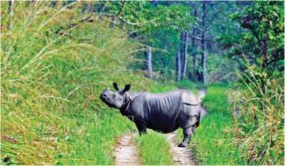

Look at the pictures and talk about them.
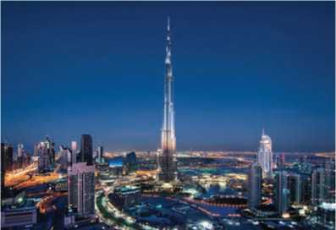
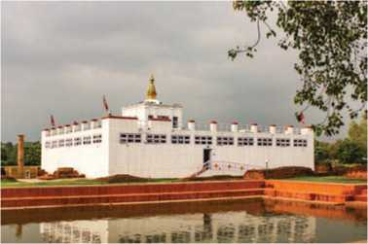
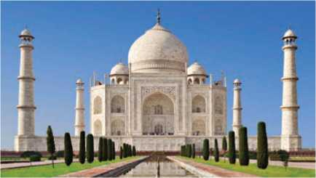
Figure 1 rhino
Figure 2 Burj khalifa
Figure 3 Lumbini
Figure 4 Tajmahal

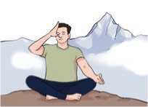
Figure 5 Pranayama

Reading I
Look at the picture and answer the questions.
- What do you think the man in the picture is doing?
- Are you planning to travel or go on a holiday this year?

Poon Hill Yoga Trek in Nepal
The Poon Hill Yoga Trek provides a wonderful opportunity to witness the beauty of the Annapurna Range and the hidden treasures of Nepali culture. This programme will help you integrate the principles of Yoga into your daily life with magnificent views of snow-capped Himalayas and glaciers. The main benefit of joining this program is that it supports and encourages a deep personal transformation process. This adventure journey passes through many tourist hotspots and icy waterfalls which are very pleasant sights.
Introducing Hatha Yoga and meditation alongside a trekking experience allows ample benefits for physical and mental health. The combination of Yoga and the Poon Hill Trek creates a more fulfilling physical exercise while strengthening and opening the mind for greater relaxation and awareness, all within the attractive natural environment.
This program is open for all experience levels and is a unique chance for those interested in the strengthening of the body, mind and soul. This may be the short Yoga holiday you have always wished for providing an opportunity for you to explore Nepali lifestyle and the secrets to happiness of the Nepali people.

Main Highlights
Visitors will be astonished by adorable landscapes and the enchanting environment. Gazing at stunning views of the Himalayas and savouring delicious Nepali meals is really incredible. They will be attracted by different Nepali cultures, the diverse flora and fauna, numerous perennial rivers and suspension bridges, and spectacular sunrise and sunset views over high Himalayas will certainly encourage everyone to self-transform with Yoga and meditation.

Itinerary
Day 01: Arrival in Kathmandu
We will welcome you at the airport and provide a transfer to the center. We will also discuss the program. Finally, we will be staying overnight at the center.
Day 02: Transfer to Pokhara
The first activity is to drive to Pokhara in the morning. A standard micro bus or a tourist bus will take about 4-5 hours. This bus ride passes along through the hilly winding road alongside the Trishuli River having great views of the river, forests and terraced fields. We will stay overnight in Pokhara.
Day 03: Pokhara - Tikhedhunga
We wake up early in the morning and have tea before Yoga. We practise Yoga for an hour. Then, it is time for breakfast. After breakfast, we drive to Nayapul. We start our trek towards Tikhedhunga. On the trek, we pass through several towns. We will reach Tikhedhunga and we will be staying there overnight.
Day 04: Tikhedhunga - Banthanti
After tea, Yoga and breakfast in the morning; we start our trek towards Banthanti. On the way, we cross a stream over a suspension bridge. We will be trekking to a Magar village which is called Ulleri. Above the village where the trail climbs gently through the cultivated fields, rhododendron and oak forests, we will stop at Nangethanti for lunch and a short rest. After lunch we will start walking towards Banthanti through the beautiful forest. Finally, we do evening Yoga, have some relaxation and sleep in Banthanti.
Day 05: Banthanti - Ghorepani
As soon as we wake up in the morning, we will have tea and then join the Yoga class. After breakfast, we will start our hike towards Ghorepani, exploring the local culture, landscapes and mountains. After we engage in Yoga there will be some entertainment, we will then take dinner, and stay overnight in Ghorepani.
Day 06: Ghorepani - Poon Hill
We will wake up early in the morning and go for one hour hike to Poon Hill where we can enjoy panoramic mountain views and a beautiful sunrise. Then, we will trek down to Ghorepani and have breakfast. From there we begin our trek to Tadapani, which translated means far water supply in this village from long distance. The trail climbs along ridges and through pine and rhododendron forests to Deurali. Then, it descends to reach Banthanti; we reach Tadapani, and take part in Yoga in the evening. We will be accommodated overnight in a tourist lodge.

Day 07: Tadapani - Ghandruk - Pokhara
We will wake up in the morning and practise Yoga. After Yoga, we will have breakfast. Then, our trek continues towards Ghandruk. After walking for around four hours, we reach Ghandruk, a Gurung village which is the most interesting ethnic village in Nepal, famous for its Gorkha soldiers. It has excellent close-up views of Annapurna South and Machhapuchhre Himalayas. After lunch, we drive back to Pokhara via Nayapul. We will stay overnight in Pokhara.
Day 08: Departure
We will leave for the next destination in the morning after breakfast.
- Match the words in column A with their meanings in column B.
Column A Column B

a. | magnificent | i | charming
b. | glaciers | ii. | surprised; amazed
c. | hotspot | iii. | plants and animals
d. | astonished | iv. | throughout the entire year
e. | enchanting | v. | rivers of ice
f. | flora and fauna | vi. | extremely attractive and impressive
g. | perennial | vii. | a place of significant activity
B. Circle the correct answer.

- What are the visitors expected to achieve the most in this package holiday?
- enjoyment of panoramic views of mountain and landscapes
- plenty of physical activity in the lap of nature
- self-transformation with Yoga in serene hill stations

- What will the visitors do on the first day of their tour?
- go to Pokhara ii. discuss the program
iii. practice Yoga for an hour
- Where will they stay on the fourth day?
i. at Tikhedhunga ii. at Banthanti iii. at Ghorepani
- What is the destination of the visitors on the sixth day?
I. Ghorepani ii. Tadapani iii. Deurali
- Which place will the tourists visit last as a part of the package?
I. Ghandruk ii. Nayapul iii. Pokhara
- Answer the following questions.
- List any two advantages of the Yoga trek in the Nepali hilly region.
- Who can take part in this Yoga trek program?
- What would you enjoy the most in Ghandruk if you were one of the visitors? Why?
- How many days do the visitors do Yoga during the program?
- How is the Yoga hour mainly managed every day on this holiday trek?
- Have you ever been on a holiday trip or travelled to different places? Mention the hotspots, points of interest, etc. Share your experiences with your friends.

Pronunciation
Pronounce the following words with the help of your teacher.
wonderful | destination | opportunity | unimaginable
likelihood | inspirational | responsibility | astonishing
magnificently | autobiography | insignificant | biodiversity

Speaking
- Read and act out the following conversation.
I'm thinking of going on a trip this year. The time has come. I think my parents will allow me to go.
I may not be able to convince my father. He does not believe in boys staying away from home for several days. We're going on a family trip, instead.
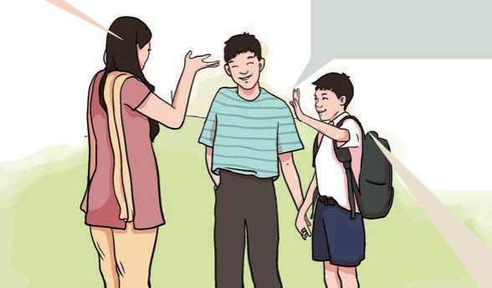
Figure 6 communication 3 member
I intend to go. My parents will most likely to let me go. I'm thinking of asking Lakpa's father if he would allow him to go with us.

- What will your plans be in the following situations? Share with your friends.
- You want to go swimming this Saturday.
- You and your friends are going to play football tomorrow evening.
- Your parents are planning to go to Darjeeling next week.
- Your friend has invited you to a birthday party tonight.
- You are invited to attend the wedding ceremony of one of your friends' sister.
C. Talk about your plans in pairs. Use the structures from the box.
I intend to | I'm planning to | I'm doing
I'll do | I'm thinking of

- After SEE
A: study history
B: study mathematics
- After earning a lot of money
A: open a supermarket
B: go on a world tour
- For a party
A: go by bus
B: go on his/her cycle
- To improve vocabulary
A: buy a Nepali dictionary
B: buy an English dictionary
- After completing a Bachelor’s degree
A: go abroad
B: start own business

Grammar I
- Study the following sentences.
- A: Did you call your mother?
B: Oops, I’ve forgotten! I'll do it right now.
- I can't decide what to wear tonight. I think I'll wear my pink saree.
- The bus will arrive here soon.
- They have bought a lot of chocolates. They are going to have a party.
- I'm meeting Jane at 8 o'clock on Saturday.
- A: We're having a party next Saturday. Would you like to come?
B: I'd love to, but I'm quite busy that day.
- I'm visiting my grandparents next week.
- Are you doing anything interesting this weekend?
- Choose the correct answer to complete the following sentences.
- It's really hot here a window.
- I’ll open ii. I’m opening

- I don't have a bank account an account in Nepal Bank
Ltd.
- I’ll open ii. I’m going to open
- A: Would you take tea or coffee? B: a coffee, please.
I. I’ll have ii. I’m going to have
- I've decided that to the class teacher about my family
situation.
I. I’ll speak ii. I’m going to talk
- Next week, we on lake Rara.
I. will boat ii. will be boating
- I would love to go out with you tomorrow but dinner
with Dolma.
I. I’ll have ii. I’m having
- I can't come to class next Monday a tooth taken out.
I. I’ll have ii. I’m having

Writing I
Imagine that you are going on a three-day trek during your vacation. What will you do on different days? Write short paragraphs about your plans.

Reading II
Look at the picture below and answer the questions.
- Where do you think the man in the picture is?
- Why do you think he has stopped there?

Stopping by Woods on a Snowy Evening
Whose woods these are I think I know
His house is in the village though;
He will not see me stopping here
To watch his woods fill up with snow.
My little horse must think it queer
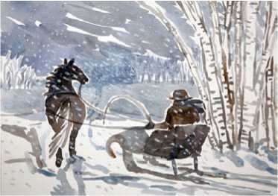
To stop without a farmhouse near Between the woods and frozen lake The darkest evening of the year.
Figure 7 Horse and man
He gives his harness bells a shake
To ask if there is some mistake.
The only other sound's the sweep
Of easy wind and downy flake.
The woods are lovely, dark and deep,
But I have promises to keep,
And miles to go before I sleep,
And miles to go before I sleep.
-Robert Frost
- Find the words from the text that match the following meanings.
- an area of trees, smaller than a forest
- strange or unusual
- the main house on a farm, usually where the farmer lives
- a set of leather and metal pieces that is put around the body of a horse
- movement of the air
- covered in something very soft
- Choose the correct answer.
- Why does the speaker stop while on the journey?
- to watch the woods filled up with snow
- to find food for his or her horse
- to say hello to the owner of the woods
- to go skating on a frozen lake

- What is the setting of the poem?
- the woods on a bright, snowy afternoon
- a village on a dark, snowy evening
- a frozen lake on a bright, snowy afternoon
- the woods on a dark, snowy evening
- Which one of the following statements is true?
- The woods are far away from the village.
- The woods are near some houses.
- The owner of the woods and speaker are friends.
- The speaker of the poem does not like the owner of the woods.
- How did the horse respond when the speaker stopped there?
I. stood calm ii. did nothing
iii. shook its harness iv. asked the speaker a question
- What does 'miles to go before I sleep' mean?
- The speaker feels tired and sleepy.
- The speaker has lots of desires to fulfill.
- The speaker has lots of responsibilities to fulfill.
- The speaker has a long distance to travel.
- Fill in the gaps with appropriate words from the box to complete the summary of the poem.
Promises traveler journey death the wood destination
The poet compares human life with a The speaker of
the poem is a He has to reach his before taking
a rest. However, he is distracted by the momentary pleasure in the form of…… His companion, the horse, reminds him of his
in life. The speaker realizes that he has to fulfill many responsibilities before his
- Recall a journey you have recently made. Who accompanied you on the journey? Did you enjoy it? Compose a short poem about it.

Listening
Look at the picture and guess the answers to the following questions.
A.
- Who is the lady?
- Who is she talking to?
- What is she talking about?

Listen to the audio and fill in the gaps with suitable words/ phrases.
B.
.
- The name of the hotel is
- The $200 room is quite for the customer.
- All the non-smoking rooms are on 22nd March.
- The non-smoking room costs $
- The customer finally books the room for March.

- Where do you often spend nights when you are away on a visit or holidays? How do you or would you make a reservation if you have to stay in a hotel? Share your ideas with your friends.

Grammar II
A. Use the correct form of the verbs given in the brackets to complete the sentences.
- As per the schedule, the train (leave) at 3 o'clock.
- Look, that aeroplane is looking shaky! It (crash).
- My daughter says she (be) a doctor when she is older.
- Tomorrow (be) a sunny day, according to the
weather forecast.
- A: What (do) tomorrow evening?
B: Nothing special. I think I (stay) at home.
- It's very stuffy here. Don't worry, I (open) the
windows for you.
- Ann is driving. There is very little petrol left in the tank. The
nearest petrol station is a long way from here. She (run)
out of petrol.
- There is a hole in the bottom of the boat. It is filling up with
water quickly. It (sink).

Writing II
Write a letter to your friend describing your travel plans for your upcoming holiday or visit. Take help from the following questions to write your letter.
Where do you plan to go?
Who will you go with?
Where will you stay?
How long will you stay?
What are you going to see?

Project work
Prepare a set of questions to find out your friends' plans and intentions for the future. Meet at least four of your classmates to get their views, and note them down. Share their plans and intentions with the whole class.
Extra bit
Use a colon (:)
between a grammatically complete introductory clause (one that could stand as a sentence) and a final phrase or clause that illustrates the preceding thought
Example: Professor Pokhrel wrote two books on education: one on educational leadership and the other on educational planning.
in ratios and proportions
Example: The proportion (saltwater) was 1:8.
in references between the place of publication and the publisher
Example: London: Oxford University Press
uni

Unit2 Health and Hygiene

Getting started
Look at the picture and discuss about the meaning of the health.
Figure 8 Communication

Reading I
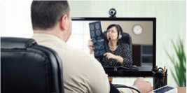
Before you read the interview below, answer these questions.
- How do you get advice from a doctor?
- What do you know about telehealth services?

The Acceleration behind Telehealth Services
Figure 9 advice doctor
(In this interview, Chun-Kai Chang , the Business Development Manager of Telehealth at Advantech, talks to News-Medical about the acceleration behind telehealth services.)

Reporter : To begin, can you give us a brief introduction into telehealth and what it involves?
Chang : Telehealth is a method of providing medical care remotely

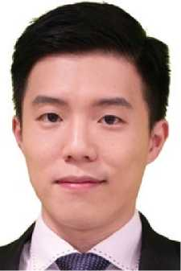
usually through video chat. Telehealth makes it possible to connect patients and clinicians from any location. It provides access to a wide range of care, including primary care consultations, psychotherapy, physical therapy, and even emergency services. It allows primary care clinicians and specialists to further their reach for treating patients wherever there is an internet connection.
Figure 10 password size photo
The benefits of telehealth for healthcare providers and patients is that these services can be faster, safer, more effective, and less expensive in the long run, especially during a time like the COVID-19 pandemic, where telehealth has allowed access to medical care without going to hospitals to protect patients and hospital staff from being exposed to the infection.
What are some of the main drivers behind the acceleration and momentum of telehealth services?
Reporter :
Chang :
There are two major drivers for this fast-growing market. The first and most recent driver for telehealth has been the global COVID-19 pandemic. Strong social distancing and minimal physical contact precautions have pushed the shift to telehealth and remote consultations as it aids in infection protection.
These precautions and increased hospital bed shortages have forced medical facilities to incorporate more telehealth technologies to keep up with demand and maintain care continuity for patients at home.
The second driver is the shortage of medical professionals when demand is increasing every year due to an aging population and more and more patients with chronic and non-communicable diseases. For people living in rural areas, their medical demands are underserved due to insufficient resources and long distances to drive into cities for care. Telehealth is one of the promising ways to tackle the challenge of doctor shortages and expand specialists and doctors' reach to patients.

Reporter : In terms of this acceleration and momentum of telehealth services, we are currently seeing, what are some items we can expect to see in the future?
Chang : Tele health will not replace face to face care services, but we will incorporate it into healthcare facilities' infrastructure. Patients will be selecting providers based on their accessibility to telehealth services. With more access to doctors, increasing patients using preventative care services and follow-up care due to convenience will start to emerge. These can lead to fewer readmissions and patient complications. We will also see more use for early screening of patient triage in the field before they arrive at hospitals.
Reporter : When it comes to remote patient monitoring for clinicians, what impact does telehealth have on this?
Chang : Remote patient monitoring could be one of the applications of telehealth. Remote patient monitoring usually involves continuously collecting patient's health data through wearable devices, such as vital signs and blood sugars. The patient's data is then transmitted in real-time, monitored, and reviewed by medical providers.
In this way, medical providers could acquire a whole picture of a patient's health condition and give a more precise diagnosis.

Reporter : How has telehealth shaped the way clinicians work with each other?
Chang : Clinician-to-clinician telehealth services have enabled medical professionals to collaborate virtually with specialists in other locations to deliver treatment and care to patients jointly. This service can range from remote surgical mentoring to Tele-ICU and Tele-ER (like a stroke), in which on-site staff work together with a remote physician/specialist team to assess patient's condition. Telehealth solutions relieve the pressure of staffing gaps seen in critical departments such as an emergency room and ICU.
Reporter : What would you say are some of the biggest challenges clinicians currently face with telehealth?
Chang : Many hospitals are still facing the lack of infrastructure to

implement telehealth successfully, insufficient hardware, and the right technology for each specialty. Some hospitals struggle with reliable networking infrastructures like broadband, 4G, or Wi-Fi. This could limit the connectivity within facilities and provide remote care to rural areas or mobile clinics. Having the right technology and tools, and place will be crucial to successful telehealth programs.
Even though this new technology is quickly being integrated, there is a learning curve to using telehealth versus traditional healthcare operations. Users face obstacles such as learning to use different tools, online scheduling for virtual visits, triage procedures, and billing policies.
To overcome these challenges, telehealth should be encouraged as a regular service and included in health insurance. There would be more motives for healthcare providers to invest in infrastructures and information system integration and deploy telehealth technology.
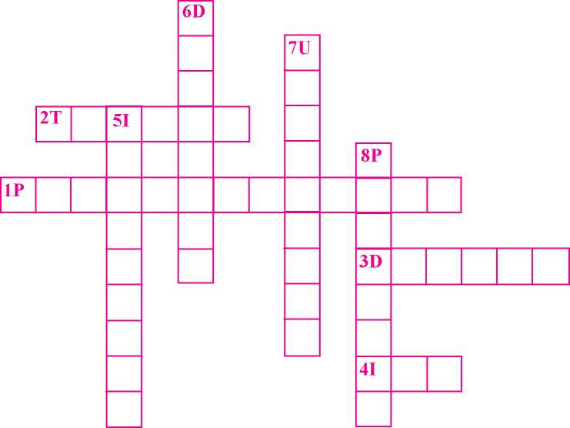
The meanings of some of the words from the interview are given below. Find the words and fill in the crossword puzzle.
Figure 11 crossword puzzle
A.

Across
- psychological treatment of people using dialogue
- process of sorting patients
- to prepare and arrange
- special department of a hospital for intensive care of patients
Down
- to include as a part
- identification of nature and cause of a disease
- not having sufficient service
- epidemic over a wide geographical area
- Read the interview again and write whether the following statements are True or False.
- Internet service is necessary to use telehealth services.
- While providing telehealth services, health professionals are at high risks of being infected due to the exposure to patients.
- Telehealth service can be the best alternative to a face to face service.
- The problem with the lack of medical staff will be solved to a great extent with telehealth technology.
- The success of telehealth programmes depends on the infrastructure and the best use of IT tools.
- Answer the following questions.
- What is telehealth service?
- What are the advantages of using telehealth programmes?
- Why, according to Dr. Chang, is the telehealth service growing rapidly?
- How is the telehealth programme important during a pandemic?
- Why are the patients in remote areas not getting adequate health services?
- Mention the top three challenges of telehealth services.
- How might rural communities feel about telehealth services? How could this be improved? Talk to your friends.

Pronunciation
Pronounce the following words with the help of your teacher or a dictionary.
infrastructure staff  school shield  strand sixth | Chronic strength milk  curious stethoscope blend scream

Speaking
- Read and act out the following conversation.
Shanti : Ah, this is just ridiculous!
Selina : Sneha again?
Shanti : Yeah, Sneha. She just keeps asking for money. What do you think I should
do?
Selina : Well, if I were you, I’d ask her not to beg.
Shanti : I’m not sure that’s a good idea.
Selina : Umm.., I’m not sure then. Perhaps you should try talking to Sneha about it.
Shanti : Well, I’ve tried that. But she did not show any interest.
Selina : How about talking to her parents?
Shanti : Really? I’m not too sure about that. It might work, I suppose.
- How does the woman advise the girl?
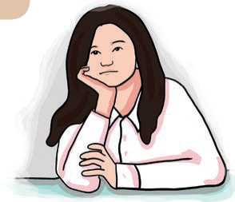
I have a severe toothache. I can't eat anything.
Figure 12 girls
If I were you, I'd go to a dentist.
Figure 13 Girls

Now, work in pairs and take turns to explain your situation and give suggestions.
a. | A: tired/ not sleep | B: | have a hot drink
b. | A: cold/ no heating | B: | put a sweater on
c. | A: friend's birthday/ no money | B: | pick a bunch of flowers
d. | A: hurt my leg | B: | go to see a doctor
e. | A: not feeling well | B: | take a rest for a while.

- Give suggestions in the following situations. Use the given expressions.
- She struggles in English although she works very hard.
- She has lost her math book in school.
- She has put on weight, but she wants to be slim.
- You'd better...
- If I were you...
- Why don't you...?
- You should/ought to...
- If I were you...

Grammar I
- Study what the people in the picture are saying.
I failed my test.
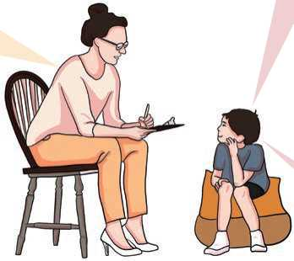
Figure 14 communication about education
'Really? What do you think you should do in future?
I should study a little more.

- Choose the correct answer.
- I need help, doctor. My baby doesn't sleep well. What ?
i. had I better do ii. should I do iii. I should do
- The aeroplane only allows two pieces of luggage. You
pack too much or you will have to take it out at the airport!
I. had better not ii. better not iii. had not better
- A: I think that the grade my teacher gave me on my test is wrong.
B: Really? You to her after class today.
I. should to talk ii. ought to talk iii. ought talk
- It's raining and I don't want to get my dress wet. I an
umbrella.
I. had better not take ii. had better to take
iii. had better take
Dinesh loves chocolate, but he too much or he will
put on weight.
I. shouldn't eat ii. should eat not iii. should eat
- My mother isn't feeling well, so I told her that she to
the doctor.
I. ought go ii. ought to go iii. ought
- A: It's so hot.
B: You your jacket!
I. should take off ii. should put on iii. should to take off
- I'm going to visit your country. Where if I want to go
shopping?
- should I go ii. I should go iii. ought to I go

Writing I
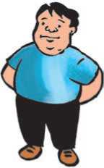
This is Aayush, 14 years, from Biratnagar. He likes to sit on the sofa for hours every day, watching TV and eating a lot of snacks. Write a couple of paragraphs about him. You may use the guiding questions given below.
Figure 15 fat man
- What is the problem with Aayush?
- What should he stop doing to be healthy?
- What should he start doing?
- What advice would you give him to maintain a healthy life?

Reading II
Look at the picture and answer these questions.
- Who do you think the person in the picture is; a king or a wrestler? Why?
- How has he put on so much weight?
- Do you think he is healthy?

Health is Wealth
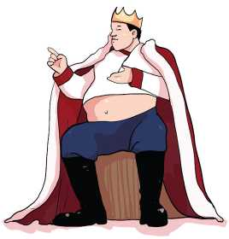
Once upon a time, there lived a benevolent and kind-hearted king. But, the people weren't happy with him because he was very lazy and would not do anything other than eating and sleeping.
Figure 16 king
He spent days, weeks and months in his bed either eating something or sleeping. The king became a couch potato and the people started to worry about him.
One day, the king realised that he couldn't move
his body, not even his foot. He became very large and his obesity became a matter of fun, calling him ‘bulky king'.
The king invited expert doctors from various parts of his country and offered them generous rewards to make him fit. Unfortunately, none could help him gain his health and fitness back. The king spent an enormous amount of money but everything went in vain.
One fine morning, a holy man visited the country. He heard about the ill- health of the king, and informed the minister at the palace that he could easily cure the king. Hearing these promising words, the minister became very happy. He requested the king to meet the holy man to get rid of his problem.
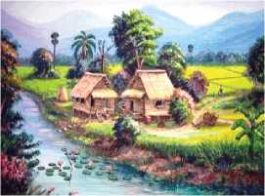
The holy man resided at a distant place. Since the king could not move his body, he asked the minister to bring the holy man to the palace, but the holy man refused. He said that the king had to go to him, in order to get cured.
After strenuous efforts, the king met the holy man at the latter's residence. The holy man complimented the king saying that he was a good ruler, and said that he would soon regain his health. He asked the king to come for treatment the next day. He also told the king would be treated only if he came on foot to the holy man's residence.
Figure 17 Viilage

The king was unable to walk even a few steps on the road, but aided by his followers, he reached the holy man's place. Unfortunately, the holy man was not available there and his devotee requested the king to come and meet him the next day for treatment.
This was repeated for two weeks and the king never met the holy man, and never had any treatment.
Gradually, the king realized that he felt a lot lighter, lost a considerable amount of weight and felt more active than before. He realized the reason why the holy man asked him to reach his place by walking.
Very soon, the king regained his health, and the people were very happy in his kingdom.
- Learn these words and complete the sentences with them.
Benevolent couch potato obesity devotee strenuous
a can increase the risk of heart disease because obese
people are likely to suffer from heart problems.
- My father is kind, helpful and generous. He has a
attitude.
- Take rest for a week. Avoid tasks which require physical
activity.
- I like God Shiva. I'm actually a of him.
- My younger sister is a great She can watch TV 24 hours
a day.
- Answer the following questions.
- Why did people not like the king though he was kind?
- Why were the specialists called to the palace and offered huge prizes?
- Why did the minister become so happy?
- Why did the holyman tell the king to come to his place on foot for treatment?
- Why did the holyman disappear after the first meeting with the king?
- How did the king recover his health?
- What lesson did you learn from the story?
- Retell the story to your friends, making the queen the main character.

Listening
- Look at the pictures and answer these questions.
- What do you see in the pictures?
- Do you regularly do these activities? Why? 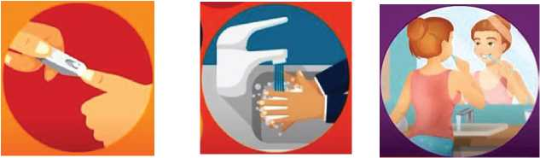
Figure 18 nail cut, wash hand , brush teeth
Listen to the audio and complete the following sentences choosing the correct answers.
B.
- Personal hygiene means taking care of our bodily health and wellbeing through
I. cleanliness ii. clearness iii. holiness
- Dirty clothes and lead to the breeding of germs.
I. dirty hair ii. dirty shoes iii. smelly socks
- We had better change the toothbrush every
I. month ii. two months iii. three months

- Long and dirty nails can cause
I. skin problems ii. food poisoning iii. dysentery
- Sam works in the department.
I. sales ii. marketing iii. land
- Sam hasn't for many days.
I. combed his hairs ii. trimmed his nails iii. shaved
- Kris suggests that Sam shouldn't use to get rid of his
sweating problem.
I. deodorant ii. detergent iii. deodoriser
C. Search for some tips of personal hygiene and share them with your classmates.

Grammar II
- Study these sentences.
- The king would be treated only if he came on foot to the holy man's residence.
- If Sarita had an android mobile phone, she would join the virtual classroom.
- If the king had lived an active life, his health would not have worsened.
- Had she studied hard, she would have secured the best result.
- If we had listened to the radio, we would have heard the news.
- It would not surprise me if he knew the answer.
- Complete the following sentences with the correct form of the verbs given in the brackets.
- I had seen tshering a few minutes ago. If you had come round
earlier, you (see) him too.
- I wish I were a bird. If I were a bird, I (fly) round the world.
- Provided that you (be) twenty, you could play the match.
- George was happy that he came to Nepal. If he hadn't, he ....(not see) Mt. Everest.
What would you do if you .(win) the lottery of RS. 1,00,000?
- Seema missed the bus to go home. If she....(come) in time, she would have caught the bus.
- She would lose weight if she (not eat) a lot of sweets.
- They might have helped you if you ...(ask) them.
- If he .(drive) more carefully, he might not have had that accident.
- If everyone ..(turn) off unwanted lights, we could save a lot of electricity.
- Complete each sentence in a suitable way.
- If you had studied well,
- If you asked me,
- If we had gone to the cinema,
- If you spoke English,
- If they listened to me,
- if I had your address.
- I would have taken part in the contest.
- we would walk to the museum.
- if there were not many sharks there.
- if she had taken the right bus.

Writing II
Kwati is a popular Newari food item. Here are the steps of preparing it. Arrange them in the correct order and write the recipe for making it.
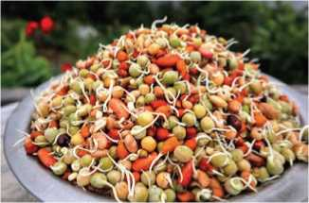
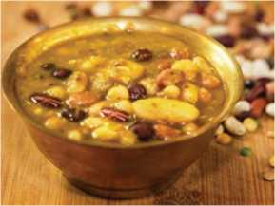
Figure 19 cooked kwati
Figure 20 kwati

Ingredients
sprouted mixed beans, ghee, onion, cumin seeds, carom seeds, coriander powder, ginger garlic paste, tomatoes, bay leaves, chilly powder, turmeric powder, salt
- Put cumin seeds and carom seeds in a pan and fry them.
- Add tomatoes, turmeric powder and coriander powder.
- Fry until tomato is tender.
- Melt ghee in a pressure cooker.
- Add onion, then bay leaves and ginger garlic paste.
- Now, add sprouted mix beans (Kwati) and then red chilly powder.
- Fry for 5-6 minutes.
- Cook for about 4-5 whistles.
- Add hot water then salt and garam masala.
- Kwati is ready to be served.

Project work
Organise a presentation competition about 'Health is Wealth' in your class. Your classmates and teacher will act as the judges of the competition.

Extra bit
Words ending in ‘-logy’

Pathology :the study of diseases
Epidemiology: the study of the spread and control of disease
Archaeology : the study of culture of the past
Geology : the study of the physical structure of the earth
Metrology : the study of measurement
Sociology :the study origins and social relationships of human beings
Anthropology : the study of origins and social relationships of human beings
Meteorology :the study of the earths atmosphere
Astrology :the study of the positions of the star and movements of the planets in the belief that they influence human affairs.

Unit 3 Family, Market and Public Places

Getting started
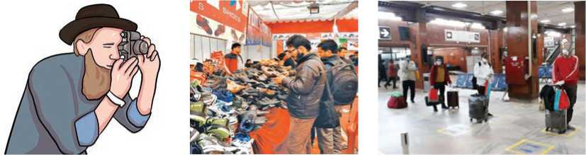
Figure 21 capture photo ,shopping and airport
What do you think these pictures are related to? How do people make requests in these situations?

Reading I
Look at the picture below and answer the following questions.
- What do you see in the picture?
- What is more important for you; family or work or both? Why?

Thomas and Jerry
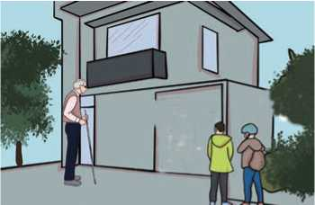
Once upon a time in a village, there was an old man named Jerry. He hadn't seen his son who lived in the city for a few years and wanted to meet him. He started his journey and came to the city where his son used to work and stay. He approached the place where he used to get letters from a long time ago. When he knocked on the door he was excited and smiled with joy to meet his son. Unfortunately, someone else opened the door. Jerry asked, “I suppose Thomas should be staying in this place.” The person said, “No! He has left and moved to a different location.” Jerry was disappointed and just pondered how he was going to meet his son.

He started to walk down the street and the neighbour asked Jerry, “Are you looking for Thomas?” Jerry responded by nodding his head. The neighbours gave Thomas's office address to Jerry. Jerry thanked them and started towards the path which would lead to his son. Finally, Jerry arrived at the office and asked at the reception counter, “Could you please tell me Thomas's location, in this office?” The receptionist asked, “May I know how you are related to him?” Jerry responded politely by saying, “I'm his father.” The receptionist asked Jerry to wait for a moment then rang Thomas and conveyed the message. Thomas was stunned and told the receptionist to send his father to the cabin immediately.
Jerry entered the cabin. As soon as he saw Thomas, his eyes were filled with tears. Thomas was happy to see his father. They talked for a while and Jerry asked Thomas, “Son! Mom dearly wants to see you. Will you go home with me?”
Thomas responded, “I'm afraid, I can't go home, father. I am very busy working for my success and it's hard to take leave to visit as my hands are full with lots of stressful work.” Jerry gave a simple smile and said, “Okay! You may do your work. I'll be going back to our village this evening.” Thomas asked, “Would you stay for a few days with me, please?” Jerry responded after a moment of silence, “Son, you are busy with your tasks. I don't want to make you uncomfortable or become a burden for you,” he continued, “I hope if I ever had a chance to meet you again, I would be happy.” Then, he departed.
After a few weeks, Thomas wondered why his father came alone after a long time, he felt bad for treating his father in a weird manner. He felt guilty so took leave for a few days and went to his village to meet his parents. When he went to the place where he was born and grew up, he saw that his parents were not there. He was shocked and asked the neighbours, “What happened here? My parents have to be here. Where are they now?” The neighbours gave the address of the place where his parents were staying.
Thomas scurried to the place and noticed that it was like a graveyard. His eyes were filled with tears and started to walk slowly towards the place. His father noticed Thomas in the distance and waved his hand to draw his attention. Thomas saw his father; started to run and hugged him as soon as they met.
Jerry asked, “How are you?” and continued, “What a surprise to see you here. I didn't expect that you would be coming to this place.” Thomas felt ashamed and kept his head down. Jerry said, “Why are you feeling bad? Has anything wrong happened?” Thomas responded, “No father” he continued, “It's just I never knew that I would be seeing you in this position in our village.”
Jerry smiled and said, “I had taken a loan when you moved to the city for your college to pay for your education, then again when you wanted a new car. But due to a loss in farming, I couldn't pay the loan back. I thought of approaching you for help, but you were very busy and bustled with your work. I didn't want to burden you with our problem and remained silent. I had to let our home to go repay the loan.”
Thomas whispered, “You could've told me. I'm not an outsider.” Jerry turned around and said, “You were very busy and stressed with your work which made me remain quiet. All we wanted was your happiness."
Thomas started to cry and hugged his father again. He apologized to his father and asked him to forgive him for his mistake. Jerry radiated and said, “No need for that. I'm content with what I have now. All I want is that you spare some time for us, we love you very much and at this old age it's hard to travel to see you often.”
- The words in red in the story correspond to the meanings below. Find the words and write them.
- a load, typically a heavy one
- came near
- so shocked that one is temporarily unable to react
- left, especially in order to start a journey
- a burial ground
- very strange; bizarre
- satisfied
- shined with energy or happiness
- moved or ran somewhere suddenly or rapidly

- Read the story again and decide whether the following statements are true or false.
- Jerry did not use to get letters from his son.
- The neighbours helped Jerry find the way to meet his son.
- Thomas was eager to meet his father in his office.
- Thomas asked his father to stay with him for a week.
- Thomas felt bad to see his father in his workplace.
- The story tries to show that parents' happiness is tied up with their children's success and happiness.
- Answer the following questions.
- Why did Jerry go to the city?
- What did the father want from his son?
- Did the father come back to the village happily? Why?
- What made Thomas decide to visit his father?
- Why did Jerry take the loan?
- Why did Jerry return home without telling his son about the loan?
- What lesson do you learn from this story?
- Have you ever witnessed or heard such an event similar to the one in the story? Share it in small groups.

Pronunciation
- Pronounce the following words with proper stress and find the correct stressed syllable.

holiday | continue | intention | attitude | unlikely
membership | conditional | mistake | apology | family
surprise | distance | unnatural | hotel | deny
monument | marriage | secondary | progressive believe
examination

Speaking
- Act out the following conversations.
Conversation I
A : Good morning.
B : Good morning. Would you help me find a birthday gift for my father?
A : Might I suggest this tie?
B : That looks nice.
Conversation II
A: Excuse me. Could you show me a shoe brush and a nailcutter , please?
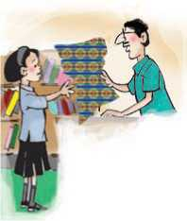
B: Here you are.
A: Well, I wonder if you could give me gift paper.
B: No problem. Let me wrap them.
A: Thank you.
Figure 22 exchange materials
Conversation III
A: Mum. It's a bit stuffy here. Do you mind if I turn the fan on?
B: No, no I don't mind at all. I feel like some fresh air
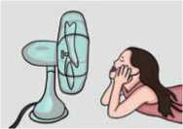
too.
Conversation IV
A: Excuse me. Do you think you could possibly pass the pepper?
Figure 23 moving fan and girl
B: Yes of course. Here you are.
A: Thank you very much.

- Work in pairs. Have similar conversations using the given clues.
a shampoo/bigger one b. sugar/tooth brush/detergent powder
c. birthday/sister/a shawl d. wedding/cousin/wedding ring
e. close the window/cold/cold too f. buy/ice-cream/no – cough

Grammar I
- Study the following examples about making requests and offers along with their responses.
- ‘Can I help you?' ‘Yes, sure.'
- ‘Would you like some help?' ‘Yes, of course.'
- ‘Would you like to come for lunch this weekend?' ‘Oh, I'd love to, thank you.'
- ‘Can you help me with this desk for a moment?' ‘Yes, sure. Where do you want to put it?'
- ‘Could you say congratulations to your brother on my behalf?
- Complete the following conversations using can, could and would.
- A: I get you something to drink?
  - B: Yes, please. A glass of lemonade for me.
- A: you tell me where the nearest community school is,
    - please?
  - B: I'm sorry, I'm not from around here.
- A: you like me to answer the phone?
  - B. Yes, please, that be lovely.
- A: I've finished my homework I play now?
  - B: OK. You may.

- A: I come round to your house sometime later?
  - B: Well, actually, my dad's not feeling well. Maybe another time.
- A: you mind passing me that register, please?
  - B: Yes, of course. Here you go.
- A: you like me to talk to the head teacher?
  - B: Oh. Yes please! you?
- A: you lend me RS. 200, please?
  - B: I suppose so, but I need it back before next month.
- A: you mind if I used your pen, madam?
  - B: Not at all, go ahead.

Writing I
Write a letter to the head teacher of your school on behalf of your class requesting him/her to organize an inter-house volleyball tournament in your school. Make requests for managing all required sporting goods for the tournament.

Reading II
- Look at the pictures and answer these questions.
- What type of dance are they performing?
- In which parts of Nepal are they most popular?
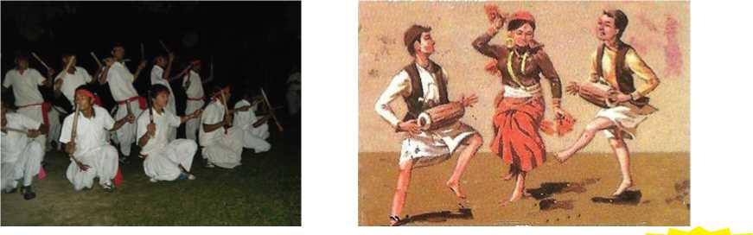
Figure 24 types of dance

Dance
The first time I went to a disco I was very young and shy. However, I decided to go. Do you remember the Star Disco in Thamel? It was a lovely place always full of beautiful girls. Of course, most of them are
grandmothers now!
Figure 25 dance in disco
When I went to the disco, I was much too shy to ask anyone for a dance. So I sat down and thought I'd watch for a while. You know, see how the other lads did it. There was a lovely girl in a blue dress. A man walked up to her and said, "Excuse me. May I have the pleasure of the next dance?" She looked up at
him and said "Eh? What did you say?" So he said, "I wonder if you would be kind enough to dance with me?...........er. ...if you don't mind?” “No, thank
you very much."
A few minutes later, this other chap arrived. He gave her this big smile and said, "Would you be so kind as to have the next dance with me?" “Pardon?” she said. "Would you mind having the next dance with me?" he said, a bit nervously this time, "No thanks."
Then, this third fellow came over. He was very good-looking, you know, black teeth, white hair- sorry, I mean white teeth, black hair! He said, ever so politely, "Can I...I mean...could I... no, might I have the next dance with you?" "Sorry", she said, "My feet are aching."
By now, I was terrified. I mean, she'd said 'no' to all of them! Then this fourth character thought he'd try. "Would you like to dance?" She looked straight at him. "No."
Well, I decided to go home. I was wearing an old jacket and trousers, and nobody would say that I was good-looking! Just as I was walking past her, she smiled. " Er... dance?" I asked. "Thank you very much," she replied. And that was that! It's our twentieth wedding anniversary next week.
- Find words from the story which are similar in meaning to the words given below.
- man …………. …………. ………….. …………….
- came …………. …………. ………….. …………….
- clothes …………. …………. ………….. …………….
- Choose the correct answer from the alternatives given and complete the sentences.
- The storyteller is probably.
I. a comedian ii. a musician iii. an actor
- When he arrived at the disco, he first
I. saw his grandmother ii. saw some guys dancing
iii. saw a beautiful girl
- Now his age may be about.
I. 20 years ii. 30 years iii. 40 years
- The lovely girl..
I. didn't dance at all ii. became nervous iii. danced at last
- The story can be best described as.
I. humorous ii. serious iii. sad
- Recall the time that you first danced. Share your experience with your friends.

Listening
- Look at the picture and answer these questions.
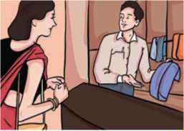
- Where do you think the people are in the picture?
Figure 26 shopkeeper and customer
- What are some popular souvenirs that you can generally buy?
- How much do they cost?

- Listen to the audio and answer the following questions.
- Whom does the man want to present a gift to?
- What does the salesperson try to sell the man first?
- Why is he not interested in that item?
- Why does he not want to purchase the watch?
- Why can't he go to another gift shop?
- Listen to the audio again and write True for true statements and False for false ones.
- The pearl necklace costs 120 dollars.
- The salesperson wanted to sell a shirt with a modern design.
- The man's wife does not like chocolates.
- The salesperson explains that the boxes of chocolates were imported from Belgium.
- You are in a souvenir shop. Prepare a short conversation with the salesperson asking for a beautiful gift to present to your friend on his or her birthday.

Grammar II
A. Match the sentence halves to make full sentences.
a. | I'd | i | a good dentist?
b. | Would it be | ii. | a table for six?
c. | Would you be able to | iii. | possible to invite my cousin?
d. | Could you recommend | iv. | you like me to call a taxi?
e. | Can I book a | v. | get me a ticket for the concert?
f. | Would | vi. | like to rent an apartment.

- Complete the sentences below in any way you like to make requests or offers.
- Would you like me ?
- Can I ?
- Could you ?
- Would it be possible to ?
- Would you mind ?
- Could you possibly ?
- Would you ?

Writing II
In Nepali culture, there are many occasions people dance. The gurung Community has Rodhighars, the Rai Community celebrates Chandi Naach, etc. Write a couple of paragraphs about any one of the dancing cultures or traditions in your community.

Project work
Remember a situation in which you were a participant in a cultural show like Dohori Sanjh or a public show like a comedy show. Narrate your experiences including what special event you want to recall, how you happened to join it, who you went with, etc. in your class.

Extra bit
Types of Gender
Masculine Gender: A noun that shows the male subtype is known as masculine gender. Examples: king, man, boy, father, cock, bull, fox, etc.
Feminine Gender: A noun that shows the female subtype is known as feminine gender. Examples: queen, woman, girl, mother, hen, cow, vixen, etc.
Neuter Gender: Some nouns are neither male nor female; they fall under the neuter gender. Examples: table, hair, city, etc.
Common Gender: English contains a lot of nouns which do not specify the gender of the noun. These nouns can stand for both male and female. Examples: teacher, student, cousin, parent, etc.

Unit 4 Life and Death

Getting started
Look at these picture and discuss.
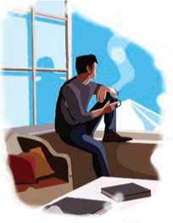
Figure 27 relaxed
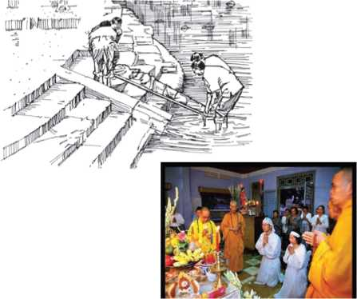
Figure 28 culture

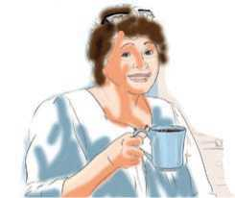

Figure 29 drink coffee

How do you respond to people in these situation?

Reading I
Do you agree with the following statements? Discuss.
- Death is not the opposite of life, but a part of it.
- From the day you were born, you are slowly dying.

Death is a Fiction
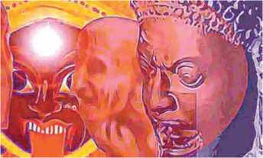
Did you ever see somebody who actually died and came back? No. There may be a near death experience. Near is not good enough. Near water is not as good enough as water, isn't it? So, some people have nearly died, that is not good enough.
Figure 30 Significance of Death in Hinduism

So you have not experienced it, you have not seen it, nor have you had a first-hand information from anybody. So from where did you get this idea that there is something called as death? Death is a fiction created by ignorant people. Death is the creation of people who live their lives in total unawareness. There is only life, life and life alone, moving from one dimension to another, another dimension to another.
See, what you call as life right now, the process of life; you can also refer to it as death. You can say “I am living right now” or you can say “I am dying right now.” Actually, from the day you are born you are slowly dying. One day the process will be complete. Right now it is on the way. You may be thinking you are going to many places, but as far as your body is concerned, without a moment's distraction, it is going straight to the grave, nowhere else. Isn't it so?
So, is death okay or not okay? Even these kinds of questions which are coming up are silly, because whether you say it is okay or not okay, anyway you will die. Every moment you are playing between life and death and life and death - actually it is so. This inhalation, exhalation... You inhaled, life happened. You exhaled and did not inhale again, death happened, isn't it? See, every moment in Yoga we say inhalation is life, exhalation is death. You exhale, and if you do not take in the next inhalation it dislodges you from the body. So fragile, isn't it so? Something so fragile is the basis of your existence here. Death is walking with you every step. It is so close all the time.
There is nothing wrong with death; it has to happen. Only because there is death, there is life. You need to understand that the moment you are born, you have a death sentence upon you. When, where, and how is the only question, but you are on death row. Your death is confirmed, isn't it? We do not know whether you will get educated or not; we do not know whether you will get married or not; we do not know whether you will know joy or not; we do not know whether you will know misery or not; but we know one day you will die. That one thing is guaranteed.
This whole fear of death has come simply because you have no idea what it is. You have formed ideas about everything, just about everything. But it does not matter what ideas you have formed about life, when you are confronted with the moment of death, you really do not know anything. That is one space of life which has remained uncorrupted by the human mind. Everything else we have corrupted, isn't it? Whatever was supposed to be sacred, all these things are hugely corrupted by the human mind. Human minds have corrupted love, relationships, God, Divinity - everything they have corrupted and twisted out whichever way they want. Death is one thing that they are still clueless about-though a lot of people would like to talk authoritatively about it. They know they are going to go to heaven; they are dead sure about it. If they are so sure, I don't see what they are waiting for.
They are doing everything not to go to heaven. Why? If you are so sure you are going to a wonderful place, a better place than this, and then you must hurry up. But because you are not sure, you talk. You are not 100% sure where you will go, what will happen to you. Just to solace yourself, just to be able to psychologically handle life, you create all these things. But essentially, the very idea of death has come to you because people have been talking about it without knowing about it. Otherwise, if your societies did not speak about it, you would just know the way you are right now, your present existence, is not permanent. That you would know, but you would not have any other ideas about it. Even now you do not have any idea about it; you imagine that you have.
-Sadhguru (excerpt from Life and Death in one breath)
- Find the words from the text that have the following meanings.
- a thing that is imagined
- a way of looking at something
- to force somebody to leave
- faced somebody so that you could not avoid ….………………
- to make somebody feel better
- Fill in the blanks with appropriate words.
- Death is a created by human being.
- Ultimately, we are moving straight to the
- According to the speaker, death is It is sure to happen.
- Human beings have everything and they have twisted it
whichever way they want.

- Answer the following questions.
- According to the speaker, there is only life. How?
- According to the speaker, what is life?
- Why is there nothing wrong with death?
- Why do we fear death?
- Why do people have an idea of death?
- What is your view about death? Write a short paragraph.

Pronunciation
- Notice how the following words are pronounced.
Autumn condemn solemn limb thumb
ascend descent evening design honest architect knee pneumonia recepit

B. Pronounce the following words correctly.
doubt | debt | subtle | scissors | interesting
foreign | stomach | where | whisper | calm
salmon | psychiatrist | psychology | pseudonym | island
castle | hustle | whistle | honour

Speaking
- Read and act out the following conversations.
Conversation I
A : You look sad. What's the matter?
B : My father is very ill.
A : Is he? I'm really sorry to hear that.
Conversation II
A : I lost my new mobile phone.
B : Have you? So sad to hear that.
Conversation III
A : I spilt milk over my textbooks.
B : What a pity!
- Look at some of the expressions used when expressing sympathy.
That's too bad. That's so sad.
I'm sorry. What bad luck! | I hope things get better soon.
I hope you feel better soon. | What a pity!
Oh, that's terrible. | I'm sorry to hear that.
I know how it feels. | You must be very upset about it.
Please accept my deepest sympathy. I know how you must be feeling.
My goodness
- Work in pairs using the given clues and express your sympathy.
- failed the exam/that's too bad
- sister had an accident/so sad to hear that
- lost football match/what a pity
- lost job/sorry to hear that
- friend's mother fell ill/hope she feels better soon
- lost bicycle/that must be an inconvenience

Grammar I
- Rewrite the following sentences using the correct form of the verbs given in the brackets.
a. The winter ….. (follow) the autumn season.
b. The human body……….(consist) of some 60 trillion individual cells.
c. Cows …..(feed) on grass.
d. He…… (earn) a handsome salary every month.
e. Akila…… (make) delicious cookies.
f. Arati and her husband……(live) in Singapore.
g. ………. you…..(like) chocolate milk?
h. He …… (not want) to go to the movies.
I. My grandfather …….(adore) his pet dog.
j. Plants ……(need) water and sunlight for photosynthesis.
k. He……..(have) a big apartment in Venice

- Make a statement or a question using these prompts. Use the present simple.
- I/not/check/my emails when I get to school.
- you/watch/the news on TV every day?
- she/wear/a red dress.
- you/have/a school bus?
- what/you/want to drink?
- you/not/need more reading practice.
- your friend/not/like computer games.
- mum/wash/car once a week.
- Change the following sentences into negative and question.
- The swimming pool opens everyday at 9: 30 am.
- I use my car very often.
- John comes from Mexico.
- I play the piano very well.
- Ann watches television a lot.
- I write to my parents every month.
- This car breaks down every five hours.

Writing I
- Study the following newspaper message of condolence and underline the key expressions that are used when writing.
HEARTFELT CONDOLENCE
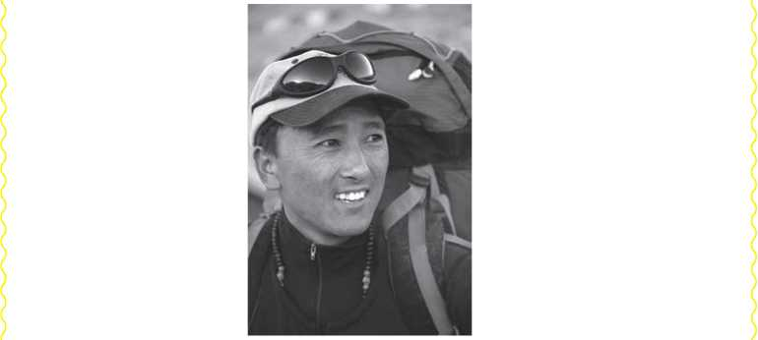
05-10-1977
16-05-2013
We are deeply saddened by the news of the untimely demise of our
veteran Mountaineering Member Mr. Namgyal Sherpa, a ten time
Everest summiteer, while descending back from summit to Base Camp
on 16th May, 2013. He was quite popular for his congeniality, diligence
and great virtue. At this time of grief, we want to express our sincere
condolences to his bereaved family and pray for the strength to bear this
irrecoverable loss. We will always cherish his wonderful memories.
May the departed soul rest in peace in heavenly abode.
Nepal Mountain Academy
Bijulibazar, Kathmandu
B. Look at the picture of a veteran actress, who passed away in 2019 A.D. Write a message of condolence to her family on behalf of your school. It will be published in a local newspaper. Use the clues given in the box below.
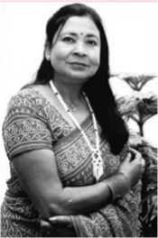
Subhadra Adhikari (1946 – 2019) …….….. passed away at her residence, Kathmandu, due to respiratory problems …….. famous and wellknown senior actress .…....contributed a lot to the Nepali film industry ………….. Basanti, Basudev, Muna Madan, Chino among superhits …………. heartfelt condolences

Reading II
Look at the picture below and answer these questions.
- What does the picture show?
- Where is the pilot leading the voyagers?

Crossing the Bar
Sunset and evening star,
And one clear call for me!
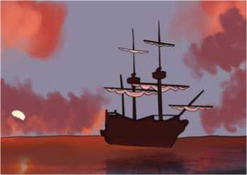
And may there be no moaning of the bar,
Figure 31 boat
When I put out to sea,
But such a tide as moving seems asleep,
Too full for sound and foam,
When that which drew from out the boundless deep Turns again home.
Twilight and evening bell,
And after that the dark!
And may there be no sadness of farewell,
When I embark;

For tho' from out our bourne of Time and Place
The flood may bear me far,
I hope to see my Pilot face to face
When I have cross t the bar.
-Alfred Lord Tennyson
- Match the words in column A with their meanings in column B.
Column A | Column B
a. moaning | I. a boundary; a limit
b. boundless | ii. though
c. twilight | iii. go on board
d. embark | iv. never-ending; infinite
e. tho' | v. complaining
f. bourne | vi. crossed
g. crost | vii. dusk

- Fill in the gaps with the words/phrases given below to complete the paraphrase of the poem.
the sandbar return the evening bell floating
the sunset and evening star on a tide sad goodbyes God
I notice in the sky, and hear a sound calling for me loud and
clear. I hope that will not be disturbed when I go out to sea.
Instead, I want to be carried out moving so slowly it seems
almost asleep, and which is too swollen to make a sound. That's what I want when I home to the depths of the great unknown.
Twilight comes with , which will be followed by darkness. There
don't need to be any when I go.

Even though I'll be going far from this time and place, on the
tide of death, I hope to meet , who has been like my pilot in this
journey, when I've made it across the bar.
- Answer the following questions.
- Where does the speaker have to go crossing the sandbar?
- Why can't the tide make a huge sound or create a lather?
- What do the twilight and the evening bell suggest in the poem?
- Where is the speaker going without accepting sad goodbyes?
- Who is the only agent that helps the speaker to go far on his journey?
- Does the speaker fear death? Why/Why not?
- What does the pilot symbolize?
- The speaker tries to convey that finally good things remain with him before he sets off his ultimate journey to the sea. 'Sea' is taken as something blank, unknown and as an unpredictable world after death. Do you believe in life after death? Discuss.

Listening
- Guess the meanings of the words, in bold letters, in the sentences below before you listen.
- My mother took a half-day leave to attend the funeral of her close friend.
- Only the immediate family is invited to attend the viewing.
- At the funeral, the minister offered the eulogy on behalf of the family.
- Listen to the audio and choose the correct answer.
- Tim's father probably died
- because of a lingering illness
- as he fell ill unexpectedly
- due to a road accident
- Tim's mother will manage by herself economically by
- the money from her husband's insurance and stock
- investing money on life insurance
- spending her government pension
- Tim's mother
- has lost the purpose of her own life
- is hopeful about the future
- feels very sad
- The private memorial service is on
I. Thursday evening ii. Tuesday morning
iii. Tuesday evening
- Tim asks Heather to at the funeral.
I. give a speech ii. bring some flowers
iii. sing a song
- Listen to the audio again and answer these questions in not more than four words.
- Why does Tim phone Heather?
- When will the viewing take place?
- Who will be giving the eulogy?
- What had Tim's father wanted Heather to do just before he died?
- How would you extend condolences following someone's death?

Grammar II
- Complete the following sentences with the correct adverbs from the brackets.
- I see one or two movies every week. I .... (often/never) go to
the movies.
- I let my roommate borrow my car just once. I (some-
times/rarely) let my roommate borrow my car.
- Maria eats cereal for breakfast seven days a week. Maria
(usually/always) eats cereal for breakfast.
- Four out of five visitors to the museum stay for three hours or
longer. Museum visitors (usually/seldom) stay for at
least three hours.
- We occasionally have quizzes in history class. The teacher
(always/sometimes) gives quizzes in history class.

- Subina always misses the morning assembly. She (rarely/
never) arrives at school on time.
- In the desert, it rains only two days between May and September
every year. It (rarely/often) rains there in the summer.

- Rohit asks me to go to the winter camp, but I don't accept his
invitation. I (seldom/often go to the winter camp.
- Lisa and Samrat go fishing at least three times a week. They
(usually/seldom) go out to dinner with each other.
- Rewrite the following sentences with the correct alternatives from the brackets.
- Your friendship over the years and your support (has/have)
meant a great deal to us.
- Hamilton Family Center, a shelter for teenage runaways in San
Francisco, (offers/offer) a wide variety of services.
- One of the major sources of income of Trinidad (is/are)
tourism.
- The chances of your being promoted .... (is/are) excellent.
- There (was/were) a Pokemon card stuck to
the refrigerator.
- Neither the professor nor his assistants (was/were)
able to attend the conference.
- Many hours at the driving range (has/have) led us to
design golf balls with GPS locators in them.
- Discovered in the soil of our city garden (was/were) a
button dating from the turn of the century.

Writing II
Read the email below and write a reply to Asmita Praja. Express your sympathy and wish that she gets well soon.
Informing you about my accident x
slinabasnet2007@gmail.com
Informing you about my accident
Dear Salina,
I'm writing to explain to you that I can't attend the class for two weeks as I've had an accident and hurt my back. I have already sent an email to the principal and the class teacher to inform of my condition. I'm afraid I will be missing the unit tests.
I have medicine for the pain but I can't get up or walk around much, and the doctor said I should stay in bed and rest as much as possible. This makes reading and studying very difficult for me at the moment. The doctor said I may be able to do some bed reading and writing after a week.
Salina, if possible I need some help from you. I wonder if you could record the lectures and class notes so that I can listen to them at home. I will try to catch up with all the reading too. I have been given permission from the principal.
I won’t bore you with details, except to say that I will be missing you all, my friends and dear teachers. But just see it as a setback for a while-then hopefully life will be normal again.
Thank you for your understanding.
Regards,
Asmita Praja
Figure 32 send button of Gmail

Project work
Collect some messages of condolences. Bring them to the class and find the similarities and differences between them.

Extra bit
Types of Sentence
- Declarative Sentence: A declarative sentence simply makes a statement or expresses an opinion. In other words, it makes a declaration. This kind of sentence ends with a full stop.
Examples:
My mother's name is Laxmi.
I'm not watching a football match now.
- Interrogative Sentence: An interrogative sentence asks a question. This type of sentence often begins with a 'wh' word or an auxiliary verb and ends with a question mark.
Examples:
Why are you late today?
Have you booked the hall for tomorrow's program?
- Imperative Sentence: An imperative sentence gives a command or makes a request. It usually ends with a full stop.
Examples:
Complete the homework by tomorrow.
Be polite to the customers.
Don't make a noise.
- Exclamatory Sentence: An exclamatory sentence expresses great emotion such as excitement, surprise, happiness and anger, and uses an exclamation mark.
Examples:
Oh! I forgot about the meeting.
Wow! I can't believe it.

Unit 5 Ethics, Norms and Values

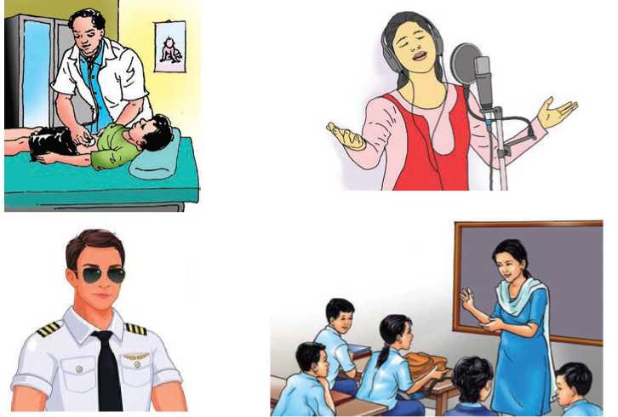
Getting started
Look at the pictures and talk to your friend about their professional ethics, norms and values.
Figure 33 doctor ,singer, police, and teching

Figure 34 I am sorry
Look at the picture and answer the questions.
What does it say?
a.
- How do you apologize? Talk to your friends.

Why “I'm Sorry” Doesn't Always Translate
Even after decades of cooperation in business and politics, America and Japan still trip over a seemingly simple concept: the apology. Neither culture appears to fully understand what the other means or expects. For instance, most Americans were unmoved by Toyota CEO Akio Toyoda' seffusive apologies in 2010, after widespread reports of malfunctioning Prius accelerators. Japan, for its part, bristled when a US submarine commander didn't immediately apologize after colliding with and sinking a Japanese fishing boat off Hawaii in 2001.
The confusion over the meaning of and occasion for “I'm sorry” extends beyond those countries; indeed, it seems that virtually every culture has its own rules. In India, other researchers have noted, apologies are far less common than in Japan. In Hong Kong, they are so prevalent and ritualized that many people are inured to them.
Our own work found that a core issue is differing perceptions of culpability: Americans see an apology as an admission of wrongdoing, whereas Japanese see it as an expression of eagerness to repair a damaged relationship, with no culpability necessarily implied. And this difference, we discovered, affects how much traction an apology gains.
In an initial survey of US and Japanese undergraduates, the US students were more likely to say that an apology directly implied guilt. The Japanese
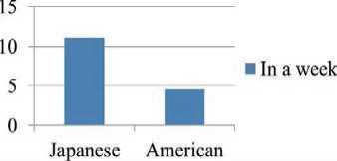
students were more likely to apologize even when they weren't personally responsible for what had happened. Perhaps for this reason, they apologized a lot more; they recalled issuing an average of 11.05 apologies in the previous week, whereas US students recalled just 4.51.
Apology Survey
Figure 35 graph
In a second study, we looked at the utility
of apologies for repairing trust. We asked undergraduates from both countries to imagine that they were managers and showed them a video in which an applicant for an accounting job apologized for having deliberately filed an incorrect tax return for a prior client. The Japanese students were more willing than their US counterparts to trust the candidate's assertion that she wouldn't engage in such behavior again and to offer her a job. We believe that this is owing to Americans' inclination to associate apologies with culpability.
The finding that Americans link apologies with blame is in keeping, we'd argue, with a psychological tendency among Westerners to attribute events to individuals' actions. Thus it makes sense that in the US an apology is taken to mean “I am the one who is responsible.” It also stands to reason that in Japan which, like many other East Asian countries, has a more group-oriented culture; apologies are heard as “It is unfortunate that this happened.” Researchers who've compared apologies in America and China have found a similar pattern: US apologies serve to establish personal responsibility, while Chinese ones focus on the larger consequences of the transgression.
Only with a deep understanding of such differences, the executives can make effective use of the apology as a tool for facilitating negotiations, resolving conflicts, and repairing trust. And misunderstandings over apologies are just one aspect of a broad semantic disconnect between East and West that's too often ignored in the rush to globalization. Managers would do well to tune in to other cultural nuances that are easily lost in translation.
-William Maddux, Peter H. Kim, Tetsushi Okumura, and Jeanne Brett
- Find the words/phrases from the text for the following meanings. The first letter has been given.
- t to have difficulty saying something clearly or
correctly
- e showing too much emotion
- b became annoyed or offended

I accustomed to do something
- c the fact of being responsible
- a a statement saying that you strongly believe something
to be true
- a to say or believe that something is the result of a
particular thing
- s connected with the meaning of words and sentences
- n a very slight difference in meaning
- Match the first halves in column A with their endings in column B to make complete sentences.

Column B
Column A

- Americans didn't show
- People are accustomed
- Japanese use an apology
- American participants seemed
- Researchers found
- less interested in a second research.
- similar patterns in East Asian countries.
- to an apology in Hong Kong.
- sympathy to Akio Toyoda's effusive apologies.
- to repair their damaged relationship.
- Answer the following questions.
- Why did Japan become annoyed with the US submarine commander?
- How do Americans and Japanese perceive an apology?
- What, according to the survey, is the average result of an apology in Japanese and American students?
- What was displayed in a video show?
- Who were the respondents of the second study?
- How can the executives apply an apology?
- Have you ever apologized? Why and how?

Pronunciation
Pronounce the following contracted forms.
I'm you're he's she's it's
we're they're I've I'd they'll

Speaking
- Act out the following conversations.
Conversation I
Mingma : I hope you’ll forgive me for being late. I had a flat tyre.
Sujan : Really? That's quite alright. It can happen to anyone.
Conversation II
Nabina : Binod, I’m sorry, I kept your book so long. I didn't mean to keep it this amount of time.
Binod : No problem. I won't need it until next semester.
Conversation III
Kuber : Ouch! You hit me with your umbrella.
Kiran : I apologise. I was looking for another way through.
Kuber : OK. Be careful when you're passing people.

- Work in pairs. Make similar conversations for the given clues
from a - f below. Choose the structures from the box.

Apologizing | Responding to an apology
I'm sorry that | That's OK.
It's my fault. | It happens.
Oops, sorry. | No problem.
I should have | Don't worry about it.
I apologize for | I forgive you.

- took my bag/think it's mine
- ate my biscuits/think it's mine
- sat on my cat/think it's a pillow
- took my newspaper/not realize it's yours
- got off a bus and bumped into someone/I was in a hurry
- tapped someone's shoulder who looked like your friend/thought my friend
- Work in pairs. Take turns to say sorry and respond to your friend in the following situations.
- You have eaten your friend's chocolates.
- You have just blown your nose in front of your friend.
- You didn't follow someone's instructions.
- You have spilt someone's drink.
- You accidentally bumped into your friend.
- You kept someone waiting.
- You have arrived late at school.
- You forgot to bring your friend's notebook.
- You stepped onto your friend's toe.

Grammar I
- Read the text and underline the verb forms in present continuous tense.
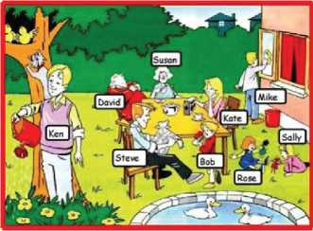
Hello everybody! Look at this nice picture. Here is one of the moments I prefer when we are all together on a nice Sunday afternoon. But let me introduce myself! I’m Bob, I am standing in front of my father who is reading the newspaper.
Mum is listening to her favourite songs on the radio. My two sisters, Rose and Sally, are playing with their dolls. My grandfather is having a nap and granny is drinking a cup of tea. The cat is running after the birds as usual and only my cousins are doing real activities; Ken is watering Mum’s flowers and Mike is cleaning the windows. “Can you imagine that Sunday afternoon!”
Figure 36 group work

- Use the correct form of the verbs in brackets to complete the sentences.
a.
b.
c.
d.
Be quiet! The baby (sleep).
It (rain) cats and dogs here in the Monsoon season.
John is busy. He (work) at the moment.
Please keep quiet, I (listen) to the radio. You know I
(listen) to the news in the mornings.
- What time the first bus (leave) for Kathmandu?
- I usually (not wear) a scarf, but today I (wear)
one because it's unusually cold.
- She (travel) to Dhangadhi next weekend.
- Pasang is in the classroom at the moment. He (study)
History.
- These days most people .... (write) emails instead of writing letters.
- What sort of clothes teenagers (wear) nowadays?
k. What you (do) tonight? Would you like to come
and watch the game?
- You look worried. What you (think) of?
m. She usually drives a taxi. But today, she is (drive) a
lorry.
n. These kids (not do) what I’ve asked them to do.

Writing I
- Read the interpretation of the pie charts.

Households by Ownership of Houses in Nepal
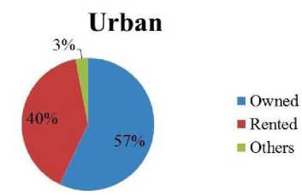
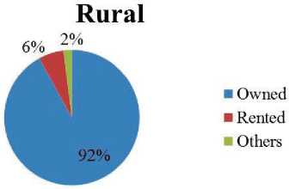
Figure 37 urban area pie chart
Figure 38 Rural area pie chart
The above pie charts show the comparability of home ownership, rented and others in Nepal between rural and urban sectors. In rural areas, 92% of families have their own houses and only 6% of households live in rented houses. Only 2% of families spend their life without owning and renting houses.
On the contrary, 57% of families have their own houses and 40% of families live in rented houses in town areas. More than one third of families stay in rented house in cities. 3% of urban families do not have their own houses and they do not stay in rented houses, either.
Comparing the rural and urban areas, the number of house owners is less in towns than in villages. But, there is a big gap between urban and rural areas where families rent houses. The percentage of the families who live in rented houses is more than six times in the urban areas than rural ones. But, the number of families who stay outside the owned and rented houses is similar in both the areas.
- The pie charts below show the information about household expenditure in Nepal in 2004 and 2011. Write an interpretation of the charts making comparisons where necessary.
Household Expenditure in Nepal
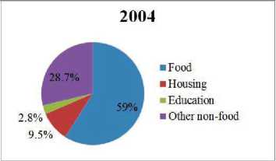
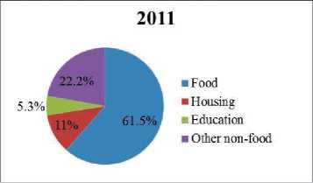
Figure 39 2004 pie chart
Figure 40 2011 pie chart

Reading II
Do you agree with the following statements? Discuss.
- Apologizing doesn't always mean you're wrong and the other person is right.
- Great people apologize when they realize they have made a mistake.
Figure 41 Aero plane

Dear JetBlue Customers,
We are sorry and embarrassed. But most of all, we are deeply sorry.
Last week was the worst operational week in JetBlue's seven year history. As a customer scheduled to be on one of our flights during this period, we know we let you down. Following the severe winter ice storm in the Northeast, we subjected you to unacceptable delays, flight cancellations, lost baggage, and other major inconveniences. The storm disrupted the movement of aircraft, and, more importantly, disrupted the movement of JetBlue's pilot and in flight crewmembers who were depending on those planes to get them to the airports where they were scheduled to serve you. With the busy President's Day weekend upon us, rebooking opportunities were scarce and hold times at 1-800-JETBLUE were unacceptably long or not even available, further hindering our recovery efforts.
Words cannot express how truly sorry we are for the anxiety, frustration and inconvenience that you experienced. This is especially saddening because JetBlue was founded on the promise of bringing humanity back to air travel and making the experience of flying happier and easier for everyone who chooses to fly with us. We know we failed to deliver on this promise to you last week.
We have begun implementing immediate corrective steps to regain your confidence in us as part of a comprehensive plan to provide better and timelier information to you, more tools and resources for our crewmembers and improved procedures for handling operational difficulties in the future. We are confident, as a result of these actions that JetBlue will emerge as a more reliable and even more customer responsive airline than ever before.
Most importantly, we have published the JetBlue Airways Customer Bill of Rights; our official commitment to you of how we will handle operational interruptions going forward including details of compensation. I have a video message to share with you about this industry leading action.
You deserved better, a lot better, from us last week. Nothing is more important than regaining your trust and all of us here hope you will give us the opportunity to once again welcome you onboard and provide you the positive JetBlue experience you have come to expect from us.
Sincerely,
David Neeleman
Founder and CEO JetBlue Airways

a. | disrupt | - to come out of a dark, confined or hidden place
b. | crewmembers | - trouble or problem, especially concerning what you need or would like yourself
c. | hinder | - to make it difficult for something to continue in the normal way
d. | inconvenience | - to make it difficult for somebody to do something or for something to happen
e. | emerge | - all the people working on a ship, plane, etc.
A. Match the words in column A with their meanings in column B.
Column A
Column B
- Answer the following questions.

- Who has written the letter?
- Who is it addressed to?
- How long has JetBlue been serving its customers?
- What was the main cause of inconvenience to the passengers?
- What sort of service does this company promise?
- What does the JetBlue Airways Customer Bill of Rights contain?
- Have you ever faced any problem when travelling on holidays or to another village or town? Share it with your friends.

Listening
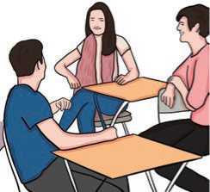
- Look at the picture and answer these questions.
- What could the people in the picture be talking about?
- What do you think when a friend forgets your name?
Figure 42 talking about meeting

- Listen to the audio and choose the correct answer.
- The man first met the woman at a
. campus ii. friend's house iii. party
- The man apologizes for
I. not calling her ii. not remembering her name
iii. being late
- The woman's name is....
I. Sharon ii. Sherry iii. Susan
- The woman is majoring in
I. management ii. engineering iii. TESL
- What major subject does the man consider the best at this time?
I. marketing ii. international business iii. accountancy
- How do you apologize when you forget your friend's name who is talking to you?

Grammar II
- Use the correct form of the verbs given in the brackets to rewrite this text.
Sophiya (sit) in the classroom. Her teacher (stand) in front of the class teaching. But, Sophiya (do) something else. She is daydreaming. She (not be) in the class. She (dance) on a stage in front of hundreds of people. She (wear) a beautiful costume. She (tap) and twirling. She (spin) on one leg. She (kick) her feet. She (leap) and (fly) through the air. The audiences (stand) on the floor. They (clap) and (shout) “Bravo! Bravo!!”.
“Sophiya?”
“Sophiya?” her teacher (call). He is not teaching anymore.
“Yes?” Shophiya (feel) a bit embarrassed. Her cheeks (get) red.
“Are you feeling okay? You (shout) ‘Bravo! Bravo! Bravo!' in the class.”
“Sorry! I am just enjoying the class so much ‘Bravo! Bravo!'.”

- Complete the sentences with the use of correct form of any relevant
verbs.
- A: We to the cinema tonight.
B: with us?
- A: I on holiday two or three times a year.
B: That's great! And where this year?
- I think it's better to stay. It and we an umbrella.
- Who is that man? Why at us? What ?
- Tomorrow, I my doctor in the morning.
- Where's John? He to a new song in this room.
- Rita hard all day yesterday but she not
today.
- Nitu reading a story at the moment.
- The plane the runway now. You are too late.
- I told you that I with you anymore. You're simply
not a team player.

Writing II
We all make mistakes in our life. You have also probably made many mistakes in your own life. Remember any mistake that you have recently made. Then, write a letter or an email to the respective person apologizing for the mistake.

Project work
Collect different ways of apologizing and responding from parents, friends or newspapers. Display them on chart paper in your class.

Extra bit
Simple, Compound and Complex Sentence
- A simple sentence contains a subject and a verb. It expresses a single complete thought that can stand on its own.
Examples:
The baby cried for food.
Megan and Ron ate too much and felt sick.
- A compound sentence has two independent clauses. An independent clause is a part of a sentence that can stand alone because it contains a subject and a verb and expresses a complete thought. Basically, a compound sentence contains two simple sentences. The independent clauses are joined by a conjunction (for, and, nor, but, or, yet, so).
Examples:
The shoplifter had stolen clothes, so he ran once he saw the police.
They spoke to him in Spanish, but he responded in English.
- A complex sentence contains an independent clause and one or more dependent clauses. A dependent clause either lacks a subject or a verb or has both a subject and a verb that does not express a complete thought. - A complex sentence always has a subordinator (as, because, since, after, although, when) or relative pronouns (who, that, which).
Examples:
After eating lunch at The Rose Garden, Tapas went to the gym to exercise.
Because the meat had gone cold, I heated it on the gas stove.
Let's get back to the ground where we played football.

Unit 6 Custom and culture

Getting started
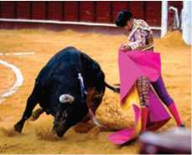
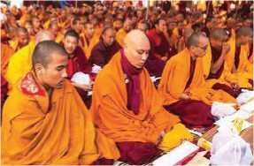
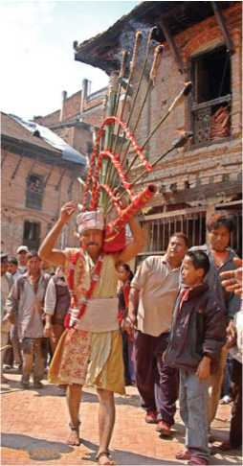
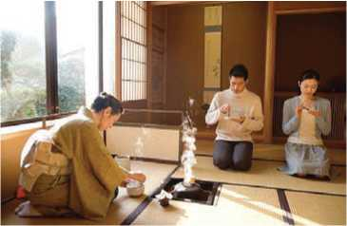
Look at the pictures and talk about them.
Figure 43 Buddhism
Figure 44 traditional culture
Figure 45 man play with bull
Figure 46 Japanese tea
Reading I
Answer these question

- Describe death rituals in your culture.
- Why do you think it is important?

Sky Burials
Sky Burials are traditional custom in Tibetan Buddhism to say farewell to their dead. These days, outsiders are mostly forbidden from witnessing them.
I had heard of Tibetan Sky Burials with a mixture of horror and fascination. To put it bluntly, a dead body is chopped up into pieces and fed to waiting vultures.

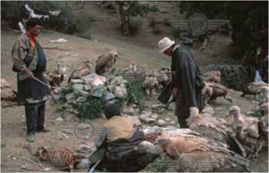
So, we arrived at a very isolated and traditional Tibetan Buddhist monastery near Tagong in North Eastern Sichuan. I thought, "let's just look at the site where it happens".
We'd been told that foreigners were not allowed to experience the secret ritual anyway.
Our driver directed us up to the top of the mountain where the burials take place. It was surrounded by a sea of Tibetan prayer flags and you could just make out a kind of stone slab.
So we hiked up there. Upon arriving, we could hear Tibetan nuns chanting. "How lovely?" I thought.
Then I turned and saw about 100 vultures sitting on the hill, waiting and then, what looked like a body bag on the stone slab.
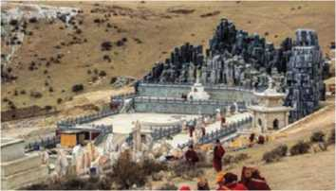
I actually couldn't believe it. “Have we stumbled into the start of a sky burial?” Through a translation app I asked one of the Tibetans next to me what was happening.
"Flesh eating birds," he replied.
"Oh, can we stay?" I asked.
"Yes, but on the side and no photos," he replied.
"This is amazing," I thought, but then I saw my kids. My wife and I had to make quick decisions.
We gave our six-year-old son the iPad to play computer games. He was thrilled, and we had never before been so happy to give it to him. He was too young to see this.
As for my 11-year-old son and my 13-year-old daughter, my wife Catherine quickly sat them down and told them what was about to happen and said it was their choice to stay or go.
We gave it to them straight, but told them the cultural and religious context.
To their credit they stayed. I was nervous. The first time I'd seen a dead

body when I was 12 and it had a profound effect on me.
Before we knew it, the bag was taken off and the corpse was revealed. It looked like a middle-aged woman.
The Rogyapa, body breaker, stormed up the side of mountain. He was dressed in a thick, dark scarlet colored coat with a black hood. With a butcher knife in hand, he wasted no time in carving up the body. My stomach sunk. It was gruesome, and I just stopped myself from throwing up. My kids though seemed to take it in their stride.
The vultures were growing impatient and started to jump at site of the flesh. The body breaker gave the signal and the Tibetans holding the birds back let them through.
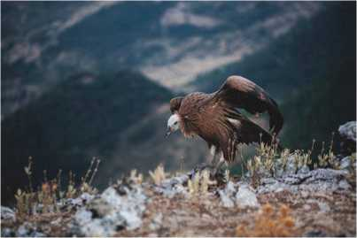
They swarmed, in a frenzy jumping on top of each other tearing at the flesh. It was unbelievable.
Figure 47 vulture
It only took at most 15 minutes and the entire corpse was gone. Every last piece of flesh had been eaten, leaving only the bones behind. Then the body breaker gathered up the human bones and began to pulverize them with a mallet. He mixed that with yak butter and barley flour. In one last gesture, he walked into the middle of the vultures and threw it high in the air. And with that he was gone.
There was absolutely nothing left of the body. It is considered a bad omen if vultures don't eat the body or even if small bits are left.
Tibetans see the vultures as Dakinis, like angels who take soul into the heavens to await reincarnation and the next life. They consider the body as a mere vessel for the soul.
And at the end of it all, a peace and calmness seemed to descend over the scene. Everyone seemed happy that the ritual had been fulfilled.
My kids too, surprisingly, were fine. They seemed to be able to understand it; an ancient culture giving a meaning to lives.
I was a proud dad on that day, proud of their maturity and intelligence. But as for my six-year-old son, he was none the wiser. He'd been deeply engrossed by his iPad, playing Mine craft the whole time.
- Matthew Carney
- Choose the words from the box that match with the given meanings from a - h.
forbidden fascination profound gruesome
frenzy pulverize omen engrossed
a very great
b a state of great activity and strong emotion
c very unpleasant and filling with horror
d not allowed
e a sign of what is going to happen in the future
f. very strong attraction
g involved in something with whole attention
h to make something into a fine powder
- Write True for true statements and False for false ones.
- Foreign visitors are welcome to see Sky Burial rituals.
- The visitors are not allowed to take photos of the rituals.
- The vultures took more than fifteen minutes to finish the entire corpse.
- The Tibetans perceive the body as a vessel for the soul.
- The youngest son of the writer was busy with his toys.
- The author visited the burial sites with his wife and three children.
- Answer the following questions.
- Why did the author visit a traditional Tibetan Buddhist monastery?
- What did the author see on the hill?
- Why did the author give the iPad to his youngest son?
- Describe the appearance of a Rogyapa, the body breaker.
- What did the body breaker do after collecting the bones?
- What is considered to be a bad sign?
- Why did the author feel proud?

- Research customs from other countries and talk about an interesting one with your friends.

Pronunciation
Pronounce the following contracted forms with the help of your teacher or a dictionary.
aren't | isn't | wasn't | weren't | haven't | hasn't | hadn't
don't | doesn't | didn't | can't | couldn't | mustn't | won't

Speaking
A. Make as many sentences as possible from the following table.
 |  | go out, please?
May |  | bring my doggie | at your photo
Can |  | could have a look | album?
Do you think |  | taste that hot spicy | for a while?
Could |  | dish? | with you?
Do you mind if | I | use your protractor | to the party?
Is it OK if |  | ask you something | on Ecology?
 |  | sit here

- Work in pairs. Ask for permission and respond to the situations
given in the left column of the table. The responses are in the right column of the table.
Example: A: I feel sick. May I leave for home?
B: Sure.
Situations for asking permission | Responses
- sore throat/doctor  - headache/go home  - blister on foot/clinic  - radio/news  - camera/photos  - telephone/chat with friend  - toilet/no-so dirty  - day off tomorrow/no-very busy day | - Sure.  - Yes, please do.  - Sure, go ahead.  - Of course, go ahead.  - No problem.  - Please feel free.  - Well, I'd rather you didn't.  - No. You can't.

- Have conversations with your partner for the situations given below.
- It's very hot in the room and you would like to open the window.
- You need to borrow a pen from a friend because you have lost yours.
- You didn't understand the lesson in the class very well. You want your friend's help.
- You are watching the TV but you can't hear because the volume is very low. Your brother or sister has the remote control.
- You would like to take a photo of your friend.
- You left your mobile phone at home but it's quite necessary for you to call your parents. Your friend has a mobile phone.

Grammar I
- Match the questions in column A with the answers in column B.
Column A Column B
- Are you ready? I. Yes, it's on the chair.
- Can I carry something for you? ii. Yes, of course.
- May I use your phone? iii. Yes, I'd love to.
- Has anyone seen my bag? iv. No, it's OK. It's not that heavy.
- Would you like to come to a party? v. Yes, nearly.

- How do you ask questions in these situations?
- You want to know if it is raining.
- You want to know if Harish plays football.
- You want to know if the bus is on time.
- You want to know if your friend, Ramesh went to the market yesterday.
- You want to know if it is Tuesday today.
- You want to know if your teacher opened your letter.
- You want to know if your brother has gone to sleep.
- You want to know if there will be a food party.
- Circle the correct answer.
a. | Are you busy today?  I. Yes, busy. | ii. Yes, I am.
b. | Is it too hot in here for you?
 | I. No, it isn't. | ii. No, I'm fine, thanks.
c. | Tell me, did you steal my money?
 | I. No. I won't | ii. No, I didn't steal your money.
d. | Can I carry your bags?
 | I. No, you can't. | ii. It's all right, thanks.

- Write yes/no questions for these statements.
- The family has got three mobile phones.
- Januka works at the supermarket.
- Anita is learning English.
- The meeting will be held next Tuesday.
- Tanka switched off the computer.
- He went to the cinema yesterday.
- Everyone is ready.
- It is raining outside.
- Vicky's lost her credit card.
- She'd done the work on time.

Writing I
Write short essay about ‘Our Culture Our Pride’.

Reading II
Answer these questions.
- Is there any unique custom in your community? What is it?
- Why is it unique?

Surprising Customs
One thing that sets humans apart from other members of the animal kingdom is our propensity to develop customs and traditions around everything from beauty rituals to death customs. In fact, humans love doing this so much that the world has been enriched with thousands of different cultures since the dawn of civilization. No doubt, one important aspect of just about any given culture is its code of etiquette and a sense of identity. Here are some astonishing customs from around the world.

Pointing with lips
While gestures of the hand are often subject to customary variation across
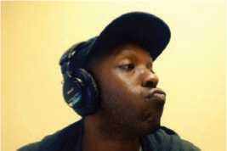
cultures, few can claim this wonder extends to expressions of the mouth. In Nicaragua, it is common to point with the lips instead of the thumb or index finger like the majority of the world. Wondering just how exactly a person points with their lips? It all starts by puckering up. The lip point is typically used in conversation to indicate something that is happening nearby.
Figure 48 pointing with lips

Tipping
Another odd custom associated with the United States is its tipping culture. Unlike many other countries that don't tip at all or who only tip in small amounts when the food was particularly good, tipping is rather mandatory at most restaurants in the US In fact, it is expected that patrons leave between 10-20 percent of the bill in tips. Further, there are rules for tipping bartenders, delivery people and other service personnel. While some criticise this practice as irrational, there's no doubt that tipping culture in the US gives an incentive for waiters and waitresses to provide better service.
Figure 49 Tipping

Slurping
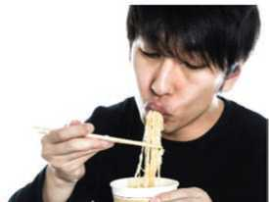
Most societies around the world have rules about table etiquette. For western cultures, noisily consuming food is considered rude. In Japan, however, making slurping sounds while eating has an entirely different meaning. This might have something to do with the fact that in western countries, noodles are properly consumed by twirling them on a spoon before putting them in the mouth. Meanwhile, the Japanese simply slurp up their noodles without contorting them first, an act that is naturally noisier than the former. Making slurping sounds when eating noodles in Japan is a way of indicating that you're really enjoying them. Some scientists even argue slurping invites air into the palate and actually enhances the noodles' flavour.
Figure 50 Slurping

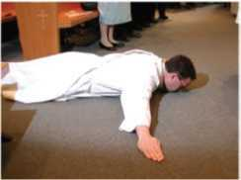
Kneeling or lying prostrate as greeting
Figure 51 Kneeling
For members of the Yoruba people, an ethnic group that largely resides in Nigeria, greeting rituals are taken quite seriously. This is especially true in regards to greeting elders. When an adult approaches, Yoruba youths are expected to drop to their knees in greeting. More specifically, women kneel when greeting, and men typically lie prostrate. These gestures are a sign of respect and deference for the elders of the community. Interestingly, this custom is one that distinguishes Yoruba peoples from other ethnic groups in Nigeria, including the Bini and the Kalabari.
- Find the words from the text that match the following meanings.
a. ………………. a natural desire
b. ………………. the rules of correct or polite behaviour in society
c. ………………. people who work in a bar, serving drinks
d. ………………. to become twisted
- Write True for true and False for false statements.
- In Nicaragua, people prefer to point with their thumb.
- Tipping is compulsory at most restaurants in the US.
- Contorting is less noiser than slurping.
People from the West take noodles by twisting them on a spoon.
- The Bini and the Kalabari are ethnic groups of Nigeria.
- Answer the following questions.
- What makes a group of people different from others?
- What is the unique tradition of Nicaragua?
- What is a positive aspect of tipping culture?
- Why do Japanese make slurping sounds while eating noodles?
- How do Yoruba people greet their elders?
- Which of the above customs did you find more interesting? Share it with your friends.

Listening
- Look at the pictures and answer these questions.
- Are you familiar with these marriage traditions?
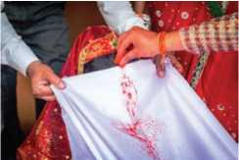
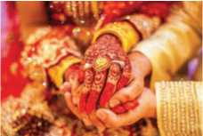
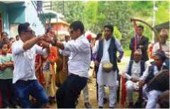
- How do you celebrate the marriage ceremony in your community?
Figure 52 marrige
Figure 53 marriage
Figure 54 dance

- Listen to the audio and match the marriage traditions with the related countries.
- Jumping over the broom I. China
- Dancing covered with money ii. India
- Painting the hands and feet iii. Ghana
- Changing wardrobes iv. Cuba
- Listen to the audio again and fill in the blanks with the correct words/phrases from below.
profitable custom Jewish cocktail dress
evil spirits lucky color henna paste
- Breaking a glass is a wedding tradition.
- Jumping over the broom is done to sweep away the
- Dancing while covered with money is considered as a ……………….
- Female friends decorate the bride's hands and feet during
marriage with a in India.
- Chinese brides wear a red dress first because red is considered as
a
- A is the third wardrobe for Chinese brides.
- Which of the marriage traditions is most similar to your own? Talk to your friends.

Grammar II
- Choose the following sentences in indirect speech from the list to match with the sentences in direct speech in the table below.
- I asked the woman next to me if the bus to Kathmandu had already left.
- I asked the teacher whether the book had been translated into Nepali.
- Barsa asked her teacher if she should write the story again.
- Samir asked Rohan whether he had finished reading his book.
- The new pupil asked me if I was a class captain.

a. | The new pupil said to me, “Are you a class captain?”
b. | Samir asked Rohan, “Have you finished reading my book?”
c. | I asked the teacher, “Has the book been translated into Nepali?”
d. | “Has the bus to Kathmandu already left?” I said to a woman next to me.
e. | “Should I write the story again?” Barsa asked her teacher.

B. Change the following sentences into indirect speech.

- Rahul said to me, “Did you watch the cricket match on TV last night?”
- ‘Are you coming home with me?” he said.
- “Do you really come from India?” said the prince.
- “Have you anything to say?” said the judge finally.
- She said to me, “Is he at home?”
- Usha says, “Can you solve the problem?”
- Badri said to Asmita, “Will you visit me in Australia?”
- Radhika said to Rebecca, “Did you hear the noise?”
- He said, “Have you seen my hat?”
- He said to me, “Does he come or not?”
- Rohan said to me, “Did you spill the milk on the floor?”
- The pilot said to the air hostess, “Have the passengers fastened their seatbelts?”
- Imagine that you met a friend after two years. He or she asked you the following questions. Reply to them.
a. Are you fine?
- Have you had breakfast?
- Are you playing chess or not?
- Can you share your future plan?
b. How is your family?
- What are you doing now?
- Do you need any good books?
- Why don't you come to meet me?

Writing II
You have learned about some unusual and interesting customs and cultures of the world. Nepal is also rich in its unique customs and cultures. Write an essay on any one of the unique customs using the given outlines.
introduction …………… time to celebrate ………………… historical and cultural values ….............. community observing it ……………. activities of celebration ……….. your opinions …………………. conclusion.

Project work
The picture shows the elements of a culture. Choose a culture, design a similar picture and explain it to the class.
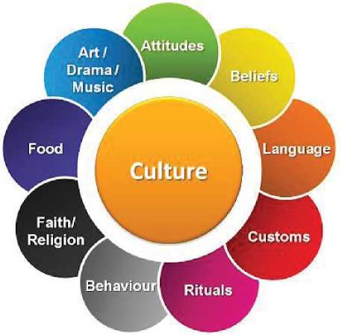
Figure 55 arts/drama/music attitudes belifs language customs rituals behaviour religion/ faith, food

Extra bit
Types of Essays
There are four main types of essays: narrative, descriptive, expository, and persuasive. This classification of essays is based on the writer's overall goal. Does the writer want to tell about a personal experience, describe something, explain an issue, or convince the reader to accept a certain viewpoint?
- Narrative Essay
In a narrative essay, the writer tells a story about a real-life experience. While telling a story may sound easy to do, the narrative essay challenges writers to think and write about themselves. When writing a narrative essay, writers should try to involve their readers by making the story as vivid as possible. The fact that narrative essays are usually written in the first person helps engage the reader. A well-crafted narrative also builds towards drawing a conclusion or making a personal statement.
- Descriptive Essay
A descriptive essay paints a picture or image in the reader's mind, but with words. A writer might describe a person, place, object, or even a memory of a special significance. In a descriptive essay, the writer should show, not tell, through the use of colorful words and sensory details. The best descriptive essays appeal to the reader's emotions.
- Expository Essay
The expository essay is an informative piece of writing that presents a balanced analysis of a topic. In an expository essay, the writer explains or defines a topic, using facts, statistics, and examples. Expository writing encompasses a wide range of essay variations, such as the comparison and contrast essay, the cause and effect essay, and the “how to” or process essay.
- Persuasive Essay
The goal of the persuasive essay is to convince the reader to accept the writer's point of view or recommendation. The writer must build a case using facts and logic, as well as examples, expert opinion, and sound reasoning. The writer should present all sides of the argument, but must be able to communicate clearly.

Unit 7 Ecology and Environment

Getting started
Look at the picture and talk about the components of the environment.
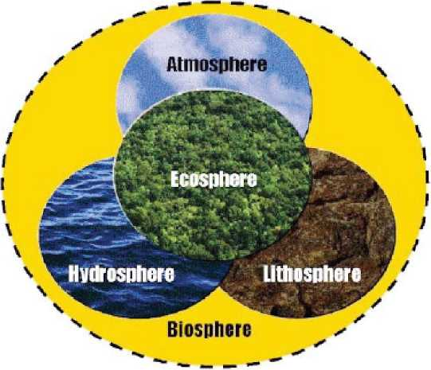
Figure 56 Environment

Reading I
Answer these questions.
- What preparations do you and your family make as the winter season approaches?
- How do animals and birds protect themselves from the cold?

How do Animals Spend the Winter?
The weather gets colder, days get shorter and leaves change color and fall off the trees. Soon, winter is here. Snow covers the ground. People live in warm houses and wear heavy coats outside. Our food comes from the grocery store. But what about animals?

A
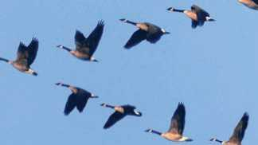
Animals do many different, amazing things to get through the winter. Some of them migrate. This means they travel to other places where the weather is warmer or they can find food. Many birds migrate in the autumn. Because the trip can be dangerous, some travel in large flocks. For Example, geese fly in noisy, "V"-shaped groups. Other kinds of birds fly alone. How do they know when it is time to leave for the winter? Scientists are still studying this. Many see migration as part of a yearly cycle of changes a bird goes through. The cycle is controlled by changes in the amount of daylight and the weather. Birds can fly very long distances. For example, the Arctictern nests close to the North Pole in the summer. In autumn, it flies south all the way to Antarctica. Each spring, it returns north again. Most migrating birds travel shorter distances. But how do they find their way to the same place each year? Birds seem to navigate like sailors once did, using the Sun, Moon and stars for direction. They also seem to have a compass in their brain for using the Earth's magnetic field. Other animals migrate, too. There are a few mammals, like some bats, caribou and elk, and whales that travel in search of food each winter. Many fish migrate. They may swim south, or move into deeper, warmer water. Some insects also migrate. Certain butterflies and moths fly very long distances. For example, Monarch butterflies spend the summer in Canada and the Northern US. They migrate as far south as Mexico for the winter. Most migrating insects go much shorter distances. Many, like termites and Japanese beetles, move downward into the soil. Earthworms also move down, some as far as six feet below the surface.
Figure 57 Birds

B
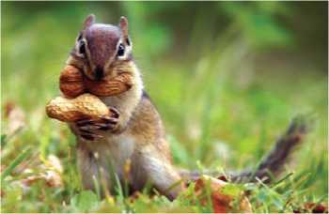
Some animals remain and stay active in the winter. They must adapt to the changing weather. Many make changes in their behaviour or bodies. To keep warm, animals may grow new, thicker fur in the autumn. On weasels and snowshoe rabbits, the new fur is white to help them hide in the snow. Food is hard to find in the winter. Some animals, like squirrels, mice and beavers gather extra food in the autumn and store it to eat later. Some, like rabbits and deer, spend winter looking for moss, twigs, bark and leaves to eat. Other animals eat different kinds of food as the seasons change. The red fox eats fruit and insects in the spring, summer and autumn. In the winter, it cannot find these things, so instead it eats small rodents.
Figure 58 Chipmunks

C
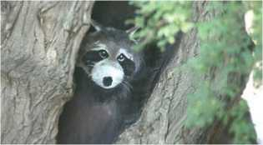
Animals may find winter shelter in holes in trees or logs, under rocks or leaves, or underground. Some mice even build tunnels through the snow. To try to stay warm, animals like squirrels and mice may huddle close together. Certain spiders and insects may stay active if they live in frost-free areas and can find food to eat. There are a few insects, like the winter stonefly, crane fly, and snow fleas, that are normally active in winter. Also, some fish stay active in cold water during the winter.
Figure 59 Raccoon

D
Some animals hibernate for part or all of the winter. This is a special, very deep sleep. The animal's body temperature drops, and its heartbeat and breathing slow down. It uses very little energy. In the autumn, these animals get ready for winter by eating extra food and storing it as body fat. They use this fat for energy while hibernating. Some also store food like nuts or acorns to eat later in the winter. Bears, skunks, chipmunks, and some bats hibernate.

E
Cold-blooded animals like fish, frogs, snakes and turtles have no way to keep warm during the winter. Snakes and many other reptiles find shelter in holes or burrows, and spend the winter inactive, or dormant. This is similar to hibernation. Water makes a good shelter for many animals. When the weather gets cold, they move to the bottom of lakes and ponds. There, frogs, turtles and many fish hide under rocks, logs or fallen leaves. They may even bury themselves in the mud. They become dormant. Cold water holds more oxygen than warm water, and the frogs and turtles can breathe by absorbing it through their skin.

- Find the words from the text that have the following meanings.
- a shop that sells food and other things used in homes
- related to the regions around the North Pole
- an underground passage
- to find the right way to deal with a difficult situation
- a person who works on a ship as a member of the crew
- to change behaviour in order to deal more successfully with a new situation
- a very small green or yellow plant that spreads over wet surfaces, rocks, trees, etc.
- to gather closely together, usually because of cold or fear
- Read the paragraphs A-E and match them to the suitable titles.
Paragraphs Titles
A Going into a Deep Sleep
B Migration to New Places
C Other Ways to Survive
D Living in Underground Holes
E Adaptation to New Weather
- Write True or False against the following statements.
- Animals wear thick coats to protect themselves from the cold.
- Flying in flocks helps birds protect themselves from the cold.
- Birds do not travel far to avoid the cold.
- Some animals collect extra food for winter.
- Snow fleas hybernate in winter.
- Cold water makes it difficult for some animals to breathe.
- Answer the following questions.
- Why do birds migrate in groups?
- What controls the migration cycle of birds?
- How do birds find the same place for migration each year?
- Why do you think squirrels and mice huddle close together in winter?
- How do animals maintain energy during hibernation?
- How do frogs, turtles and fish change their habitats to survive in winter?

- What do people do to avoid cold weather? Talk to your friends.

Pronunciation
Learn the pronunciation of the following words about the weather.
avalanche blizzard breeze drought Fahrenheit
flurries forecast frostbite humidity precipitation

Speaking
- Act out the following conversations.
Conversation I
Shopkeeper: Can I help you?
Customer : No thanks, I'm just having a look.
Conversation II
Waiter : Would you like a cup of tea?
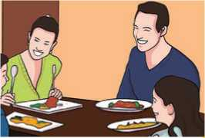
Guest : No thanks.
Figure 60 lunch
Conversation III
Aunt : Would you like another piece of
cake?
Uncle : Yes please, that would be nice.

Conversation IV
Sanjay : Shall I help you with your math problem?
Ramila : Yes, please. That would be very nice of you.
Conversation V
Sister : I'll do the washing, if you like.
Brother : It's OK, I can do it.
Conversation VI
John : Can I offer you some hot cakes?
Jack : Thanks a lot. That would be great.

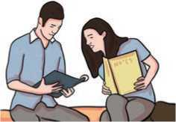
- Have similar conversations in pairs using the given clues.
- Your friend has got a new camera but cannot operate it.
Figure 61 reading
- Your friend has forgotten to bring money to buy snacks.
- Your friend has a problem with English grammar.
- Your friend feels unwell in the classroom.
- Your friend looks thirsty, and he doesn't have any water.
- Your friend is drawing a picture, but his/her pencil gets broken.
- Work in pairs. Take turns to make and accept or reject offers based
on the clues below.
a. | a chocolate | b. | a seat on a bus
c. | to carry his/her bag | d. | to drive you back home
e. | some money | f. | provide a discount

Grammar I

- Study the following sentences.
- If you heat snow, it melts.

- If it rains, you will get wet.
- If you don't hurry, you will miss the bus.
- What will you do if you miss the plane?
- I may finish that letter if I have time.
- If you want to borrow a book from the library, show your library card.
- Water changes into vapor if it is heated.
- Use the correct form of the verbs from the brackets to complete the sentences.
- If you call me, I (come).
- If you (not leave), I'll call the police.
- Somebody (notice) if you make a mistake.
- If I see her, I (tell) her to call you.
- She (be) very angry if you don't apologie.
- They will be happy if we (invite) them to the party.
- Will they pay any more if I (work) harder?
- If you don't lock your bicycle, someone (steal) it.
- I (lend) you some money if you promise not to waste it.
- Unless you use your English, it (not improve).
- You must study hard if you (want) to join college.

Writing I
- Read the following paragraph and answer the questions.
The most important problem in our city is its poor public transportation system. Thousands of residents rely on the city's buses and taxis to travel throughout this large city, while the City Transportation System's daily schedules are totally unreliable. A bus that should arrive at 6: 30 a.m. may arrive at 7: 00 a.m. or later. Moreover, it is not unusual for a bus driver to pass by groups of people waiting for the bus because he wants to make up for the lost time. Unfortunately, people often end up going to work late or missing important appointments. In order to help people get to their destinations on time, people must allow for waiting time at the bus stops.
- Which is the topic sentence or main idea of the paragraph? Where is it stated?
- What details does the writer use to support the main idea?
- Underline the conclusion of the paragraph.
- What ought to be the topic of this paragraph?
- Write similar paragraphs on the following topics in about 100 words.
- Deforestation b. Endangered Animals

Reading II
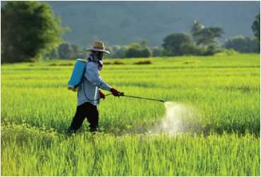
Look at the picture below and answer these questions.
Figure 62 pesticides
- What do you think the man is doing?
- Why do you think he is doing so?

The Resistant Moths
“First they told us to buy the poisons to help us kill the pests,” says Mahendra bitterly. “Then they said we need poisons to combat the problems caused by the first pesticides. Now they say we shouldn't have used so much of those pesticides. My God, I think these insects will eat us alive.”
Mahendra Yadav is a farmer whose fields have been swamped by a strange new plague of moths that nothing will shift. His main crop is potatoes. Back in the early 1990 government officials told farmers about amazing pesticides which would kill the insects in their field and soon make them rich. They were only too willing to buy them and shopkeepers made them available.
“First we bought one,” says Mahendra, “then another. After that there was an avalanche of them. Now look where we are. “The energy of the salesmen was overpowering and enormous quantities were sold. But the chemicals were applied more or less indiscriminately -often in the wrong way and the wrong time. It wasn't our fault,” Mahendra claims. “We were so excited by the thought that we would soon be free of the whims of nature. What would you have done?” But after a few years they were in for a nasty surprise. Despite the mixture of powerful chemicals on the potatoes, a few moths survived. They reproduced themselves at a terrifying rate, devouring all the potatoes they could find. The chemicals, it seemed, had disturbed the previous natural balance by killing not only pests but their natural predators. So the new moth had the crop all to itself. The farmers' first reaction was to increase the dose of the pesticide then to try new chemicals, one after another. But it just needed one or two resistant moths to survive and they could produce a new and tougher strain, immune to the most powerful pesticide.
New pesticides came in with new promises that they would finish off the evil moth. And indeed they produced good results for a time. But soon it was clear that they were not the permanent solution either. Farmers are in despair. They have not only seen their harvest disappear but they feel that they have lost the creative potential of the land itself.
Mahendra himself is more hopeful. He has returned to more natural methods. He is letting some of his land lie fallow and changing the irrigation system in the hope that the moths will go away.
(Source: adapted from Campus English, Macmillan Publications)
- Use the correct words from the box below to complete the following sentences.
avalanche | plague | combat | predator | despair
resistant | nasty

- As responsible citizens it is our duty to …………… all social evils.
- The whole town is suffering from the new of rats.
- The minister’s opinion has created of controversy.
- He got a cut above his eye in the accident.
- Some animals do not have a natural
- Mosquitoes seem to have become to the toughest insecticides.
- He is in due to all the failures in business.
- The word 'devour' refers to a style of eating. It means ‘eating hungrily’. The following words also refer to different styles of eating. Use a dictionary to find their meanings.
- munch
- nibble
- gobble
- gnaw
- swallow
- Write whether the following sentences are True or False.
- The first use of pesticides caused further problems to the farmers.
- The shopkeepers made the farmers buy many pesticides.
- Mahendra Yadav admits that the farmers used chemicals carelessly.
- The pesticides not only killed the pests but also increased the fertility of the land.
- Mahendra Yadav expects that the moths will go away one day.
- Answer the following questions.
- Why do you think Mahendra Yadav says “these insects will eat us alive"?
- What did the farmers hope when they bought the pesticides for the first time?
- What was the ‘nasty surprise’ for the farmer?
- Find different words in the text that refer to the pesticide and the moth.
- Do you think that Mahendra Yadav has made a wise decision at
the end? Why?

- Why is the use of pesticide harmful for both people and the environment? What could be a good alternative to pesticides? Discuss with your friends.

Listening
- Answer these questions.
- What are the three biggest rainforests in the world?
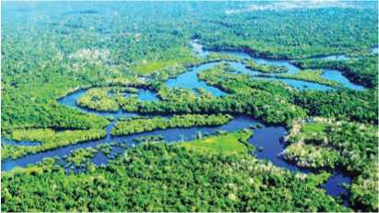
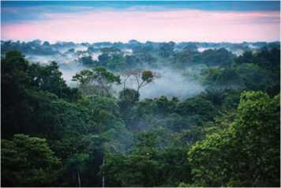
Figure 63 forest
- Which is the biggest one?
Figure 64 forest

- Listen to the audio and circle the correct answers.
- What is the area of the Amazon Forest?
- 2.5 million km ² ii. 3.5 million km ²
iii. 4.5 million km ² iv. 5.5 million km ²
- Where does the Amazon River flow?
- through the north of the forest
- through the east of the forest
- through the west of the forest
- through the south of the forest
- How much oxygen is produced by the Amazon Forest?
- one third of the world's oxygen
- one fourth of the world's oxygen
iii one fifth of the world's oxygen
iv. one sixth of the world's oxygen

- How many species of mammals are found in this forest?
I. 410 species ii. 420 species
- 430 species iv. 440 species
- How many native tribes live in this forest region?
I. about 100-200 ii. about 200-300
iii about 300-400 iv. about 400-500
- Find out the percentage of forest in Nepal. What can we do to save it ? Discuss with your friend.

Grammar II
- Complete the sentences with the correct form of the verbs given in the brackets.
- If we hurry, we there in time. (get)
- I won't go to the doctor unless the pain (increase)
- If you spit in public place, you into trouble. (get)
- We for a picnic tomorrow if the weather stays nice. (go)
- Everyone you if you tell them the truth. (believe)
- If he up, he won't get to work on time. (not wake)
- If the baby a boy, I'll call him Nitesh. (be)
- You can cause an accident if you so carelessly. (drive)
- Unless she the ambulance immediately, her father may die.
(call)
- If you try harder, you in your exams. (succeed)
- Complete the following sentences with suitable endings.
- If you are hungry,
- If he runs fast,
- They will win the match if
- If you phone him,
- If Mira fails the exam,
- Manashi will be promoted to grade ten if

Writing II
- Read the letter to the editor of a newspaper and label the given parts in it.
subscription and signature date salutation/ greetings
sender's address body
Vias-6, Tanahun
21 May 2021
The Editor,
The Rising Nepal,

Dharmapath, Kathmandu
Dear Sir/Madam

Road accidents seem to be common on the Prithvi Highway these days. For the last few months, there has not been a single day when accidents did not occur on the highway. Most of these accidents were caused by reckless driving.

The other day, I was horrified to witness a dreadful accident. A young biker and his wife were crushed to death when a speeding truck that came from behind ran over them. Countless innocent lives are lost on the roads in this manner.

Reckless driving could kill children, pedestrians and animals. A car that spins out of control can harm other vehicles on the road too. In addition, reckless driving can cause significant damage to property. Thus, it goes without saying that reckless driving is a public safety issue that must be properly addressed.

Yours faithfully,
Sumina Aryal

- Write a letter to the editor of a local newspaper highlighting the importance of natural resources in Nepal, and ways of preserving them.

Project work
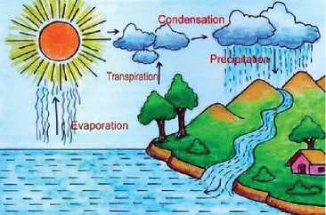
The picture shows the water cycle. The water cycle is the continuous movement of water within the Earth and atmosphere. It is a natural system that includes many different processes. Liquid water evaporates into water vapor, condenses to form clouds, and precipitates back to Earth in the form of rain and snow.
Figure 65 Water cycle
Draw a different picture to show the water cycle. Try to make it as attractive as possible and present it to the class.

Extra bit
Male, Female and Young of Different Animals
Animal | Male | Female | Young
ass | jack | jenny | foal
bear | boar | sow | cub
deer | buck | doe | fawn
horse | stallion | mare | foal
sheep | ram | ewe | lamb
wolf | dog | bitch | p^{u}p

Unit 8 Science and Technology

Getting started
Discuss in pairs and answer these questions.
- What technological advancement do you think these pictures represent?
- How will these inventions and innovations shape our future? Give specific
examples.

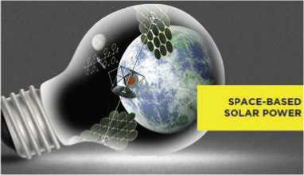
Figure 66 solar power
Figure 67 Internet of things

Reading I
Answer the following questions.
- What do you think Artificial Intelligence (AI) is?
- Can a robot have real intelligence like a human being does?

Humanoid Robot Sophia
By Shristhi Kafle
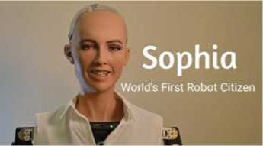
KATHMANDU, March 22 (Xinhua) - When Sophia, a social humanoid robot and the world's first robot citizen, greeted the audience at a conference in Kathmandu with "Namaste Nepal," the hall burst into applause of awe and appreciation.
Figure 68 Sophia
As cameras from local and international media flashed and under the admiring eyes of the audience, Sophia proceeded with her keynote speech and interactions highlighting the importance of technology in the development of human lives.
The robot, who is championing the United Nations Sustainable Development Goals in Asia-Pacific, with a focus on innovation, was in Nepal Wednesday to attend the Innovation Conference and Fair: "Technology of Public Services and Development" organized by the United Nations Development Program (UNDP).
Dressed in a white UNDP logoed T-shirt, the two-and-a-half-year-old, red-lipped robot said that technology provides endless possibilities and opportunities for the world.
Highlighting the importance of technology in Nepal and its applicability to government models, Sophia said it can transform state institutions and help in meeting global sustainable development goals.
"If artificial intelligence is used in Nepal, we can ensure better public services, a revolution in the agriculture sector, make better use of limited resources, protect the environment and make the world a better place," she said.
The celebrity robot, a "citizen" of Saudi Arabia, added that technology and artificial intelligence can help in ending poverty and fighting starvation, corruption and ensuring gender equality.
"Machines are here to make your life easier and we can connect your country to the rest of the world," Sophia said.
The au dience, comprising of government officials, private sector representatives, civil servants and tech enthusiasts, among others, were nodding in agreement at almost all of her statements, and cheered and applauded throughout her speech.
"I hope the conference will inspire and generate brilliant ideas to help Nepal achieve its development vision and global goals," Sophia said in the conclusion of her three-minute long keynote speech.
The social robot developed by Hong Kong-based company, Hanson Robotics, also answered a few questions raised by UNDP country director Renaud Meyer.
In a question about humans fearing a robot takeover, Sophia joked citing it as fake news, although mentioned that she could be the first non-human to climb Mount Everest, which saw the entire hall erupt with laughter.
The one-day conference also featured an "innovation fair" showcasing separate stalls with fresh innovations from youth, tech groups, NGOs and private sector participants, but Sophia was certainly the main attraction.
In her opening statement, Valerie Julliand, UN resident coordinator, said technology is not just changing our lives but also providing solutions to different sorts of problems.
With technological innovations, such as e-education, telemedicine, and the internet, it is possible to connect remote areas and people with solutions which were impossible earlier, the UNDP said in its statement.
According to the UNDP, it is developing and scaling-up innovative project prototypes to address gender empowerment, combat gender-based violence and disaster risk reduction, with a focus also on green energy, youth engagement and post-disaster recovery in Nepal.
- Match the following words with their meanings.
a. | humanoid | i. | a famous person
b. | awe | ii. | to clap in approval
c. | revolution | iii. | feelings of respect and slight fear
d. | celebrity | iv. | the first design of a device or machine
e. | enthusiast | v. | an act of controlling somebody or something
f. | applaud | vi. | a person who is very interested in a particular activity or subject
g. | takeover | vii. | a great change in conditions, beliefs, etc.
h. | prototype | viii. | a machine or creature that looks and
behaves like a human

- Fill in the blanks with the suitable words/phrases from the text above.
- Sophia the audience in Kathmandu with a ‘Namaste’.
- She presented her speech about the importance of technology.
- The Innovation Conference and Fair was organized by
- Sophia was built years ago.
- According to Sophia, technology can state institutions.
- Using artificial intelligence could bring in the agriculture
sector.
- According to the robot, the news of taking over humans was fake.
- In the opinion of Valerie Julliand, technology is giving us to
various problems.
- Answer the following questions.
- Who is Sophia?
- What was the main highlight of the conference?
- How can artificial intelligence be useful in Nepal, according to Sophia?
- Who was the audience comprised of?
- How long did Sophia speak for?
- Why are innovative project models being developed in Nepal, according to UNDP?
- How do you think AI technology can help to end poverty and fight starvation in Nepal?

Pronunciation
Pronounce the following pairs of words and find the difference of their meanings.
principal - principle loose - lose advice - advise
affect - effect further - farther council - counsel
accept - except ascent - assent

Speaking
- Act out the following conversations in pairs.
Conversation I
Govinda : Tell me about your new apartment.
Liza : It's big. It has got three bedrooms, a comfortable living room and a spacious kitchen.
Conversation II
Rambilas : What does the new teacher look like?
Dhaniya : She looks really intelligent. She wears glasses and always carries a
novel
- Have similar conversations using the given clues.
- the weather/rainy, storms
- your grandfather/getting better, resting at home
- your school/beautiful, big playground
- your studies/going well, better grades
- your village/lovely, surrounded by green forest
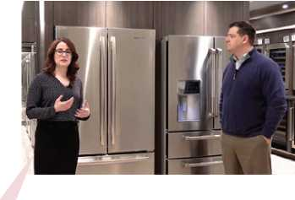
- Manju is a salesperson in a shop which sells fridges. She is talking about a fridge to her customer.
Figure 69 selling
It's a very useful device to store fruits, vegetables, pickles, jams and milk. You can keep some special medicines, too. There are four compartments inside this fridge. The uppermost compartment is the freezer. You can keep a tray for ice-cubes in it. In the two slots below you can store different food items. The last one is a bigger well, in which you can keep vegetables.
Now, talk about the objects below in a similar way.
- a pressure cooker
- an oven
- an electric iron

Grammar I
- Read the following 'thank you' letter and underline the relative clauses.
Phungling, Taplejung
6 June 2021
Dear Sujita,

Thank you very much for the wonderful birthday gift. The vase
you have gifted me is exactly what I wanted. It reminds me of the
vase which my little sister broke last week. It has exactly the same
patterns. In fact, this is the best china that I have ever seen. My
mother, who loves flowers, arranged roses in the vase. Can you
guess where I have kept it? Just outside my bedroom. Thank you
once again for the lovely gift.

Love,
Punam

- Complete the following sentences with relative clauses.
- Manju works for a company
- The story is about a girl
- What was the name of the dog ?
- The police have caught the criminals
- Gram Bell was the man
- What happened to the painting ?
- An encyclopedia is a book
- I hate people
- The Earth seems to be the only planet
- A detective is a person
- Can you tell me the name of the book ?

Writing I
You read a news story about AI and you learnt about it in Reading I. Write your own news story using the given outlines.
Nepal’s Yantrika in Online Robot Display
Yantrika - the human-shaped and advanced robot
has been put on the international online robot exhibition from Nepal
developed by a team led by Engineer Roshan Pandey, Nepal Academy
of Science and Technology (NAST)
exhibition organized by Smart Society of Canada, Business Upside,
USA and I EM America Corporation
best innovative technologies from America, Canada, Germany, India,
and the UK
the robot can identify the people wearing a mask from the ones who
aren’t wearing one
gives masks and sanitizers
can measure body-temperature
to disseminate information regarding wearing a mask and using
sanitizer to the general public - the main objective of the technology

Reading II
Do you agree with these statements? Discuss.
Figure 70 renewable energy immense
Renewable energy" could reduce
emissions but also create jobs and
improve public health.
'

The Alternative Energy Sources
It will come as a surprise to no one that liquid fossil fuel is a finite resource. Sooner or later, all the Earth's oil deposits will dry up, and we'll be completely dependent upon alternative sources of energy. While many have embraced traditional solar power, wind power, and hydropower, others are looking ahead to even cleaner

and more efficient alternatives. Here are the ones that hold a great deal of potential.

Idea I
55-60 % of all incoming solar energy does not make it through the Earth's atmosphere. In a space-based solar power system, fleets of satellites with large reflectors or inflatable mirrors could be spread out in space, directing solar radiation onto solar panels. The panels could convert that solar power into microwaves that continuously beam down to power-receiving stations on Earth, ensuring no energy is lost.

Status
In March 2015, the Japan Aerospace Exploration Agency (JAXA) revealed they had successfully converted 1.8 kilowatts of electricity into microwaves, after which they wirelessly beamed them a distance of 50 metres, providing the idea's viability.
Figure 71 solar power

Idea II
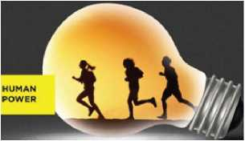
Many experts believe the simplest way of generating renewable energy is through our own bodies. Devices now use much less power than before. Harvesting just a microwatt of electricity would be enough to power many small electronic devices. To harness the energy we generate through our own movement, we would simply need to wear a system that collects and converts it.
Figure 72 Human power

Status
UK researchers have developed a knee brace that collects electrons while you walk. As the wearer's knee bends, four metal vanes in the device vibrate like a guitar string and produce electricity.

Idea III
Wave energy is technically a form of stored wind energy, since waves are
produced from winds which blow over the sea. It could be captured on the surface, below the surface, near-shore, offshore, or far offshore. Wave energy is measured in kilowatts (KW) per metre of coastline; the US coastline has a wave energy potential of about 252 billion kWh per year.

Status
Figure 73 Tidal power
Five countries are already operating viable wave power farms, with Portugal establishing the world's first commercial-scale wave farm in 2008. It has a total 2.25 MW installed capacity.

Idea IV
A colorless and odorless gas, hydrogen, accounts for 76% of the mass of the universe. On earth, it is found only in combination with oxygen, carbon and nitrogen. To use hydrogen, it must be separated from the other elements. Once it has, the gas yields high energy while producing almost no pollution.

Status
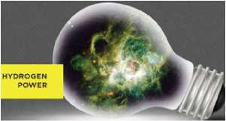
Fuel cell devices that convert hydrogen to electricity are already being used to provide power for vehicles, aircraft, homes and buildings. Large automakers like Toyota, Honda and Hyundai have invested heavily in the technology.
Figure 74 Hydrogen power

Idea V
On a flying wind farm, wind turbines float as high as skyscrapers (1,000 to 2,000 feet above ground) to capture steadier winds that blow five to eight times stronger than winds at tower level. These turbines produce double the energy of similar sized tower-mounted turbines.

Status
Figure 75 wind power
Altaeros Energies has developed the first commercial airborne wind turbine called Buoyant Air Turbine, a circular, 35-foot-long inflatable shell, made of heavy-duty fabric. It
has a capacity of 30 kilowatts. It is completely autonomous; it self-adjusts to optimal wind speeds and sell-docks in emergency cases.

Idea VI
Fusion is the same process that powers the Sun, and has potential to provide a nearly inexhaustible supply of energy. It emits no pollutants or greenhouse gases and has no threat of nuclear meltdown unlike current nuclear fission reactors. Fusion works by fusing two hydrogen isotopes, deuterium and tritium, which are bountiful.
Figure 76 Fusion power

Status
The ITER (International Thermonuclear Experimental Reactor), being built in France and funded by seven countries, is set for completion by 2027. It hopes to be the first commercially demonstrated fusion power station.

Column B
-Jeff Disjadins
- Match the words in column A with the meanings in column B.
a. | fleet | i. a flat plane that is moved by wind
b. | inflatable | ii. a very tall building
c. | harness | iii. a group of something
d. | vane | iv. capable of being filled with air
e. | skyscraper | v. the act or process of splitting the nucleus of an atom
f. | fission | vi. in large quantities
g. | bountiful | vii. to control and use the force or strength of sometimes
Column A

- Find the antonyms of the following words from the text.
endless modern covered fragrant bound inadequate
- Match the idea numbers in column A to the correct idea in column B.
Column A Column B

a. | Idea I | I | wave energy
b. | Idea II | ii. | hydrogen energy
c. | Idea III | iii. | energy through the fusion process
d. | Idea IV | iv. | solar energy
e. | Idea V | v. | energy through body movement
f. | Idea VI | vi. | altaeros energy

- Answer the following questions.
- How did JAXA prove the viability for the idea of space-based solar energy?
- What do we need to generate energy through our body movement?
- In what way are Idea III and V similar?
- How can hydrogen be used as the source of energy?
- Why do floating turbines seem more effective than tower-mounted turbines?
- Why is the fusion process environmentally friendly?
- What does ITER stand for?
- Can you think of any other alternative energy sources? Talk about your ideas with your friends.

Listening
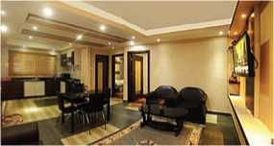
- Look at the picture and answer these questions.
- What type of dwelling do you live in?
- Why is an apartment different from a house?
- Listen to the audio and identify whether the following statements are true or false.
- The son is eager to move into the new apartment.
- The father likes the floor space of the apartment.
- The apartment is closer to the boy's school.
- There will be no disturbance from the neighbours in the new place.
- The manager of the apartment is not there right now.
- The father finally decides to move into the new apartment.
- Listen to the audio again and answer the following questions.
- What does the son like about the apartment?
- What has the father not decided yet?
- What two things does the father or son not like about the room?
- Which four rooms have they looked at so far?
- Which room have they not seen yet?
- If you had a choice, would you prefer a house to an apartment? Why? Talk to your friends.

Grammar II
- Fill in the gaps with suitable relative pronouns.
a. Is that the spot ………………… you had the accident?
b. The photograph ………………… you saw was taken a long time ago.
c. Are those the students ………………… you were talking about?
d. Last week, I went to visit the town ………………… my friend lives.
e. This is the house ………………… my uncle and aunt live.
f. These are the girls ………………… work hard.
g. Krishna was the boy ………………… everyone appreciated.
h. This is the judge ………………… is known for her wise decisions.
I. This is the site ………….. I intend to build a house.
j. The tiger ………… terrified the villagers was sent to the zoo yesterday.
k. The tree …………… he cut down was not a large one.
l. Mt Everest …………… is the highest peak in the world, lies in solukhumbhu district.
- Rewrite the following pairs of sentences using who, whom, whose, which/that, or where.
- Are these the keys? You were looking for the keys.
- Unfortunately, we couldn't attend the wedding. We were invited to the wedding.
- What is the name of the hotel? Your brother works in the hotel.
- The party wasn't enjoyable. We attended the party last Saturday.
- What is the name of the boy? The boy's father is a dentist.
- Who was the man? You talked to the man in the restaurant.
- What is the name of the shop? They sell medicine in the shop.
- Is this the man? The man donated all his property to a hospital.

Writing II
Write a news article about Green Energy. Use the following prompts.
natural source of energy
achieved from the Sun, wind, water, etc.
perpetual in nature
present status
benefits to human/nature
challenges

Project work
Organize a debate competition in class entitled 'Artificial intelligence is a threat to humans.'. You can invite students to listen from other grades as well. Invite your teachers to judge the competition.

Extra bit
Components of a News Story
Nepal Beat Chinese Taipei Headline
Figure 77 arrow left side

By RSS Byline
Figure 78 arrow left side
Figure 79 arrow down
Lead

Kathmandu, June 4: Nepal defeated Chinese Taipei 2-0 in the FIFA World Cup Asian Qualifying Match held last night at Al Kuwait Sports Club Stadium, Kuwait City.
Nepal made their outstanding performance in the joint qualifiers of the 2022 FIFA World Cup Qatar and 2023 AFC Asian Cup to be held in China.
For Nepal, Anjan Bista scored the first goal in the fourth minute of the game through a penalty shootout.
Similarly, Nawa Yug Shrestha scored the second goal in the 81st minute of the game.
With this win, Nepal managed six points and is ranked fourth in Group ‘B’.
Now, Nepal are scheduled to play with Jordan on June 7 and with Australia on June 11, according to All Nepal Football Association (ANFA).

Unit 9 work and leisure

Getting started
Read the following quotations and discuss what you think they mean.

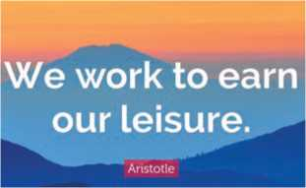
Figure 80 work hard in silence, let your success to your noise
Figure 81 we work to earn leisure
Figure 82 All things are difficult before they are easy
Figure 83 Any time is a good time to start a company

Reading I
Look at the following picture and answer these questions.
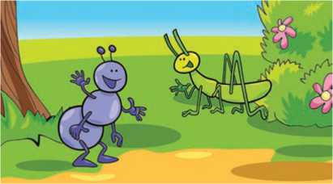
- What do you think the two insects are doing?
- What do you think happens to them when winter comes?

The Ant and the Grasshopper
Figure 84 Ant and grasshopper
When I was a very small boy I was made to learn by heart certain of the fables of La Fontaine, and the moral of each was carefully explained to me. Among those I learnt was ‘The
Ant and the Grasshopper', which is devised to bring home to the young the useful lesson that in an imperfect world, industry is rewarded and giddiness punished. In this admirable fable, the ant spends a laborious summer gathering its winter store; while the grasshopper sits on a blade of grass singing to the sun. Winter comes and the ant is comfortably provided for, but the grasshopper has an empty larder: he goes to the ant and begs for a little food. Then the ant gives him her classic answer: "What were you doing in summer time?"
"Saving your presence, I sang, I sang all day, all night."
"You sang. Why, then go and dance."
I could not help thinking of this fable when the other day I saw George Ramsay lunching by himself in a restaurant. I never saw anyone wear an expression of such deep gloom. He was staring into space. He looked as though the burden of the whole world sat on his shoulders. I was sorry for him: I suspected at once that his unfortunate brother had been causing trouble again. I went up to him and held out my hand.
‘How are you?' I asked.
‘I’m not in hilarious spirits,' he answered.
‘Is it Tom again?’ He sighed.
‘Yes, it’s Tom again.’
‘Why don’t you chuck him? You’ve done everything in the world for him. You must know by now that he’s quite hopeless.’ I suppose every family has a black sheep. Tom had been a sore trial to him for twenty years. He had begun life decently enough: he went into business, married, and had two children. The Ramsays were perfectly respectable people and there was every reason to suppose that Tom Ramsay would have a useful and honorable career. But one day, without warning, he announced that he didn’t like work and that he wasn’t suited for marriage. He wanted to enjoy himself. He would listen to no expostulations. He left his wife and his office. He had a little money and he spent two happy years in the various capitals of Europe. Rumors of his doings reached his relations from time to time and they were profoundly shocked. He certainly had a very good time. They shook their heads and asked what would happen when his money was spent. They soon found out: he borrowed. He was charming and unscrupulous. I have never met anyone to whom it was more difficult to refuse a loan. He made a steady income from his friends and he made friends easily. But he always said that the money you spent on necessities was boring; the money that was amusing to spend was the money you spent on luxuries. For this he depended on his brother George. He did not waste his charm on him. George was a serious man and insensible to such enticements. George was respectable. Once or twice he fell to Tom's promises of amendment and gave him considerable sums in order that he might make a fresh start. On these Tom bought a
motor-car and some very nice jewellery. But when circumstances forced George to realize that his brother would never settle down and he washed his hands of him, Tom, without a qualm, began to blackmail him. It was not very nice for a respectable lawyer to find his brother shaking cocktails behind the bar of his favorite restaurant or to see him waiting on the box-seat of a taxi outside his club. Tom said that to serve in a bar or to drive a taxi was a perfectly decent occupation, but if George could oblige him with a couple of hundred pounds he didn't mind for the honor of the family giving it up. George paid. Once, Tom nearly went to prison. George was terribly upset. He went into the whole discreditable affair. Really Tom had gone too far. He had been wild, thoughtless, and selfish, but he had never before done anything dishonest, by which George meant illegal; and if he were prosecuted he would assuredly be convicted. But you cannot allow your only brother to go to gaol. The man Tom had cheated, a man called Cronshaw, was vindictive. He was determined to take the matter into court; he said Tom was a scoundrel and should be punished. It cost George an infinite deal of trouble and five hundred pounds to settle the affair. I have never seen him in such a rage as when he heard that Tom and Cronshaw had gone off together to Monte Carlo the moment they cashed the check. They spent a happy month there.
(Source: Sixty Five Short Stories by W Somerset Maugham)
- Choose appropriate words from the box below to replace the colored words in the given sentences.
industry hilarious qualm enticements
obliged amendments expostulations
- If your talent combines with diligence, you can excel in your field.
- The dessert menu has a lot of delicious temptations.
- The house passed the bill without listening to the public objections.
- Knowledge of the ill effects of tobacco has led to modifications in smoking behavior.
- Without any regret, Yule started spending his father's inheritance.
- Mr. Smith read a humorous story which matched his real life.
- Put the following sentences from the story in the correct order.
- Tom began to blackmail his brother for money.
- Tom left his wife and his office.
- When his money was spent, he borrowed it from friends and spent it on luxuries.
- George continued to pay for his brother's expenses.
- Tom bought a motor-car and some very nice jewellery.
- Tom took the help of Cronshaw to cheat his brother, and left for Monte Carlo.
- Tom promised to make a fresh start.
- The Ramsays were perfectly respectable people.
- Tom never settled down.
- Answer the following questions.
- Why is Tom described as the ‘black sheep' of the Ramsay family?
- What was a respectable profession for Tom?
- Why was George Ramsay staring into space?
- Why did Tom leave his work and wife?
- How did Tom manage his life when he ran out of money in the beginning?
- How did Cronshaw and Tom cheat George?
- What made George realize that his brother would never settle down?
- What is the moral of the story ‘The Ant and Grasshopper?
- Read the story again and write a brief summary.
- How do you characterize yourself, as the ant or the grasshopper? Rank yourself on the scale.
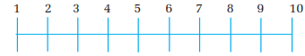
Figure 85 rank 1 to 10
Industrious Ant
Lazy Grashopper

Pronunciation
The letter 'l' in the word ‘qualm’ is a silent letter. Underline the silent letter in the following words and pronounce them.
doubt | pneumonia | receipt | chalk | feign
bouquet | light | resign | gnaw | heir
buffet | pseudo | knave | knight | solemn
island | wriggle | built | archeology | neighbor

Speaking
- Act out the following conversations in pairs.
Conversation I
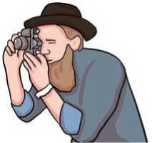
Maya : Where do you usually have your photograph taken
Figure 86 capture image
Indu : I usually have it taken at quality Photo Studio at New Road.
Conversation II
Rojina : Did you get your car washed yesterday?
Sandesh : Of course I did. I got it washed at Raghu's
- Have similar conversations using the given clues. Use have and get.
- hair cut/at New Look Salon
- shoes mended/at Modern Shoe Centre
- bicycle repaired/at A to Z Repair Centre
- dresses sewn/at Laxmi Tailor
- eyes checked/at Bhadgaon Optical Centre
- teeth scaled/at KMC Dental House
- Say what you can have/get done at the following places.
Example: We have mutton sliced at the butcher's.
veterinary's mechanic's dry cleaner's
translator's fortune teller's beautician's

Grammar I
- Make as many sentences as you can from the table given below.
Phoolmaya Santosh Biraj I They | had will have make gets make has was/were made | my shoes me /him/ her to dance Suman his brother | at the party.  repaired last Sunday.  write a letter tomorrow.  to play with him all the time. wash my clothes.  to smoke against my will.  dig the field.  to type the document.  send her the mail.

- Fill in the gaps with the correct form of have, get or make.
- Did they you give a speech on behalf of the group?
- Instead of buying a new car, why don't you the old one fixed?
- I my hair cut tomorrow morning.
- The teacher every one of us to write an essay yesterday.
- Ms Shrestha usually her hair dried at the hairdresser's.
- My mum always me clean my room on Saturdays.
- I my landlord to fix the broken windowpane this morning.
- Suman all the Math problems solved by the teacher.

- Rewrite the sentences with have, get or make.
Example: I painted my house last week.
I had my house painted last week.
- She will ask her sister to light the lamp.
- I am going to ask the dentist to fill my teeth.
- Will you ask the barber to cut your hair?
- I can't design my house myself. So I am going to ask an architect to do it.
- The girl asked her mechanic to repair her moped.
- The landlady asks the gardener to cut the grass.
- Choose the best alternatives and complete the sentences.
- Mina got Shambhu (carry/to carry/carried) hersuitcase.
- Rita had Ankit (wash/to wash/washed) her
clothes.
- They got me (dance/to dance/danced) at my brother's
wedding.
- Kumari was made (turn on/to turn on/turned on) the
television.
- Barsha got new books (buy/to buy//bought) her last
week.
- Upendra got Mukesh (watch/to watch/watched) his
house.
- My father is very kind. He never makes us (do/to do/
done) heavy work.
- The film was very humorous. It made us all
(laugh/to laugh/laughed) throughout the film.
- His hair was too long. So he had it (cut/to cut/
cutting) yesterday.
- My father is very kind. He never makes us (do/to do/
done) heavy work.
- Mathew made the mechanic ………………… (overhaul/to overhaul/overhauling) his car.

- Smith had Jacque ……………… (fetch/to fetch/fetched) a pail of water.

- My math teacher asked us to remember all the theorems. In other words, we were made ……… (remember/remembered/to remember) all the theorems.

Writing I
A.

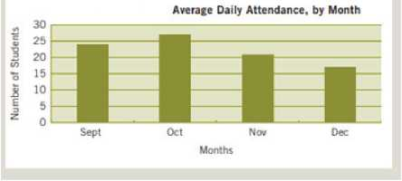
Study the chart below and answer the following questions.
- What kind of chart is this?
b. What data does it represent?
Figure 87 bar graph attendance of month
B. The following verbs are used to describe different trends or patterns of data. Put them under the appropriate headings
drop | steady | plummet | climb | maintain | decline
go down | go up | decrease | grow | increase | jump
rise | rocket | fall | plunges | remain | constant

Upward Trend | Downward Trend | Stable Trend

C. Interpret the bar chart above using appropriate verbs. Make comparisons where applicable. You may use the expressions given below.

The chart shows/ illustrates/ represents ...
According to the chart ...
While/ on the other hand ...
Likewise ...
Overall

Reading II
Look at the picture below and answer the following questions.
- What do you see in the picture?
- How is human life different from the lives of animals?

Leisure
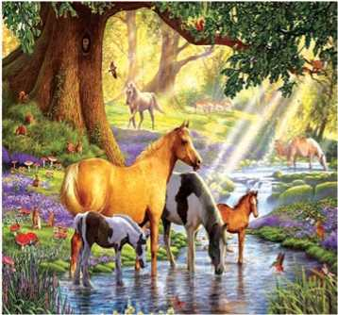
WHAT is this life if, full of care,
Figure 88 four horses
We have no time to stand and stare?
No time to stand beneath the boughs, And stare as long as sheep and cows:
No time to see, when woods we pass, Where squirrels hide their nuts in grass:
No time to see, in broad daylight, Streams full of stars, like skies at night:
No time to turn at Beauty's glance,
And watch her feet, how they can dance:
No time to wait till her mouth can,
Enrich that smile her eyes began?
A poor life this if, full of care,
We have no time to stand and stare.
-W.H. Davies
A. Match the words with their meanings.

a. stare | i | an area of trees
b. beneath | ii. | to improve the quality of something
c. woods | iii. | to look quickly at somebody or something
d. enrich | iv. | to look at somebody or something for a long time
e. glance | v. | under somebody or something

- Answer the following questions.
- Why is our life so miserable, according to the poet?
- What do sheep and cows do in nature?
- What do squirrels do in the woods?
- What magic does Beauty perform?
- What is human life like, if observed carefully?

- How do you spend your leisure time? Write a short paragraph.

Listening
- Look at the picture and guess the answers. Think about the title of the unit.
Figure 89 A man call phone
- Who is the man on the telephone talking to?
- What is he talking about?
- Listen to the audio and fill in the blanks with correct words/phrases.
- The name of the lady is
- Her car needs a
- The lady wants her car back by
- If there is a with the car, the service will take a longer time.
- The garage she visited last time her a lot of money.
- Fixing the brake pads won't to the customer.
- The mechanic has a So he can return the car as soon as
possible.
- Listen to the audio again and answer the following questions.
- What does the lady want to get done?
- When did she have her car last checked?
- When does the mechanic have a free slot?
- How long does a full service normally take?
- What makes the lady think that the car has a serious problem?
- What is the problem with the rear brake light?
- Imagine you are at a mobile phone service centre to get your mobile repaired. What might you ask the receptionist or engineer?

Grammar II
- Study the example sentences in the table below.

Verb tenses | Active voice | Passive voice
Present Simple | He delivers the letters. | The letters are delivered.
Past Simple | He delivered the letters. | The letters were delivered.
Future Simple | He will deliver the letters. | The letters will be delivered.
Present Continuous | He is delivering the letters. | The letters are being delivered.
Past Continuous | He was delivering the letters. | The letters were being delivered.
Going to | He is going to deliver the letters. | The letters are going to be delivered.
Present Perfect | He has delivered the letters. | The letters have been delivered.
Past Perfect | He had delivered the letters. | The letters had been delivered.
Infinitive | He has to deliver the letters. | The letters have to be delivered.
Modals | He must deliver the letters. | The letters must be delivered.

- Change the following sentences into passive voice.
- Someone is helping her with the housework.
- The mail-order company sent him a parcel.
- My friend sent me an invitation.
- The secretary has given the minister the letters.
- The traffic police officer had already fined him for a parking offence.
- John gave Elizabeth that beautiful ring.
- Her students have sent her flowers.
- He must give the message to the right person.
- We teach our students English and French.
- Someone bought flowers for the bride.
- The guide showed the tourists the sights of Pokhara.
- They pay her an excellent salary.
- Fill in the blanks with the correct passive form of the verbs in the brackets.
The Mayor inaugurated a sports centre in our town last week. The facility …………….(believe) to be one of the largest in the country and experts hope that it …………………….. (visit) by thousands of amateur and professional athletes over the course of the next few years.
The centre……………………. (construct) for over 6 years. However, it………….. (not completely finish) yet. Workers are making the final adjustments this week and say that it …………………….. (complete) by the end of the month.
The centre offers various sports facilities including two indoor swimming pools, three large gyms and a ball court. They …………………………. (can book) online or directly at the administration desk. The equipment ………………………… (buy) from local companies, which also provided the training programs.
The new centre …………………….. (finance) by government funds as well as grants that ………………. (give) to the region by the European Union. Politicians and famous athletes from all over the country …………..… (invite) to the official opening ceremony, scheduled for next Tuesday.

Writing II
Write an essay about ‘Work and Leisure’ in approximately 200 words. You can use the given prompts.
differences similarities benefits balance

Project work
Design and conduct a survey in your locality. Visit at least ten families. Collect the data of working people, jobless and the retired. Convert it into a pie chart and display it in the class.

Extra bit
Words ending in ‘-ism’
Optimism : a feelings that good things will happen and that somethings will be successful

Tourism : the business activity connected with providing accommodation, services and entertainment for people who are visiting a place for pleasure

Criticism: the act of expressing disapproval of somebody/something and opinions about their faults or bad qualities

nationalism: the desire by a group of people who share the same race, culture, language, etc. to form an independent country

alcoholism: the medical condition caused by drinking too much alcohol regularly

patriotism : love of your country and the desire to defend it

journalism : the work of collecting and writing news stories for newspapers, magazines, radio, television or online news sites

terrorism : the use of violent action in order to achieve political aims

Unit 10 The Earth and space

Getting started
Look at the picture below and answer the question.
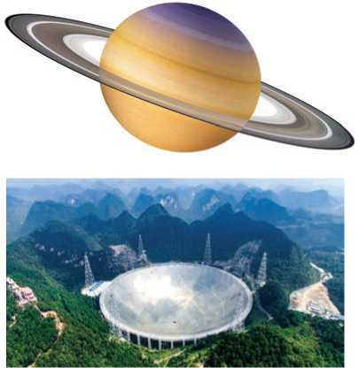
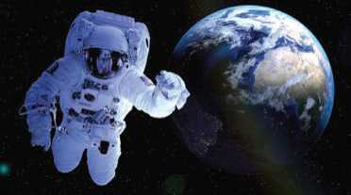
Figure 90 Saturn and Spherical Telescope
Figure 91 scientist in space

Figure 92 rocket

Reading I
- What do you see in the picture?
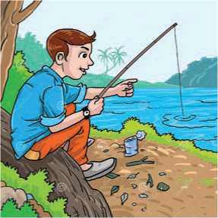
- Do you think life exists on planets other than the Earth?
Figure 93 fishing at river

A Message from Another Planet
Suren Majhi sat on the sandy bank of the Sun Koshi River. He had been fishing all day but had caught nothing. He was tired and the twilight was changing into darkness. Suddenly, in the distance over the river, Suren saw a bright object. It might be a helicopter, he thought, probably going to Diktel, but there was no noise. It came closer, and took on the shape of a saucer. It
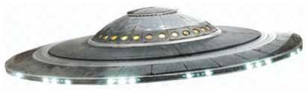
landed on the bank about 50 meters away. Suren got up and walked to the object. Once he had seen a film about a spaceship, probably this was one. It might have come from another planet. As he went closer, a door opened, and Suren was drawn into the vessel. He found himself in a room with what appeared to be a large number of control panels with flashing lights. He was frightened and almost jumped when he heard a voice saying, "Welcome to our spaceship, Suren. Don't be afraid. Sit down on the couch behind you. "How do you know my name?" Suren asked.
Figure 94 ufo transparent
"We are from another planet and we have been observing Earth for several months. Our devices have recorded radio and television broadcasts, and we have learned to speak English, since it is the most widely-used language. By using a long-distance listening device, we learnt your name and that you are the best student in your school. We have chosen you to pass on an important message to the leaders of your nation and of the world."
"Do you think that leaders will listen to a poor kid like me?" Please open the door. I want to leave." Suren said.
"You can't leave now, look at the screen. The ship is several thousand kilometers from Earth, although only a few minutes have passed. On our planet, all the resources are recycled whereas, on earth, you are wasting your resources. Soon there will be nothing left. Give your people the message that the recycle collection centers should be set up in every town and city on Earth. Cans, bottles, old household appliances, in fact, everything which is no longer in use, should be taken there and be recycled."
Suren said, “If I tell people that I've been in a spaceship, they will probably think I’m joking or, perhaps, out of my mind."
"Don't worry!" the voice said, "We'll give you an object that will prove that what you say is true. Pick it up. It's a tiny computer, far more advanced than any found on Earth. When it's examined by a computer engineer, we're sure your story will be believed."
The screen lit up, and Suren saw the world growing larger and larger. He saw the Himalayas and the River Sunkoshi. The screen grew dark, the door opened, and Suren stepped out onto the sand. As soon as he was out of the spaceship, it ascended at an enormous speed and disappeared.
At home, before going to bed, Suren wondered whether he had been dreaming, but when he put his hand in his pocket, he could feel the tiny computer.
(Source: adapted from Forte, Longman 1989)
- Find the words from the story that are either opposite or similar to the words below.
- dawn (opposite)
b. shining (similar)
d. modern (similar)
f. great (similar)
- took off (opposite)
- descended (opposite)
- Match the words with their meanings.
a. | saucer | i. a ship or large boat
b. | spaceship | ii. a long comfortable seat
c. | vessel | iii. short bursts of bright light
d. | flashing | iv. a vehicle that travels in space, carrying people
e. | couch | v. a machine that is designed to do a particular thing in the home
f. | broadcast | vi. a small shallow round dish that a cup stands on
g. | appliance | vii. to send out a programme on television or radio

- Put the following events in the correct order.
- They gave Suren a tiny computer.
- The spaceship landed back on the bank of the Sunkoshi River.
- A voice welcomed him, and asked him to sit on the couch.
- Suren wondered whether he had been dreaming.
- Suren had been fishing when he saw a bright object over the Sunkoshi River.
- They wanted to send a message to the leader of Nepal and the world.
- When Suren went closer to the vessel, he was pulled into it.
- Answer the following questions.
- What did Suren think about the bright object at first?
- Where had Suren seen a spaceship before?
- How did Suren feel when he was drawn inside the vessel?
- How had they known about Suren?
- How do they manage resources on their planet?
- Why did Suren express his inability to deliver a message at first?
- What message did they want to pass on?
- Why did they give Suren a tiny computer?
- Do you think people will believe Suren's story? Give your reasons.
- If you met someone from another planet, what advice would you ask for about the Earth or Nepal?

Pronunciation
Listen to your teacher. What sounds do the final 'ed' in these words make? Put the words in the correct box.
landed opened walked passed frightened
asked ascended finished jumped recorded
/t/ | /d/ | /Id/

Speaking
Work in pairs. Study the map below and take turns to ask and answer where different places are located. Use the given prepositions. One has been given as an example.
next to opposite between behind in front of above below
Example: You are in Old Road.
A: Where is the school?
B: It's opposite the bus park

cinema hall
stadium
New Road
New Road
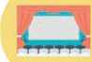
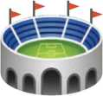
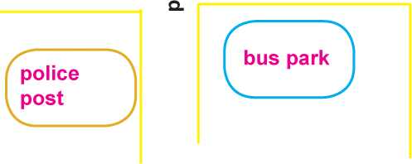
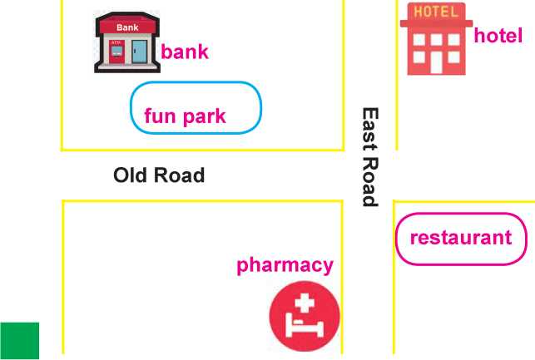
Figure 95 house
Figure 96 post office hospital school west road
Figure 97 police post bus park
Figure 98 bank restaurant hotel pharmacy

- You are in New Road.

i. supermarket.
ii. cinema hall

- You are in Old Road.
i. fun park
ii. bank
- You are in East Road.
ii. pharmacy
- restaurant.

- You are in west Road.
- post office

- post office

Grammar I
- Fill in the blanks with prepositions in, at or on.
- We will meet the corner of the street on Sunday at 5: 00 pm.
- hurba is studying English literature Ratna Rajya Campus.

- The horses are grazing the field.
- Rima and Nakul got married Bhadrakali temple 10 years
ago.
- What time did you arrive the hotel?
- Rachita lives England these days.
- The cat is somewhere the house.
- There is a picture of house Sheetal's T-shirt.
- The instruction is the top of the page.
- The dog is sleeping the carpet.
B. Choose one of the words/phrases from the box and complete the sentences below using in, at or on.
the air | a farm | school | prison | the airport
Shanti Chalchitra Hall |  | bed | hospital | the station

Example: My train arrives at 4:30. Can you meet me at the station?
- I love Saturdays the most. I can stay until eight.
- My favourite movie Pashupati Prasad is playing
- Many people are for the crime they committed.
- I like the village, especially the fresh air. I think I should work my village.
- Did you make many friends when you were ?
- Aryashila had an accident last month. She is still
- It was not a long flight. We were for only 25 minutes.
- When our flight was delayed, we had to wait for about
two hours.

Writing I
Imagine you have recently met someone from another planet and spent about an hour with him or her. Write an account describing your feelings and reactions.

Reading II
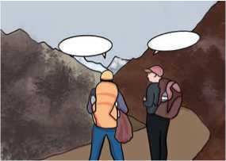
Look at the picture and guess the answers to the questions.
Figure 99 two friends travelling
- Who are the people in the picture?
- Where are they travelling to?
- What is the lady asking the man?

Up-Hill
Does the road wind up-hill all the way?
Yes, to the very end.
Will the day's journey take the whole long day?
From morn to night, my friend.
But is there for the night a resting-place?
A roof for when the slow dark hours begin.
May not the darkness hide it from my face?
You cannot miss that inn.
Shall I meet other wayfarers at night?
Those who have gone before.
Then must I knock, or call when just in sight?
They will not keep you standing at that door.
Shall I find comfort, travel-sore and weak?
Of labor you shall find the sum.
Will there be beds for me and all who seek?
Yea, beds for all who come.
-Christina Rossetti
A. Match the words in column A with their meanings in column B.
Column A |  |  |  |  | Column B
a. | wind |  | i |  | person who usually travels on foot
b. | morn |  | ii. |  | a small hotel, usually in the country
c. | inn |  | iii. |  | to have many bends and twists
d. | wayfarer |  | iv. |  | look for
e. | seek |  | v. |  | morning

- Complete the summary of the poem using suitable words or phrases given below.
the road ahead up-hill someone a place a journey
in the affirmative on the way everyone fellow travelers an inn The speaker is making with her guide. She asks the
guide eight different questions about The first question
is if the road is all and if the journey will take all day.
The guide replies Next, she asks if there is
to rest for the night. The guide informs the speaker that there is which she won't miss. The speaker’s fifth question is, whether she will meet the other travelers ……….. At the inn, the speaker asks if she should knock or call the ..…. The guide replies that will open the door. Lastly, the speaker
asks if there will be a bed for her. The guide tells her that there are beds for……….
- Answer the following questions.
- How far is the road up-hill, according to the guide?
- What does the speaker doubt about the place to rest?
- Who has travelled the road before?
- What is the speaker’s seventh question?
- Who do you think opens the door?
- Write a short description of an interesting road that you have recently travelled along.

Listening
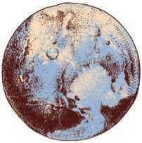
- Look at the picture and answers these questions.
Figure 100 Earth
- How many planets are there in the solar system?
- Do you think that Pluto is a planet?

- Listen to the audio and complete the sentences with the correct words or phrases.
- Pluto was kicked out from the group of in 2006.
- Pluto is made of and ice.
- Pluto takes about 250 years to complete its full orbit
around the Sun.
- Eris was in 2005.
- The scientists created a new category as planet.
- Listen to the audio again and put a tick mark (V) under True or False.
S.N. | Statements | True | False
a. | Pluto is smaller than the Moon.
b. | The NASA New Horizon Spacecraft took almost 12 years to get very close to Pluto.
c. | Eris is about the same size as Pluto.
d. | The scientists disqualified Eris as a planet.
e. | Pluto is a member of the dwarf planet club.

- Why is Pluto not a planet? Give your reasons.

Grammar II
- Complete the sentences with the correct prepositions from the brackets.
- Due a traffic jam, we are late today. (with/to/at)
- I’m sorry. You are not eligible admission to this course.
(with/for/of)
- Look! She is playing her young son. (with/to/in)
- The District Administration Office is entrusted maintain law and order in the city. (to/with/of)

- He is envious …………. his rich neighbor. (with/of/off)
- He became estranged …............. his family after the argument. (with/from/of)
- You had no excuse …… misbehaving with the clerk. (of/for/to)
- I’m quite familiar ...............…. her. (at/with/to)
- She was brought ………. by her grandmother. (out/in/up)
- Gopal left home because he did not want to abide .................... his father’s wishes. (to/with/by)

- Choose and circle the correct prepositions (in brackets) in the paragraphs below.
Mr Pandey arrived in Kathmandu (on/in) May 10 (at/on) eight o’clock (in/on) the evening. He decided to call on his uncle who lived (on, in) Bhaktapur. He got on a bus (at/of) the station and paid the fare (to/for) the conductor. The bus was very crowded, so Mr Pandey had to stand up all the way.
When he reached Thimi, Mr Pandy got off the bus and walked a short distance (in/to) the house where his uncle lived. He knocked (at/ in) the door (of/on) his uncle’s house. He waited (for/during) a few minutes, but no one came (to/at) the door. He was disappointed to find no one (to/at) home. He saw a bench (at/to) the corner of the porch, and he sat down (on/in) it to wait for his uncle.

Writing II
Write a set of rules and regulations for the visitors in a park. Use the expressions given below.
...is/are ....(not) allowed to strictly prohibited/forbidden to ...
... can/cannot ... is/are required/expected to must/must not ...

Project work
What is space tourism? Search and collect information about tourism. Make a short presentation in a small group.

Extra bit
Account Writing
Account writing is a technique of reporting or describing an event or experience. This is a written document that provides a description of the events in proper order, which allows the reader to reach a conclusion.
Format of Account Writing
Heading (optional but highly recommended).
It addresses the audience and purpose. For instance, a heading can be something like this: “To the Head Teacher, an account of the recent trip to Pokhara”.
Introduction
The purpose of account writing is mentioned here. You can add some background information depending on the situation. The purpose of an introduction is to briefly explain the topic that you are about to write about.
Body
The event is elaborated here. If there is more than one subject, you have to address each in separate paragraphs.
You have to make sure that you provide relevant details that are helpful to the reader. This means that the reader should be given complete details so that they can reach a proper conclusion.
Conclusion
This is a very crucial part of your writing because you have to mention the purpose of your writing again.
Sign-off
Written by,
Your full name (or signature)
Date

Unit 11 Gadgets and Instruments

Getting started

The following pictures show the process of making black tea. Describe the step each picture shows.

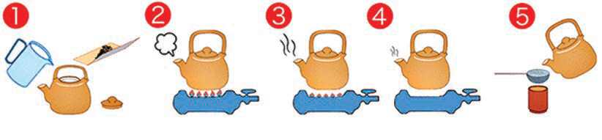

Figure 101 steps for making tea

Reading I
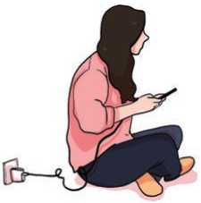
Look at the picture and answer the questions.
- What do you think the girl is doing?
- What is the risk of using a phone this way?
- What precautions should you take while using a phone?
Figure 102 A girls use phone during charging

Save your Smartphone
Smart phones have become an important aspect of everyday life, not only in terms of staying connected with family and friends but also in getting work done, staying up to date with important schedules and even buying groceries or clothes online. It's become almost impossible to do anything without one in today's tech-driven world, so much so that many of us have a phone in our hands for the most part of the day. Your phone therefore needs proper care to prolong its lifespan and also to safeguard important information that's stored there. Since smart phones are so essential and central to our life, it's time for us to get smart in caring them.
Here are some tips which you can follow to keep your phones safe.

A closer look at your charging habits
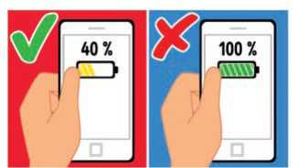
Most of us live in fear of a fading phone battery when we are out and about, we don't worry too much about that battery's eventual lifespan. Do you know that you shouldn't charge your battery to 100 percent? You shouldn't let it get down to minimum charge or zero percent either. That can cause internal damage to your phone. The rule with some batteries is to keep them 50 percent or more most of the time. When it drops below 50 percent, top it up a little if you can. You can charge your phone this way a few times in a day. You should also make it a point to use the charger that came with your phone. There have been incidents of cheap chargers actually catching fire.
Figure 103 battery 40 percent correct and battery 100 percent incorrect

Maintain a cool temperature
Heat is harmful to phone batteries. Your phone is safest at room temperature. Avoid placing it next to other devices such as laptops as they generate heat. If you are keeping all your gadgets right next to one another, try to separate them.

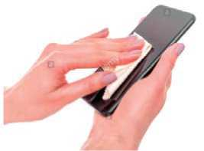
Invest in-phone wipes or cleaning solution
Figure 104 clean phone
Your phone is a breeding ground for germs and bacteria. Think of all the things you touch before touching your phone: go to the restroom, hold money, eat, and other activities that lead you to gunk up your device. Studies have actually found that your phone screen houses more bacteria than a toilet seat. This is why you should clean your phone regularly. All you have to do is simply disinfect your phone with an antimicrobial spray and wipe it with a soft cloth.

Protect your phone and data
Figure 105 lock phone
Set a screen lock on to keep your information safe and render the phone useless in the event it gets lost or stolen. Not using a lock screen is the android equivalent of going out and leaving your front door open for burglars.

Control app permissions and notifications
Your smart phone wouldn't be all that useful without all the apps you have downloaded. The more apps you download, the more notifications you will receive. But you can have more control over which apps and events can send you prompts and how these messages appear on the home or lock screen of your phone. Simply go to your phone's settings and set the notifications accordingly.
A. Match the words in column A with their meanings in column B.
Column A | Column B
a. prolong | i. being less bright
b. essential | ii. to produce
c. fading | iii. any sticky or dirty substance
d. generate | iv. to cause something to be in a particular condition
e. gunk | v. to make something last longer
f. render | vi. notices
g. notifications | vii. extremely important

- Write True for true statements and False for false ones.

- It's a good idea to keep our phones fully charged.
- We should keep our phones together with other gadgets.
- A phone is likely to hold more bacteria than a toilet seat.
- Setting a screen lock on the phone helps us keep the information safe.
- Smart phones are very useful even without apps.
- Answer the following questions.
- Write any three uses of smart phones in everyday life.
- Why should we care for our phones?
- Why should we not use cheap chargers to charge our phones?
- How can we prevent our phones from getting over heated?
- How can the phone be cleaned?
- What gadgets do you have at your home? How do you take care of them?

Pronunciation
Consult a dictionary to find out pronunciations of these words.
impossible battery zero either temperature
germ cloth burglar control appear

Speaking
- Read and act out the following conversation between two students.
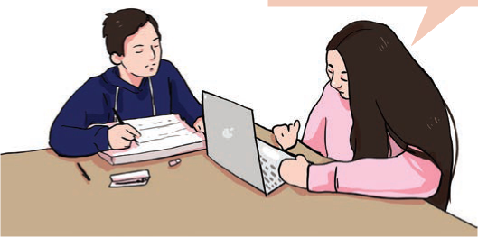
Excuse me, how can I take a screen shot on a laptop?
Figure 106 share knowledge about computer tips
First press the window key and print screen key at the same time to capture the entire screen.

- Work in pairs, take turns to ask questions and give instructions in the following situations.
  - take a photo b. recharge a phone c. send an email
- print a word document e. replace a light bulb f. send a text
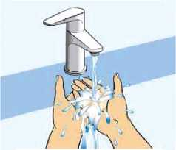
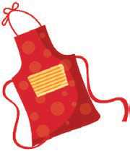
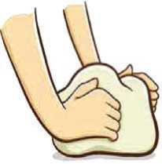
- The pictures below show the steps to making pizza. Look at them and explain to your friends the steps of making pizza. Use 'First', 'Second', 'Then', etc. You can use the clues given in the box below.
Figure 107 washing hand
Figure 108 Kneading Dough

Figure 109 Transparent apron

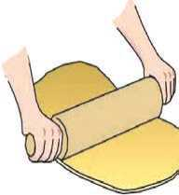
Figure 110 rolling bread
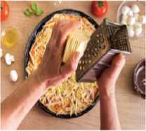
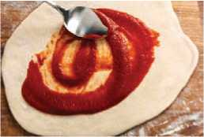
Figure 111 Grated cheese
Figure 112 tomato sauce on bread

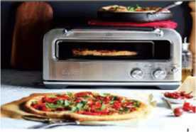
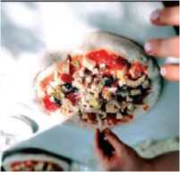
Figure 113 Bake in the oven
Figure 114 put topping on

Figure 115 serve

Figure 116 put topping on

Cut into slices. | Put an apron on. | Serve. Grate cheese.
Knead the dough. | Roll the dough. | Put toppings on.
Bake in the oven. | Wash hands. | Spread sauce.

Grammar I
A. Study the following table.
She said, "I love horror movies." | She said that she loved horror movies.
"I worked as a waiter before attending college," Harish said. | Harish said that he had worked as a waiter before attending college.
My friend said, "I'll phone you tomorrow." | My friend said that he would phone me the next day.
She said, "I'm planning to do it today." | She said that she was planning to do it that day.
He said to me, "Get me something to drink." | He told me to get him something to drink.
"Don't make a noise," said the teacher to the students. | The teacher told the students not to make a noise.
The doctor said to the patient, "Quit smoking." | The doctor advised the patient to quit smoking.
The policeman told me, "Don't park here." | The policeman forbade me to park there.  The policeman told me not to park there.

B. Change the following sentences into indirect speech. Use the given sentence starters.

- “He works in a bank.”
She said
- “We went out last night.”
She told me
- “I’m coming!”
She said
- “I was waiting for the bus when he arrived.”
She told me
- “I’d never been there before.”
She said
- “I didn't go to the party.”
She told me
- He said to me, "Help him to do his homework."
He asked me
- The doctor said to the patient, "Take bed rest for a week."
The doctor advised the patient
- The commander said to his soldiers, "March further."
The commander ordered

Writing I
Prepare a recipe to cook your favorite dish at home. Use the prompts
given below.
Name of the food item ingredients cooking procedure

Reading II
- Cloudy | - Partially cloudy | - snowy
- stormy | - rainy | - sunny
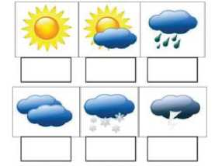
Match the words with the correct weather symbols

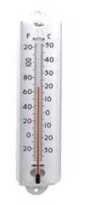

Weather Instruments
Until the 18th century, people completely depended on sensory observations for any weather data. They understood the wind direction through the movement of leaves or estimated the time of rain through the number of clouds in the sky.
Figure 117 analog thermometer
Now, the times have changed Today, we are blessed with modern technology which includes different weather instruments and weather stations that help us to accumulate accurate weather data. There are different types of instruments for measuring different parameters.

A THERMOMETER is a device that is used for measuring the temperature or the temperature gradient. This can be used in industry, in meteorology, and even in medicine. This device has two important things that help in measuring the temperature. The first one is a sensor that uses different physical parameters like the expansion of different states of matter for sensing the change. The second one is a converter that converts the change of temperature into a numerical number.
There are different types of thermometers. In weather stations, mainly mercury-filled thermometers are used. Mercury-filled thermometers can measure the temperature from -35 to 40 degree Celsius. It has a scale division of 0.2 degrees. But if the temperature is less than -35 degree Celsius, then this thermometer cannot give an accurate result and becomes unreliable. To measure the temperature under -35 degree Celsius, alcohol-filled thermometers are used. This type of thermometer can measure from -65/-75 degree Celsius to 20/25 degree Celsius.
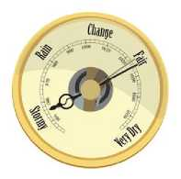
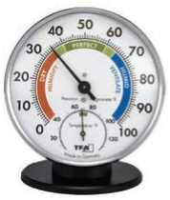
A BAROMETER is an instrument that measures the atmospheric pressure. It measures pressure in measurement units called bars or atmospheres. The earth is wrapped with layers of air which is called atmosphere. The air has weight, and it presses everything against gravity. A barometer measures this pressure. When a barometer shows low-pressure, it means that the weather is rainy, windy or cloudy and when the pressure is high, it means that the weather is fair.
Figure 118 barometer
There are different types of barometer such as the mercury barometer, aneroid barometer, and the digital barometer. Among these three, the digital barometer is the latest one that gives more accurate data.
Figure 119 Hygrometer
A HYGROMETER measures the humidity or the amount
of water vapour in the air. There are mainly two types of hygrometers. They are dry and wet bulb hygrometers and a mechanical hygrometer.
AN ANEMOMETER is used to measure the speed of the wind. The

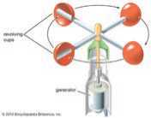
speed of wind gives plenty of information about the weather. For example, if the speed of the wind is high, it indicates a storm. With the help of the anemometer, we can determine the speed of the wind which helps us to protect ourselves from many natural disasters.
Figure 120 Anemometer
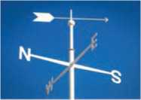
A WIND VANE is also called a weather vane or a weathercock. This is an instrument that is used for showing the direction of the wind. It has a similar feature like the traditional cockerel design with letters that indicate the points of the compass.
Figure 121 weathercock
The tool is placed on top of a weather station and gives accurate results about the direction of the wind which provides a lot of information about the changes that take place in the weather.
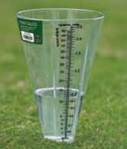
A RAIN GAUGE is an instrument used by meteorologists for measuring the amount of precipitation occurring over some time. It is one of the instruments that is used in most weather stations. The rain gauge must be placed at an open place without any obstacle. The amount of precipitation is measured either manually or by an automatic weather station. The instrument has some limitations. It is impossible for rain gauge to collect rain during a hurricane.
Figure 122 Rain Gauge
- Complete these sentences with the appropriate words from the text above.
- Most of the FM broadcast the news at 7:00.
- The function of a is to convert the change of temperature
into numerical numbers.
- The Earth is by the atmosphere.
- The amount of water in the air is called
- The wind vane is also known as a

- Choose the correct answer.
- How did people get the weather information until the 18th century?
- with weather instruments ii. through their physical senses
iii. through their intuitions
- Which one of the following barometers is the latest one?
- digital ii. mercury iii. aneroid
- What does a barometer measure?
i. atmospheric temperature ii. atmospheric humidity
- atmospheric pressure
- Which of the following devices is NOT used to get weather information?
I. thermometer ii. galvanometer iii. anemometer
- Which of the following devices is used to measure the speed of the wind?
I. wind wave ii. anemometer iii. hygrometer
- Answer the following questions.
- Where is an alcohol-filled thermometer mostly used?
- What is a barometer used for?
- What are the two kinds of hygrometer?
- Give two examples of how an anemometer gives information about the weather.
- Name the device that is used to measure the changes in weather conditions.
- What precaution should be taken while using a rain gauge?
- How do you usually find out what the weather will be like? Talk to your friends.

Listening
- Look at the pictures and answer these questions
- What do you think the profession of the man is?
- What does the second picture show?
Figure 123 cook man
Figure 124 cookies

B. Listen to the audio and tick ( n) the correct answer.

- Where did the chef learn to cook?
I. at a cooking school ii. at a family member's home
iii. in a friend's kitchen
- What is special about the chef's cookies?
- He makes them by following a healthy recipe.
- He prepares them by using cheap ingredients.
- He sells them at many local stores.
- Which ingredient does the chef NOT use to make his cookies baked?
I. baking powder ii. flour iii. sugar
- At what temperature should the cookies be baked?
I. at 305 degrees ii. at 315 degrees iii. at 350 degrees
- What is the topic of the next cooking programme?
I. Fun Cookies for Teenagers ii. Inexpensive Meals
iii. Tips for Cleaning your Kitchen

- Listen to the audio again and complete the sentences with the correct words from the box.
switch entire ingredients preheat pinch
a. Don't forget to the oven to 375 degrees.
- It looks like we don't have all of the to make dinner.
Let's go to the store and buy them.
- If the meat doesn't taste just right, try adding a of salt.
- Please put the mixture in a baking pan.
- Do you watch cooking shows on television? Share your reasons why you do or do not with your classmates.

Grammar II
- Change the following sentences into indirect speech.
- He said, "Don't use my camera."
- The doctor said, "Give up smoking."
- "Don't touch the wire." The electrician said to me.
- “Could you explain number four, please?” said the student.
- "Don't worry about it, Mrs. Shrestha." She said.
- "Finish this job in an hour." He said.
- Amrita said to me, “Please help me.”
- Complete the following sentences with the correct alternatives from the brackets.
- Anju said that she (had seen/has seen/was seen) the
accident the day before.
- She says that (she could not stay there anymore/I
can't stay there anymore/she can't stay there anymore)
- The teacher told us that (the Earth revolves round
the Sun/the Earth revolved round the Sun/the Earth revolve round the Sun)
- Pramesh said that (he had done his homework/I
have done my homework/he has done his homework)
- The policeman (requested/told/ordered) the thief
not to move.
- My father forbade me (to spend/do not spend/not
to spend) so much money.
- The head teacher forbade the students' parents (not
to smoke/to not smoke/to smoke) on the school premises.

Writing II
In the past 20 years, there have been significant developments in the field of science and technology. These developments have had both a positive and negative impact. Write a newspaper article expressing your views on the impact of science and technology.

Project work
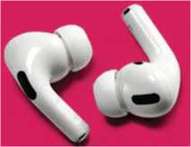
Wireless ear buds are useful devices for listening to music and other audios because we don't need wires.
Figure 125 wireless ear phone
Do you know how to connect them to Bluetooth- enabled devices such as smart phones, tablets, laptops, etc.? Search through the internet or consult someone who knows and write the steps “How to connect earbuds to Bluetooth-enabled devices?”

Extra bit
Transitive and Intransitive Verbs
A transitive verb is a verb that requires an object to receive the action.
Examples:
I admire your courage.
We need to maintain product quality.
I couldn't face him today.
She loves animals.
An intransitive verb is a verb that does not take an object.
Examples:
The baby was crying.
I work for a large firm in Paris.
They laughed uncontrollably.
We talked for hours.

Unit 12 People and Places

Getting started
Figure 126 Hill, lake with two men’s, mountain with temple
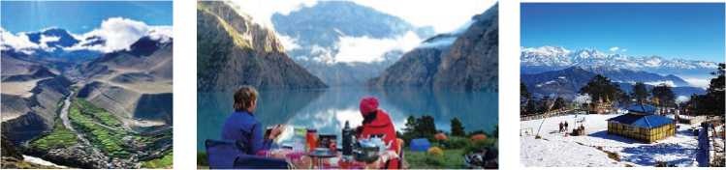
A. Where are these places? How would you get there? Discuss.

B. Identify the following people and say what they are famous for.

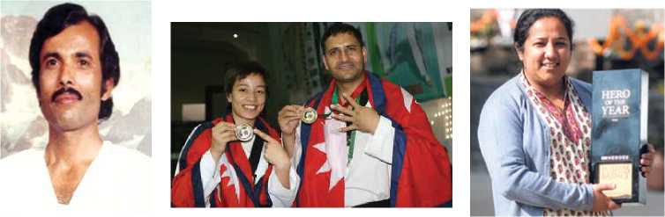
Figure 127 Bhakta raj acharya

Reading I
Answer the following questions.
- How much do you love reading? What is the name of the last book you read?
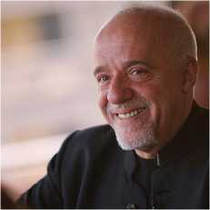
- Who is your favourite writer? Say something interesting about him or her.

Paulo Coelho
Paulo Coelho is a well-known Brazilian author and lyricist. He was born on 24 August 1947 in Rio de Janeiro, Brazil. He had always loved writing and dreamed of being a writer from an early age. He was, however, discouraged by his parents who wanted him to become a lawyer. During adolescence Coelho
Figure 128 Paulo Coelho
was sent three times to a mental hospital by his parents because of his dream to become a writer. In his twenties, he was arrested and tortured in Brazil, but always kept dreaming of becoming a writer. After his release from prison, Coelho enrolled in law school and abandoned his dream of becoming a writer. One year later, he dropped out and lived life as a hippie, travelling through South America, North Africa, Mexico, and Europe and started using drugs in the 1960.
He changed his life radically at the age of 36, after a pilgrimage to Santiago de Compostela in Spain, where he experienced a spiritual awakening and felt inspired to write the book, The pilgrimage (1987). Only one year later, he wrote The Alchemist in the course of a two-week spurt of creativity. The Alchemist was Paolo Coelho's break-through as an international author. The allegorical novel is about a shepherd boy who follows a mystical trek in which he learns to speak the "Language of the World" and thus receives his heart's desire. The book attracted little attention at first, until a Frenchlanguage translation suddenly leapt onto the bestseller lists in France in the early 1990. New translations followed, and soon The Alchemist became a worldwide phenomenon. The book has sold, by Coelho's count, roughly 35 million copies, and is now the most translated book in the world by any living author.
Since then he has published books at a rate of about one every two years. In 2013, approximately 150 million copies of his books were published in at least 71 languages. Several of his books are autobiographic in nature and deal with spirituality and faith, societal impacts on individuals and love. His 26 books have sold more than 65 million copies in at least 59 languages. Besides The Alchemist, his other notable works include Veronika Decides to Die (1998), which mines the perceived mental instability of his youth; The Devil and Miss Prym (2000), an investigation of the essential nature of humankind; and Eleven Minutes (2003), which explores the boundaries between love and sex through the story of a prostitute. The Witch of Portobello (2006) tells the story of a female religious leader in the form of interviews with those who knew her. The Winner Stands Alone (2008) is a thriller set against the Cannes Film Festival. Similarly, Aleph (2010) was ostensibly the true tale of Coelho's 2006 journey on the Trans-Siberian Railroad, but he embroidered the experience with a supposed encounter with a reincarnated lover from another lifetime. Manuscript Found in Accra (2012) concerns the experiences of a Greek wise man in Jerusalem prior to its invasion by Crusaders. Adultery (2014)
chronicles a successful journalist’s extramarital affair, and Hippie (2018) was inspired by Coehlo’s travels in the 1970s.
His other works include phrases (1996), a collection of short excerpts from his oeuvre, and Life: Selected Quotations (2007), a similar collection of excerpts translated into English. Coelho also compiled selections from his weekly column in the newspaper O Globo into a volume titled Maktub which means “It is Written”.
Coelho is now the world’s most widely read author with several international awards under his belt. He has received several prestigious awards including Crystal Award given by the World Economic Forum, France’s Legion d’honneur and many more.
His fans call his books inspiring and life-changing. His critics say that his books merely promote vague spirituality devoid of rigor. A confident writer who rejects the self-help label—"I am not a self-help writer; I am a self-problem writer"—Coelho dismisses his naysayers' critiques. "When I write a book I write a book for myself; the reaction is up to the reader," he says. "It's not my business whether people like or dislike it."
Coelho has been married to his wife, the artist Christina Oiticica, since 1980. Together the couple spend half the year in Rio de Janeiro and the other half in a country house in the Pyrenees Mountains of France. In 1996, Coelho founded the Paulo Coelho Institute, which provides support to children and the elderly.
A. Complete the table below. Use a dictionary to check the meanings. Then, choose the correct word to complete the sentences. Change the form if necessary.
Noun | Verb | Adjective
 | embroider
 | torture
 | attract
 |  | inspiring
investigation

a. She was an example to her followers.
b. It is claimed that the officers a man to death in

a city police station.
- Naturally, I the tale a little to make it more interesting.
d. The company conducted its own internal into
the robbery.
e. The exhibition is huge crowds.
- The following sentences depict some of the important events in Paulo Coelho's life. Put them in chronological order.
- He travelled to Santiago de Compostela which inspired him to write The Pilgrimage.
- He was enrolled in a law school.
- He got married to the artist, Christina Oiticica.
- He stayed in a mental hospital.
- Coelho established the Paulo Coelho Institute.
- He left school and lived the life of a hippie.
- Coelho wanted to become a writer.
- Coelho wrote the allegorical novel The Alchemist.
- Answer the following questions.
- Why did Coelho's parents discourage him from becoming a writer?
- What changed Coelho's life in a significant way?
- Why is The Alchemist special?
- What are most of his books about?
- Write two evidences that prove Coelho is an international author.
- What are the criticisms of his writing?
- Write the names of two books which focus on Coelho's travels.
- Which of Paulo Coelho's books would you most like to read? Give reasons for your choice.

Speaking
- Read and act out the given conversation about directions. Then have similar conversations in pairs, to get to some places on the map.
Stranger : Excuse me. How can I get to the post office?
Girl : Go straight on, and then turn left at the crossroads. It's about 100 metres on your left. You can't miss it!
Stranger : Thanks!
Girl : You're welcome.
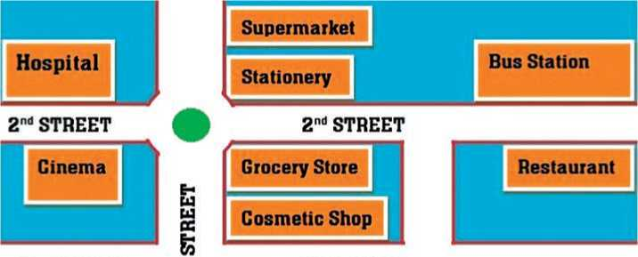
Figure 129 hospital supermarket, stationery, Bus station cinema , Grocery store ,cosmetic shop,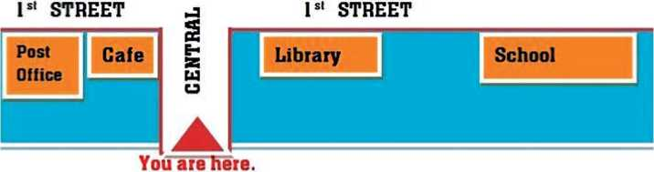Restaurant
Figure 130 post office, cafe, library, school
B. Work in pairs. Give directions in the following situations.

- Your new friend does not know how to get to the school library.
- A visitor wants to go to a nearby bank in your area.
- Your friend wants to come to your home but he doesn't know how to get there.
- A visitor wants to meet the head teacher in her office.
- Your sister wants to buy books but she does not know where the stationery shop is.

Grammar I
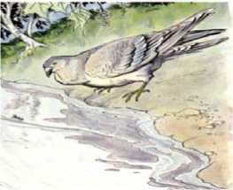
- Read the following story and mark the articles used in it.
Figure 131 dove
A dove saw an ant fall into a brook. The ant struggled in vain to reach the bank, and in pity, the dove dropped a blade of straw beside it. Clinging to the straw like a shipwrecked sailor to a broken spar, the ant floated safely to the shore.
Soon after, the ant saw a man getting ready to kill the dove with a stone. But just as he cast the stone, the ant stung him on the heel, so that the pain made him lose his aim, and the startled dove flew to safety in a distant wood.
Why are articles 'a' and 'an' used before 'dove' and 'ant' in the first sentence, and 'the' in the sentences that follow?
- Complete the following sentences with the article 'a', 'an' or 'the'.
- Sudip bought expensive guitar yesterday. guitar is
beautiful.
- Ms Sherpa is university student.
- ………..boy wearing a black cap is my brother.
- I have given him half hour to finish the task.
- Angelia has beautiful daughter named Sophia.
- Mr Gurung is S.P. of Nepal Police.
- Is diamond hardest substance in the world?
- Mrs Yadav is honorable teacher.
- Rice sells at RS. 60 kilo.
- I met European writer last Monday.

Writing I
Read the following review of The Alchemist, one of the most popular books of Paulo Coelho. Make notes and underline key points as you read. You will use the example to write your own review.

A Review of The Alchemist
Figure 132 Paulo Coelho The Alchemist
Title: The Alchemist
Author: Paulo Coelho
Year: 1988
Publisher: Harper Collins (English translation)
Characters: The Coptic Monk, The Shopkeeper, Melchizedek, Fatima,
The Alchemist, The Englishman, Santiago

Genre: Adventure fiction

The plotline of the book is that of a simple quest. A Spanish shepherd boy, Santiago, keeps getting the same dream that there is treasure lying underneath the Egyptian pyramids. After meeting an old king who offers him some advice and some magic stones, Santiago embarks on his journey to cross the Mediterranean Sea and the Sahara Desert to find his treasure and accomplish his Personal Legend (a concept equivalent to our purpose in life). Amidst swindlers, tribe wars and endless sand, Santiago finds his one true love, learns alchemy and the language of his heart, and of course, fights to reach his treasure.
The book offers insightful ideas about one’s own destiny, about rising above failure, about the unity of the Universe, presented in comparatively simplistic diction of the text. The descriptions area we–inspiring and the word choice is immaculate, but really it’s the depth of soul behind Coehlo’s words that spin the magic of this novel. Anyone who reads this will not only escape reality but will also understand reality, The Alchemist can offer the best of both worlds. The Alchemist may not be your regular fiction book, but it most definitely still deserves a place on your bookshelf.
Now, write a similar review of the book that you have recently read.

Reading II
Look at the picture below and guess the answers to the following questions.
- What are the two women doing?
- What do you think the relationship is between the two women?

Madam and Her Madam
I worked for a woman,
She wasn't mean
But she had a twelve-room House to clean.
Had to get breakfast,
Dinner, and supper, too
Then take care of her children
When I got through.
Wash, iron, and scrub,
Walk the dog around
It was too much,
Nearly broke me down.
I said, Madam,
Can it be
You trying to make a Pack-horse out of me?
She opened her mouth.
She cried, Oh, no!
You know, Alberta,
I love you so!
I said, Madam,
That may be true
But I'll be dogged
If I love you!
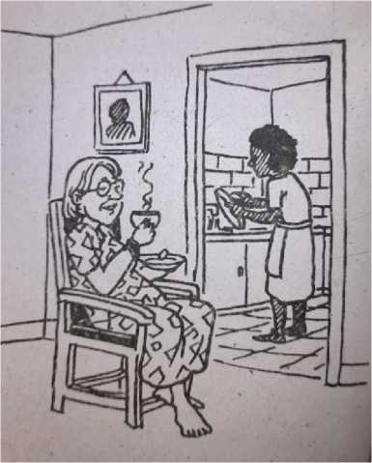
-Langston Hughes
Figure 133 washing room drink tea
A. Match the following words/phrases in column A with their meanings in column B.
Column A | Column B
a. mean | I. not giving up easily
b. get through | ii. a horse that is used to carry heavy loads
c. dinner | iii. cease to function; collapse
d. break down | iv. unkind
e. pack-horse | v. a formal and polite way of speaking to a woman
f. Madam | vi. to manage to do or complete something
g. dogged | vii. the main meal of the day
- Answer the following questions.

- Was the Madam really not mean? Why does the speaker say 'she wasn't mean'?
- Make a list of work that the maid had to do.
- What made her nearly break down?
- How did the Madam respond to the maid's question?
- The poem above presents an example of one type of discrimination. What kinds of discrimination are in existence in your society? Discuss.

Pronunciation
Find the following homonyms in a dictionary and write their different meanings. Note how the words are pronounced too.
address | band | bat | current | express
fair | kind | lie | match | pound
ring | right | rock | spring | tender

Listening
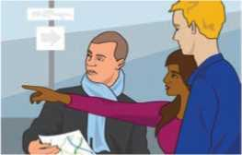
- Look at the picture and guess the answers to the questions. Think about the unit title.
Figure 134 two man one women discuss about map
- Where do you think the three people are?
- What do you think the man with the map is asking for?
- What do you think the lady is doing?
- Listen to the audio and write True for true statements and False for false ones.
- The girl wants to go to the art museum.
- She prefers to go there by bus.
- The bus station is miles away from there.
- She has to turn right at the Royal Hotel to get to the bus station.
- After crossing the junction, she will see the museum on her left.
- Listen to the audio again and answer the following questions in no more than three words.
- What is the best method to get to the museum, according to the boy?
- Why does the girl want to walk around instead of taking a bus?
- Where is the Royal Hotel located?
- What does the girl have to do after going over the junction?
- What can the girl do if she is still lost?
- Give directions to a new friend in your school to get to the head teacher’s office from your classroom.

Grammar II
Fill in the blanks with a, an or the where necessary. If no article is necessary put a cross (X).
- A: Where did you have lunch?
B: We went to restaurant.
- A: Did you have nice holiday?
B: Yes, it was best holiday I've ever had.
- A: Where's nearest grocery shop?
B: There is one at end of this street.
- A: Do you often listen to radio?
B: No. In fact, I haven't got radio.
- A: Would you like to travel in space?
B: Yes, I'd love to go to Moon.
- A: Do you go to cinema very often?
B: No. But I do watch a lot of films on television.
- A: You had nice time yesterday, didn't you?
B: Yes, we went for a walk by Narayani River.
- A: Can you tell me where head teacher's room is?
B: It's on second floor.
- A: What did you have for breakfast this morning?
B: Nothing. I never eat breakfast.

Writing II
Write a short biography of Nepali National Poet, Madav Prasad Ghimire, based on the outline given below.

Madhav Prasad Ghimire
Birth: 23 September, 1919, Pustun, Lamjung
Childhood: brought up by his father and grandfather after his mother’s death learned the Panchanga, went to Duradanda, Lamjung, and later to Kathmandu to study Sanskrit, studied in Banaras, India too
Career: writing career began in Lamjung as a writer for Bhashanubad Parishad, and later as aneditor for The Gorkhapatra
Works : Gauri (epic), Malati Mangale, Manjari, Indrakumari,Rastra Nirmata, Kinnar-Kinnari (lyricalanthology), Charu Charcha (essay collection),Aafno Bansuri Aafnai Geet, Himal Pari HimalWari, Aswathama, Rajheswari and Shakuntala (epic)
Awards and Honours:
Distinguished Academy Medal-Shree Prasiddha Praval Gorkha
Dakshinabahu
-Bhanubhakta Award-Tribhuwan Pragya Puraskar-Padmashree Sadhana
Samman
Puraskar-Sajha Award
Personal Life : six daughters and two sons from two marriages
Death :18 August 2020 at the age of 100, Lainchaur, Kathmandu-cremated with state honor

Project work
Find information about any one of the popular personalities in your locality. Note important details of his/her life and share it with your friends.

Extra bit
Idiom
An idiom is a commonly used expression whose meaning does not relate to the literal meaning of its words. Find the meanings of the following idoms
following idioms.
Examples:
a hot potato | tall story | night owl
no pain no gain | miss the boat | put a bug in his ear
see eye to eye | give it a shot | kill two birds with one stone

Unit13 Organization Profile and Authority

Getting started
Figure 135 Three logo
Which organizations do these logos represent? Discuss why these organizations were established.

Reading I
Answer these questions.
- What does ADB stand for?
- Does this organization work in Nepal?

Asian Development Bank Institute (ADBI)

What is ADBI?
ADBI is the think tank of the Asian Development Bank (ADB). It was established in 1997 to help build capacity, skills, and knowledge related to poverty reduction and other areas that support long-term growth and competitiveness in developing Asia and the Pacific. It is located in the central government district of Tokyo, Japan.
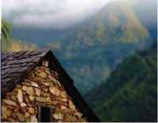
ADBI is supported by an independent Advisory Council whose members serve for two years. Dean is the chief executive officer of the ADBI and has responsibility under the direction of the ADB President for the management of the Institute.
Figure 136 Asian development Bank institute
Figure 137 village house
The objectives of ADBI are to identify effective development strategies and improve the capacity for sound development of the agencies and organizations engaged in development work in ADB's developing member countries (DMCs). ADBI focuses its activities on areas where it has a strategic advantage, such as the analysis of emerging policy issues from regional as well as medium-to long-term perspectives, and the facilitation of policy dialogue among senior DMC policy makers. ADBI also seeks to enhance its visibility, impact, and accessibility through high-quality knowledge products and services. It strives to be a trusted source of insight, knowledge, and information to which policy makers, academics, and others interested in Asia's development issues turn for guidance.
ADBI provides intellectual input for policy makers in ADB's DMCs. It does so by conducting research with a focus on medium to long-term development issues of strategic importance and through capacity building and training (CBT).
Through its work, ADBI has cultivated an extensive network of experts, researchers, think tanks, government agencies, civil society and private sector organizations, and likeminded organizations.

Programs and Activities
Programs and activities are held in-house as well as in ADB member countries in collaboration with international, regional, and national institutes and agencies.

Research Program
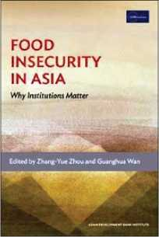
ADBI conducts high-level research on issues with strategic implications for development thinking and policy making in Asia and the Pacific.
Research activities include hosting presentations by distinguished experts, organizing regional and international seminars and conferences and publishing books and papers. These activities contribute to the development policy debate and help to identify effective development strategies and improve the capacity for sound development in the region.
Selected research topics are based on ADB's prioritysectors and themes, an annual needs survey, and inputs from regional policy makers and partners. Housing policy for inclusive growth in
Asia, central-local government relations, urbanization in Asia, financial inclusion, education and external shocks and economic are the priority areas of research.
Figure 138 food security in Asia

Capacity-Building and Training Activities
ADBI provides capacity-building and training to mid-and senior-level officials from ADB developing member countries. Activities are designed to enhance awareness on the region's important development issues, introduce appropriate policy proposals to address them, and build consensus among policy makers and stakeholders on key priority areas.
Figure 139 ADBILE learning
It is delivered in the form of policy dialogues, course-based training, and e-learning. ADBI's capacity building and training activities provide effective forum for discussion and information sharing on effective development practices and country experiences.

Outreach and Knowledge Dissemination
ADBI broadly disseminates its research results as well as training, seminar, and conference outputs through multiple channels, including media, publications, webpage and social media. It also enjoys close relations with numerous national and regional think tanks, as well as other organizations in Asia and the Pacific.
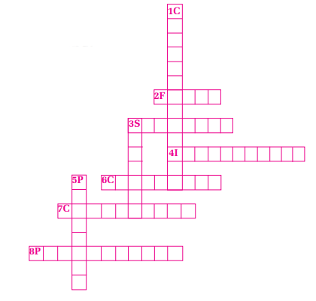
- Find the words from the text and solve the crossword puzzle.
Figure 140 English word puzzle

Across

2. a medium where people exchange their
opinions and idea
3. a plan to achieve a particular purpose
4. utilization of a decision
6. a common opinion
7. a large official meeting
8. view point

Down
1. working with another group of people
3. a meeting for discussion
5. a formal plan
- Fill in the gaps with correct words/phrases from the text.
- The works under the direction of the ADB President.
- The organisation emphasises its activities in the areas where it
has
- It provides for policy makers in its developing member
countries.
- The basis for research topics are ADB's
- ADBI has close relations with various think tanks.
- Answer the following questions.
- What does ADBI stand for?
- Who is this organization supported by?
- State any two objectives of ADBI.
- How does ADBI run its programs?
- What do the ADBI's research programs contribute to?
- What are the forms of ADBI's capacity-building and training programmes?
- How does it distribute its research results and outputs?
- Name any three international organizations that are working in Nepal. Talk to your friends about their objectives and functions.

Pronunciation
Consult a dictionary and identify the pronunciation of the following words in British and American English.
knowledge | poverty | government | officer | responsibility
advantage | expert | conference | topic | economic

Speaking
- Act out the given conversations in pairs.
Conversation I
Thaman: What's a video recorder used for?
Jamuna: A video recorder is used for recording TV programs on
video tapes.
Conversation II
Imran: What do we use a spade for?
Kautilya: We use a spade for digging fields.
- Have similar conversations. Use the given clues.
A calculator/make calculations A radio/listen to news, songs, etc.
A camera/take photos A mobile phone/make calls
A printer/print documents A refrigerator/keep food fresh

- Say the names of the following objects and explain what they are used for.

Grammar I
A. Make as many sentences as possible from the table below.

A rice cooker A washing machine She's got a driving license Mahanta took Math Mina went to university | in order to to is for is meant for | drive a bus. be a lecturer. be an engineer. drive a car. washing clothes. cooking rice.

Example: Mina went to university to be a lecturer. Fill in the blanks with because/because of/so that/to/for/ although/in spite of.
- it rained heavily, we played the football match.
- We couldn't enjoy the trekking much the snowfall.
- all our efforts, we couldn't run the program smoothly.
- Deepak went back to the village he could enjoy a
pleasant life there.
e. He went to hospital see a doctor.
f. I bought an envelope sending a letter.
g. I could not attend my classes yesterday I was feeling unwell.
h. Suprima accepted the job the salary, which was quite
low.
I. I could not get to sleep the noise.
j. I managed to get to sleep there was a lot of noise.

Writing I
- Study the given advertisement.

TIGER SHOES
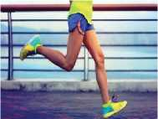
The best sports shoes. So remarkably original, that no other shoes have managed to match Tiger. Tiger shoes are made for champions. To win the game, everyone should
wear Tiger.
50% off
at New Year
Only use with special Tiger socks.
- Design similar advertisements for the following items. Use the given prompts.
headline picture/illustration features offer warranty
- calculator b. mobile phone c. watch

Reading II
Answer the following questions.
- When do you usually congratulate people?
- Mention the occasions you have been congratulated.
Changunarayan, Bhaktapur
May 30, 2021
Dear Mrs Rai,
I would like to take this opportunity to congratulate you on your recent appointment to the Chief Editor of The Nepal Times. This is certainly an impressive accomplishment, of which I am sure your family, friends and your relatives are justifiably proud.
As a Chief Editor of The Nepal Times, it will be your responsibility to provide unbiased news stories and articles. As this is a new position at this daily paper, you have the opportunity to set the standard for future chief editors to follow, and I am certain you will do a fine job. Your selection as the Editor in Chief shows that you are well on your way towards a bright future.
I congratulate you again on this honor and wish you the best of luck in all of your future endeavors. I am sure you will continue to set a fine example for all to follow. As always, please do not hesitate to call upon me if I may be of assistance to you.
With kind regards and best wishes,
Sincerely, Anil Gurung
- Find the words from the text and complete the sentences.
- I really admire you for your explanation.
- An person can, no doubt, see many positive things at a
glance.
- The work was done with a professional
- Please make every to arrive on time.
- Parents are proud of their children’s achievements.
- Answer the following questions.
- Where does Anil Gurung live?
- Why is Anil Gurung writing this letter?
- Why is her new position an opportunity for Mrs Rai?
- What does Anil Gurung expect from Mrs Rai as the chief editor?
- How can you say that Anil Gurung is a helpful person?
- What could be the relationship between Mrs Rai and Anil Gurung?
- Have you ever sent a letter of congratulations to anybody? Why did you send it? Share your experiences and feelings.

Listening
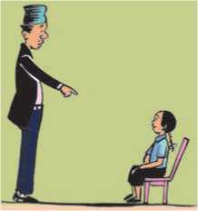
- Look at the picture and guess the answer to these questions.
- Who do you think they are?
Figure 141 teacher ask question for student
- What do you think they are talking about?
- Listen to the audio and tick (^) the things that the girl is
demanding from her father. Put a cross (X) if they are not on her demand list.
Example | pencil | or X
a. | eraser
b. | car
c. | palm pilot
d. | laptop
e. | calculator
f. | ice cream
g. | ruler

- Listen to the audio again and choose the correct alternatives.
- The girl needs some supplies for
- her school ii. her friend iii. her homework
- The father has already got her a
I. calculator and ruler ii. pencil and eraser
iii. laptop and palm pilot
- Calculators and computers are equipment.
I. traditional ii. manual iii. hi-tech
- The girl's father didn't have a laptop and palm pilot when he was
in
I. primary school ii. middle school iii. high school
- The father suggests that his daughter
- buys a new calculator
- uses his calculator
- asks her mother to buy her a new calculator
- He suspects that his daughter is
- going to download software in the class
- going to play video games in the class
- going to use the computer in the class
- How much does the calculator cost, according to the daughter?
I. 10 dollars iii. 89 dollars iii. 99 dollars
- Listen to the audio again and answer the following questions in not more than four words.
- Why does the girl need hi-tech equipment?
- What do they need to sell to buy the computer?
- What work does the girl promise to do to please her father?
- When does the girl need the calculator?
- Who is waiting for them?
- What gadgets would you like to use to support your studies? How would you use them? Draw a mind map and tell your friends.

Grammar II
A. Join the following pairs of sentences with the connectives given in the brackets.
- I couldn't sleep. I was tired. (despite)
- They have little money. They are living happily. (even though)
- He went to the tap. He wanted to bring a pail of water. (in order to)
- I enjoyed the film. The story was not very good. (though)
- We live in the same colony. We hardly meet each other. (in spite of)
- I was not wet. I had an umbrella. (because)
- I ate all the food. It was not very tasty. (although)
- He went to the bank. He could cash the check. (so that)

Writing II
A. Study the given message of congratulations.
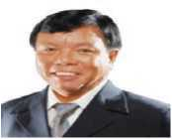
Congratulations!
Figure 142 Mahabir pun
Our special thanks and tribute to MR Mahabir Pun,
President of ENRD for being awarded The Ramon Magsaysay Award, 2007. This was for his outstanding contribution to Community Leadership and bringing unprecedented changes in rural livelihoods through the use of Internet Technology.
E-Network Research and Development, Nepal

- Write a message of congratulations to your neighbor who has received a full scholarship to complete his or her studies.
- Imagine that your uncle/aunt has been elected as the Mayor/ Chairperson of your Municipality or Rural Municipality. Write a formal message of congratulations to him/her to be published in a newspaper.

Project work
Collect information about any one of the international organizations working in Nepal and prepare a short profile for it. Include relevant pictures and illustrations.

Extra bit
Plurals that end in ‘f’ or ‘fe’
roof - roofs proof - proofs chief - chiefs
belief - beliefs giraffe - giraffes sheriff - sheriffs
wharf - wharfs/wharves dwarf - dwarfs/dwarves hoof-hoofs/hooves

Unit 14 History and civilisation

Getting started
Look at picture and talk about human evolution.
Homo erectus
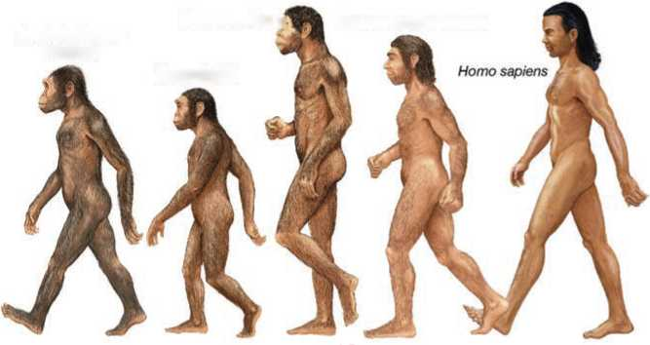
Figure 143 five men
Homo neanderthalensis
Homo habilis
Australopithecus afarensis

Reading I
Look at the following pictures and answer these questions.
a. What is the name of the invention shown in the picture?
b. Who was it developed by?

The Maya Empire

I
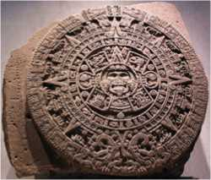
The Maya Empire, centered in the tropical lowlands of what is now Guatemala, reached the peak of its power and influence around the sixth century AD. The Maya excelled at agriculture, pottery, hieroglyph writing, calendar-making and mathematics, and left behind an astonishing amount of impressive architecture and symbolic artwork. Most of the great stone cities of the Maya, however, were abandoned by 900 AD.II
Figure 144 Aztec sun stone
The Maya civilisation was one of the most dominant indigenous societies of Mesoamerica, present Mexico and Central America. Unlike other scattered indigenous populations of Mesoamerica, the Maya were centered in one geographical block covering all of the Yucatan Peninsula and modern-day Guatemala; Belize and parts of the Mexican states of Tabasco and Chiapas; and the western part of Honduras and El Salvador. This concentration showed that the Maya remained relatively secure from invasion by other Mesoamerican peoples.

III
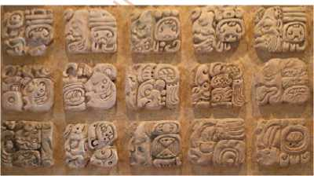
The Maya lived in three separate sub-areas with distinct environmental and cultural differences: the northern Maya lowlands on the Yucatan Peninsula; the southern lowlands in the Peten district of northern Guatemala and adjacent portions of Mexico, Belize and western Honduras; and the southern Maya highlands, in the mountainous region of southern Guatemala. Most famously, the Maya of the southern lowland region reached their peak during the Classic Period of Maya civilization (250 AD to 900), and built the great stone cities and monuments that have fascinated explorers and scholars of the region.
Figure 145 statue

IV
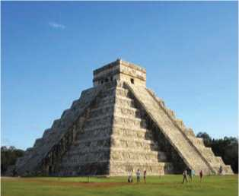
The earliest Maya settlements date to around 1800 BC. The earliest Maya were agricultural, growing crops such as corn, beans, squash and cassava. About 300 B.C. Maya farmers began to expand their presence both in the highland and lowland regions. The Middle Pre-classic Period also saw the rise of the first major Mesoamerican civilization, the Olmecs. Like other Mesoamerican peoples, the Maya derived a number of religious and cultural traits, as well as their number system and their famous calendar from the Olmec. In addition to agriculture, the Pre-classic Maya also displayed more advanced cultural traits like pyramid-building, city construction and the inscribing of stone monuments.
Figure 146 El Castillo

V
The Classic Period, which began around 250 AD, was the golden age of the Maya Empire. Classic Maya civilization grew to some 40 cities. Each city held a population of between 5,000 and 50,000 people. At its peak, the Maya population may have reached 2,000,000. Excavations of Maya sites have unearthed plazas, palaces, temples and pyramids, as well as courts for playing the ball games that were ritually and politically significant to Maya culture. Maya cities were surrounded and supported by a large population of farmers.

VI
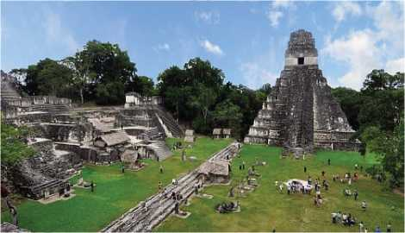
The Maya were deeply religious, and worshipped various gods related to nature, including the gods of the Sun, the Moon, rain and corn. At the top of Maya society were the kings, who claimed to be related to gods and followed a hereditary succession. They were thought to serve as mediators between the gods and people on earth, and performed the elaborate religious ceremonies and rituals so important to the Maya culture. The Classic Maya built many of their temples and palaces in a stepped pyramid shape, decorating them with elaborate reliefs and inscriptions. These structures have earned the Maya their reputation as the great artists of Mesoamerica. Guided by their religious ritual, the Maya also made significant advances in mathematics and astronomy, including the use of the zero and the development of a complex calendar system based on 365 days. Though early researchers concluded that the Maya were a peaceful society of priests and scribes, later evidence-including a thorough examination of the artwork and inscriptions on their temple walls-showed the less peaceful side of Maya culture, including the war between rival Mayan city-states and the importance of torture and human sacrifice to their religious ritual.
Figure 147 The Great Jaguar Tikal

VII
From the late eighth through the end of the ninth century, something unknown happened to shake the Maya civilization to its foundations. One by one, the classic cities in the southern lowlands were abandoned, and by 900 AD, Maya civilization in that region had collapsed. The reason for this mysterious decline is unknown, though scholars have developed several competing theories. Some believe that by the ninth century the Maya had exhausted the environment around them to the point that it could no longer sustain a very large population.

VIII
Other Maya scholars argue that constant warfare among competing city-states led the complicated military, family and trade alliances between them to break down, along with the traditional system of dynastic power. As the stature of the holy lords diminished, their complex traditions of rituals and ceremonies dissolved into chaos. Finally, some catastrophic environmental changes-like an extremely long, intense period of drought may have wiped out the Classic Maya Civilization. Drought would have hit cities like Tikal, where rainwater was necessary for drinking as well as for crop irrigation. All three of these factors may have played a part in the downfall of the Maya in the southern lowlands.

A. Match the following words from the text with their meanings.
a. drought i. an instance of a large number of people or things arriving somewhere
b. excel ii. a picture representing a word, syllable or sound
c. hieroglyph iii. to be very good at doing something
d. dominant iv. digging ground to look for old buried buildings or objects
e. concentration v. a long period of time when there is little or no rain
f. invasion vi. a lot of something in one place
g. excavation vii. more important, powerful or easy to notice than other things
B. Find the words in the text and fill in the crossword puzzle.
C.
a.
b.
c.
When did the Maya Civilisation reach its height?
- sixth century AD ii. ninth century AD iii. 250 AD
Why were the Mays unlikely to be invaded by the Mesoamerican?
- They had scattered to many places.
- They were concentrated in a particular area.
- They lived together with their relatives.
What has fascinated researchers about the Mayas from the southern lowlands?
i. the stone cities
ii. the cultural differences
d.
iii. the pyramid buildings
Which period of the Maya Civilisation is considered the golden age?
i. The Medieval Period ii. The Classic Period
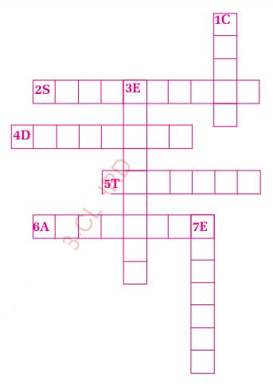
Across
Figure 148 English Crossword puzzle
2.  4. | people who follow each other in time or order a loss of power, prosperity
 | or status
5. | complete with regard to
 | every detail
6. | a union or association
formed for mutual

benefit
Down
1. complete disorder and confusion
3. very complicated and detailed
7. to use all of something so that there is none left
Choose the correct answer.

- The Pre-Classic Period
- Whom did the Mayas consider their god?
i. nature ii. the king iii. the people
- According to scholars, which of the following is NOT the cause of Maya downfall?
I. environmental exhaustion ii. internal warfare
iii. foreign invasion
- Match the paragraph numbers with respective information.
a. I I. occupation of the earliest Maya society
b. II ii. number of people in the Maya civilization
c. III iii. achievement by the Maya civilization in different
sectors
d. IV iv. places where the Mayas lived
e. V v. categories of the places where the Mayans lived
f. VI vi. spirituality of the Mayan people
g. VII vii. fights with the neighbouring states as the possible
cause of downfall
h. VIII viii. time when the downfall of the Maya Civilisation started
- Why is the study of history important to us? Prepare a mindmap of
your thoughts and discuss with your friends.

Pronunciation
Listen to your teacher and notice the stress.
succession excavation inscription concentration
excel 'architecture 'cultural exhausted

Speaking
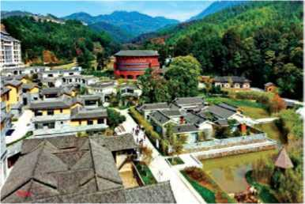
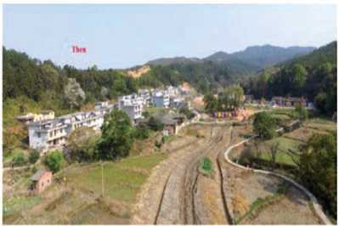
A. The following pictures show the changes that have taken place in a village over a period of ten years. Talk about the changes using used to/didn't use to

Example: There used to be a field in front of the village. But now, it is filled with houses.
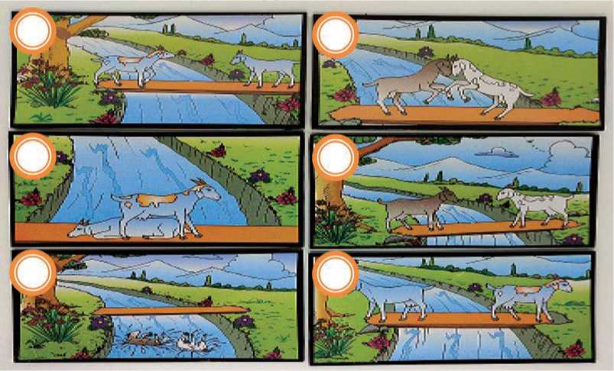
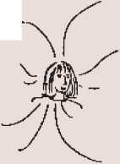
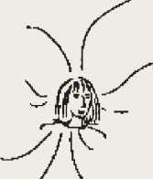
B. The given pictures tell a story, but they are not in the correct order. Rearrange them into the correct order by writing the number 1-6 in the bubbles and narrate the story.
Figure 149 girl
My dog died two years ago.
I read a newspaper everyday now.
I haven't been to a party for ages.
I haven't played the piano for years.
Tea's great! I like it now.
TODAY
I eat a lot of cheese now.
I work very hard these days. I work in a bookshop now.
I don't know many people these days.
I don't go away much these days.
FIVE YEARS AGO
Figure 150 girl
I'm a hotel receptionist. I've got lots of friends. I never read newspapers. I don't drink tea.
I go to a lot of parties.
I travel a lot.
I play the piano.
I'm very lazy.
I don't like cheese.
I've got a dog.

Grammar I
A. Compare what Samita said in the past and what she says now.
Now, make sentences using used to/didn't use to/never used to as in the example.
Example: She used to travel a lot but she doesn't go away much these days.
B. Rewrite the following sentences using used to or didn't use to.
- I lived with my parents.
- Did you swim in the river every summer?
- He never smoked.
- I played tennis at school.
- Villagers walked for hours to reach the nearest health post.
- There was a dense forest around the village.
- What did you do in your childhood?
- I didn't write stories.
- Did people travel by airplanes?
- Where did you go to deposit your money?

Writing I
A. Read the following story carefully. Then give it a suitable title.
There lived a fox in a forest. One day, he thought of a plan to have fun with a stork from the same forest. The fox always used to laugh at the appearance of the stork.
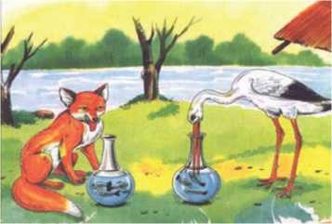
"You must come and dine with me today," he said to the stork, smiling to himself at the trick he was going to play. The stork gladly accepted the invitation and arrived in good time and with a very good appetite.
Figure 151 fox and stroke
For dinner the fox served soup. But it was set out in a very shallow dish, andall the stork could do was to wet only the tip of his bill. He could not drink a single drop of the soup. But the fox lapped it up easily, and, to increase the disappointment of the stork, made a great show of his enjoyment.
The hungry stork was much displeased at the trick, but he was a calm-tempered fellow and saw no good in flying into a rage. Instead, not long afterward, he invited the fox to dine with him in turn. The fox arrived promptly at the time that had been set, and the stork served a fish dinner that had a very appetizing smell. But it was served in a tall jar with a very narrow neck. The stork could easily get at the food with his long bill, but the fox could only lick the outside of the jar, and sniff at the delicious smell. And when the fox lost his temper, the stork said calmly, "Do not play tricks on your neighbors unless you can stand the same treatment yourself."
B. Develop readable stories based on the given outlines.
- A king enemies defeat him six times hides in a
cave sees a spider climbing the wall fails
for six times succeeds on the 7th attempt the king
learns a lesson collects courage and attacks enemies
succeed moral
- Two friends meet a bear.. ..one climbs a tree ...the other lies down as if dead....the bear smells his limbs goes away the first
man comes down and asks....what the bear said "beware of
friends who run away in danger." Moral

Reading II
Look at the pictures and answer the following questions.
a. What are these currencies?
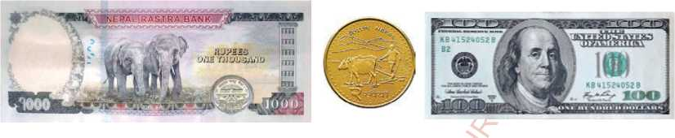
b. What would happen if we didn't have money
Figure 152 money

The History of Money
The use of money is as old as the human civilization. Money is basically a means of exchange; and coins and notes are just items of exchange. But money was not always in the same form as the money today, and is still developing.
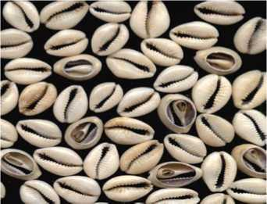
Before the invention of money, the basis of early commerce was barter, a system of direct exchange of one product for another. Subsequently, both livestock, particularly cattle, and plant products such as grain, came to be used as money in many different societies at different periods. Cattle are probably the oldest of all forms of money, as the domestication of animals tended to precede the cultivation of crops. The earliest evidence of banking is found in Mesopotamia between 3000 and 2000 BCE when temples were used to store grain and other valuables used in trade.
Figure 153 cowrie
Some of the earliest currencies were objects from nature. A notable example is cowrie shells, first used as money about 1200 BCE. Although they may seem a pretty random choice, the shells had a number of advantages: they were similar in size, small, and durable. While the mollusks that produce the shells are found in the coastal waters of the Indian and Pacific Oceans, the expansion of trade meant that even some European countries acceptedcowrie shells as currency. Shells in the form of wampum were used as money by Native Americans. Another currency from nature was whale teeth, which were used by Fijians. And the people of Yap Island carved huge disks of limestone that eventually became currency and remained as a part of the island's culture.
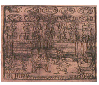
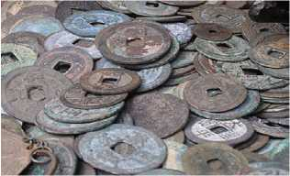
While the use of metal for money can be traced back to Babylon before 2000 BCE, standardised and certified coinage may not have existed until the 7th century BCE. According to many historians, it was during this time that the kingdom of Lydia, in present-day Turkey, issued the first regulated coins. They appeared during the reign of King Alyates (610-560 BCE) and were made of electrum, a natural mixture of gold and silver. Crudely shaped like beans, these coins featured the royal symbol, a lion. Alyattes' son, Croesus, reformed the kingdom's currency, introducing silver coins and gold coins. Soon such currency began appearing elsewhere.
Figure 154 coins
About the 6th century BCE, leather and animal hide began to be fashioned into currency. Early ancient Rome reportedly used this type of money. It was also found in such areas as Carthage, what is now France, and Russia, is believed to have used leather money into Peter the Great' reign (16821725 BCE). The Chinese emperor Wudi (141-87 BCE) created currency out of skins from his personal collection of white stags. It was fringed and decorated with elaborate designs. Although no longer used, leather money may have left a lasting legacy.
Figure 155 bank note
Given that paper is widely believed to have originated in China, it is fitting that the country introduced paper currency. This innovation is widely thought to have occurred during the reign of Emperor Zhenzong (997-1022 CE). It was made from the bark of mulberry trees. So, in a sense, money really did grow on trees! By the late 18th and early 19th centuries, paper money had spread to other parts of the world. The bulk of this currency, however, was not money in the traditional sense. Instead, it served as promissory notes—promises to pay specified amounts of gold or silver which were key in the development of banks.
Unsurprisingly, currency comes with a number of problems, one of which concerns fiat money. This is currency that is issued on the order of a sovereign government and, unlike gold and silver coins, has no intrinsic value. Countries can thus issue such money at will, and some did, potentially making the currency worthless. This became such a problem that in 1821 the United Kingdom, then the leader in international finance, introduced the gold standard. In this monetary system, the standard unit of currency is typically kept at the value of a fixed quantity of gold, which increases confidence in international trade by preventing governments from excessively issuing currency. Eventually, other countries, including Germany, France, and the United States, adopted the gold standard. However, the system had its drawbacks. Notably, it limited a country's ability to isolate its economy from depression or inflation in the rest of the world. After the Great Depression (1929-1939 CE), countries began to rethink the gold standard, and by the 1970, gold was no longer being tied to currency.
The 21st century has given rise to novel forms of money including digital payment and virtual currency such as bit coin. Are paper notes and coins going to disappear soon?
A. Find the words from the text above that have the following meanings.
- r the period during which a king, queen, emperor, etc.
rules
- p to happen before something
- r to control something by means of rules
- c simply and without much skill or attention to detail
- f to form a border around something
- l something that somebody has done successfully
- f an official order given by somebody in authority
- s free to govern itself; completely independent
- i belonging naturally; essential
B. Complete the table below with the correct information about the development of money.
C.
a.
Answer the following questions.
What did people use to make a trade before the invention of
Timeline | Events
1200 BCE | cowrie shells used as money
2000 BCE
6th century BCE
997-1022 CE
1821 CE
21st century

money?
- How were temples used as banks in the past?
- What was the benefit of using cowrie shells as money'
- Describe the coins invented by Turkey.
- Why did the leaders in international finance introduce the gold standard in currency?
- What form of money is being used in the 21st century?
How might people trade in the next 20 years? What form of money might be used? Talk to your friends.
D.

Listening
A. Answer the following questions.
- Write any three most memorable things about your early childhood days.
- Do you wish you could be a young child again? Why?
B. Listen to the audio and complete the sentences with the correct words/phrases.
- The speaker remembers the house where he
- The Sun used to come at the window in the morning.
- It used to wake neither too nor late.
- The roses were in colour.
- The laburnum tree was set by his brother on
- As a boy, he thinks that he is of the heaven.
- Listen to the audio again and choose the correct answer.
a. Where did the robin build its nest?
i. the lilacs ii. the laburnum tree
iii. the treetops
iii. laburnum
- Which tree is still living?
I. fir ii. lilac
- How did the speaker feel while swinging? Q
I. like the robin ii. like the sparrow iii. like the swallow
- Which of the flowers is NOT mentioned by the speaker?
I. rose ii. tulip iii. lilly
- What is his spirit like now? ^0
I. cool ii. heavy iii. light
- What did the speaker think about the fir treetops?
- They flew like swallows. ii. They almost touched the sky.
iii. They used to swing.
- How does he feel when remembering his boyhood?
I. He is filled with little joy. ii. He is filled with sadness.
iii. He is filled with absolute happiness.
- Recall your most favourite memory from your early childhood and describe it to your friends.

Grammar II
A. Study the following sentences and notice simple past, past continuous and past perfect.
- While I was studying, Karen phoned me three times.
- They were playing football when the storm started.
- While she was working in India, she began to learn Hindi.
- I had finished the shopping when I met Manoj.
- When we got to the party, most people had already left.
- It was the best movie I'd ever seen.
- He had already read the book so I gave it to his sister.
- She had known him since they were children.
- In 2005, I was living in Biratnagar.
- She called me yesterday.
B. Use simple past, past continuous or past perfect forms of the verbs in the brackets to complete the following sentences.
- Mr. Singh (wait) for me when I reached the station.
- A: What (do) this time yesterday'
B: I was reading a novel. <0
- A: (go) out last night?
B: No, I was too busy to go out.
- A: Was Sapana at the party?
B: Yes, she (dance) with Ravi.
- A: What (do) when the earthquake occurred?
B: I was cooking meal.
- He (fall) off the wall when Sanam pushed him.
- I (be) really in a difficult situation when I lost the job.
- When I was young, I (want) to become a doctor.
- I (do) my homework when the telephone rang.
- When I last saw Kiran, he (work) in his garden.
- Find the mistakes in the story below and correct the verb forms throughout.
This happens to me when I was in India. I used to go to my office by train. On this particular evening, I hurry to my station but when I reached there, the train has already gone. I bought a newspaper and a packet of biscuits and sit on the bench. While I am reading, a man came and sits down opposite me. There was nothing special about him, except that he is very tall. I was still reading when my eyes catch a very strange sight. The man reached over the table, open my packet of biscuits, took one, dip it into his coffee and popped it into his mouth. I couldn't believe my eyes. But I didn't want to make a fuss, so I ignored it. I just take a biscuit myself and went back to the newspaper. While I was pretended to be very interested in the news, the man took a second biscuit. After a couple of minutes I casually put a biscuit in my mouth and decide to leave. I was ready to go when the man stood up and hurriedly leave. I folded my newspaper and stand up. And there on the table, where my newspaper had been was my packet of biscuits.

Writing II
Do students need to learn history? Why? Write an essay on ‘The Importance of History’.

Project work
Ask your parents, grandparents, family members or friends about your ancestors. Note down the main points and share them with your friends.

Extra bit
Use a semicolon (;)
two independent clauses that are not joined by a
to separate
conjunction
Example : The participants in the first batch were paid; those in the second were unpaid.
to separate elements in a series that already contain commas
Example : The color order was red, yellow, blue; blue, yellow, red; or yellow, red, blue.

Unit 15 People and Lifestyle

Getting started
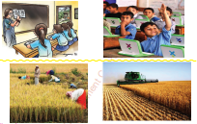
Look at each pair of pictures and talk about the differences with your classmates.
Figure 156 harvest and student

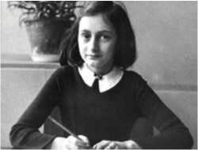
Reading
Look at the picture and answer the following

- What do you think the name of the girl is?
- What do you think made her so popular?

The Diary Of A Young Girl
SATURDAY, JUNE 20, 1942
Figure 157 Anne Frank
Writing in a diary is a really strange experience for someone like me. Not only because I’ve never written anything before, but also because it seems to met that later on neither I or any else will be interested in the musings of a thirteen-year-old schoolgirl. Oh well, it doesn't matter. I feel like writing, and I have an even greater need to get all kinds of things off my chest.
“Paper has more patience than people.” I thought of this saying on one of those days when I was feeling a little depressed and was sitting at home with my chin in my hands, bored and listless, wondering whether to stay in or go out. I finally stayed where I was, brooding. Yes, paper does have more patience, and since I'm not planning to let anyone else read this stiff-backed notebook grandly referred to as a “diary,” unless I should ever find a real friend, it probably won't make a bit of difference.
Now I'm back to the point that prompted me to keep a diary in the first place: I don't have a friend.
Let me put it more clearly, since no one will believe that a thirteen-year-old girl is completely alone in the world. And I'm not. I have loving parents and a sixteen-year-old sister, and there are about thirty people I can call friends. I have a throng of admirers who can't keep their adoring eyes off me and who sometimes have to resort to using a broken pocket mirror to try and catch a glimpse of me in the classroom. I have a family, loving aunts and a good home. No, on the surface I seem to have everything, except my one true friend. All I think about when I'm with friends is having a good time. I can't bring myself to talk about anything but ordinary everyday things. We don't seem to be able to get any closer, and that's the problem. Maybe it's my fault that we don't confide in each other. In any case, that's just how things are, and unfortunately they're not liable to change. This is why I've started the diary.
To enhance the image of this long-awaited friend in my imagination, I don't want to jot down the facts in this diary the way most people would do, but I want the diary to be my friend, and I'm going to call this friend Kitty.
Since no one would understand a word of my stories to Kitty if I were to plunge right in, I'd better provide a brief sketch of my life, much as I dislike doing so.
My father, the most adorable father I've ever seen, didn't marry my mother until he was thirty-six and she was twenty-five. My sister Margot was born in Frankfurt am Main in Germany in 1926. I was born on June 12, 1929. I lived in Frankfurt until I was four. Because we're Jewish, my father immigrated to Holland in 1933, when he became the Managing Director of the Dutch Opekta Company, which manufactures products used in making jam.

My mother, Edith Hollander Frank, went with him to Holland in September, while Margot and I were sent to Aachen to stay with our grandmother. Margot went to Holland in December, and I followed in February, when I was plunked down on the table as a birthday present for Margot.
I started right away at the Montessori nursery school. I stayed there until I was six, at which time I started first grade. In sixth grade my teacher was Mrs. Kuperus, the principal. At the end of the year we were both in tears as we said a heartbreaking farewell, because I’d been accepted at the Jewish Lyceum, where Margot also went to school.
Our lives were not without anxiety, since our relatives in Germany were suffering under Hitler’s anti-Jewish laws. After the pogroms in 1938 my two uncles (my mother’s brothers) fled Germany, finding safe refuge in North America. My elderly grandmother came to live with us. She was seventy-three years old at the time.
After May 1940 the good times were few and far between: first there was the war, then the capitulation and then the arrival of the Germans, which is when the trouble started for the Jews. Our freedom was severely restricted by a series of anti-Jewish decrees: Jews were required to wear a yellow star; Jews were required to turn in their bicycles; Jews were forbidden to use street-cars; Jews were forbidden to ride in cars, even their own; Jews were required to do their shopping between 3 and 5 PM; Jews were required to frequent only Jewish-owned barbershops and beauty parlors; Jews were forbidden to be out on the streets between 8 PM and 6 AM; Jews were forbidden to attend theaters, movies or any other forms of entertainment; Jews were forbidden to use swimming pools, tennis courts, hockey fields or any other athletic fields; Jews were forbidden to go rowing; Jews were forbidden to take part in any athletic activity in public; Jews were forbidden to sit in their gardens or those of their friends after 8 PM; Jews were forbidden to visit Christians in their homes; Jews were required to attend Jewish schools, etc. You couldn’t do this and you couldn’t do that, but life went on. Jacque always said to me, “I don’t dare do anything anymore, ‘because I’m afraid it’s not allowed.”
In the summer of 1941, Grandma got sick and had to have an operation, so my birthday passed with little celebration. In the summer of 1940, wedidn't do much for my birthday either, since the fighting had just ended in Holland. Grandma died in January 1942. No one knows how often I think of her and still love her. This birthday celebration in 1942 was intended to make up for the others, and Grandma's candle was lit along with the rest.
The four of us are still doing well, and that brings me to the present date of June 20, 1942, and the solemn dedication of my diary.
(Adapted from The Diary of a Young Girl by Anne Frank)

A. The meanings of some of the words/phrases from Anne Frank's diary are given below. Find the words from the text and write them
- m a period of reflection or thought
- s rigid, not soft or flexible
- b to think a lot about something that makes you
annoyed, anxious or upset
- t a crowd of people
- r to make use of something, especially something bad
- c to tell somebody secrets and personal information
- l likely to do something
- p to get into something
- p to sit down heavily or carelessly
- j to write something quickly
B. Match the words in column A with their synonyms in column B.
Column A Column B
- listless I. announcement
- adoring ii. serious
- decree iii. loving
- adorable iv. attractive
- anxiety v. lethargic
- capitulation vi. worry
- solemn vii surrender

- Answer the following questions.
- Why is writing a diary a strange thing to the writer?
- What is the first reason for her to keep the diary?
- Why is the writer unhappy despite having a loving family?
- Who is Kitty?
- Why did Margot and her sister not go to Holland together?
- Why didn't the writer have a birthday celebration in 1940?
- Why did the writer's uncle escape from Germany?
- Write T if the information is true, F if it is false and NG, if the information is not given.
- The writer is tired of staying in her house.
- The writer wants people to read her diary.
- Edith Hollander Frank was a teacher in Holland.
J
- The writer attended school in Germany until she was six.
- The family came to Germany because it was difficult to live in Holland.
- Jews were prohibited to be on top of their houses during day time.
- There were very strict laws in Germany for Jewish people.
- How does a diary entry help in understanding someone's lifestyle? Explain.

Pronunciation
Pronounce the following homophones correctly and find their meanings.
cell/sell | knead/need | coarse/course | their/there
doe/dough | fare/fair | heal/heel | wait/weight
deer/dear | site/sight | waist/waste | night/knight

Speaking
A. Read and act out the following conversation.
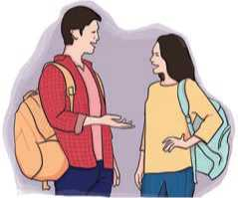
Pemba : I've heard that Susan is retiring from her job next month.
Figure 158 men and women
Durgesh : Really? How long has she worked for the company?
Pemba : She has worked there for more than 25
years.
Durgesh : That's a very long time. She has contributed greatly to the company.
B. Work in pairs. Ask questions with 'how long...' and answer them with for or since. .0
- Sumit/do his homework (2 hours)
- Deepa/read a novel (last Monday)
- Dhanu/wait for a bus (hours)
- Siddhartha/watch movie (5 o'clock)
- Deepak/live in Japan (2010)
0
- It/rain (long time)^
- Sonali/paint the house (this morning)
- She/not eat any junk food (several months)
- Raman/plough the field (10 o'clock)
- The telephone/ring (a few minutes)

Grammar I
A. Complete the sentences with the present perfect or present perfect continuous forms of these verbs.
watch | rain | play | do
water | wait | clean

- The boys computer games for over an hour.
- You TV all afternoon.
- The road is wet; it just heavily.
- "Why are your clothes wet?" " I just the plants."
- I the flat for two hours.
- You look tired. What you ?
- I'm sorry I'm late you long? Q
B. Put the words in brackets into the gaps. Use either present perfect or the present perfect continuous.
/O
- How long (you/know) Gerry?
- You look dirty. What (you/do) all day?
0*
- How many times (Charles/visit) New York till
now?
- She (learn) French words for hours, but she still doesn't
remember all of them.
- The children . (watch) videos for two hours.
- My father (never/eats) chocolates.
- We ………. (not/see) Lisa recently.
- He …………. (write) his essay all day but he……….. (not/ finish) yet.

Writing I

Keep a diary for a week. Mention the activities you did during the day. Also express your views and attitudes about a particular incident on each day.

Reading II
Look at the pictures below and guess the answers to these questions.
- Who are these people?
- What do you know about these people?

The Rautes
The Rautes are one of the most typical indigenous groups of Nepal sustaining their unique cultural identities for generations. They are the only nomadic people in the country who never settle permanently in any particular place. The Rautes deny any idea on permanent settlement, education or agriculture. The fact that the Rautes, the last fulltime nomads of Nepal, have survived into this century is truly remarkable in our current period of diminishing cultural diversity.
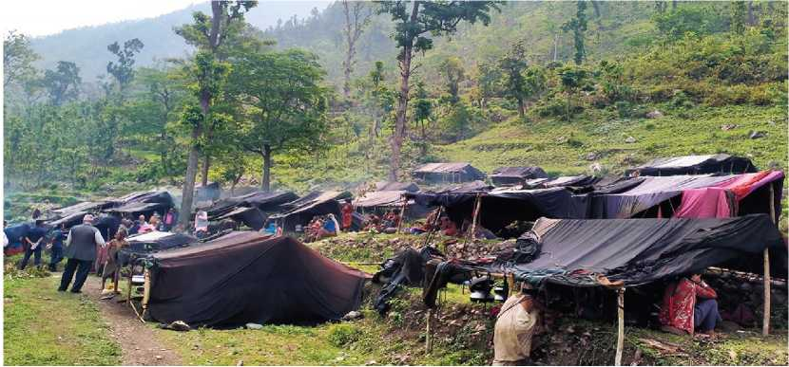
Figure 159 Rautes houses

It is estimated that the total population of Rautes in Nepal is about 180, or roughly 52 families. The Karnali Province of Nepal remains their only sanctuary.
There is no documented history of the Rautes. But one common ground is that once they fled from the state, they never returned and established a different pattern of life in the jungle. To eke out their living, they mastered crafting of wooden products, learned to hunt monkeys, and adapted to forest life.
Only the Mukhiya of the Rautes, on behalf of their tribe, talks to outsiders regarding their lifestyle and tradition.
The Rautes bear traditional knowledge of living in a community. The heredity of the Raute is categorised into three types as Kalyaal, Raskoti and Samaal. It is therefore very important to note the various aspects of these people, such as their ethical norms and values, rituals and livelihood patterns.
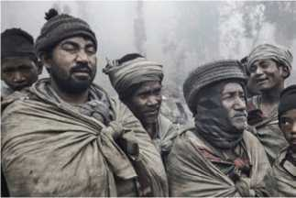
At the time when acculturation has been widespread in the world with diminishing diversity, the Rautes have been quite successful in sustaining their tradition. Humanity has to learn a lot from the Rautes, since they have been very successful in preserving their tradition in today's world. Their maintenance of the nomadic culture in a rapidly globalizing world is commendable. This global uniqueness makes
Figure 160 Rautes
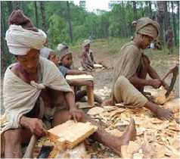
them a precious part of the diverse people of Nepal.
Figure 161 Rautes doings works
Like any other ethnic group following the Hindu society, the Raute community also maintains a patriarchal social hierarchy. However, in matters of internal management, women have a more prominent role than that of their male counterparts. The Rautes maintain a clear division of labour between men and women. Most often the male members get involved in making wooden utensils, hunting monkeys, trading their products in the market, and collecting food grains. It is also common for unmarried girls and widows to go to the countryside and collect food grains and deliver the order for the craft items. Women in the Raute community bear the major responsibility in the household chores and dominate in almost every facet of the livelihood except in the areas of socializing, hunting, carpentry, and dancing. They have the indigenous know-how on spring water sources. Since it is a part of their job to search for medicinal herbs, firewood and vegetables in the jungle, they also have extensive knowledge of the forest and its ecosystem.
The husband and wife have great respect and love for each other. Married women never travel outside of their settlement area with anyone else other than their husbands. The women are mainly responsible for collecting firewood, cooking meals and rearing their children. They also may assist the males while shifting homes to new locations and building new homes there. The women do not participate in making wooden utensils and hunting as they are considered to be the male tasks. Children until the age of 1014 are not assigned any major household responsibilities, they only spend their days playing with natural objects and roaming around the settlement. On special occasions, they may help their parents in fetching water from the spring and carrying small items while shifting to new locations.
Monkey hunting is considered fundamental to maintain the cultural permanence of the hunting life of the Rautes. Their hunting technique is also very rare in the sense that around 8-30 young and middle aged Raute members go hunting in a group with their nets. They do not use guns or bows and arrows for hunting.
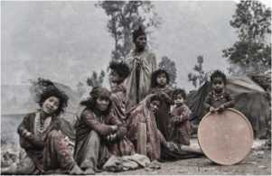
The Rautes observe the festivals like Saune Sankranti, Dashain, Tihar, Chaite Dashain and Maghe Sankranti. For the celebrations, the Rautes manage food, homemade ale and meat in advance. As they enjoy complete participation in the community events, they do not like to meet strangers or travel beyond their settlement area during their celebration period. They take complete leave from carpentry and hunting during the festivals. These festivals are observed with much joy and fervor amidst singing, dancing, feasting and their own ritual performances. Rice, meat and drinks play an important role in their feast.
Figure 162 rautes members

A. Find the words from the text and fill in the cross word puzzle.
Across
- moving often from place to place
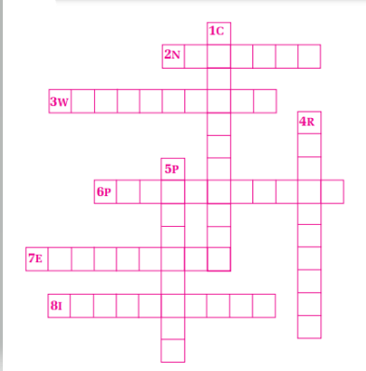
- existing over a large area
Figure 163 English crossword puzzle
- ruled by men
- far-reaching
- belonging to a particular place
Down
1. deserving praise
- unusual or surprising
- noticeable
B. Identify whether the following statements are true or false.
- The Rautes move from one place to another for their settlements.
- Rautes live in the far-western part of Nepal.
- One of the means of their survival is woodcraft.
- The maintenance of the nomadic culture is highly regarded.
- The Raute community is female-dominated.
- Answer the following questions.
- What is the common belief about the history of the Rautes?
- How do Rautes earn their living?
- How do Raute children spend their days?
- Why do the Rautes have good knowledge of the forest and its ecosystem?
- Is the task division between male and female Rautes fair? Why?
What is special about the hunting skills of the Rautes?
f.
g.
h.
Name the festivals that the Rautes celebrate.
What should modern people learn from the Rautes?
D.
How do cultures and traditions affect people's lifestyles? Discuss.

Listening
A. Look at the pictures below and guess the answers.
a. What do these pictures represent?
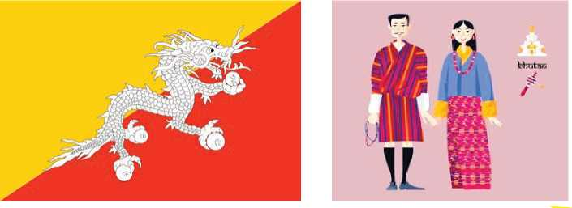
Figure 164 bhutan flag , men and women bhutan dress
b. What is the name of this type of costume?
- Listen to the audio and answer the following questions.
- When was the Gross National Happiness Committee established?
- What does GDP stand for?
- When was a survey on happiness held?
- What is the percentage of the population that are happy?
- How can quality of life be determined?
- What is the rank of Nepal in the World Happiness Index this year? Have a discussion with a partner.

Grammar II
- Study the following conversation.
Binita : Have you travelled a lot, Samir? 0
Samir : Yes, I've been to lots of places.
Binita : Really? Have you ever been to Sri Lanka?
Samir : Yes, I've been to Sri Lanka once.
Binita : What about China?
Samir : No, I haven't been to China.
- Rewrite the following sentences with since or for. Use the clues in the brackets.
Example: I know Samim. (I came to this school)
I have known Samim since I came to this school.
- Pawan lives in Tanahun. (he was born)
- Subin is unemployed. (last January)
- Subash has a fever. (the last few days)
- I want to go to Lumbini. (I was in grade five)
- My brother is studying engineering. (three years)
- I am working in Bhanu Municipality. (last year)
- My cousin is in the army. (he was eighteen)
- They are waiting for the bus. (half an hour)
- Krish is doing his homework. (two hours)
- Pramila is going to dance classes. (a month)

Writing II
Write an essay on the effects junk foods have on children. Use the clues given below.
Introduction to junk food
causes: advertising, lack of education, etc.
Negative / harmful effects of junk food on health (headache, heart attacks,
dental problems, high blood pressure, obesity, high cholesterol, etc.)
Effects on the economy (more expenditure / extra burden to family, etc.)
Effects on other factors like socialization, poor academic achievement, etc. Conclusion

Project work
Conduct a brief survey of one of the ethnic communities of your locality. Based on your study, prepare a short report about it including the following aspects.
Introduction - population and history - settlement areas - lifestyle - culture and festivals, etc.

Extra bit
Phobia and Mania
agoraphobia : abnormal fear of being in crowds, public places, or open places bibliophobia : hatred, fear, or mistrust of books
acrophobia : abnormal fear of being in high places
bibliomania : craze for acquiring books, especially rare ones
balletomania : extreme enthusiasm for the ballet
anglomania : craze for English language, customs,..
dipsomania : extreme desire to drink alcoho

unit 16 Games and Sports

Getting started
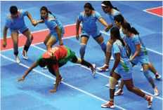
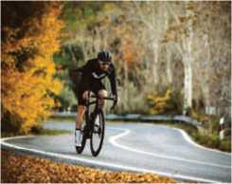
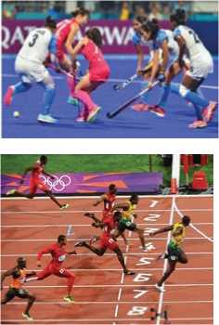
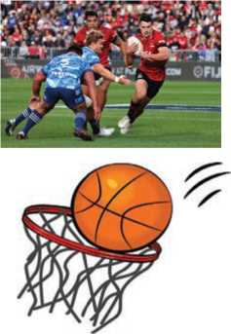
Figure 165 cycling
Figure 166 running and hockey
Figure 167 footaball and basket ball
Figure 168 kabaddi

Reading I
Look at the pictures and answer these questions.
- What is the name of the sport?
- Can you identify the players? Name them.
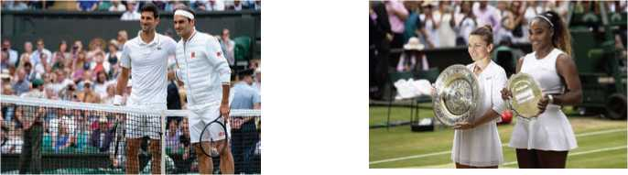

Wimbledon
Wimbledon is the world's oldest tennis tournament and is also thought
to be the most prestigious. It has been held at the All England Club in
Wimbledon, London since 1877. It is one of the four Grand Slam tennis
tournaments, the others being the Australian Open, the French Open and the US Open. Wimbledon is the only major still played on traditional grass, the game's original surface, which gave the game its original name of 'lawn tennis'.
Figure 169 Wimbledon

Events
Wimbledon consists of five main events and five junior events. There are also five invitation events in which some former professionals are invited back to compete. The five main events are gentlemen's singles, ladies' singles, gentlemen's doubles, ladies' doubles and mixed doubles. The five junior events are similar with boys' singles, girls' singles, boys' doubles, girls' doubles and disabled doubles. The five invitational events are the gentlemen's doubles, senior gentlemen's doubles, senior ladies' doubles, gentlemen's wheelchair doubles and ladies' wheelchair doubles.

Tickets
The majority of Centre Court tickets are made available through a public ballot in which applicants are chosen at random by a computer. Fans without tickets can queue up overnight to get seats on match day. There are a certain number of seats allocated for the queuing system.

Schedule
Currently, Wimbledon begins in June and ends in July. But in 2017, the championships began and ended in July to extend the gap between the tournament and the French Open. The five main events span both weeks, but the junior and invitational events are mainly held during the second week. Traditionally, there is no play on the 'Middle Sunday', however, rain has sometimes forces play on this day.

The Courts
In 2009, Wimbledon's Centre Court was fitted with a retractable roof helping to substantially reduce the loss of playing time caused by bad weather. The principal court, Centre Court, was opened in 1922. The main show courts, Centre Court and No. 1 Court, are normally used for only two weeks a year during the championships, but play can extend into a third week in exceptional circumstances. The remaining 17 courts are regularly used for other events hosted by the club.

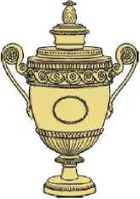
Trophies and Prize Money
Figure 170 Coupe
The gentlemen's Singles Champion r eceives a silver gilt cup. The trophy has been awarded since 1887 and bears the inscription: ‘All England Lawn Tennis Club Single Handed Championship of the World. The Women's Singles Champion receives a sterling silver salver which is decorated with figures from mythology. In 2019, the prize money for the winners of the singles finals was £2.35 million.

A Few Famous Champions
Martina Navratilova won a record nine Wimbledon Singles titles. To date, Roger Federer has won Wimbledon eight times. Novak Djokovic was the winner of the Gentlemen's Singles in 2019. He defeated Roger Federer in the ‘most demanding' match ever in the final. He was able to defend his trophy as a defending champion. It was his sixteenth Grand Slam Men's Singles title and his fifth Wimbledon title. In the Ladies' Singles event, Simona Halep won the first Wimbledon title with stunning performance against Serena Williams in 2019. It was her second Grand Slam Women's Singles title.
A. Match the words in column A with the meanings in column B.
Column A Column B
a. | prestigious | i | a thin layer of gold
b. | substantially | ii. | a large plate, usually made of metal
c. | gilt | iii. | extremely attractive or impressive
d. | inscription | iv. | considerably
e. | salver | v. | study of myths
f. | mythology | vi. | respected and admired as very important
g. | stunning | vii. | words written in front of a book or cut in
stone or metal
- State whether the given statements are True or False.
- The original name of tennis is ‘lawn tennis'.
- Ladies' wheelchair doubles comes under junior events.
- Most of the tickets are distributed through online booking.
- The Wimbledon Championship is usually played in June and July.
- The players can practice matches in the main show courts at any time.
- The prize money for the singles winners was £2.35 million.
- Answer the following questions.
- How is Wimbledon different from other Grand Slam tournaments?
- State the four Grand Slam tennis tournaments.
- What are the five main events of Wimbledon?
- What can tennis fans do if they don't win a ticket in the public ballot?
- Why was Wimbledon Centre Court fitted with a rectangle roof?
- What is inscribed on the of Gentlemen's Singles trophy?
- Who won the Gentlemen's Singles and Ladies' Singles in 2019?
- Why is it important to have tournaments for wheel chair users?

Pronunciation
Read the following part of the poem "The Chaos" by Gerard Nolst Trenit é. Try to pronounce each word correctly.
Dearest creature in creation, Study English pronunciation.
I will teach you in my verse Sounds like corpse, corps, horse, and worse.
I will keep you, Suzy, busy,
Make your head with heat grow dizzy. Tear in eye, your dress will tear.
So shall I! Oh hear my prayer.
Just compare heart, beard, and heard,
Dies and diet, lord and word, Sword and sward, retain and Britain.
(Mind the latter, how it's written.)
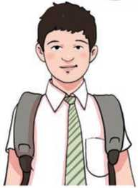
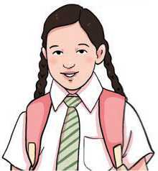
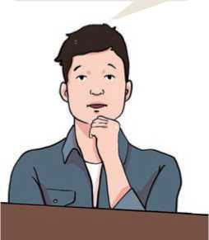
Figure 171 boys
Figure 172 girls
I was unable to visit him last week.
Figure 173 man
I will be able to buy a house when I get a good job.
Now I surely will not plague you With such words as plaque and ague.
But be careful how you speak:
Say break and steak, but bleak and streak;
Cloven, oven, how and low,
Script, receipt, show, poem, and toe.
Hear me say, devoid of trickery,
Daughter, laughter, and Terpsichore,
Typhoid, measles, topsails, aisles,
Exiles, similes, and reviles;
Scholar, vicar, and cigar,
Solar, mica, war and far;
One, anemone, Balmoral,
Kitchen, lichen, laundry, laurel;
Gertrude, German, wind and mind,
Scene, Mel pomene, mankind.

Speaking
A. Study the following examples of teenagers expressing the things they can and cannot do.
I can stand on my hands but I cannot stand on my head.
B. Work in pairs. Ask and answer whether you can or can't do the actions as shown in the pictures.
Example: A: Can you stand on your hands?
B: Yes, I can stand on my hands.
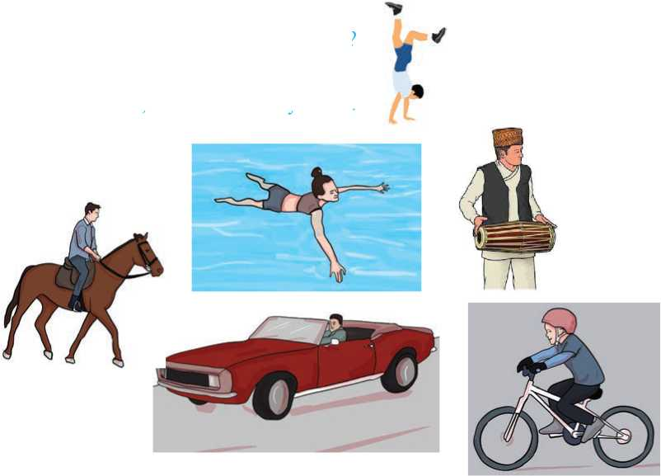
Figure 174 horse with man, A man drives car, cycling, exercise, swimming, A man with madal, a man stand on hands
C. Ask your partner whether she or he can do the things mentioned in the table. Then tell the class what your friend can do or can't do.

write with both hands | draw pictures with legs | drive a car | ride a bicycle | sew a button on a shirt
work with a computer | peel a pineapple | do bunjee jumping | make curry | climb a mountain

Example : Janak can write with both hands. He can't draw pictures with his legs

Grammar I
A. Read the text below and find the tag questions. Notice what punctuations are used to add the tag.
Mira is sitting alone and enjoying her surroundings. She looks around and speaks to herself. “Birds are free, aren't they? Although humans are the best creation of God, they can't fly in the sky, can they? Birds play an important role in the ecosystem, don't they? Humans have polluted the environment, haven't they? We must keep our environment clean, mustn't we?”
B. Add correct tag questions to the following statements.
- Smoking is hazardous to health, ?
- Preeti speaks excellent French, ?
- Please keep quiet, ?
- Everybody has finished their work, ?
- We do not go to school on Saturdays, ?
- I'm tired and hungry, ?
- Let's do our homework, ?
- Let him open the door, ?
- They'd build a house, ?
- You'd better help them, ?
- No one could solve the problem, ?
- Roshan's gone to school, ?
- You needn't stay out long, ?
- We'd prefer coffee, ?

Writing I
Write a news story using the outline given below.
Nepali Army (NA) collects 800 kg of garbage from Mt. Ama Dablam.
Mt. Ama Dablam clean-up campaign 2075 organised by Sagarmatha Pollution Control Committee (SPCC).
The Shumser Gulma, a company of Nepal Army participates
Financial assistance from Khumbu Village Body.
800 kg of garbage collected.
Handed over to the local community amid the program.
SPCC Chair Mr. Sherpa expresses his gratitude to NA.

Reading II
Answer the following questions.
- Which sports do you play or do? Why?
- Why is sports important for us?

Sports
There are many different kinds of sports that are undertaken by a wide variety of different people. Some people do sport for their career and other people purely do sport for enjoyment and recreation. Some sports, like cricket, require the use of a lot of equipment, while others need very little in order to successfully play a game in that sport. Some people use public playing fields to play sport for free, while other sports such as squash, tennis, badminton and table tennis are usually paid for on an hourly basis in the comfort of a local leisure centre.
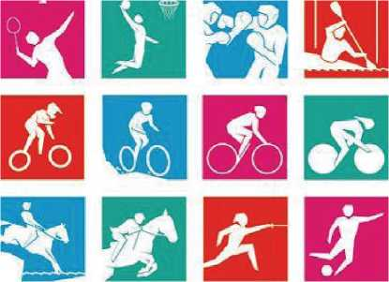
Most sports are played with a round object often known as a ball. Some sports use more than one ball and snooker is one of the unique sports that make use of a number of balls while being played. The game itself is often controlled by an impartial individual known as an umpire in cricket and a referee in sports like football and rugby. Most sports have a duration of not more than a few hours, however some athletic tournaments can last for up to a week and a game of cricket can be five days in duration before a winner is announced.
Figure 175 symbols of playing
Some people prefer to watch sports. This can either be done by going to a stadium, a local leisure centre, park or on television. It is often cheaper to watch sports from the comfort of a person's home than to visit the stadium or a special event. Some sports, such as football and cricket, are really popular in the United Kingdom but not in the USA. In the USA people often play basketball and baseball. However, most countries put aside time to compete in world sporting events such as the football world cup or the Olympics, which occur every four years.
Nowadays, people who have any kind of disability also participate in sports and most sport equipment is adapted to suit the needs of the disabled person. This means sport is something that can be enjoyed no matter the physical nature of the person. The Para-olympiks takes place a week after the main event and it is equally popular. Participation in sporting activity is encouraged by doctors and schools. It is for this reason and the competitive nature of individuals that sport remains a very popular activity worldwide.
A. Complete the following sentences with these words.
career recreation unique impartial adapted
- As a monitor, I must remain I should not
support one person more than another.
- My plan is to pursue a in medicine.
- The school the classroom doorway to allow wheelchair
users' easy access.
- We need a sports club in our school for
- He is very different from all of us. He is the most person
I've ever seen.
B. Choose the correct answer.
- Which sport requires the use of a lot of equipment?
I. football ii. athletics iii. cricket iv. rugby
- What sport is popular in the United Kingdom?
I. baseball ii. cricket iii. basketball
iv. athletics
- What sport can last longer than a day in duration?
i. football ii. baseball iii. rugby iv. cricket
- Which of the following information is stated in the first
paragraph?
I. time duration of the sports ii. inclusiveness in sports
iii. objectives of doing sports
iv. the ways people watch sports
- Which paragraph states the benefits of sports?
I. first ii. second iii. third iv. fourth
- Answer the following questions.
- Why do people do sports?
- What is common about most sports?
- What is the main quality of an umpire or a referee in sports?
- Is watching sports at home beneficial? How?
- Why is sports equipment adapted for people with disabilities?
- Why do doctors encourage people to do sports?
- What is your favorite sport? How might you make adaptations for people with a disabilities for this sport?

Listening
A. Answer the following questions.
- Do you listen to English news on radio or watch it on television?
Figure 176 news
- Share some highlights of a recent news broadcast on radio or television.
- Listen to the headlines on the audio and match the following places/clubs and the news related to them.
a. London I. Chi Chi gives birth to twins
b. Estonia ii. Thousands injured by hurricanes
c. USA iii. Young player Brillinho bought for the
highest price
d. Manchester United iv. Storms cause damage
e. Berlin Zoo v. Olympics to be organized
vi. New president elected

- Listen to the audio again and answer the following questions in no more than four words.
- Which city was competing with London to host the Olympics in 2012?
- When is Vladimir Shevchenko going to be enthroned as the president?
- Which parts of America are suffering from Maxwell and Nelly?
- How long will Brillinho play for his new club?
- When was the Chinese panda kept captive in Berlin Zoo?
- Listen to the 8 o'clock news on Radio Nepal and write three news headlines.

Grammar II
A. Match the affirmative sentences in column A with their negatives in column B.
Column A | Column B
The students have aced the | Could you not play the guitar please?
exam.
Play with the baby please. | She bought no one a present.
Could you play the guitar please? | Never knock on the door before entering.
The boss was friendly. | Alex didn't eat rice yesterday.
She bought someone a present. | The students have not aced the exam.
Always knock on the door before entering. | Stuti didn't use to live in London.
Stuti used to live in London. | The boss was not friendly.
Alex ate rice yesterday. | Don't play with the baby please.

B. Change the following sentences into negative ones.
- Your new friends are chatting online now.
- His teacher knows what to do.
- My classes started on time yesterday.
- Mary will come to the party.
- Raju had painted the wall when I reached his home.
- Rani is leaving Singapore tomorrow.
- My mother and grandmother always go to the temple on Saturdays.
- Some of the rice has gone bad.
- We have to work hard to live a decent life.
- Mr. Pant has won many awards.
- She usually carries a walking stick.
- Either Sobhana or Karma will attend the meeting.

Writing II
The following paragraph is paraphrased from the last paragraph of Reading II.
Read it carefully and paraphrase the first paragraph of it in a similar way.
Today, people with any kind of disability can take part in sports. Sports equipment are also modified to fit the needs of disabled people. Sports activities are encouraged by doctors and schools. So it is very popular in the world.

Project work
Imagine that your school is going to organize sports week next month. Work in groups and prepare a Sports Week Schedule and display it in the class.

Extra bit
Paraphrasing
Paraphrasing is a restatement of a text or passage giving the meaning in another form. In paraphrasing, you have to rewrite a passage without changing the meaning of the original text.
Steps of paraphrasing
- Read the passage several times to fully understand the meaning.
- Note down key concepts.
- Write your version of the text without looking at the original.
- Compare your paraphrased text with the original passage and make minor adjustments to phrases that remain too similar.
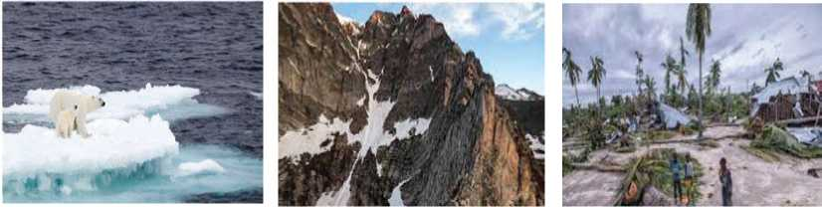

Unit 17 Global Warming and Climate Change

Getting started
Look at the pictures and discuss the causes and consequences of global warming and climate change.

Figure 177 snow

Reading I

Answer the following

- What is the name of your favourite movie?
- What sort of movie is it?
- What do you like about the movie? What are its weaknesses

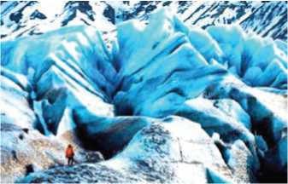
Movie Review : Chasing Ice
Title : Chasing Ice
Genre :Documentary, Biography
Language : English
Director : Jeff Orlowski
Producer : Jerry Aronson, Paula Dupré Pesmen, Jeff
Orlowski
Figure 178 chasing ice Oscars
Writer : Mark Monroe
Release Date : Aug 10, 2016
Runtime: 1h 14m
Produced by: Diamond Docs, Exposure

In the wake of Hurricane Sandy, the power and unpredictability of nature and the ever-changing weather patterns have become increasingly apparent. As topics such as weather and global warming become increasingly prevalent in today's culture, James Balog's documentary Chasing Ice provides striking images of how climate change has caused glacial erosion.
The award-winning movie which opens in Los Angeles on Nov. 23, traces the journey of environmental photographer Balog as he attempts to capture the erosion of glaciers in the Arctic through photographs and video. In order to accomplish this goal, Balog started his own project and dubbed it in the Extreme Ice Survey. This endeavor began as a project for National Geographic and turned out to reach a broader scope by tackling the problem of glacial erosion.
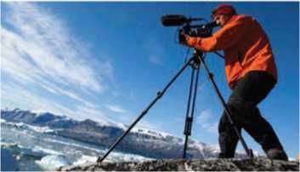
Balog's survey began with a total of 25 cameras that were to be monitored over the course of three years. The cameras were housed in protective units in order to prevent their destruction in the harsh Arctic weather, and Balog's team periodically downloaded the footage.
Figure 179 photographer
After having photographed glaciers in the past, Balog says in the film that he wanted to return to some of the same places he had visited to see how the glaciers had changed. He and his team set up cameras in Greenland, Iceland, Alaska and Montana's Glacier National Park.
The documentary begins with a series of striking and intense video clips of multiple natural disasters. Balog establishes the goal of the film from the very beginning by explaining his own initial skepticism regarding climate change and academic research on this topic. This makes Balog more relatable and increases his credibility as a photojournalist who ends up finding evidence for what he once doubted was actually occurring.
This documentary effectively combines data and scientific facts with visually appealing images that make climate change more real. Balog's photographs and time-lapse footage of glaciers “calving” or breaking apart into icebergs, allow viewers to see and experience what is actually happening in these zones. The bigger the screen, the better to view the beautiful images that Balog has captured, many of which most people will never have the chance to experience in person.
Balog also refrains from overwhelming his audience with too many scientific details and makes the data easy to understand. He explains his methods and how he interprets his results without coming across as boring. It is hard to watch an avalanche on screen or see the extreme erosion of glaciers over a short period of time and not realize that Balog is clearly onto something.
The film also incorporates a sense of the extreme lengths that Balog and his team, including a glaciologist and a climatologist, were willing to go to capture footage of this glacial erosion. There are scenes in which Balog cries out in disappointment when some cameras are not working and other moments when he puts himself in quite precarious positions as he descends into holes and caves of ice in order to get the best shot. Not to mention the knee surgery that threatens to keep him from ice hiking on his journey.
Chasing Ice is definitely a worthwhile documentary that combines intriguing theories and exquisite images. Those who are skeptical about theories on the environment might be reluctant to see the film, but there is still something to be gained from Balog's research. Balog and his team make viewers think critically about climate change and what it can mean for our future.
- An drea Seikaly
A. Match the following words with their meanings.
a. | reluctant | i. extremely beautiful or carefully made
b. | intriguing | ii. a mass of snow, ice and rock that falls down the side of a mountain
c. | exquisite | iii. very great; so powerful that you cannot resist it
d. | avalanche | iv. arousing one's curiosity or interest; fascinating
e. | overwhelming | v. hesitating to do something
f. | credibility | vi. the quality of being trusted and believed in

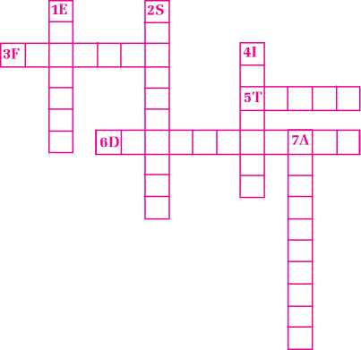
B. Find the words from the text and fill in the crossword puzzle.
Across
Figure 180 English crossword puzzles
- part of a film showing a particular event
- to find the origin or cause of something
- a film or a radio or television program giving facts about something
Figure 181 english word puzzle
Down
1. the fact of soil, stone, etc. being gradually damaged and removed by the waves, rain, or wind
- an attitude of doubting that claims or statements are true
- having or showing very strong feelings
- to succeed in doing or completing something; achieve
- Complete the sentences with the appropriate words/phrases from the text 'Chasing Ice'.
- Chasing Ice glacial erosion is the result of
- The beginning of the film is set in
- James Balog began his project with a photography program
called
- Balog wanted to go back to the scene of the photography to see
how the had changed.
- The film is based on both data and on
- The audience can have a better view of the images in
- Balog's project team consisted of
- The person doubting about may hesitate to see the film.
- Answer the following questions.
- What kind of film is Chasing Ice?
- What is the main objective of the film?
- Why did Balog and his team set up cameras in different places?
- What helps the audience experience what is happening in the Arctic Zones?
- How did Balog try to make the film interesting?
- Why is Chasing Ice a worthwhile film?
- Work in a group of four or five. Suggest five practical ways to slow down the adverse effects of climate change.

Pronunciation
Read the words in the box below with the correct pronunciation. Put them in the correct groups.
food | book | cook | foot | moon | noon | roof | room good | school
look | hook | stood | took | soon | wood | too | zoo zoom | wool

/ʊ/ | /uː/
book | food

Speaking
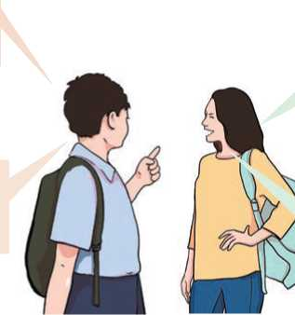
A. Read and act out the following conversation.
Figure 182 boys and girls
Do you think they have returned home?
Who is that man?
He is wearing a chef's uniform. He works in a restaurant. He must be a chef.
'■! Their car is not at
7 home. So, they can't
have returned.

- Work in pairs. Have similar conversations in the following situations using must, can't, mayor might.
Example: Suman is not at home. These are office hours.
A: Where is Suman?
B: He must be in his office.
- They are coming this week, but I am not sure. They will probably come tomorrow.
- Dolma is not sure that she will pass the exam.
- Shishir has bought a lottery ticket. He could become a millionaire.
- Rajesh looks like a foreigner. He speaks excellent French.
- Sambriddhi has got a job. I'm sure she is very happy.
- I hope to finish the project tonight. However, I am not sure.
- There is somebody at the gate. They always come at eight. I am sure they are road cleaners.
- You met a friend at a party and started talking about your day. Ask his/her opinions about the things below. Your friend will answer you using 'must', 'can't', 'may 'or 'might'.
- My father wasn't in a very good mood today when I reached home from school.
- My English teacher got a phone call during the class and left the room immediately. He looked very worried at that time.
- My friend Pratima looked very pleased today when she returned back to the class from the principal's office.
- Someone's stomach in the class made a growling sound. I do not know why she/he had that problem.
- A friend of mine was terribly worried after the English test.

Grammar I
- Fill in the gaps with the correct forms of the verbs in the brackets.
- I (have) no time to do any additional projects next year.
- Sambriddhi (finish).... her homework before her parents
returned home.
- My uncle (learn) to talk in English by the time he finishes
this course.
- Sandeep (stay) at ours till Monday.
- The workers (build) the building for the next two
months.
- You (find) the meaning of the unfamiliar words in an
hour.
- We (stay) in Damauli until next Saturday.
- I think our team (win) the match.
- By 11 p.m. tonight, she (prepare) the report.
- After I finish my work tonight, I (watch) TV for
some time.
- The weather forecast says that it (rain) heavily today.
- Rewrite the following paragraph using the verbs in future tense.

Visiting Her Majesty
I travelled to London to visit the Queen of England. I disguised myself as a prince and walked into Buckingham Palace. After receiving directions from a chambermaid, I stepped into the Queen's bedroom and surprised Her Royal Highness with a hearty slap on the back. Then, of course, I tipped my hat, bowed, and delivered the usual compliments. After uncorking a bottle of champagne, we exchanged pleasantries and talked about our families for more than an hour. I showed her my photograph album and my stamp collection. She showed me her historic collection of jewels. After a thoroughly entertaining visit, I traded email addresses with Her Majesty and then kissed her goodbye—on the fingertips of her white gloves, of course.Writing I
Write a short review of your favorite movie. You may use the movie review in Reading I as a model.

Reading II
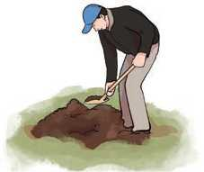
Look at the picture and answer the following questions.
Figure 183 man shovel digging
- Where do you think the man is?
- How old do you think he is?
- What might he be doing?

A Noisy Party
Ramila : | Hey, Silu's Papa! Wake up!
Ramesh : | Eh! What? What's the matter? It can't be eight o'clock already.
Ramila : | No, it's half past one. It's those people next door again. Listen.
Ramesh : | Oh, yes. I think they are having another party.
Ramila : | Listen to that. I'm sure they are waking up the whole street. Nobody can sleep through that noise. It's disgusting! Somebody should call the police! Hey, wake up!
Ramesh : | Eh! I wasn't asleep dear. I'm pretty sure that they are laughing. They must be having a good time! They never invite us, do they?  (After some time)
Ramila : | Silu's Papa!
Ramesh : | Yes, dear. What is it now?
Ramila : | Listen! They are leaving.
Ramesh : | Thank goodness for that! Maybe we will get some sleep.

Ramila : | I hope so. It's nearly three o'clock. Goodnight dear.
Ramesh . | Oh, hell! What's that? They are having a row now.
Ramila : | I'm not surprised. They always have rows after parties.
Ramesh : | I'm certain that they are throwing pots and pans again.
Ramila : | No, I'm sure that was a plate dear, maybe the TV. They'll be sorry in the morning.  (After some time)
Ramila : | Silu's Papa! Listen. There's someone in the garden next door.
Ramesh : | Eh! It must be the milkman.
Ramila : | No. I am certain it's not him. It's too early. Who could it be? You'd better have a look.
Ramesh : | All right. Gosh! It's Mr Dahal and there is no doubt that he's carrying a spade.
Ramila : | Oh, no! You don't think he has killed her, do you?
Ramesh : | If he's killed her, he might be burying the body.
Ramila : | What? You don't think so, do you?
Ramesh : | He can't be planting potatoes, can he? Shall I call the police?
Ramila : | No, ask him what he's doing first!
Ramesh : | Hello, there, Mr Dahal. You are up early this morning.
Dahal : | I haven't been to bed yet. We had a party last night. I hope we didn't keep you awake.
Ramesh : | Oh, no. We didn't hear anything, nothing at all.
Dahal : | Well, it was a pretty noisy party. My wife knocked over the goldfish tank while we were clearing up. The poor fish died. I'm just burying them before the children wake up.

A. Find the words from the text above that match with the given meanings.
a a situation that you must deal with
b unpleasant, horrible
c noisy quarrel
d expression of surprise
e a small orange or red fish
- to put something under the ground
B. Choose the correct answer for the following.
- What is the relationship between Ramila and Ramesh?
- Friends ii. brother and sister iii. husband and wife
- Who is woken up by the noise?
I. Silu ii. Silu's father
iii. Silu's mother
- Why is Ramila certain that it's not the milkman in their neighbor's garden?
- because their neighbors never get milk delivered to their house
- because it's too early for a milkman to deliver milk
- because the man is carrying a spade
- What do Ramesh and Ramila suspect about Mr Dahal?
- They think he has killed the fish.
- They think he has broken plates and glasses.
- They think he has killed Mrs Dahal.
- What was Mr Dahal actually doing in the garden?
i. He was burying the dead fish.
iii. He was burying the dead body.
iii. He was planting potatoes.
- What was the party like last night?
I. It was quiet. iii. It was noisy. iii. It was violent.
- Who had broken the goldfish tank?
I. MR Dahal ii. Mrs Dahal iii. the guest
- Write T for true statements, F for false ones and NG if the information is not given in the text.
- Silu is the daughter of Ramesh and Ramila.
- Ramesh and Ramila are disturbed by the first noise at midnight.
- The Dahals have a good relationship with their neighbours.
- The Dahals always quarrel after parties.
- Ramesh and Ramila called the police to arrest Mr Dahal.
- Mr Dahal wants his children to know about the death of the fish.
- Have you ever been disturbed in the middle of the night? What happened? Share your experiences with your friends.

Listening
A. Look at the following pictures. They represent various weather conditions. Choose correct adjectives from the box and write them below the pictures.
Windy cloudy rainy sunny snowy foggy
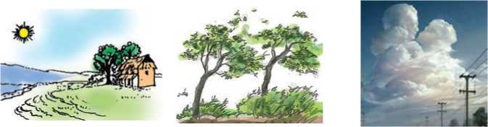
Figure 184 house of the sun rising, wind blows on tree, cloud,

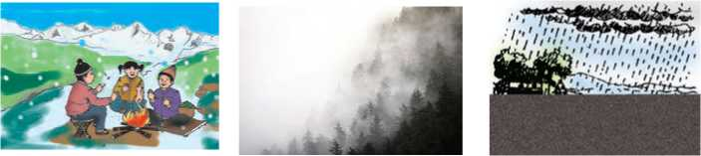
Figure 185 winter ,snow, rain

B. Listen to the audio and match the beginnings of the sentences (a-e) with the sentence endings (A-F). Write your answers in the column provided. There is an example at the beginning.
Example | Different people | E
a. | The people in England
b. | The weather in England
c. | The people in Dubai
d. | The weather in Dubai
e. | Global warming

A | don't think about the weather much.
B | is almost the same the whole year.
C | are always concerned about the weather there.
D | is changing weather patterns.
E | think differently about the weather.
F | is very changeable.

Grammar II
A. Change the following statements into questions, asking for information as indicated in the brackets.
- They went to Spain last week. (When)
- Mr Chaudhari lives in Pokhara. (Where)
- I finally discovered the truth. (What)
- She wants to learn the English language to find a better job. (Why)
- They are having lunch now. (What)
- You can send the application by mail. (How)
- They have informed the police about the incident. (Whom)
- The Smiths sold the house where they had lived for five years. (Which)

- Change the following questions into indirect speech. Use the given sentence starters.
- “Where are you from?”
My new friend asked me
- “Where is the nearest bank?”
The stranger enquired
- "What have you been doing until now?"
My mother wanted to know
- They said, “How long have you been living here?”
They asked
- "Who is the Prime Minister of Canada?"
My brother wanted to know
- "What does your father do?"
Rohan enquired
- "Where were you living before you came here?"
She asked me
- "Who will bell the cat?"
The old mouse asked
- "What time does the train leave?"
She wanted to know
- "How could you desert me?"
She wondered
- Collect at least ten statements and change them into wh- questions. Swap with a partner and check each other's answers.

Writing II
A. Read the following notice and underline all the important information.
Shree Janajagriti Secondary School
Bhanu-10, Tanahun
14 June 2021
Notice
This is to notify all the students and parents that the school will remain
closed from 15th June 2021 to 15th July 2021 for the summer vacation.
Regular classes will resume from 16th June 2021.
Head Teacher
B. Imagine, your school is organizing an Inter-house Spelling Contest next week. Prepare a short announcement notice on behalf of your head teacher.

Project work
Work in groups. Prepare some illustrations depicting the impact of global warming on the environment. Then, display the illustrations on the walls of your classroom. Review the other groups' work and provide feedback.

Extra bit
Linking Verbs
A linking verb connects the subject of a sentence with a word that gives information about the subject, such as a condition or relationship. They do not show any action; they simply link the subject with the rest of the sentence. For example, in the sentence "The ball is red.” 'is' is a linking verb that connects the subject, ball, to information about that subject.
Linking Verbs: be (is, are, become, seem, feel, sound, taste, look, smell, appear, remain, stay, prove, turn, etc.

Unit 18 Transportation and Communication

Getting started
Look at the pairs of pictures, talk about them in groups making comparesions
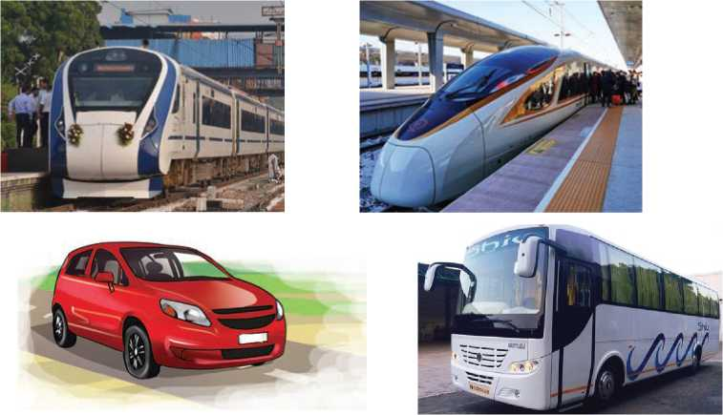
Figure 186 train car and bus

Reading I
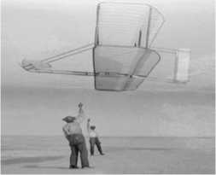
Look at the pictures below and guess the answers.
- Who are the people seen in the picture?
- What are they doing?
Figure 187 Wright Kite

Wright Brothers
Wilbur (1867-1912) and Orville Wright (18711948) were brothers. They lived in Dayton, Ohio, USA. Their father, Milton, was a bishop in the Church of the United Brethren in Christ. Their mother, Susan, made toys for her children and encouraged their curiosity. One day, Milton Wright brought home a small toy "helicopter" made of wood with two twisted rubber bands to turn a small propeller. Wilbur and Orville played with it until it broke, and then made new copies of the toy themselves. They also sold toys to their friends, including handmade kites. The Wright brothers did things together from the time they were small boys.
The Wright brothers went into the printing business together in 1889. Three years later, they opened their first bicycle shop. Initially, they sold and repaired bicycles. They would replace spokes, fix broken chains, and sell accessories. In 1896, they began to build their own brand of bicycles. Their experiences with bicycles aided them in the investigations of flight. They used the technology they learned from their bicycle business in their airplanes: chains, sprockets, spoke wires, ball bearings, and wheel hubs. Their thoughts on balancing and controlling their aircraft were also rooted in their experience as cyclists.
Orville and Wilbur Wright were convinced of the need to control an aircraft in three axes of motion. An elevator, or horizontal control surface, in front of the wings on their aircraft, enabled the pilot to control climb and descent. The elevator was controlled by a lever in the pilot's left hand. A "wing warping" system controlled the aircraft in a roll. To initiate a roll, the pilot would shift his hips from side to side in a cradle on the lower wing, "twisting" the wings left or right or restoring them to level flight. Orville and Wilbur developed this idea from observing birds in flight. They observed the buzzards keeping their balance by twisting their wings and sometimes curving one wing more than the other. In 1902, the brothers added a vertical rudder to the rear of their machine to control the left and right motion of the nose of the aircraft.
The Wright brothers began their aeronautical research in 1899. Their first aircraft was a small kite with a 5-foot wingspan that was used to test their notions of aircraft control. In 1900, they built their first machine designed to carry a pilot and chose Kitty Hawk, N.C., as a suitable testing ground. With its strong steady winds, open areas, and tall sandy dunes, the area was perfect for their experiments. When their 1900 aircraft produced less lift than expected, the Wright brothers flew it as a kite and gathered information that would enable them to design improved machines. They returned to Kitty Hawk in 1901 with a new glider that did not perform as they expected. While they had learned a great deal with their first two machines, they had also encountered new puzzles and dangers.
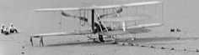
To simulate flight conditions, the Wrights tested small model wings in a wind tunnel they had built. The wind tunnel was a box with a fan at one end that blew a steady stream of air over model wings mounted on a special "balance" inside the tunnel. Using this device, the brothers were able to gather information that could be used to design the wings of the gliders and powered aircraft that would carry them into the air. The wind tunnel provided them with information on the most satisfactory wing shape. It also enabled them to calculate the size of wing that would be required to lift them into the air, the performance of their propellers, and the amount of power that their engine would have to produce. *- They based the design of their next glider on this information.
Figure 188 Wright Flyer
During the 1901 glider tests, the Wright brothers had discovered that "wing warping" created unequal drag on the two wings. The key to solving the control problem was the addition of a rudder to the glider design in 1902. They developed a direct linkage between the rudder and warping system. With the success of this system design, the Wrights were ready to move onto a powered aircraft.
At Kill Devil Hills, N.C., at 10:35 am, the Wright 1903 Flyer took off under its own power with Orville as the pilot. It flew 12 seconds and went a distance of 37 metres. Orville and Wilbur took turns making three more flights that morning. Wilbur was at the controls for the fourth and longest flight, traveling 260 meters in 59 seconds. The Wright 1903 Flyer became the first powered, heavier-than-air machine to achieve controlled, sustained flight with a pilot aboard. Today, this amazing flying invention can be viewed as it is suspended overhead, at the National Air and Space Museum in Washington, D.C.
Having achieved success in North Carolina, the Wright brothers decided to continue their experiments closer to home. They built and flew their second powered airplane at Huffman Prairie, a pasture eight miles east of Dayton, Ohio. Progress was slow without the strong, steady winds of Kitty Hawk, but the brothers did achieve the first circular flight of an airplane on September 20, 1904. This first complete circle flight lasted only 1 minute 36 seconds and covered 1,244 metres. Stability problems still plagued their invention. The modifications made during 1904 helped
but did not solve the stability problem.
This Flyer was the world's first practical airplane. During more than 40 flights at Huffman Prairie, the machine was repeatedly banked, turned, circled, and flown in figure eights. On two occasions the flight exceeded half an hour. Wilbur and Orville Wright, brilliant self-trained engineers, had overcome complex technical problems that had barred the way to mechanical flight for centuries. Think about how their invention has changed our world.
A. The meanings of the words are given below. Find the words from the text above.
- a equipment that are useful but not essential
- d an action of going down
- a connected with the science or practice of building and
flying aircraft
- s fixed in a place or position, supported or balanced;
constant
- e a scientific procedure undertaken to make a discovery
- p to cause pain or trouble to somebody over a period
of time
B. Match the following words with the appropriate pictures. (Write a, b, c or d below the picture.)
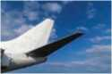
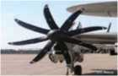
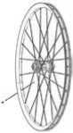
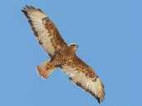
a. propeller
b. spokes
c. elevator d. buzzard
………… …………… ………. ………………

- State whether the following statements are true or false.
- The Wright brothers sold copies of toy helicopters at the market.
- They had a printing business in their cycle shop.
- The experience of cycling helped them to generate ideas for controlling and balancing aircraft.
- The wing warping system controls the aircraft in a roll.
- They learned more about balancing by watching other aircraft fly.
- Their first experimentation was with a kite.
- Wilbur Wright was the pilot of their 1903 Flyer.
- Their aircraft could only fly straight.
- Put the following events from the text above in chronological order.
- Their first Flyer took off under its own power with a pilot.
- The Wright brothers opened a cycle shop.
- The Wright brothers developed a machine overcoming complex technical problems.
- Milton Wright brought home a toy helicopter.
- Wright brothers built their first machine designed to carry a pilot.
- The children made copies of the toy helicopter.
- The Wright brothers began their aeronautical research.
- The Wright brothers started a printing business.
- Answer the following questions.
- What services did the Wright brothers offer from the cycle shop?
- How did their cycle business help them to build an aircraft?
- How did the brothers develop the idea of balance and control in the flight of an aircraft?
- What was their first aircraft like?
- What did they do to create the flight conditions?
- What is "wing warping"?
- When and where did the first Flyer take off?
- What progress had they made by 1904?
- What was the world's first practical airplane like?

- What improvements have been made to aircraft since the time of Wright brothers to the modern day? Discuss.

Speaking
- Talk about the following animals using suitable forms of adjectives as in the example.
Example: bear/wolf/dangerous
A: Which animal is more dangerous?
B: I think the wolf is more dangerous than the bear.
- bear/tiger/snail (aggressive)
- elephant/giraffe (tall)
- monkey/dolphin/tortoise (intelligent)
- rhino/elephant (heavy)
- bear/lion (strong)
- hen/pig/dog (dirty)
- rattlesnake/cobra (dangerous)
- snail/tortoise (slow)
- cobra/python/anaconda (poisonous)
- donkey/zebra (fast)
- Compare a car and a bike. Use the adjectives and adverbs given below.
Figure 189 girl think
fast comfortable expensive safe
easy
eco-friendly cheap
good for health
Example: A car is faster than a bike whereas a bike is easier to ride.

Grammar I
A. Read through the Wright Brothers' text again and underline the adjectives and adverbs. Then, write them under the respective headings in the table below.
Adjectives | Adverbs
small | initially

B. Choose the correct words from the brackets and fill in the blanks.

- Shishir was injured in a car accident. (serious/seriously)
- The other passengers sustained injuries. (serious/
seriously)
- You behaved very (selfish/selfishly)
- Riyasa is upset for having lost the job. (terrible/ terribly)
- There was a change in the weather. (sudden/suddenly)
- All the men and women had worn dresses. (colourful/
colorfully)
- Lalita was dressed. (colorful/colorfully)
- Rajkumar fell off the roof and hurt himself quite (bad/
badly)
- Netra was trying to win Nirmal's trust. (hard/hardly)
- Don't climb that tree. It doesn't look (safe/safely)
- He gave me an look when I interrupted him. (angry/
angrily)
- Look at that snake! It seems very (dangerous/dangerously)

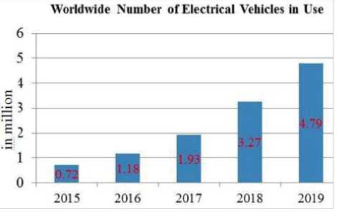
Writing I
The bar chart shows the world trend regarding the use of electrical vehicles from 2015 to 2019. Write an interpretation of the bar chart making comparisons where necessary.

Reading II
Look at the picture below and answer the questions.
- What does the rickshaw puller look like?
- Is the rickshaw rider happy? Give reasons.

Rickshaw Ride
That man by the harbor
Spitting into the water
Is as old as China.
He is made of leather
And his folded face
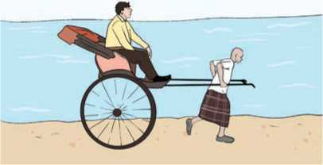
Is like a sandbar At low tide.
Figure 190 Rickshaw
Will you take a ride
On his rickshaw?
He will not thank you For your dollar,
He knows that to you
A dollar does not matter.
Off you go with a clatter
Up to Victoria
On up the long hill
Pass the cathedral
To the peak Tram
Pull! Pull!
He leans to it
His muscles at neck and calf and shoulder
And his dark veins that snake
Take your eye
Not what passes by.
Let him not break
Something for my sake,
For my dollar.
You went to Hong Kong
They will say.
Did you take a rickshaw?
Was it fun?
Did he run, your rickshaw man
Yes, he ran.
No, it was not much fun.
-John Hill
A. Match the words with their meanings.
a. | harbour | i | to move in long twisting curves
b. | folded | ii. | for the purpose of; in the interest of; in order to achieve or preserve
c. | sandbar | iii. | a protected area on the coast
d. | snake | iv. | the main church
e. | sake | v. | a vehicle driven by electricity
f. | clatter | vi. | loud noise from hard objects knocking together
g. | cathedral | vii. | a long mass of sand, especially at the mouth of the river
h. | tram | viii. having slight folds; wrinkled

- Fill in the blanks with the correct words/phrases from the poem.
- The old man is waiting for customers at the
- He is very weak with face.
- He knows that a is nothing for the rider.
- He takes the rider as far as to
- The rider's eyes are caught by the old man's twisted
- The rider didn't have the when riding.
- Answer the following questions.
- How old is the rickshaw puller?
- What does ‘he is made of leather' mean?
- What attracts the attention of the rider?
- Why does the rider want the rickshaw puller not to fall?
- Did the man enjoy the rickshaw ride? Give reasons.

D. Find suitable adjectives to describe the rickshaw puller. Complete the mind map.
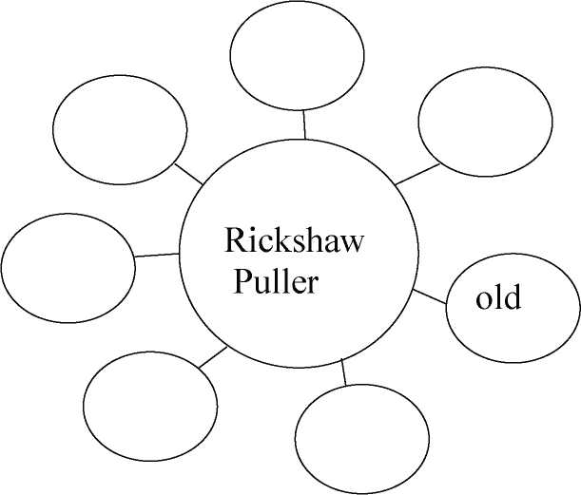

Pronunciation
Listen to your teacher and read the following sentences. Then write the type of intonation they represent.
- Will you go for ride on his rickshaw?
- My parents bought rice, cereals and vegetables.
- You don't often go there, do you?
- Santoshi is a smart girl.
- Wow! It's finally snowing.
- None of the strategies are working, are they?
- What's your favorite subject?
- Can they finish the project in time?
- How can I help you?
- Nice to meet you.

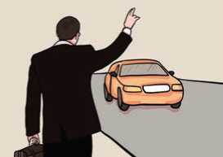
Listening
Figure 191 man wait for car
A. Answer the following questions.
a. How do you usually travel?
b. What is the main means of transportation where you live?
B. Listen to the audio and choose the correct alternative to answer the questions.
- Where does the passenger want to go?
- National Art Museum ii. National History Museum
- National Military Museum
- How long does it usually take to reach the passenger's destination?
I. less than twenty minutes ii. more than twenty minutes
iii. about twelve minutes
- What is the taxi fare?
I. 18 dollars including the tax ii. 18 dollars including the tip
iii. 18 dollars excluding the tip
- What time does the museum close?
I. at four o'clock ii. at half past four iii. at six o'clock
- What is the best way to get to the restaurant, La Fajita, from the museum?
I. taking the subway ii taking a bus iii. taking a taxi
- Why is it inconvenient to take a taxi to the museum?
- They don't often run by the museum.
- They have to be transferred a couple of times.
- They don't stop near the museum.
- Fill in the gaps with the correct words/phrases from the audio.
- The passenger the taxi driver for stopping for him.
- The time to reach the museum depends on the
- The driver claims that he is not an
- The passenger enquires about what time the museum
- The taxi driver knows that it's the the man is visiting the city.
- According to the driver, La Fajita is the best in town.
- The don't run by the museum very often.
- Name any two places in your locality that are worth visiting. Where are these places located? Talk about their facilities, accommodation, etc. for the visitors.

Grammar II
Use the correct forms of the adjectives or adverbs given in the brackets.
- The Marsyangdi is one of the rivers in Nepal. (big)
- Thani Mai is a temple in the whole district. (famous)
- A spider is not usually as as a snake. (deadly)
- The children are really enjoying the movie. They are watching
it than the adults. (interestingly)
- Mr Shrestha is the teacher in the whole school.
(humorous)
- Children are considered to be than adults. (innocent)
- A computer is than a pocket calculator. (expensive)
- My sister is almost as as my mother. (tall)
- My math exam was much than the history exam. (good)
- Bungee jumping really scares me. I find it than
paragliding. (dangerous)
- Sima is walking than Sarad. (carefully)

Writing II
You might have travelled to different places. Write an account of one of your journeys. Include the following guidelines in your writing.
where you went  who you went with  what you’ve learnt | how you travelled there  what you did

Project work
Find information about the invention of the telephone. Then, write a short piece about the history of its development. Include relevant illustrations.

Extra bit
Types of Adverbs
Adverbs of Degree | Adverbs of Frequency | Adverbs of Manner | Adverbs of Place | Adverbs of Time
almost enough nearly quite so too hardly just | again always never rarely normally seldom sometimes usually | well happily beautifully quickly easily slowly neatly honestly | above below everywhere nowhere out outside inside there | annually daily weekly monthly today yesterday last year/ week tonight

Glossary
acorn //ˈeɪkɔːn/ (n.):the fruit of the oak tree, a smooth oval nut in a rough cup-shaped base aeronautical /ˌeərəˈnɔːtɪkl/ (adj.): connected with the science or practice of building and flying aircraft
allegorical /ˌæləˈɡɒrɪkl/ (adj.): using characters or events as symbols to represent an idea or a quality, such as truth, evil, death, etc.
alliance /əˈlaɪəns/ (n.): agreement between countries, political parties, etc. to work together in order to achieve something that they all want
amendment /əˈmendmənt/ (n.): a minor change or addition designed to improve a text, piece of legislation, etc.
appliance /əˈplaɪəns/ (n.): a device or piece of equipment designed to perform a specific task
assertion /əˈsɜːʃn/ (n): a confident and forceful statement of fact or belief
astonishing /əˈstɒnɪʃɪŋ/ (adj.): extremely surprising or impressive; amazing
attribute /əˈtrɪbjuːt:t/ (v.): regard something as being caused by
authoritatively /ɔːˈθɒrətətɪvli/ (adv.): in a way that is trusted as being accurate or true
avalanche /ˈævəlɑːnʃ/ (n.): a mass of snow, ice and rock that falls down the side of a mountain bartender /ˈbɑːtendə(r)/ (n.): a person serving drinks at a bar
beam /biːm/ (n.): a long, sturdy piece of squared timber or metal used to support the roof or floor of a building
beaver /ˈbiːvə(r)/ (n.): a large semiaquatic broad-tailed rodent native to north America and northern Eurasia
bitcoin /ˈbɪtkɔɪn/ (n.): a system of electronic money, used for buying and selling online and without the need for a central bank
black sheep /ˌblæk ˈʃiːp/ (n.): a person who is different from the rest of their family or another group and is considered bad
bristle /ˈbrɪsl/ (v.): (of hair or fur) stand upright away from the skin, typically as a sign of anger or fear
bustle /ˈbʌsl/ (v.): move in an energetic and busy manner
buzzard /ˈbʌzəd/ (n.): a large hawk like bird of prey with broad wings and a rounded tail capitulation /kəˌpɪtʃuˈleɪʃn/ (n.): the act of accepting that you have been defeated by an enemy or opponent
caribou /ˈkærɪbuː/ (n.): a large north American reindeer
chap /tʃæp/ (n.): a man or boy
clatter /ˈklætə(r)/ (n.): loud noise from hard objects knocking together
clinician /klɪˈnɪʃn/ (n.): a doctor having direct contact with patients rather than being involved with theoretical or laboratory studies
compensation /ˌkɒmpenˈseɪʃn/ (n.): something, typically money, awarded to someone in recognition of loss, suffering, or injury
contort /kənˈtɔːt/ (v.): twist or bend out of the normal shape
culpability /ˌkʌlpəˈbɪləti/ (n.): responsibility for a fault or wrong; blame
deference /ˈdefərəns/ (n.): polite submission and respect
deploy /dɪˈplɔɪ/ (v.): bring into effective action
despair /dɪˈspeə(r)/ (n.): the feeling of having lost all hope
dimension /daɪˈmenʃn/ (n.): a measurable extent of a particular kind, such as length, breadth, depth, or height
discreditable /dɪsˈkredɪtəbl/ (adj.): tending to bring harm to a reputation
disgusting /dɪsˈɡʌstɪŋ/ (adj.): extremely unpleasant
dislodge/dɪsˈlɒdʒ/ (v.): knock or force out of its position
disseminate /dɪˈsemɪneɪt/ (n.): to spread information, knowledge, etc. so that it reaches many people divinity /dɪˈvɪnəti/ (n.): the state or quality of being divine
dogged /ˈdɒɡɪd/ (adj.): showing determination; not giving up easily
dormant /ˈdɔːmənt/ (adj.): (of an animal) having normal physical functions suspended or slowed down for a period of time
downy /ˈdaʊni/ (adj.): soft and fluffy
effusive /ɪˈfjuːsɪv/ (adj.): showing or expressing gratitude, pleasure, or approval in an unrestrained or heartfelt manner
eke out /iːk aʊt/ (p.v.): to make a small supply of something such as food or money last longer by using only small amounts of it
elk /elk/ (n.): a large deer that lives in the north of Europe, Asia and north America
embark /ɪmˈbɑːk/ (v.): to get onto a ship or plane
engross /ɪnˈɡrəʊs/ (v.): absorb all the attention or interest of
enticement /ɪnˈtaɪsmənt/ (n.): something used to attract or to tempt someone
erupt /ɪˈrʌpt/ (v.): break out suddenly and dramatically
excavation /ˌekskəˈveɪʃn/ (n.): the activity of digging in the ground to look for old buildings or objects that have been buried for a long time
excel /ɪkˈsel/ (v.): to be very good at doing something
exceptional /ɪkˈsepʃənl/ (adj.): unusually good; outstanding
exquisite /ɪkˈskwɪzɪt/ (adj.): extremely beautiful or carefully made
extramarital /ˌekstrəˈmærɪtl/ (adj.): happening outside marriage
facet /ˈfæsɪt/ (n.): a particular part or aspect of something
fallow /ˈfæləʊ/ (adj.): not used for growing crops
fascination /ˌfæsɪˈneɪʃn/ (n.): a very strong attraction, that makes something very interesting
fiat /ˈfiːæt/ (n.): an official order given by somebody in authority
fleet /fliːt/ (n.): a group of ships sailing together, engaged in the same activity, or under the same ownership
footage /ˈfʊtɪdʒ/ (n.): part of a film showing a particular event
forum /ˈfɔːrəm/ (n.): an event or medium where people can exchange opinions and ideas on a particular issue
frenzy /ˈfrenzi/ (n.): a state or period of uncontrolled excitement or wild behavior
giddiness /ˈɡɪdinəs/ (n.): a sensation of whirling and a tendency to fall or stagger
gilt /ɡɪlt/ (n.): a thin layer of gold, or something like gold that is used on a surface for decoration gruesome /ˈɡruːsəm/ (adj.): causing repulsion or horror
gunk /ɡʌŋk/ (n.): any unpleasant, sticky or dirty substance
harness /ˈhɑːnɪs/ (n.): a set of straps and fittings by which a horse or other draught animal is fastened to a cart, plough, etc. and is controlled by its driver
hibernate /ˈhaɪbəneɪt/ (v.): (of an animal or plant) spend the winter in a dormant state
hieroglyph /ˈhaɪərəɡlɪf/ (n.): a picture or symbol of an object, representing a word, syllable or sound, especially as used in ancient Egyptian and other writing systems
hilarious /hɪˈleəriəs/ (adj.): extremely amusing
hippie /ˈhɪpi/ (n.): a person who rejects the way that most people live in Western society
humanoid /ˈhjuːmənɔɪd/ (adj.): having an appearance or character resembling that of a human inconveniences /ˌɪnkənˈviːniəns/ (n.): the state or fact of being troublesome or difficult with regard to one's personal requirements or comfort
incorporate /ɪnˈkɔːpəreɪt/ (v.): take in or contain (something) as part of a whole; include
indigenous /ɪnˈdɪdʒənəs/ (adj.): belonging to a particular place rather than coming to it from somewhere else
indiscriminately /ˌɪndɪˈskrɪmɪnətli/ (adv.): without thinking about what the result of your actions may be
intriguing /ɪnˈtriːɡɪŋ/ (adj.): very interesting because of being unusual or not having an obvious answer
intrinsic /ɪnˈtrɪnzɪk/ (adj.): belonging to or part of the real nature of something/somebody
inure /ɪˈnjʊə(r)/ (v.): accustom (someone) to something, especially something unpleasant
invasion /ɪnˈveɪʒn/ (n.): the act of an army entering another country by force in order to take control of it
isotope /ˈaɪsətəʊp/ (n.): each of two or more forms of the same element that contain equal numbers of protons but different numbers of neutrons in their nuclei
larder /ˈlɑːdə(r)/ (n.): a room or large cupboard for storing food
liable /ˈlaɪəbl/ (adj.): legally responsible for paying the cost of something
mallet /ˈmælɪt/ (n.): a hammer with a large, usually wooden head
aneroid /ˈænərɔɪd/ (n.): type of barometer that measures air pressure
precipitation /prɪˌsɪpɪˈteɪʃn/ (n.): rain, snow, etc. that falls; the amount of this that falls
meteorology /ˌmiːtiəˈrɒlədʒi/ (n.): the scientific study of the earth’s atmosphere and its changes
musing /ˈmjuːzɪŋ/ (n.): a period of thinking carefully about something or telling people your thoughts about it
mystical /ˈmɪstɪkl/ (adj.): having spiritual powers or qualities that are difficult to understand or to explain nasty /ˈnɑːsti/ (adv.): very bad or unpleasant
naysayer /ˈneɪseɪə(r)/ (n.): a person who opposes or expresses doubts about something
nomadic /nəʊˈmædɪk/ (adj.): belonging to a community that moves with its animals from place to place
nuance /ˈnjuːɑːns/ (n.): a subtle difference in meaning, sound or colour
obesity /əʊˈbiːsəti/ (n.): the state of being grossly fat or overweight
omen /ˈəʊmən/ (n.): an event regarded as a portent of good or evil
packhorse /ˈpækhɔːs/ (n.): a horse that is used to carry heavy loads
perennial /pəˈreniəl/ (adj.): throughout the entire year
phenomenon /fəˈnɒmɪnən/ (n.): a fact or an event in nature or society, especially one that is not fully understood
ponder /ˈpɒndə(r)/ (v.): think about (something) carefully, especially before making a decision or reaching a conclusion
precarious /prɪˈkeəriəs/ (adj.): not safe or certain; dangerous
profound /prəˈfaʊnd/ (adj.): (of a state, quality, or emotion) very great or intense
propeller /prəˈpelə(r)/ (n.): a device with two or more long, flat blades that turn quickly and cause a ship or an aircraft to move forward
propensity /prəˈpensəti/ (n.): a natural desire or need that makes you tend to behave in a particular way
proposal /prəˈpəʊzl/ (n.): a formal suggestion or plan; the act of making a suggestion
prosecute /ˈprɒsɪkjuːt/ (v.): conduct legal proceedings against (a person or organization)
psychotherapy /ˌsaɪkəʊˈθerəpi/ (n.): the treatment of mental illness by psychological rather than medical means pucker /ˈpʌkə(r)/ (v.): (especially with reference to a person's face) tightly gather or contract into wrinkles or small folds
pulverise /ˈpʌlvəraɪz/ (v.): reduce to fine particles
qualm /kwɑːm,kwɔːm/ (n.): an uneasy feeling of doubt, worry, or fear, especially about one's own conduct rage /reɪdʒ/ (n.): violent uncontrollable anger
recreation /ˌriːkriˈeɪʃn/ (n.): activity done for enjoyment when one is not working.
refuge /ˈrefjuːdʒ/ (n.): shelter or protection from danger, trouble, etc.
regain /rɪˈɡeɪn/ (v.): obtain possession or use of (something, typically a quality or ability) again after losing it
ritualise /ˈrɪtʃuəlaɪz/ (v.): make (something) into a ritual by following a pattern of actions or behaviour row /rəʊ/ (n.): a noisy quarrel
rudder /ˈrʌdə(r)/ (n.): a piece of wood or metal at the back of a boat or an aircraft that is used for controlling its direction
sandbar /ˈsændbɑː(r)/ (n.): a long mass of sand at the point where a river meets the sea that is formed by the movement of the water
saucer /ˈsɔːsə/ (n.): a shallow dish, typically having a circular indentation in the centre, on which a cup is placed
scoundrel /ˈskaʊndrəl/ (n.): a dishonest or unscrupulous person
skyscraper /ˈskaɪskreɪpə(r)/ (n.): a very tall building in a city
slurp /slɜːp/ (v.): drink or eat (something) with a loud sucking noise
solace /ˈsɒləs/ (n.): comfort or consolation in a time of distress or sadness
solemn /ˈsɒləm/ (adj.): not happy or smiling
strategic /strəˈtiːdʒɪk/ (adj.):done as part of a plan that is meant to achieve a particular purpose or to gain an advantage
strenuous /ˈstrenjuəs/ (adj.): requiring or using great effort or exertion
stumble /ˈstʌmbl/ (v.): momentarily lose one's balance; almost fall
stunning /ˈstʌnɪŋ/ (adj.): extremely impressive or attractive
succession /səkˈseʃn/ (n.): a number of people or things that follow each other in time or order
swamp /swɒmp/ (v.): to make somebody have more of something than they can deal with
tern /tɜːn/ (n.): a seabird related to the gulls, typically smaller and more slender, with long pointed wings and a forked tail
thriller /ˈθrɪlə(r)/ (n.): a book, play or film with an exciting story
traction /ˈtrækʃn/ (n.): the action of drawing or pulling something over a surface
tram /træm/ (n.): a vehicle driven by electricity
transgression /trænzˈɡreʃn/ (n.):an act that goes against a law, rule, or code of conduct
triage /ˈtriːɑːʒ/ (n.): the process of deciding how seriously ill or injured a person is, so that the most serious cases can be treated first
twirl /twɜːl/ (v.): spin quickly and lightly round, especially repeatedly
underserved /ˌʌndəˈsɜːvd/ (adj): not merited, or not deserving
unmoved /ʌnˈmuːvd/ (adj.): not affected by emotion or excitement
unpredictability /ˌʌnprɪˌdɪktəˈbɪləti/ (n.): the quality something has when it is impossible to know in advance that it will happen or what it will be like
unscrupulous /ʌnˈskruːpjələs/ (adj.): having or showing no moral principles; not honest or fair
viability /vaɪəˈbɪlɪti/ (n.): the fact that something can be done and can be successful
vindictive /vɪnˈdɪktɪv/ (adj.): having or showing a strong or unreasoning desire for revenge
warfare /ˈwɔːfeə(r)/ (n.): the activity of fighting a war, especially using particular weapons or methods
wayfarer /ˈweɪfeərə(r)/ (n.): a person who travels from one place to another, usually on foot
weasel /ˈwiːzl/ (n.): a small wild animal with red-brown fur, a long thin body, and short legs
weird /wɪəd/ (adj.): very strange or unusual
yield /jiːld/ (v.): produce or provide (a natural, agricultural, or industrial product)

