Approved by Government of Nepal, Ministry of Education, Curriculum Development
Center (CDC), Sanothimi, Bhaktapur as an Additional Material.
Swarnim
Computer Science
Book 9
Authors
Krishna K. Shrestha
SagarKhattri
Yam Kumar Baral
Language Editor
Kama Bahadur Gurung
Publisher:
Figure 1 swarnim logo
Swarnim Pvt- Ltd.
स्वर्णिम पब्लिकेशन प्रा लि
पोखरा -९ दरबारथोक मार्ग
फो नः 061-522683
Published By:
Swarnim Publication (P) Ltd.
Pokhara, Nepal
Publisher:
No part of this publication, stored in a retrieval system or transmitted in any form either in electronics or mechanical or photo recording without the written consent of the author, can be published

Edition
First Edition ,2013
Revised Edition, 2019 (2076)
Revised Edition, 2021 (2078)
Computer & Layout Setting
SujanChhetri
Printed at Nepal
ISBN: 978-9937-604-05-5

Prefece
Evolution and prosperity of homosapiens from Stone age to the age of ICT has proven the progressive interest of human being, The existing world without computers is almost impossible. This is an era of IT and ICT. Knowledge of computer has become an inseparable part to carry out all the assigments of our day to day life. In this context; a person without computer knowledge is semi-wit gentleman.
Keeping all those issues in consideration, the series of Swarnim Computer Science from grade 3 to 10 have been developed and written according to Government curriculum prepared by Curriculum Development Center (CDC), Bhaktapur, nepal. The Prime motive of introducing this book is to remove the extra burden of memorizing bulky definitions from the young children's mind and teaching them in innovative and practical methods through pictures, graphics, illustrations and examples.
We would like to extend our sincere gratitude to all the IT lovers, our computer colleagues, scholars and undoutly to Swarnim Publication Pvt. Ltd. Furthermore, we are thankful to the graphic designers,Desktop publishing staff and language editors for their invaluable contribution to bring this book in existence.
We anticipate valuable and constructive suggestions, criticism and feedback from the well-wishers, teachers, parents, expert, students and friends for the improvement of this series and promise to incorporate the good suggestions in the revised edition.
- Authors

 | TABLE OF CONTENT
S.N. | SUBJECT | PAGE
1. | Chapter 1  Introduction to Computer | 1
2. | Chapter 2  Types of Computer | 14
3. | Chapter 3 Computer System | 27
4. | Chapter 4 Computer Hardware | 37
5. | Chapter 5  Computer Software | 66
6. | Chapter 6  Working with Graphics | 90
7. | Chapter 7  Internet and Web Technology | 119
8. | Chapter 8
 | HTML | 130
9. | Chapter 9  Cascading Styte sheet (CSS) | 161
10. | Chapter 10  General Concept of Computer Programming | 193
11. | Chapter 11  Programming in QBASIC | 209

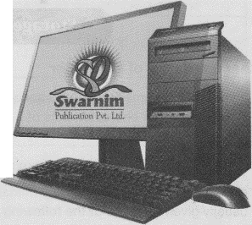
Chapter 1INTRODUCTION TOCOMPUTER
Figure 2 computer
THIS CHAPTER COVERS:
- Introduction to computer.
- Characteristics of computer.
- Limitations of computer.
- Modern application areas of Computers

Introduction
A computer is a machine that helps us to enter data, store them and process to give the meaningful result as output. In other words, a computer is an electronic calculating device that takes data according to the instructions as input, stores them, processes the data according to the instructions and produced the desired result as output. It was derived from the Latin word 'Computare' which means to calculate. Now, we use computers to process alphanumeric as well as other types of data.

A computer not only performs addition, subtraction, multiplication and division but also reads data, stores them, processes them to produce the results. So, we can say that the functions of a computer are broader than just computing.

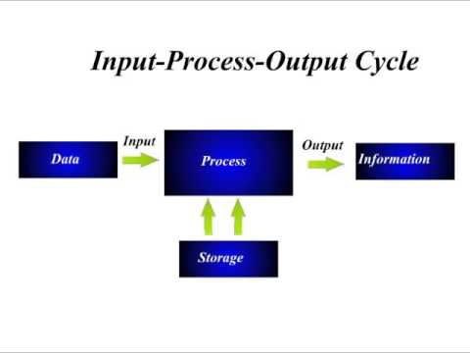
Figure 3 Input process output cycle

Characteristics of Computer
A computer has some features or capabilities that make it a special device. Some of the major characteristics of a computer are discussed below:

a. Speed
The speed of a computer is very high. It can process millions of instructions per seconds (MIPS) without any mistake. The speed of a computer is usually given in terms of the following time units.
Units of Time | Parts of seconds
1 Millisecond  (1ms) | 1/1000 or10‘³ | A thousands of a seconds
1 Microsecond (1us) | 1/1000000 or10'⁶ | A millionth of a second
1 Nanosecond (1ns) | 1/1000000000 or 10'⁹ | A thousand millionth of a second
1 Picosecond  (1 PS) | 1/1000000000000 or 10¹² | A million millionth of a second

Units of Time | Parts of seconds | Meaning
1 Femtosecond (fs) | 1/1000000000000000 or 10⁻¹⁵ | A trillion of a second
1 Auto second  (as) | 1/1000000000000000000 or 10⁻¹⁸ | A thousand trillionth of a second
1 jepto second (1zs) | 1/1000000000000000000000 or 10⁻²¹ | A million trillionth of a second
1 Yoctosecond | 1/1000000000000000000000000 or 10⁻²⁴ | A trillion trillionth of a second
The speed of a computer is also measured in terms of instruction per second like KIPS (Kilo Instructions Per Second ) or MIPS (Millions of Instructions Per Second).

b. Storage.
Computers can store a large amount of data. They have main memory and secondary memory. The storage capacity of a computer is unlimited due to the capacities of secondary storage devices. They can store and retrieve a huge volume of data in an easy, fast and efficient manner, the storage capacity of primary as well as secondary memories of a computer is measured in terms of bits, Bytes, Kilobytes, Megabytes, Giga bytes, Terabytes and so on.
The following table gives the basic measurement units of computer memory.

1 or 0 | 1 bit
4 bits | 1 Nibble
8 bits | 1 Byte
1024 Bytes | 1 Kilobyte(KB)
1024 KB | 1 Megabyte (MB)
1024MB | 1 Gigabyte (GB)
1024 GB | 1 Terabyte (TB)
1024TB | 1 Petabyte (PB)
1024 PB | 1 Exabyte(EB)
1024 EB | 1 Zettabyte(ZB)
1024 ZB) | - Yottabyte(YB)

d. Accuracy
The accuracy of a computer is 100% in spite of its high speed. If we find any error, they are due to human factor rather than the computer. The error may be in coding the program, program logic and data entry. The errors of computer program are called bugs. The process of removing errors from a program is called debugging. If a wrong or false input is given, the output is also wrong. So, a computer is also called as GIGO (Garbage In Garbage Out) machine.

d. Versatility
Computer are versatile machines. It means, they can perform varieties of jobs ranging from simple to complex and sophisticated calculation. In other words, we can say that computers are capable to do any type of tasks. The application areas of computers are very wide. So, they can be used in educational, business, commercial, industrial, medical, engineering and many others sectors.

e.Diligence
Computer are diligence machines. Human beings suffer from weaknesses like tiredness, lack of concentration and laziness. So, human beings can't perform the same task over and over again with the same speed, accuracy and efficiency. Being a machine, a computer does not get tired or bored. It doesn't lose concentration and feel lazy. This feature of a computer is called diligence.

f. Automatic.
A computer is an automatic machine. Once the process has been initiated, it is capable of functioning automatically till completion. It doesn't require instructions again and again once the data is provided.

Limitations of a Computer
a. Computers don't have common sense; IQ of computer is zero.
b. Computers don't have thinking capacity.
c. Computers cannot run without electricity.
d. They can't decide on their own.

Disadvantages of Computer.
a. Computer can affect our eyes, if we sit in front of screen for long time.
b. Computers can reduce our creativity depend if we more upon it.
c. Computer is a machine and machine can broke anytime.
d. Due to the change in technology daily, people believe that they can loose their jobs if they will not upgrade themselves.

Application of Computer
It is obvious that the computers are changing our daily life. People are using computer for performing small to complex nature of work at present. You can use your computer system for different applications by changing the software packages. In education sector, computers are especially used for the teaching/learning process, In Business, computers are used for promoting their business and for calculation purpose, in communication sector it is especially used for reliable communication like that in medical computers are especially used for the diagnosis. Some of the common applications of computer are :
- Business application | - Scientific research
- Education | - Entertainment
- Banks | - Communication
- Engineering | - Medicine
- Office and so on

i) Business Application
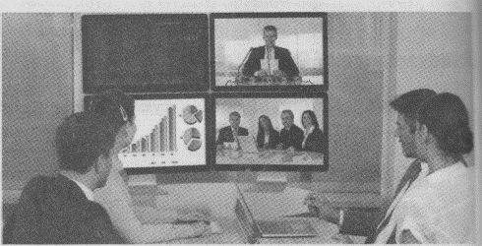
In Business through computer, companies can grow their business as fast as possible with quick analysis of their previous project on the computer screen (according to the data supplied inside) and
Figure 4 Business application
Figure 5 Business application
deciding what to do next without any delay. As from individual to

multinational companies, all are using computer for business purpose like keeping account information, stocks, prices, items as well as for promoting their business all over the world.

ii) Scientific Research
Scientific research is also one of the application of computer, as computer was first used to perform this job that is scientific research. At that time to now, the speed and accuracy of computer enabled scientific analysis carried out too fast. Computer controlled robots must be used in all those areas where there is danger to human being such as in nuclear research and deep sea investigation etc.

iii) Education
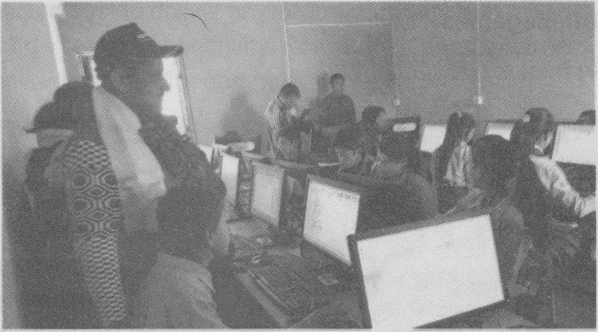
Education sector is also one of the application areas of computer due to which we can easily understand he subject matter teachers and students can deliver their knowledge through the different tools like projector, laptops, online classes etc. Now-a-days, there are thousands of websites available over Internet that are ready to deliver education for free in almost every subjects. You can choose whether you want to learn online or offline. In online learning, you can open any website to read your desired topic while in offline learning you can learn through videos, PDFs photos etc., and all these documents can be
Figure 6Education
Figure 7 Education
Downloaded through internet.

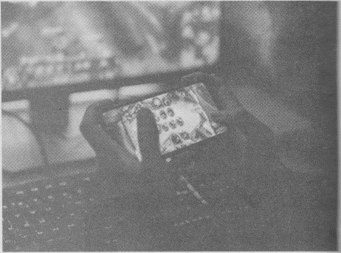
iv) Entertainment and Game playing
Figure 8 Entertainment and Game playing
Most of the persons are using computer for entertainment purposes such as watching movies, watching videos, listening songs, animations etc. Computer can be used to create these things in an attractive manner so that user loves to enjoy the things. Computers are also used to play different online and offline games.

v) Banks
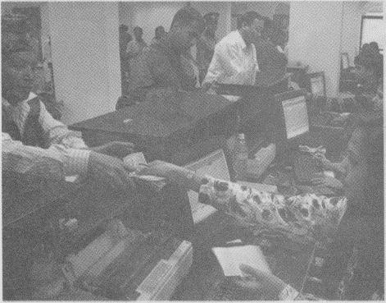
Banks are the place where there are continuous uses of computer or we can say that banks are the major use's computers. For example, ATM (Automated teller machine) is used where we are free to either deposit or withdraw our cash in/from our Bar In banks, all information such as account holder's detail, deposits, withdrawal, interest are managed by computers. Banks are also using computer network interconnect all of its branches so that their users feel always free to deposit his or her money in any branch of the same bank.
Figure 9 Banks

vi) Communication

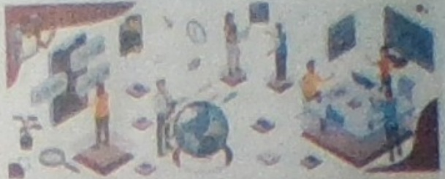
Using your computer system for the purpose of communication gives you a lot of benefits. For example, if you will use email to send message or anything to your friends or any of your contacts, then you don’t have to use pen and paper to write and take that paper to the post office and then postman will deliver that later after some or few days that will not good if you want to send any urgent information to the same person. Therefore, using email, you can also save your time and cost to deliver any information very fast. You only need a computer and internet connectivity. Now-a-days, people are using chat message, email, voice-mail. for communication purpose.
Figure 10 communication

vii) Engineering Purposes
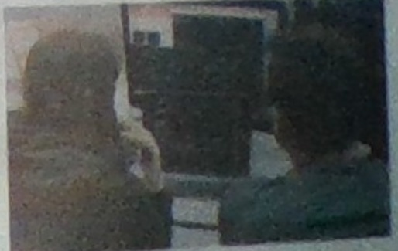
Figure 11 Engineering purpose
Computers are also using for the purpose of Engineering, that is, to design any machine without actually making it through CAD (Computer Aided Design) software and once the design is accepted, and then using CAM (Computer Aided Manufacturing) process company can produce a large Number of such products at very fast speed. Architects are also using computers to draw and design individual houses to big buildings like - Apartments. There are a lot more uses of computer for engineering purposes.

viii) Medicines Related

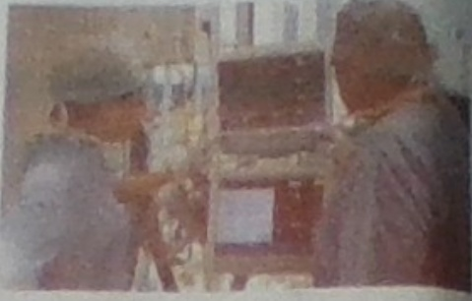
Computer plays an important role in medical field also. For example, in ICU (Intensive Care Unit) chamber in hospital, computer keeps track of each and everything going inside the patient's body such as blood pressure and
Figure 12 medical report
Heartbeat. Keeping record of patients and medicines also becomes easy through the use of Computer. Computer also plays an important role to perform CT (Computed Tomography) scan and X-Ray of patients to give the scanned object of specified area of patient's body in the form of graphics like images.

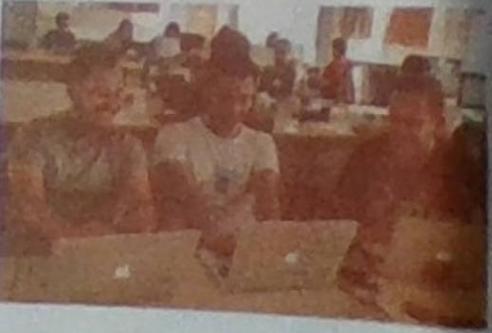
ix) Office
Figure 13 office

Computers are used in office for keeping the different records as well as for the processing of different things. Due to the computers in office the text file is replaced by the digital file. Computers have helped to improve the efficiency and accuracy of office workers by providing different software and communication functions to help execute work tasks. Computers are now a part of nearly every office, with most workplaces now unable to function without the use of computers.

Summary
- A computer is an electronic data processing device.
- A company has become a special device due to its storage capability.
- The speed of a computer is measured in millions of instructions per second.
- The storage capacity of a computer is measured in bits, Bytes, kilobytes, Megabytes and so on.
- Computer don't have self decision making capability.
- Computers can create different types of health problems.
- Computer are capable of doing simple to complex type of calculations.
- Computer never feel tired bored or loose concentrations.
- We can use computer system or different applications by changing the software packages.
- In medical, computers are us for the diagnosis.
- Banks are the place where computers are continuous uses of computer.
- Computers are the part of every office.

Full Forms
GIGO : Garbage In Garbage Out
MIPS : Millions of instructions Per Second.

KIPS:  MB:  IT:  KB: | Kilo Instructions Per Second.  Megabyte  Information Technology.  Intelligence Quotient
TB: | Terabyte
ZB: | Zettabyte
ATM: | Automated Teller Machine
IQ:  EB: | Intelligence Quotient  Exabyte
YB: | Yottabyte
ICU: | Intensive Care Unit
CT: | Computed Tomography
PDF: | Portable Document Format
CAD: | Computer Aided Design
CAM: | Computer Aided Manufacturing

Exercises
1.Fill in the blanks.
- It ……………. is a programmable machine.

- The word computer was derived from the Latin word
which means to calculate.
- 1 microsecond is a …….of a second.
- 1GB is equal to ………MB.
- Computers can affect our ……..if we sit in front for long time.
- Computer are 100%..............
- Different types machines are design by……..……… software.

2. State whether the following statements are True or False.
- A computer is an electronic programmable machine.
- A computer performs arithmetical and logical operations.
- Computers can make their own decisions when needed.
- Computer is not a diligent device.
- Computers are capable of doing many tasks.
- Computers are not automatic they need human to operate.
- Risk job is done by robots.
3. Write technical terms for the following.
- The result produced by a computer.
- The error in a computer program.
- The collection of 1024 Bytes.
- One million millionth of a second.
- Process of removing errors or bugs from computer.
- The term in which, if wrong instruction is given result is also
wrong.
- A machine which gives 24 hours services.
- A trillion trillionth of a second.
4. Write the full form of:
- CAD ii. ZB iii. ICU iv). PDF v) GIGO vi). MIPS

5. Answer the following questions.
- Define computer.
- List all the characteristics of a computer.
- Define the terms bug and debugging.
- Make a table of time units to measure the speed of computer.
- Make a table of measurement units of computer data.
- Why is computer called a diligent device?
- Write the limitations of a computer.
- Write some of the disadvantages of computer.
- What is CAD and CAM?

CHAPTER- 2 TYPES OF COMPUTER

THIS CHAPTER COVERS
- Analog, Digital and Hybrid computers.
- Mainframe, Mini and Microcomputers.
- IBM PC, IBM compatibles and Apple/Macintosh computers.
- XT, AT and PS/2 computers.
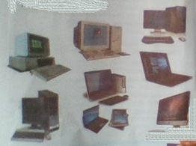
Figure 14 desktop, laptop

All around the world there are different types of computers used by different people at different places. These computers can be classified into different categories on the following basis:
On the basis of Work.
On the basis of Size.
On the basis of Brand.
On the basis of Model.

1. On the basis of Work.
On the basis of working principle, there are there types of computers They are:
- Analog Computers
- Digital Computers
- Hybrid Computers

Analog Computer:
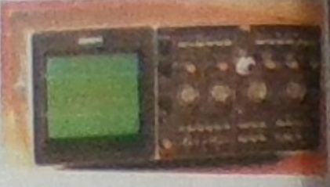
Figure 15 Analog computer
An Analog computer is the one that measures physical quantities such as temperature, pressure, voltage and current. Analogcomputers are especially suited for the solution of complex equation s Firstly, all operations in an analog computer are performed in parallel
Secondly, data are represented in an analog computer as voltages
Analog computers are specific purpose computers.
Speedometer in cars and motor bikes are example of analog devices Some examples of analog computers are Seismograph, Plesley and so no. Also the devices which measure the size of kidney in hospitals are analog computers. Hetauda cement factors is also using an analog computer named Process Control. Among all the computer in Nepal, the analog computers are less than 1%.

Digital Computer:
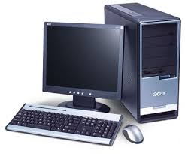
Figure 16 Digital computer
A computer that stores data in terms of digits (number) is known as digital computer. Digital computer are general purpose computers. In digital computers, letter, words and whole texts are represented digitally. Digital computers don't measure the distance, quantities or pressure. These computers are mostly used in the preparation of reports, results, tabulation and graphic representations. They are mostly used in mathematics, engineering, statistics and so on. On% of computers in Nepal are digital computers.

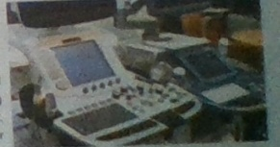
Hybrid Computer:
Figure 17 Hybrid Computer

Hybrid computer is the combination of Analog and Digital computers. This integration is obtained by digital to analog and analog to digital converter. A hybrid computer may user or produce analog data or digital data. It accepts a continuously varying input which is then converted into a set of discrete values for digital processing. These computers are generally used in ICU's of hospitals to measure

the heartbeat of the patient. Hybrid Machines are generally used in big industries, scientific research institutions, airplanes and others areas. Both the jet planes of Nepal-Karnali and Gandaki are facilitated with hybrid computers and therefore, these planes are called computerized jet planes. Some hybrid computers are: Flight Management Computer (FMC), Engine Indicator and Crew Alert System (ELCAS).
Differences between Analog and Digital computers.
Analog Computer | Digital Computer
- It measures continues data | - It measure discontinuous or discrete data.
- It measures physical quantities such as temperature, pressure, voltage and currents. | - It measure digital value like 0 and 1
- Some examples are Seismograph, plesley, process control. | - Some examples are personal computer or microcomputers like desktop, laptop, palmtop.

2. On the basis of Size.
Computers are of various sizes. According to their size, they are mainly divided into three categories. They are:
- Mainframe Computers.
- Mini Computers.
- Micro Computers.

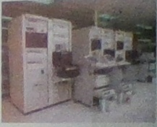
a. Mainframe Computer:
Figure 18 Main frame computer
They are largest, fastest and perhaps one of the most expensive computers. Super computers are more powerful and computes have large strong capacity and high processing speed. These computers are multi terminal systems as they are concerned with more than hundred terminals(monitors). These computer scan do big capacity of processing tasks such as population census, Agro census, Industries, SLC result processing, Provident Fund processing of Government employees and so no. IBM 1401 was the first mainframe computers brought in Nepal for the population census of 2028 BS. ICL 2950/10 was another mainframe computer which was used for the 2038 BS. census. These computers are still present in National Computer Center (NCC).

b. Mini Computer
These computers are smaller than Mainframe computers in size. They are more powerful and expensive than microcomputers. These are also multi terminal computers, as they are connected with more than 50 terminals at a time. National Computer Center, Nepal Telecommunication, Nepal Rastra Bank, Agricultural Bank, Police. Headquarters and Electricity authorities are using Mini computers. Some example of Mini computers are Data General, Primer, Neck and so on.

Microcomputers:
Figure 19 Desktop
These computers contain microprocessor as the main processor. They are also called Home computers or personal computers. They are mostly used at homes and offices. Nowadays, its capabilities and speed have increased. A small office is enough for microcomputers to set up. They are smaller then Mini Computers and are available in various sizes like Desktop, Laptop and Palmtop.

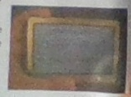
i. Laptop: We call them Laptop because they can easily be kept on the laps of user. They are portable computers which can be carried anywhere easily just like a briefcase. The personals involve in such type of tasks, where they have to move from one place to another like of tasks, where they have to move from one place 1 another like to have laptops as they are essay to use and are handy.
Figure 20 Palmtop
Figure 21 laptop
ii. Palmtop: These computers are smaller than the laptop and can be adjusted within the palm of the user.
iii. Desktop: These computers can easily be placed on a desk. So, we call it as desktop computers. These computers are specially used for personal computers or PC Generally, we see these computers in schools.

3. On the basis of Brand.
On the basis of brand, there are three types of computers. They are:
- IBM PC.
- IBM Compatibles
- Apple / Macintosh

a. IBM PC:
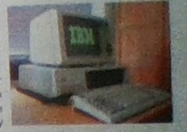
IBM PC stands for International Business Machine Personal Computer which is made by IBM company established by Dr. Herman Hollerith in 1923 AD. It is the largest computer manufacturing computer in the world even today. All the computers manufactured bythis company are IBM PCs.
Figure 22 IBM PC
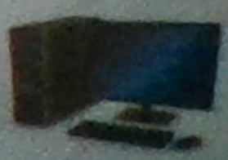
These computers are more reliable, durable and they have higherprocessing capacity. They are also known as Branded computer as all the parts of this computers are manufactured by this companyare IBM PCs. These computers are more reliable, durable and also known as Branded computers as all the parts of this computer are manufactured by IBM company itself.

b. IBM Compatibles:
Compatible means can be adjusted to work together. So, all the computers that are not manufactured by IBM Company but are the same in
Figure 23 IBM compatibles

appearance and manufacturing like IBM PCs are known as IBM. Compatible computers. It is also called assembled PC as parts of different companies are assembled to make the computer. They are less powerful, less expensive and less durable than IBM branded PCs. They are the most popular computers of the work today. They are also known as duplicates of IBM.

c. Apple/Macintosh:
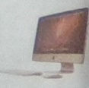
Apple corporation is also one of the largest computer manufacturing companies of the USA. All the computers that are manufactured by Apple Corporation, USA are known as Apple/ Macintosh computers. In these computers, monitor and system unit are attached with each other. Thesecomputers have their own hardware and software. They are mostly used in designing Works.
Figure 24 Apple

4. On the basis of Model.
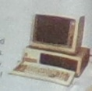
On the basis of model, there are three types of computers. They are:
Figure 25 XT
- XT (extended Technology).
- AT (Advanced Technology).
- PA/2 (Personal System-2).

a. XT:The computers having 8086 and microprocessors are XT computers. XT stands for extended Technology. They have the processing speed of 4.77 MHZ.

b. AT:
The computers having 80286, 80386, 80486 microprocessors are AT computers. AT stands for Advanced Technology. They have higher capacity than XT. In these computers, apart from AT processor, math co-processors are also used for additional calculations.

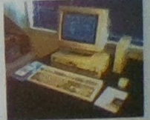
c. PS/2:
Figure 26 PS/2
The new model computers manufactured by IBM after 1990 are Known as PS/2 (Personal system/2) computers. These computers are used for general purpose computation. They can run word processing, spreadsheet, database management and accounting packages and so no. The processing speed of
these computers is higher than AT computers.
Word Meaning

Complex:  Brand: | difficult, confusing.  maker's name or trademark.
Seismograph: | device used to measure earthquake.
Discrete: | discontinuous (not in order).
Multi terminal: | having many terminals (monitor).
Census: | counting of population.
Portable: | which can be carried easily to other places.

Summary

- On the basis of size, computers are categorized as Mainframe, Mini and Microcomputers.
- On the basis of brand, computers are categorized as IBM PC IBM compatibles and Apple/Macintosh computers.
- On the basis of work, computers are categorized as Analog Digital and Hybrid computers.
- On the basis of model, computers are categorized as XT, PS/2 computers.

Full Forms
IBM:International Computer Limited
ICL:International Computer Limited
XT:extended Technology.
AT: Advanced Technology
PS/2: Personal System/2

Exercise
- Fill in the blanks :
- The……….computers are also called personal computers.
- Mainframe computers are the……. and most………….computers.
- The IBM Compatibles computers are also called as………….IBM.
- IBM PC uses microprocessor of…………company.
- ………………computers have their own hardware and soft
ware.
- Laptop and Palmtop are examples of ……………..computers.
- Mainframe are………….terminal system.
- Minicomputers are……………than mainframe computers.
- State whether the following statements are True or False.
- Motorola processor is used in IBM computers.
- Micro computer contains microprocessor as the main processor.
- Mini computers are bigger than Mainframe computers.
- IBM PC and IBM compatibles are the same computers.
- Only 10 terminals can be attached to a mainframe computer.
- Analog computers represent data in the form of physical quantity
- The mini computers are bigger than mainframe computers.
- Digital computers work in analog signal.
- Microcomputers are used in your school and homes.

- Answer the following questions.
- List the main categories of computers.
- What are different types of computers according to size?
- Differentiate between mainframe and mini computers.
- Name the different types of microcomputers.
- What is the difference between IBM PC and IBM Compatibles?
- Why do we call IBM Compatible as duplicates IBM PCs?
- Differentiate between analog and digital computers.
- Given any two examples of hybrid computers.
- Write the technical terms for the following.
- Computers that measures physical quantities.
- Computer that stores data in terms of digits.
- First computer brought in Nepal.
- Computers having 80286, 80368, 80486 microprocessor.
- Computer, also known as branded computer.
- Computer easily carried like a briefcase.
5. Match the following.

Group "A" | Group "B"
- Analog computer | - manufactured after 1990
- Laptop computer | - branded computer
- IBM PC | - contains microprocessor
- PS/2 computer | - measure physical quantities
 | - portable computers

Chapter-3 COMPUTER SYSTEM
This chapter covers:
- Introduction to computer system
- Input devices.
- Processing unit.
- Output devices.
- Storage devices.
System
Unit
Output Devices
Input Devices
Mass Storage Device
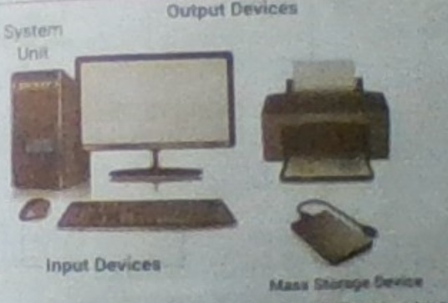
Figure 27 monitor, keyboard, mouse, system unit

Introduction: A computer system is the combination of different computer hardware that work together to achieve the common objectives. In other words, a computer system is the set of hardware and software which work together to process data accounting to the instruction given by ne user in order to given information. Computer hardware and software work together to perform the tasks given by the user.

A computer system performs mainly five basic operations in order to convert raw data into meaningful information. They are:

Inputting: The process of entering data and instructions into the computer.
Storing: Saving data and instruction so that they are available as and when require.
Processing: Performing arithmetic operations or logical operations on data in order to convert them into useful information:
Outputting: The process of producing useful information or results for the user.
Controlling: Directing the manner and sequence in which all the above operations are performed.
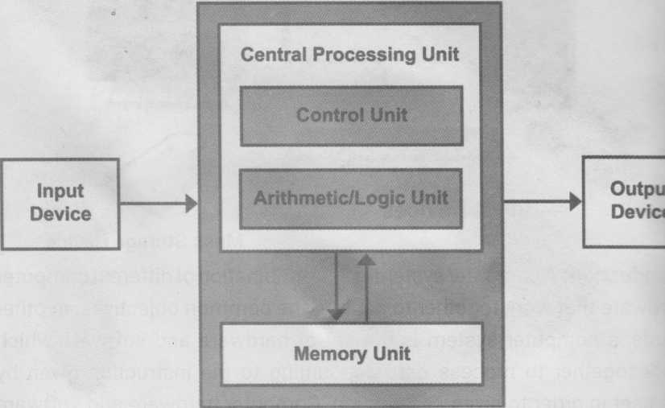
Figure 28 Computer system

Input Unit
Data and instructions must enter the computer system before any computation can be performed on the supplies data. Input device accept data and instructions from the user. In short, the following function are performed by the input unit:
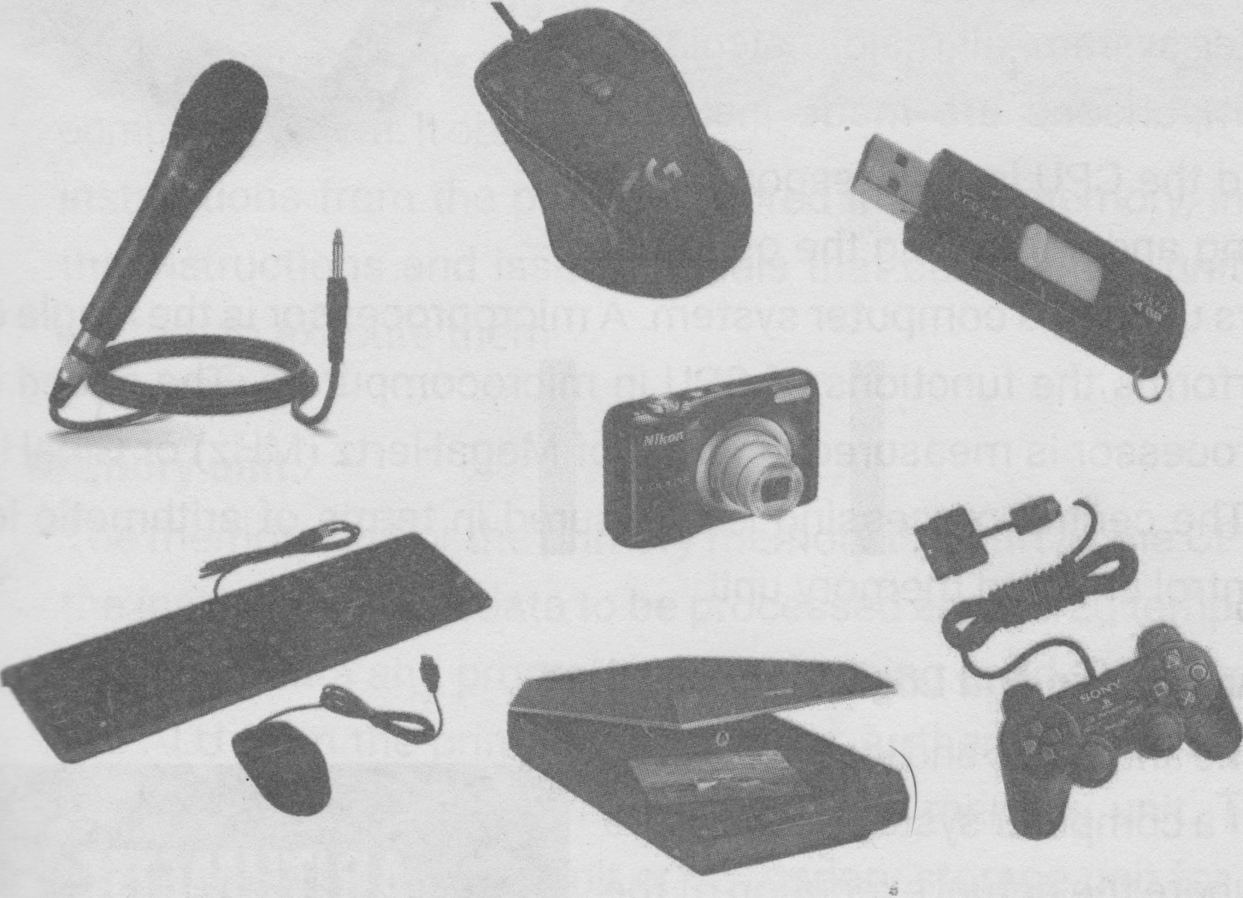
Figure 29 mic, camera, mouse, pendrive, joystick, scanner,
- It accepts the list of instruction and data from the outside world.
- It converts these instructions and data into computer acceptable form i.e. binary code.
- It supplies the converted instruction and data to the computer system for further processing.
The commonly used input devices are keyboard, mouse, joystick, touchpad, microphone, scanner, digital camera and so no.

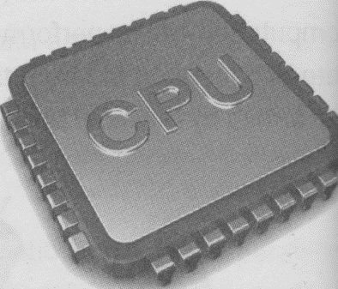
Central Processing Unit (CPU).
Figure 30 CPU
The CPU is the brain of any computer system. In a human body, all major decisions are taken by the brain and all other parts of the body functions as directed by the brain. Similarly, in computer system, all major calculations and comparisons are made inside the CPU and the CPU is also responsible for
activating and controlling the operations
of others units of a computer system. A microprocessor is the single chip
that performs the functions of CPU in microcomputers. The speed of microprocessor is measured in terms of MegaHerz (MHZ) or GigaHertz(GHz). The central processing is measured in terms of arithmetic logic unit, control unit and memory unit.

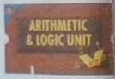
a. Arithmetic and Logic Unit (ALU).
Figure 31 Arithmetic and Logic Unit
The arithmetic and logic unit (ALU) of a computer system is the place where the actual execution of the instructions takes place during the processing. To be clearer, all calculations and decisions are made in the ALU. The data and instruction stored in the primary memory before processing, are transferred as and when need the ALU where processing takes place. ALU is designed to perform the four basic arithmetic operations-add, subtract, multiply, divide and logical comparisons such as less than, greater than or equal to.

b. Control Unit.
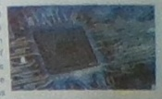
Although, control unit does not perform any actual processing on the data, it acts as a central nervous system for the other components of the computer. It manages and coordinates the entire computer system. It obtains instructions from the program stored in main memory, interprets the instructions and issues signals that cause other units of the system to execute them
Figure 32 Control Unit

c. Memory unit.
The memory unit or the primary memory is a part of the CPU where the instructions and data to be processed are stored temporarily. It holds the data and program currently being used. Data are sent to the ALU from the primary memory for further processing and the processed data are returned back to the memory unit. Then, the data are sent to output unit or secondary storage unit for storage. So, the primary memory is the working space used by computer to hold the program and data that are currently running.

The two most used primary are:
Random Access Memory (RAM)
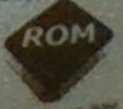
Read Only Memory (ROM)
Figure 33 ROM
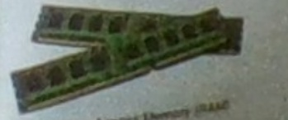
Figure 34 RAM

The most commonly used secondary storage are:
Floppy Disk
Hard Disk
Pen drive
Memory Card
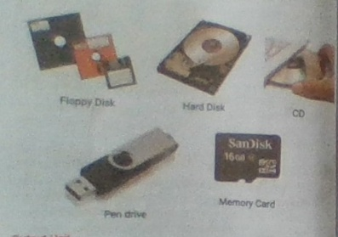
Figure 35 floppy disk, hard drive, Cd rom, pen drive, memory card

Output Unit
The job of an output unit is just the reverse of that of an input unit. It supplies information and results of computation to the outside world. Thus, it links the computer with the external environment. In short, following function are performed by an output unit.
    - It accepts the results produced by the computer which is understandable to us
- It converts the result into human understandable from.
- It supplies the converted results to outside world. 1 commonly used output devices are monitor, printer, plotter and speaker.

Software: Software is also a major part of computer system. It is used operate the computer. It enables the computer to do work. It is not possible to operate the computer system without software. It instructs
End coordinate all the physical parts of computer system.
SPEAKER
HEADPHONE
PLOTTER
PRINTER
PROJECTOR
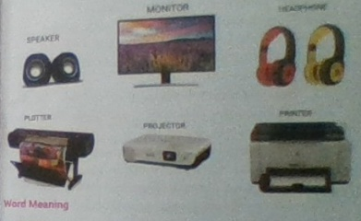
Figure 36 monitor, head phone, speaker, projector, plotter

word Meaning
coordinates: to make many different things work effective as a whole.
comparison: the act of comparing two or more people or things.
objective: a thing the is aimed, goal.
reverse: complete change in direction.
execution: the carrying out of a plan, order, or course of action.

Summary
- A computer system is the combination of different computer hardware that work together to achieve the common objectives.
- A computer system performs mainly five basic operations in order to convert raw data into meaningful information.
- Input devices accept data and instructions from the user.
- The CPU is the brain of any computer system.
The speed of a microprocessor is measured in terms of MegaHerta (MHz) or GigaHertz (GHz).
- ALU is designed to perform the four basic arithmetic operations add, subtract, multiply, divided and logical comparisons such a; less than, greater than or equal to.
- Control Unit manages and coordinates the entire computer system
- The memory unit or the primary memory is a part of the CPU when the instructions and data to be processed are stored temporarily.
- Output Unit supplies information and result of computation to the outside world.

Full Forms
CPU: Central Processing Unit
ALU: Arithmetic and Logic unit
GHz: Giga Hertz
RAM: Random Access Memory
ROM: Read Only Memory.
MHz: Mega Hertz.

Exercise
1.Write whether the following statements are True or False.
- Inputting, storing, processing, outputting and controlling are the five main basic operations of a computer system.
- Input unit accepts data and instructing from the user and convert them into human understandable from.
- The CPU contains arithmetic logic unit, control unit and memory unit.
- All the calculation and decisions are made in the ALU.
- Actual processing on the data is performed by the control unit.
2 Fill in the blanks.
- A……………. is the set of hardware and software which work together to achieve the common objectives.
- The speed of microprocessor is measured in terms of …..
Or…………..
- The………..is a section of CPU where the actual execution of
The instructions takes place during the processing.
- ………….and…………are the example of primary
memory or main memory.
- ……….unit supplies the final results to the outside world.
3. Write the full form of the following abbreviations.
CPU, ALU, MHz, RAM, ROM

- Match the following.

Group "A"
- Inputting
- Storing
- Processing
- Outputting
Group ”B”
- saving data and instruction
- producing useful information
- entering data and instructions
- performing arithmetic and logical operations

- Write the technical terms for the following.
- Directing the manner and sequence in which the operations are performed.
- The place where the actual execution of the instructions takes place during the processing.
- The unit that acts as a central nervous system.
- The unit of a computer that supplies information to the outside world.
- It acts as a central nervous system.
- It converts the result into human understandable from.

- Answer the following questions.
- Define computer system. Name the five basic operations of computer system.
- What are the functions performed by the input unit?
- Name any four input devices.
- What is the role of ALU in the computer system?
- What is memory unit? Why does a computer need primary memory?
- What is output devices? Name any four output devices.

Chapter -4 Computer Hardware
System fan
Floppy
Heat sink
Hard drive
Optical drive
Ram Modules
Processors
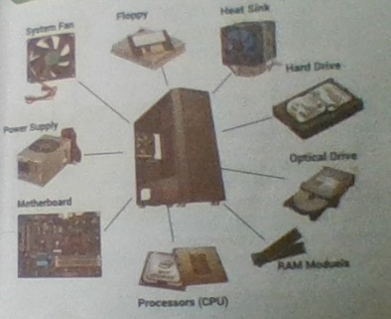
Figure 37 floppy, heatsink, hard drive, optical drive, RAM modules, processor, motherboard, power supply, system fan
This chapter covers:
physical parts of the computer.
Motherboard.
Microprocessor\
Memory and storage.
Input Devices.
Output Devices.

Introduction.
Physical parts of computer which can be seen and touched are known hardware. All the peripheral devices attached to the computer are hardware like keyboard, mouse monitor, system unit, CD, floppies, scanners and print are the hardware. All the power cables, data cables, connecters and chips a hardware.

Let's discuss about the main circuit board of a computer which is also known printed circuit board or motherboard.

Motherboard.
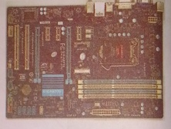
Figure 38 Motherboard
The motherboard is the main component inside the system case. It holds many of the crucial electronic components of the system such as the Central Processing Unit (CPU) and memory and provides connectors for other peripherals. CPU is also known as the brain of the computer which is present in motherboard. Since CPU is the brain of the computer, motherboard is the central nervous system of the computer.

Components of a Motherboard

Central Processing Unit (CPU)

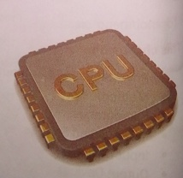
A central processing unit (CPU) is the hardware within a computer that carries out the instructions of a computer program by preforming the basic arithmetical, logical and input/output operations of the system.
Figure 39 CPU

Bus
A computer bus (often simply called Bus) is an electronic pathway. Its role is to transfer data, signal or power from one part to another part of computer. Different types of buses are data bus, address bus and control bus
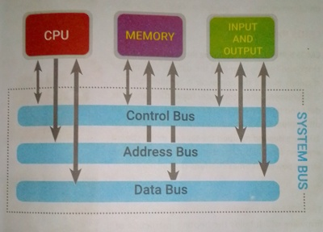
CPU
Memory
Input and output

Control bus
Address bus
Data bus
Figure 40 system BUS

Expansion Slot
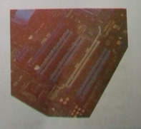
Figure 41 Expansion slot
An expansion slot is a socket on the motherboard mat is used to insert an expansion card (or circuit board) which allow to connect additional devices to a computer such as video, sound, advanced graphics, Ethernet or memory.

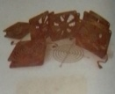
Cooling fan
Figure 42 cooling fan
Cooling fan is fan present inside the system unit which keeps the computer cool by throwing the hot air into the system unit from outside.

CMOS Battery
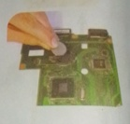
CMOS batteries help in running the computer internal clock and help in changing the data of a computer regularly even if the computer is switched off. This is the reasons why a computer regularly changes its data and time even when the computer is switched off. Lithium CR2032 batteries which lasts from 2 to 10 years depending upon the type of motherboard are best for computers. Higher temperatures and longer power off times shortens the cell life.
Figure 43 CMOS battery

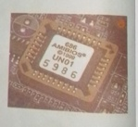
ROM BIOS

The ROM chip contains a small program known as firmware which holds the booting instruction of a computer. It helps in starting up the computer.

Parts of Motherboard
Figure 44 ROM BIOS

Parallel Port
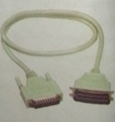
A parallel port is a type of interface found on computers (personal and others) for connecting peripherals. In computing, a parallel port is a parallel communication physical interface. It is also known as a printer port. The parallel port interface was originally known as the LPT (Line Print Terminal) port.
Figure 45 Parallel Port

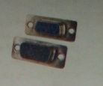
Serial Port
Figure 46 Serial Port
As the name suggests, it allows the transfer of data in serial way. In serial port, only one line/wire is used to transfer data. It is used for slow speed peripherals as keyboard, mouse, modem and others. Serial ports are faster parallel ports.

PS/2 port
Figure 47 PS/2 port
Ps/2 was developed by IBM. It is also called mouse port. It is used to connect a computer mouse or keyboard, IT around connector with 6 pins. A color code is used distinguish between the two ports. The keyboard port purple and the mouse port is green.

Universal Serial Bus (USB) Port
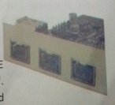
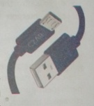
USB was designed to standardize the connection of computer peripherals (including keyboards, pointing ices, digital cameras, printers, portable media players, drives and network adapters) to personal computers, both to communicate and supply electric power. It has become a PDAs and video games. USB has effectively aced a variety of earlier interface such as serial and parallel ports as well as separate power chargers for able devices.
Figure 48 Fire wire port
Figure 49 USB port

Fire Wire Port
Fire interface is also known as IEEE 1394 port. IEEE s for 'Institute of Electrical and Electronic Engineers', serial bus interface especially created for high speed audio and video transmission.

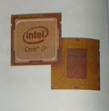
Microprocessor
Figure 50 MIcroprocessor
Microprocessor is a single chip in which millions of components like transistors. It performs all the operations of the computers processor. It is made of VLSI (Very Large Scale Integrated Circuit) and ULSI (Ultra Large Scale Integrated Circuit). Intel Corporation of USA developed the first microprocessor named 'Intel 4004' in 1971 AD.
The main responsible of microprocessor are:
- To control and coordinates all the operations and other components the computer system.
- To carry out processing.
- To give commands to all the other components of the computer system
- To control the sequence of operation in the computer system.
- To interpret the data, instruction and information in the computer system.

Memory
Memory is the space where data and information are stored. The devices that are used to store the data and program instructions either temporarily
Or permanently are called memory and storage devices. Data and instructions a storage in memory in the form of binary digital called bits. Bits is the small unit of storage and combination of 8 bits is called a byte. Each byte is ah referred to as single character.
Memory is further divided into types.
They are: Primary Memory and Secondary Memory.
1. Primary Memory: The primary memory is the main memory of a computer This is the place where our data and instruction are stored before processing and the result are stored before displaying output. Memory which stores da and information currently being used by the computer is known as Primary
\

Memory. It is further dividend into RAM (Random Access Memory) and ROM Read Only Memory). Cache memory and virtual memory also primary memory.
Figure 51 RAM

a. RAM (Random Access Memory):
It is a memory where data and instruction are stored temporarily. It is also known as volatile memory as data and instructions remain only till electricity is supplied there. If power is switched off, the data stored in RAM is erased by itself. A user can read from and write onto RAM. Hence, it is also known as Read and Write Memory.

There are two type of RAM. They are:

- SRAM (Static RAM)
- DRAM (Dynamic RAM)

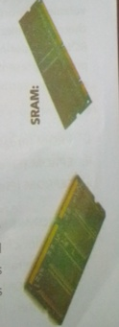
i. SRAM (Static RAM)
Figure 52 SDRAM
SRAM stands for Static Random Access Memory and it is made up of transistors. It is called Static because it can remember or retain its memory contents without being refreshed or recharged as long as there is power. SRAM does not need to be refreshed or recharged periodically like DRAM. It is faster than DRAM but is more expensive, bigger in size and consumes more electricity than DRAM.

ii)DRAM (Dynamic RAM)
DRAM stands for Dynamic Random Access Memory. It is the most common and cheapest type of memory chip. It is made of capacitors which is capable of storing then electric charge. Due to leakage of charges, the capacitors discharge gradually and the memory cells lose their contents. DRAM has to be refreshed periodically by recharging the capacitors to retain its memory contents. It is slower than SRAM and consumes less electricity and is less expensive too.

Differences between SRAM and DRAM
SRAM | DRAM
1. SRAM is made up of transistors. | 1. DRAM is made up of small tiny capacitors
2. It is less dense. | 2. It is dense in nature.
3. Charge doesn't leak from transistors. | 3. Charge leaks from capacitor.
4. It doesn't need to refresh time to time to preserve the information. | 4. It needs to refresh time to time to preserve the information.
5. It is much faster than DRAM. | 5. It is slower than SRAM
6. It is more expensive than DRAM. | 6. It is cheaper than SRAM.

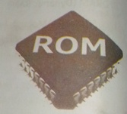
b. ROM (Read Only Memory):
It is the memory where data and instructions are stored permanently. It is also known as nonvolatile memory as data and instruction remain there is no electricity supply. Data is stored in ROM chip during the manufacturing time. The program present in ROM is known as 'firmware' and is responsible to boot the computer.
Different types of ROM are:
Figure 53 ROM
- PROM (Programmable Read Only Memory).
- EPROM (Erasable Program Read Only Memory).
Figure 54 PROM
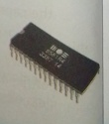
- EEPROM (Electrically Erasable Program Read Only Memory).
I)PROM: PROM stands for Programmable Read Only Memory. Initially, it is the blank chip which can be written or programmed only once by using a special machine called ROM programmer or RAM burner. Once the PROM is written, it cannot be modified and becomes ROM.
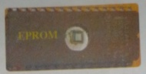
ii EPROM: EPROM stands for Erasable
Figure 55 EPROM
Programmable Read Only Memory. It is a special chip which can be re-programmed to record different information. The data and information are erased by exposing it to the intensive ultra violet light. EPROM chips are used in product development and experimental projects.
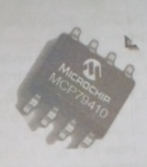
iii. EEPROM: EEPROM stands for Electrically Erasable Programmable Read Only Memory. This type of chip can be erased and reprogrammed repeatedly with special electrical pulses. It does not require a special device to write onto it. EEPROM can be reprogrammed without removing it from the computer.
Figure 56 EEPROM
Difference between RAM and ROM
SRAM | DRAM
1. It is a volatile or temporary memory i.e. data are lost when the power supply is switched off. | 1. It is nonvolatile or permanent memory.rs.
2. It is read/write memory. | 2. It is read only memory.
3. It is fixed in the memory card slot on the motherboard. | 3. It is attached with the motherboard.
4. It is working memory of computer. | 4. It is startup memory of the computer which stores the startup information.
5. It is usually expensive on per unit basis. | 5. It is usually Cheaper in terms of per unit basis.

Cache Memory
Cache memory is an extremely fast small memory. It is placed between CPU and main memory whose access time is closer to the processing speed of CPU. It acts as a high speed buffer memory between CPU and main memory and is used to store very active data and instructions temporarily during processing.

Virtual Memory
The process of using the reserved or additional memory of secondary storage as primary memory is known as virtual memory. Sometimes the primary memory of computer may be insufficient while running large and complex programs in such case this memory technique is very useful.
2. Secondary Memory: Memory which stores data and instruction permanently for future reference is known as secondary memory. It is the permanent memory where data and information remain forever. It has a huge storage capacity of up to Gigabytes and Terabytes. It is a non-volatile memory in nature where data and instructions remain even if there is no electricity Different secondary storage media are: Magnetic storage device, Optical storage device and Flash storage device.

a. Magnetic Storage Devices:
It is storage media in which data are stored onto the disk in the form of magnetic spots. A costing of magnetic metallic oxide like ferric oxide is done over the disk which attracts the data to bi deposited over them. Some of the magnetic storage media are magnetic tapes, floppy disks, hard disk, SSD and so no.
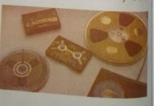
i. Magnetic Tape: This is a secondary storage device of computer which is made of plastic materials coated with magnetic material only on side of tape. It is used to back up the large amount of data and information. It is also used to transfer data from the computer to another. The main drawback of magnetic tape is that it can access contents only sequentially.
Figure 57 Magnetic Tape

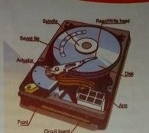
ii. Hard Disk: Hard disk is a secondary storage device of a computer. It is an airtight sealed unit consisting of a number of magnetic disks (platters) mounted on a spindle. It was introduced by IBM in 1956AD. At first, it was called 'Winchester Disk'. Unlike floppy disks, the platters cannot be bent so they are hard disk. It is mainly used to store large volume of data and programs permanently as it is also non-volatile of data and programs permanently as it is also non-volatile in nature. The disk is divided into a number of concentric circles called tracks and these tracks are divided into invisible segments called sector. There are two types of hard disk: Internal Hard disk and External hard disk.
Figure 58 Hard Disk

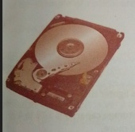
Internal Hard Disk:
Figure 59 Internal hard disk
The internal hard disk is not portable. It is permanently fixed with the system unit and connected to motherboard by a data cable. So, internal hard disk is also called a fixed disk.

External Hard Disk
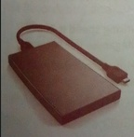
The working principle of external hard disk is similar to that of internal hard drive but it is not placed inside CPU casing. It can be externally connected with a USB (Universal Serial Bus) port. It is portable and easy to carry. It is used to transfer data, information and software from one computer to another.
Figure 60 External Hard disk

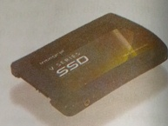
iii. SSD (Solid State Drive)
Figure 61 SSD
A solid-state drive (SSD) is a solid-state storage device that uses integrated circuit. Hard disk can be replaced and upgraded by SSD (Solid State Drive) as new technology. Semiconductor chips are used to store data in SSD. The speed to read and write data is greater than hard disk. So, its price is more expensive than hard disk. Laptop, notebook, ultra book uses SSD as storage device. Its storage capacity is about 4 TB but various companies are trying t c develop SSD with high storage capacity. It is more costly than HDD (Hard Dis< Drive).
Differences between SSD and Hard disk
Hard Disk | SSD
- The weight of Hard Disk is heavier than SSD.  - The storage capacity is 500 GB to 100 or more.  - It is cheaper than SSD.  - The file writing speed is 50-120 MBPS (Megabyte Per Second)  - It is made up of aluminum material. | - This is lighter than hard disk.  - The storage capacity is 1 TB to 4  TB or more.  - It is more expensive than hard  Disk.  - The file writing speed is 200-550  MBPS (Megabyte Per Second)  - It is made up of semiconductor  Microchip.

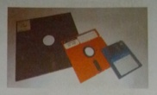
iv . Floppy Disk:
Figure 62Floopy disk
It is a round and flat disk which is made up of
mylar (a plastic material) coated with magnetic
material. It is read/write memory as we
can read from it is as well as write onto it. We
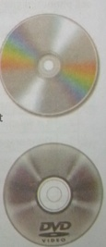
can access the information from a floppy randomly. We can use a floppy disk to store data and programs, back up files, transfer data from me computer to another computer and so no. It is also called as diskette.

b. Optical Storage Device:
It is also a non-volatile secondary storage medium. It is flat round disk made up of plastic polycarbonate material coated with aluminum alloy. A very fine laser ream is projected on the reflecting surface to read data from the disk. Some of the example of optical are CD-ROM and DVD.

i.CD-ROM:
CD-DM stands for Compact Disk Read Only Memory. As it is a optical storage medium, laser beam is used to access data from the disk. It can store about 700 MB of data or 80 minutes of video. It is very useful in storing large amount
Figure 63 CD ROM
Of data like computer software, movies, audio or video songs and so no. Others types of CD-ROM are CD-R(Compact Disk Recordable) and CD-RW (Compact Disk Re Writable).
I. DVD: DVD stands for Digital Versatile Disk or Digital Video
Disk. It is also a type of optical memory device which has very large storage capacity. It is also considered as the improved from of CD ROM. DVD also uses the same technology as that of a CD-ROM for reading and writing data.
Figure 64 DVD ROM

DVD-R, DVD-RW and DVD-RAM are examples of DVD. DVD- R is a recordable DVD format similar to CD-R. DVD-RW stands for Digital Versatile Disc Rewritable. A DVD-RAM discs can be recorded and erased repeatedly The storage capacity of one DVD is almost 6 times more than a CD.

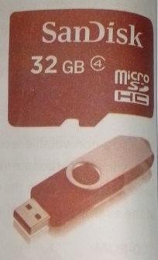
c. Flash Memory:
Figure 65 Flash Memory
It is a non-volatile, erasable and programmable, solid state memory which is made of semiconductor chips. It was introduced at first in the mid 1980 by Fujio Masuoka at Toshiba Corporation, Japan. It can be reprogrammed at high speed and hence the name flash, it is derived from Electrically Erasable Programmable Read Only Memory can be erased in a few second by using electric technology. Flash memory is used in many input/output and storage devices. It is also used to store data and program in cell phones, digital camera and MP3 music player.
Differences between Primary memory and Secondary memory:
S.  N. | Primary Memory | Secondary Memory
1 | It is also called main memory or internal memory. | It is also called auxiliary memory or backup memory.
2 | It is volatile and non-volatile memory. | It is non-volatile memory.
3 | The storage capacity is less. | The storage capacity is more.
4 | Its types are RAM, ROM | Its types are: Hard disk, CD/DVD.
5 | It is made up of semiconductor. | It is made up of magnetic materials, poly carbon
6 | The data is directly accessed by the processing unit. | The data cannot be directly accessed by the processing unit.

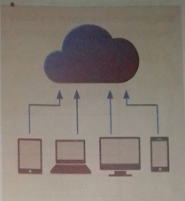
Cloud Storage
Figure 66CLoud storage
Cloud storage means "the storage of data online in the cloud," where in a company's data are stored in and accessible from multiple distributed and connected resources that comprise a cloud. Cloud storage can provide the benefits of greater accessibility and reliability; rapid deployment; strong protection for data backup, archival and disaster recovery purposes and lower overall storage costs as a result of not having to purchase, manage and maintain expensive hardware. However, cloud storage does have the potential for security and compliance concerns.

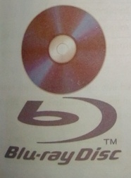
Blue Ray Disk
Figure 67 Blue ray disk
A Blue Ray Disk(BD) is a high capacity optical disk medium developed for recording, rewriting and playing back high definition video. It can store large amounts of data compared to DVDs, up to 50 GB for dual layered discs. But it is currently expensive compared to DVDs and most computers don't have Blue ray players/ recorders as standard. Blue Ray Disk can store upto 17 GB of data.

Units of Memory Measurement
The smallest unit of memory measurement is bit (Binary digit - 0 or 1). The data stored in a computer is a binary digit, byte, Kilobyte, Megabyte, Gigabyte, Terabyte, Petabyte, Exabyte, Zettabyte, Yottabyte, Brontobyte and so on.
The following table gives the basic measurement units of computer memory.
1 or 0 | 1 bit
4 bits | 1 Nibble
8 bits | 1 Byte
1024 Bytes | 1 Kilobyte(KB)
1024 KB | 1 Megabyte (MB)
1024MB | 1 Gigabyte (GB)
1024 GB | 1 Terabyte (TB)
1024TB | 1 Petabyte (PB)
1024 PB | 1 Exabyte(EB)
1024 EB | 1 Zettabyte(ZB)
1024(ZB) | 1 Yottabyte(YB)
1024(YB) | 1 Brontobyte(BB)

Input Devices
Input means any data or instructions entered into the computer in the form of signals. Input devices convert the data and instructions into suitable binary form which is accepted by computer for processing.
Therefore, the devices that are used to enter data and instructions or commands into the computer are called input devices. The input devices can be considered as the eyes and ears of computers.

Some of the commonly used input devices are given below:

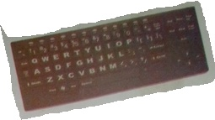
Keyboard :The keyboard is the most commonly used primary input device in the personal computer. It is used tofeed data and instructions into a computer. A keyboard contains keys for each alphabetic characters, numbers, special characters and some additional keys for specific functions. The data and instructions are fed into the computer by pressing the related keys on the keyboard.
Figure 68 Keyboard

Keyboard used with personal computer typically have from 101 to 105 keys, different companies are manufacturing keyboards with different layout. The most common English language key layout is the 'QWERTY' layout. Some of tie types of keyboards are XT-keyboard, AT-keyboard, Enhance keyboard, Multimedia keyboard.
The different keys present in the keyboard are:
Alphabet keys - A-Z
Numeric Keys -0-9
Function Keys– F1, F2,F12
Special Purpose Keys – Shift, Delete, Alt, Enter, Ctrl
Arrow keys- → (right arrow),← (left arrow),↑ (top arrow),↓ (down arrow)
Mouse :The mouse is the most commonly used pointing input device in the personal computer. It is used to point objects and give commands to the computer. When you move the mouse on the mouse pad, the mouse pointer on the screen moves in the corresponding direction.

Generally, a mouse contains two buttons: a left button that is called the primary button and right button that is called secondary button. The primary button is the one we use most often. Some mouse also have a scroll wheel between the buttons. That wheel helps the users to scroll through documents and long pages in website more easily. Some of the types of mouse are: Seri mouse, Optical mouse, Wireless mouse and so on.
Figure 69 Mouse

Scanner
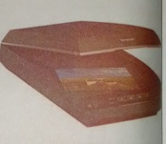
A scanner is an input device that optically scans images, printed text, handwriting, or an object, and converts it to a digital image and then sends to the computer. Scanners are also called the direct entry or non- keyboard input devices. Today, different types of scanners are found in the market. Commonly used scanners are flatbed scanners where the document is placed on a glass window for scanning.
Figure 70 scanner
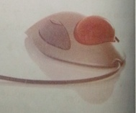
- Trackball: Trackball is a stationary pointing devices that contains a movable ball rotated with a figure or palm. It contains of a ball resting on two rollers at right angles to each other, which translates the ball's motion into vertical and horizontal movement on the screen. A trackball also has one or more buttons to initiate other actions.
Figure 71 Trackball

The trackball unit is held stationary while the ball is manually rotated by hand in any direction. The major advantage of a trackball is that it takes little desktop surface.
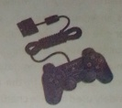
e. Joystick: Joystick is also pointing input device. It is the most commonly used device to play computer James. It consists of a stick for controlling. It has one or more push buttons through which we can play and control computer games. The function of Buttons depends upon the types of software being used in computer.
Figure 72 joystick

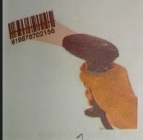
f. Bar Code Reader:A barcode reader, also called a price scanner or Point-
Figure 73 Bar code reader
Of-Sale (POS) scanner. It is a hand-held or stationary input device used to capture and read information contained in a barcode. Barcodes are often used to help organize and index information or prices about an object. A barcode reader consists of a scanner, a decoder, and a cable used to connect the reader with a computer. We might have seen in super market barcode scanner that reads and logs the price of a product.
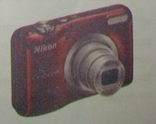
Digital Camera :A digital camera is an input device that takes video or photographs. Then, it inputs to the computer in the digital format. At first, the photographs are stored in the camera's memory and then are transferred to a computer by connecting it through a caste. Editor can edit them according to our
Figure 74 Digital camera

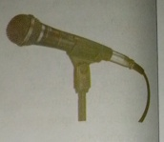
requirement. Most of the camera we use today are digital. It stores data in digital format.
Figure 75 Microphone
Microphone: A microphone also called a MIC is an input device. It is used to input voice or sound into the computer. We can record speech, songs in the computer by using microphone. A computer stores recorded voice and sound in the digital format. It is widely used in voice chatting over the Internet and video conferencing. It is specially used in messenger apps.

Digitizer : A digitizer is also called drawing tablet or pen tablet. It is an input device used to convert hand-drawn images into the digital format. Images are usually drawn onto a flat surface with a stylus and then appear on a computer monitor. It enables an artist to draw or sketch easier than they would be able to do with a standard computer mouse.
Figure 76 Digitizer

QR Code Scanner: Quick Response Code is a type of bar code that contains matrix of dots. This code is scanned or red with the help of QR-Scanner or any other mobile phone having a built-in camera.
Figure 77 web camera
Web Camera: a web camera is a kind of camera that takes photos or videos and sends them into the computer. It is widely used in Internet chatting and for video telephony. It is used in messenger apps. It is connected to a computer often by using a USB port.

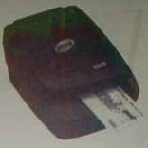
MICR: Magnetic Ink Character Recognition is a character recognition system that uses special ink and characters. When a document that contains this ink needs to be read, it passes through a machine, which magnetizes the ink and then translates the magnetic information into characters. MICR technology is used by banks. Numbers and characters found on the bottom of checks are printed by using Magnetic Ink.
Figure 78 MICR
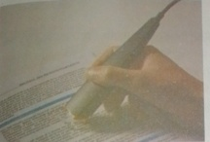
OCR: It stands for Optical Character Reader. It is a type of scanner that scans the text documents and converts them into the form that the computer can manipulate. An OCR enables to take a book or a magazine article, feed it directly into an electronic computer file, and then edit the file by using a word processor.
Figure 79 OCR
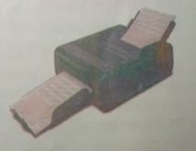
OMR: It stands for Optical Mark Reader. It is a device that scans the document and reads the data from the marked fields. It scans a printed form and reads predefined positions and records where marks are made on the form. This technology is useful for applications in which large numbers of hand-filled forms need to be blessed quickly and with great accuracy, as surveys, reply cards, questionnaires.
Figure 80 OMR
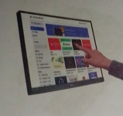
Touch Screen: Touch Screen is a touch sensitive display panel covering the screen. We can use our fingers to select objects on the screen and give commands to the computer like a mouse. It replaces the use of mouse or light pen as a pointing device. Touch screens are mostly used on portable computers such as laptop computer, palmtop computer, note book computer and so on.
Figure 81 touch screen

Output Devices:
The devices which display the meaningful information after processing is called output devices. When input data is processed, computer generates several types of output, depending upon the hardware and software used and the requirements of the user. We can see the output on a screen, print it on the printer or hear it through speakers. Some commonly used output devices are: Monitor, Printer, Speaker, Plotter and so on.
The output devices are normally classifieds into two types:
- Softcopy Output Devices
- Hardcopy Output Devices

Softcopy Output Devices:
Softcopy output refers to the output displayed on the screen. The output on the screen is lost when the computer is turned off. The output displayed on the monitor's screen in the form of text, graphics, video and sound from its speaker is called softcopy output. The most commonly used softcopy output devices are monitor and speaker.
Monitor: The monitor is a popular and most commonly used output device. It consists of a screen and the electronic components that produce the output on

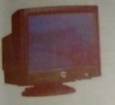
the screen for a temporary period. It is also called the Visual Display Unit (VDU) that provides visual display. The output displayed on the monitor screen is called softcopy output. Most monitors used in personal computers display the output in the form of text, graphics and video. There are two types of monitor:
Monochrome Monitor: Monochrome means information displayed in single color.
Colour Monitors:Color monitors are used to display output in different colors. Color monitors are further divided into 3 types:
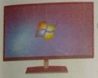
CRT Monitor:The full form of CRT is Cathode Ray Tube. It is big in size and takes a lot of desk space. It uses a cathode ray tube to display video and graphics on the screen.
Figure 82 LCD monitor
Figure 83 CRT monitor
LCD Monitor :The full form of LCD is Liquid Crystal Display. It uses special kind of liquid crystal to display video and graphics on the screen. It consumes very less power than CRT monitor. It is very lighter and more portable than the CRT monitor.
LED Monitor:The full form of LED is Light Emitting Diodes. LED is the advance application of LCD. It is far better than the LCD technology. Due to the better techniques used in the LED monitors, these monitors are very accurate in their colour display.
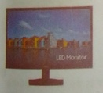
Speaker:The speakers are most commonly used sound output device. They are used to receive sound output. The speakers are used to play music and songs from the computer. Some speakers are also inbuilt inside the system unit and they produce different sounds while using computer.
Figure 84 LED monitor
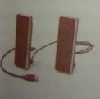
Figure 85 Speaker

Hardcopy Output Devices:
Hardcopy output refers to printing letters, graphics or pictures on a permanent medium such as paper of film. The most common hardcopy output devices are printer and plotter.
Printer is the most popular and commonly used hardcopy output device. It prints the output on the paper. There are two types of printers are available in the market. According to the manner of printing, the printers are classified as
Impact printer
Non impact printer

Impact Printer:
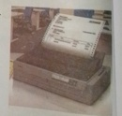
Impact printers use electromechanical mechanism that causes hammers or pins strike against a ribbon and paper to print the text. Impact printers produce sound during printing. So, they are also called noisy printers. Dot Matrix printer Daisy wheel printer, Drum printers are the examples of impact printer.
Dot Matrix Printer:It prints text and graphics on paper by physically striking pins against an inked ribbon. The inked ribbon is placed between the print head and the paper. The printing speed of this printer is slow and it produces low quality.
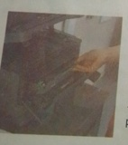
Drum Printer:Drum printer is an impact printer that consists of a cylindrical drum on which character are embossed and it rotates at uniform speed. It is capable of printing at a very high speed rang 125 to 3000 lines per minute. It is very expensive printer.
Figure 86 Drum printer
Figure 87 Dot matrix printer

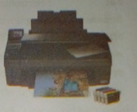
Non-impact Printer: Unlike impact printers, use electromechanical printing head to strike against ribbon and paper. Non-impact printers use thermal, chemical, electrostatic laser beam or inkjet technology for printing the text. They are faster than impact printers. They do not produce sound while printing. Inkjet printer and laser printers are the examples non -impact printers.
Figure 88Injket Printer
Inkjet Printer:It prints text and graphics on the pacer by spraying small drops of ink into paper. It is faster and produces very high quality of print than dot matrix printer. Inkjet printers are the most common type of printers.

Laser Printer:
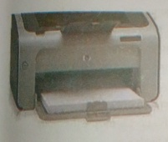
Laser printer uses a laser beam to print high quality of text and graphics on the paper. The quality of laser printer depends on the toner it uses. The printing speed of this printer is high in comparison to other printers. The laser printers are much more expensive and produce high quality output than the dot matrix printers.
Figure 89 Laser printer
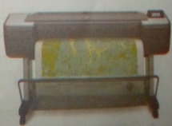
Plotter: The plotter is a kind of hardcopy output device. It gives hard copy output printer. It is used to produce a hard copy of large graphs and designs on paper. Potters are often used for the production of engineering drawings, construction "maps and business charts.
Figure 90 plotter

Word Meaning
peripheral | : equipment connected to the computer for different purposes.
electronic | : which runs with the help of electricity.
bus | : electronic pathway through which data flows.
firmware | : program stored in ROM for starting the computer.
PDA | : Personal Digital Assistant (mobile phones).
static | : fixed, which cannot be changed.
dynamic | : which changes always like a variable

Summary
- Hardware are the Physical parts of a computer which can be seen and touched.
- Motherboard holds the CPU, which is known as the brain of the computer.
- Bus is used to transfer data, signals or power among the components of the computer.
- CPU fan keeps the computer cool by throwing out the hot air.
- The keyboard port is green and the mouse port is purple in color.
- IEEE stands for Institute of Electrical and Engineers.
- SRAM does not need to be refreshed or recharged periodically like DRAM
- The storage capacity of one DVD is almost 6 times more than a CD.
- Flash memory is derived from Electrically Erasable Programmable Rea< Only Memory (EPROM).
- Laser Printer uses a laser beam to print high quality of text graphics on the paper.
- Input devices convert the data and instructions into suitable binary form.
- Output devices display the meaningful information after processing.

Exercises
- Fill in the blanks.
- ………………are the peripheral devices attached to the computer.
- CPU is the brain of the ………………
- Different types of buses are data bus, address bus and………………
- The………………port interface was also known as the Line Print Terminal port.
- ………………is a serial bus interface especially created for high speed
audio and video transmission.
- The leakage of………………discharges the memory cells and lose contents.
- Memory which stores data and instructions permanently for future
reference is known……………… as memory.
- Monitor is also called ………………
- State whether the following statements are True or False.
- Fujio Masuoka Corporation has introduced flash memory.
- The storage capacity of one DVD is almost 10 times than a CD.
- In a optical storage medium, laser beam is used to access the data.
- Hard disk is also called 'Windows Disk'.
- Date are stored in ROM chip during manufacturing time.
- Date are stored in memory in the form of decimal digitals.
- Bit is the smallest unit of storage.
- A……………… is an input device that takes video or photos.

3. Write the technical terms for the following.
- The physical parts of a computer.
- The main circuit boards of a computer.
- The unit that performs arithmetic calculations and logical operations.
- Socket on the motherboard that is used to insert an expansion card.
- A device helps to run the internal clock of computer.
- Program that holds the booting instructions of a computer.
- Memory in which data and instruction are erased with electrical pulses.
- A storage media whose storage capacity is almost 6 times than a CD.
- Concentric circles for storing data and information in a disk.
- The smallest unit to store computer data.
- A noisy printer that is slow in printing.
- Match the following.
i. Group "A"  - Parallel port  - Serial port  - PS/2  - USB port  - Fire-Wire port | ii.Group "B"  - faster than parallel port  - digital camera and pen drive.  - IEEE1394  - printer  - green and purple port  - Byte

ii. Group "A"  - SRAM  - DRAM  - EPROM  - EPROM  - EPROM | Group "B"  ii. firmware  iii. ROM burner  iv. UV light  v. leakage of charges  vi. electrical pulses  vii. no periodic refreshing

5.Write the full from of.
CPU | CMOS | IEEE | RAM
ROM | PROM | CD ROM | DVD
PS/2 | SRAM | EPROM | USB
DRAM | EEPROM | LED | QR

- Answer the following questions.
- What do you mean by computer hardware? List some hardware devices.
- Why motherboard is called as central nervous system of a computer? Explain.
- List different components of a Motherboard.
- List different ports of motherboard. Explain USB and Fire-Wire ports.
- Explain different types of RAM.
- Write short notes on:
  - PROM.
  - EPROM.
  - EPROM.
- What do you mean by Flash memory? Explain.
- Briefly describe the working mechanism of hard disk.
- Classify the types of printers.
- What is an input device? Give any 10 examples.
- What is an output device? Give any 4 example.

Chapter 5 COMPUTER SOFTWARE
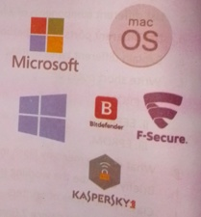
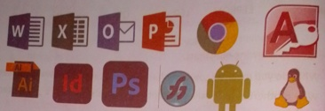
Figure 91 Microsoft Kaspersky, Bitdefender, mac OS
Figure 92 word excel outlook power point, chrome MS access , illustrator InDesign, Photoshop, android Linux

This chapter covers:
- Introduction to Software
- Types of Software
» System Software
» Application Software
» Utility Software
» GUI Environment
» Desktop Application
» Web Application

Introduction:
Software is a collection of instructions that enable the user to interact with
a computer. Software are such type of programs which instruct the computer what to do? when to do? and how to do? any task. Without software, most computers would be useless. The set of instruction written in any programming language that can be understood by the computer is called program. Collection of computer programs is called software.

Types of Computer Software: -
There are different types of computer software, designed to perform different task either for user or for computer. Broadly we have three type of software’s, they are: -

- System Software
- Application Software
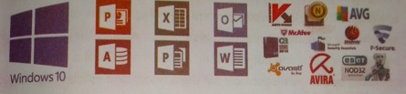
- Utility Software
Figure 93 window 10 power point, MS access excel outlook MS word Avira avast avg mc fee, e set nod 32 , f- secure Norton

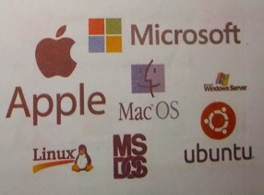
a) System Software
System software is a set of one or more programs designed to control the operation of a computer system. These programs don't solve specific problems. They are general programs written to assist humans in the use of the computer system. In general, system software supports the development of other types of software and monitor the use of various hardware resources. Thus, system software controls
Figure 94 Microsoft apple, mac Ubuntu ms Dos
and manages the overall operation of the computer system and the person who prepares system software is called as a system programmer. The system software is classified into two categories. They are:
- Operating System
- Language Processor
I) Operating System and its functions
An operating system (OS) is an integrated set of programs that is used to manage the various resources and overall operations of a computer system. The objective of operating system is to improve the performance and efficiency of a computer system. As the manager of a company, an operating system is responsible for the smooth and efficient operation control and manages a company of the entire computer system. The operating system provides the platform on which all other programs can run. The major functions of the operating system are:
- Process Management
- Memory Management
- Input/output Management
- File Management and so on

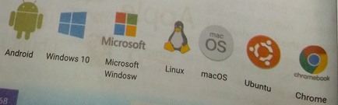
Figure 95 Android, windows 10, microsoft window, linux, macOs, Ubuntu, chrome

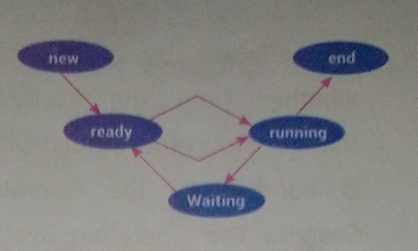
Process Management
Figure 96 Process management
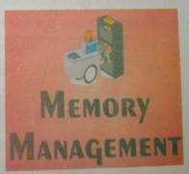
Process is a task performed by the processor. The OS decides the order in which processes have access to the processor, and how much processing time eac hprocess has. Different types ofprocess present in the processor are new process, running process, waiting process, ready process, end process. OS is responsible for scheduling the process, related to process management an Operating System performs the following activities. It keeps tracks of the status of processes. Allocates the CPU time to a process. Deal locates processor when a process is no more required.

Memory Management
The operating system manages the Primary Memory or Main Memory. In order to execute a program, it first loaded in the main memory. An Operating System performs the following activities for memory management: It keeps tracks of primary memory, i.e., which bytes
of memory are used by which user program. It also tracks memory addresses that have already been allocated and the memory addresses of the memory that has not yet been used.
Figure 97 Memory management

Input/output Management:
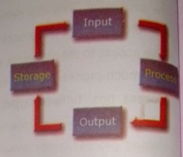
Figure 98 Input output management
All different types of input, whether from the keyboard, mouse or any other input devices is handled by the Operating System. The Operating System is responsible for performing different types of interfaces
related to input or output in the most appropriate manner. For example, there is difference in nature of all types of peripheral devices such as mouse or keyboard, Operating System is responsible for handling data between them.

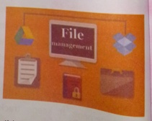
File Management:
Figure 99FIle management
A file is a organized collection of related data and a place where they are stored is directories. An operating system organizes files and directories for efficient or easy navigation and usage. Regarding the file management an operating system is responsible for keeping track of where information is stored, user access settings and status of every
and directories.

Some of the examples of operating system are : MS-DOS, Microsoft windows 98/ME/ 2000/ XP/ Vista, UNIX, Linux, Mac OS and so on.

Types of Operating System: Based on mode of user, there are two types operating systems, they are:-

Single user operating system
Figure 100 Single user operating system
A single user operating system allows only one user to use the computer resources at a time. Such operating systems are generally used by people at home. Most of the operating system used by micro- computers is single user operating system like DOS, Windows etc. DOS is a single user and single tasking operating system whereas a window is a single user and multitasking operating system.

Multiuser operating system
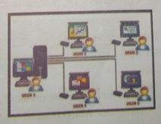
A multiuser operating system allows more than one user to use the computer resources at a time. The 'resources of the computer may include hardware as well as software components. Multiuser operating systems are used in offices and z g companies or organizations where many user can access the same computer at once. It means, multiuser operating system allows
Figure 101 Multiuser operating system
Some user to work on a network environment. Some of the examples of multi user operating system are: - UNIX, Novell Netware, Linux and so

ii) Language Processor
Language processor is the system software that is used to translate the instruction written in a programming language into a machine understandable code. There are three types of language processors. There are:-
- Assembler
- Interpreter
- Complier

Assembler
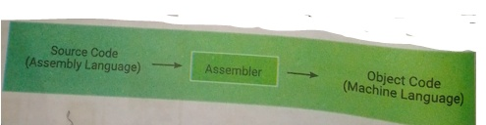
An assembler is a language processor that translates it program written in assembly level language into its equivalent machine level language. It takes the basic commands and operations from assembly (mnemonic) code and converts them into binary code. Assemblers are similar to compilers as it also product executable code. A program written by a programmer in assembly language is called a source program. When source program converted to machine code it is called object program.
Figure 102 source code to assembler and assembler to object code
Source Code (Assembly Language)
To Assembler then
Object Code

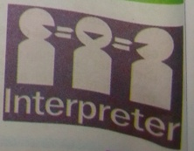
Interpreter
Figure 103 Interpreter
An interpreter is a language translator which is used fo rtranslating high level language code into machine language code. It takes one statement of a high-level language and translates it
(Machine

into machine instruction and executes it immediately. Interpreters do not create any object program.
A compiler is a language translator that converts the whole instructions of a high-level language into machine language at once. Compilers are large programs which reside permanently in the secondary storage. When the translation of the program is done, they are copied into the main memory of the computer.
Source Code
To Compiler
Then
Object code (Machine Level Language)

Application Software
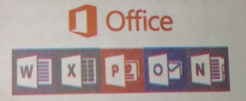
Figure 104 word, excel, power, point one, note, outlook
Application software is a set of one or more programs which are designed to do a specific task. It is made to fulfill the user's demand.
Compiler
Object Code (Machine Language)
Application is also called as application package. For example, a payroll package produces pay slips as the output, word processing jobs are done by word processing software (Ms-word) and School Management System processes examination results and produces nark sheets. There are two types of application software.
- Packaged Software
- Tailored Software

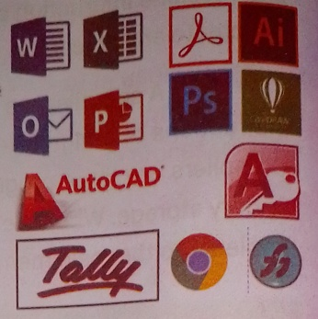
Figure 105 packaged software
a) Packaged Software: It is readymade software developed by a reputed company. It is developed for the global users to perform their generalized
tasks. MS-Word, MS-Excel, Photoshop and Corel Draw are some of the examples of packaged software. Some of the common packaged software are:-
- Word processing package: - MS-Word, Word Perfect.
- Spreadsheet package:- MS-Excel, Lotus 1-2-3.
- DBMS package: - MS-Access, Oracle, My-Sql.
- Accounting package: - Tally, Fact.
- Graphical package:- Adobe Photoshop, Corel draw, freehand
- Engineering package: - CAD, Auto CAD, CAM.
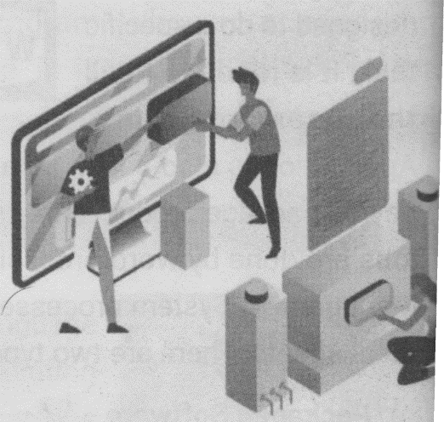
b) Tailored Software: It is also known as customized software. It performs a specific task for the specific person or organization. It is made due to the specific requirement of the user. For example, school management system, payrollpackage, mark sheet preparation and so on. This software is m according to the specific requirement of the organization or company.
Figure 106 Tailored Software

Differences between packaged and tailored software
Packaged software | Tailored software
The requirement of many organizations and users can't be perfectly matched. | The requirement of the user or organization can be perfectly matched
This software can be trusted as they are made by reputed software houses. | These software are generally made by local programmers. So, it may contain error.
They cannot be changed easily. | They can be changed easily.
They are expensive for small organizations. | They are cheap.
MS Word, MS Excel, Adobe Photoshop and so on | School Management System, Payroll System, Billing System and so on.

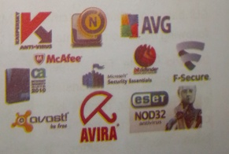
Utility Software
Figure 107 Utility Software

Utility software is the supporting software which is used to perform specific tasks related the maintenance of the computer system. Some of the software are included in mating System Software, r-e are available as a separate

utility in the market. Utility programs are also called as service programs The examples of utility software are Norton utilities, PC tools, WinZip
Partition magic, Backup Utility, Disk Defragmenter and so on.

GUI Environment:

Introduction:
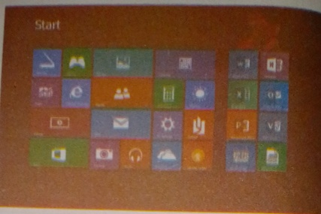
A GUI (Graphical User Interface)is a computer environment that represents programs, commands, files, and other options as visual elements, such as icons, pull-down menus, buttons, scroll bars ,windows, and dialog boxes. It helps in simplifying user interaction with the computer. The graphical user interface (GUI) was introduced to overcome the drawback of Character User Interface (CUI) in which user has to memorized the commands and instruct the computer by typing.
Figure 108 GUI Environment

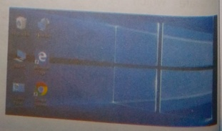
Basic Components of GUI:
Figure 109 Desktop
GUI based operating system such MS-Windows and Mac. OS has the following basic components:
Desktop :The first screen of windows, which consists of my computer, recycle bin, control panel, taskbar, start button etc. is desktop. It

appears whenever user presses the switch "ON" of the computer system.
Figure 110 Icons
Icons : A small picture element presenting a file program or command s icon. User can open any program by 'asking the mouse pointer over the icon and double clicking the left mouse button.
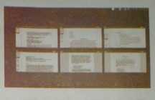
Window s:A rectangular frame which represents different application programs is window. The name is so, as in appearance it looks like a window. User can customize the windows in cascading manner where each window contains different programs. It can bea sized, maximized and minimized too. It also contains horizontal and vertical scroll bars to navigate around.
Figure 111WIndows
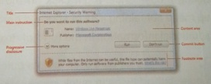
Dialog Box :The dialog box (also called dialogue box) is a graphical control a element in the form of a smallwindow that communicatesinformation to the user and prompts them for a response.
Figure 112 Dialog box

Pointing Device: A device (e.g. a graphics tablet, mouse, stylus, or trackball) used to control the movement of a cursor on a computer screen.
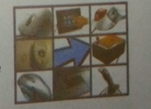
Figure 113 Pointing device

Mouse Pointer: A mouse pointer, is a graphical image(generally in the shape of an arrow) that is used to control certain elements in a graphical user interface(GUI). More plainly, it indicates where your mouse should perform its next action, such as opening a program, or dragging a file to another location. The mouse pointer follows the path of the user's hand as they move their mouse. The graphic shows an example of a mouse pointer.
Figure 114 Mouse pointer

Activities of mouse pointer

Figure 115 Left click
It is a symbol used for selecting object on the computer screen. Some of the activities performed by mouse pointers are:-
Left Click: Left click means pressing the left button of the mouse once. Left click on mouse selects the objects on the screen. Using left click user can select programs, files, folders, icons or any other object.
Right Click Right click means pressing the right button of the mouse once. Right click on mouse opens the pop- up menu containing lists of shortcut commands. It provides additional information in the form of drop-down menu.
Figure 116 Right Click

Double-Click Double click means quickly pressing the left mouse button twice in quick succession. It is used to open or execute a file, folder, or software program.
Figure 117 Double click
Drag and Drop: Drag and drop means pressing and holding the left mouse button and releasing it after moving the mouse to new location, drag and drop is a pointing device action in which the user selects a object by "grabbing" it and dragging it to a different location or onto another place.

Figure 118 Drag and drop

Files and Folder Management
File: Organized collection of related information stored in a computer is file. In GUI environment icon of a file indicates its type. Like if it is a MS- Word application file or MS-Excel file user can easily identify it by its icon or picture. It is the electronic storage or any information in computer. Every file has its unique name and it has two parts: file name and extension which is separated by a dot(.). Some list of files along with their icon and extension is given below. 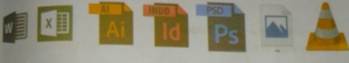
Figure 119 word , excel, illustrator, InDesign, Photoshop ,image, vlc, media player

Folder:A folder, also called a directory, is a special place used to store files, other folders. The related files are kept in a particular folder so that it helps us to find them easily. A folder is represented by an icon. A folder inside another folder is called sub-folder.
Figure 120 Folder

Working with files and folders
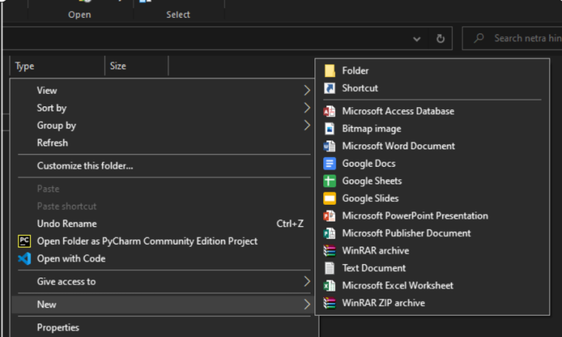
Creating a new file or folder
- Right click on the computer screen for creating file or folder.
- Choose "New" and click at application file name for file and folder for new folder.
- Type the name of file or folder.
- Press Enter key.
Figure 121 Creating new folder

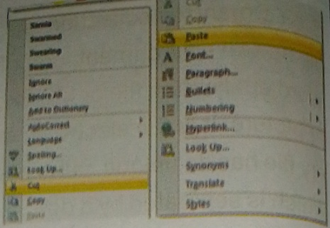
Moving a file or folder (ctrl + X and Ctrl + V)
Figure 122 move
- Right click on the file or folder that
you want to move.
2. Click at "Cut" option.
3. Go to the destination location.
4. Right click and choose "Paste" option
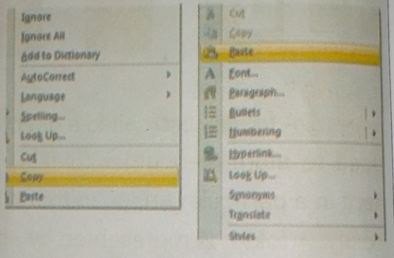
Copying a file or folder(Ctrl + C and Ctrl + V)
Figure 123 copy
1. Right click on the file or folder
that you want to copy
2. Click at "Copy" option.
3. Go to the destination location.
4. Right click and choose "Paste" option
Renaming a file or folder
- Right click on the file or folder that
you want to rename
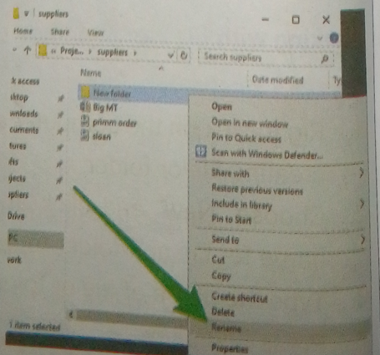
2. Click at "Rename" option.
Figure 124 rename files and folder
3. Type the new name for file or folder
4. Press enter key.
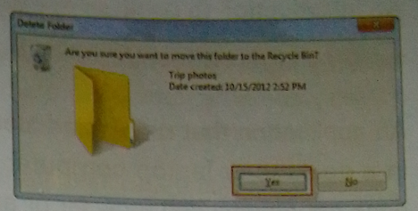
Deleting a file or folder
Figure 125 deleting files or folder
- Right click on the file or folder that you want to delete
- Click at "Delete" option.
- A dialog box will appear asking you for confirmation.
- Click at "Yes".

Open Source Software:
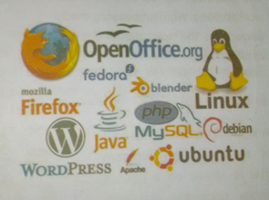
Introduction : Open source software is the software whose source software is freely available so the user. In other words, the software that fall under General Public License (GPL) is open source software. Users can customize the source code of the open source software according to their requirements.
Figure 126 Mozilla Firefox, Ubuntu, WordPress, Linux
They needn't to buy the license in order to use the software. Source code can be modified and re-distributed to any other person legally. These software are available free of cost. So, we also call them Free and Open Source Software (FOSS). Some of the examples of open source software are:- Linux, Open Office, Apache, Mozilla Firefox and so on.

An Introduction to Desktop Application and Web Application:-
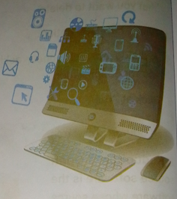
Figure 127 Desktop Application

Desktop Application:
An application that runs stand-alone in a desktop or laptop computer. It does not require web browser or any other platform to run. These programs should be installed in each computer. They are the machine dependent programs that run on personal computer like desktop, laptop and personal workstations. Word processors, media players are the examples of desktop applications.

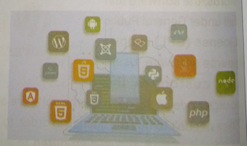
Web Application:
Figure 128 html, JavaScript, jQuery, nodejs
A Web application (Web app) is an application program that is stored on a remote server computer and with the help of Internet and web browser displayed on client computers. Some of the best examples of web applications are online shopping, E-commerce online forms, online banking, and shopping carts and so on. Some common web applications include Gmail, Yahoo and AOL. Popular application: include Google Apps.

Comparison between Desktop and Web application
- A web application can be accessed from any computer no matter where the person is with the help of internet whereas desktop app. can only be accessed if user has his/her computer.
- Web applications are costlier than desktop apps.
- Web applications can be installed only once whereas desktop applications can be installed any number of times on separate computer.
- Web applications are not reliable as user has to depend on Internet for its reliability whereas desktop apps are more secure and reliable.
- Web applications are platform-independent; they can work in different types of platforms with the help of a web browser whereas desktop applications need to be developed separately for different platform machines.

Word Meaning
Assist : help, someone
Integrated : various parts linked or coordinated.
Efficient : working in a well-organized and competent way.
Execute : put into effect.
Platform :a program supporting various types of devices or programs Grabbing : grasp or seize suddenly and roughly.
Navigate : Explore or move from one area to another.
Allocate : to give resources for a particular job.
Deal locate : to remove a set of resources.

Quick succession: following one after another in a short interval
Stand-alone: a computer that can operate on its own, without being connected to a network

Summary
- Software is a collection of instructions that enable the user to interact with a computer.
- Without software, most computers would be useless.
- System software is a set of one or more programs designed to control the operation of a computer system.
- System software controls and manages the overall operation of the computer system and the person who prepares system software is called as a system programmer.
- An operating system (OS) is an integrated set of programs that is used to manage the various resources and overall operations of a computer system.
- Readymade software developed by a reputed company is known as Packaged Software.
- Software made due to the specific requirement of the user is Tailored Software. .
- A supporting software which is used to perform specific tasks related to the maintenance of the computer system is Utility Software.
- A file is organized collection of related information stored in a computer
- A folder is a special space used to store files and other folders.
- A software whose source code is freely available to the user is Open" source software.
- An application that runs on a stand-alone computer is a desktop application.
- An application program that is stored on a remote server computer and can be viewed with the help of Internet and web browser is application.

Exercise
      - Write very short answer for the following.
- Collection of instruction that helps to interact with the computer.
- List different types of software.
- Name the software designed to control the operation of the computer.
- List the major functions of the operating system.
- Based on the mode of user, name different types of operating system.
- Name the operating system where more than one user can work at a time.
- Software that gives special service to the user of the computer.
- Name the software that falls under General Public License (GPL).
- Name any two-application software's.
      - Answer the following questions in short.
- Compare Desktop and Web application.
- Define utility software with example.
- What is open-source software? What is the meaning of FOSS?
- Differentiate between packaged and tailored software.
- Define Language processor. List different types of language processors.

f) Define File and Folder.
g) List different types of mouse activities.
h) What is a dialog box?
) Write the steps for moving and copying a file.
3. Long Answer questions.
a)What do you understand by GUI environment. List and explain basic components of GUI based operating system.
b)What is Software? Write about different types of software in detail
4)Select the best alternative from the given choices.
a) Which of the following is not a type of system software.
I) Operating System iii) Tailored Software
ii) Language Translator
iv) None

b)Process Management is not related to.
I) New process ii) Old Process
iii) Running Process iv) Waiting Process

c)Which is not an Operating system ?
I) MS-DOS ii) MS-Windows
iii) UNIX iv) Ms-Word

d)Which of the following is a Single user and single tasking OS?
I) MS-DOS ii) MS-Windows
iii) UNIX iv) LINUX

e)Which one is not a Multiuser operating system?
I) UNIX ii) Novell Netware
iii) Linux iv) Windows
f)Which one is not one of the activities of mouse pointer?
I) Left Click ii) Right Click
iii) Double Click iv) Middle Click
g)Which language processor creates Mnemonic codes?
I) Compiler ii)Interpreter
iii)Assembleriv)Translator
h)Which Translator translates whole program at once?
I) Compiler ii) Interpreter
iii) Assembler iv) None
I)Which of the following is/are Utility software?
I)Partition Magic ii) Winzip
iii) Backup iv) All of them
j)Which one is not an Open Source Software?
I)Linux ii) Open Office
iii) Apache iv) Google Chrome

- Match the following with appropriate choice.
Group A  - Cut  - Copy  - Paste  - Mnemonic | Group B  - Ctrl + Y  - Ctrl + X  - Assembly Language  - Ctrl + C  - Ctrl + V

Group A  - Web Application  - Desktop Application  - FOSS  - Utility Software | Group B  - Standalone computer.  - Partition Magic  - MS-Word.  - Server Computer.  - Open Source Software

Group A  - Spread Package  - Database Package  - Graphical Package  - Engineering Package | - MS-Access  - Photoshop  - Tally  - MS-Excel  - Auto - CAD

6. write the name of the following tools:
Tools | Name | Function

7. Write full form for the following.
a)GPL b) FOSS c)CAD d)CAM
e)GUI f)CUI g)OS

CHAPTER – 6 Working with GRAPHICS
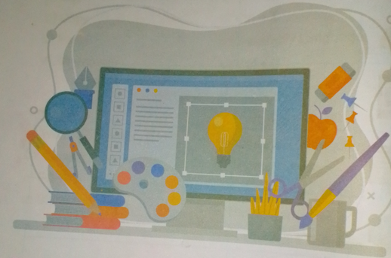
Figure 129 monitor and pen
This Chapter Covers:-
Introduction to Graphics Application of computer graphics Uses of Graphics
Different graphics formats Graphics for web
Adobe Photoshop
Working with Photoshop tools Image Editing
Printing Images

Computer Science

Introduction to Computer Graphics:-
Figure 130 Computer Graphics
Computer graphics refers to the creation, storage and manipulation of pictures and drawings using digital computers. It enhances communication between computers and users. The term Graphics was derived from the Greek word "Graphik os" which means to present any object having specific shape size through a medium. Graphics include good quality image or picture which is notthe form of text or sound. Computer Graphics makes us easy to understand and interpret any topic. Computer graphic has amazing impact act on many types of media and has revolutionized animation, movies and the video game industries. Some of the graphic software - MS-Paint, Freehand, Adobe In Design, CorelDraw, Adobe Photoshop.

Application Computer Graphics:-

DESIGNING:-

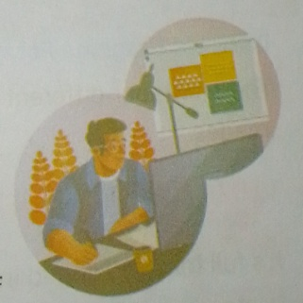
In order to design consumer products and many other applications Engineers and Architects uses graphics. Engineers use CAD (Computer Aided Design) program to build designs of buildings, cities, aircraft, spacecraft, and defense mechanism and so on. Graphics make computer applications much interactive, active and dynamic. It opens unlimited experimenting for the designer.
Figure 131 Designing

2D AND 3 D IMAGE PROCESSING AND VISUALIZATION:
Figure 132 2d 3d image

In 2 D and 3 D image processing and visualization of images animation, Morphing, Simulation, E-learning, Graphic design are playing a vital role. For examples graphic design of a car 3 D picture Animation

Uses of Computer Graphics:-
Figure 133 computer graphics
The following are the common uses of computer graphics in differ fields.
- Web Design
- Video Game
- Computer-Aided Design (CAD)
- Virtual Reality
- Digital Art
6

Different Graphics Format:-
There are four different types of formats used for storing graphics and images.
Figure 134 TIFF

1 .TIFF (ENDING IN, TIF) :
Its full form is Tagged Image File Format. TIFF are used to store a very large file sizes. They are in uncompressed form and contain a lot of detailed image data. TIFF is the most common file type used in photo software (such as Photoshop).

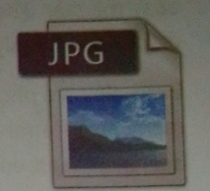
2. JPEG (ENDING IN JPG)
Figure 135 JPG
Its full form is Joint Photographic Experts Group. These formats files are compressed to store a lot of Information in a small-size file. Most digital cameras store photos in JPEG format.
Figure 136 GIF

3. GIF (ENDING IN .GIF)
GIF stands for Graphic Interchange Format. This Format can be used for animations.GIF images cannot be as small as JPEG.

4. PNG (ENDING IN . PNG):-
PNG stands for Portable Network Graphics. It also allows for a full range of color and better compression. It's used almost exclusively for web images. For photographs, PNG is not as good as JPEG, because it creates a larger file.
Figure 137 PNG

GRAPHICS FOR WEB:-
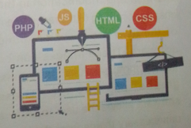
Images are a vital component of any website, and using the right ones can enhance both your content and design. Graphics used for web site are the representation of an idea or feeling. It can impact the user emotionally or can entertain or educate the user in a very
Figure 138 Graphics for web

easy manner. There are plenty of tools that can help you create stylish graphics with only a little practice
Examples are photographs, drawings, line art, graphs, diagrams, typography art of arranging letters and text), numbers, symbols, geometric designs, maps, engineering drawings, or other images.

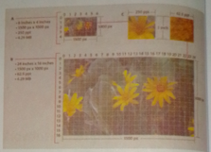
IMAGE SIZE AND RESOLUTION:-
Figure 139 Image size and resolution

Resolution refers to the number of pixels in an image. Resolution is identified by not only the total number of pixels in the image but sometimes through the height and width of the image as well. For example, an image that is 1500 pixels wide and 1000 pixels high(1500 x 1000) contains 1,500,000 pixels (or 1.5 Megapixels).

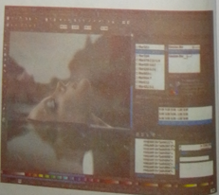
GRAPHIC EDITING:-
Figure 140 graphics editing

A software designed to do changes and modification in the images according to the requirement of the user are graphic editing software. These images can be digital photographs, illustrations, graphs, pictures etc. These software allows the user to remove unnecessary things from the image

and includes impressive effects on it. There are various graphic editing programs available in the market like Adobe Photoshop, Microsoft Picture Manager, GIMP (Gnu Image Manipulation Program), photo filter.

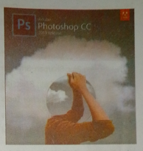
ADOBE PHOTOSHOP-
Figure 141 Adobe photoshop
It is a photo/Graphic editing software. This software is specially designed to perform different changes to the pictures like changing the background of the pictures, changing color, making powerful advertisements, converting boring pictures into eye catching ones and so on. Adobe -Photoshop is one of the popular graphics Design and image-editing software developed by American brothers Thomas Knoll and John Knoll at Adobe Company in 1388. It is very much useful for the professionals like desktop publishers, web designers, digital photographers, videographer, etc. for image manipulation and printing.

FEATURES OF PHOTOSHOP:
Some of the features of Adobe Photoshop are as follows.
- It is easy and effective for creating and editing images.
- It provides several tools to perform the image task quickly.
- It supports 2 D to 3 D image conversion.
- It allows to save images for the web.
- It allows to format and print images in desired style.

THE LIST OF THE COMMON TOOLS WITH THEIR FUNCTION IN PHOTO SHOP IS GIVEN BELOW
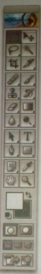
Figure 142 tools
Marquee Select Tools
Lasso Select Tools
Crop
Healing Brush, Patch Clone & Pattern Stamp
Erase
Blur, Sharpen, Smudge
Path Selection
Pen & Anchor Tools
Notes Hand Tool
Foreground / Background Color
Screen Mode (Standard /Full Screen
Move
Magic Wand
Slice, Slice Select
Brush, Pencil
History Brush, Art History Brush
Paint Bucket, Gradient
Dodge, Burn, Sponge
Text
Shape Tools
Color Picker, Sampler, measure
Zoom
Edit Mode (Standard / Quick Mask)
Jump to Image Ready
Icon | Tool Name | Use
 | Move (V) | Moves selections or layers.
 | Marquee (M) | Makes rectangular, elliptical, single row, and single column selections.
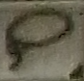 | Lasso(L) | Makes freehand, polygonal (straight-edged), and magnetic selections.
 | Quick Selection (W) | Make selections by painting.

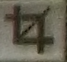 | Crop (C) |  |  | Crops an image.
 | Eyedropper (I) |  |  | Samples pixels.
 | Spot Healing (J) |  |  | Removes imperfections.
 | Brush (B) |  |  | Paints the foreground color.
 | Clone Stamp (S) |  |  | Paints with a sample of the image.
 | History Brush (Y) |  |  | Paints with the selected state or snapshot.
 | Eraser (E) |  |  | Erases pixels—or reverts to a saved history state.
 | Gradient (G) |  |  | Creates a gradient.
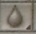 | Blur (no shortcut) |  |  | Blurs pixels.
 | Dodge (0) |  |  | Lightens pixels in an image.
 |  | Pen (P) | Draws a vector path.
 |  | Horizontal Type (T) | Creates a type layer.
 |  | Path Selection (A) | Allows you to manipulate a path.
 |  | Rectangle(U) | Draw vector shapes
 |  | Hand(H) | Navigates the page
 |  | Zoom(Z) | Increase and decrease the relative size of the view.

MARQUEE SELECT TOOL
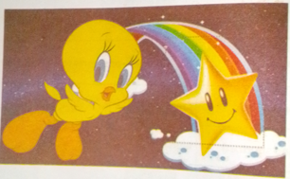
Figure 143 marquee tools
This tool selects a part of picture in different shapes, steps to use this tool is as follows
Step 1: Click on "Select tool" on the tool box.
Step 2 : Click and drag over the picture in order to select a part.
Step 3 : Selected part will be seen as indicated with dotted line in the picture.

MOVE TOOL:
Figure 144 move tools
This tool is used to move the selected part or any other object in the picture to new location, steps to use this tool is as follows

Step1: Click on "Move tool" on the tool box.
Step2: Click and drag the selected part of the picture.
Step 3: Move it to the new location as shown in the picture.

LASSO TOOL:-
Figure 145 lasso tools
This tool is used for free selection of image, steps to use this tool is as follows
Step 1 : Click on "Lasso tool" on the tool box.
Step 2 : Click and Move the pointer freely to any part of the picture.
Step 3 : Selection should end at the same point from where you
have started.
Step 4 : A free selected portion will be seen with dotted line as shown
above.

MAGIC WAND TOOL
Figure 146 magic wand tools
The Magic Wand tool selects similar color portion of the picture. This tool helps in removing the background part of the picture, before using this tool the lock over the layer must be removed by double clicking over the lock and click OK. Steps to use this tool is as follows.
Step 1: Click on "Magic Wand tool" on the tool box.
Step 2: Click over a color in the picture and press delete key.
Step 3: In this way keep on selecting the similar color background from the image and remove it by pressing delete key.
Step 4: The whole background can be deleted in this way and user can keep a new background in the picture.

CROP TOOL:
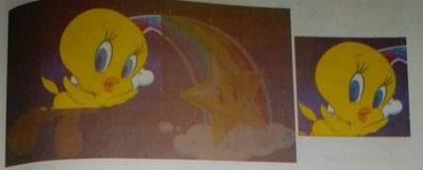
Figure 147 crop tools
Crop tool is used to select and cut a portion of the image. It helps in reducing the size of the image, steps to use this tool is as follows
Step 1: Click on "Crop tool" on the tool box.
Step 2: Select the portion of the picture.
Step 3: Press enter to get the selected portion only as shown above.

TEXT TOOL:-
Text tool is used to write some text or words over the picture. Steps to use this tools is as follows
Step 1: Click on "Text tool" on the tool box.
Step 2: Select a portion over the picture, where user wants to type.
Step 3: Start typing over the picture.

ERASER TOOL:-
Figure 148 eraser toosl
The eraser tool consists of three sub types Eraser, Background Eraser and Magic Eraser. Eraser erases whole picture, background eraser erases background and magic eraser erases similar color portion like magic wand, steps to use this tool is as follows
Step 1: Click on "Erase Tool" on the tool box.
Step 2: Right click and choose one of the option like
Background Eraser Tool".
Step 3: Drag over the picture to erase the background as above.

GRADIENT TOOL:-
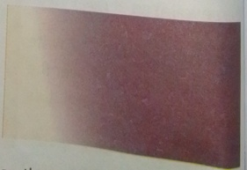
Figure 149 gradient tools
Gradient tool is useful in creating banners as it fills shaded color at the background, steps to use this tool is as follows
Step 1 Click on the "Gradient Tool" on the tool box
Step 2 Drag across the image.
Step 3 Move towards left to right or right to left to determine flow of gradient

PEN TOOL:-
Figure 150 pen tools
The pen tool is used to select the specific portion Of the picture. Steps to use this tool is as follows.
Step 1: Click on the "Pen Tool" on the tool box
Step 2 : Move over the picture vertically and horizontally to select the required portion.
Step 3: Result will be as shown above.

SLICE TOOL
Figure 151 slice tools

The slice tool is used to divide an image into different sections, and these separate parts can used as pieces, steps to this tool is as follows
Step 1: Click on the "Slice Tool" on the tool box.
Step 2: Click and drag over the picture.
Step3: Picture will be divided into different slices or parts.
Step 4: Now we can save sliced part as separate file.

DODGE TOOL:-
Figure 152 doge tools
The dodge tool is used to remove the darkness of the image and make it bright or bring lighten, steps to use this tool is as follows.
Step 1: Click on the "Dodge Tool" on the tool box.
Step 2: Move the pointer over the picture by pressing the left button.
Step 3: Picture will be seen brighter over the rubbed portion.

NOTE TOOL:-
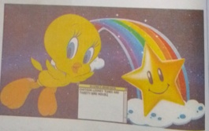
Figure 153 note tools
The note tool is used to type note or reference text about the existing picture. Steps to use this tool is as follows
Step 1: Click on the "Note Tool" on the tool box.
Step 2 : Drag over the picture to create a box as shown above.
Step 3: Now type over the notepad.

ZOOM TOOL:
Figure 154 zoom tools
Zoom tool is used to room in the picture as if user is looking through magnifying lens, steps to use this tool is as follows
Step 1: Click on the "Zoom Tool" on the tool box.

Step 2: Click the left mouse button to zoom the image.

Step 3: the enlarge size picture will be seen as shown above.

HAND TOOL:-
Figure 155 hand tools

The hand tool is used to move the age horizontally vertically, steps to use this tool is as follows.
Step 1: Click on the "Hand Tool" on the tool box.
Step 2: Click on picture or text then drag the mouse pointer.

PATH SELECTION TOOL:-
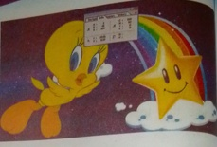
Figure 156 path selection tools
The path selection tool is used to change or transform the direction of the image picture, steps to use this tool is as follows.
Step 1: Click on the "Path Selection Tool" on the tool box.
Step 2: Now drag the mouse pointer over the picture.
Step 3: Navigation tool box will indicate the direction of your
Pointer both vertically and horizontally.

CLONE TOOL:
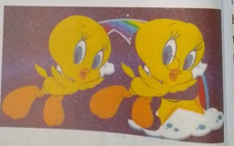
Figure 157 clone tools
Clone tool helps to create a cloning image or duplicate image over the same picture. Steps to use this tool is as follows.
Step 1 Click on "Clone Tool" on the tool box.
Step 2 Press alt key over the portion of image whose cloning user want to do.
Step 3 Move over the picture by pressing the left button.
Step 4 Duplicate image will be created in new location as shown above.

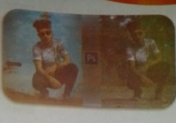
IMAGE EDITING:-
Figure 158 edit image of man

Adobe Photoshop is full of rage editing features. Some of them are Resizing, Setting “brightness, Rotating image, Saving image, Scanning image and Printing image.

RESIZING AN IMAGE:-
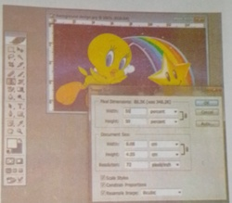
This option is used for changing the size of image according to the dimensions given by the user. User can supply the different values for width, height, resolution etc. Steps to use this tool is as follows.
Figure 159 resize image
Step 1: Open the image whose size user wants to change.
Step 2: Click on "Image Menu" then choose "Image Size".
Step 3:"Image Size" dialog box appears over the image.
Step 4 :Specify the width and height in percent or pixels and resolution as per requirement.
Step 5: Click "OK" button to accept the changed dimensions as shown above.

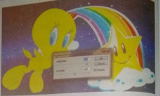
SETTING BRIGHTNESS ON AN IMAGE:-
Figure 160 change brightness of image

User can set brightness and contrast on the image according to his/her own choice. For doing show follow the steps given below.
Step: 1 Open the image to change the brightness or contrast.
Step: 2 Click on "Image Menu" then choose the "Adjustments' option followed by "Brightness/Contrast".
Step: 3 "Brightness/Contrast" dialog box appears. Change the brightness and contrast according to requirement.
Step 4 Click on "OK" button.

ROTATE OR FLIP IMAGE:-
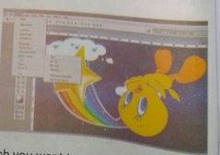
Figure 161 rotate image
This option is used for turning the image upside down or from left to right. Steps to flip the image is as follows.
Step 1 Open an image which you want to rotate or flip.
Step 2 Click on "Image Menu". Again click on "Rotate Canvas'
Step 3 Choose one of the options like "1800, 900 CW, 900 CCW
Step 4 Result will be as shown above of 180°.

SAVING IMAGES FOR THE WEB:-
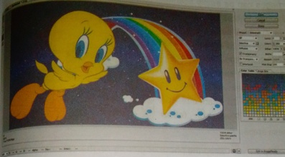
Figure 162 image save on web
In Photoshop we can save any image in a good quality for web sites. Web sites supports two types of images .GIF (Graphic Interchange Format) and .JPEG (Joint Photographic Expert Group). JPEG is of high quality in comparison to GIF. Steps to save the image for web is as follows.
Step: 1 Open the image which user wants to save for web site.
Step: 2 Click on the "File Menu".
Step: 3 Click on "Save for Web" option.
Step: 4 Save for Web and Device dialog box appears on the screen.
Step: 5 Click on "Save". A dialog box appears, type name, select location and finally click on "Save".

SCANNING PHOTOS USING SCANNER: -
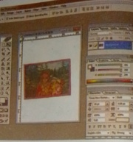
Figure 163 scanning photo
Images can be easily scanned through Photoshop, user need not to install separate scanner in computer. Photos, pictures, graphics, plain text etc. can be scanned and edited using the scanner effectively in Photoshop. To scan and edit picture in Photoshop follow these steps.
Step 1: Keep the photo or picture on the scanner.

Step 2: Click on "File Menu" then select the option "Import".

Step 3: Select the name of your scanner from sub options of Import like Brother DCP JIOO.Now scanning windows screen will appear.

Step 4: Click on preview button.

Step 5: Click on color mode combo box and choose the required color mode such as RGB, black, white, Grayscale etc.

Step 6: Click on scan button. Now scanning progress dialog box appears and after few seconds the photo will be seen on the Photoshop window.

Step 7: Now save the scanned photo.

PRINTING IMAGE DOCUMENT-
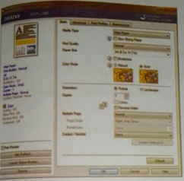
Figure 164 print image
The image created, edited and formatted can be printed from printer to produce hardcopy output for future use. To print a Photoshop document follow these steps:

Step 1: Open the Picture or Image to print.
Step 2: Click on "File Menu" then select the option print.Now print dialog box will appear as shown.
Step 3: Supply print range for printing.
Supply number of copies.
Step 5: Select other options from the dialog box such as document properties and give the values.
Step 6: Click on Finish tab.
Step 7: Click on print on both sides if the document is to be printed on both the sides.
Step 8: Finally click on "OK" button.
Now the document will be printed on the paper.

WORD MEANING
Manipulation: the control or use of something in a way that shows skill.
Enhances : improve the good quality
Dynamic : extraordinary qualities in a software.
Morphing : to change smoothly from one image to another using computer
Animation : Process of giving movement to pictures
Simulation : A situation in which a particular set of conditions is created artificially in order to study or experience something that could exist in reality
Compression: the act of pressing things together or pressing something into a smaller space
Illustrations : a drawing or picture in a book, magazine, for decoration or to explain something

SUMMARY
- Computer graphics refers to the creation, storage and manipulation of pictures and drawings using digital computers.
- Engineers and Architects uses graphics In order to design consumer products and many other applications.
- Engineers use CAD (Computer Aided Design) program to build designs of buildings, cities, aircraft, spacecraft, and defense mechanism and so on.

- There are four different types of formats used for storing graphics and images viz, TIFF, PNG, .JPEG, .GIF.
- Images are a vital component of any website.
- A software designed to do changes and modification in the images according to the requirement of the user are graphic editing software.
- Adobe Photoshop is specially designed to perform different changes to the pictures like changing the background of the pictures, changing color, making powerful advertisements, converting boring pictures into eye catching ones and so on.
- Select tool selects a part of picture in different shapes.
- Lasso tool is used for free selection of image.
- Text tool is used to write some text or words over the picture.
- The dodge tool is used to remove the darkness of the image and make it bright or bring lighten.
- Photos, pictures, graphics, plain text etc. can be scanned and edited using the scanner effectively in Photoshop.

Exercise
1. Write very short answer for the following.
- Name the Greek word from which graphics was derived.
- Name any two Medias who have revolutionized computer graphics?
- Name the application used by engineers to build designs of buildings and cities.
- List some of fields playing a vital role in processing of 2 D and 3 D images.
- The image format which is in uncompressed form and contain a lot of details.
- Name the image format used for animation.
- An image that is 3500 pixels wide and 2500 pixels high contains, how many Megapixels.
- Who developed Adobe Photoshop and in which year?
- Name the tool which makes freehand selections.
- Name the tool which navigates the page.
- Image format made up of 256 colors or less.
- Name the tool which create a duplicate image.
- Name the tool which looks like a magnifying glass.

n) Name the tool used to type reference about the image.
o) Name the tool which divides the image into different section.
p) Name the tool which is helpful in creating banner.
q) Number of pixels in an image.
- Answer the following questions in short.
- What is computer Graphics? List some graphics software.
- Write any four uses of computer graphics.
- What is Adobe Photoshop? List some popular photo editing software.
- How can graphics for web impact the user? List some examples of web graphics.
- Name the different graphic formats with their full forms.
- Write some of the features of Adobe Photoshop.
- Write the uses of following Photoshop tools.

3. Long Answer questions.
- List any 10 tools of Adobe Photoshop with their use.
- Adobe Photoshop is a popular photo/graphic editing software. Justify this statement by giving few examples from day to day life.

4.Select the best alternatives from the given choices.
- Which of the following is not a graphics software.
i. ms paints ii. Ms word iii. free hand iv. none
- Which of these is not a graphic format?
i. .TIFF ii .GIF iii. .jpg iv. MDB
- Which is not a graphic format?
i. photograph ii. text iii. diagram iv. flowchart
- Which of the following is not a photo editing program?
- i. photo filter ii. Photoshop iii. ms word iv. ALL
- Which tools a vector path?
i. pencil tools ii. pen tools iii. eraser tool iv. zoom
- Which tools helps in cutting a part of the image?
i. paste tool ii. crop tools iii. part tools iv. cut
- Eye dropper is used to …….
i. drop color ii. select a color iii. drop color to eye iv. none
- We can also scan pictures through photoshop.
i. only sometimes ii. never iii. always iv. not
- Resolution of image is measured in ……..
i. dpi ii. ddi iii. isi iv. bsi
- which is the option for image rotation?
I) 90° CW ii) CCW iii) 180° CW
iv) All

- Match the following wit happropriate choice.

Group A  - Free hand  - Clone Tool  - Text Tool  - Hand Tool | Group B  - To type character.  - To Navigate the photo.  - Graphic Software.  - To fill more than one color.  - To make duplicate.

Group A  - Eraser Tool  - GIMP  - Slice Tool  - Magic Wand Tool | Group B  - To divide image into different section  - Select picture based on color.  - To bring lightness on the image.  - To remove part of image.  - Photo Editing Software.

Group A  - Move Tool  - Virtual Reality  - Zoom Tool  - Design and patterns | Group B  - Uses of Graphics.  - Graphics for web.  - Adobe Photoshop.  - To view image in Larger mode.  - To make duplicate image.

6. Write name of the following tool with their function.
Tools | Name | Function

7. Write Full form for the following.
a) CAD b) TIFF c) JPG d) GIF e) PNG
f) GIMP g) DPI

Chapter- 7 Internet and web Technology

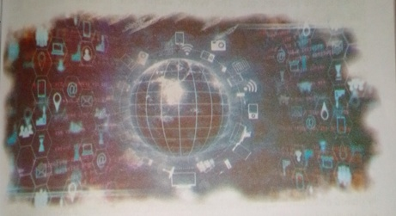
Figure 165 Internet and web technology
This chapter Covers:
- WWW, Web Page, Web Browser, Website,
Search Engines, Web Server, DNS
- Internet of things (lot)
- Cloud Computing

World Wide Web
World Wide Web, which is also known as a Web, is a collection of websites or web pages stored in web servers and connected to local computers through the internet. These websites contain text pages, digital images, audios, videos, etc. Users can access the content of these sites from any part of the world over the internet using their devices such as computers laptops, cell phones, etc. The WWW, along with internet, enables retrieval and display of text and media to your device.

The building blocks of the Web are web pages which are formatted in HTML and connected by links called "hypertext" or hyperlinks and accessed by HTTP. These links are electronic connections that I related pieces of information so that users can access the desired information quickly. Hypertext offers the advantage to select a word or phrase from text and thus to access other pages that provide addition information related to that word or phrase.
A web page is given an online address called a Uniform Resource Locator (URL). A particular collection of web pages that belong to a specific URL is called a website, e.g., www.facebook.com,www.google.com, etc. So the World Wide Web is like a huge electronic book whose pages an stored on multiple servers across the world.

Small websites store all of their Web pages on a single server, but big websites or organizations place their Web pages on different server’s ii different countries so that when users of a country search their site they could get the information quickly from the nearest server.
So, the web provides a communication platform for users to retrieve an exchange information over the internet. Unlike a book, where we move from one page to another in a sequence, on World Wide Web we follow

a web of hypertext links to visit a web page and from that web page to move to other web pages. You need a browser, which is installed on your computer, to access the Web.

Web Page
A web page is defined as a single document or a solitary page of any website. Every webpage is attached to a unique URL address used to render or access that particular page. These URLs and web pages can be private or public, depending on how the developers have configured them. Any web browser can be used to navigate URLs, which can also be copied and shared by users. Viewing a website does not usually need any navigation if we have its URL address. However, most URLs are connected a website that helps developers create a proper sitemap and structured user interface. This also helps with search engine optimization (SEO).

The following are the characteristics of the webpage:
- Being a part of a website, the web page contains several topics linked to the website.
- Different web pages can use the same name (title name), but they should reside in different documents having different URLs.
- Web pages take less time to be developed as compared to the website.
- The webpage is relatively easy to develop.

Website
Website is a collection of related web pages that may contain text, ages, audio, and video, etc. The first page of a website is called a home page. Each website has a specific internet address (URL) that you need enter in your browser to access a website.

A website is hosted on one or more servers and can be/accessed by visiting its homepage using a computer network. A website is managed by its owner that can be an individual, company, or organization.
The first website was introduced on 6 August 1991. It was developed Tim Berners-Lee at CERN.

Web Browser
A browser is a software program that is used to explore, retrieve, and display the information available on the World Wide Web. This information may be in the form of pictures, web pages, videos, and other files that all are connected via hyperlinks and categorized with the help of URU (Uniform Resource Identifiers). For example, you are viewing this page by using a browser.

Uniform Resource Locator (URL)
A uniform resource locator is the address of a resource on the intern or the World Wide Web. It is also known as a web address or uniform resource identifier (URI). For example, https: www.onlinekhabar.con which is the URL or web address for the news website. A URL represent the address of a resource, including the protocol used to access it.
A URL includes the following information:
- It uses the protocol to access the resource.
- It defines the location of a server by IP address or the domain name.
- It includes a fragment identifier, which is optional.
- It contains the location of the resource in the directory of the server

Search Engines
A search engine is an online answering machine, which is used to search, understand, and organize content's result in its database based on the search query (keywords) inserted by the end-users (internet user). To display search results, all search engines first find the valuable result from their database, sort them to make an ordered list based on the search algorithm, and display in front of end-users. The process of organizing content in the form of a list is commonly known as a Search Engine Jesuits Page (SERP)
Google, Yahoo!, Bing, YouTube, and Duck DuckGo are some popular Examples of search engines.

Web server
Web server is a computer where the web content is stored. Basically web server is used to host the web sites but there exists other web server’ such as gaming, storage, FTP, email etc.
Website is collection of web pages while web server is a software that pond to the request for web resources.
The requested page if requested page is found then it will send it to client with an HTTP response.
• If the requested web page is not found, web server will the send an HTTP response: Error 404 Not found.
• If client has requested for some other resources then the web server will contact to the application server and data store to construct the HTTP response.

DNS
An application layer protocol defines how the application processes running on different systems, pass the messages to each other.
- DNS stands for Domain Name System.
- DNS is a directory service that provides a mapping between the name of a host on the network and its numerical address.
- DNS is required for the functioning of the internet.
- Each node in a tree has a domain name, and a full domain name a sequence of symbols specified by dots.
- DNS is a service that translates the domain name into IP address. this allows the users of networks to utilize user-friendly names when looking for other hosts instead of remembering the addresses.
- For example, suppose the FTP site at Edu Soft had an IP address 132.147.165.50, most people would reach this site by specify! ftp.EduSoft.com. Therefore, the domain name is more reliable the domain name is more reliable than IP address.

loT (Internet of Things)
lot stands for Internet of Things, which means accessing and controlling" daily usable equipment’s and devices using Internet.
Let's us look closely at our mobile device which contains GPS Tracking, Mobile Gyroscope, Adaptive brightness, Voice detection, Face detection etc. These components have their own individual features, but what about if these all communicate with each other to provide a better environment? For example, the phone brightness is adjusted based on my GPS location or my direction.

Connecting everyday things embedded with electronics, software, and sensors to internet enabling to collect and exchange data without human interaction called as the Internet of Things (lot).
The term "Things" in the Internet of Things refers to anything and everything in day to day life which is accessed or connected through the internet. IoT is an advanced automation and analytics system which deals with artificial intelligence, sensor, networking, electronic, cloud messaging etc. to deliver complete systems for the product or services. The system created by loT has greater transparency, control, and performance.
As we have a platform such as a cloud that contains all the data through which we connect all the things around us. For example, a house, where we can connect our home appliances such as air conditioner, light, etc. through each other and all these things are managed at the same platform. Since we have a platform, we can connect our car, track its fuel meter, speed level, and also track the location of the car.

How does Internet of Thing (loT) Work?
The working of loT is different for different loT echo system (architecture), However, the key concept of there working are similar. The entire working access of loT starts with the device themselves, such as smartphones,digital watches, electronic appliances, which securely communicate with lot platform. The platforms collect and analyze the data from all multiple devices and platforms and transfer the most valuable data with applications to devices.

Features of IOT

The most important features of loT on which it works are connectivity, analyzing, integrating, active engagement, and many more. Some of them are listed below:

Connectivity:Connectivity refers to establish a proper connection between all the things of loT to loT platform it may be server or cloud After connecting the loT devices, it needs a high speed messaging between the devices and cloud to enable reliable, secure and bi-directional communication.
After connecting all the relevant things, it comes to real-time analyzing the data collected and use them to build effective business intelligence. If we have a good insight into data gathered from all these things, then we call our system has a smart system.
Integrating: loT integrating the various models to improve the us experience as well.
Artificial Intelligence:loT makes things smart and enhances life through the use of data. For example, if we have a coffee machine whose beans have going to end, then the coffee machine itself order the coffee beans of your choice from the retailer.
Sensing: The sensor devices used in loT technologies detect and measure any change in the environment and report on their status. loT technology brings passive networks to active networks. Without sensors, there could not hold an effective or true loT environment.
Active Engagement: loT makes the connected technology, product, and services to active engagement between each other.
It is important to be the endpoint management all the loT system otherwise, it makes the complete failure of the system for example, if a coffee machine itself order the coffee beans when goes to end but what happens when it orders the beans from a retailer and we are not present at home for a few days, it leads to the failure the loT system. So, there must be a need for endpoint management.

Cloud Computing
The term 'cloud' refers to a network or the internet. It is a technology that uses remote servers on the internet to store, manage, and access data online rather than local drives. The data can be anything such as files, images, documents, audio, video, and more.
Following are the operations that we can do using cloud computing:
- Developing new applications and services
- Storage, back up, and recovery of data
- Hosting blogs and websites
- Delivery of software on demand
- Analysis of data
- Streaming videos and audios

Why is Cloud Computing important ?
Small as well as large IT companies, follow the traditional methods to provide the IT infrastructure. That means for any IT company, we need a Server Room that is the basic need of IT companies.
In that server room, there should be a database server, mail server, networking, firewalls, routers, modem, switches, QPS (Query Per second means how much queries or load will be handled by the server), Configurable system, high net speed, and the maintenance engineers.
To establish such IT infrastructure, we need to spend lots of money. To overcome all these problems and to reduce the IT infrastructure cost, cloud Computing comes into existence.

SUMMARY
- World Wide Web, which is also known as a Web, is a collection of websites or web pages stored in web servers and connected to local computers through the internet.
- A particular collection of web pages that belong to a specific URL is called a website.
- A Web browser is a software program that is used to explore, retrieve, and display the information available on the World Wide Web.
- A uniform resource locator is the address of a resource on the internet or the World Wide Web.
- A search engine is an online answering machine, which is used to search, understand, and organize content's result in its database based on the search query (keywords) inserted by the end-users (internet user).
- Web server is a computer where the web content is stored.
- loT stands for Internet of Things, which means accessing and controlling daily usable equipment’s and devices using Internet.
- Cloud Computing is a technology that uses remote servers on the internet to store, manage, and access data online rather than local drives.

Exercise
a. Fill in the blanks.
A………….is a software program that is used to explore,
retrieve, and display the information on the world wide web.
A………….is a single document or a solitary page of any website.
The first website was introduced by………….at CERN.
DNS stands for………….
The term………….refers to a network or the internet.
b. Answer the followings questions.
- What is WWW?
- What is a search engine? Give examples.
- Define loT. Explain the advantages and disadvantages of loT.
- What is web server?
- What are the benefits of cloud computing?

Chapter 8 HTML Hyper Text Markup Language

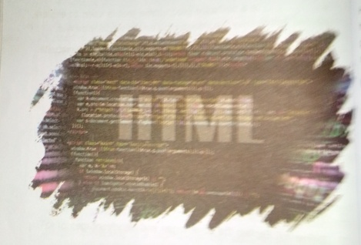
Figure 166 HTML

This Chapter Covers:-
- Introduction to HTML
- Building Blocks of HTML
- HTML elements
HTML image, link, List, Table, Form

Introduction of HTML
HTML is an acronym which stands for Hyper Text Markup Language which used for creating web pages and web applications. Let's see what is meant by Hypertext Markup Language, and Web page.

Hyper Text:
HyperText simply means "Text within Text." A text has a link within it, is a hypertext. Whenever you click on a link which brings you to a new webpage, you have clicked on a hypertext. Hypertext is a way to link two or more web pages (HTML documents) with each other.

Markup language:
A markup language is a computer language that is used to apply layout
and formatting conventions to a text document. Markup language makes fed more interactive and dynamic. It can turn text into images, tables, links, etc.

Web Page:
A web page is a document which is commonly written in HTML and translated by a web browser. A web page can be identified by entering an URL. A Web page can be of the static or dynamic type. With the help of HTML only, we can create static web pages.
Hence, HTML is a markup language which is used for creating attractive web pages with the help of styling, and which looks in a nice format on a fee browser. An HTML document is made of many HTML tags and each HTML tag contains different content.

Let’s see a simple example of HTML.
<html>
<head>
<title>Web page title</title></head>
<body>
<h1 >Write Your First Heading</h1 ><p>Write Your First Paragraph.</p></body>
The major points of HTML are given below:
HTML stands for Hypertext Markup Language.
HTML is used to create web pages and web applications.
HTML is widely used language on the web.
We can create a static website by HTML only.
Technically, HTML is a Markup language rather than a programming language.

HTML text Editors
- An HTML file is a text file, so to create an HTML file we can use a text editors.
- Text editors are the programs which allow editing in a written text hence to create a web page we need to write our code in some text editor.

- There are various types of text editors available which you can directly download, but for a beginner, the best text editor is Notepad (Windows) or Text Edit (Mac).
- After learning the basics, you can easily use other professional text editors which are, Notepad++, Sublime Text, Vim, etc.
- We will use Notepad and sublime text editor.

A.HTML code with Notepad
Notepad is a simple text editor and suitable for beginners to learn HTML. It is available in all versions of Windows, from where you easily access
Step 1 : Open Notepad (Windows)
Step 2 : Write code in HTML
Step 3 : Save the HTML file with .html or .html extension.
Step 4 : Open the HTML page in your web browser.

To run the HTML page, you need to open the file location, where you have saved the file and then either double-click on file or click on Open with option.
Building blocks of HTML
HTML document consist of its basic building blocks which are:
- Tags: An HTML tag surrounds the content and apply meaning to it. It is written between < and > brackets.
- Attribute: An attribute in HTML provides extra information about

the element, and it is applied within the start tag. An HTML attribute contains two fields: name & value.
Syntax
1. <tag name at ribute name= " attr_value" > content </tag name> Elements: An HTML element is an individual component of an
HTML file. In an HTML file, everything written within tags are termed as HTML elements.

HTML Tags
HTML tags are like keywords which defines that how web browser format and display the content. With the help of tags, a web browser can distinguish between an HTML content and a simple content. HTML contain three main parts: opening tag, content and closing tag. But son! HTML tags are unclosed tags.

When a web browser reads an HTML document, browser reads it from top to bottom and left to right. HTML tags are used to create HTML documents and render their properties. Each HTML tags have differed properties.
An HTML file must have some essential tags so that web browser can differentiate between a simple text and HTML text. You can use as many tags you want as per your code requirement.
- All HTML tags must enclosed within <> these brackets.
- Every tag in HTML perform different tasks.
- If you have used an open tag <tag>, then you must use a close tab;
</tag> (except some tags)

Syntax
<tag> content </tag>
HTML Tag Examples
note: HTML Tags are always written in lowercase letters. The basic HTML tags are
Given below:
<p> Paragraph Tag </p>
<h 2> Heading Tag </h 2>
<b> Bold Tag </b>
<I> Italic Tag </i>
<u>Underline Tag</u>
Unnclosed HTML Tags (Empty Tags)
Some HTML tags are not closed, for example br and hr.
<br> Tag: br stands for break line, it breaks the line of the code.
<hr> Tag: hr stands for Horizontal Rule. This tag is used to put a line across the webpage.
HTML Meta Tags
COC TYPE, title, link, meta and style
HTML Text Tags
<p>, <h 1>, <h 2>, <h 3>, <h 4>, <h 5>, <h 6>, <strong>, <em>, <abbr>, <acronym>, <address>, <bdo>, <blockquote>, <cite>, <q>, <code>, <ins>, <del>, <dfn>, <kbd>, <pre>, <samp>, <var> and <br>
HTML Link Tags
<a> and <base>

HTML Image and Object Tags
<img>, <area>, <map>, <param> and <object>
HTML List Tags
<ul>, <ol>, <li>, <dl>, <dt> and <dd>
HTML Table Tags
table, tr, td, th, tbody, thead, tfoot, col, colgroup and caption
HTML Form Tags
form, input, textarea, select, option, optgroup, button, label, fieldset and legend
HTML Scripting Tags
script and noscript

HTML Attribute
- HTML attributes are special words which provide additional information about the elements or attributes are the modifier of the HTML element.
- Each element or tag can have attributes, which defines the behavior of that element.
- Attributes should always be applied with start tag.
- The Attribute should always be applied with its name and value pair.
- The Attributes name and values are case sensitive, and it is recommended by W 3 C that it should be written in Lowercase only.

- You can add multiple attributes in one HTML element, but need to
give space between two attributes.
Syntax
<element attribute_name="value">content</element>
Example
<html>
<head>
</head>
<body>
<h1 >This is Style attribute</h 1>
<p style="height: 50 px; color: blue">lt will add style property in element</p>
<p style="color: red">lt will change the color of content</p>
</body>
</html>

HTML Elements
An HTML file is made of elements. These elements are responsible for formatting web pages and define content in that webpage. An element in
ML usually consist of a start tag <tag name>, close tag </tag name> and content inserted between them. Technically, an element is a collection n of start tag, attributes, end tag, content between them.
Note: Some elements does not have end tag and content, these element sare termed as empty elements or self-closing element or void elements.

Such as:
<p> Hello world!!! </p>

HTML Heading
A HTML heading or HTML h tag can be defined as a title or a subtitle a which you want to display on the webpage. When you place the text within the heading tags <h1>…….</h1>, it is displayed on the browser
in the bold format and size of the text depends on the number of heading.
There are six different HTML headings which are defined with the <h1 to <h6> tags, from highest level h1 (main heading) to the least level h6 (least important heading).
H1 is the largest heading tag and h6 is the smallest one. So hi is used for most important heading and h6 is used for least important.

Headings in HTML helps the search engine to understand and index the structure of web page.

Note: The main keyword of the whole content of a webpage should display by hl heading tag.
See this example:
<h1>Heading no. 1 </h1 >
<h2>Heading no. 2</h2>
<h3>Heading no. 3</h3>
<h4>Heading no. 4</h4>
<h5>Heading no. 5</h5>
<h6>Heading no. 6</h6>

HTML Paragraph
HTML paragraph or HTML p tag is used to define a paragraph in a web-
Let's take a simple example to see how it work. It is a notable point a browser itself add an empty line before and after a paragraph. An HTML <p> tag indicates starting of new paragraph.

Note: If we are using various <p> tags in one HTML file then browser automatically adds a single blank line between the two paragraphs.
See this example:
<p>his is first paragraph.</p>
<p>Phis is second paragraph.</p>
<p>Phis is third paragraph.</p>
HTML Anchor
The HTML anchor tag defines a hyperlink that links one page to another page. It can create hyperlink to other web page as well as files, location, or any URL. The "href" attribute is the most important attribute of the HTML a tag. and which links to destination page or URL.
href attribute of HTML anchor tag
he href attribute is used to define the address of the file to be linked. In rer words, it points out the destination page.
The syntax of HTML anchor tag is given below.
<a href = "…………"> Link Text </a>
Let’s see an example of HTML anchor tag.
<a href="second.html">Click for Second Page</a>

Example:
<html>
<head>
<title></title>
</head>
<body>
<p>Click on <a href="https:// www.facebook.com/" target=' blank">this-link </a>to go on home page of Facebook. </p>
</body>
</html>

HTML Image
HTML img tag is used to display image on the web page. HTML img tag is an empty tag that contains attributes only, closing tags are not used HTML image element.
Let's see an example of HTML image.
<h2>HTML Image Example</h2>
<imgsrc="good_morning.jpg" alt="Good Morning Friends"/>

Attributes of HTML img tag
The src and alt are important attributes of HTML img tag. All attributes HTML image tag are given below.

1) src
It is a necessary attribute that describes the source or path of the image. It instructs the browser where to look for the image on the server. The location of image may be on the same directory or another server.

2) alt
The alt attribute defines an alternate text for the image, if it can't be displayed. The value of the alt attribute describe the image in words. The alt attribute is considered good for SEO prospective.

3) width
It is an optional attribute which is used to specify the width to display the image. It is not recommended now. You should apply CSS in place of width attribute.

4)height
It h3 the height of the image. The HTML height attribute also supports I frame, image and object elements. It is not recommended now. You should apply CSS in place of height attribute.
Example:
<imgsrc="animal.jpg" height="180" width="300" alt="animal image">

how to get image from another directory/folder?
To insert an image in your web, that image must be present in your same folder where you have put the HTML file. But if in some case image is available in some other directory then you can access the image like this:
<imgsrc="E: /images/animal
height-"180" width="300" alt="animal image">
In above statement we have put image in local disk
<imgsrc "E:/images- animal.png.
Note: If src URL will be incorrect or misspell then it will not display your image on web page, so try to put correct URL.

Use <img>tag as a link
We can also link an image with other page or we can use an image as link. To do this, put <img> tag inside the <a> tag.

Example:
<a href="https://www.javatpoint.com/what-is-robotics"><imgsrc="rob jpg" height="100" width="100"></a>

HTML Lists
HTML Lists are used to specify lists of information. All lists may contain one or more list elements. There are three different types of HTML list

- Ordered List or Numbered List (ol)
- Unordered List or Bulleted List (ul)
- Description List or Definition List (dl)

Note: We can create a list inside another list, which will be termed nested List.

HTML Ordered List or Numbered List
In the ordered HTML lists, all the list items are marked with numbers default. It is known as numbered list also. The ordered list starts with<all> tag and the list items start with <li> tag.
<ol>
<li>Aries</li>
<li>Bingo</li>
<li>Leo</li>
<li>Oracle</li>
</ol>

HTML Unordered List or Bulleted List
In HTML Unordered list, all the list items are marked with bullets. It is also known as bulleted list also. The Unordered list starts with <ul> tag and items start with the <li> tag.
<ul>
<li>Aries</li>
<li>Bingo</li>
<li>Leo</li>
<li>Oracle</li>
</ul>

HTML Description List or Definition List
HTML Description list is also a list style which is supported by HTML and XHTML. It is also known as definition list where entries are listed like a dictionary or encyclopedia.
The definition list is very appropriate when you want to present glossary, list of terms or other name-value list.
Pie HTML definition list contains following three tags:
- <dl> tag defines the start of the list.
- <dt> tag defines a term.
- <dd> tag defines the term definition (description).
<dl>
<dt>Aries</dt>
<dd>-One of the 12 horoscope sign.</dd>
<dt>Bingo</dt>
<dd>-One of my evening snacks</dd>
<dt>Leo</dt>

<dd>-lt is also an one of the 12 horoscope sign.</dd>
<dt>Oracle</dt>
<dd>-lt is a multinational technology corporation.</dd>
</dl>

HTML Nested List
A list within another list is termed as nested list. If you want a bullet li inside a numbered list then such type of list will called as nested list.
Code:
<html>
<head>
<title>Nested list</title>
</head>
<body>
<p>List of Nepali Provinces with their capital</p>
<ol>
<li>Province no.1 <ul><li>Dhankuta</li></ul>
</li>
<li>Province No.2
<ul>
<li>Janakpur</li></ul>
</li>

<li>Bagmati
<ul>
<li>Hetauda</li>
</ul>
</li>
<li>Gandaki</li>
<ul>
</li>
<li>Pokhara</li>
</ul>
</li>
<li>Lumbini</li>
<ul>
<li>Dang</li>
</ul>
<li>Karnali</li>
<ul>
<li>Birendra Nagar</li></ul>
</li>
<Li>SudurPaschim
<ul>
<li>Dhangadhi</li>
</ol>
</body>
</html>

HTML Table
HTML table tag is used to display data in tabular form (row * column). There can be many columns in a row.

We can create a table to display data in tabular form, using <table> element, with the help of <tr>, <td>, and <th> elements.

In Each table, table row is defined by <tr> tag, table header is defined by <th>, and table data is defined by <td> tags.

HTML tables are used to manage the layout of the page e.g. header section, navigation bar, body content, footer section etc. But it is recommended to use div tag over table to manage the layout of the page.

HTML Table Tags
Tag | Description
<table> | It defines a table.
<tr> | It defines a row in a table.
<th> | It defines a header cell in a table.
<td> | It defines a cell in a table.
<caption> | It defines the table caption.
<colgroup> | It specifies a group of one or more columns in a table for formatting.
<col> | It is used with <colgroup> element to specify column properties for each column.
<tbody> | It is used to group the body content in a table.
<thead> | It is used to group the header content in a table.
<tfooter> | It is used to group the footer content in a table.

HTML Table Example
Let’s see the example of HTML table tag. It output is shown above.
<table>
<tr><th>First_Name</th><th>Last_Name</th><th>Marks</th></tr>
<tr><td>Sujan</td><td>Regmi</td><td>60</td></tr>
<tr><td>Anamol</td><td>Sharma</td><td>80</td></tr>
<tr><td>Priya</td><td>K.C.</td><td>82</td></tr>
<tr><td>Rekha</td><td>Subedi</td><td>72</td></tr>
</table>

HTML Table with Border
There are two ways to specify border for HTML tables.
1. By border attribute of table in HTML
2. By border property in CSS

HTML Border attribute
You can use border attribute of table tag in HTML to specify border. But it is not recommended now.
<table Border = "1">
<tr>th>First_Name</th><th>Last_Name</th><th>Marks</th></tr><tr>td>Sujan</tdxtd>Regmi</tdxtd>60</td>/tr><tr>td>Anamol</td>td>Sharma</td><td>80</td></tr><tr>td>Priya</td><td>K.C.</td><td>82</tdx</tr><tr><td>Rekha</td><td>Subedi</td><td>72</td></tr>
</table>

HTML Table - Add Cell Padding
Cell padding specifies the space between the cell content and its borders. lf you do not specify a padding, the table cells will be displayed without padding.
To set the padding, use the CSS padding property:
Example
th, td {
padding: 15px;
}
HTML Table - Cell that Spans Many Rows To make a cell span more than one row, use the rowspan attribute:
Example
<table style="width:100%">
<tr>
<th>Name:</th>
<td>Bill Gates</td>
</tr>
<tr>
<th>rowspan="2">Telephone:</th>
<td>560232</td>
</tr>
<tr>
<td>534275</td>
</tr>
</table>

HTML Table - Add a Caption
To add a caption to a table, use the <caption> tag:
Example
<table style="widh: 100%">
<caption>Monthly savings</caption>
<tr>
<th>Month</th>
<th>Savings</th>
</tr>
<td>January</td>
<td>1OOO</td></tr>
<tr>
<td>February</td>
<td>5000</td></tr>
</table>
Use the HTML <table> element to define a table
Use the HTML <tr> element to define a table row
Use the HTML <td> element to define a table data
Use the HTML <th> element to define a table heading
Use the HTML <caption> element to define a table caption
Use the CSS border property to define a border
Use the CSS border-collapse property to collapse cell borders
Use the CSS padding property to add padding to cells

. Use the CSS text-align property to align cell text
- Use the CSS border-spacing property to set the spacing between cells
- Use the cols pan attribute to make a cell span many columns
- Use the rows pan attribute to make a cell span many rows
*
- Use the id attribute to uniquely define one table

HTML Form
An HTML form is a section of a document which contains controls sue as text fields, password fields, checkboxes, radio buttons, submit button menus.
An HTML form facilitates the user to enter data that is to be sent to the server for processing such as name, email address, password, phone number.
Why to use HTML Form ?
HTML forms are required if you want to collect some data from of the site visitor.

For example: If a user want to purchase some items on internet, he/she must fill the form such as shipping address and credit/debit card details so that item can be sent to the given address.

HTML Form Syntax
<form action-“server url” method-“getpost”>
//input controls e.g. text field, text area, radio button, button
</form>

HTML Form Tags
Let’s see the list of HTML 5 form tags.
Tag | Description
<form> | It defines an HTML form to enter inputs by the used side.
<input> | It defines an input control.  .. , * ,
<textarea> | It defines a multi-line input control.
<label> | It defines a label for an input element.
<fieldset> | It groups the related element in a form.
<legend> | It defines a caption for a <fieldset> element.
<select> | It defines a drop-down list.
<optgroup> | It defines a group of related options in a drop-down list.
<option> | It defines an option in a drop-down list.
<button> | It defines a clickable button.

HTML<form> element

The HTML <form> element provide a document section to take input user. It provides various interactive controls for submitting information to web server such as text field, text area, password field, etc.
Note: The <form> element does not itself create a form but it is contain to contain all required form elements, such as <input>, <label>, etc.
Syntax
<form>
//Form elements
</form>

HTML <input> element
The HTML <input> element is fundamental form element. It is used to create form fields, to take input from user. We can apply different input files to gather different information form user. Following is the exam; to show the simple text input.
Example:
<body>
<form>
Enter your name <br>
<input type="text" name="username">
</form>
</body>

HTML Text Field Control
The type="text" attribute of input tag creates text field control also known as single line text field control. The name attribute is optional, but it is required for the server side component such as JSP, ASP, and PHP etc.
<Form>
First Name: <input type="text" name="first name”/><br/>
Last Name: <input type="text" name="last name”/><br/>
</Form>

HTML <text area> tag in form
The <text area> tag in HTML is used to insert multiple-line text in a form. The size of <text area> can be specify either using "rows" or "cols" attributes or by CSS.
Computer Science

Example:
<html>
<head>
<title>Form in HTML</title>
</head>
<body>
<form>
Enter your address:<br>
<textarea rows="2" cols="20"></textarea>
</form>
</body>
</html>

LabelTag in Form
It is considered better to have label in form. As it makes the code parser/browser/user friendly.
If click on the label tag, it will focus on the text control. To do so, you need to have for attribute in label tag that must be same as id attribute Inputtag.
NOTE: It is good to use <label> tag with form, although it is optional but if you will use it, then it will provide a focus when you tap or click on label is more worthy with touch screens.

<form>
<label for="first name">First Name: </label><br/>
<input type="text" id="first name" name="first name"/></br>
<label for="last name">Last Name: </label>
<input type="text" id="last name" name="last name"/></br></form>

HTML Password Field Control
The password is not visible to the user in password field control.
<form>
<label for="password">Password: </label>
<inputtype="password" id="password" name-'password' />
</br>
</form>

HTML 5 Email Field Control
The email field in new in HTML 5. It validates the text for correct e address. You must use @ and. in this field.
<form>
<label for="email">Email: </label>
<input type="email" id="email" name="email7></br>
</form>

Radio Button Control
The radio button is used to select one option from multiple options, used for selection of gender, quiz questions etc.
Computer Science
If you use one name for all the radio buttons, only one radio button can be selected at a time.
Using radio buttons for multiple options, you can only choose a single option at a time.
<form>
<label for="gender">Gender: </label>
<input type="radio" id="gender" name="gender" value="male"/>Male
<input type="radio" id="gender" name="gender" value="female"/>Fe male <br/>
</form>

Checkbox Control
The checkbox control is used to check multiple options from given checkboxes.
<form>
Hobby:<br>
<input type="checkbox" id="cricket" name="cricket" value= "cricket"/> label for="cricket">Cricket</label><br>
<input type="checkbox" id="football" name="football" value="football"/>
<label for="football">Football</label><br>
<input type="checkbox" id="hockey" name="hockey" value="hockey"/>
<label for="hockey">Hockey</label>
</form>

Submit button control
HTML <input type="submit"> are used to add a submit button on web page. When user clicks on submit button, then form get submit to the server.

Syntax:
1. <input type="submit" value="submit">
The type = submit, specifying that it is a submit button
The value attribute can be anything which we write on button on webpage.
The name attribute can be omit here.
Example:
<form>
<label for="name">Enter name</label><br>
<input type="text" id="name" name="name"><br>
<label for="pass">Enter Password</label><br>
<input type="Password" id="pass" name="pass"><br>
<input type="submit" value="submit">
</form>

HTML <field set>.element:
The <field set> element in HTML is used to group the related information of a form. This element is used with <legend> element which provide caption for the grouped elements.
Example:
<form>
<field set>
<legend>User information:</legend>

<label for-“name”>Enter name</label><br>
<input type="text" id-'name" name="name"><br>
<label for="pass">Enter Password</label><br>
<input type="Password" id="pass" name="pass"><br>
<input type-'submit" value="submit">
</fieldset>

</form>

HTML Form Example
Following is the example for a simple form of registration.
<html>
<head>
<title>Form in HTML</title>
</head>
<body>
<h2>Registration form</h2>
<form>
<fieldset>
<legend>User personal information</legend>
<label>Enter your full name</label><br>
<input type="text" name="name"><br>
<label>Enter your email</label><br>
<input type="email" name="email"><br>\
<label>Enter your password</label><br>
<input type="password" name="pass"><br>

<label>confirm your password</label><br>
<input type="password" name="pass"><br><br><label>Enter your gender</label><br>
<input type=”radio” id="gender" name="gender" value="male”/>Male <br>
<input type=”radio" id="gender" name="gender" value=”female”>Female <br/>
<inputtype="radio" id="gender" name="gender" value-“others”/>others <br/>
<br>Enter your Address:<br>
<textarea></textarea><br>
<input type="submit" value="sign-up">
</fieldset>
</form>
</body>
</html>
SUMMARY
- HTML is an acronym which stands for Hyper Text Markup Language which is used for creating web pages and web applications.
- HTML tags are like keywords which defines that how web browser will format and display the content.

Exercise
1)Multiple Choice Questions
I. HTML stands for
- High Text Machine Language
- Hyper Text and links Markup Language
- Hyper Text Markup Language
- None of these
ii. The correct sequence of HTML tags for starting a webpage is
a. Head, Title, HTML, body b. HTML, Body, Title, Head
c. HTML, Head, Title, Body d. HTML, Head, Title, Body
iii. Which of the following element is responsible for making the text bold in HTML?
a. <pre> b. <a> c. <b> d. <br>
iv. Which of the following tag is used for inserting the largest heading in HTML?
a. <h3> b. <h1> c. <h5> d.<h6>
v. Which of the following tag is used to add rows in the table?
a. <td> and </td> b. <th> and </th>
c. <tr> and </tr> d. None of the above
vi. A program in HTML can be rendered and read by
a. Web browser b. Server c.Interpreter d. None of the above

2. Write the syntax and functions of following tags.
a) <HTML> b) <A> c) <SUP>
d) <SUP> e) <A> f) <STYLE>
g) <FOR Mh) <TABLE>

3. Answer the following questions
- What is HTML?
- What are HTML tags?
- Differentiate between uploading and downloading.
- What is a web site? List any 5 e-commerce web sites.
- What is Internet of Things (loT)? Explain with example.
- How many types of heading does an HTML contain? Explain with example.
- How to create a hyperlink in HTML?
- Project Work (Lab Work)
Design and develop a website on any topic of your choice containing at least the following requirements and submit it to your subject teacher.
- It should contain at least 5 web pages
- It should contain hyperlink, images, videos and other items
- It should contain marquee text, table, form and various types of lists
- It should contain the style sheets to make your web site look professional.

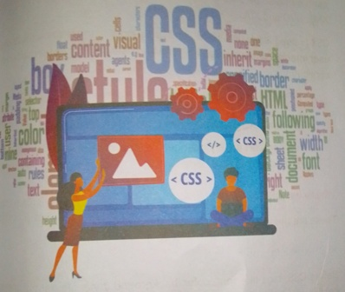
CHAPTER-9 CASCADING STYLE SHEET [CSS]
Figure 167 CSS

This Chapter Covers:
- Introduction to CSS
- CSS selector
- Types of CSS
- CSS font
- CSS margin

Introduction to css
CSS stands for Cascading Style Sheets. It is a style sheet language which is used to describe the look and formatting of a document written markup language. It provides an additional feature to HTML. It is generally used with HTML to change the style of web pages and user interfaces. It can also be used with any kind of XML documents including plain XML, SVG and XUL.
CSS is used along with HTML and JavaScript in most websites to create user interfaces for web applications and user interfaces for many mob applications.
What does CSS do?
- You can add new looks to your old HTML documents.
- You can completely change the look of your website with only few changes in CSS code.

Why to use CSS ?
These are the three major benefits of CSS:

1) Solves a big problem
Before CSS, tags like font, color, background style, element alignment border and size had to be repeated on every web page. This was a very long process. For example: If you are developing a large website where fonts and color information are added on every single page, it will be become a long and expensive process. CSS was created to solve this problem. It was a W3C recommendation.

2) Saves a lot of time
CSS style definitions are saved in external CSS files so it is possible to change the entire websites by changing just one file.
H1{ color: yellow; font-size: 11 px;}
Declaration Blog
Property
Value
Selector
Saves a lot of time

3)Provide more attributes
CSS provides more detailed attributes than plain HTML to define the look and feel of the website.

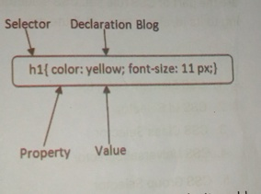
CSS Syntax
Figure 168 CSS syntax
A CSS rule set contains a selector and a declaration block.

Selector: Selector indicates the HTML element you want to style. It could be any tag like <h1 >, <title> etc.
Declaration Block: The declaration block can contain one or more declarations separated by a semicolon. For the above example, there are two declarations:
1. color: yellow;
2. font-size: 11 px;
Each declaration contains a property name and value, separated by a colon.
Property: A Property is a type of attribute of HTML element. It could be color, border etc.
Value : Values are assigned to CSS properties. In the above example,

value “yellow” is assigned to color property.
Selector{Property 1: value 1; Property 2: value 2;….. ;}

CSS Selector

CSS selectors are used to select the content you want to style. Selector are the part of CSS rule set. CSS selectors select HTML elements according to its id, class, type, attribute etc.
There are several different types of selectors in CSS.
- CSS Element Selector
- CSS Id Selector
- CSS Class Selector
- CSS Universal Selector
- CSS Group Selector

1) CSS Element Selector
The element selector selects the HTML element by name.
<html>
<head>
<style>
p{
text-align: center;
color: blue;
}
</style>
</head>

<body>
<p>This style will be applied on every paragraph.</p>
<p id=" para 1 ">Me too!</p>
<p>And me!</p>
</body>
</html>

CSS Id Selector
The id selector selects the id attribute of an HTML element to select a specific element. An id is always unique within the page so it is chosen: select a single, unique element.
It is written with the hash character (#), followed by the id of the element.
Lets? take an example with the id "para1".
<html>
<head>
<style>
#para 1 {
text-align: center;
color: blue;
}
</style>
</head>
<body>
<p id="para1">Hello Friends</p>

<p>This paragraph will not be affected.</p>
</body>
</html>

3) CSS Class Selector
The class selector selects HTML elements with a specific class attribute. It is used with a period character. (full stop symbol) followed by the class name.
Note: A class name should not be started with a number.
Let's take an example with a class "center".
<html>
<head>
<style>
.center {
text-align: center;
color: blue;
}
</style>
</head>
<body>
<h1 class="center">This heading is blue and center-aligned.</h1><p class="center">This paragraph is blue and center-aligned.</p></body>
</html>

CSS Universal Selector

The universal selector is used as a wildcard character. It selects all the elements on the pages.
<html>
<head>
<style>

*{
color: green;
font-size: 20px;
}
</style>
</head>
<body>
<h2>This is heading</h2>
<p>This style will be applied on every paragraph.</p>
<p id="para1 ">Me too!</p>
<p>And me!</p>
</body>
1. </html>

5)CSS Group Selector
The grouping selector is used to select all the elements with the same style definitions.
Grouping selector is used to minimize the code. Commas are used to separate each selector in grouping.

Let's see the CSS code without group selector.
H1 {
text-align: center;
color: blue;
}
h2{
text-align: center;
color: blue;
}
p{
text-align: center;
color: blue;
}
As you can see, you need to define CSS properties for all the elements. It can be grouped in following ways:
h1,h2,p {
text-align: center;
color: blue;
}
Let's see the full example of CSS group selector.
<html>
<head>
<style>
h1,h2,p{

text-align: center;
color: blue;
}
</style>
</head>
<body>
<h1 >Hello Friends</h1 >
<h2>Hello Friends(ln smaller font)</h2>
<p>This is a paragraph.</p>
</body>
</html>

How to add CSS ?
CSS is added to HTML pages to format the document according to information in the style sheet. There are three ways to insert CSS in HTML documents.
- Inline CSS
- Internal CSS
- External CSS

Inline CSS
CSS is used to apply CSS on a single line or element.
For example:
1. <p style="color: blue">Hello CSS</p>
For more visit here: Inline CSS

2) Internal CSS
Internal CSS is used to apply CSS on a single document or page. It can affect all the elements of the page. It is written inside the style tag without head section of html.
For example:
- <style>
- p{color: blue}
- </style>
For more visit here: Internal CSS
3) External CSS
External CSS is used to apply CSS on multiple pages or all pages.Here we write all the CSS code in a css file. Its extension must be .css for example style.css.
For example:
1. p{color:blue}
You need to link this style.css file to your html pages like this:
1. <Iinkrel="stylesheet" type="text/css" href="style.css">
The link tag must be used inside head section of html.
Inline CSS
We can apply CSS in a single element by inline CSS technique.
The inline CSS is also a method to insert style sheets in HTML document. This method mitigates some advantages of style sheets so it is advised to use this method sparingly.

If you want to use inline CSS, you should use the style attribute to the relevant tag.
Syntax:
- <htmltag style="cssproperty1 :value; cssproperty 2:value;"></htmltag>
Example:
  - <h2 style="color:red;margin-left:40px;">lnline CSS is applied on this heading.</h2>
  - <p>This paragraph is not affected.</p>

Disadvantages of Inline CSS
- You cannot use quotations within inline CSS. If you use quotations the browser will interpret this as an end of your style value.
- These styles cannot be reused anywhere else.
- These styles are tough to be edited because they are not stored at a single place.
- It is not possible to style pseudo-codes and pseudo-classes with inline CSS.
- Inline CSS does not provide browser cache advantages.

External CSS
The external style sheet is generally used when you want to make changes on multiple pages. It is ideal for this condition because it facilitates you to change the look of the entire web site by changing just one file.
It uses the <link> tag on every pages and the <link> tag should be put inside the head section.

Example:
- <head>
- dink rel= " style sheet" type="text/css" href="mystyle.css">
- </head>
The external style sheet may be written in any text editor but must saved with a .css extension. This file should not contain HTML element
Let's take an example of a style sheet file named "mystyle.css".
File: mystyle.css
body {
background-color: light blue;
}
h1{
color: navy;
margin-left: 20px;
}

Note: You should not use a space between the property value and the unit. For example: It should be margin-left: 20px not margin-left:20px.

CSS Comments
CSS comments are generally written to explain your code. It is very help for the users who reads your code so that they can easily understand t code.
Comments are ignored by browsers.

Comments are single or multiple lines statement and written within
/*……..*/
<html>
<head>
<style>
p{
color: blue;
/* This is a single-line comment */
text-align: center;
}
/* This is
a multi-line
comment */
</style>
</head>
<body>
<p>Hello Friends</p>
<p>This statement is styled with CSS.</p><p>CSS comments are ignored by the browsers and not shown in the output.</p></body>
</html>

CSS Background
CSS background property is used to define the background effects on element. There are 5 CSS background properties that affects the HTML elements:
- background-color
- background-image
- background-repeat
- background-attachment
- background-position

1) CSS background-color
The background-color property is used to specify the background color of the element.
You can set the background color like this:
<html>
<head>
<style>
h2,p{
background-color: #b0d4de;
}
</style>
</head>
<body>
<h2>My first CSS page.</h2>
<p>Hello Friends. This is an example of CSS background-color.</p>
</body>
</html>

2) CSS background-image
The background-image property is used to set an image as a background of an element. By default the image covers the entire element. You can set the background image for a page like this.
<html>
<head>
<style>
body {
background-image: url("paper1 .gif");
margin-left:! 100px;
}
</style>
</head>
<body>
<h1 >Hello Friends</h1>
</body>
</html>

CSS Border
The CSS border is a shorthand property used to set the border on an element.
The CSS border properties are use to specify the style, color and size of the border of an element. The CSS border properties are given below
- border-style
- border-color
- border-width
- border-radius
Computer Science

1) CSS border-style
The Border style property is used to specify the border type which you want to display on the web page.
There are some border style values which are used with border-style. property to define a border.
Value | Description
None | It doesn't define any border.
Dotted | It is used to define a dotted border.
Dashed | It is used to define a dashed border.
Solid | It is used to define a solid border.
Double | It defines two borders with the same border-width value
Groove | It defines a 3d grooved border, effect is generated according to border-color value.
Ridge | It defines a 3d ridged border, effect is generated according to border-color value
Inset | It defines a 3d inset border, effect is generated according to border-color value.
Outset | It defines a 3d outset border, effect is generated according to border-color value

CSS Units
CSS has several different units for expressing a length. Many C properties take "length" values, such as width, margin, padding, font-size etc. Length is a number followed by a length unit, such as 10px, 2px, etc

Example
Set different length values, using px (pixels):
h1{
font-size: 60px;
font-size: 25px; line-height: 50px;

CSS Colors
The color property in CSS is used to set the color of HTML elements, typically, this property is used to set the background color or the font Color of an element.
In CSS, we use color values for specifying the color. We can also use this property for the border-color and other decorative effects.
We can define the color of an element by using the following ways:
- RGB format.
- RGBA format.
- Hexadecimal notation.
- HSL.
- HSLA.
- Built-in color.
Let’s understand the syntax and description of the above ways in detail.

RGB Format
RGB format is the short form of 'RED GREEN and BLUE' that is used for defining the color of an HTML element simply by specifying the values R, G, B that are in the range of 0 to 255.
The color values in this format are specified by using the rgb() property. This property allows three values that can either be in percentage integer (range from 0 to 255).
This property is not supported in all browsers; that's why it is recommended to use it.
Syntax
1. color: rgb(R, G, B);

RGBA Format
It is almost similar to RGB format except that RGBA contains A (Alpha) that specifies the element's transparency. The value of alpha is in the range C to 1.0, in which 0.0 is for fully transparent, and 1.0 is for not transparent.
Syntax
1. color: rgba(R, G, B, A);

Hexadecimal Notation
Hexadecimal can be defined as a six-digit color representation. The notation starts with the # symbol followed by six characters ranges from 0 to F. In hexadecimal notation, the first two digits represent then (RR) color value, the next two digits represent the green (GG) color values and the last two digits represent the blue (BB) color value.

The black color notation in hexadecimal is #000000, and the white color notation in hexadecimal is #FFFFFF. Some of the codes in hexadecimal notation are #FF0000, #00FF00, #0000FF, #FFFF00, and many more.
Syntax
1. color:#(0-F)(0-F)(0-F)(0-F)(0-F)(0-F);
Short Hex codes
It is a short form of hexadecimal notation in which every digit is recreated o arrive at an equivalent hexadecimal value.
For example, #7B6 becomes #77BB66 in hexadecimal.
The black color notation in short hex is #000, and the white color notation in short hex is #FFF. Some of the codes in short hex are #F00, #0F0, JFF, #FF0, and many more.

HSL
It is a short form of Hue, Saturation, and Lightness. Let's understand them individually.

HUE: It can be defined as the degree on the color wheel from 0 to 360. 0 represents red, 120 represents green, 240 represents blue.
Saturation: It takes value in percentage in which 100% represents fully saturated, i.e., no shades of gray, 50% represent 50% gray, but the color is still visible, and 0% represents fully unsaturated, i.e., completely gray, and the color is invisible.
Lightness: The lightness of the color can be defined as the light that we

want to provide the color in which 0% represents black (there is no light): 50% represents neither dark nor light, and 100% represents white (full lightness).
Let's see the syntax of HSL in color property.
Syntax
1. color: hsl(H, S, L);

HSLA
It is entirely similar to HSL property, except that it contains A (alpha)that specifies the element's transparency. The value of alpha is in the range 0.0 to 1.0, in which 0.0 indicates fully transparent, and 1.0 indicates not transparent.
Syntax
1. Color: hsla(H, S, L, A);

Built-in Color
As its name implies, built-in color means the collection of previously defined colors that are used by using a name such as red, blue, green, etc.
Syntax
1. color color-name;
Let's see the list of built-in colors along with their decimal and hexade: email values.

S.no. | Color name | Hexadecimal Value | Decimal Value or rgb() value
1. | Red | #FF0000 | rgb(255,0,0)
2. | Orange | &FFA500 | rgb(255,165,0)
3. | Yellow | #FFFF00 | rgb(255,255,0)

4. | Pink | #FFC0CB | rgb(255,192,203)
5. | Green | #008000 | rgb(0,128,0)
6. | Violet | #EE82EE | rgb(238,130,238)
7. | Blue | #0000FF | rgb(0,0,255)
8. | Aqua | #00FFFF | rgb(0,255,255)
9. | Brown | #A52A2A | rgb(l 65,42,42)
10. | White | #FFFFFF | rgb(255,255,255)
11. | Gray | #808080 | rgb(128,128,128)
12. | Black | #000000 | rgb(0,0,0)
The illustration of CSS colors, which includes the above properties, is given below.
Example
<html>
<head>
<title>CSS hsl color property</title><style>
h1{
text-align: center;
}
# rgb{
color: rgb(255,0,0);
}
#rgba{
color:rgba(255,0,0,0.5);
}
#hex{
color: #EE82EE;
}
#short{ color: #E8E;

}
#hsl{
color:hsl(0,50%,50%);
}
#hsla{ color:hsla(0,50%,50%,0.5);
}
#built{
Color:green;
}
</style>
</head>
<body>
<h1 id="rgb">
Hello World. This is RGB format.
</h1>
<h1 id="rgba">
Hello World. This is RGBA format.
</h1>
<h1 id="hex">
Hello World. This is Hexadecimal format.
</h1>
<h1 id="short">
Hello World. This is Short-hexadecimal format.
</h1>
<h1 id="hsl">
Hello World. This is HSL format.
</h1>
<h1 id="hsla">
Hello World. This is HSLA format.

</h1>
<h1 id="built">
Hello World. This is Built-in color format.
</h1>
</body>
</html>
CSS Font
CSS Font
CSS Font property is used to control the look of texts. By the use of CSS font property you can change the text size, color, style and more. You lave already studied how to make text bold or underlined. Here, you will also know how to resize your font using percentage.

These are some important font attributes:
- CSS Font color: This property is used to change the color of the text, (standalone attribute)
- CSS Font family: This property is used to change the face of the font.
- CSS Font size: This property is used to increase or decrease the size of the font.
- CSS Font style: This property is used to make the font bold, italic or oblique.
- CSS Font variant: This property creates a small-caps effect.
- CSS Font weight: This property is used to increase or decrease the boldness and lightness of the font.

1) CSS Font Color
CSS font color is a standalone attribute in CSS although it seems that: is a part of CSS fonts. It is used to change the color of the text.
There are three different formats to define a color:
- By a color name
- By hexadecimal value
- By RGB
In the above example, we have defined all these formats.
<!DOC TYPE html>
<html>
<head>
<style>
body {
font-size: 100%;
}
H1 {color: red;}
h2{ color: #9000 A1;}
p {color:rgb(0, 220, 98);}
}
</style>
</head>
<body>
<h1>This is heading 1 </h1 >
<h2>This is heading 2</h2>
<p>This is a paragraph.</p>

</body>
</html>
Output:
This is heading 1
This is heading 2
This is a paragraph.

2) CSS Font
Family
CSS font family can be divided in two types:
- Generic family: It includes Serif, Sans-serif, and Mono space.
- Font family: It specifies the font family name like Arial, New Times Roman etc.
Serif: Serif fonts include small lines at the end of characters. Example of serif: Times new roman, Georgia etc.
Sans-serif: A sans-serif font doesn't include the small lines at the end of characters. Example of Sans-serif: Arial, Verdana etc.
<html>
<head>
<style> body {
font-size: 100%;

H1 {font-family: sans-serif;}
h2 {font-family: serif;}
p {font-family: mono space;}
}
</style>
</head>
<body>
<h1 >This heading is shown in sans-serif.</h1>
<h2>This heading is shown in serif.</h2>
<p>This paragraph is written in mono space.</p></body>
</html>
Output:
This heading is shown in sans-serif.
This heading is shown in serif.
This paragraph is written in mono space.

3) CSS Font Size
CSS font size property is used to change the size of the font.
These are the possible values that can be used to set the font size:
Font Size Value | Description
xx-small | used to display the extremely small text size.
x-small | used to display the extra small text size.
small | used to display small text size.

medium | used to display medium text size.
large | used to display large text size.
x-large | used to display extra large text size.
xx-large | used to display extremely large text size.
smaller | used to display comparatively smaller text size.
larger | used to display comparatively larger text size.
size in pixels or % | used to set value in percentage or in pixels.
<html>
<head>
<title>Practice CSS font-size property</title>
</head>
<body>
<p style="font-size: xx-small;"> This font size is extremely small.</p>
<p style="font-size: x-small;"> This font size is extra small</p>
<p style="font-size:small;"> This font size is small</p>
<p style="font-size: medium;"> This font size is medium. </p>
<p style="font-size:large;"> This font size is large. </p>
<p style="font-size: x-large;"> This font size is extra large. </p>
<p style="font-size: xx-large;"> This font size is extremely large. </p>
<p style="font-size: smaller;"> This font size is smaller. </p>
<p style="font-size:larger;"> This font size is larger. </p>
<p style="font-size: 200%;"> This font size is set on 200%. </p>
<p style="font-size: 20 px;"> This font size is 20 pixels. </p>

</body>
</html>

CSS Margins
CSS Margin
CSS Margin property is used to define the space around elements. It is completely transparent and doesn't have any background color. It clears an area around the element.
Top, bottom, left and right margin can be changed independently using separate properties. You can also change all properties at once by using shorthand margin property.
There are following CSS margin properties:
CSS Margin Properties
Property | Description
margin | This property is used to set all the properties in one declaration.
margin-left | It is used to set left margin of an element.
margin-right | It is used to set right margin of an element.
margin-top | It is used to set top margin of an element.
margin-bottom | It is used to set bottom margin of an element.

These are some possible values for margin property.
Value | Description
Auto | This is used to let the browser calculate a margin.
Length | It is used to specify a margin ptpx, cm, etc. its default value is 0px.
% | It is used to define a margin in percent of the width of containing element.
inherit | It is used to inherit margin from parent element.
Note: You can also use negative values to overlap content.
CSS margin Example
You can define different margin for different sides for an element.
<html>
<head>
<style>
P{
background-color: pink;
p.ex{
margin-top: 50px;
margin-bottom: 50px;
margin-right: 100px;
margin-left: 100px;
}
</style></head><body>

<p>This paragraph is not displayed with specified margin. </p>
<p class="ex">This paragraph is displayed with specified margin.</p></body>
</html>

Summary
- CSS is a style sheet language which is used to describe the look and formatting of a document written in markup language.
- CSS selectors are used to select the content you want to style.
- There are three ways to insert CSS in HTML documents.
- Inline CSS
- Internal CSS
- External CSS
- Inline CSS is used to apply CSS on a single line or element.
- Internal CSS is used to apply CSS on a single document or page. It can affect all the elements of the page.
- External CSS is used to apply CSS on multiple pages or all pages Here, we write all the CSS code in a css file.
- CSS comments are generally written to explain your code.

Exercises

1. Multiple choice questions:
CSS stands for -
a. Cascade style sheets b. Color and style sheets
c. Cascading style sheets d. None of the above
2. Which of the following is the correct syntax for referring the external style sheet?
a. <style src = example.css> b.<style src = "example.css" >
c.<stylesheet> example.css </stylesheet>
d. <link rel="stylesheet" type="text/css" href="example.css">
iii)The property in CSS used to change the background color of an element is -
a. bgcolorb. color
c.background-color d. All of the above

iv) The property in CSS used to change the text color of an element is -
a. bgcolor b.color
c. background-color d. All of the above
v) The CSS property used to control the element's font-size is
a. text-style
c. font-size
b. color
b. text-size
d. None of the above

vi) The HTML attribute used to define the internal stylesheet is
a. <style>b. style
c. <link> d. <script>

2. Answer the following questions:
- What is CSS?
- How can you integrate CSS on a web page?
- What are the advantages of CSS?
- What are the limitations of CSS?
- What is Embedded Style Sheet?
- What are the advantages of Embedded Style Sheets?
- What is a CSS selector?
- What is the difference between class selectors and id selectors?
- What are the advantages of External Style Sheets?

Chapter 10 GENERAL CONCEPTS OF COMPUTER PROGRAMMING
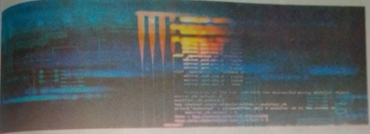
Figure 169 Programming
THIS CHAPTER COVERS:
- Introduction to programming and programmer
- Programming Language
- Language Processors
- Algorithm and Flow Chart

Programming and Programmer
Programming is the process in which programmer provides a set of instructions to the computer in a language which is easily understood
By the computer. Just like humans understands a few languages (like Nepali, English, Spanish, Hindi, French, etc.), so is the case with Computers. Computers understand instructions that are written in a specific syntactical form called a programming language. The program written by the programmers in any of the computer language is source

code whereas the same program is converted to machine language in order to make computer understand it, is object code.
A programmer is a person that writes or creates computer software or applications with the help of some specific programming instructions. Most of the computer programmers have a broad knowledge in computing and coding field and knows many programming languages like C, C++, and Java and so on.

Programming Language:
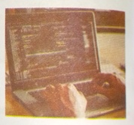
Figure 170 Programming
We know that computer does not understand anything by itself. It needs instructions to perform any task. A set of instructions given to a computer is program. The process of writing a program is programming and the person who writes the program is called a programmer. The language that is used to write programs is programming language and the language understood by the computer is called computer language. Computer language is divided into two types. They are: Low level language and high level language.

1. Low Level Language:
Low level language is machine dependent language. So, it is direct understood by the computer. It is difficult to write a program using Iow level language, as a programmer must know the detail architecture of machine. It is further classified into two types. They are:
- Machine Level Language
- Assembly Level Language

a. Machine level language(MLL):
It is the first programming language which was used by Lady Ada for the first time to write a program in computer. This language is writtenusing series of binary codes 0's and 1's which represents 'OFF' and 'ON' rate of electricity in computer circuit.
Nowadays too, modern computer uses machine level language
for processing and storing data in computer but it is not used as a programming language.
Figure 171Object program to processor

Some of the advantages and disadvantages of writing a program in
Machine level language are as follows.

Advantages of Machine Level Language.
- Program execution is faster than any other language as it is directly understood by the computer
- It does not require any translating program like compiler or interpreter as program itself is in binary form.

Disadvantages of Machine Level Language
- It is very difficult and boring to make a program in machine language since every instruction must be written in the form of 0 and 1.
- Writing a program in MLL is time consuming and almost impossible to develop a large program.
- It is machine-dependent language. So, programs written for processor cannot be used by another.
Computer Science

Assembly Level Language (ALL):
Assembly Level Language is also an example of low level language In this language, instead of writing the instructions in the series of 0s and 1s, we can use mnemonics (symbolic instruction) like ADD , SUB, DIV, MOD, JMP and so on. Since it is closer to machine level language a programmer should have detailed knowledge of computer internal architecture in order to write a program. This language is faster comparison to high level language. This language is not understood by the computer directly as the computer understands only machine level language. So, the assembler is required to convert assembly language
machine level language.

Figure 172 source program to Assembler and object program to processor

Program in ALL
Translator Program in MLL

Advantages of Assembly Level Language
- It is easier to write, debug and understand than Machine level language due to the use of mnemonics.
- Program execution is faster than High level language.
- It is efficient in program execution. Hence, ALL is still used in developing firmware, device drivers and operating system kernel.

Disadvantages of Assembly Level Language.
- It is machine dependent language. The program made for one processor does not work for another processor
- Program development and debugging is more difficult and time consuming than in high level language.
- It is very hard to remember the mnemonics since they are in abbreviated forms and large in numbers.

3. High Level Language (HLL): High
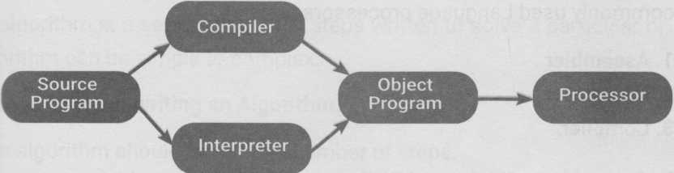
level language is closer to English language.HLL code is written in English like structure by using mathematical notations. Since it is similar to English language, it is easier to write, debug and understand the program. High level language instructions are not directly understood by the processor for execution. It needs conversion and the conversion is one by translating software like ’compiler’ or ’interpreter’ the programs that are converted to machine language are object programs. FORTRAN (formula Translation) introduced in 1956 AD is the first High Level Language. Nowadays, many High Level Languages High level language are available. Some of them are: PASCAL, C, C++, Visual Basic and so on.
Figure 173 Source program to compiler to object program to processor

Advantages of High Level Language
- It is easier to write, debug and understand the High level language instructions due to the simple English language and mathematical notations.
- Program development is faster and requires less effort than other languages.
- As it is machine-independent programming language, program made for one processor can be used in another processors too. Programmer does not need to remember larger number of mnemonics and other unusual codes.

Disadvantages of High Level Language
- Computer does not understand HLL directly. So, the program needs conversion before execution.
- Program execution time is longer than in low level language.
- Every high level language must have its own translator because it can't directly generate executable code.
Language processors:
Language processors are the programs that translates a program written in high level language or assembly level language into machine! level language which can be understood by the computer. Some of the commonly used Language processors are:

- Assembler :An Assembler is a system software that translates a programming language written in assembly language into machine! language and vice-versa. It converts the whole program at once. If some errors occur, they have to be corrected, debugged and assembled again.

Interpreter:
Interpreter is a program that translates a program written
in high level language into machine level language line by line. As it translates only one line at a time, it takes more time than compiler.
- Compiler:It is also a language processor that translates a program written in high level language into machine level language as a whole at once. It reads the whole program at once, if it is bug free, it converts it into machine code at once.

Compiler | Interpreter
- It translates the entire program at once. | i. It translates one statement at a time.
- It reports all errors at once. | ii. It reports errors line by line.
- It does not create object code. | iii. It creates object code.
- Debugging is complex. | iv. Debugging is easier.
- Translation is not preserved. So, execution is fast. | v. Translation is preserved. So, execution is slow.

Algorithm
An algorithm is a set of sequential steps written to solve a particular algorithm can be simple to complex.

General rules for writing an Algorithm.
An algorithm should have finite number of steps.
An algorithm should not depend on a particular computer language.
The steps should be executed by the computer.
An algorithm is independent of programming language.
An algorithm must produce an output.
Algorithm to calculate the Area of a right-angled triangle.
Step 1 : Start.
Step 2 : Read base and height of triangle.
Step3 : Multiply base and height and divide it by 2.
Step 4 : Store the result in a variable. Suppose a
Step 5 : Printthevalueof the variable a.
Step6 : Stop.
Computer Science

Example 2
Algorithm to find the simple interest.
Step 1 : Start
Step 2 : Read Principal(P), Rate(R) and Time(T).
Step 3 : Multiply Principal, Rate and Time and store in a variable.
Step 4 : Divide the product by 100 and store in another variable. Suppose SI
Step 5 : Print the value of variable SI.
Step 6 : Stop.
Example 3
Algorithm to find the perimeter of a rectangle
Step 1: Start
Step 2: Read the Length(L) and Breadth(B) of a rectangle.
Step 3: Add the length and breadth and multiply the addition by 2.
Step 4: Store the value in a variable P. (P=2*(L+B)]
Step 5: Print the value of P.
Step 6: Stop.
Example 4
Algorithm to find the volume of cube
Step 1: Start.
Step 2: Read the length of cube and store in a variable L.
Step 3: Multiply the length of cube 3 times and store in a variable

(A=L*L*L) Step 4: Print the value of A.
Step 5: Stop.

Flow chart.
A flowchart is a graphical representation of an algorithm. It contains many Symbols having pre-defined meanings. The first formal flowchart was designed by John Von Newmann in 1945.

Rules for drawing a flowchart.
- The flowchart always flows from top to bottom or left to right.
- The flow lines should not cross each other.
- The arrowheads of flow lines indicate the direction of flow in the flow hart.
- Flowchart should be easily understood by others.

Advantages of Flowchart.
- It is easier to understand the program from flowchart.
- It is a convenient method of communication.
- It is an important tool for planning and designing a new system.
- Once flowchart is developed, it can be translated into any computer language.

Disadvantages of Flowchart.
- It is a time consuming work for the programmer.
- Sometimes, it is not clear to everybody due to its complexity.

Symbols that are used in flowchart with their meaning are given below:
s. No. | Name | Symbol | Meaning
1. | Terminal |  | It is used to indicate start, Pause! And end. It is oval in shape.
2. | Process |  | It is used to indicate the processing It holds all the calculations and movements. It is rectangular shape
3. | Input / Output |  | It is used to indicate inputdata or display the output. It is parallelogram in shape.
4. | Decision |  | It is used to indicate a decision. It is diamond in shape.
5. | Flow Line |  | It is used to indicate the flow 1 of operation and to connect different flowchart symbols use 1 in flowchart.
6. | a  Connector |  | It is used to connect different section of flowchart, it is Circular 1 in shape
7. | Annotation |  | It is used to put comments or remarks in the program.
8. | For. Next Symbol | 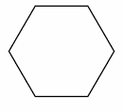 | This symbol is used to indicate the position where For..... Next statement is used in the program!

Example 1
"Flowchart to find the quotient after dividing a number by another.
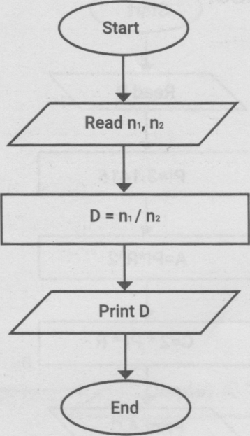
Figure 174 flowchart

Example 2

Flowchart to read Principal (P), Time (T) and Rate (R) and calculate the simple interest

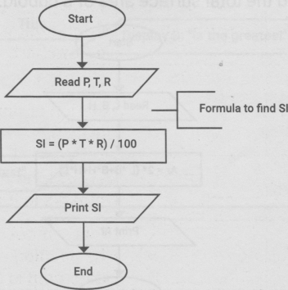
Figure 175FLowchart

Example 3
Flowchart to read radius and calculate area and circumference of a circle.
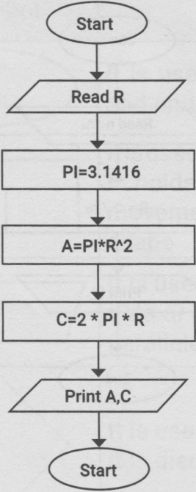
Figure 176FLowchart

Example 4
Flowchart to find the total surface area of a cuboid.
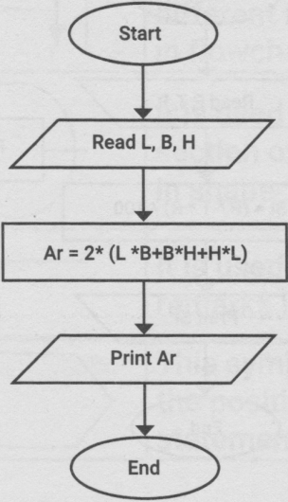
Figure 177FLowchart

Example 5
Flowchart to print the greatest number among three different numbers.
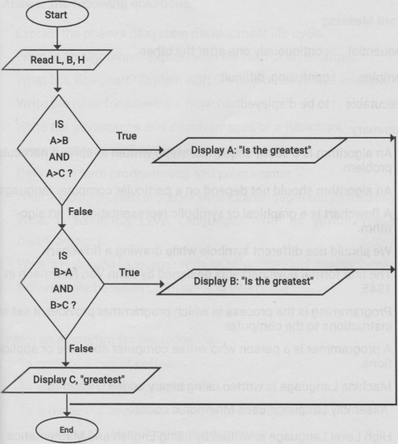
Figure 178FLowchart

Syntactical:
The structure of statements or elements in a computer language
Architecture:
The art or practice of designing and constructing

Word Meaning
Sequential: continuously one after the other
Complex: confusing, difficult
Executable: to be displayed.

Summary
- An algorithm is a set of sequential steps written to solve a particular problem.
- An algorithm should not depend on a particular computer language
- A flowchart is a graphical or symbolic representation of an algorithm.
- We should use different symbols while drawing a flowchart.
- The first formal flowchart was designed by John VonNewmann in 1945,
- Programming is the process in which programmer provides a set of instructions to the computer.
- A programmer is a person who writes computer software or applications.
- Machine Language is written using binary codes 0's and I’s.
- Assembly Language uses Mnemonic codes.
- High Level Language is written by using English and Mathematics codes

Exercises

- Answer the following questions.

- Explain the phases of system development life cycle.
- What is an algorithm? Explain with the help of an example.
- What is a flowchart? Explain with the help of a suitable example.
- Write the rules for drawing a flowchart.
- Write the advantages and disadvantages of a flowchart.
- Explain system analysis and system design phase.
- Define the term programming and programmer.
- What is Machine Level Language? Write its advantages and disadvantages.
- What is Assembly Level Language? Write its advantages and disadvantages.
- What is High Level Language? Write its advantages and disadvantages.
- Differentiate between Compiler and Interpreter
Write an algorithm for the following.
- To prepare a cup of coffee.
- To arranging a picnic program for your class.
- To arrange the books according to your daily routine.
- To find a word technology in the dictionary.
- To calculate the sum and difference of any two numbers.

3. Draw a flowchart for the following.
- To read three numbers and calculate their product and sum.
- To calculate the area of a rectangle.
- To calculate the sum of a square of all the numbers up to 100.
- To find the sum of square root of all the even numbers up to 50.
- To calculate the area and circumference of a circle.
- To calculate the product of all odd numbers up to 10.
- To check whether the input number is prime or composite.

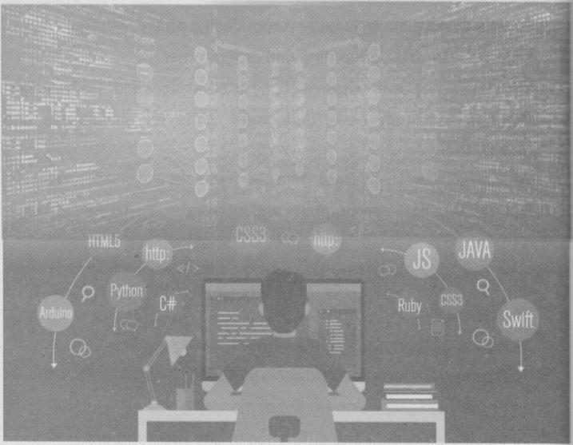
Figure 179 programming

Chapter 11 PROGRAMMING IN QBASIC

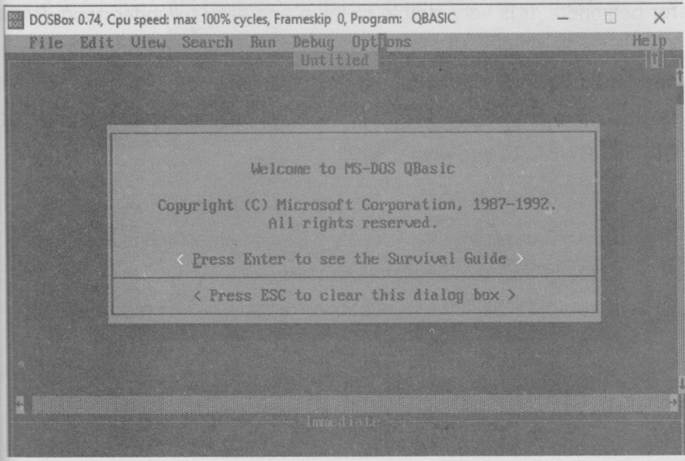
Figure 180 QBASIC SCREEN
This chapter covers:
» Introduction to QBASIC programming.
» Data types in QBASIC.
» Operators, Operands and expressions.
» Program Statements(Use and Syntax)
»Program flow and control structures
» Library Functions
» Arrays (Declaring and using)

INTRODUCTION
In order to communicate with the computer, knowledge of compute language is required. QBASIC is one of the high level languages developed by Microsoft Corporation, USA in 1985. The original version" of QBASIC was BASIC, one of the most popular programming languages for beginners. It is very simple to learn and easy to understand. BASIC stands for Beginners All Purpose Symbolic Instruction Code. BASIC was developed by Prof. John Kemeny and Thomas Kurtz in 1964 in USA Nowadays, many version of BASIC are available such as-Turbo BASIC QBASIC, G WBASIC and Visual BASIC.

a) Features of QBASIC programming
  - QBASIC provides user-friendly environment which is easy to use.
- It accepts simple English like statements.
- It automatically checks syntax errors and givens report at each line.
- It capitalizes the reserved words of QBASIC.
- We can use a mouse as well as a keyboard.
S
- We can use online help whenever required.

Loading QBASIC.
Select the folder that contains QBASIC.
Double click on QB to run QBASIC interpreter.
or
Go to Search option from Start menu.
Type QB.EXE in filename text box and click on Search.
Double click on the searched file. That is, QB.EXE.

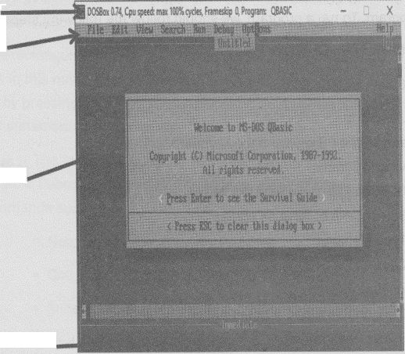
QBASIC screen appears as shown.
Figure 181 QBASIC SCREEN
Title Bar -
Menu Bar
View Window
Immediate Window,

Using the QBASIC Editor Menu and Commands.
To activate QBASIC menus and command, simply press the highlighted letter on keyboard after pressing ALT key or click a menu or command with the left mouse button. To cancel command, simply press ESC key or click the mouse anywhere outside the menu. QBASIC menus display the sub-menus.

Running the Program
In order to see the output after writing a program, we should run a program. To run a program, we should follow the following steps.
- Click on Run menu or press ALT+ R.
- Select START option.
OR
Press Shift + F5 key from the keyboard.
Saving Program.
- Click on File menu or press ALT+F.
- Select Save or Save as option.
- Type filename.
- Click on Ok.
Opening Program.
- Click on File menu or press ALT+F.
- Select Open option.
- Type or select filename.
- Click on Open.
- QBasic Interface (Screen, menus, shortcut commands)
- Screen:- QBASIC screen is divided into two windows, they are
- View Window.

Immediate Window
View Window
The largest portion of the QBASIC editor screen is called view window or program window. Statements of program are stored in memory and

then executed (run) by pressing Shif+F5 key. Programs are usually written and stored in this mode.

Immediate Window
The wide rectangular area just above the reference bar is called immediate window. In this mode, lines of statements are written and run (executed) directly by pressing Enter key. It is useful to find out the instant result of BASIC statements or commands.
ii) Menus The Menu Bar consists of list of commands like File, View, search, Run, Debug, Options and Help. These menus again have some sub commands such as
File= New, Open, Save, Save As, Print, Exit.
EDIT= Cut, Copy, Paste, Clear, New Sub, New Function.
VIEW= Subs, Spilt, Output Screen.
SEARCH= Find, Repeat Last Find, Change.
RUN= Start, Restart, Continue.
DEBUG= Step, Procedure Step, Trace On, Toggle Breakpoint,
Clear All Breakpoints, Set Next Statement.
OPTIONS= Display, Help Path, Syntax Checking.

ii) Shortcut commands (Immediate mode commands)
FILES:- this command displays the list of files and directories.
Syntax: FILES<path specification>

E.g. FILES =List all the files and directories of default directory. FILES "*.BAS": It lists all the files having extension. BAS. FILES FILES" D:\*. *": It lists all the files and directories of D drive.
CHDIR: This command changes the default directory with specified directory.
Syntax CHDIR<Directory name>
E.g. CHDIR "C:\RAM": It changes the default directory by RAM directory
MKDIR: This command creates a new directory in the specified location.
Syntax: MKDIR<Directory name>
E.g. RMDIR "D:\ABC": It creates a new directory ABC in D: drive. RMDIR: This command removes or deletes the empty directory.
Syntax RMDIR< Directory name.
E.g. RMDI "C:\RAM" It deletes the directory RAM from C: drive NAME: This command charges the name of file with a new name. Syntax NAME, old file name>AS <new file or files.
E.g. NAME "TEMP.DAT AS "RECORD.DAT": It renames the file "TEMP. DA' to 'RECORD.DAT".
KILL This command is used to delete a file or files.
Syntax: KILL<file name>
E.g. KILL "record.dat": It deletes or removes a file named "record.dat". SHELL: This command charge the QBASIC mode to DOS mode.
Syntax: SHELL
E.g. SHELL: It charges QBASIC mode to DOS mode.

DATA TYPES IN QBASIC
There are two types of data in QBASIC. They are:
Numeric Data Type.
Numeric data consist all numeric values (0 to 9) that can be used for mathematical calculations.
String Data Type.
String data consist all alphanumeric values.
Variable and constant.

Variable.
Variables are the location or address where the values are kept. The Value of a variable is changeable during the program execution. Like keeping things we need a bag, in the same way, for keeping values we need variables. For Example A=5, N$= "Nepal". Here, A=5 is a numeric variable that holds the values "Nepal". If we print the values of A or N$, Computer will print the values 5 or "Nepali"
Variables are also defined as the entities that charges their value while running the program. We can't keep different values in the same place, we want to keep 5 and 10 in the variable A, whatever be the last value I be stored.
Example: Write the given program in a computer and check the output understand the concept of variable.
CLS
FOR l= 1 TO 5 READeN
NEXT I

DATA 1, 2, 3, 4, 5
FOR l= 1 TO 5
PRINT N;
NEXT I
The output will be 5 5 5 5 5
Though N will read 5 values, at last 5 is stored in the variable N. So, if we print the value of N, it only prints 5.
There are two types of variables.
- Numeric variable
- String variable

a) Numeric variable.
The variable which is used to store only numeric values which can be used for mathematical calculation is called numeric variable. For example 4 B4, class and so no are numeric variables
Sample Program.
REM Program to show numeric variables and numeric constants.
A=30
B=20
S=A+ B
PRINT "Sum is";S
END
In this program, A and B are numeric variables that store numeric constants 30 and 20 respectively. S is also a numeric variable which stores the sum value of A and B. Further numeric variable are declared into four different types depending upon their value.

I. Integer: Variables having (%) sing at the end are integer variables. They store a numbers from -32767 to 32768.
LET A%= 25
Long Integer: Variable having (&) sing at the end are long Integer variables. They store values from -2147483648 to 2147483647.
LETB&= 123454321
Single precision: A variable that have (!) sing at the end single precision variable. If it exceeds seven digits, it is rounded to its closest integer.
LET D# =2345.564798
Result is 2345.5648
Double precision: A variable having (#) sing at the end are double decision variable. If it exceeds 16 digitals, it is rounded to its closest Integer.
LET D# = 3.9776391348632179
Suit is 3.977639134863218
Memory allocation
Data types with memory allocation: data types with their memory allocation are:
Data Type Memory allocation

Integer 2
Long integer 4
Single precision 4
Double precision 8

String variable.
A string variable can store alphanumeric values. It is presented by analphabet followed by a dollar sing ($). Its value is always enclosed double quotation marks. Name$ and Add$ are examples of string variables.
Sample program.
REM Example of string variables and String constants.
A$ = "Nepal"
B$ = "Pokhara"
PRINT "My country name is"; A$
PRINT "My hometown is"; B$
END
In the above program, A$ and B$ are string variables that store values of string constants "Nepal" and "Pokhara".
Rules for naming a variable
- A variable name must start with an alphabet. For example: 3A is an invalid variable name whereas A3 is valid.
- The length of a variable name may be from 1 to 40 characters.
- A variables name can be written with the combination of letter numbers, decimal points and data declaration symbols. For example: CLS, INPUT, LET are invalid variable names.

Constant (Literals and symbols)
The data item whose value remains the same or unchanged during the execution of program is called constant. There are two types of constant: They are:

1) Literal Constant
- Numeric Constant
- String Constant

a) Numeric constant.
Numeric constant are those values that can be used for mathematical calculations. For example: 2,36 and so no.
Rules for writing Numeric constants.
- Do not give a spec in a numeric constant. For example: 1 23 is invalid whereas 123 is valid.
- Comma is not allowed in numeric constant. For example: 1,23 is invalid whereas 123 is valid.
- Minus sign is compulsorily used to represent a negative number but"+" sing is optional for a positive number. For example: -2 is negative number, 2 is positive number.

b)String constant
String constants may be number, alphabets or group of numbers and alphabets and always enclosed within double quotation marks. For example: "Nepal", "pokhara" and so no.
Rules for writing string constants.
- String constants must be written within double quotation marks. For example: "Nepal", "pokhara".
- Space can be written in a string or alphanumeric constants. For example: "Nepal visit year 2011".

2) Symbolic Constant:
A fixed value which is represented by some scientific symbols is called symbolic constant. For examples 3.1416. In QBASIC we use CONST statement to declare one or more symbolic constants. Its syntax is:
CONST constant name = expression
Constant name:
The name of the constant. This name can consist up to 40 characters and must begin with a letter. Valid characters are A-Z, 0-9, and period (•)•
Example:
Const PI = 3.141593
INPUT "Radius of Circle:”;r
Print "Area = "; PI * r*r
b) Variable declaration (Implicit and Explicit)
a
In two ways we can declare a variable in Qbasic
- Implicit declaration
- Explicit declaration
i) Implicit Variable Declaration (Using type declaration characters -%,&,!,#,$)
In Implicit variable declaration, the variable is declared with type type declaration characters (%,&,!,#,$) as a suffix just after the variable name. Thus in this declaration the type of the variable is declared at the same time when the value is assigned to it.

For example A%=127,B&=8756321,
E$= "SAGAR"
Note: If there is no character used after the variable name then QBASIC program assign the default data type as a single precision variable.
Explicit Variable Declaration (Using DIM AS statement)
In Explicit Variable Declaration, the variable type and the assignment is done separately. The variable type is declared first with DIM statement then the value is assigned later. So the declaration characters are not used here. In programming languages like C and C++ the variables must be declared explicitly.
Syntax DIM [Variable name] AS TYPE
The type can be STRING, INTEGER, LONG, SINGLE, DOUBLE
For example:
' DIM N AS INTEGER ’ N has been declared as an integer variable
DIM name AS STRING *15 'variable name has been declared as a string variable which
can store 15 characters.
OPERATOR, OPERANDS AND EXPRESSIONS

Operator
Operators are symbols or sign used to perform different operations between two or more operands and give result. There are four types of operators.
- Arithmetical operator

- Relational operator
- Logical operator
- String operator

1. Arithmetical operators.
These operators are used to perform arithmetic calculations. Arithmetic operators are given below:
Symbols | Meaning | Example | Output
+ | Addition | 9+6 | 15
- | Subtraction | 20-6 | 14
* | Multiplication | 5*5 | 25
/ | Division | 45/9 | 5
A | Exponential | 3^3 | 27
MOD | Modulus division (gives remainder) | 9 MOD 4 | 1

2. Relational operators.
Relational operators are used to compare two data values. Relational operators are given below:
Symbols | Meaning | Example
= | Equal to | 5=5
> | Greater than | 6>4
< | Less than | 10<6
>= | Greater than or equal to | 7>=5
<= | Less than or equal to | 6<=6
<> | Not equal to | 7<>9

3. Logical Operators
Logical operators are used to combine two or more expressions containing

relational operators. Logical operators are given below:
- AND operator.
- OR operator.
- NOT operator.
a) AND operator :AND operator gives true result when all the given conditions are true. The truth table for AND operator is given below:
Condition 1 | Condition 2 | Result
T | T | T
T | F | F
F | T | F
F | F | F
b) OR operator :OR operator will gives true result even if any one of the given conditions is true. The truth table for OR operator is given below:
Condition 1 | Condition 2 | Result
T | T | T
T | F | T
F | T | T
F | F | F

c) NOT operator: NOT operator gives the reverse result of the given condition. The truth table for NOT operator is given below:
Condition | Result
T | F
F | T

d) String Operator
An operator which is used to join or concatenate two or more string is called a string operator. In QBASIC "+" operator is used to concatenate strings.
Operator | Meaning | Example | Result
+ | Concatenate | PRINT "POK" + "HARA" | POKHARA
Operator and their precedence
When we use more than one operators in an expression the order of precedence to evaluate the operations is called hierarchy of operation. When the operators are having the same priority, they are evaluated from left to right in the order they appear in the expression. The order following by QBASIC while evaluating an expression is given below:
1. Arithmetic operation.
- Exponentiation
- Multiplication and division.
- Integer division
- Modulo arithmetic.
- Addition and subtraction.
2. Relational operations
- =
- >
- <
- <>
- <=
- >=

3. Logical operation
- AND
- OR
- NOT
Operand
Variables and constants that are used to perform different types of calculations are operands. For example 4+5-3, (x*y)/z, here 4, 5, 3, x, y, z are the operands.
Expression:-
An expression can be a variable or constant or combination of constants, variables with operators. On the basis of result returned by an expression, there are three types of expressions. They are:
- Arithmetic or Numeric expression.
- Logical or Boolean expression.
- String expression.
I) Arithmetic or Numeric expression: The expression which returns a numeric value as an output is called numeric or arithmetic expression. Arithmetic operators are symbols used in arithmetic expression. The example of arithmetic expressions are given below:
SI = P*T*R/100
= (I^ 2) + Z
ii) Logical or Boolean expression: The expression which returns one of two logical values either true or false is called logical expression. This type of expression also called Boolean expression. It gives -1 if the result true and 0 if the result is false. For example:

PRINT 10>5 returns-1.
PRINT 5<3 returns 0.
iii) String expression The expression which returns the string value after processing string with the help of string operators is called string expression.
For example:
CLS
A$= "Computer"
B$= "Science"
PRINT A$ + B$
END
Conversion of Algebraic expression into QBASIC expression.
While using expression in QBASIC, we should use QBASIC expression in programming. The following table shows the conversion of Algebraic expression into QBASIC expressing.
Mathematical Expression | QBASIC Expression
AB + CD | A* B + C*D
l= PxTxR  100 | l=(P*T* R)/100
A = l x b | A = l * b
P = 2(l+ b) | P = 2 * (1 + b)
3C³ + 2A² | 3*C^ 3+ 2*A^ 2
 | (a + b)^ (1/2)
AB  NM | (A* B)/(N * M)
A²+B² | (A ^ 2) + (B^2)

Word Meaning
precedence :the right of going before in order of importance.
hierarchy: an arrangement in order of rank, importance.
compiler: a program to translate language to machine code.

Summary
BASIC is one of the most popular programming languages.
QBASIC is a high level programming language development by Microsoft Corporation, USA.
The largest portion of the QBASIC editor screen is called view window or program window.
The wide rectangular of the reference barn is called immediate window.
Numeric data consists all numeric values (0 to 9) that can be used for mathematical calculations.
String data consists of all the alphanumeric values.
A variable is a name or reference for any value. There are two types of variables used in QBASIC. They are: Numeric variable and string variable.
The data item whose value remains the same or unchanged during the execution of program is called constant. There are two types of constants used in QBASIC. They are: Numeric constant and string constant.
Keywords are those words which have special meanings in QBASIC. They are the commands that instruct the computer to carry out an action.

Operations are symbols or sings used to perform different operationsbetween operands and give result. Relations operators are used tocompare two values.
Logical operators are used to combine two or more expressions containing relational operators.
An expression can be a variable or constant or combination of constants, variable with operators.

Full Forms
BASIC : Beginners All-purpose Symbolic Instruction Code.
QBASIC : Quick Beginners All-purpose Symbolic Instruction Code.
GWBASIC : Gee Whiz Beginners All-purpose Symbolic Instruction Code
BASICA : Beginners All-purpose Symbolic Instruction Code Advance

Exercises
- Fill in the blanks.
a ………..is the high level programming language.
- The two of QBASIC screen is called………..and………..
- The original version of QBASIC is………..
- In QBASIC, we can use mouse as well as………..
- Two data types used in QBASIC are………..and ………..
- Numeric variables can store only………..
- Variables having (%) sing at the end are………..variables.
- Memory consumption of double precision variable is bytes.
- The length of variable name can be from………..to characters.
- String constant may be numbers, alphabets or group of…. and......
2.Write whether the following statements are True or False.
- QBASIC was developed by Microsoft Corporation.
- The order of precedence to evaluate the operation is called hierarchy.
- Logical expression returns three logical values.
- NOT operator gives the reverse result of the given conditions.
- Operators are symbols or sings that are used to perform different operations.

- Keywords are those words which have opposite meanings in QBASIC
- The wide rectangular area just above the reference bar is called view window
h. Comma is allowed in numeric constant.
3. Find out valid or invalid variables and gives reason if in vild.
a. SMS$ b. B&5 c. INPUT d. Middle Name
e. LNAME f. 234MS g. "Nepal" h. PRINT
i. KISHORE
4. Find out whether the following assignments are valid or invalid and give reason if invalid:
a. C$= "DHARAN"
b. R= 5%
c. Sal= $5000
d. N$= "NEPAL¹
e. Age= 15 years
f. Ram= 657
g. 12CD= 450
h. AX$2= "KEF
5. Answer the following questions.
a. What is a variable?
b. What are relational operators?
c.Make a truth table of AND, OR and NOT operators.
d. Write the rules to following while declaring a variable.
e. Differentiate between view window and immediate window
f. Differentiate between variable and constant.

- What are data types of QBASIC? Write the memory consumption of each data type.
- Define keyword. Give some examples.
- Define operators. Write its types.
- What is QBASIC? List features.
- Define logical operator.
- Define expression. Write its types.
- What is an operators? List different types of operator used in QBASIC.
- Write memory consumption of all numeric data types.
- Write down the syntax and meaning of the following commands.
I. NAMES ii. FILES iii. KILL vi. MKDIR

PROGRAM STATEMENTS (USE AND SYNTAX)

The statement is a collection of commands used in the program. CLS, INPUT, PRINT, REM and END are some of the example of QBASIC statements.
- Declaration statements.
- Assignment statements.
- Input/output statement
a) Declaration statements (CONST, DIM, REM):The statements which are used to declare variable in the program are called declaration statements. CONST, DIM and REM are the examples of declaration statements.
CONST statement: - This statement holds the constant value for the variable and makes it fixed throughout the program execution. Here CONST stands for constant. According to its name, this statement is used to store only one data in particular variable through the program execution.
Syntax:
CONST PI = 22/7
DIM statement:- DIM statement is especially used to declare an array. variables. It can also be used to declare an ordinary variable (explict declaration)
Syntax:
DIM variable AS data type
-> Simple/explicit variable declaration.

DIM variable(subscript)
->Array variable declaration.
Example:
DIM NAME AS STRING
DIM AGE AS INTEGER -> Simple Variable declaration

DIM NAME$(5)
DIM AGE (5) -> Array variable declaration

REM statement
This statement is used to give remarks or comments to the program or statement. We can use this statement any number of times as possible, but it does not increase the size of the program. We can also use single quote (') in place of REM statement
Syntax:
REM comment for the program or statement
' comment for the program or statement
Example:
REM program for finding simple interest.
' this statement will store value for rate of interest.
b) Assignment statements(LET/SWAP): The statements which are used to assign a numeric or string value to a variable are called assignment statements. LET and SWAP are examples of assignment statement.
LET statement: It is used to assign a numeric value or a string expression to a variable. But, it is an optional statement.
Syntax:
[LET]<variable>=<string expression/ value>

Example:
LET I = 25
LET C$ = "COMPUTER"
SWAP statement.
This statement is used to exchange the values of two similar types of variables.
Syntax: SWAP < variable1, variable2>
Example
CLS
A= 5
B= 10
0=15
D= 20
PRINT "Before swapping"
PRINT A, B, C, D
SWAP A, B
SWAP C, D
PRINT "After swapping"
PRINT A, B, C, D
END
c) Input/output Statement: Input/ Output statements are those statements that allow the user to input data to the computer and pint the data. They are used to perform input/ output operation for the computer INPUT, PRINT and L PRINT are some of the example of Input/ Output statements
CLS statement:
It clears the previous output from the display screen and makes the screen blank.

Syntax:
CLS
Example:
CLS
INPUT Statement:
INPUT statement is used to read input from the keyboard during program execution.
Syntax:
INPUT ["Prompt" {; I,}] var1, var2, var3,…..var n.
Example:
INPUT "Enter your name"; n$
INPUT "Enter your roll no. and section"; r, sec$
LINE INPUT Statement
"This statement allows to input line of data at a time and assign into single variable. It can accept a complete line of maximum 255 characters.
Syntax:
LINE INPUT "string "; string variable
Example:
CLS
LINE INPUT "please enter the line of text"; n$
PRINT n$
END
READ...DATA statement.
READ...DATA statement is used as complimentary to each other.
READ statement reads multiple values by multiple variables from the data listed in the DATA statement. The number of data listed in DATA statement must

be equal or more than the variables in READ statement. The sequence of type of variable used in READ statement and the types of data in the DATA statements must match.
Syntax:
READ variable 1, variable 2,.
DATA value 1, value 2,
Example:
CLS
READ
SNO,
NAME$, CL
PRINT SNO, NAMES, CL
DATA 5, Ram, 9
END
INPUTS Statement
This statement will show a string of character read from a specified file
Syntax:
INPUTS (n[,[#]file number%])
Example:
OPEN "TEST.DAT" FOR OUTPUT AS #1
PRINT #1," SWARNIM"
CLOSE
OPEN "TEST.DAT" FOR INPUT AS #1
PRINT INPUT$(3,1) ‘Print first 3 characters.
CLOSE
IN KEYS Statement
This statement reads a character from the keyboard.
Syntax:
IN KEY$

Example:
PRINT "Press Esc to exit...."
DO
PRINT "SWARNIM PUBLICATION PVT.LTD."
LOOP UNTIL INKEY$ = CHAR$(27) '27 is the ASCII code for Esc.
PRINT (?) statement
PRINT statement is used to display string expression and/ or the value of variable(s) stated, on the screen. PRINT statement without any string expression or variable is used for leaving a blank line on the output screen. In place of PRINT statement we can use? (question mark).
Syntax:
PRINT ["String Expression" {, I;}] var 1, var 2... var n.
Example:
PRINT "My first program in QBASIC"
PRINT
PRINT "Value of variable A and B is"; A, B
L PRINT Statements
This statement allows to input line of data at a time and assign into single variable.
Syntax:
LINE INPUT "string"; string variable
Example:
CLS
LINE INPUT "please enter the data"; n$
PRINT n$
END

PRINT USING Statement
PRINT USING write formatted output to the screen or to a file.
Syntax:
PRINT USING "formatting string"; expression
! | Display only the first character of string
\n\ | Print first n+2 characters from the string
& | Display all the string
 | Digit position is spacified
&& | Print leading & sing
^^^ | Prints the number in exponential format
. | Decimal point position specification
Example:
CLS
S$ = "Ram"
K$ = "Kumar"
PRINT USING "!"; s$”.”;
PRINT USING “&”k$;
END
LPRINT USING
LPRINT USING prints formatted output on the printer LPT1.
Syntax:
LPRINT USING formatstring$; expressionlist [{; I,}]
Example:
a = 123.4567
LPRINT USING "+###.####"; a
a$ = "SWARNIM"
LPRINT USING "\\"; a$

TAB Statement:
This statement is used to insert the given the numbers of spaces before printing. It is used with PRINT or LPRINT statements.
TAB (column %)
PRINT "KATHMANDU"; TAB (25); "NEPAL'
A$ = "SWARNIM" B$ = "COMPUTER"
PRINT A$; TAB (10); B$
SPC Statement:
"The SPC statement is used in PRINT and LPRINT statements to print or output a number of space characters.

Syntax: SPC (count %)
Example: PRINT "ABC"; SPC (3); "123"

LOCATE Statement:
LOCATE statement moves the cursor to a specified position on the screen.
Syntax:
LOCATE [row%],[column%]
Example:
CLS
LOCATE 5, 5
PRINT "SWARNIM PUBLICATION PVT LTD."
DATES Statement
The DATE$ statement sets the current system date on your computer, syntax:
DATE$ = string expressions
Example:
DATES = "03-01-19"
PRINT DATE$

TIME$ Statement
The TIME$ statement sets the current system time on you' computer.
Syntax:
TIME$ = string expression$
Example:
TIME$ = "10:55:38"
PRINT TIME$

PROGRAM FLOW AND CONTROL STATEMENTS
Control Structure is the statement of the structure that is used to handle different condition and iteration. It is used to control the flow of the program. They are Sequential Structure, Selection Structure and Loop Structure.

Sequential Structure:
A structure in which the statements are executed sequentially one after another without changing the flow of the program.
Example:
CLS
INPUT A
INPUT B
LET S=A+B
PRINT "Sum of Numbers"; S
END

Selection Structure:
It is also known as a branching structure that allows to transfer the program control from one part to another on the basis of a specified condition or without condition.

Types of Selection Structure:
I) If Statement
ii) Select Case Statement

I) IF statement.
As we know, QBASIC executes the instructions of program sequentially one after another. But, sometimes problems cannot be solved sequentially. So, we need to branch or jump from one line to another line. IF...THEN statement is the conditional branching (jumping) statement. This statement in used to make decision. It executes a statement or a block of statements depending upon the given condition. The condition is given between IF...THEN. If the condition is true, it executes the statements and if the condition is false the execution continues with the next executable statement. It branches the control flow of program instructions according to the given condition.
This statement can be used in the given condition. IF:...THEN statement, (single line IF statement)
Syntax:
IF<condition> THEN<statement>
Example:
CLS
INPUT "Enter first number"; A
INPUT "Enter second number"; B
IFA>B THEN PRINT A
END
IF…THEN...ELSE statement. (Multi Line IF statement)

Syntax:
IF<condition>THEN
< statement 1 >
ELSE
<statement 2>
END IF
Example:
CLS
INPUT "Enter any number"; N
IF N MOD 2 = OTHER
PRINT "Even Number"
ELSE
PRINT "Odd Number"
END IF
END
IF...THEN...ELSE IF statement. (Nested IF statement)
Syntax:
IF<condition 1>THEN
<statement 1 >
ELSE
IF<condition 2>THEN
<Statement 2>
ELSE statement n>
END IF

Example:
CLS
INPUT "Enter a number"; N
IF N< 100 THEN
PRINT "It is lesser than 100"
ELSE
IF N= 100 THEN
PRINT" It is equal to 100
ELSE
PRINT "It greater than 100"
END IF
END

ii)SELECT CASE statement
Executes one of several statement blocks depending on the value of an expression.
Syntax:
SELECT CASE test expression
CASE expression list 1
[Statement block]
CASE expression list 2
[statement block 2]
CASE ELSE
[statement block n]
END SELECT

Example:
CLS
INPUT "Enter Your percentage"; Per
SELECT CASE Per
CASE IS >= 90
PRINT "You Got A+"
CASE 80 TO 89
PRINT "You Got A"
CASE 70 TO 79
PRINT "You Got B+
CASE 60 TO 69
PRINT "You Got B"
CASE 50 TO 59
PRINT "You Got C+"
CASE 40 TO 49
PRINT "You Got C"
CASE ELSE
PRINT "Sorry very less Grade"
END SELECT
END
Loop Structure:Looping is the repeated execution of a statement of block of statements many times without recording them. The loop is repeated as long as the given conditional is satisfied. It is terminates when the given condition is not satisfied. A loop become infinite loop if never terminates. In QBASIC, there are three looping statements. They
are:

- FOR...NEXT
- WHILE...WEND
- DO...LOOP

I) FOR. NEXT Loop.
It repeats a statement or a block of statements for a specified number of times. The statements are written in between FOR and NEXT.
Syntax:
FOR <counter>=<initial value> TO <Sentinel value><Step value> Statement(s)
NEXT <counter>
Here, counter is a numeric variable that controls the loop. It is also called control variable. The execution of the loop begins by specifying the initial, sentinel and step values. If step value is not defined, QBASIC assumes SET P as '1' by default and will increase the value of computer variable by 1.
Example 1: Program to print first 20 natural numbers horizontally.
CLS
FOR I = 1 to 20
PRINT I;
NEXT I
END

Example 2: Program to print all Odd numbers from 49 to 5.
CLS
FOR I = 49 to 5 step -2
PRINT I;
NEXT I
END

Example 3 Program to print your school's name 20 times.
CLS
INPUT "Enter your school's name"; N$
FOR I = 1 to 20
PRINT "My school's name is"; N$
NEXT I
EXIT FOR Statement
This statement exits a FOR loop
Syntax:
EXIT FOR
Example:-
FOR A= 1 TO 20 STEP 1
PRINT A;
IF A= 14 THEN EXIT FOR
NEXT A

ii)WHILE...WEND Loop.
WHILE...WEND looping structure executes a series of statement as long as the given condition is true. If the condition is false, the loop termir and other statements following WHILE...WEND statements are executed. The 'WHILE' keyword is followed by the condition.
Syntax:
<initial Value>
WHILE < Condition>

<statement>
<step Value>
WEND

Example 1: Program to print even numbers from 2 to 50. CLS
l = 2
WHILE l<=20
PRINT I;
l= I+2
WEND
END
Example 2: Program to generate the series 7,14,21…..70
CLS
WHILE l<= 70
PRINT I;
WEND
END
Example 3: Program to print sum of 1 to n numbers.
CLS
INPUT "Enter any number"; N
S=0
WHILE l<=N
S=S + I
I=I+1
WEND
PRINT S
END

iii) DO... LOOP
It repeats a statement or a block of statements while a condition is true or until a condition become false. The WHILE or UNTIL keyword (any one of them) is used with DO...LOOP. If we used 'WHILE', the loop terminateswhen the given condition evaluates to false whereas if we use 'UNTIL, theloop terminates when the given condition evaluates to true.
Syntax:
DO {WHILE/UNTIL}
Statement or statements block
LOOP
OR
DO
Statement or statements block
LOOP {WHILE /UNTIL}
EXIT DO Statement
This statement ends a DO loop.
Syntax:
N= 1
DO
PRINT N;
IF N=8 THEN EXIT DO
N= N+ 1
LOOP WHILE N<=10
Example1: Program to print first 20 odd numbers.

  - Using DO WHILE...LOOP
CLS
I = 1
A= 1
DO WHILE I <=20
PRINT A;
l= 1 + 1
A= A + 2
LOOP
END
  - Using DO...LOOP WHILE
CLS
I = 1
A= 1
Do
PRINT A;
1=I + 1
A= A + 2
LOOP WHILE l<=20
END

  - Using DO UNTIL...LOOP
CLS
A= 1
DO UNTIL l> 20
PRINT A;
1=1 + 1
A= A + 2
LOOP
END

  - Using DO...LOOP UNTIL
CLS
A= 1
DO
PRINT A;
I=I + 1
A= A + 2
LOOP UNTIL I >20
END

NESTED LOOP

A loop within a loop is called a nested loop. One kind of looping statement in contain another same or different type of looping statement. The looping statement can be nested at any level deep.
Syntax:
FOR <counter 1 >=<initial value> TO <Sentinel value> [step value] [statement block]
FOR <counter 2>=<initial value> TO <Sentinel value> [step value] [statement block]
NEXT [counter2]
[Statement block]
NEXT [counter]
Example Program to print the following series.
5
4 4
3 3 3
2 2 2 2
11111
CLS
FOR 1= 5 TO 1 STEP-1
FOR J= 5 TO I STEP-1
PRINT I;
NEXT J
PRINT
NEXT I
END
Sample programs.
REM program to find the perimeter of a rectangle.
CLS
INPUT "Enter length of a rectangle"; I

INPUT "Enter breath of a rectangle"; b
p= 2 *(l + b)
PRINT "Perimeter of rectangle-'; p
END
REM to find the simple interest and amount.
CLS
INPUT "Enter principle"; p
INPUT "Enter rate"; r
INPUT "Enter time"; t
si= (p*t* r) / 100
a= p + SI
PRINT "Simple interest='; si
PRINT "Amount=; a
END
REM Program to enter any three numbers and print the middle number.
CLS
INPUT "Enter first number"; A
INPUT "Enter second number"; B
INPUT" Enter third number"; C
IF (A>B AND A<C) OR (A<B AND A>C) THEN M=A
IF (B>A AND B<C) OR (B<A AND B>C) THEN M=B
IF (C> A AND C<B) OR (C<A AND C>B) THEN M=C
PRINT "The Middle number is"; M
END
REM Program that will read the percentage and display the position.
CLS
INPUT "Enter your percentage"; P

IF P>= 80 THEN
PRINT "You are passed in Distinction"
ELSEIF P >= 60 THEN
PRINT "You are passed in First division"
ELSEIF P >=45 THEN
PRINT "You are passed in Second division"
ELSEIF P>=32 THEN
PRINT "You are passed in Third division"
ELSE
PRINT "You are Fail"
END IF
END
Program to generate the following series.
3 33 333 3333 33333
Solution:
CLS
A=3
FOR I =1 TO 5
PRINT A;
A=A * 10 + 3
NEXT I
END
Program to generate the following series.
5 4 3 2 1
4 3 2 1
3 2 1
2 1
1

Solution:
CLS
A= 5
DO UNTIL A <1
B= A
DO UNTIL B < 1 PRINT B;
B= B-1
LOOP
A= A-1
PRINT
LOOP
END
Program to generate the following series.
5
5 5
5 5 5
5 5 5 5
55555

Solution:
CLS
A=5
FOR I = 1 TO 5
PRINT A
A=A*10 + 5
NEXT I
END
Program to generate the following series.
1 4 9 16 25……. upt o 10 ^{th}term.

Solution
CLS
A=1
WHILE A< =10
PRINTA^2
A=A + 1
WEND
END
Program to generate the following series.
1
1 0
1 0 1
1 0 1 0
1 0 1 1 0
Solution:
CLS
FOR l=1 TO 5
FOR J=1 TO I
PRINT J MOD 2;
NEXT J
PRINT
NEXT I
END

Functions IN QBASIC.
Function are ready-made programs which take some data manipulate them and return either numeric or string value. They are the programs that calculate or manipulate data and return a value. In another words, Function is a built-in formula to perform a certain task. Once a
function is written, it can be used again and again. There are two types of Functions supported by QBASIC. They are:
- User Defined functions.
- Library or Built-in functions.

User Defined functions.

This function is written by the programmer to do specific task. We can use FUNCTION...END FUNCTION statement to create a user defined function.

Library or Built-in functions.

Library functions are those functions provided by the QBASIC to do a specific task. Library function can be called (used) by the user according to the requirement. Some common examples of library functions are LEN, LEFT$, SQR and so no. Library functions are classified into two types. They are:
- String manipulation functions
- Mathematical calculation functions

a) String Manipulation Functions:-
Strings functions are used to manipulate or compute string type of data and return a single value. Some of the string functions are explained below.
I) AS C FUNCTION
This function returns the ASCII code for corresponding specified character.
Syntax:
ASC(String Character)
Example:
PRINT ASC("A")

- CHR$ FUNCTION
This function returns the character corresponding to a specified ASCI code.
Syntax:
CHR$(ascil-code%)
Example:
PRINT CHR$(65)
- LEFT$ FUNCTION.
This function is used to extract or return the specified number of characters from the left side of the given string.
Syntax: LEFT$ (String expression, number)
Syntax: PRINT LEFT$("Nepal", 4)
- RIGHT$ Function.
i
This function is used to extract or return the specified number of characters from the right side of the given string.
RIGHT$(String expression, number)
PRINT RIGHT$ ("Pokhara", 3)
V) MID$ FUNCTION.
This function is used to extract the specified number of characters from the given position of the string.
MID$ (String expression, position, number)
PRINT MID$ ("KATHMANDU", 3, 4)

VI) LEN FUNCTION.
This function is used to find the length of the given string by counting he numbers of characters that are enclosed in quotes or assigned to string variable.
Syntax: LEN (String expression)
Example: PRINT LEN ("TECHNOLOGY")

VII) LTRIM$, RTRIM$ FUNCTIONS
Remove leading and trailing spaces from a string.
Syntax:
LTRIM $ (Stringexpression$)
RTRIM$ (stringexpression$)
Example:
N$= " SWARNIM "
PRINT "*" + N$ + "*"
PRINT "*" + LTRIM$(a$) +"*"
PRINT "*" + RTRIM$(a$) + "*"
VIII)VAL FUNCTION.
This function is used to charge the string representation of a number into a numerical value. If the first character of the string is non-numeric, it returns 0.
VAL (String expression)

Example:
PRINT VAL ("061 POKHARA")
PRINT VAL ("NEPAL” 977")
IX) STR$ FUNCTION
STR$ returns a sting representation of a number.
Syntax:
STR$ (numeric-expression)
Example:
PRINT STR$(41)
X) STRINGS FUNCTION
Returns a string of a specified length made up of a repeating character.
Syntax:
PRINT STRINGS (length%, stringexpressionS)
Example:
PRINT STRING$(5, "*");
PRINT "SWARNIM";
PRINT STRING$(5, "*")
XI)SPACES FUNCTION
Returns a string of spaces.
Syntax:
SPACE$(n%)

Example:
FOR Ii % = 1 TO 5
x$ = SPACES (I%) PRINT x$;I%
NEXT I%
XII) UCASE $ FUNCTION.
This function is used to convert the given string into upper case.
Syntax:
UCASE$ (String expression)
Example:
PRINT UCASE$ ("Microsoft Corporation")
Output: MICROSOFT CORPORATION
V$= "NePalGuNj"
PRINT UCASE$(V$)
XIII) INSTR
Returns the position of the first occurrence of a string in another string.
Syntax:
IN STR ([start%,] string expression 1 $, string expression 2 $)
Example:
a$= "Microsoft QBasic"
PRINT "String position-'; INSTR (1, a$, "QBasic")

- LCASE $ FUNCTION.
This function is used to convert the given string into lower case
Suntax: LCASE$ (string)
Example: PRINT LCASE$ ("FEWALAKE")
- DATES FUNCTION
The DATE$ function returns the computer's current system date.
DATES
PRINT DATES
- TIMES FUNCTION
The TIMES function returns the computer's current system time.
TIMES
PRINT TIMES
TIMES = "10:55:38"
'Note: The new system time remains in effect until' you change it again.
PRINT "Time set to"; TIME$

b. Mathematical calculation Functions:-
Numeric functions are used to manipulate numeric type of data and return a single value. They are used for mathematical computations. Some mathematical functions are explained below : 9

I) ABS FUNCTION
It returns the absolute value of a numeric expression.
Syntax: ABS (numeric expression)
Example: PRINT ABS (-53.6)
PRINT ABS (4-9)
- SIN FUNCTION
It returns the sine value of an angle.
Syntax: SIN (numeric expression)
Example: PRINT SIN (45)
- COS FUNCTION
It returns the cosine value of an angle.
COS (numeric expression)
PRINT COS (45)
III) TAN FUNCTION
It returns the tangent value of an angle.
Syntax: TAN (numeric expression)
Example: PRINT TAN (45)
IV) SQR FUNCTION.
It returns the square root of a positive numeric expression.
SQR (numeric expression)
Example: PRINT SQR (81)
PRINT SQR (49)

VRINT FUNCTION.
It returns the integer part of a number after removing the decimal part of given numeric expression. It rounds down the number.
Syntax:
INT (numeric expression)
Example:
PRINT INT (37.3)
PRINT INT (99.999)
PRINT INT (-6.3)
VI) SGN FUNCTION.
It returns a value that indicates the sing of the given numeric expression. It returns 1 for the positive numbers,-1 for the negative numbers and 0 for the number 0.
Syntax: SGN (numeric expression)
Example: PRINT SGN (7 + 5)
PRINT SGN (3-8)

WORD MEANING
Categorize: to put things in groups (Category).
Particular: things though of separately from other.
Optional: a matter of choice.
Terminate: to bring or come to an end.
Sentinel: the last value.

SUMMARY
- Statements are the group of commands given to the computer to perform some actions.
- Input/ Output statement give data to the computer and get result from the computer.
- Declaration statements declare a variable in the program.
- The statements which are used to assign a numeric or string value to a variable are called assignment statements.
- The statements which are used to control the flow of execution of the program statement(s) are called control flow statements.
- Branching and jumping take the program from one location to another within a program.
- The term looping means repeated execution of a sequence of statements in a program.
- A loop inside another loop is called a nested loop.
- Logical operators are used to combine two or more expressions containing relational operators.
- An expression can be a variable or constant or combination of constants, variables and operators.

Exercise
1. Fill in the blanks.
- IF...THEN statement is………statement.
- FOR...NEXT is……statement.
- READ statement is followed by……statement.
- DIM statement is especially created to declare…….variables.
- A loop inside another loop is called a…………..
- The…………statement assigns a value to a variable,
- ……….Statement converts the tent into capital letter.
2. Write whether the following statements are True or False.
- The WHILE or UNTIL keyword can be used in DO………LOOR
- LET is an optional statement.
- A loop repeats statements till the given conditional is satisfied.
- DATA is an be executable statement.
- ? sign can be used in place of PRINT statement.
LTRIM$ deletes the number of gaps from right side of string.
3.Write the use and syntax for the following statements.
- DIM statements:
- IF....THEN statement
GO TO
- DO....LOOP
- READ...DATA statement
- LET statement
- FOR...NEXT statement
- INPUT Statement
- NSTR
- STRING$
4. Answer the following questions.
- In how many groups are the QABSIC statements categorized? List them.
- Example Declaration statements with examples.
- Can the number of data in the DATA statement be more than the number of variables in READ statement? Explain.
- Define control statement. Given some examples.
- What is looping? Write the types of loop used in QBASIC.
- What do you understand by the term nested loop?
- A loop becomes endless, if it is not terminated. Why?

- Write the syntax, use and function of the following.
I) INT() ii- CINT() iii. LEFT$()
MID$() v.VAL() vi. UCASE$()
- RTRIM$() viii. SPACE$() ix. CHR$() x. LTRIM$()
- What is the difference between Dates and function and Date$ Statement.
- Different between Times$ function and statement.

5. Write the programs for the followings.
- Write a program to input three different numbers and print their sum and product.
- Write a program to input length and print the perimeter of a square.
- Write a program to input Nepali currency and convert it into Indian currency.
- Write a program to input a number and check whether the input number is palindrome or not [a number which is read same from both sides is a palindrome number. For example: 12321].
- Write a program to input a number and check whether the input number is Armstrong number or not. [if the sum of cube of individual digits of a number is equal to the original number itself then it is called Armstrong number. For example: 153=1³ + 5³ - 3³. So, the number 153 is Armstrong number.]
- Write a program to input a string and check whether the input

string is palindrome or not. [a word which is read same from both the sides is palindrome. For example: NAYAN].
- Write a program to check whether the input number is Prime or Composite.
- Write a program to display "Swarnim Publication Pvt Ltd" 10 times using WHILE...WEND.
- Write a program to print the first 25 even numbers using DO... LOOP.
- Write a program to find out factorial of a given number using FOR...NEXT.
- Write a program to input marks of all your subjects and print total, percentage, result and division.
- Write a program to find the area of a cube [Hints A=6 I ²].
- Write a program to find the curved surface area of a cylinder. [Hints A=2rh],
- Write a program to find the total surface area of a cylinder. [Hints A=2 r(r+h)].
- Write a program to calculate the distance travelled by body. [Hints S=ut+1/2 at ²].
- Write a program to input the temperature in degree Fahrenheit and display in degree Celsius. [Hints F=9 C/5+32].
- Write a program to input a number and check whether it is perfect square or nat.

- Write a program to find the occurrence of character in another string.
- Write a program to input sales amount and calculate commission on the following basics:
Sales Amount Commission
<=5000 10%
>5000 15%
t. Write a program working nested if condition to calculation to calculate commission on the basic of sales amount.
Sales Amount Commission
up to 10000 5%
>10000 and <=20000 10%
>20000 and <=40000 15%
Above 40000 20%
6. Write a program to generate the following series.
- 2, 4, 6, 8.... up to 10th terms
- 1,8, 27, 64.... Up to 10th terms.
- 100, 98,96, 94.... Up to 10th terms.
- 1,4,9.... up to 10th terms.
- 5, 25,125.... Up to 5th terms.
- 1, 2, 3, 6, 11, 20, 37 ….. Up to 10th terms.
- 5, 16, 8, 4, 2, 1, 4, 2,1,4.
- 66666, 6666, 666, 66, 6.

- 2, 8, 18, 32,….up to 10th terms.
- 7, 22,11,34,17, 52, 26, 13, 40, 20.
- k. 1 /2, 2/3, 3/4, ……up to 10th term
- 1,1, 2,3,4,8 ……5 ^{th} term.
- 9, 7, 5, 3, 1, ……5th term.
- 3, 6, 12, 15 …..10th term.
- 1, 121, 12321, 123434,123454321…..5th term.
7. Write a program to display the given the output
a. | 54321 | b. 11111 | c. 12345
 | 4321 | 2222 | 1234
 | 321 | 333 | 123
 | 21 | 44 | 12
 | 1 | 5 | 1
d. | 5 | e. 1 | f. 5
 | 54 | 13 | 44
 | 543 | 135 | 333
 | 5432 | 1357 | 2222
 | 54321 | 11111
g. | 123 | h. 1 | i. 55555 | j. 1
 | 234 | 33 | 4444 | 124
 | 345 | 555 | 333 | 123421
 | 456 | 7777 | 22 | 1234321
 | 567 | 1 | 12345321

8. Write the output for the following.
a. | CLS  A=15  B= 20  C= 30  SWAP A, B  PRINT A, B, C  END | b. | CLS  LET C= 1  WHILE C<= 5  PRINT C;  C= C+1  WEND  END
c. | CLS | d. | CLS
 | A= 1 |  | FOR l= 5TO 1 STEP-1
 | X= 1 |  | FOR J= 5 TO I STEP-1
 | DO WHILE A<=3 |  | PRINT J;
 | PRINT X |  | NEXT J
 | X=X*10 + 1 |  | PRINT
 | A=A + 1  LOOP  END |  | NEXT I  END
e. | CLS | f. | CLS
 | N$, = "COMPUTER" |  | A$= "KATHMANDU"
 | A$, = LEFTS, (N$, 2) |  | N= LEN (A$,)
 | B$, = RIGHT$ (N$, 3) |  | FOR 1=1 TO 5 STEP 1
 | PRINT A$;B$, |  | PRINT TAB (1); MID$ (A$, l,N)
 | END |  | N= N-2
 |  |  | NEXTI
 |  |  | END

9. Debug the following programs.
        - REM Program to sum given two numbers
CLS
INPUT "Enter first number"; t
TYPE "Enter second number"; p
SUM=t + z
Display SUM
End
- REM to display the sum given equivalent of decimal number
CLS
INPUT "Enter a decimal number'; d
WHILE d=0
r= d MOD 2
s$= VAL (r) +s$
d=d/10
WEND
x= STR$(s$)
PRINT "The equivalent binary is"; x
END
- clear
N= 365
WHILE N>0
R= N/10

X= X*10+ R
N=N/10
DISPLAY X
END
- CLS
A$= "LIRIL'
FOR S= L TO LENGTH (A$)
B$= A$= MID$ (A$, 1,1)
WEND
IF A$= B$ THEN
PRINT" Palindrome"
ELSER
PRINT "NOT"
END IF
THE END
10. Study the given program and answer the following questions.
a. CLS
FOR J=5 TO 1
PRINT J,
PRINT
NEXT J
END

- What is the Iteration statement used in the above program?
- If we replace comma sign with semi column, what type of output we will get?
b.CLS
M$= "COMPUTER"
C= LEN (M$)
B= 1
WHILE B<C
PRINT MID$(M$, B, 1);
B= B + 2
WEND
END
- List out the numeric and string variables used in the above program.
- What will happen if the statement B=B+ 2 removed from the program?

ARRAYS (DECLARING AND USING]

Introduction.
A simple variable stores one data at a time. We need more number of variables when we want to store more data. In order to manipulate and use large number of data in a program, we use an array variable. An array variable can store more than one data of the same type with a common name having different subscript. Array variable holds a list of data of the same type. An array is useful for organizing multiple variables. The individual data item in an array is called an Element. A subscript is an integer number which is enclosed in parentheses. For example: DIM num (10) where DIM is the statement to declare an array variable, num is an array variable name and 10 is subscript. Array variable name should be unique in a program. The rules we follow to declare a simple variable will apply to array variable also.

Advantages of an Array.
- Use of array reduces the number of variables used in the program.
- Once we enter data in a program using array, we can use them many times without re-entering them.
- Using array, program can be made more efficient.
- Searching and sorting of data can be done easily.
- Types of Arrays.
- We can classify array into Single multidimensional array.

Single Dimensional Array.
An array having a single subscript is known as single dimensional array that represents series of the same type of data. The data may be of numbers or strings arranged in single row or single column. For example DIM Pal(5).
Elements of array | Pal(1) | Pal(2) | Pal(3) | Pal(4) | Pal(5)
Data stored | 10 | 40 | 20 | 5 | 30
Points to remember.
Array variable stores data of the same data type.
Array variable may be of numeric or string type.
Array variable name should be unique in a program.
Variables, Constants or expressions can be written as subscript

Array Declaration.
DIM statement is used to declare an array variable. An array variable can also be used without using DIM statement. But, it can store maximum of 11 elements (0 to 10).

DIM statement .
The DIM statement is used to declare an array variable or simple variable.
“The syntax of DIM statement is:
DIM variable_name (subscripts) [AS Data-type]

Where,
Variable_ name is the name of array variable.
Subscripts are numeric variables or numeric constants to declare the maximum elements of an array.
[AS Data-type] declares the data type of an array variable.
Examples:
Example 1
REM Simple program to print the values of any five variables
REM The following program does not use array
CLS
A= 2
B= 4
C=6
D= 8
E=10
PRINT A, B, C, D, E
END
The output will be.
2 4 6 8 10
REM above program using array
CLS
DIM N (5)
N (1) = 2

N (2) = 4
N (3) = 6
N (4) = 8
N(5) = 10
PRINT N (1), N (2), N (3), N (4), N (5)
END
The output will be;
2 4 6 8 10
Example 3
REM Program using array to print five integer values
DIM Num (5) AS INTEGER
CLS
Num (1) = 10
Num (2) = 15
Num (3) = 50
Num (4) = 2
Num (5) = 19
PRINT Num (1)
PRINT Num (2)
PRINT Num (3)
PRINT Num (4)
PRINT Num (5)
END
The output will be:
10
15

50
2
19
Example 4
REM Program using array to printer five string values
DIM Names (5) AS STRING
CLS
Names (1) = "Rohit"
Names (2) = "Santosh"
Names (3) = "Aashish"
Names (4) = "Krishna"
Names (5) = "Puskal"
PRINT Names (1)
PRINT Names (2)
PRINT Names (3)
PRINT Names (4)
PRINT Names (5)
END
The output will be:
Rohit
Santosh
Aashish
Krishish

Example 5
REM Program to input any 10 numbers and print their sum using
array.
CLS
DIM Num (10)
Sum = 0
FORI = 1 TO 10
INPUT "Enter a number:"; Num (I)
Sum = Sum + Num (I)
NEXT I
PRINT "The sum is:"; Sum
END
OPTION BASE Statement.
OPTION BASE statement is used to define the lower bound value for an array. This statement is used before declaring array.
Syntax:
OPTION BASE n
Where, n is a number whose value is either 0 or 1. By default, the
lower bound is 0
Example 6
REM program to print the biggest and smallest numbers among
10 input numbers.
OPTION BASE 1
DIM Num (10)

FOR I = 1 TO 10
INPUT "Enter a number:"; Num(l)
NEXT I
LET BIG = Num (1)
LET SMALL = Num (1)
FORJ = 2TO10
IF Num (J)>BIG THEN BIG = Num(J)
IF Num (J)<SMALL THEN SMALL = Num(J)
NEXT J
PRINT "Biggest number is:" BIG
PRINT "Smallest number is:"; SMALL

Data sorting using Array.
Sorting is the process of arranging data either in ascending or descending order. The sorted data are more meaningful as compared to unsorted data. We use several sorting techniques to sort the elements of an array. For example: an array named symbol number contains the five symbol number as follows.
Symbol numbers: 2054 2052 2053 2051 2055
After sorting the above symbol numbers in ascending order, the values of the array will be as follows:
Sorted symbol numbers: 2051 2052 2053 2054 2055
There are many method for sorting the data of an array like:
- Bubble sorting.
- Selection sorting.

i. Bubble Sorting.
In this method of sorting, data are sorted by comparing the adjacent values and putting in ascending or descending order. This method is suitable for easier and quicker sorting for less number of items. If we want to sort the items in ascending order, the first value is compared with the second value. If the first value is greater than the second, then the values are interchanged. If the first value is smaller than the second, then they are left as they are. In the second step, the current second value is compared with the third value. If the second value is greater, interchange will be done otherwise they are left as they are. This process continues until the second last value is compared with the last value. At the end of all these first round of steps, the last values would be sorted. In the next round, comparison is done for the rest of the values. In this round, the third last value is sorted. In this way, all the values are sorted in n-1 round where n is the number of items to be sorted.
SWAP Statement.
SWAP statement is used to exchange the values of any two same variables of the same type.
Syntax:
SWAP var1, var2
Example 7
REM program to sort the numbers in ascending order
DIM Num (10)
FOR l= 1 TO 10

READ Num (I)
NEXT I
FOR 1= 1 TO 10
FOR J= 1 TO 10-1
IF Num (J)>Num (J+ 1) THEN SWAP Num (J), Num
(j+1)
NEXT J
NEXT I
FOR P= 1 TO 10
PRINT Num (P)
NEXT P
DATA 20, 25,14, 84, 99, 47,1, 54, 65, 4
END

String Sorting.
String sorting is done by comparing the first character of the string with the first character of another string. If the first character of both the string are same, the second characters are compared. Computer uses the ASCII value of characters to compare strings.
Example 8.
REM program to sort string in descending order.
DIM Num (10) AS STRING
FOR 1=1 TO 10
READ Num (I)
NEXT I

FORI = 1 TO 10
FORJ = 1 TO 10-I
IF Num (J) <Num (J+1)THEN
TEMP$= Num(J)
Num (J) = Num (J+ 1)
Num (J+ 1) = TEMP$
END IF
NEXT J
NEXT I
CLS
REM to print sorted strings
FOR P = 1 TO 10
PRINT Num (P)
NEXT P
DATA YAM, KRISHNA, GAJENDRA, KABITA, MINA, UMESH,
DATA SAGAR, SIRJANA, RAJU, RICH A

b. Selection sort.
In selection sort method, in order to sort the numbers in an ascending order, first the smallest number is selected from the array and it is stored in the first location of the array. In next step, the smallest number among the rest is selected and is stored in the second location of the array or not. The basic search techniques are sequential search and binary search.

Example 9
REM search name in the list
OPTION BASE 1
DIM Num (10) AS STRING
FOR P=1 TO 10
READ Num (P)
NEXT P
DATA SAMIKSHYA, PRATIKSHYA, JYOTI, UTSAV, ROSHAN, PRAKASH
DATA GOVINDA, BIDIT, SUBIN, SISHIR
INPUT "Enter a name:"; Name$
FOR P= 1 TO 10
IF UCASE$(Name$) = Num(P) THEN
FOUND=1
PRINT "The name is found in the list"
EXIT FOR
END IF
NEXT P
IF Found "SORRY, name is not found in the list"
END

Double Dimensional Array.
An array using two subscripts to store the data in the form of table matrix is called double dimensional array. Two subscripts are used for declaring double dimensional array; one for row and another for column.

Syntax:
DIM Array_name (row, column) [AS TYPE]
Where, row and column specify the number of rows and columns in the table.
For example: DIM N (3,4) AS INTERGER
This defines a two dimensional array with 3 row and 4 columns and stores altogether 12 data.
The value to the double dimensional array can be done as follows:
N (1,1) = 10
N (1,2) = 15
N (1,3) = 20
N (1,4) = 25
N (2,1) = 30
N (2, 2) = 35
N (2, 3) = 40
N (2,4) = 45
N (3,1) = 50
N (3, 2) = 55
N (3, 3) = 60
N (3, 4) = 65
Example:
REM read the data from DATA statement and printing them in tabular from
OPTION BASE 1

DIM N (3, 4) AS INTEGER
FOR I = 1 TO 3
FOR J = 1 TO 4 READ N (I, J)
NEXT J
NEXT I
PRINT "Printing data in tabular form"
FOR I = 1 TO 3
FOR J = 1 TO 4
PRINT N (I, J);
NEXT J
PRINT
NEXT I
DATA 1,2,3,4,5,6,7,8,9,10,11,12
END
The output will be
Printing data in tabular from
1 2 3 4
5 6 7 8
9 10 11 12
Example:
CLS
REM to read numbers and print matrix addition
DIM A (2, 2), B(2, 2), C(2, 2)
PRINT "FIRST MATRIX"
FOR I = 1 TO 2

FOR J = 1 TO 2
READ A (I, J) PRINT A (I, L);
NEXT J
PRINT
NEXT I
PRINT "SECOND MATRIX"
FOR I = 1 TO 2
FOR J = 1 TO 2 READ B (I, J)
PRINT B (I, J);
NEXT J
PRINT
NEXT I
PRINT "SUM MATRIX"
FOR I = 1 TO 2
FOR J = 1 TO 2
C (I, J) = A (I, J) + B(l, J)
PRINT C (I, J);
NEXT J
PRINT
NEXT I
DATA 1,2,3,4,5,6,7,8
END

Summary
- In order to manipulate and use large number of data in a program, we use array variable.
- An array variable can store more than one data of the same type with a common name having different subscript.
- A subscript is an integer number which is enclosed in parentheses.
- Use of array reduces the number of variable used in the program.
- We can classify array into Single dimensional or multidimensional array.
- DIM statement is used to declare an array variable.
- OPTION BASE statement is used to define the lower bound value for an array.
- Sorting is the process of arranging data either in ascending or descending order.
- In bubble sorting, data are sorted by comparing the adjacent values and putting in ascending or descending order.
- SWAP statement is used to exchange the values of any two same variables of the same type.
- Searching the data in array is the process of finding or seeking a particulars data or information from large amount of data.
- An array using two subscript to store the data in the form of table or matrix is called double dimensional array.

Exercise
- Answer the following questions.
- What is an array? Write the advantages of array variable over simple variable.
- What is single dimensional array? Write the points to remember while declaring array variable.
- Write the syntax and use of DIM, OPTION BASE and SWAP statements.
- What is the difference between data sorting and searching?
- What is double dimensional array? Write the syntax for defining double dimensional array.
WAP to read any 10 numbers and print their sum.
- WAP to input any 10 string and print the longest and shortest strings among them.
- WAP to input any 5 numbers, sort them in ascending order and print them.
- WAP to input any 5 string, sort them in ascending order and print them.
- WAP to read the following data and print them in matrix form.
DATA 4, 5, 6, 7
- WAP to store the name and capital of SAARC countries and print them.

- WAP to read the following data and print the number of positive and negative numbers.
DATA4,8,40,-80,75,-54,-7
- WAP to input the names and total marks of 10 students. Print names and marks for all those students who have scored greater than or equal to 450.
- WAP to input serial number, name and marks in 5 different subjects of any 10 students and print the name and marks of highest scorer.
- WAP to read name and mobile number of any 5 students from the given data statement. Ask the user to input a name and print his/her mobile number.
- WAPto input the name of any 10 persons and sortthem in ascending order.
- WAP to input the values for two 2x2 matrices and print the sum matrix.
- WAP to perform horizontal and vertical addition of matrix as given in the table.
5 | 6 | 9 | 20
7 | 8 | 3 | 18
4 | 6 | 2 | 12
16 | 20 | 14 | 50

